Single technician
- Existing visits got expanded to produce maximum good joints. Inserting visit 3

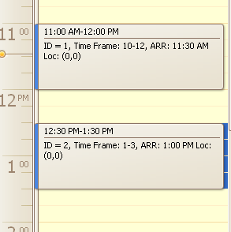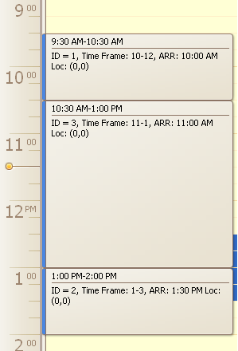

- Existing visits got shifted to produce maximum good joints. Inserting visit 3

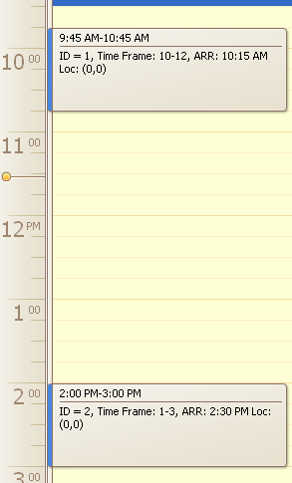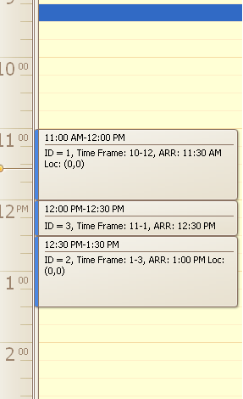

- Algorithm shifts and expands group of visits as well as single visits. Inserting visit 4 (4-6)
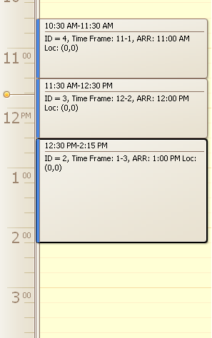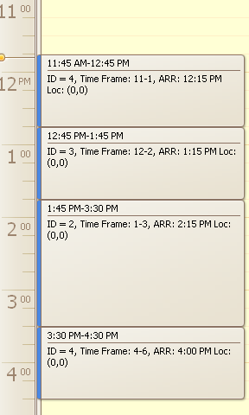
- Algorithm can change visits order to produce best joint rank. Inserting visit 3

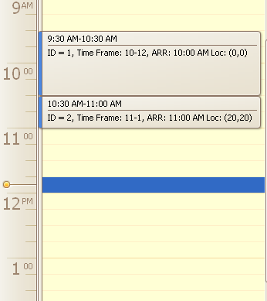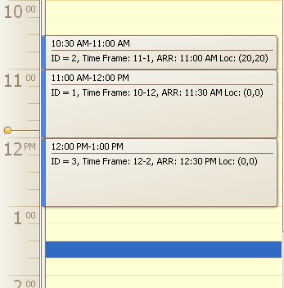

- Algorithm can change visits order if there is no other way to fit visit. Inserting visit 3

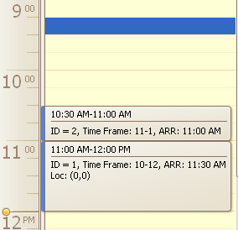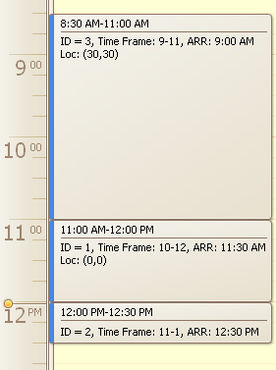

- Having visits with lower time frames earlier, not always guarantees more free time for new visits. In this example we can have more free time at top if we change visits order. Inserting visit 3
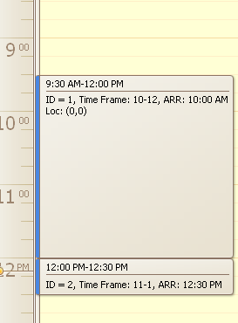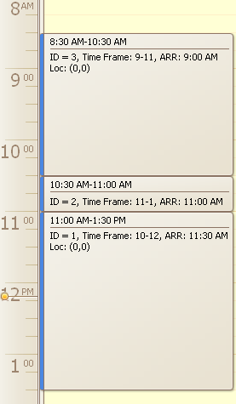

- If good joints were manually broken, they will be fixed on next insertion. Inserting visit 4
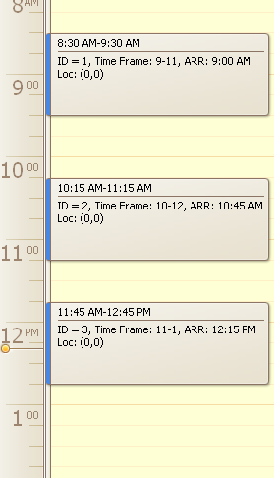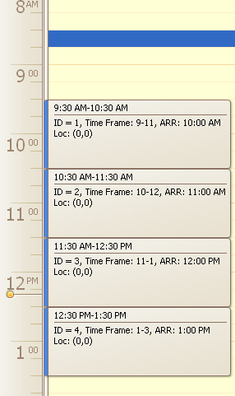

- Multiple visit order changes can be done to produce best joint rank. Inserting visit 5, algorithms swapped 1 with 2, and 4 with 3.
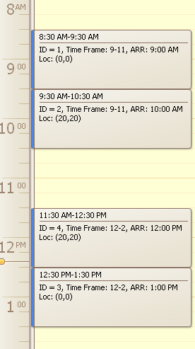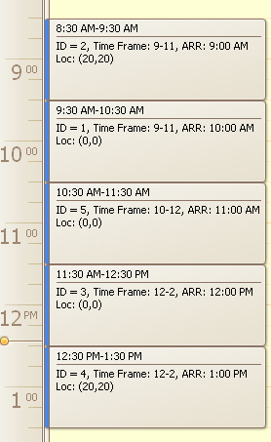

- New good joint will not be produced if this new joint can only be done by breaking existing joint. Inserting visit 3, visit 2 and 3 can have a good joint but this joint will not be created because it breaks joint between visits 1 and 2
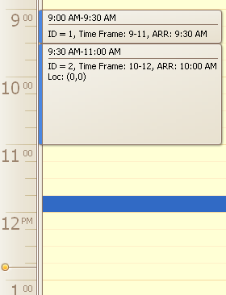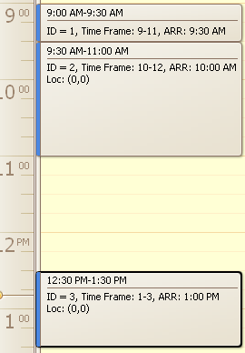

- Existing joint will be broken if new joint (instead of broken) will be earlier. Inserting visit 4
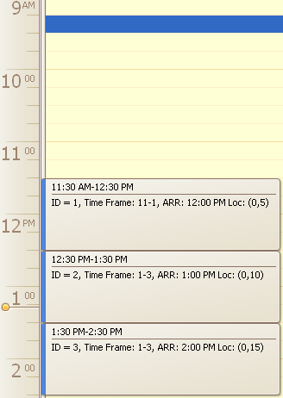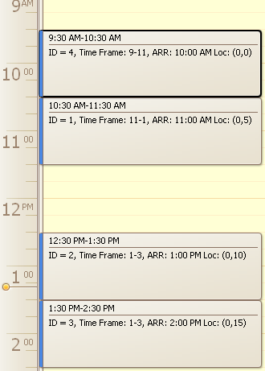

- Even if there is no way to insert new visit w/o breaking existing good joint – visit still can be inserted. Inserting visit 3

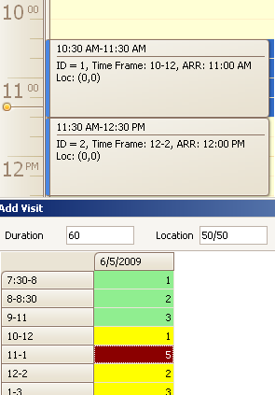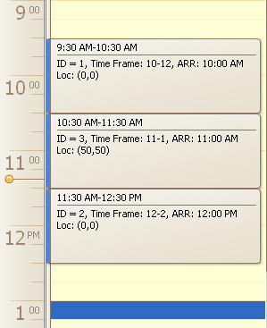

Multiple technicians
- Algorithm finds existing visits to produce good joint on multiple technicians. Inserting visit 3
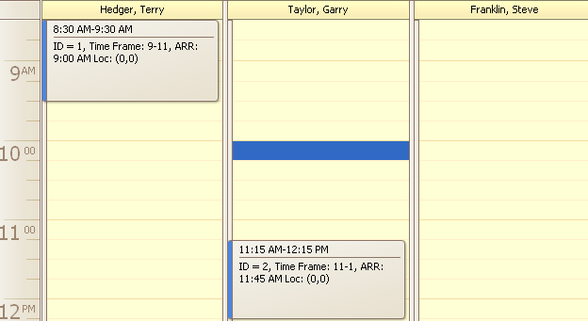

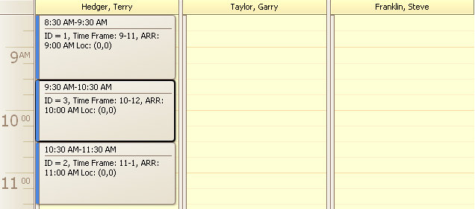

- If joint is possible on the whole, but not possible on technician who has joinable visit, the new good joint will be produced on other technician who has enough free time for this. Inserting visit 3
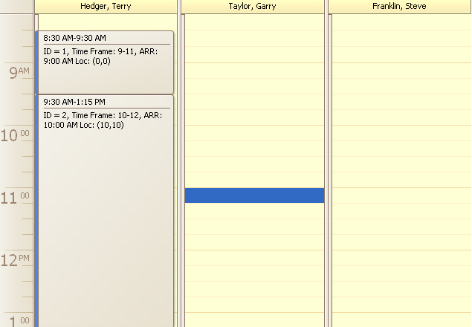

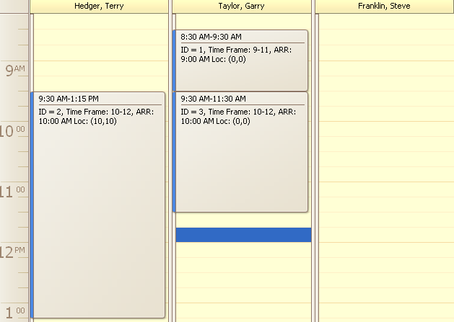
- If some existing visit prevents getting best joint, this visit gets transferred to another technician. Inserting visit 5. Example shows getting rank 2 joint
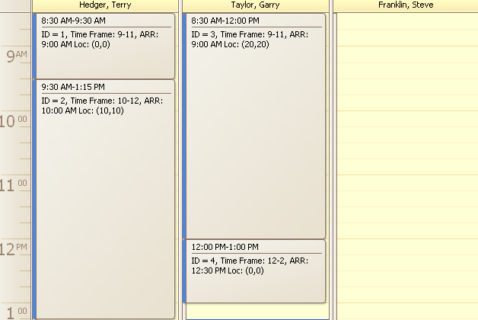

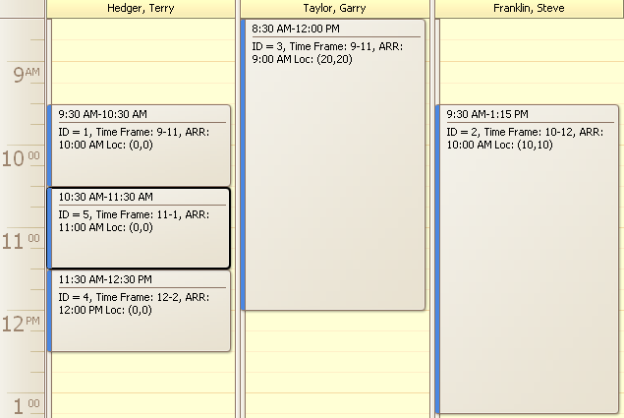
- Algorithm tries to minimize technician resources to do all the jobs. So if job list can be done with 2 technicians it will find a way. Inserting visit 5. Algorithm didn’t create 2 good joints on third technician because it could be done with 2 technicians
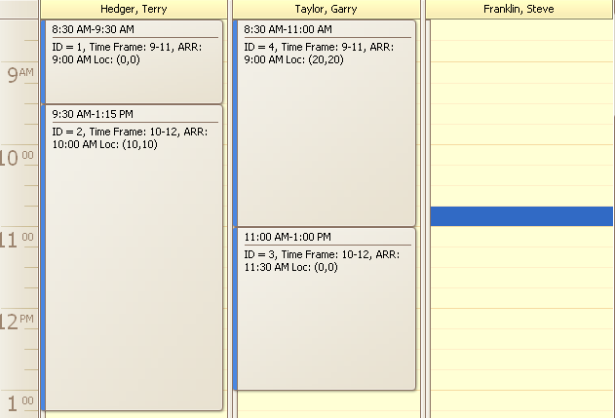

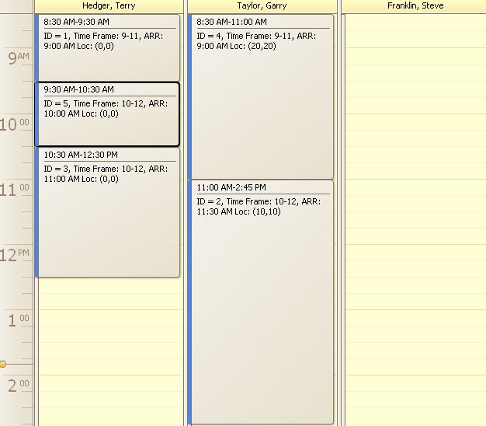
- If visit can be placed on technician w/o removals – no reinsertions will be performed. Inserting visit 4
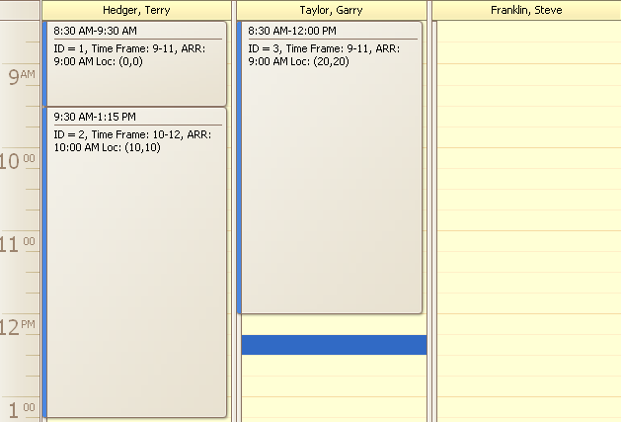

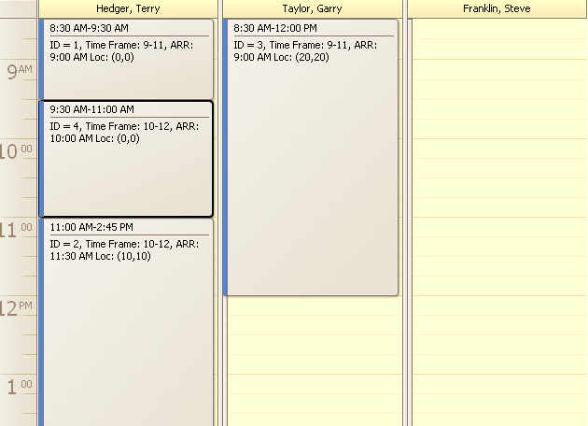
- More than one visit can be removed and reinserted to one or many technicians. Inserting visit 8. This visit is too big to be inserted on some technician w/o removals. So we do reinsertion of smaller visits to other technicians and moreover producing 2 good joints. Visit 4 has been transferred from Taylor Garry to produce 2 good joints, visits 2 and 3 has been removed, visit 2 inserted to Taylor Garry, visit 3 inserted to Frankin Steve
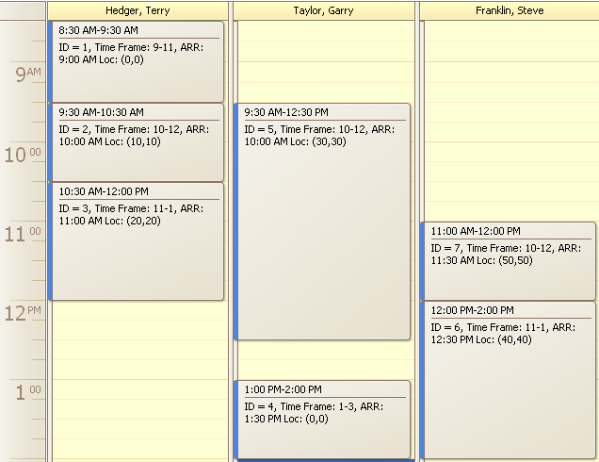

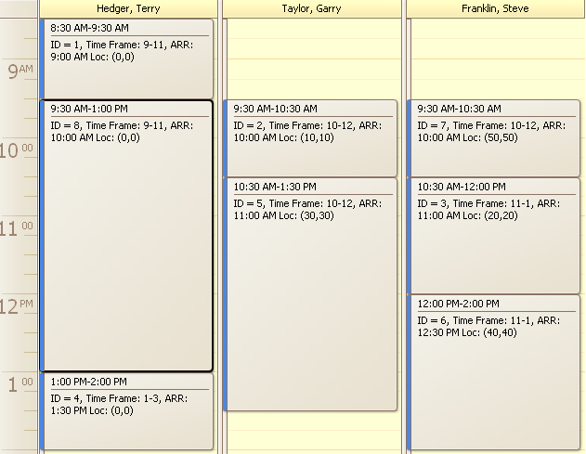
- Algorithm will not always preserve existing good joints between removed visits. Inserting visit 9. Visits 2 and 3 removed from Terry Hedger. Visit 2 inserted to Garry Taylor and visit 3 to Franklin Steve. This solution is not optimal because both of them could be placed on Franklin Steve preserving their good joint

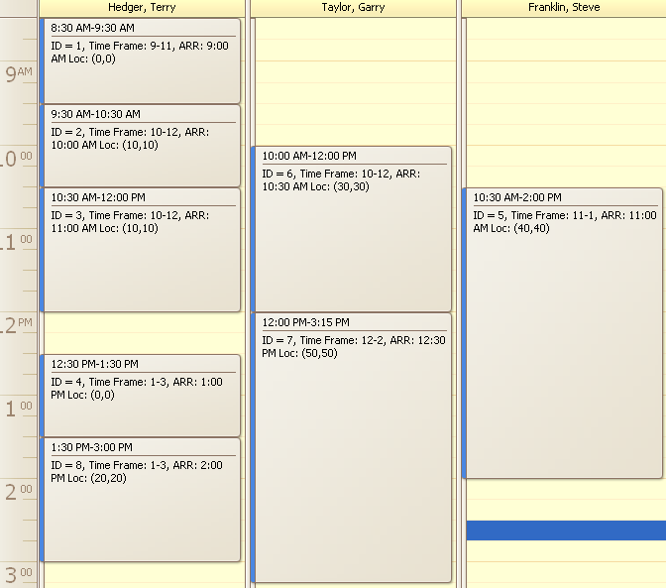

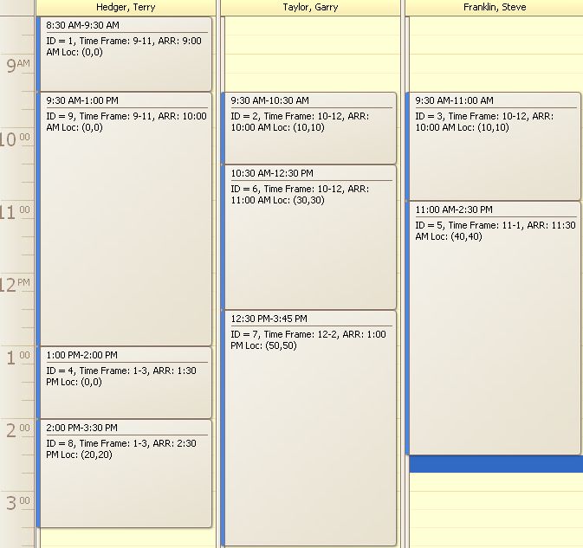

- But if it’s possible to get new good joint on another technician, it will not break existing good joint but move other visits in addition to existing good joint chain. Inserting visit 8. In this example algorithm tried to remove visits 2 and 3 and after reinsertion wasn’t able to compensate lost good joint (see previous example). So system decided to place new good joint block on Taylor Garry (1, 8, 4), move 6 to Franklin Steve and 7 to Terry Hedger. This solution didn’t break good joint on 2 and 3


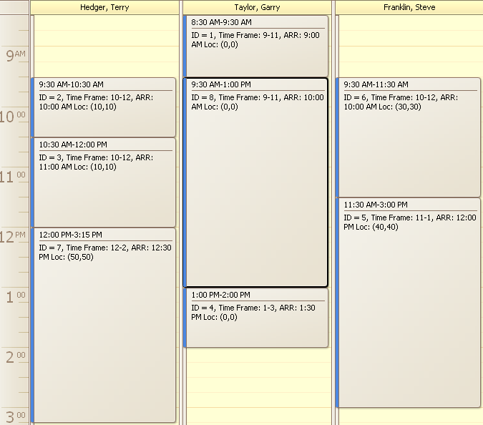

- If removed visit has produced good joint with another visit, algorithm will try to compensate lost joint on reinsertion. Inserting visit 6. Making good joints 1, 6, 3. Visit 2 removed (we’ve lost one joint) and reinserted to Franklin Steve (got this joint back)

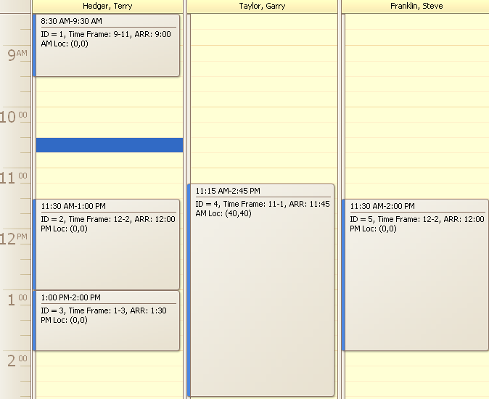

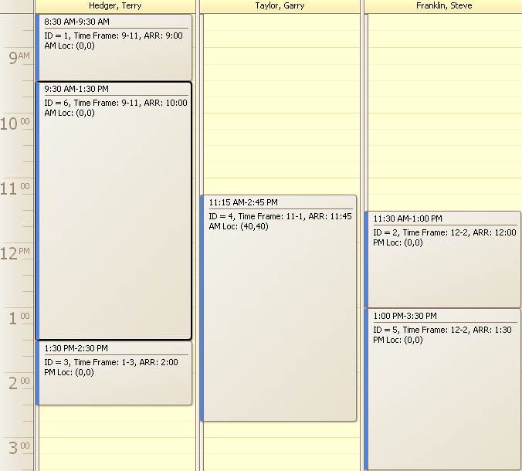
- Algorithm tries to minimize rank loss when forming block to insert. Inserting visit 5. It’s possible to get 2 good joints (1, 5, 4). But visit 1 should be removed so existing joint will be lost. But system found it is possible not to loose joint while removing visit 1, so Terry Hedger schedule has been recalculated
