Primary and Secondary zip codes on multiple technicians
- Inserting visit 2. Visit 1 moved to Hasty Ted in primary area because primary area for visit 1 is on Baker Tj only

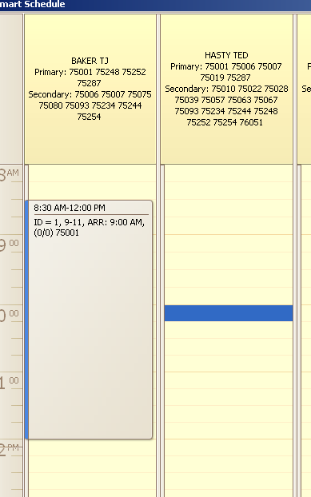
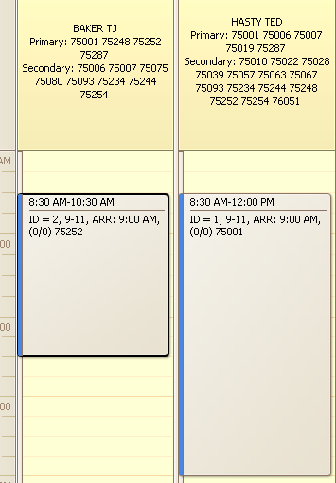
- Inserting visit 4. Visit 4 can have good joint with visit 1 on Baker Tj when visit 4 in secondary area, so system put visit 4 on Hasty Ted in primary area w/o joint

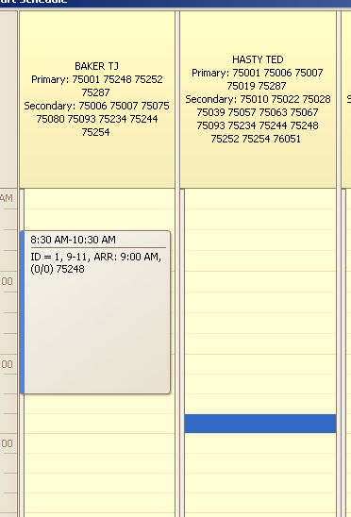
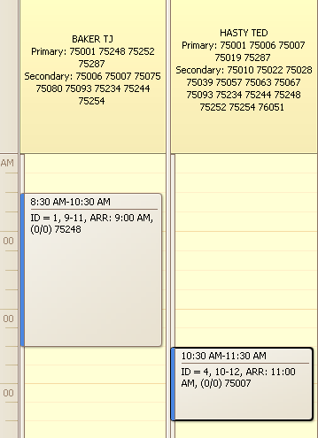

- Inserting visit 16. Visit 16 can be placed on Baker Tj in secondary area with 2 good joints, but system placed it on Hasty Ted in primary area w/o good joints

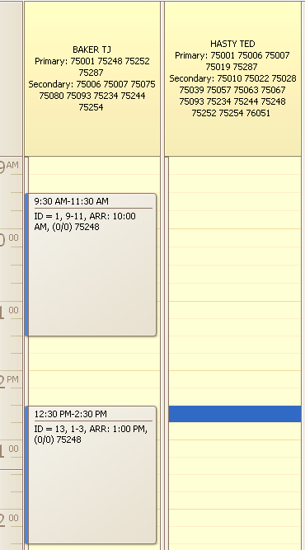
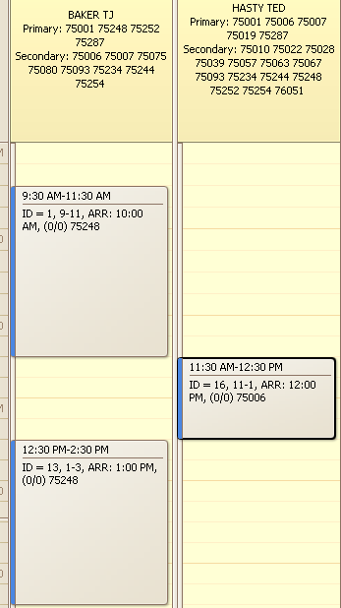
- Inserting visit 18. This visit cannot be placed to any technician into primary area. Instead of placing this visit to any of allowed technicians system has chosen particular technician where visit 18 can have good joint with existing visit

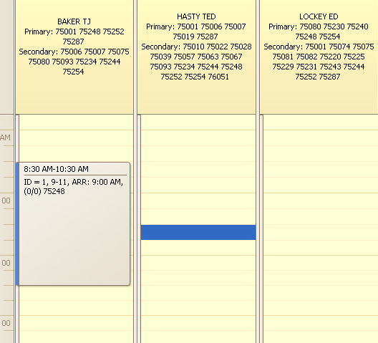

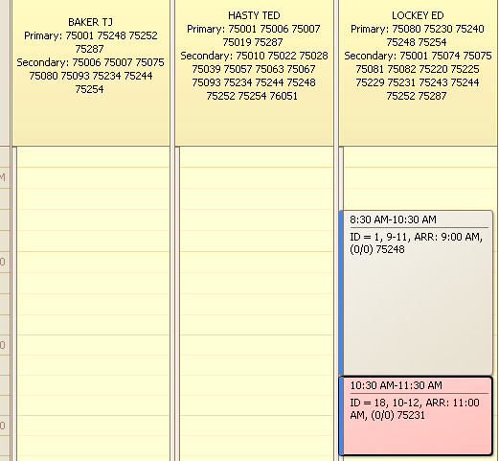
- Algorithm can move existing visit in block into primary area and reinsert another visit into secondary area. Inserting visit 4. This visit cannot be inserted into primary area w/o moving visit 1. Visits 2 and 4 placed on Baker Tj with good joint, visit 1 reinserted into secondary area

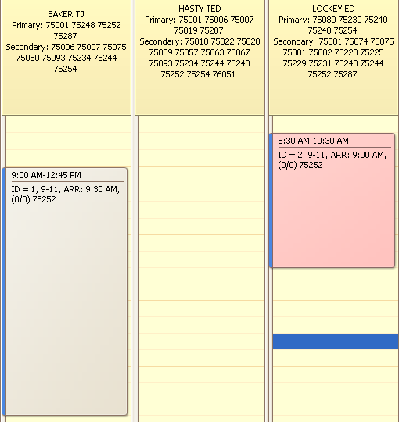
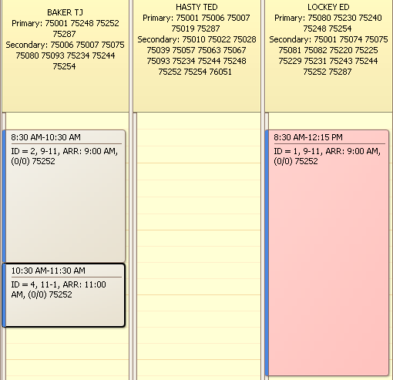
- Inserting visit 5. In this example new visit can make a good joint with visit 1 only. So visits 1 and 2 has been swapped to produce good joint instead just placing new visit on Hasty Ted w/o good joint

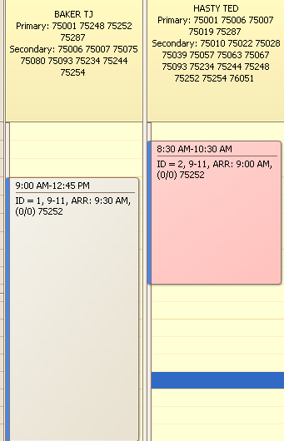
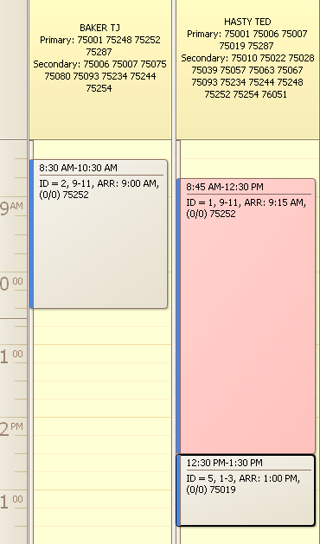
- Existing visit in block can be moved to secondary area if another secondary area visit can be reinserted into primary area (to preserve secondary area visits count). Inserting visit 6

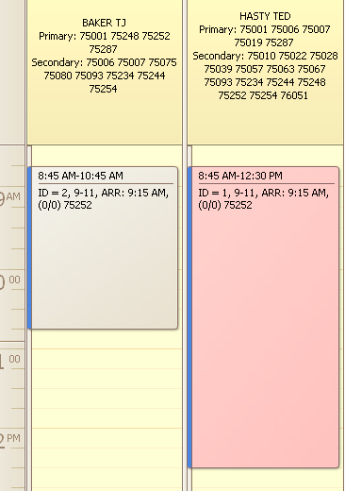

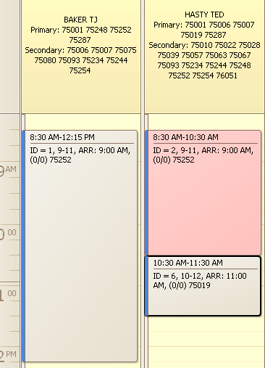

- Inserting visit 14. In this example there is a possibility to create good joint with visit 1 when visit 1 in secondary area. But this joint cannot be created because visit 12 cannot be reinserted into primary area

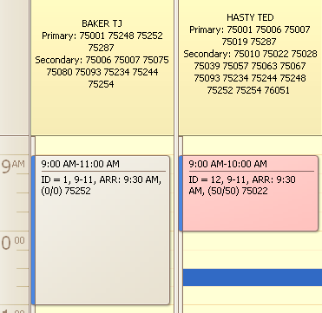

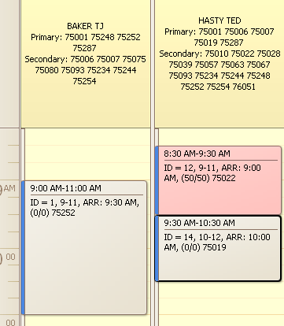
- Inserting visit 19. Any visit can be reinserted from secondary area to primary (not only the visits which prevent block insertion). In this example visit 1 and 19 produce good joint, but this block can be placed on Hasty Ted w/o removing visit 18. Visit 18 reinsertion is a mandatory requirement to not to increase secondary area visits. Visit 18 reinsertion to Baker Tj is possible only when visit 1 removed from Baker Tj, but visit 1 can coexist with visit 18 on Hasty Ted

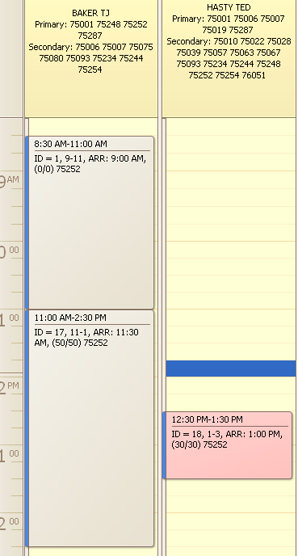
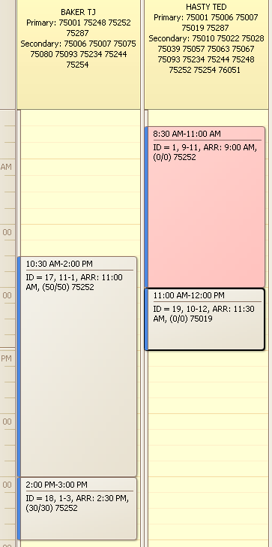
- Inserting visit 29. This works like previous example and shows how visits that prevent block placement got transferred into their areas (visit 28 reinserted to another technician into secondary area)

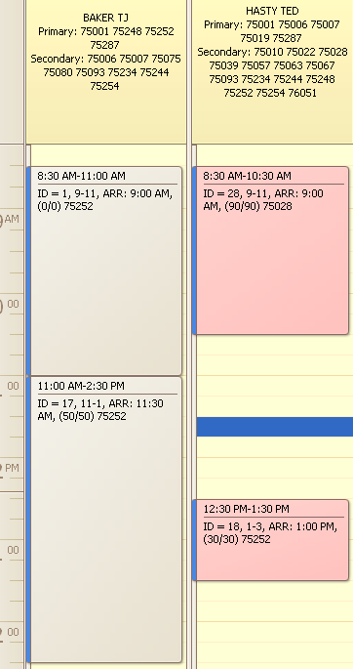
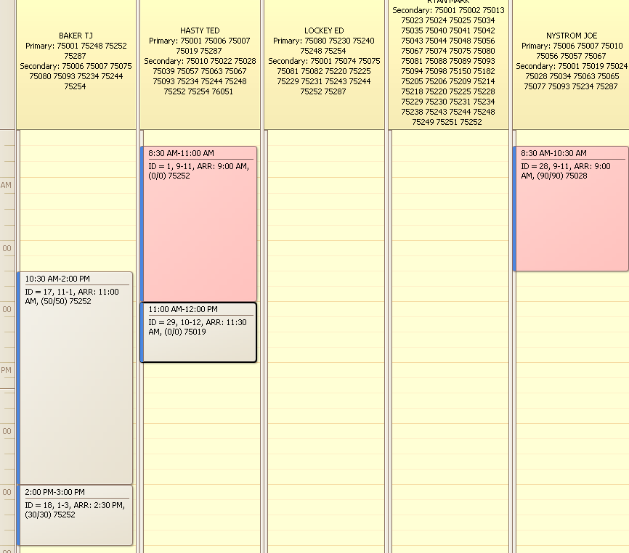
- Inserting visit 41. Block with 2 good joints can be placed on technician where only one of existing visits will be in secondary area, another one in primary. On reinsertion we need to compensate one visit by reinserting it from secondary area into primary

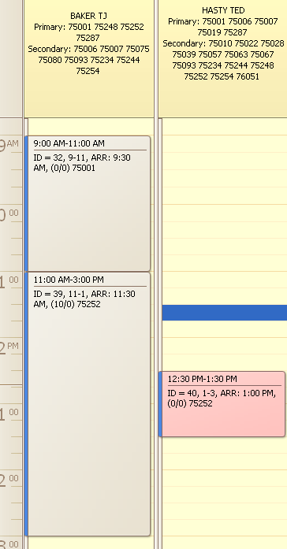
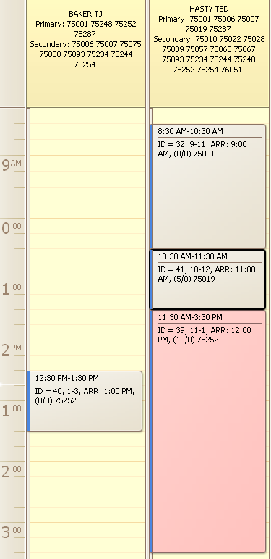
- Inserting visit 51. Both visits in joint block can be placed into secondary area if there are 2 another visits in secondary are which can be reinserted into primary area

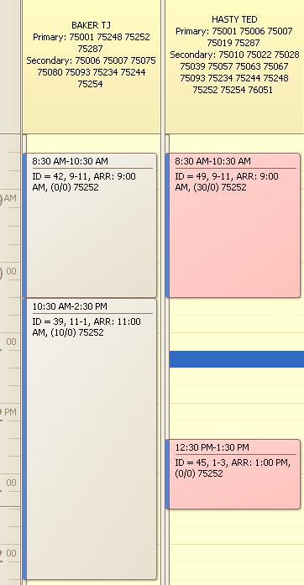
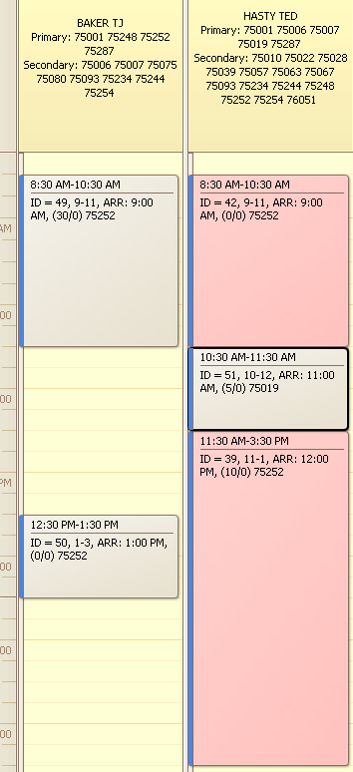
- Similar to previous example. Inserting visit 53. Here visit 52 cannot be reinserted into primary area, so joint block (42, 53, 39) cannot be placed on Hasty Ted. Joint with rank 1 created instead

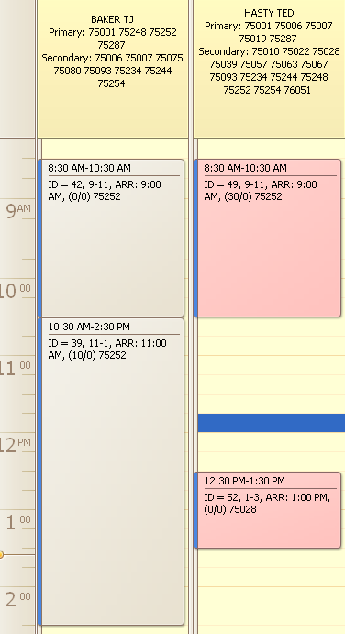
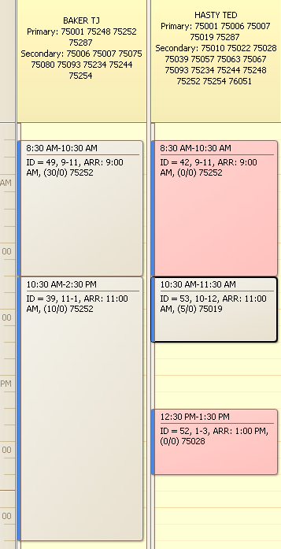
- Block can be placed on technician where existing visits in block will be in primary area instead of secondary. In this case other visits can be reinserted from primary to secondary area. Inserting visit 62. Visits 55 and 62 produce block and placed both in primary area, visit 54 reinserted into secondary area. Reinsertion from primary into secondary area possible not only on Hasty Ted

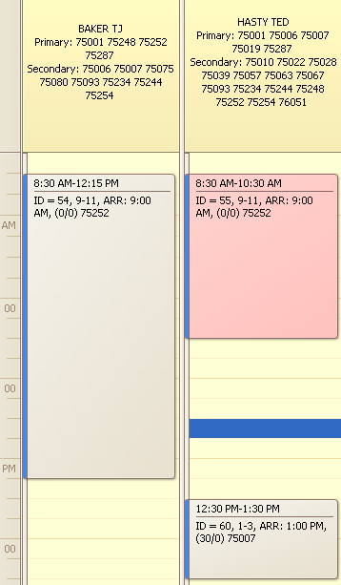
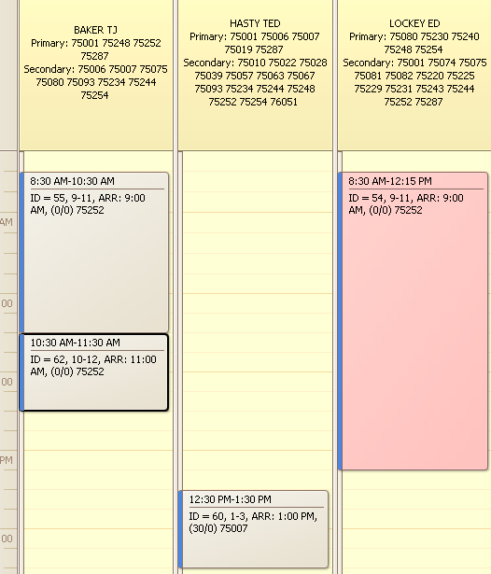
- Inserting visit 65. Similar to previous example, but 2 visits in block has been placed in primary area, and other 2 visits has been reinserted from primary into secondary area

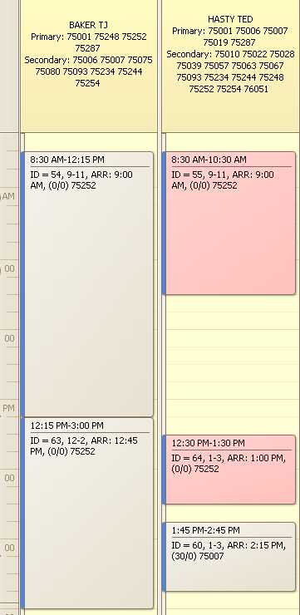
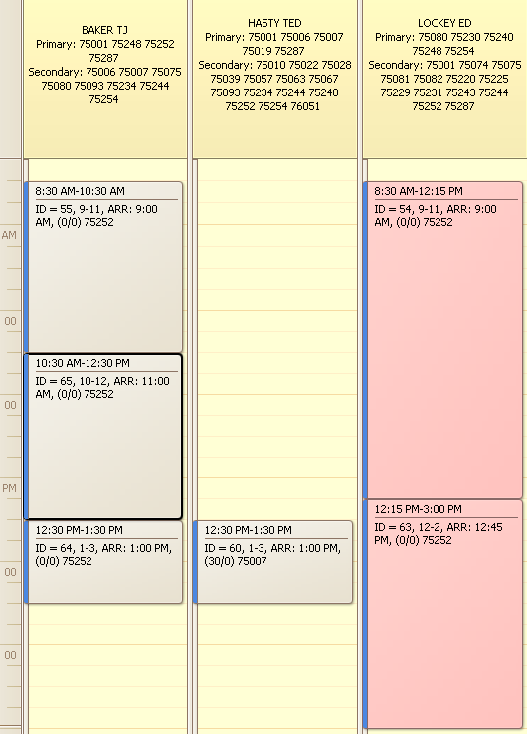
- Insertion is not allowed if visit placement increases secondary area visits count by 2. In this example we cannot place new visit on Hasty Ted because of existing visit. Existing visit can be transferred to secondary area only and new visit will be in secondary area too

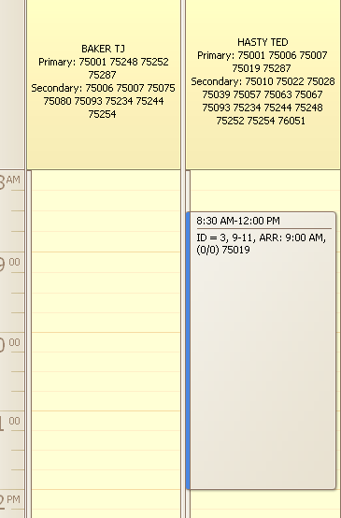
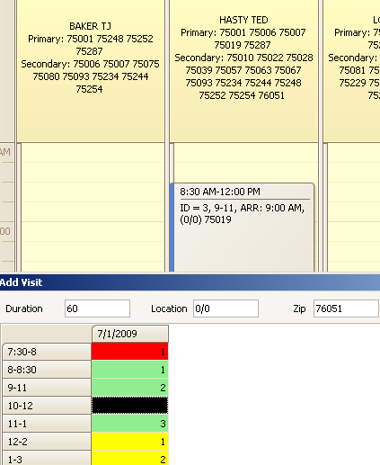
- Inserting visit 16. This visit cannot be placed in primary area by itself. Instead of placing it on Hasty Ted it is placed on Baker Tj in primary area, and existing visit reinserted from primary to secondary area. This combination gets rank 1 with one extra visit in secondary area

