Meeting notes

- Current release OPEN tasks
- Next release Open tasks

Open issue summary
- Boris
- Valera
  - During creation of new project , progress says “0”, should say “Unknown”
- Sergei
  - Linda issue with taxes (sync)
    - h_deflood
      - tax_prct must be greater then 0, Default 8.25, Now we leave some 0, but majority not.
  - Another sync issue
      - csr_id we overwrride now with 555. If we import order and servman already set it, we should not override it.
      - b_person - book person. Should not override
      - l_person - last person modified it. If we change it, we need to put our id of who last modified it. Each order that restoration modified, l_person should be Nick Hobbs.

Completed Construction issues
  - Code review and make sure app is working ok, Sergei and me.
  - Test against copy of production db – Boris.
  - Remove TicketPrint class from lead sheet report. Use Dalworth.Server.Domain.package.ProjectPrint class instead
  - h_deflood
  - tax_prct must be greater then 0
  - Default 8.25
  - Now we leave some 0, but majority not.
  - Totals on Project Edit – work incorrect. Tell Valery to fix
  - “Customer Projects” screen
    - Shouldn’t be shown in task bar
    - Add cancel button
    - B label shows up on top of the grid
    - Remake this dialog to be like the rest of dialogs. Dialog shouldn’t have minimize, minimize buttons, shouldn’t be shown in task bar. Do not show icon, do not allow resize this form
    - Panel is not fully docked to the form (can see gray line near the form edge)
    - Do not place buttons into separate panel
    - No tab order, shortcuts. Grid should be focused with Alt-B. User should leave grid by tab
    - Pressing esc should cancel operation. Do not show project edit
  - “Void and create new” – Transaction should be voided only when new transaction has created. If user pressed cancel – do not void. Boris agreed
  - Store Total Scope amount in Project.ClosedAmount. Rename pcd.ScopeAmount to BilledAmount. Store total billed amount in BilledAmount field instead of ClosedAmount.
  - Fix reports. Construction Time line – use Amount Billed from new field. Construction Manager – use Amount Billed from new field
  - ProjectPrint class – in ProjectAmount use ClosedAmount instead of ScopeAmount
  - Alt-B shortcuts for both grids on Project Edit
  - Right now when decline date is set – Sign Up date and job cost becomes null automatically. When job cost is set or sign up date is set – decline date becomes null. To do – do not modify fields automatically, use validators instead saying some field cannot coexist with another field
  - When showing message that project cannot be declined because of existing transactions – activate transactions tab and focus invoices/payments grid
  - Create db upgrade scripts for schema and data – Valera
- Adsource issues
  - If project has an ad source which is not in list of available ad sources for restoration – combobox shows no ad source (on edit visit, on edit project). Correct adsource shown on complete visit. In this case empty adsource validated ok which is wrong
  - When project adsource is not in restoration list – list of adsources should contain all the restoration adsources plus one extra item (currently selected)
  - Test with 2 different projects with non restoration adsources.
  - Test complete visit
- Construction Manager report
  - Project must be paid in full to be in the report
- Construction Lead report – Job Closed is a SignOff date. SignOff date is removed. What should be used to count job as closed. Use last payment date. Project must be paid in full
- add void and create new button – must be able to edit it - Valera
- Change scope date to app date in project form, reports and tickets - Valera
- Add the following people to account managers and project managers: JR Chapman, Amber Holleman, Buddy McKinney, Jenny Davis as PM and AM - Valera
- When signup date is not null, allow enter unique job number. If signup date is deleted, then job number is set to null - Valera
- Use progress to decide whether to print Lead ticket or Job ticket. Print Lead ticket when progress is Lead, print Job ticket in the rest of cases
- Print job and lead ticket on line printer. Every time change of progress happens, we need to print. Print when progress changes to Lead and to Job. When project is created in status Lead or Job then also print. – Boris
- Printing, wrong reports - Sergei
- Slow startup of the application, will send sergei db - Sergei
- Prevent construction duplicities. I have coded it but need gui clean up - Valera
- Fix email capture on construction project. – Valera
- On create new project, only show ad sources that are related to restoration. On edit, show all ad sources. (Whole application, all project types)
  - On Ad sources, only show active technicians. Now we are doing it in code already. However nee d to ask Jammie to update it in servman who is active and who is not.
  - Create update script that would update adsources that are used in restoration
  - Get a list of used ad sources and number of times each ad source used (Used Ad Sources.xls)
  - Make sure they are on the list in the document.
  - For ad sources that are not on the list, make sure we don’t need them on create project or add them to the list.
  - If there are similar ad sources in wish list and in used list need to make decision whether to create new ad source or use one of existing (for ex. we want to have TV but there is TV General exists)
  - For new add sources, need to ask Jammy to add them to servman
  - Run ad source sync to get ad sources from servman to our system.
  - Make add sources as restoration ad sources. Mark ad sources as used for creation project process.
  - Add report by ad sources. (Need to discuss with Courney)
  - QUESTION: DO we need to show these ad sources on construction lead report? No, Only Liberty Mutual and Statefarm PSP
  - Ad source list required (Done in UsedAdsources.xls)

- Remove description of the loss. Just leave notes
  - Question: Right now it is used on lead sheet. A: Just put notes there
- Billing dates and payment dates
  - Estimated amount – just amount entered when project is created. Just means initial estimate
- Implement Scope information. Ability to enter scope transactions Each scope record must have the following fields
    - Department – Construction or Content. Do we really need it here?
    - Type of job. Allow to type anything
    - Amount
    - Date entered
  - Total that affects amount due will be total of scope transactions (scope amount), not estimated amount).
  - Allow to enter change orders – negative amount
  - Allow void, create
  - Implement Invoices and Payment transactions for each project
    - Transaction Type, Transaction Number (entered manually), Issue Date, Is Voided, Amount, Notes
    - Show payments and bills like in ConstructionPaymentsAndBills.xls with filters for transaction type, dates, etc. Show it on edit project screen.
    - Show summary information for the project – last billing date, last payment date, amount billed, amount paid, amount due (estimated amount – amount paid) as read only fields.
    - Ability to create transaction, void transaction
    - Payment transaction can be negative amount. (Adjustments) . Invoice transaction can only be positive
    - As soon amount due is zero (change in total scope amount, new payment received, payment voided), and estimated amount equal total payments received, then ask if project is completed. If user says YES, then mark project as status “Closed” and progress “Paid IN FULL”. If user says “No” progress is “Paid” and status is “Open”
    - If amount due changes from 0 , then ask “Do you want to reopen the project?”. If yes, mark project status as “Open” and progress as “Paid”
    - Credit and Payment transactions should be shown in grid as negative values. Total Credit and total paid are negative also.
    - In addition to Invoice and Payment need to support Credit transaction type. This means Billed amount adjustment (reduces billed amount). Add Credit filter for Bill/Pay grid
    - All the negative values (in grid or in totals) should have red fore color
    - Any transaction entry dialog should allow positive amount only
    - Bill/Pay grid should have additional column Balance. When filter is set to All – invoice transaction adds amount to the balance, Credit and Payment transactions subtract amount from the Balance. When specific transaction type is selected – balance should be considered as running total (positive for invoice, negative for payment and credit)
    - When specific transaction type is selected in grid filter and new transaction with another transaction type was added – change grid filter to “ALL” and focus newly added record
    - Modify totals section – leave last billing date and last payment date, billed amount, collected amount and amount due should be removed (will be included in extended total calculation sections). Add Bill Summary and Payment Summary sections
    - Bill Summary
      - Total Scope Amount – duplicated from Scopes
      - Billed Amount = Sum(Invoice transactions)
      - Credit Amount = - 1 * Sum(Abs(Credit Transactions))
      - Work In Progress = Total Scope Amount - Billed Amount + Credit Amount. Can be negative. When “Unbilled amount” is negative that means customer is over billed. “Total Scope Amount” should be increased or Credit should be added.
      - Add (Estimate Total to scope amount)
    - Payment Summary
      - Billed Amount – see above
      - Credit Amount – see above
      - Collected Amount = -1 * Sum(Abs(Payment Transactions))
      - Unpaid Amount = Billed Amount + Credit Amount + Collected Amount. Can be negative
      - Reorder columns. Scopes grid – Date, Job Type, Amount, Notes, Is Voided. Bills/Payments – Date, Number, Transaction Type, Amount, Balance, Notes, Is Voided
      - Invoice, Payment and Credit issue number shouldn’t be required
      - On void, show editor (scope transaction editor or Bill/Pay transaction editor) with all the fields read only other then notes. Only notes can be edited.
      - Allow editing of notes for all transactions from grid.
      - When create new transaction add
        - Scope type (Scope, Change order)
        - Is Estimate check box (estimated scope)
        - IF IsEstimate is true, then transaction can be edited.
      - On scope grid, add type (Scope, Change Order)
      - If transaction is estimated, show question mark where we show voided.
      - Return back Scope date as separate field. Scope Date is a date of scope appointment. It does not mean that appointment happened; it just means it is scheduled.

- Remove fields
  - Remove the following dates: Signoff date, Actual Completion date, Actual Start Date
  - Sergei will research affect of removal of each date and write it here
    - Signoff date
      - When Signoff date is set - progress is "Job Done" and project status is "Completed" A: Just move project to completed when it is paid off.
      - Used on Construction Timeline report A: Remove it from there
    - Actual Completion date
      - Used on Construction Timeline report – Remove it
      - Used on printed ticket – Remove it
    - Actual Start Date
      - Used on Construction Timeline report – A:Remove it
      - Used on printed ticket – A:Remove it

- Add account manager to project. Same people can be project managers and account managers. Just different roles. Same person can be both.
- Add JR Chapman, Amber Holleman, Buddy McKinney, Jenny Davis as PM and AM
- Printing.
  - I was not able to print into printer. Printer is trying to use some other paper size. What paper size do we use? I will try to print locally at home and make sure it works.
  - Question: Do we support Letter size (8.5x11) or A4? How did we print other reports? They all where designed set to A4. NEED 8.5X11.
  - Reports broken: Construction manager – not printing, construction time line should be landscape but now it is portrait.

- Progresses
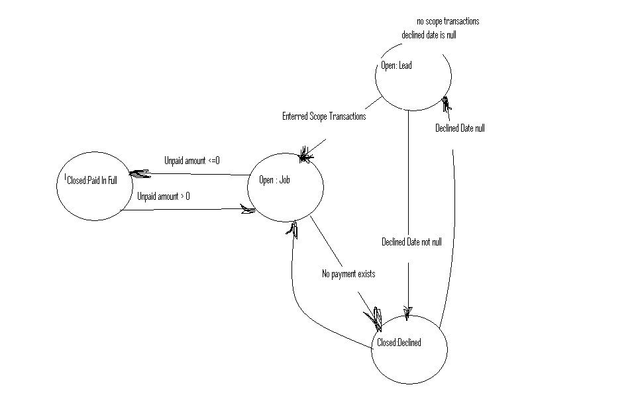
  - Lead – all conditions should be true
    - Sign Up Date is null
    - Decline date is null
    - Last Billing date is null
    - Last Payment Date is null
    - Quantity of not voided credit transactions equal 0
  - Declined
    - Declined Date is not null
    - Sign Up date is null
    - Last Billing date is null
    - Last Payment Date is null
    - Quantity of not voided credit transactions is 0
  - Paid in full
    - Declined Date is null
    - Total Scope Amount greater than 0
    - Quantity of not voided estimate scope transactions equal 0
    - Last Billing date is not null
    - Work In Progress is equal 0
    - Unpaid Amount is less or equal 0
  - Job
    - Progress is not ‘Lead’
    - Progress is not ‘Declined’
    - Progress is not ‘Paid in full’
- Project statuses
  - Open
    - Progress is ‘Lead’ or ‘Job’
  - Closed
    - Progress is ‘Paid in Full’ or ‘Declined’
- User confirmations
  - If Declined Date is not null and at least one of the rest conditions for ‘Decline’ progress is false – corresponding message should be shown that declined date cannot coexist with specific fields or transactions. Message: Project cannot be declined with non voided invoices, payments or credits”. OK
  - Progress becomes ‘Declined’ ask user “Are you sure project is Declined?” message on decline
    - Yes: Status – Closed, Progress – Declined
    - No: return to project editor
  - Progress becomes ‘Paid in full’ ask user “Would you like to complete Project?” Yes/No/Cancel.
    - Yes: Status – Closed, Progress – Paid in full
    - No: Status – Open, Progress – Job
    - Cancel: return to project editor
  - Progress becomes ‘Lead’ or ‘Job’ and previous progress is ‘Declined’ or ‘Paid in full’ ask user “Would you like to re-open Project?”
    - Yes: Status – Open, Progress – ‘Lead’ or ‘Job’
    - No: return to project editor
- Miscellaneous issues on Project Edit screen
  - Scopes grid should be ordered by date and type, where type order is Scope, Scope Estimate, Change Order
  - Job type column should be wide enough to include pretty long text
  - Amount column should be wide enough to show 100 000 w/o dots
  - ‘Create Scope’ dialog changes
    - Rename OK button to Save
    - Add button “Save and Add”. When button is clicked current information should be added on grid, and newly added record is focused. Dialog window stays open, all the information on dialog should be cleared except Scope Date and ready for the next record entry.
  - Rename block ‘Scopes’ to ‘Scope Info’
  - Rename ‘Bills/Payments’ to ‘Invoices/Payments’
  - Rename ‘Last Billing Date’ to ‘Last Invoice Date’
  - ‘Outstanding amount’ is misspelled
- Change layout
    - ‘Customer’ and ‘Totals’ should be out of tabs in the header
    - ‘General’ tab should include all the blocks except ‘Scopes’, ‘Bills/Payments’ and header
    - ‘Transactions’ tab should include ‘Scope Info’ and ‘Bills/Payments’
    - This dialog should fit into 1024x768 resolution
- Prevent construction projects duplicates
  - Project should have LastModified date. Put this date into ProjectConstructionDetail table
  - On Construction or Content project creation if selected customer has at least one not closed Construction or Content projects or closed project which was modified not more than 30 days ago
    - Show dialog with all the open or recently closed projects for this customer
    - Dialog contains
      - Customer info block
      - Existing Projects grid. Grid contains following columns: Project Type, Status, Progress, Lead Date, Project Manager.
      - ‘Create Project’ button
      - ‘Edit Project’ button, which is enabled when one of grid records is focused
    - Customer can continue project creation or can edit one of existing projects
- Review bugs
  - ad source must be required
  - on save and add, move cursor to job type
  - add void and create new button
  - on grid edit estimate/payments, must edit on enter
  - Modify Work in progress calc, not include credit
  - Work in progress and unpaid must have more room for $(9999,999.99)
  - Check if reports are correct.

Non Construction issues need fixing
- Email address capture
  - Fix email capture on construction project - Valera
  - Show email capture and create visit, close visit screen. Any time it can be updated.
  - If customer has email address, show it on customer edit screen.
  - Sync email address into servman
  - For existing customers, need to bring emails from servman.

- Linda issue with servman. Need to ask Jammie to setup access to servman Boris Needs to talk to Linda to understand her issue. Make screenshots.
  - 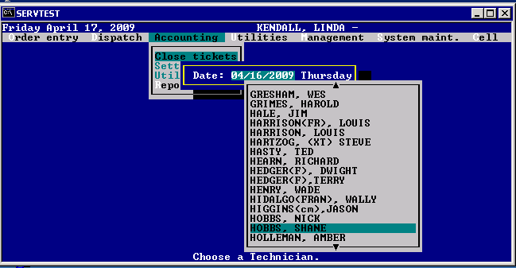
  - 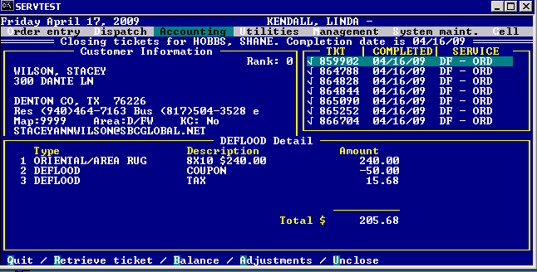
  - Need to talk to Jammie about Taxes.
  - Jammie Response:
Boris
The tax problems is from the field in Hdeflood.tax_perc is being set to 0.00. This field needs to have a percentage in it even if the dollar amount is 0 or if the job is tax exempt it should always have a value.

One other thing. The fields:
Hdeflood.csr_id
Hdeflood.b_person
Hdeflood.l_person
Are not being updated correctly. If the csr_id and b_person id have a value in them when you retrieve the job from servman then that value needs to stay the same. This is so the original booking agent maintains credit for the job. The field l_person should be updated by the last person to change the record. If you create the record then you should put the user id in the csr_id and b_person field.

Thanks
Jammie

- Monitoring date assignment
  - When close monitor or deflood, if date is not assigned for next monitor, ask “Are you sure next monitoring is not scheduled?” 99% of all monitors close with next monitoring date
  - IF at least one of the pending visit task is monitoring, show visit under current with Red. Done
  - Don’t show it under unscheduled Done
  - Don’t ask if you need to schedule next appointment if next appointment has deflood. By default show edit visit dialog so user can setup service date
  - Split visit. IF any of the visits have deflood, make sure ask them to set service date.
  - When Fail /Cancel Deflood visit, don’t allow to modify fail cancel Monitoring task. And also only allow to enter notes into Deflood. Right now they fail monitoring and think they failed deflood.

- Add ability to attach pictures to projects.
- Add functionality to trace how projects got created. Construction, content project may be created as a result of other project.
  - Add ability to create new project from existing project or visit. Is this usability of to remember connection between the projects?
  - Need more discussion. Would it be enough just to show report of projects that come close in time for a customer? Projects created in 1 month for same customer Flood->Construction->Rug Cleaning->Carpet Cleaning->Misc. All sequential by date.
- Need report to show jobs generated as result of flood, construction, content
- Need discussion with me and sergei Missing equipment on some jobs. Courtney will tell issue list. Need to discuss how to redesign equipment.

- Project screen - History Lookup
  - Show history of the project notes and readings when click on project so that he does not have to click on each task
  - Show list of task notes and relate them to tasks for selected project. When click on note highlight task, when click on task, highlight note. Allow to scroll notes up and down
  - Add historical notes. Many notes to one task and remember date added – may be.
  - Show readings history related to tasks for selected project.
  - Create project detail report that has all the information about this project on one sheet of paper.
  - Question. Do we need to do both – 6.1-6.4 and 6.5 or just 6.5?
  - Create note as separate entity and relate note to projects, to tasks, to visit.

- When completing flood with payment, it will ask “do you want to schedule next appointment” I click yes and then It automatically prompts me to the payment screen. It should prompt me to the schedule screen and then payment screen Need to discuss with Nick
- Time collisions still experienced. Need to figure out how. I thought we have removed all time collisions. Need to discuss. Need real examples.

