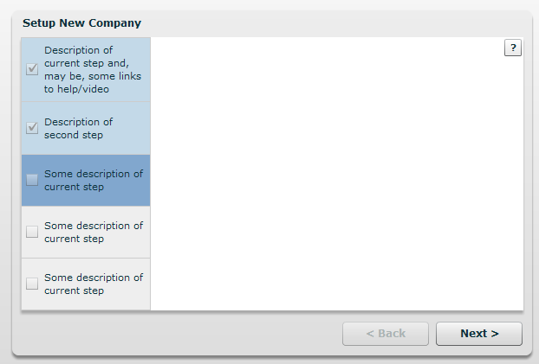 | Empty wizard.  Template for all wizards steps  Left part – progress step-by-step
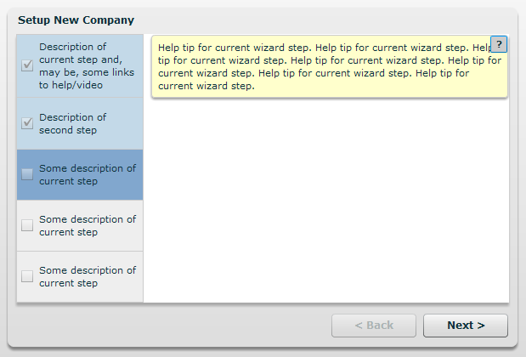 | All steps has helptips
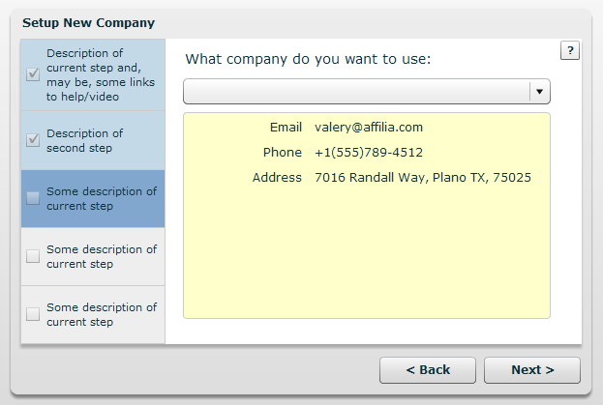 | Select company for create default messages for phone calls.  Fill Combo Box from QB data.  Read-only screen.  Email for contact to customer  Phone – the same.
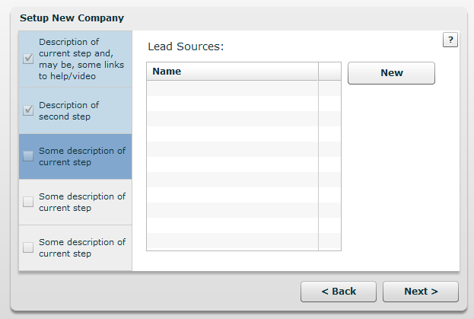 | Create new Lead Sources.  Any named point, from which customer can get Leads.  Can be optional if we will use Autocomplete Control. Like we used for Rob’s project.
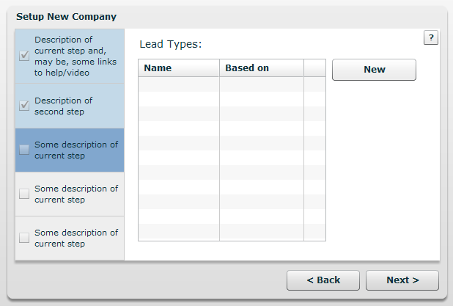 | Lead Types.  Can be optional if we will use Autocomplete Control. Like we used for Rob’s project.
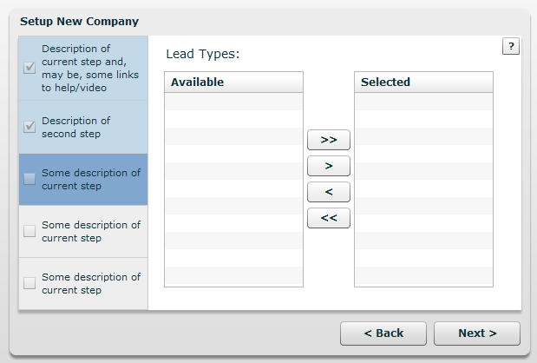 | Alternate screen for previous
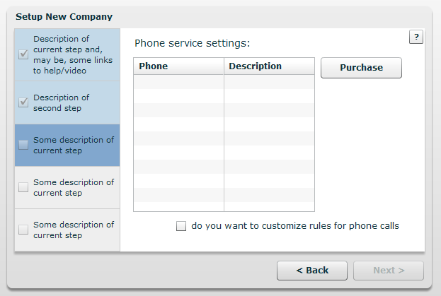 | Phone purchase.  When user purchase any phone number – we can create two default rules for him:  - Queue rule  for 9:00Am-6:00PM for Mon-Fri  - Voice mail for any other calls.  Before this screen we can insert screen to ask if user wants to use phone service for generating leads.

All User management features we can move to QuickBooks User Management System.
We don’t need any custom fields for our functionality.

Our User table can be used as link between QuickBooks Users and our internal userId only.

