Request for Proposal Response

Warehouse Ordering
And
Inventory Management

February 2008

Prepared By:
Boris Furman
bfurman@affilia.com
(214) 335-4143


Table of Contents

Application Overview 3
Company Goals 3
Warehouse Application Users 3
Technical Architecture requirement 4
Modules 4
Database Design 5
Item, Brands, Warehouse 5
Users 6
Customer 7
Order 8
Shopping Cart 10
Inventory 11
Use Cases 12
Warehouse Store Use cases 12
Management Tool Use cases 25
Synchronization processes 26
Update Inventory 26
Update prices 26
Update list of Customers available per Brand 26
Missed Opportunity Report 26
Mac Pac Service DLL 27
Customer Center Service DLL 27

Application Overview
The Warehouse Application will act as a unified and centralized application for ordering new items and verification of inventoried parts and products across multiple brands and warehouses.

Ordering from a centralized Warehouse application allows items, which are readily available, to be shipped for customers at a more efficient deliver rate and with reduction in overall delays.

Company Goals
Enable Sales Rep to order pre made items from multiple warehouses.

Warehouse Application Users

Warehouse Store Users

Sales Rep
- Order items from ASC for resale from multiple warehouses
- Review Sales History
- Review Item Inventory and Availability
- Can work for multiple Customers

Maintenance Application Users

Brand Administrator
- Administer how items are presented in the menu based on brand

Finance
- Modify Max Order Credit Limit for any Customer in any brand
System Administrator
- Monitor and Manage maintenance and capacity on application and SQL server
- Monitor all jobs and batch processes
- Monitor data synchronization with Mac Pac

Technical Architecture requirement

Application must run as part of brand web site. Based on brand, it must conform to brand web site look at feel. Warehouse application will be embedded into html to show brand top menu. End user must feel that it is part of the site. GUI interface will be implemented utilizing Adobe Flex 3.0. Backend services will be built in VB.NET. The Database will utilize SQL Server 2000.

Modules
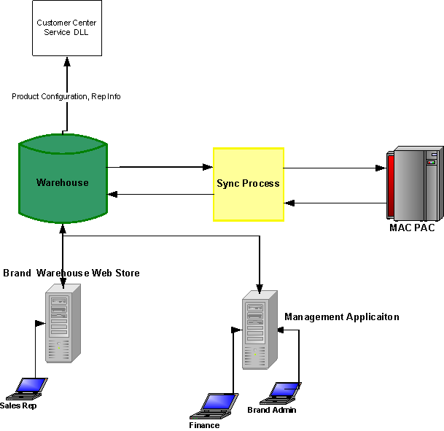

- Warehouse Web Store, Warehouse db – web store used by Sales Reps
- Management Application – application used by ASC employees for management purposes
- Sync Process – synchronization of data with Mac Pac
- Customer Center Service DLL – provided by ASC, queries login, customer, rep information.

Database Design

Item, Brands, Warehouse
Item – description of the item sold. Uniquely identified by SKU Number
Brand – description of different brands that application must support (Titus, Krueger, PennBarry and Tuttle&Bailey)
Category- list of categories depending on the Brand. To be used in the menu.
Model – model of the product.
ModelItem – Depending on the brand, model + configuration defines the SKU

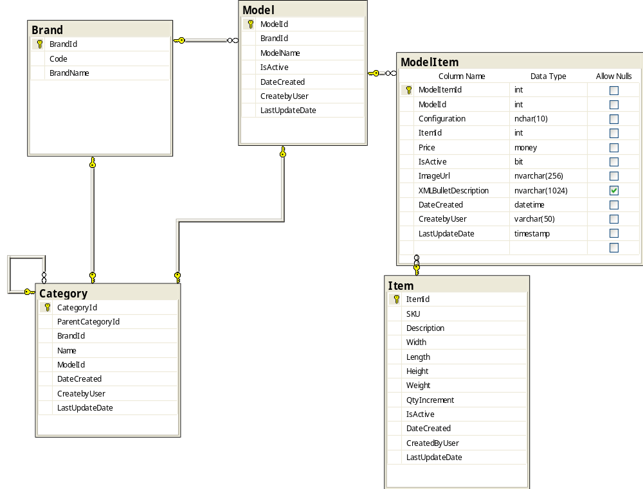

Users

ASCUser – defines who the user works for (ASC, Titus, Krueger, PennBarry, Tuttle&Bailey). Used only in the Admin application
.

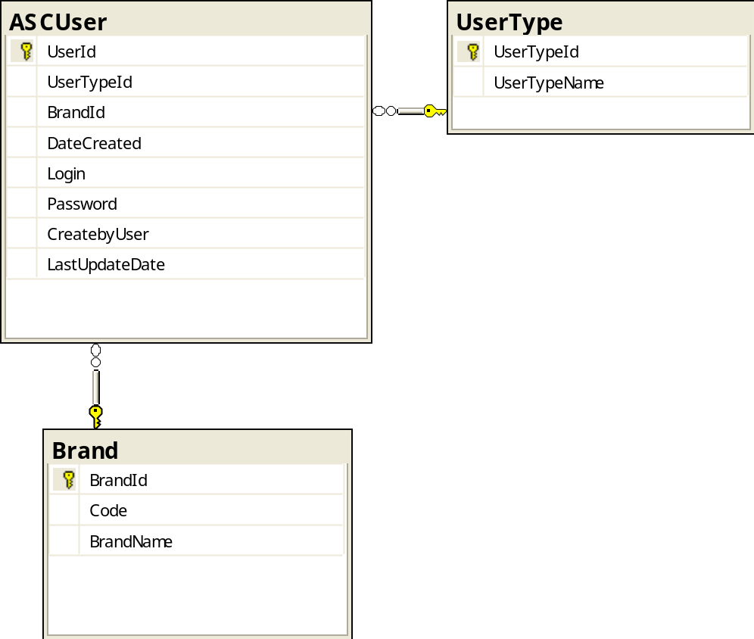

Customer

Customer – customer of ASC. Customer that buys ASC products
MaxOrderTotal – restricts total amount of all orders per day
Credit Status - defines if the Customer can place a new order.
Multiplier – used to calculate price for items sold.
CustomerShippingAddress – list of addresses where orders where shipped for this Customer

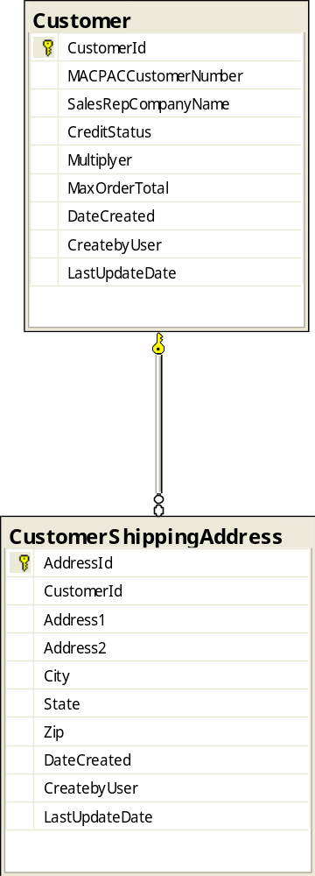

Order
Order – order that is placed
IPAddress – address from which order was placed
PONumber – uniquely defines order per SalesRepCustomer. Must be unique for each SalesRepCustomer
MacPacOrderNumber – order number assigned by Mac Pac after order is confirmed
ReleaseNumber – number assigned by Mac Pac after order is confirmed
OrderStatusId – defines order status. The following statuses are available:
Submitted – submitted for processing
Confirmed – confirmed that Mac Pac received the order
BrandID – defines for which brand the order was placed
SalesRepCompanyId – defines for which Customer the order was placed
CreatedByLoginId – login id of the user who created the order
Total – total value of the order without shipping charges
ShippingTotalAllWarehouses – order shipping total for all warehouses
GrandTotal – grand total of the order. Amount the customer will be charged
AddressId – address where the order is shipped

OrderDetail – Defines order line item
OrderId– defines which order OrderDetail belongs to
OrderShipmentId – defines how item was shipped
WarehouseId – defines which warehouse this line item will be shipped from
LineItemNumber - line item number of the order
ModelItemId – defines which ModelItem order contains
SKU – defines which item will be shipped. Duplicated here for safety reasons
QtyOrdered – defines how many items customer ordered from this warehouse
QtyNeeded – defines how many items the customer actually wanted to purchase
Price – prices at which item was sold
OrderShipment – Shipping information for OrderDetails per Warehouse
OrderId – to which order OrderShipment belongs
WarehouseID – which warehouse to ship from
ShippingType – type of shipping selected for this warehouse in this order. Values can be Ground, 2nd Day Air, 3rd Day Air, Overnight, LTL
ShippingTotal – total shipping charge for this warehouse in the order
TrackingNumber – number assigned after order is Confirmed as shipped
ShippingDate – date when order was shipped
OrderStatusLog – records changes to the order status
ShippingAddressBook – address book associated which each SalesRepCustomer

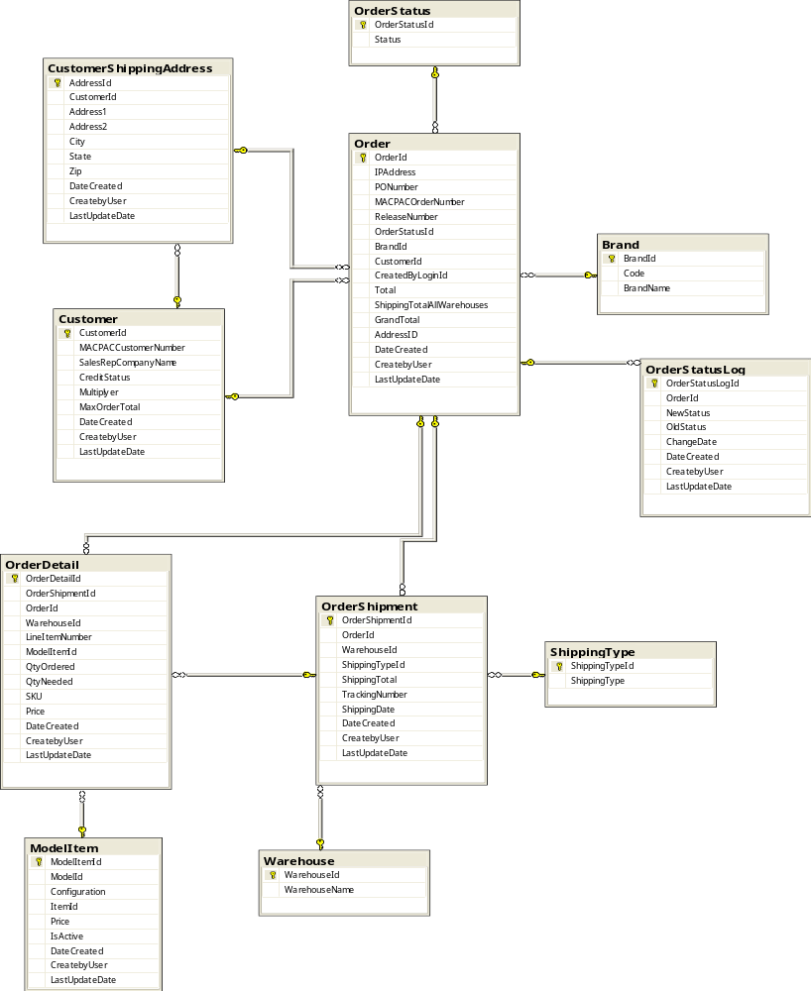

Shopping Cart
ShoppingCartOrder – temporary order created during shopping
ShoppingCardOrderItem – items placed in shopping cart

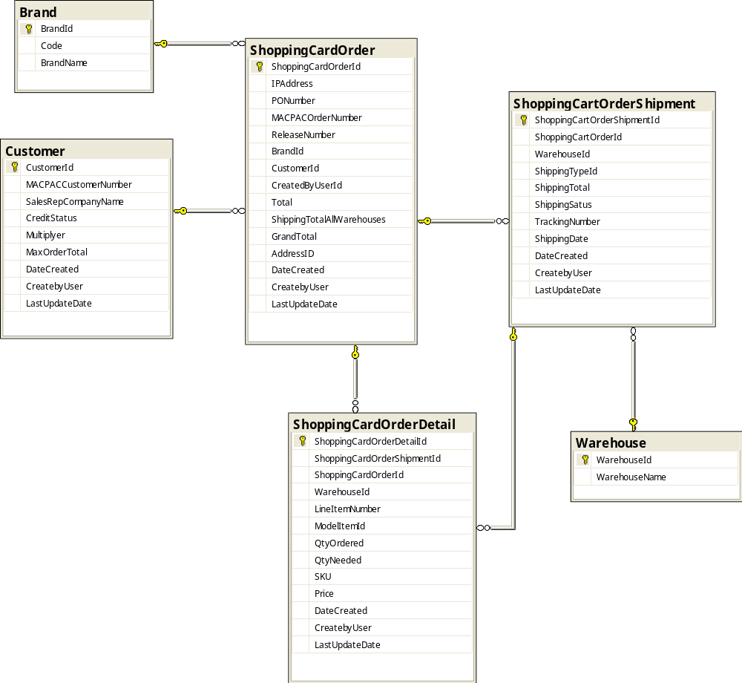

Inventory

Inventory – defines quantity per warehouse for each Item
MacPacUpdate – daily data downloaded from Mac Pac
InventoryChangeLog – records changes to inventory
ChangeDate – date of the change
WarehouseId – Defines warehouse
ItemId – defines Item
Qty – amount by which inventory is changed. If reducing quantity, then negative amount
MacPacUpdateId – Mac Pac Request is the reason for change
Balance – balance after change is applied

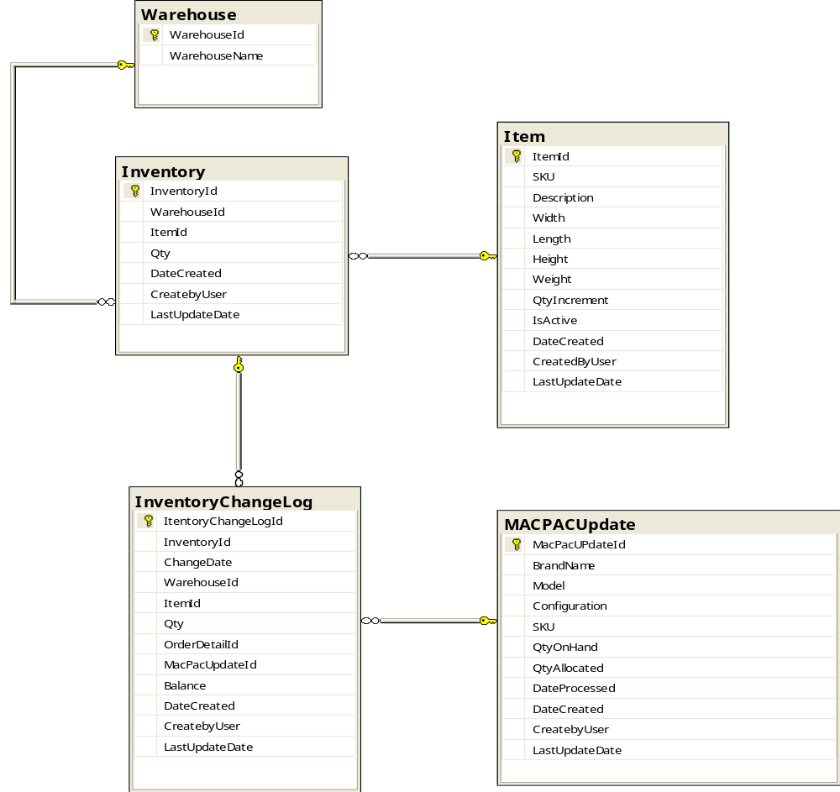

Use Cases

Warehouse Store Use cases

Log In
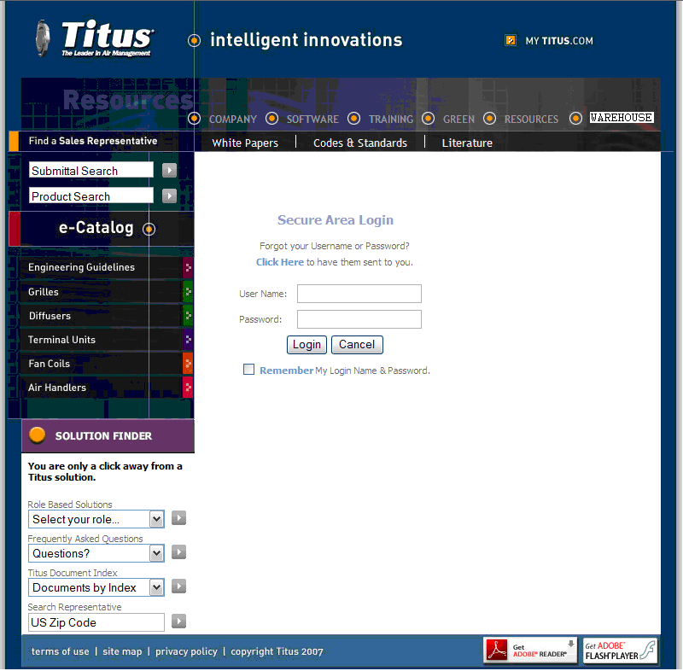

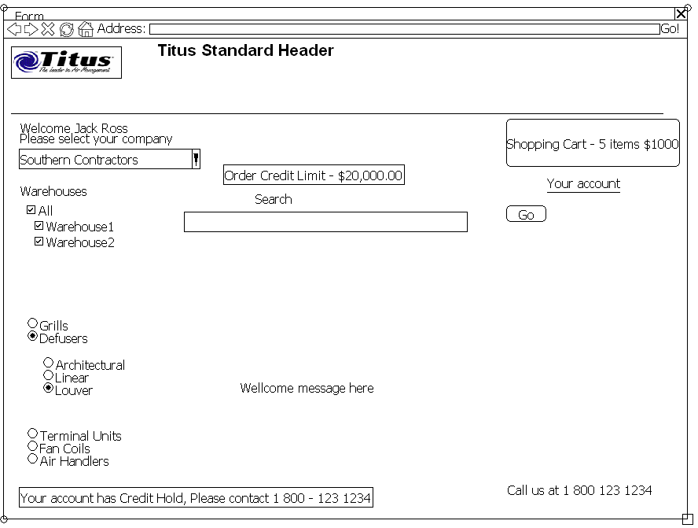
Main Flow

- User logs into Brand Customer Center
- If User is authenticated, System writes a cookie with LoginId
- System queries Customer Center to get list of Customers to which this user belongs (CustomerCenterService.GetSalesRepInfo (loginId))
- System makes sure that the Customers this user belong to are configured in the Warehouse Application and CreditLimit is set
- If user belongs to multiple Customers, system must prompt to select which Customer he will be shopping for before allowing a search to occur
- After Customer is selected, system must show Credit Limit and (if applicable) Credit Hold
- On Home page, user must be able to do the following
  - See how many items are in the Shopping Cart and Dollar Amount
  - Go to Shopping Cart
  - View Customer Credit Limit
  - View if Customer has a Credit Hold
  - Begin search for items
  - Go to Your Account section
- If no activity is registered during predefined period of time, system must log the user out of the Warehouse Application
  - Timeout Length must be defined in system configuration

Alternative flows
1.A User is not authenticated in Customer Center
System does not allow user to access Warehouse Application
2.A User is not defined for the Brand in Warehouse Application
System shows error message indicating the user is not able to access the Warehouse Application

Manage Shopping cart

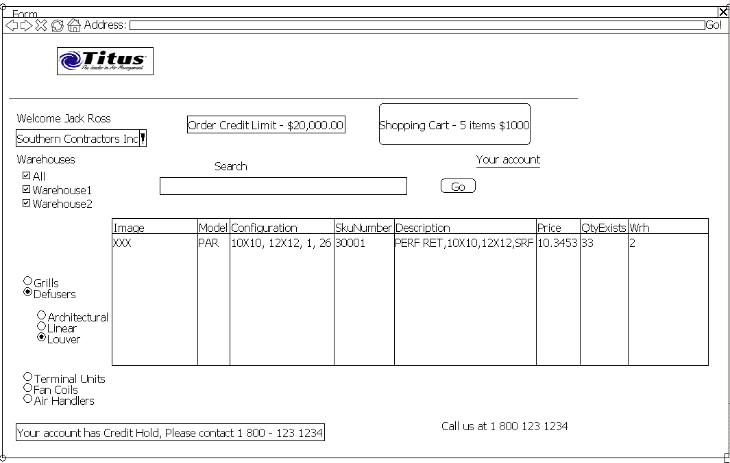

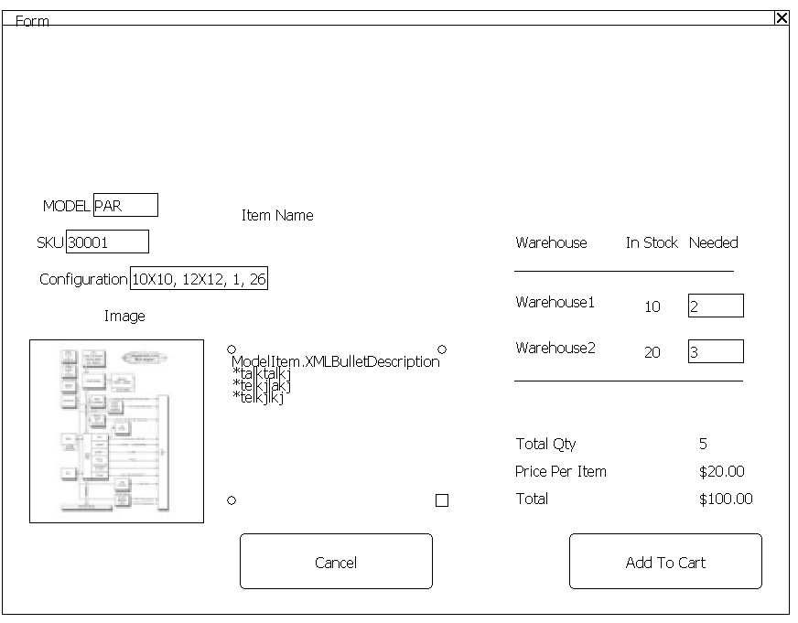
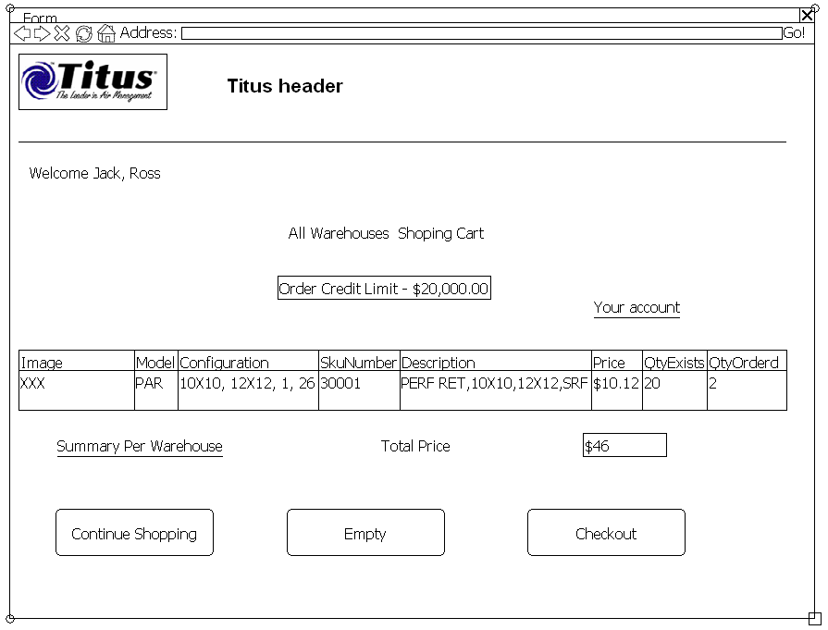

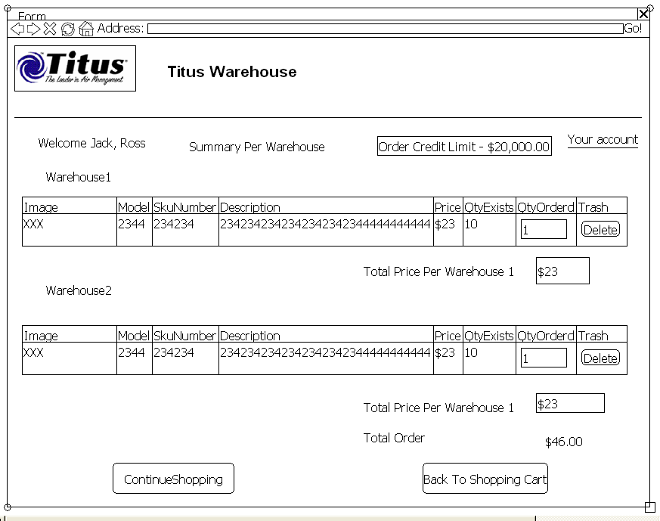

Preconditions –
User Logged In
Actors – Sales Rep

Main Flow

- Sales Rep selects Customer for which to make a purchase (dropdown under Reps name )
- System looks if any ShoppingCartOrder orders for this Customer created by this Sales Rep and shows it as a content of the Shopping Cart
- System shows credit limit for the selected Customer
- Sales Rep searches Brand Items which to purchase
  - Search by browsing
    - User selects category / subcategory
    - System shows grid with items for category/subcategory combination
  - Search by specifying SKU number or Model Number
    - User specifies exact SKU number or Model Number
    - System shows list of items that match SKU number or Model Number.
  - Search by any key word
    - User must be able to specify any keyword
    - System must show list of items found for this key word
    - System must search in all item, brand item properties
- System determines price for each item by Customer.Multiplier * ModelItem.Price
- System shows list of items that match the search criteria. For each item the following properties are shown:
  - Image
  - Sku number
  - Model
  - Configuration
  - Description
  - Price
  - Quantity exists
- User must be able to select item and add to the Shopping Cart
  - System must show Item Info screen
    - Item Name
    - Model
    - SKU
    - Image
    - Description
    - Price Per Item
    - For each warehouse
    - How much of this item in stock
    - User must be able to select quantity of this item from each warehouse
    - System must insure that users adds number of items multiple of Item.QtyIncrement. For example if Item.QtyIncrement = 3, then user can only purchase 3, 6, 9. .. items. If user selects less, system corrects the amount to a multiple of Item.QtyIncrement
    - System must dynamically recalculate total cost of the items
    - User must be able to click Add to Shopping Cart in order to add the item to the Shopping Cart
    - User must be able to cancel and return back to the Warehouse Application home page
- Shopping Cart
  - User must be able to see list of item in the Shopping Cart
    - Item Name
    - Model
    - Configuration
    - SKU
    - Image
    - Description
    - Total Ordered per Item
    - Number of warehouses
  - User must be able to go to Summary Per Warehouse screen to view the break down of each item per warehouse
    - User must see grid with the list of items per each warehouse
    - User must be able to modify quantity ordered for each warehouse
    - System must recalculate totals
  - User must be able to go to Order Checkout
  - User must be able to remove items from the Shopping Cart
  - System must recalculate total, shipping charge, grand total
- User must be able to return back to search for more items
- User must be able to go to Order Checkout
- User must be able to clear the Shopping Cart
- If cart was modified more then 1 week back, content of the cart will be deleted.

Order Checkout
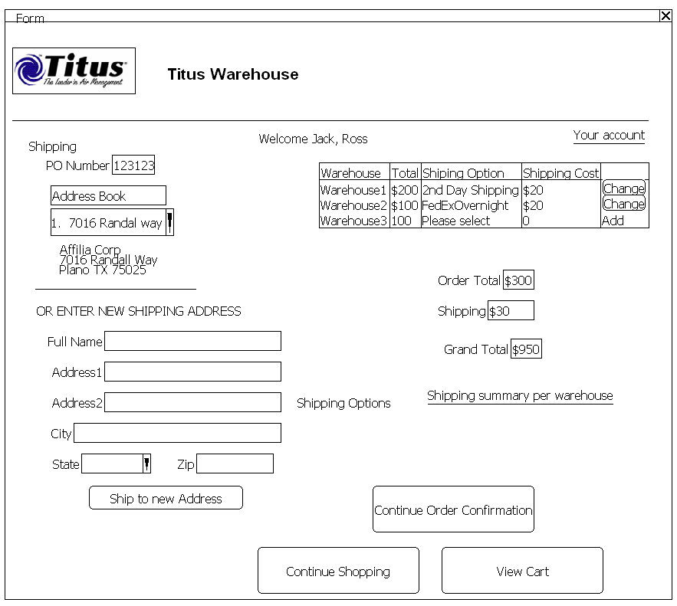

Main Flow
- System must check Credit Status of the Customer for which order is being created and make sure there is not a “Credit Hold”
- System must check if Grand Total of the order is not greater than MaxOrderAmount defined for each Sales Rep Customer
- System must check that the amount placed in Amount Needed is less then or equal to the amount of items available
  - If amount is greater, then system must show list of items where Amount Needed is greater and notify the user that the order will be modified for these items
  - System must record Amount Needed (ShoppingCartDetail.QtyNeeded)
- User must enter PO number (24 chars)
  - System must verify that PO number is unique for Sales Rep Customer
- User selects shipping address for Sales Rep Address Book
- User must be able to add new address to the address book and select that address as the Ship To Address
- User selects shipping options for each warehouse
  - System must show item total for each warehouse
  - User must select shipping options
    - Ground
    - 2nd day shipping
    - 3rd day air
    - Overnight
    - LTL
  - System must show shipping cost per warehouse
  - System must calculate shipping charge
    - System calls FedEx Web Service to calculate shipping charge based on Zip code of Warehouse , Zip Code of destination order address, number of items, weight, height, length, width for each item
    - System multiplies FedEx charge by a predefined (configured) percentage (15%)
  - System must show total shipping cost
- System calculates shipping changes based on Zip Code and type of shipping
- System multiplies shipping charge by configured value (15%)
- System shows Total Order Cost, Shipping Charge, Grand Total
- User must be able to perform the following:
  - Proceed to Order Confirmation to complete the order
  - Continue Shopping to add more items to the Shopping Cart
  - View content of the Shopping Cart

Order Confirmation
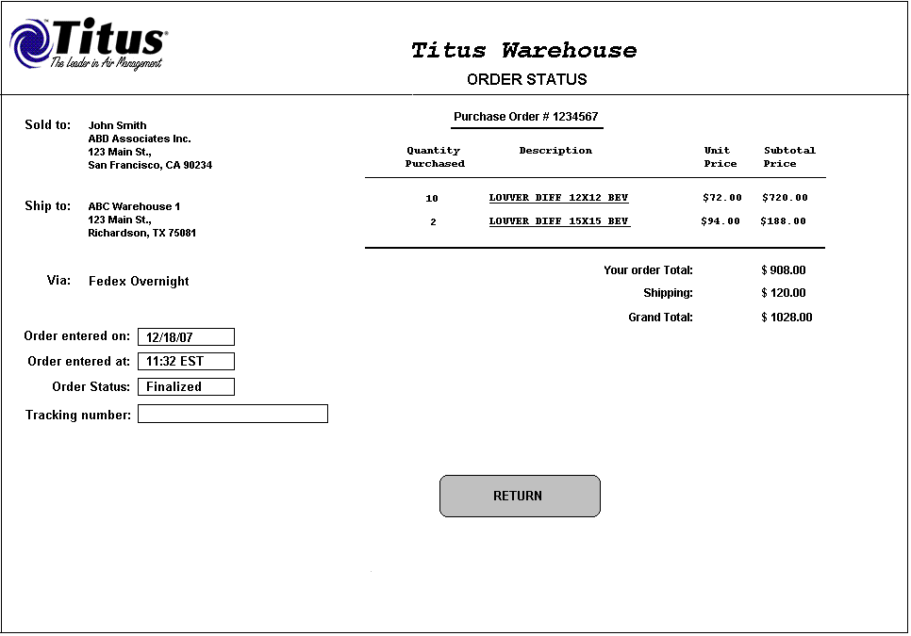

- System begins transaction
- System checks Credit Hold of the Customer for which the order is being placed
- System checks MaxOrderValue of the Customer for which this order is being placed
- System validates that the warehouse has enough quantities to complete the order
  - System checks the quantity in inventory minus sum of all items that are in “Submitted” orders
- System validates again that PONumber is unique for the order by Customer
- System transfers information from Shopping Cart tables to Order table and creates an order in the status of “Submitted”
- System empties Shopping Cart
- System commits transaction
- System generates XML file to transmit order to Mac Pac and places file into predefined directory
- System generates email to the User and to the Sales Rep for which the order was created. If user is a Sales Rep, only one email is generated
- System shows “Thank you” screen with the order information

Order Search by Sales Rep
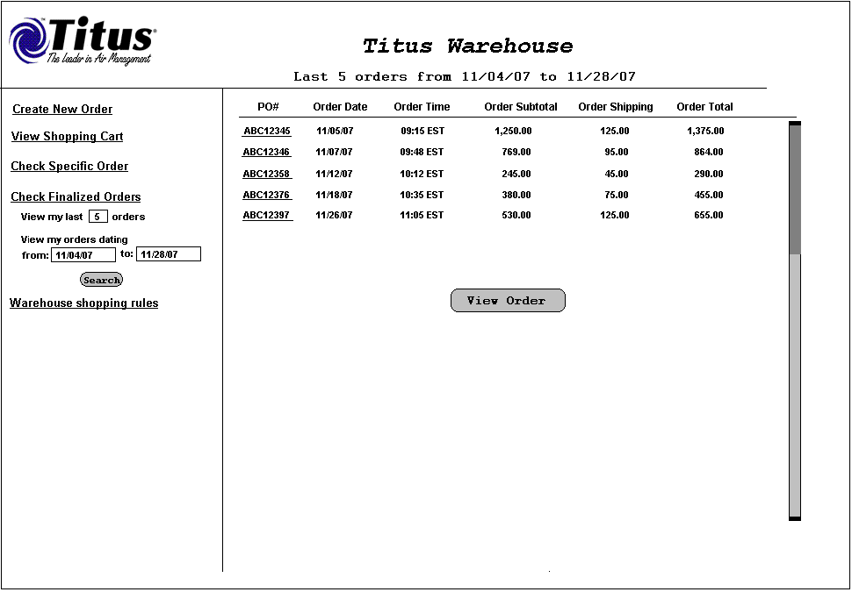

Actor: Sales Rep

Precondition:
User is logged in

Main Flow
- System must support the following criteria for order search:
  - Specific order by PONumber
  - Last N orders
  - Orders placed between 2 dates
- System must show the following grid with the list of orders
  - PO Number (Link to View Order Details)
  - Order Date
  - Order Time
  - Order Subtotal
  - Order Shipping
  - Order Total
- User must be able to click on PO Number and view full order information
- User must be able to return to the list of orders from full order information screen

Order Search by Brand CSR
- Brand CSR must be able to search orders by Sales Rep Customer

View Shipping Warehouse Rules

- User clicks on Shipping Warehouse Rules link
- Right hand pane updates to display list of rules

Figure 1 Warehouse Shipping Rules
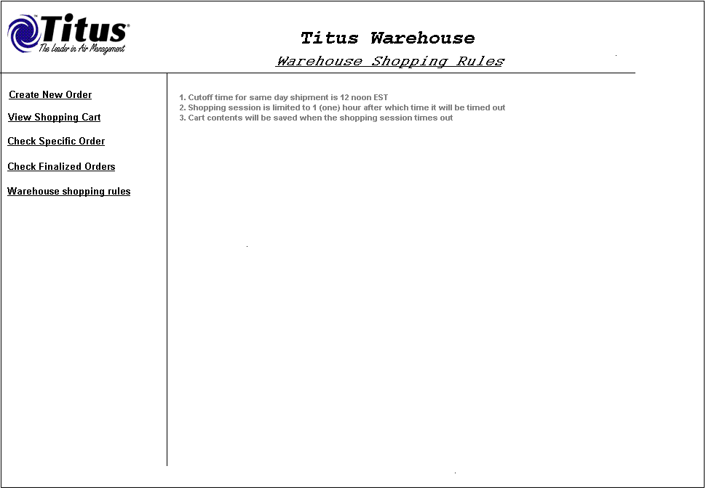

Management Tool Use cases
Management application is a stand alone Flex application.
Customers will not have access to the tool. Only for ASC employees.

Management Tool Login
- User Logs In by supplying userid/password
- System checks ASCUser table to validate
- System determines user type Finance, Brand Admin, System Administrator

Manage Max Order Total and Credit Hold
Actor: Finance
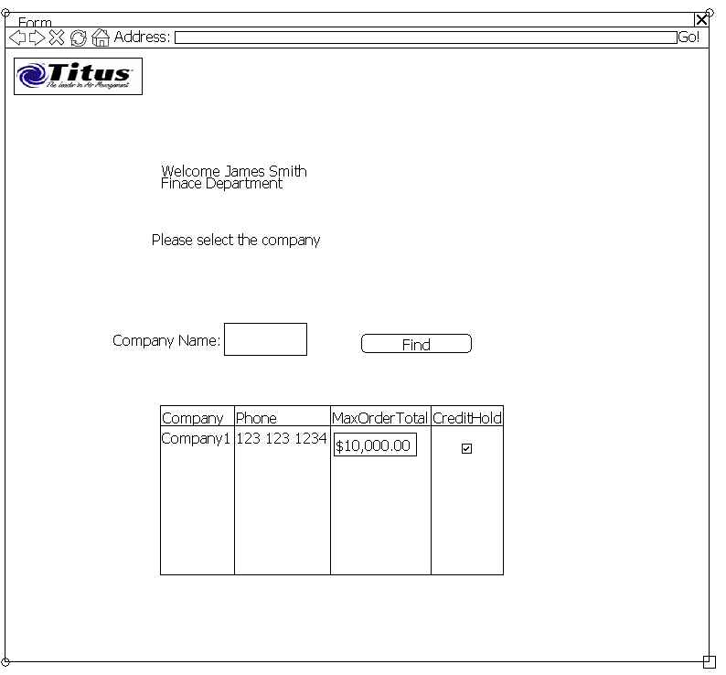
- Finance selects Customer and modifies max order total
- Finance selects to override Credit Hold value from Mac Pac
  - System must notify Finance that the value will be overwritten at night.

Synchronization processes

Update Inventory
Executes once per hour every hour
- System selects each order in the status of “Submitted” and calls MACPACService.GetOrder(PONumber)
- If order is already in Mac Pac, system updates the order status to “Confirmed”
- System downloads list of items available in Mac Pac into MACPACUpdate table
- System inserts records into InventoryChangeLog
- System updates Inventory of the item

Update prices
Executes once a day at night
- Executes once per night MACPACUpdate and updates prices in ModelItem table
- If Item is no longer available in MACPACUpdate table, system update ModelItem.isActive flag to false
- If new items in MACPACUpdate, system inserts new ModelItem records

Update list of Customers available per Brand
- Process calls Customer Center. GetCompanyByBrand(brandId)
- For each Customer, process creates new Customers, deactivates Customers that are not in the list, and updates credit limit.

Missed Opportunity Report
Executes once a day at night
For each order, examine OrderItem.QtyOrdered and OrderItem.QtyNeeded and generate report on difference

Mac Pac Service DLL
ASC will provide the .NET component which communicates with Mac Pac

Name: MACPACServiceDll

Order GetOrder (PONumber, BrandName)
Returns order information from Mac Pac based on PONumber. If order is not yet processed, return null

Customer Center Service DLL
ASC will provide the following .NET component

Name : CustomerCenterService

Company[] GetCompanyByBrand (BrandId)
Returns all the companies that sell particular brand
SalesRep[] GetRepsbyCompany(CompanyID)
Returns all the reps for the company.
SalesRep GetSalesRepInfo(LoginId)
Returns Sales Rep Info by Login Id. Information must contain which Customer rep works for

