General

1) Resolution – we encountered an issue today where by on the presentation laptop we did not have the ability to scroll down on the results section. We need to address resolution/screen size.

2) We agreed to now have a default Warehouse based on user.

When user clicks on ‘Account’ - the user will be able to change from a drop down menu what their default Warehouse is going to be. All users will start with a default of Tarboro, NC

3) Based on the attached Titus.xls spreadsheet – which is currently being updated – View Row 58 plus. Our next version of the prototype needs to incorporate actual examples rather than dummy data.

Tree Search and Display of Results

4) The tree drill down search on the left hand side of the page:

- We need to incorporate three levels (reference spreadsheet):
  - Cat 1
  - Cat 2
  - Cat 3
- Remove check boxes – user will expand and collapse tree by clicking on Cat1 ,Cat2 and Cat3 Titles
- User clicks on Cat 1 title
  - We expand the menu tree to show Cat 2 listings
  - Right hand side of pane displays all SKUs for Cat1 and relevant data
  - User clicks on Cat 1 title again to collapse tree menu
- User clicks on Cat 2 name
  - We expand the menu tree to show Cat 3 listings
  - Right hand side of pane filters to show only SKUs for Cat 2 with relevant data
  - User clicks on Cat 2 title again to collapse tree menu
- User clicks on Cat 3 name
  - Right hand side filters to show only those SKUs associated with Cat 3.
  - Right hand pane sorts by SKU - Ascending
- Ability for user to expand the left hand side pane (tree menu/search) – Add an arrow for intuitive design on expanding window pane
- If user hovers over Cat 1/2/3 Title – show full name
- As user clicks through each Category – highlight selection for history trail
- On right hand side pane – results - Below Products bar – remove current entries and add columns titles with ability for the user to sort by any column title.

5) Right hand screen will contain grid displaying:
a) No image – user will hover over SKU number for image and additional details
b) Sku, Model#, Short Description, Configuration string, etc.
c) Based on default warehouse – we will see QTY in Stock
d) Amt Needed – entry field
e) Add to Cart icon – user clicks on Add to cart – item/QTY is added to cart
f) View Additional Warehouses – this button should be enabled if QTY exists in more than one warehouse – otherwise disabled.
1. User clicks on View additional Warehouses and is taken to current pop-up window displaying all warehouses where QTY exists
2. Ability to enter QTY by warehouse and Add to Cart

Open Search Results

1) User searches for any text
a) Maintain displayed left hand tree menu - If user had previously searched by the Menu tree on left hand side of page – then we will collapse the tree to only show Cat 1 titles.
b) Grid results should be displayed exactly as if they searched by the menu tree:
- No image – user will hover over Sku number for image and additional details
- Sku, Model#, Short Description, Configuration string, etc.
- Based on default warehouse – we will see QTY in Stock
- Amt Needed – entry field
- Add to Cart icon – user clicks on Add to cart – items/QTY is added to cart
- View Additional Warehouses – this button should be enabled if QTY exists in more than one warehouse – otherwise disabled.
  - User clicks on View additional Warehouses and is taken to current pop-up window displaying all warehouse where QTY exists
  - Ability to enter QTY by warehouse and Add to Cart

Top Menu Bar

1) Where we currently have a Blank dropdown bar on left right hand side of page below Welcome, John Doe – simply display Default Warehouse Name – no modifications can be made – we are simply displaying the users Default Warehouse.

2) Remove warehouse box with selections of Warehouse

3) Instead of Warehouse box – move the open Search functionality to this area. Above the Tree search

4) Move Max Order Limit next to customer Selection

5) Move cart Total Amt Next to Your Cart Items

Drill down from menu/tree search or Open Search - Results are displayed the same.

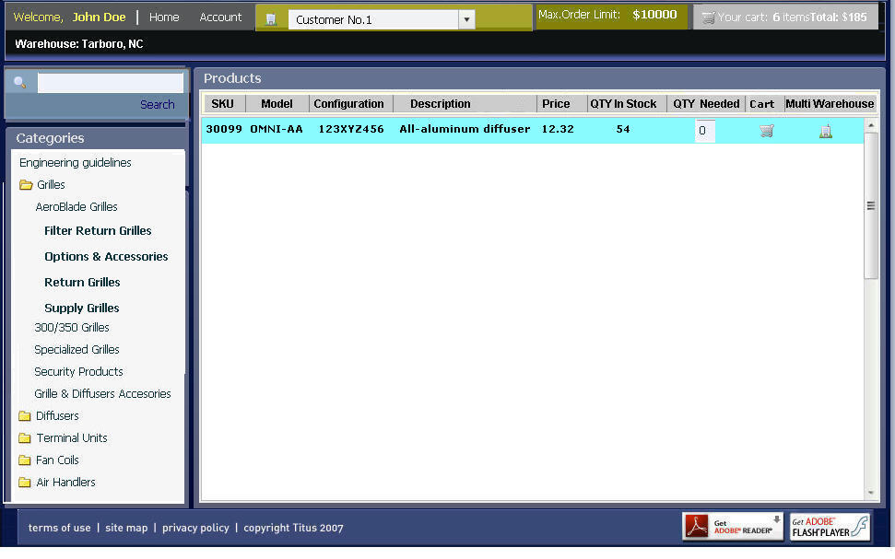

User clicks on Multi Warehouse icon – send user to the existing pop up window

