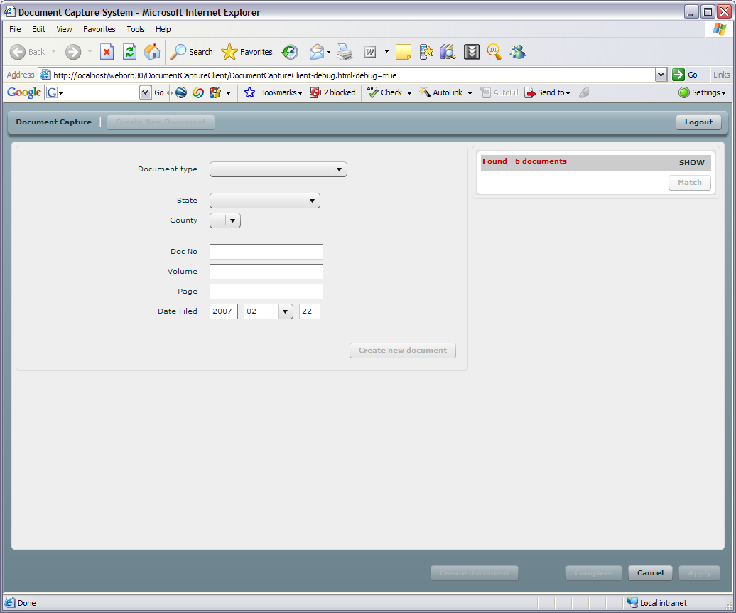

Field name | Required | Format | Min length | Max length | Type | Comments
Document Type | Yes | Text |  |  |  | Retrieves list of doc types from DB
State | Yes | Text | 2 | 2 |  | Retrieves list of states from DB
County | Yes |  |  |  |  | Retrieves list of counties filtered from state selection from DB
Document No | Yes | Text | 0 | 26 |  | Pertains only to doc of public record.
Volume | Yes | Integer | 0 | 26 |  | Pertains only to doc of public record.
Page | Yes | Integer | 0 | 26 |  | Pertains only to doc of public record.
Date Filed | Yes | Date |  |  |  | Pertains only to doc of public record.

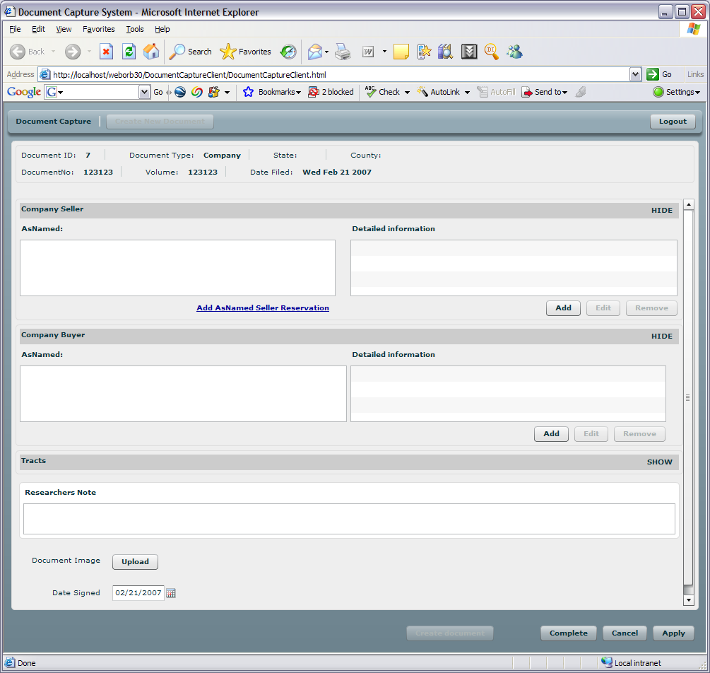

Field name | Required | Format | Min length | Max length | Type | Comments
Seller As Named | Yes
Buyer As Named | Yes
Researchers Note | No
Document Image | Yes/No
Date Signed | Yes

Make sure Date signed is not predefined.
User must enter date signed. It is required field

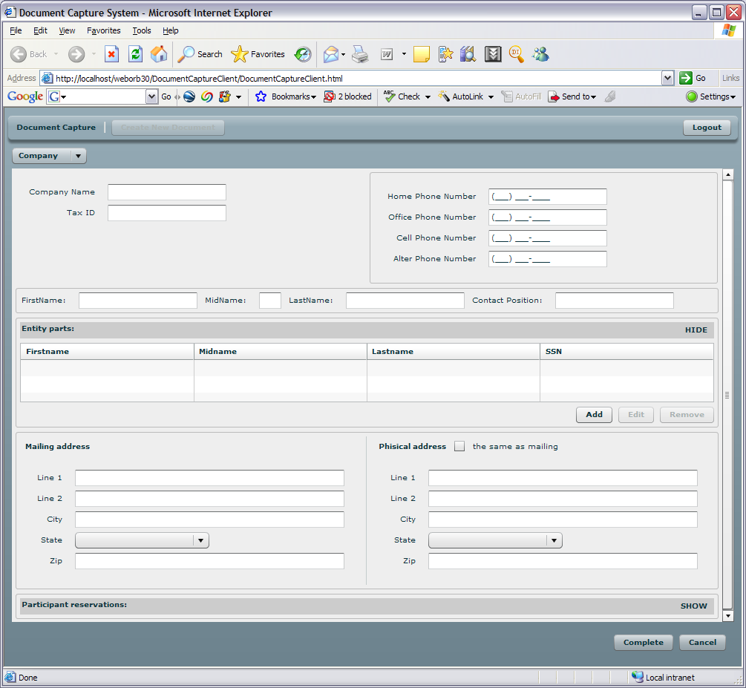

If any of the contact fields are not empty, then First Name and Last Name are required.

IF any of the parts fields are not empty, then First Name and Last Name are required.

If any of the Mailing address fields are not empty, Line1, City, State and Zip are required.

If any of the physical address fields are not empty, Line1, City, State and Zip are required.

Field name | Required | Format | Min length | Max length | Type | Comments
Company Name | Yes
Tax ID
Home Phone
Office phone
Cell phone
Alter phone
Contact First name
Contact Midname
Contact Last name
Contact position
Entity parts
Mailing Address:
- Line 1
- Line 2
- City
- State
- Zip
Physical Address

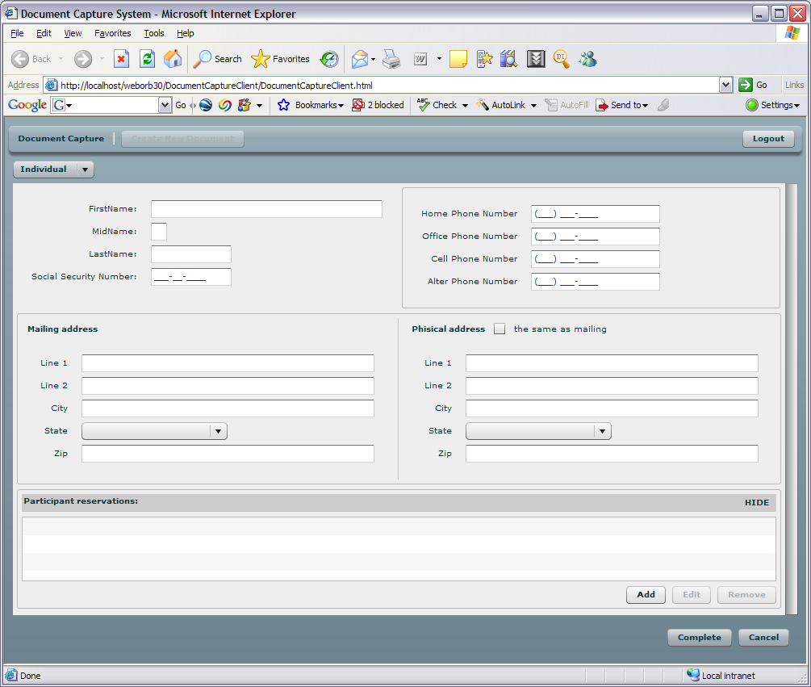

If any of the Mailing address fields are not empty, Line1, City, State and Zip are required.

If any of the physical address fields are not empty, Line1, City, State and Zip are required.

Field name | Required | Format | Min length | Max length | Type | Comments
First name | Yes
Middle name
Last name | Yes
SSN
Home Phone
Office phone
Cell phone
Alter phone
Mailing Address:
- Line 1
- Line 2
- City
- State
- Zip
Physical Address

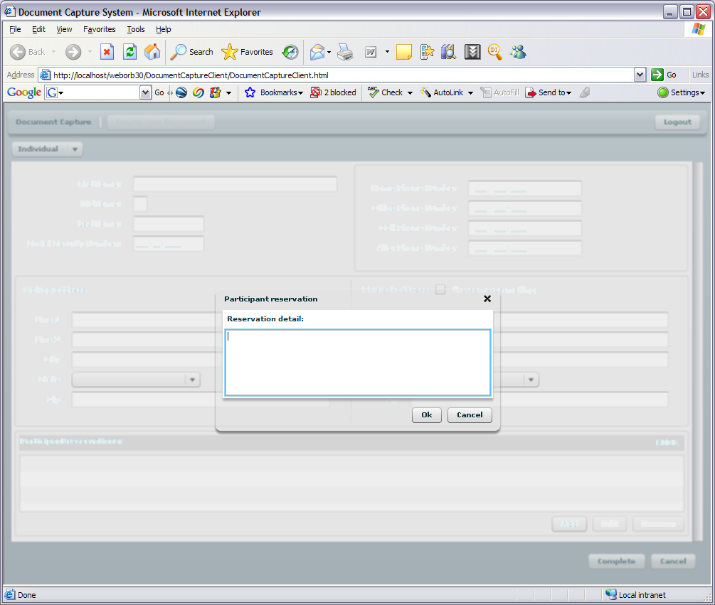

If nothing is entered in Reservation detailed field or empty string , then user can only cancel
Cannot save empty string.

Field name | Required | Format | Min length | Max length | Type | Comments
Reservation details | No

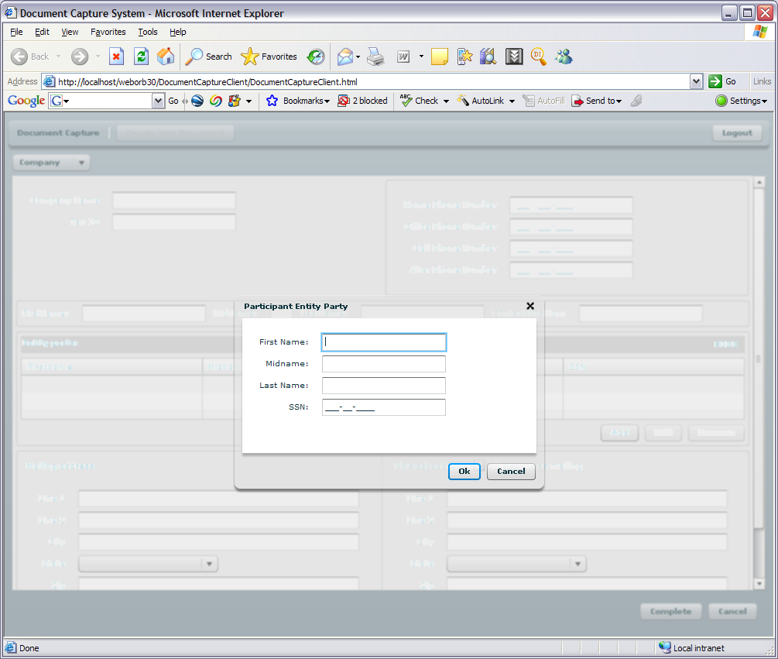

If any of the Participant Entity party fields are not empty, ten First Name, Last Name is required.
If all fields are emty or only spaces entrred, then user can only cancel.

Field name | Required | Format | Min length | Max length | Type | Comments
First name | No
Middle name | No
Last name | No
SSN | No

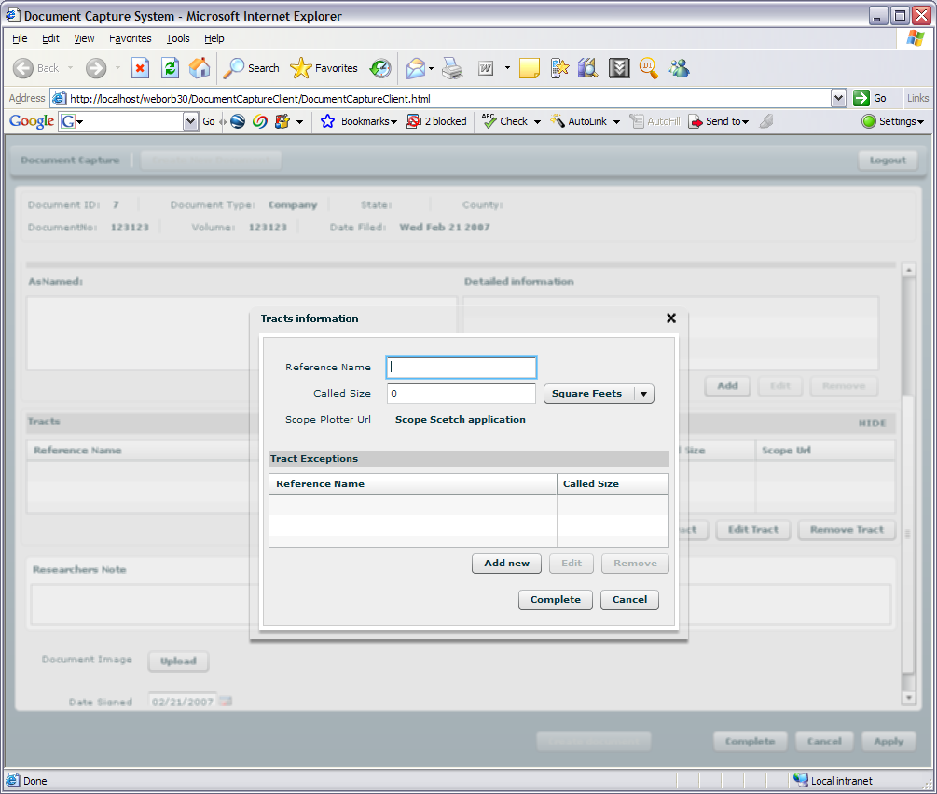

IF anything is entered, then Reference Name and Called size is required
If nothing entered can only cancel.

Field name | Required | Format | Min length | Max length | Type | Comments
Reference name | Yes
Called Size | Yes
Scope Plotter Url | Yes/No |  |  |  |  | If required by client

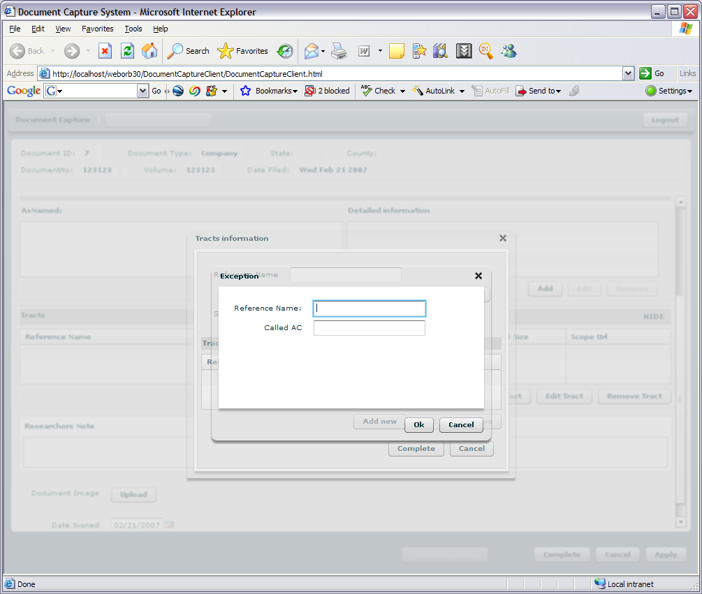

This screen will be changed – based on new requirements.

Field name | Required | Format | Min length | Max length | Type | Comments
Reference name | Yes
Called Size | Yes

