
SW-FFG-00204

SpendWorks
.
.
.
.
.
.
.
.
.
. . . . . . . . . . . . . . . . . . . . . . . . . . . . . . . . . . .

. . . . .

Client Services: Vendor Intake

Flat File Specifications

Anadarko Petroleum Company Required Electronic Invoicing Information



CONFIDENTIALITY
This document contains confidential and proprietary information of TransZap, Inc., and may not be disclosed to other than those to whom it was originally distributed.

© TransZap, Inc. 2003

Process
A general understanding of the electronic invoicing process from a flat file is usually helpful for getting good test results and efficient approval to go live.

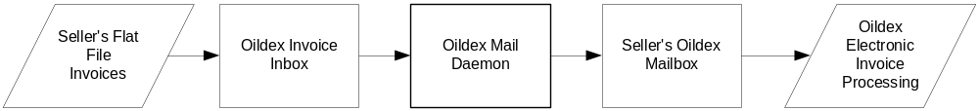

As shown in the diagram above, the steps to process from a flat file are as follows:
- Flat file is sent to invoice@oildex.com as an attachment.
- The Oildex Mail Daemon retrieves the file and sends it to the Seller’s Oildex mailbox (Inbox) based on information in the SellerId field.
- The Oildex File Daemon processes the file in the Seller’s inbox and sends it to the appropriate customer mailbox and validates to generate a “state” for processing by the customer.

APC Electronic Fields
The following is a list of fields that are required for Anadarko Petroleum electronic invoices.

Amount Due
Buyer
Charge To#
Description (Line item description)
Employee Name/ID
Invoice Amount Due
Invoice Date
Invoice #
Item Code
Payment Due Date
Qty
Seller
Service From Date
Ship to Name
Ship to State
Unit of Measure (UOM)
Unit Price

Spreadsheet Information
- The first row in the spreadsheet corresponds to the APC electronic Fields. This is just a guideline and this row needs to be removed before submitting a test file.
- The third row is the header row. This row must be row 1 in the file in order to be processed by the Oildex system.
- The text in the header fields must appear exactly as shown in the sample spreadsheet.
- The order of the columns does not matter as long as all required fields appear. The required fields are highlighted in yellow in the spreadsheet.
- Other information can be provided in the non-required fields.
- The BuyerName field provides the key for the Vendor-Operator relation in the Oildex system. A vendor can invoice different buyers in the same file as long as those buyers have been established as trading partners in the Oildex system. The BuyerName must have an exact match in the Oildex system, so multiple trading partners have to be coordinated with the Oildex Client Services team.
- The SellerId field is the Oildex 15-character name. This number can be hard-coded in the file as it is unique and will remain the same for any invoicing transactions. This number will be provided by Oildex Client Services.
- The AttentionTo field is based on APC employee ID codes, and denotes the APC order contact or APC representative. These codes will be provided by either APC or by Oildex Client Services. For testing, the AttentionTo code must be KXM001.
- Invoicers need to key in the correct code to be mapped for the AttentionTo; no field is provided for the order contact name. If the vendor’s accounting system requires a name, this field will not be mapped to the flat file.
- There are “Charge To” fields in the Oildex system that are populated by APC account code information. These codes are known as AFE numbers, Property numbers, Well numbers, or Cost Centers.
- These charge-to codes should be provided by the APC order contact at the time of purchase request. For testing, invoicers need to provide a valid APC charge-to code from previously submitted invoices.
- Oildex has several rules for validating Charge-To codes, but for processing flat files it is necessary that there is either a valid AFE in the AFENo field, OR a valid property number in the LocationNo field, OR a valid well number in the WellNo field. Oildex can process both if both are available, but there must be at least one.
- The Tax data are validated against all three fields: Tax Exempt, Tax Type, and Tax Amount. If tax information appears, all fields must display a value. The Tax Exempt field is a Yes/No field. The Tax Type refers to types of tax such as State, Federal, etc.
- There can be multiple taxes applied with the format of InvoiceTax[Attribute]1, InvoiceTax[Attribute]2, etc.
- If the vendor uses field tickets, there must be reference to the field ticket number in the TicketNo field.
- Field Tickets are faxed to special fax numbers (or can be scanned and sent as images if that is an option for vendors). The field tickets should have a reference to the corresponding invoice number.
- It is strongly recommended that you append the word TEST to your invoice number.

