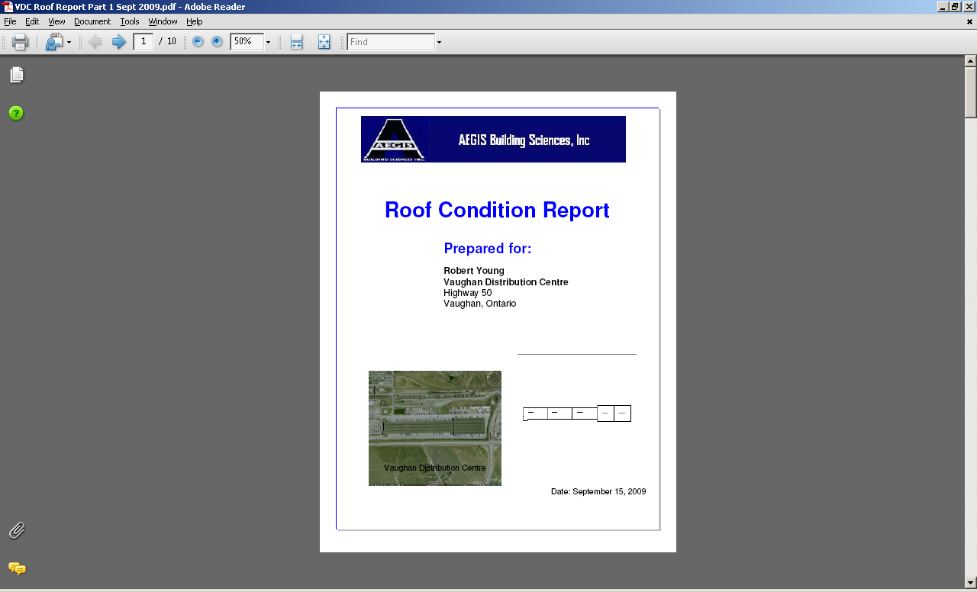

Facility.Keyplan

Facility.Photo

Facility.Primary Contact

Facility.Facility Name

Facility.Address (memo- 1 to 3 lines)

Facility.City, Facility.Province

Consultant.ReportBanner

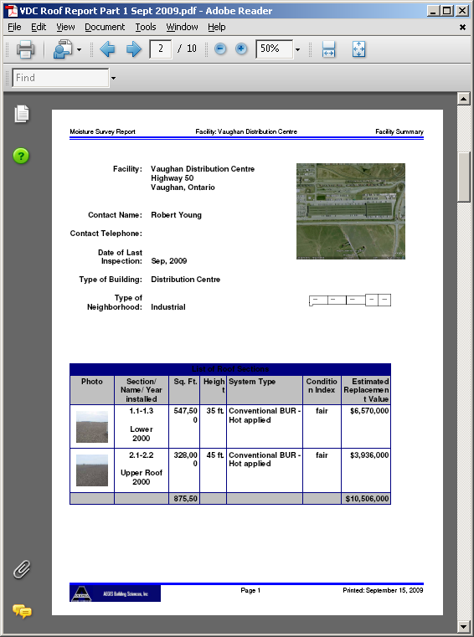

**Repeat for each section:**

Photo Designation Sq Ft Height Roof System Condition Index Est Cost

Roof Name

Year Installed

Facility.Type of Building

Facility.Neighbourhood

Facility.Primary Contact

Facility.Phone

Not required - remove

Facility.Photo

Facility.Keyplan

Facility.Facility Name

Facility.Address (memo- 1 to 3 lines)

Facility.City, Facility.Province

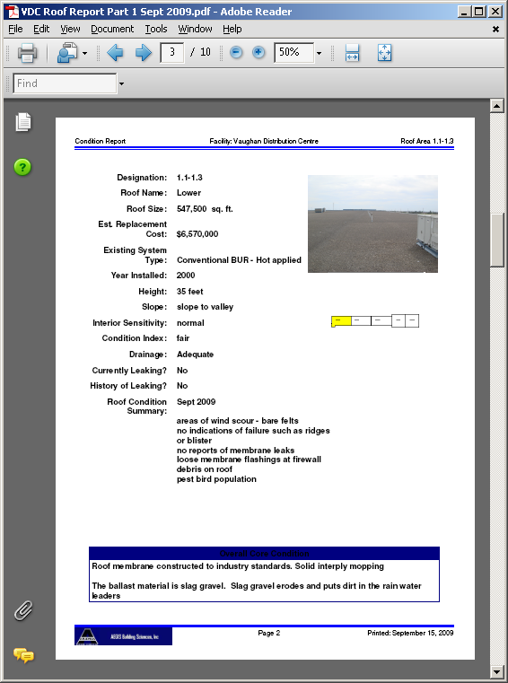

Sections.Overall Core Condition

Sections.Designation

Sections.Roof Name

Sections.Sq Ft

Sections.Est Cost

Sections.Roof System

Sections.Year Installed

Sections.Height

Sections.Slope

Sections.Interior Sensitivity

Sections.Condition Index

Sections.Drainage

Sections.Currently Leaking

Sections.History of Leaking

Sections.Condition Details

Keyplan not reqd

Sections.Photo

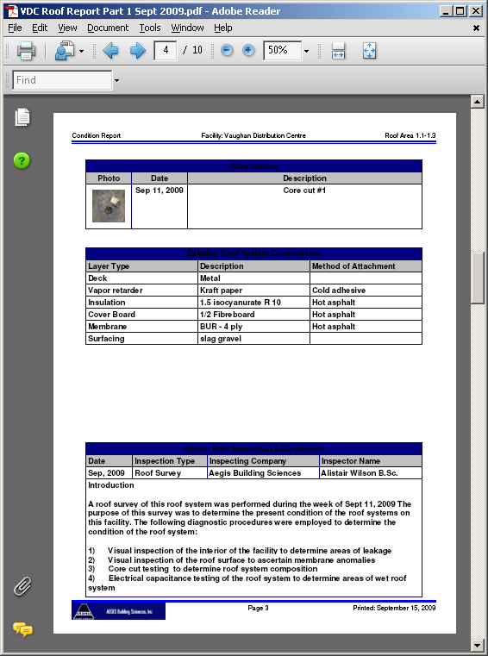

**Inspections.**

Inspection Date Inspection Type Inspector Company Inspector Name

Layers.

Layer Type Description Attachment

Inspections.Assessment

Core Photos.Photo

Core Photos.Date Core Photos.Description

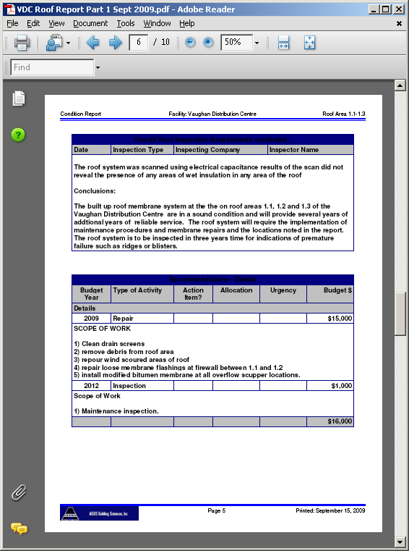

**Expenditures.**

Budget Year Type of Work Action Item Allocation Urgency Amount

Expenditures.Description