**eRoof**

**Software Design**

May, 2010

**eRoof Asset Management System**

TABLE OF CONTENTS

1 Introduction 4

1.1 Business objectives **Error! Bookmark not defined.**

1.2 Menu 4

1.3 Reports 4

2 Admin 5

2.1 Business setup 5

2.2 Preferences 5

2.3 Report Library 5

2.4 Database 6

2.5 Roles 6

2.6 Access Rights 6

3 Facilities 7

3.1 Purpose 7

3.2 Design Concepts 7

3.3 Navigation tree 8

3.4 Add procedure 9

3.5 Business Folders 10

3.6 Segment Folders 11

3.7 Client Folders 12

3.8 Facility Folders 14

3.9 Section Folders 17

4 Analysis 23

4.1 Sections 23

4.2 Systems 23

4.3 Details 23

4.4 Deficiences 23

4.5 Expenditures 23

4.6 Inspections 23

4.7 Action Items 23

4.8 Warranties 23

5 Tasks 24

5.1 Inspections 24

5.2 Service work 24

5.3 Maintenance 24

5.4 Tendering 24

5.5 Project inspections 24

6 Technical Notes 25

6.1 Location markers 26

6.2 Photo display component 26

# 

# Introduction

## Menu

There are 5 main menus in the eRoof application:

* **Admin** – Used by the system administrator to enter business configuration, preferences, roles and permissions, and report definitions.
* **Facilities** – Used to view details on specific clients, facilities and roof sections.
* **Analysis** – Used to analyse information across multiple clients and facilities. For example, warranties for all roof sections can be viewed and sorted by date to determine warranties that are about to expire
* **Financial** – Used to view and revise financial data – including repair, maintenance and replacement budgets, and 10 year financial plans.
* **Tasks** – Used to execute tasks available to the current user – such as entering inspection data (an inspector), approving invoices (a consulting), or entering payment details (a client).

Details for each of these menus are provided in the following sections.

## Reports

Reports are integrated into the application and available from selected screens. A printer icon is displayed at the top right of the page when one or more reports are available

# Admin

The Admin menu provides functions used to perform administrative tasks that are available to the current user.

There are 6 sub-menus, as follows.

## Business setup

* A form for display and entry of business information:
  + Business name
  + Contact
  + Address
  + Phone
  + Logo (image upload)
  + Report heading
  + Report footing
* Form starts in view mode. Edit button used to revise.

## Preferences

* To be determined.

## Report Library

The report library is used to define reports that may be printed and/or saved. The following information is entered for each report.

* Report Name – A report name of up to 20 characters. Duplicate report names are allowed, since different reports may be assigned to different roles. The same report name may also be used from different menu locations.
* Permitted Roles – A multiple-select field that defines which roles may use the report.
* Screen name – A screen name where the report is available, in the format Menu.SubMenu.Level.Tab – for example Facilities..Facility.Summary
* Definition – The definition tags in a memo field.

All reports are listed in a grid – with the report name, permitted roles and screen name.

* Add Report - Prompt for a report name.
* Edit – Edit all 4 fields in form.

No validation is required.

## Database

* Developer Grids to view/ edit database content
* Tree with table names on left side.

## Roles

The application contains 5 standard roles.

* Admin – System administrator, with access to access menus, forms and fields.
* Consultant – A consultant with access to assigned clients.
* Inspector – An inspector with limited access to selected roof sections.
* Client – A client with limited access to their information.
* Contractor – A contractor has limited access to selected facilities.

The following information may be defined for each role.

* The menu items available.
* The facilities tree levels available.
* The analysis functions available.
* The specific fields that are viewable and editable.
* The specific database content that is available (see next section)

## Access Rights

A tabbed dialog box is displayed with 3 pages – Client Access, Facility Access, and Section Access.

Each form display a list of the current access rights, with add, edit, delete functions

* Client Access - list of client names and users.
* Facility Access – list of client name, facility name, users
* Section Access – list of client name, facility name, designation, users.

No validation is required.

# Facilities

Misc Notes

* On application start-up, the map displays as full screen before resizing into the form?

## Purpose

* Used to view information on specific clients, facilities and roof sections, plus summary information at the segment and business levels.

## Design Concepts

Summary tabs

The first tab for each level is a summary tab that provides information on the selected item.

* Business – Summary stats and map.
* Segment – Summary stats and map.
* Client – Client address and contact information, client logo, head office photo, map.
* Facility – Facility name, address, contact information, facility photo, map location, site plan and other summary information.
* Section – Designation, roof name, size, year installed and other summary information

List tabs

The second tab lists the “child records” with summary information, providing sorting and searching functions

Lists

* Business – A list of segments with total # of clients, etc.
* Segment – A list of clients
* Client – A list of facilities
* Facility – A list of roof sections

Functions

* Display all records – no paging.
* Column sorts.
* Find on a sort column.
* Double click to go to the child and display the detail form, with an edit option.
* In-place editing

Maps

* Used to display facility locations with visual navigation.
* Maps always indicate an exact facility location – not the geocoded address.
* Use markers as in google (in place of house icons) – yellow fill.
* Remove the Microsoft Road aerial Hybrid selections (these will be fixed – and not user selectable)
* Can buttons, such as Save Map, overlay the map content, rather than create a blank line?
* We should have logic to ensure that all locations are displayed within the user-defined map.

Site plans

* Satelite images that display site plans and roof plans.

## Navigation tree

Admin and Consultant roles

* Business🡪Segments 🡪Clients 🡪Facilities 🡪 Sections.

Clients, Inspectors and Contractors roles

* Clients 🡪Facilities 🡪 Sections.

Notes

* All nodes should be sorted.
* Icons not required.
* Section nodes should display Designation.
* Nodes should not be expanded by clicking on the name – only on the arrow prefix.

Future (depending on time required)

* Support for client regions.
* Addititional structures
  + Not showing the business and segment levels.
* Active account concept.
* Expand All / Contract All for the selected level.

## Add procedure

An add button is displayed above the navigation tree, to add one or more child records. The button display is based on the currently selected tree level:

* Business selected 🡪 Add a segment.
* A segment is selected 🡪 Add a client.
* A client is selected 🡪 Add a facility.
* A facility is selected 🡪 Add a section.
* A section is selected 🡪 Not displayed.

The following input forms are displayed.

Add Segment

* Segment Name – required, must be unique

Add Client

* Client Name – required, must be unique across all segments
* Brief name – required, must be unique across all segments
* Address
* City
* Province – select list, default ON
* Postal Code
* Country – default Canada

Add Facility

* Facility Name – required, must be unique within client.
* Brief Name – required, must be unique within client.
* Address
* City
* Province – select list, default ON
* Postal Code
* Country – default Canada

Add Section

* Designation – required, must be unique with the facility.
* Roof name

Notes

* Input form will have the basic fields only that are required to create a record. Additional values are entering using the Edit function.
* The input forms are displayed on the left side of the screen – over the navigation tree – as a modal pop-up, with Save and Cancel options.
* After a record is added, the tree is re-displayed, and the tree node for the added record is displayed. The summary tab for the added record should be selected, allowing the user to immediate click on Edit to enter additional information for the added record, if required.

## Business Folders

* Display information on the overall business, with summary information for each segment.
* Heading “Business Summary: Aegis Building Sciences”

Summary tab

**Aegis Building Sciences Inc**.

Oakville Ontario

Total # of clients = 99

Total # of facilities = 770

Total # of sections = 2,000

Total Sq. Ft = 1,200,000

Total Est Asset Value = $ 12,333,444

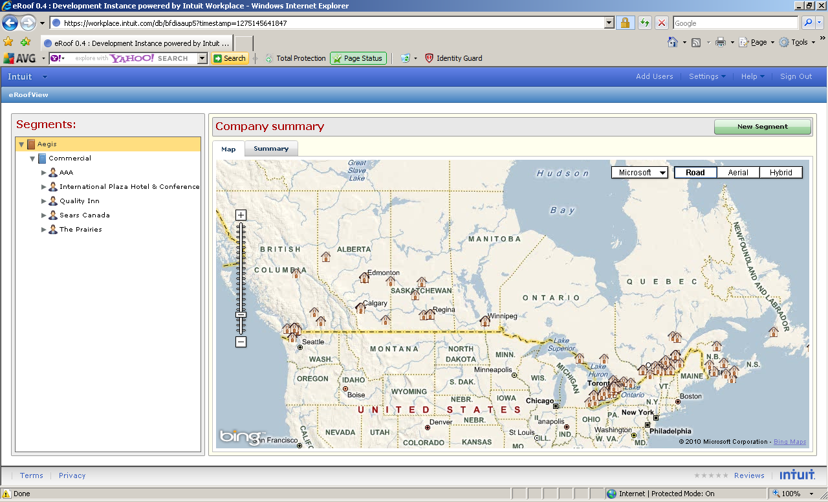

Map functions.

* Displays locations of all facilities.
* Use the Bing markers rather than house icons.
* **View in New Window** Button to open in a new window, full screen.
* **Save Map** – Save center and zoomlevel – full screen window only.
* Information box: Client name, facility name, address, contact, phone, E-Mail, and link to site plan – on both small and full screen windows.
* Note – This should be a re-usable component – for maps on the business, segment and client Summary tabs.

Segments tab

* A list of all segments with totals, as below:
* Column sorts.
* Inplace cell edit on segment name.
* Column totals at bottom.

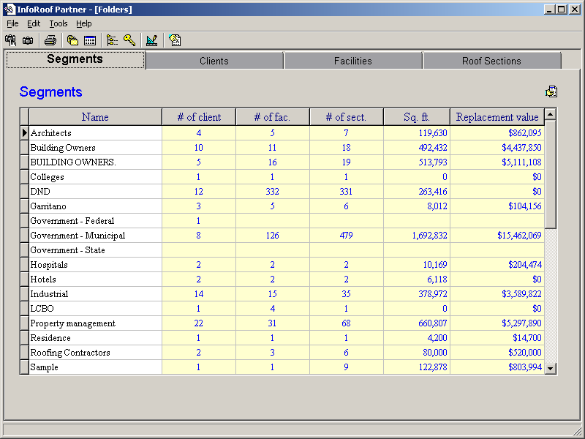

Est Value

## Segment Folders

* Displays summary information on a selected segment – with summary information on the clients within the segment.
* Heading “Commercial Segment Summary”

Summary tab



**Commercial Segment**

Total # of clients = 99

Total # of facilities = 770

Total # of sections = 2,000

Total Sq. Ft = 1,200,000

Total Est Asset Value = $ 12,333,444

Map functions.

* Displays locations of all facilities.
* Use the Bing markers rather than house icons.
* Remove the Microsoft, Road, Aerial, Hybrid selections/ buttons – maps will always be fixed.
* **View in New Window** Button to open in a new window, full screen.
* **Save Map** – Save center and zoomlevel – available on full screen window only.
* Information box: Client name, facility name, address, contact, phone, E-Mail, and link to site plan – on both small and full screen windows.
* Can map content be consistent between the small/ full-screen windows?

.

Clients tab

* List of clients, as below
* Column sorts.
* User filters – based on value selection for a single column – for example City=Ottawa – Can be coded as required (versus general capability of grids).
* Inplace edit of client name, brief name, address and city – single cell – double click?
* Column totals at bottom.

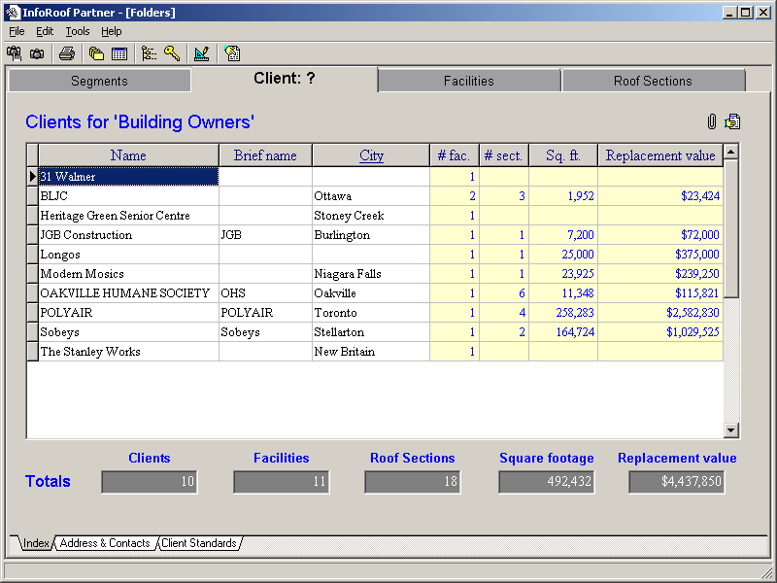

Add Address column

Est Value

## Client Folders

* Display summary information for all facilities for the selected client.
* Heading “Client Summary: Sears Canada”

Summary Tab

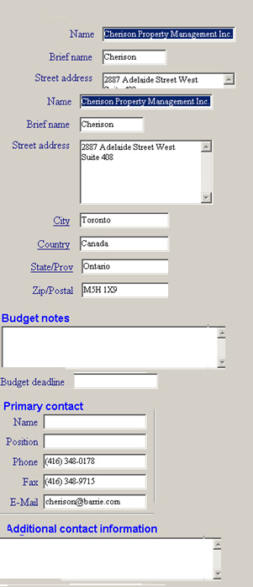

Edit

Logo

Facilities Tab

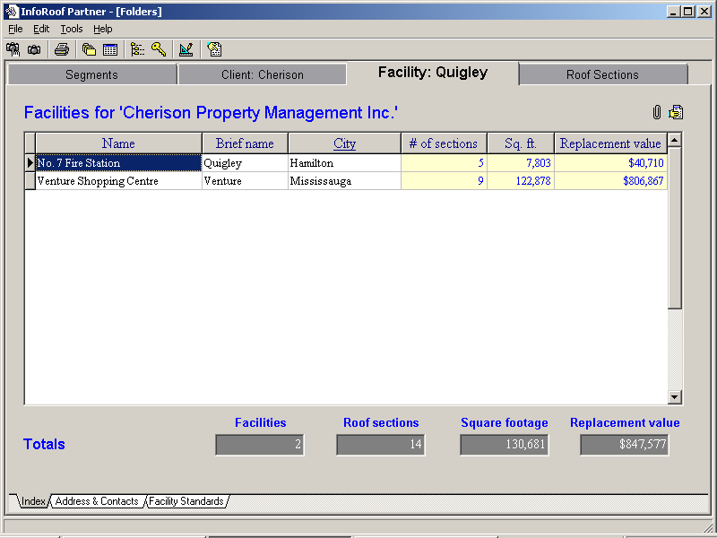

Documents

## Facility Folders

* Displays summary information on a selected facility – with summary information on the sections within the facility.
* Heading “Facilty: No 7 Fire Station (Sample Client)”

Summary Tab

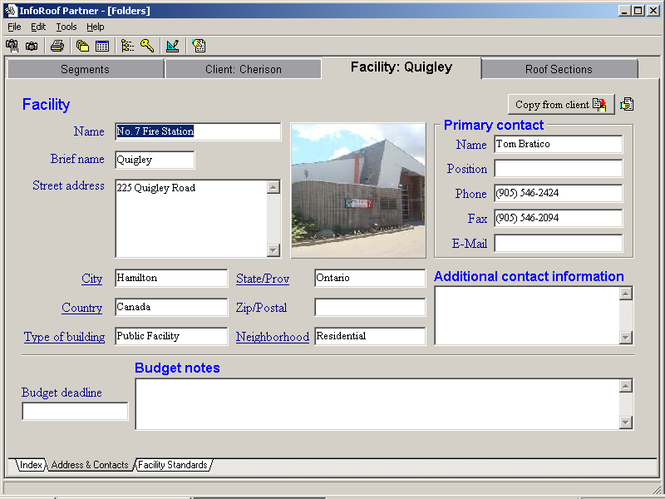

Edit

Changes

* Fields arrange vertically in left panel.
* Right panel displays:
  + Map – Street map of the area.
  + Site plan – Satelite map of the facility.
  + Photos – One or more photos of the facility.
  + See section 6.2

Site Plan

* Site plans are created using satelite images. A drawing may also be created for each roof section (see section 3.9).
* There are 3 layers that may be displayed – the satelite image, the street map, and the roof section drawings. These may be displayed in any combination.

Satelite image:

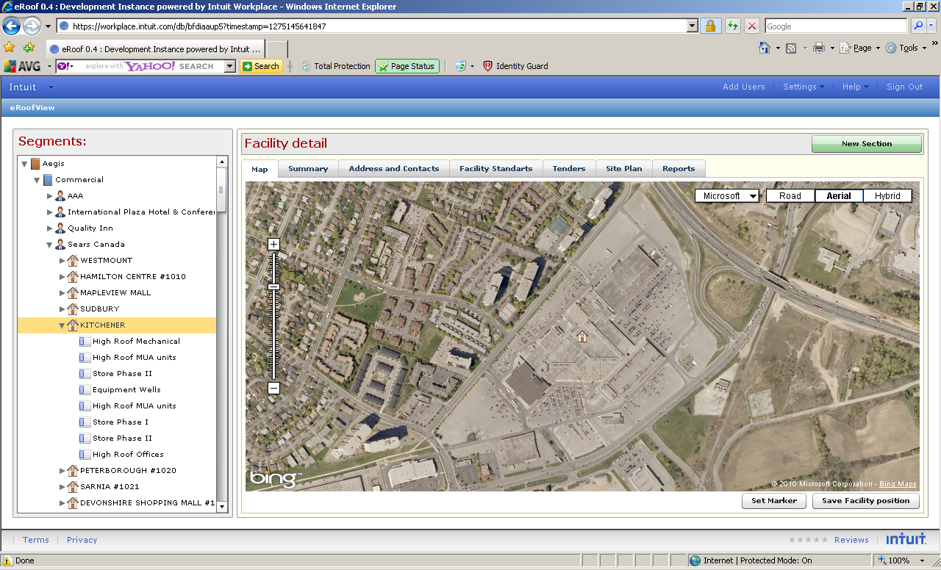

Street map and drawing:

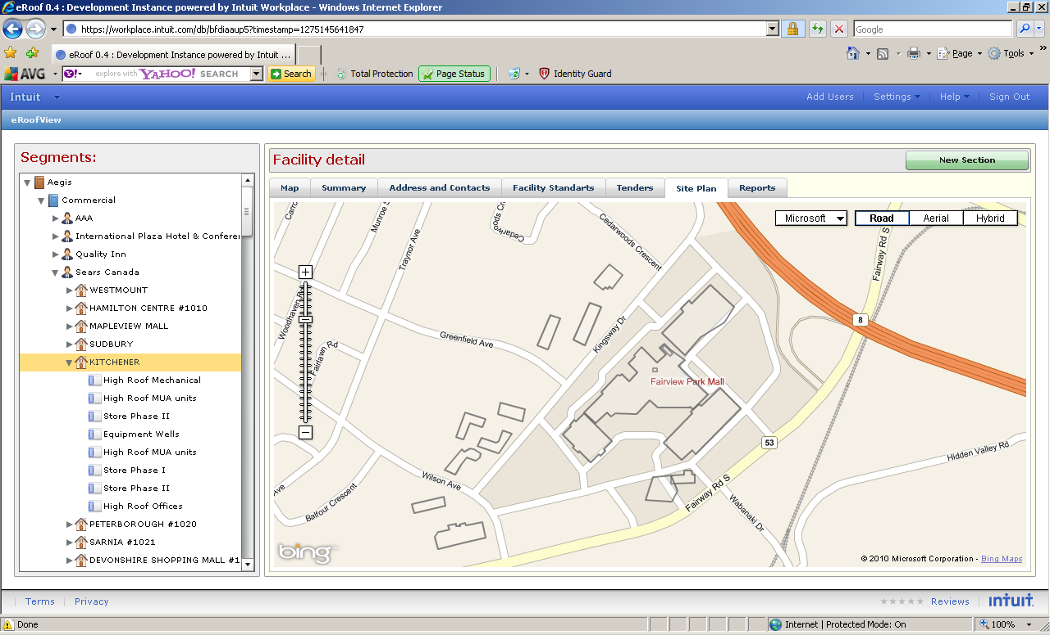

The following functions are available:

* **Find Address** – Sets the facility marker based on the facility address. This button is grayed if the address is not complete.
* Move location – Allows the facility location marker to be moved. This is a toggle button that indicates it’s mode. The button is reset with the Save SitePlan.
* Save Site Map – Saves the map center, the zoom level, and the facility location.
* Display Satelite Drawing Both

Notes

* Allow positioning of the site location independently of the map center.
* Implement logic to ensure that the location is always within the viewable map (see technical notes section)

Sections

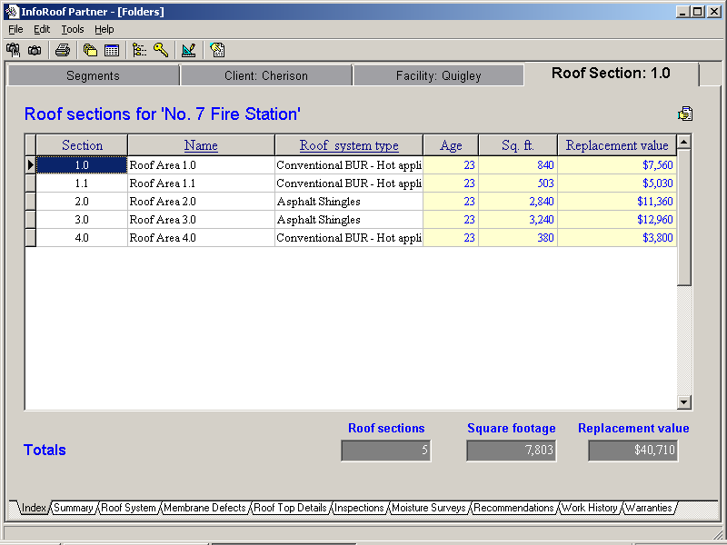

Documents

Section Details Tabs

The following tabs provides lists of information that has been entered for the sections at the facility. The tabs contain the same information as the corresponding tabs at the section level, but with a Designation column added as the first column.

* Deficiences
* Details
* Expenditures
* Inspections
* Action items
* Warranties

## Section Folders

* Displays summary information on a selected segment – with summary information on the clients within the segment.
* Heading: Section 1.0 (Sears Canada – Head Office)

Summary tab

**Reformat to horizontal:**

Known ( ) Estimated ( )

**Reformat to horizontal:**

Restorable? ( ) Yes ( ) No

Drainage Adequate? ( ) Yes ( ) No

Currently Leaking? ( ) Yes ( ) No ( ) Unknown

History of Leaking ? ( ) Yes ( ) No ( ) Unknown

Min fields not reqd

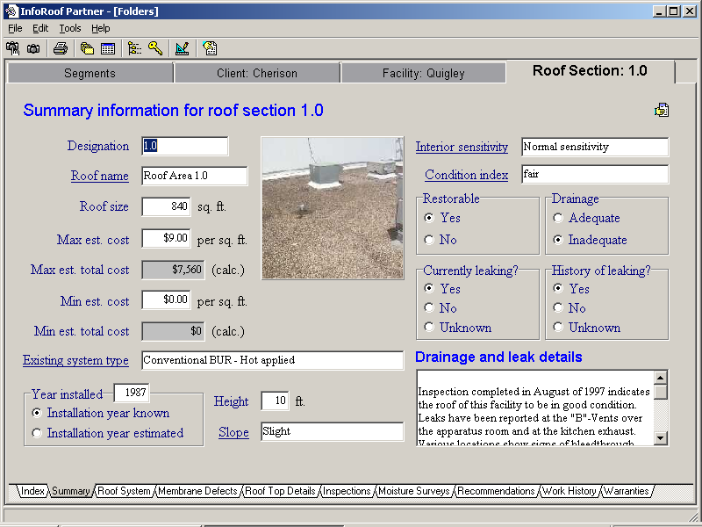

Roof ondition Summary

Notes

* All fields can be aligned vertical – i.e. fields on right side of above form can be moved below the Year Installed information.
* The screen is initially displayed in view mode.
* Edit button on top right of form used to invoke Edit mode.
* Edit button replaced with Save/ Cancel while in Edit mode.
* Form should be modal while in edit mode.
* The DateInstalled field can be added to show the calendar control.
* The photo should display in the view and edit screen, and should have an Upload control in the edit screen.
* Use RTF control for the roof condition summary memo.

Creating roof plans

A roof plan is creating using 2 drawings tools – available using the icons at the top left of the screen:

Create tool

* Drawing the roof plan by clicking on each point along the roof perimeter.
* Double click on the last point to complete the drawing.
* Alternative, use ESC after the last point is clicked.

Edit tool

* Click on a polygon to revise.
* A new line may be created by moving the mid-point of a line.
* A point may be removed by moving the mouse over the point, then click on the red X that appears.

Roof System tab

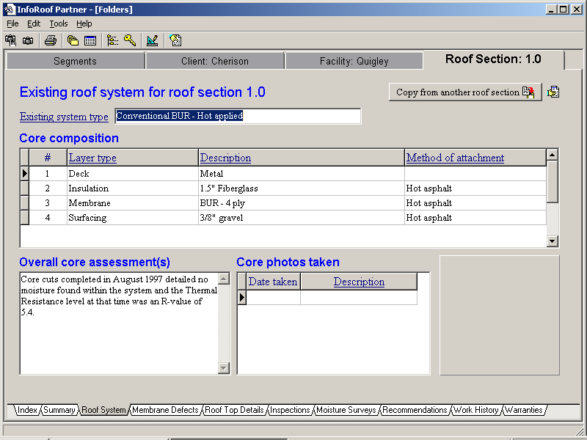

Details tab

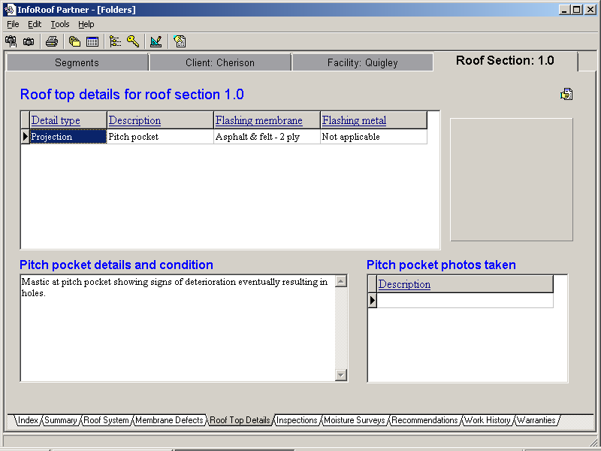

A roofplan/ photo display panel will be displayed on the right side.

Deficiencies tab

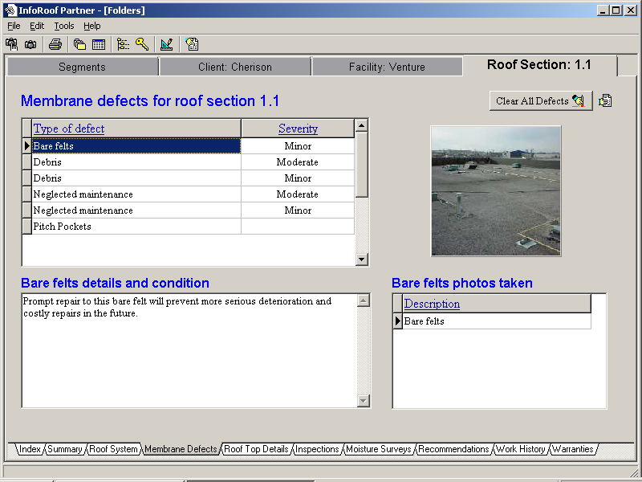

A roofplan/ photo display panel will be displayed on the right side.

Inspections tab

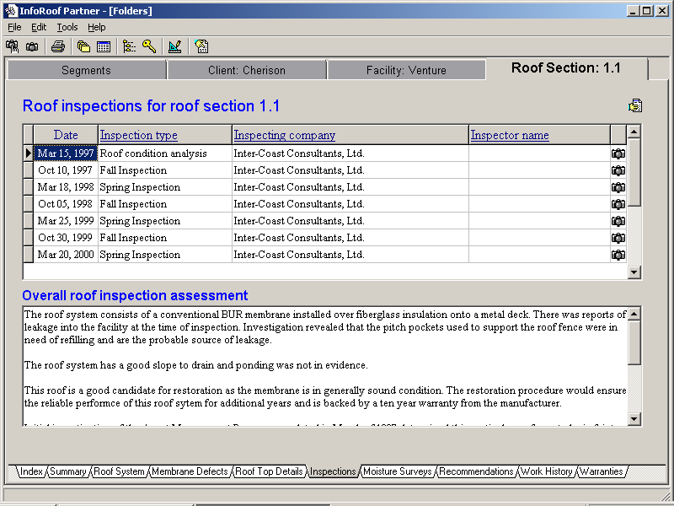

Moisture Surveys tab

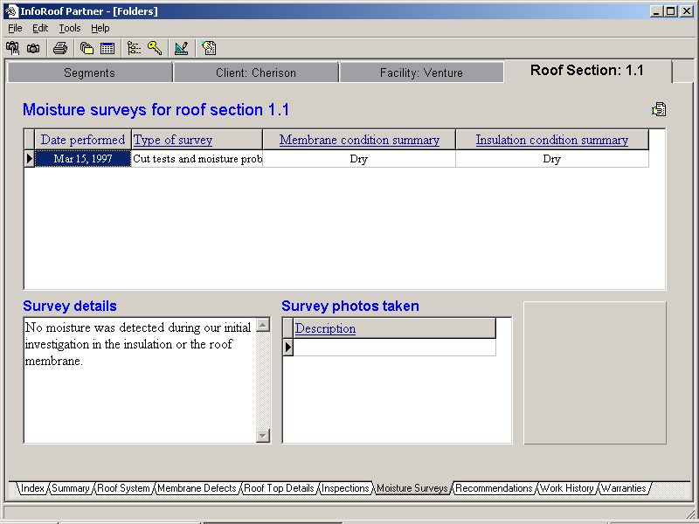

Expenditures tab

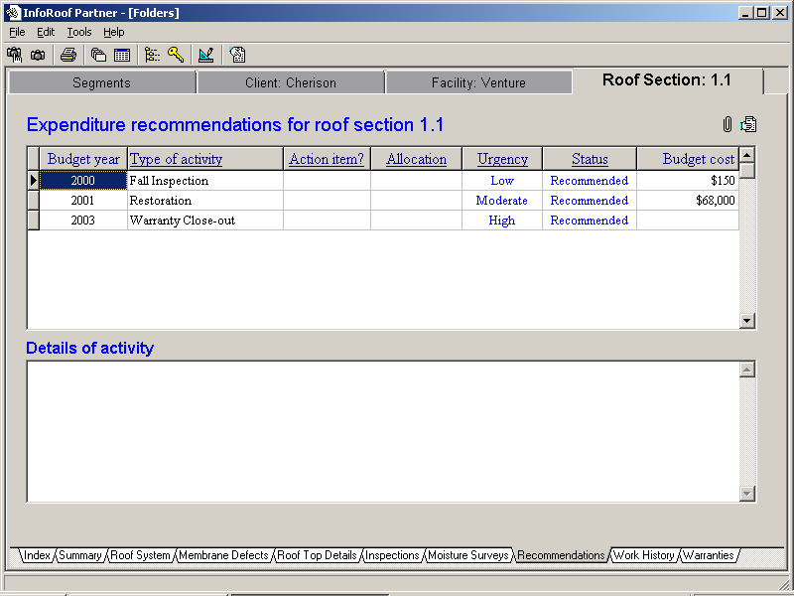

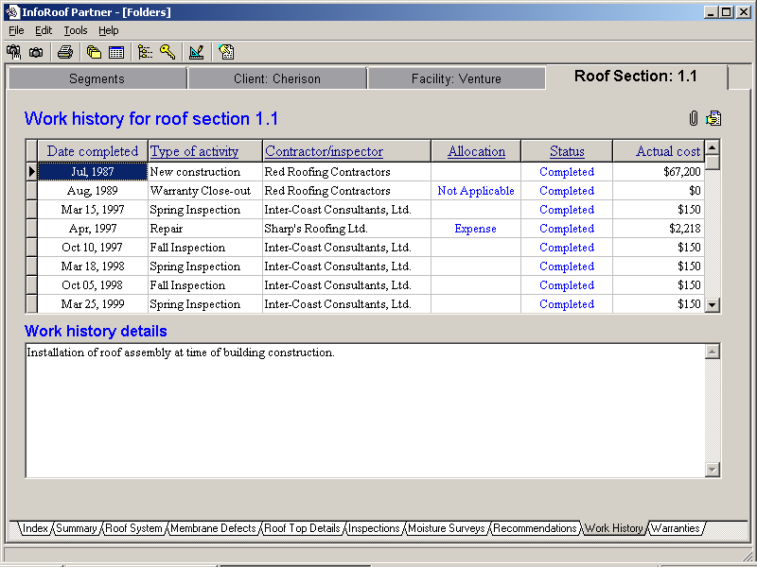

Warranties tab

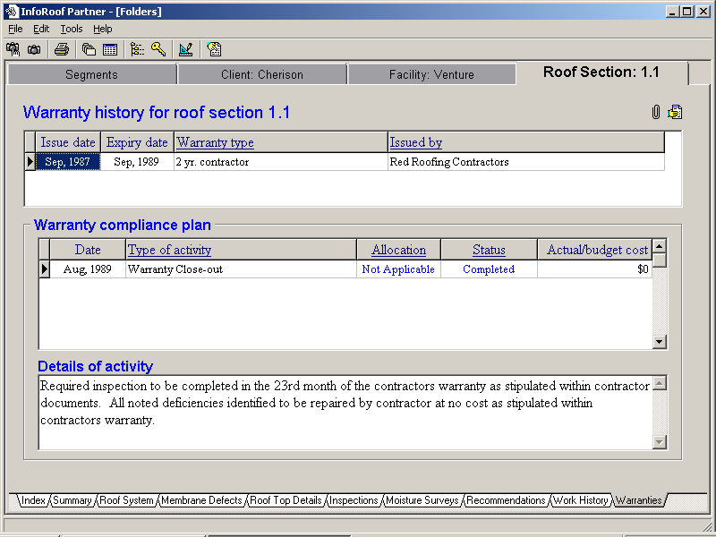

# Analysis

## Sections

* Client
* Facility
* Designation
* Roof System
* Age
* Sq Ft

## Systems

* Client
* Facility
* Designation
* #
* Type
* Description
* Attachment

## Details

## Deficiences

## Expenditures

## Inspections

## Action Items

## Warranties

# Tasks

## Inspections

## Service work

## Maintenance

## Tendering

## Project inspections

771 Golf Links Road

# On-roof data inspections

## Data capture

* Start new form
* Dictate address
* Take photos, enter annotations.

# Technical Notes

## Location markers

## Photo display component

The following screens require multiple photos.

* Roof summary
* Core
* Details
* Deficiencies
* Inspections

These forms require a common component with the following functions

* Display icons on the map at the location of each photo, with the photo number.
* If map location has not been entered, then the icons will be displayed below the picture.
* A Move button will enable icon moving, including moving the icons below the roof plan.
* Clicking on an icon will display the photo and annotation.
* A renumber function is required.

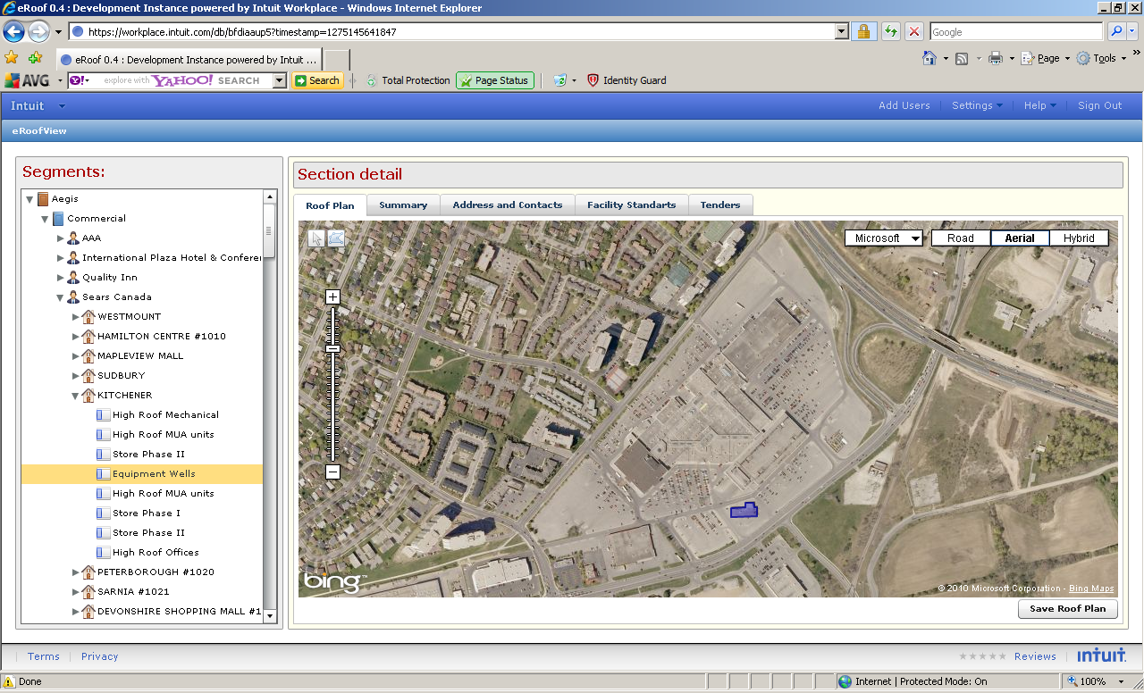

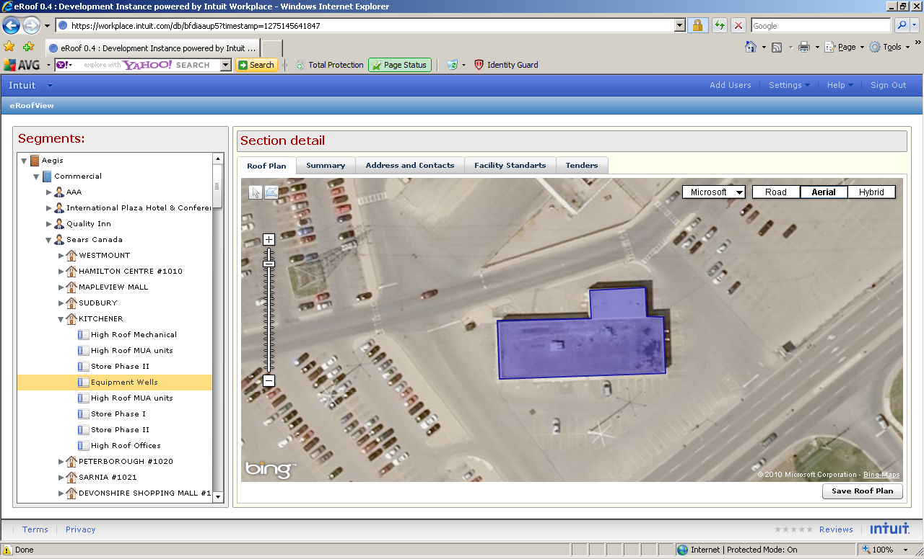

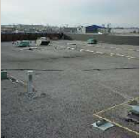

# Notes

Priorities – to drive Affilia work

* Add screens – Segment, Client, Facility, Section.
* Edit screen – Business, Segment, Client, Facility, Section.
* Delete functions.
* All screens.