Metal ball valve (Q41/341/641/941F/H/Y)

Introduce:
Ball valve , opening and closing parts (ball) driven by the valve stem, and around the axis of the ball valve for rotating movement of the valve. It can also be used for fluid regulation and control, the hard seal V-type ball valve with V-type core and surfacing carbide metal valve seat has a strong shear force, especially suitable for containing fiber, small solid materials and other media. The multi-pass ball valve in the pipeline can not only flexibly control the medium confluence, shunt, and flow switch, but also can close any channel and make the other two channels connected. This type of valve shall generally be installed horizontally in the pipeline. Ball valve according to the driving mode is divided into: pneumatic ball valve, electric ball valve, manual ball valve.

Main parts and materials
Name/Material | WCB | CF8 | CF3 | CF8M | CF3M
Body | WCB | CF8 | CF3 | CF8M | CF3M
Ball/Stem | WCB | CF8 | CF3 | CF8M | CF3M
Seat | PTFE / RPTFE/PPL
Bolt/Nut | B7/2H | B8/8 | B8/8 | B8M/8M | B8M/8M

Technical Specification
Design&Manufacture Standard | GB/T12237 | API 6D
FTF Dimension Standard | GB/T12221 | ASME B16.10
Flange standard | HG/T20592 | ASME B16.5
Inspection & Test Standard | HG/T13927 | API 598

The main connection size

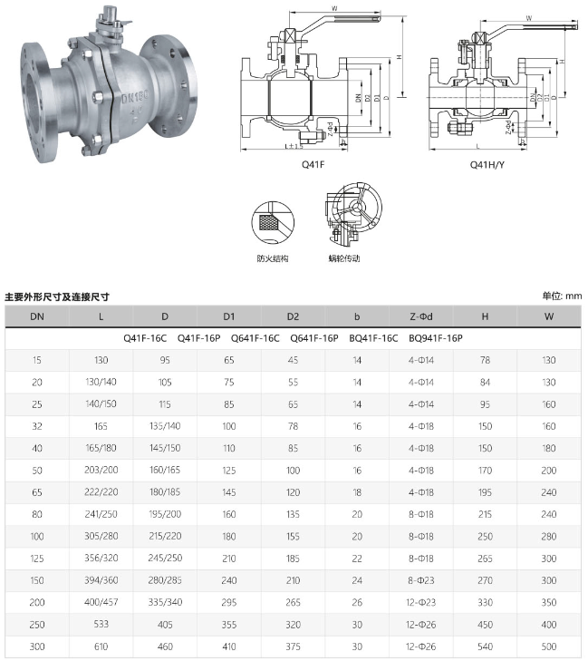

DN (mm | L | D | D1 | D2 | b | Z-Φd | H | W
Q41F-16C Q41F-16P Q641F-16C Q641F-16P BQ41F-16C BQ941F-16P
15 | 130 | 95 | 65 | 45 | 14 | 4φ14 | 78 | 130
20 | 130/140 | 105 | 75 | 55 | 14 | 4φ14 | 84 | 130
25 | 140/150 | 115 | 85 | 65 | 14 | 4φ14 | 95 | 160
32 | 165 | 135/140 | 100 | 78 | 16 | 4φ18 | 150 | 160
40 | 165/180 | 145/150 | 110 | 85 | 16 | 4φ18 | 150 | 180
50 | 203/200 | 160/165 | 125 | 100 | 16 | 4φ18 | 170 | 200
65 | 222/220 | 180/185 | 145 | 120 | 18 | 4φ18 | 195 | 240
80 | 241/250 | 195/200 | 160 | 135 | 20 | 8φ18 | 215 | 240
100 | 305/280 | 215/220 | 180 | 155 | 20 | 8φ18 | 250 | 280
125 | 356/320 | 245/250 | 210 | 185 | 22 | 8φ18 | 265 | 300
150 | 394/360 | 280/285 | 240 | 210 | 24 | 8φ23 | 270 | 300
200 | 400/457 | 335/340 | 295 | 265 | 26 | 12φ23 | 330 | 350
250 | 533 | 405 | 355 | 320 | 30 | 12φ26 | 450 | 400
300 | 610 | 460 | 410 | 375 | 30 | 12φ26 | 540 | 500

