# 1. Introduction

The **EduFin Credit Solutions** dataset is a comprehensive synthetic loan ecosystem designed specifically for corporate analytics training and educational purposes. This end-to-end simulation encompasses the complete student loan lifecycle, from initial application through disbursement, repayment, and potential default scenarios.

# 1.1. Dataset Scope

This synthetic dataset provides realistic financial data patterns while maintaining complete privacy compliance. It covers:

* Educational Institution Partnerships - University and college collaboration details
* Customer Onboarding - KYC, demographics, and financial profiles
* Loan Lifecycle Management - Application, approval, disbursement, and terms
* Payment Processing - EMI transactions, delays, and payment behaviors
* Default Management - Risk assessment, collection stages, and recovery analytics

# Key Benefits

* Risk-Free Training Environment - Practice with realistic date without privacy concerns
* Complete Ecosystem View - End-to-end loan operations in a single dataset
* Scalable Analytics - Suitable for both individual leaning and team training
* Industry-Standard Structure - Mirrors real-world financial data architectures

# 1.2. Dataset Architecture

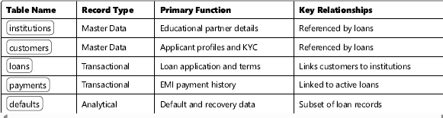

**1.3. Data Volume Estimates**

* **Institutions**: 500–1,000 records
* **Customers**: 10,000–50,000 records
* **Loans**: 8,000–40,000 records
* **Payments**: 100,000–500,000 records
* **Defaults**: 1,000–5,000 records

1. **Table Schema Specifications**
   1. **Institutions Table**

*Educational institutions in partnership with EduFin*

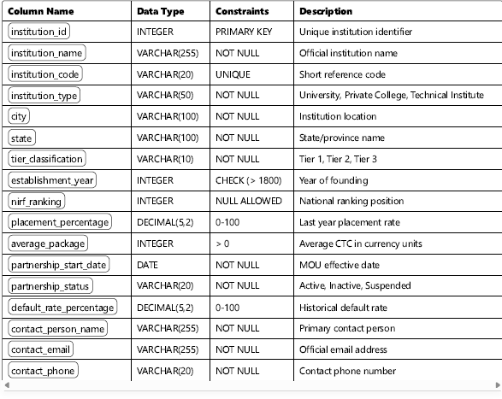

* 1. **Customer Table**

*Student loan applicant profiles and KYC data.*

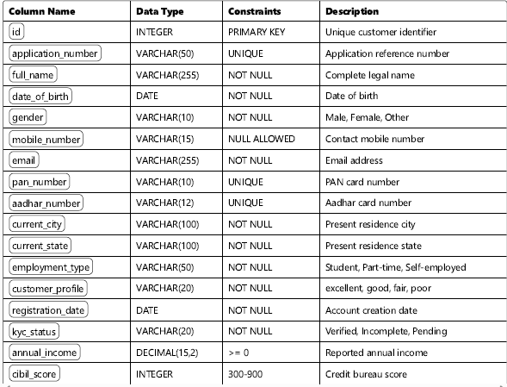

* 1. **Loans Table**

*Complete loan application approval, and disbursement records*

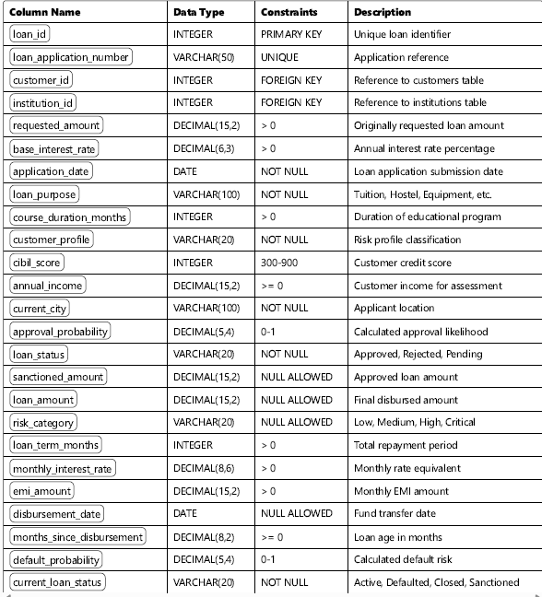

* 1. **Payments Table**

*EMI payment transaction history*

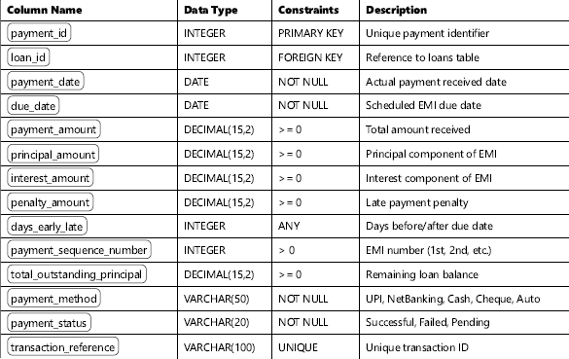

* 1. **Defaults Table**

*Default classification and recovery management*

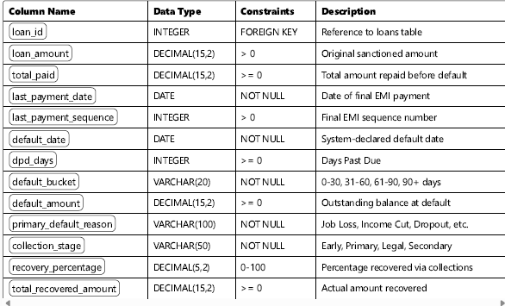

* 1. **Relationship Details**

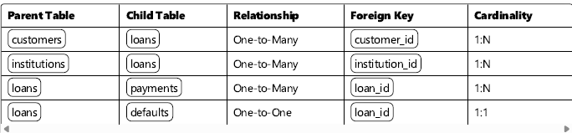

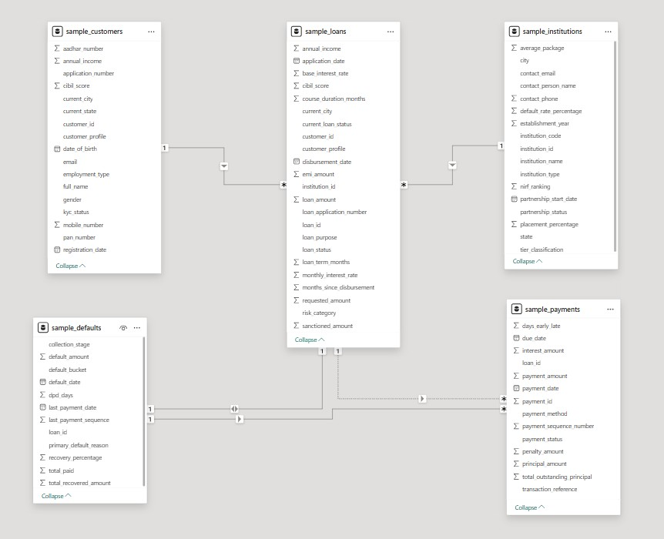

# Entity-Relationship Diagram: Theoretical Explanation

The ER diagram represents a relational model for a student loan ecosystem, capturing the key entities and their relationships involved in the loan lifecycle — from application to repayment and default. The system is designed for data analytics, reporting, and machine learning use cases in the educational finance domain.

1. **Entities and Attributes**
   1. **Institutions**

This table holds master data for partner educational institutions.

* + - **Primary Key: institution_id**
    - **Attributes: institution_name, institution_type, tier_classification, partnership_status, default_rate_%**
    - **Purpose: Links each loan to the corresponding institution, allowing institution-level risk and performance analysis.**
  1. **Customers**

Represents loan applicants and students.

* + - **Primary Key: id**
    - **Attributes: application_no, full_name, cibil_score, annual_income, kyc_status**
    - **Purpose: Captures applicant details including creditworthiness (CIBIL score) and income for underwriting purposes.**
  1. **Loans**

Stores transactional information about each loan.

* + - **Primary Key: loan_id**
    - **Foreign Keys: customer_id (→ Customers), institution_id (→ Institutions)**
    - **Attributes: loan_amount, loan_status, emi_amount**
    - **Purpose: Core table that connects customers to institutions and tracks the disbursement and status of loans.**
  1. **Payments**

Records EMI transactions made against active loans.

* + - **Primary Key: payment_id**
    - **Foreign Key: loan_id (→ Loans)**
    - **Attributes: payment_date, payment_amount, payment_status**
    - **Purpose: Enables repayment tracking, payment behavior analysis, and early warning for delinquencies.**
  1. **Defaults**

Captures default events and recovery performance.

* + - **Foreign Key: loan_id (→ Loans)**
    - **Attributes: default_date, dpd_days (days past due), recovery_%, collection_stage**
    - **Purpose: Used for modeling recovery processes, risk analytics, and regulatory reporting on loan defaults.**

1. **Relationships Between Entities**

* **Institutions ↔ Loans: A *one-to-many* relationship exists, where one institution can be associated with many loans through the institution_id.**
* **Customers ↔ Loans: A *one-to-many* relationship, where a single customer may apply for one or more loans.**
* **Loans ↔ Payments: A *one-to-many* relationship, where each loan can have multiple associated EMI payment records.**
* **Loans ↔ Defaults: A *one-to-one (optional)* relationship, indicating that not all loans will default, but each default record must be linked to a specific loan.**

1. **Integrity Constraints**

* **Primary Keys (PK): Ensure uniqueness within each table.**
* **Foreign Keys (FK): Maintain referential integrity by linking related records across tables.**
* **Cascading Policies: Carefully handled (e.g., CASCADE DELETE is avoided to preserve audit history).**

1. **Suggested Usage Scenarios**
   1. **Credit Risk Analytics**
      * **Credit Risk Modeling** – Build ML models to predict loan defaults
      * **Risk Scoring Assessment** – Develop customer risk assessment algorithms
      * **Portfolio Risk Assessment** – Analyze institution-wise and geography-wise risk
      * **Early Warning Systems** – Identify anomalies through missed or delayed EMI signals
   2. **Business Intelligence & Reporting**
      * **Loan Performance Dashboards** – Track disbursement, collections, and defaults
      * **Institution Partnership Analysis** – Evaluate risk by institution
      * **Customer Segment Behavior** – Group customers by demographic and behavior
      * **Channel Trend Analysis** – Compare traditional vs. digital onboarding
   3. **Operational Analytics**
      * **EMI Collection Optimization** – Improve payment collection strategies
      * **Delinquency Monitoring** – Identify customers falling behind on payments
      * **Customer Segmentation** – Analyze customer interaction patterns
      * **Fraud Detection** – Identify suspicious application or payment patterns
   4. **Machine Learning & AI Applications**
      * **Automated Underwriting** – ML-powered application decision engines
      * **Dynamic Pricing Models** – Optimize interest rates based on risk
      * **Collection Strategy Optimization** – Improve recovery rates through ML
      * **Customer Lifetime Value** – Predict long-term customer profitability
   5. **Training & Education**
      * **SQL Query Practice** – Complex joins, aggregations, and window functions
      * **Data Visualization Training** – Create meaningful BI charts and reports
      * **Statistical Analysis** – Practice correlation, regression, and hypothesis testing
      * **Business Case Studies** – Real-world scenarios for analytical decision making

**6. Technology Stack**

* 1. **Data Generation**
     + **Apache Spark** – Distributed data generation framework
     + **Pyspark** – Python API for Spark
     + **Faker** – Synthetic data creation library
     + **dbldatagen** – Table-based data generation
     + **Pandas** – In-memory manipulation
     + **Numpy** – Numerical and array support
  2. **Data Storage & Access**
     + **CSV Format** – For SQL import portability
     + **Parquet Support** – For efficient columnar storage
     + **Google Drive + GitHub** – Dataset download and sync
     + **Spark DataFrames** – In-memory processing format
  3. **Analytics & Visualization**
     + **Python** – Primary scripting language
     + **Jupyter Notebooks** – IDE for training workflows
     + **Power BI** – Dashboard creation tool
     + **Tableau** – Visual data exploration
     + **Jupyter Notebook** – Interactive analysis environment