TFS and CR Guide

First thing that you will need to do is to open a CR so that you can get the number assigned. It can be a skeleton at first. (Below)

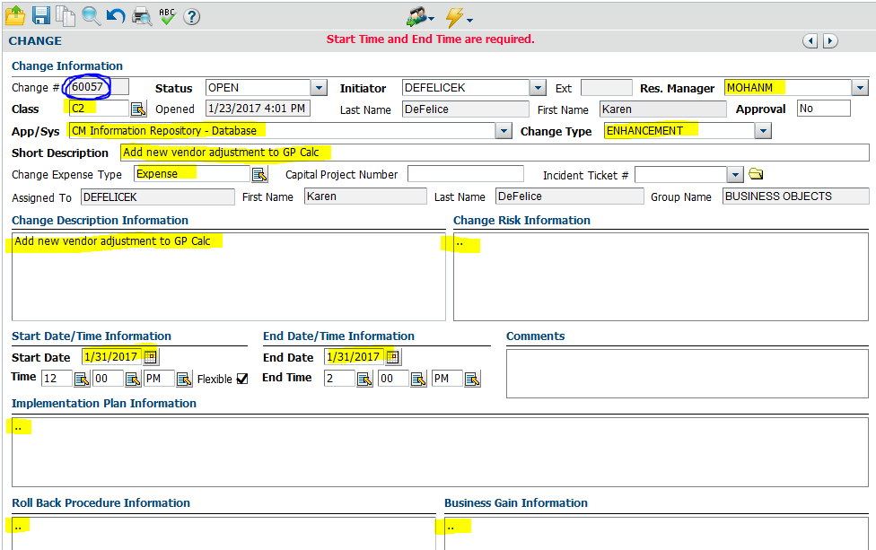

Now that you have your CR, open up TFS so that you can create your new development branch for that CR. Navigate to IM / Main / MainIM; then right click and pick branching and merging; then Branch.

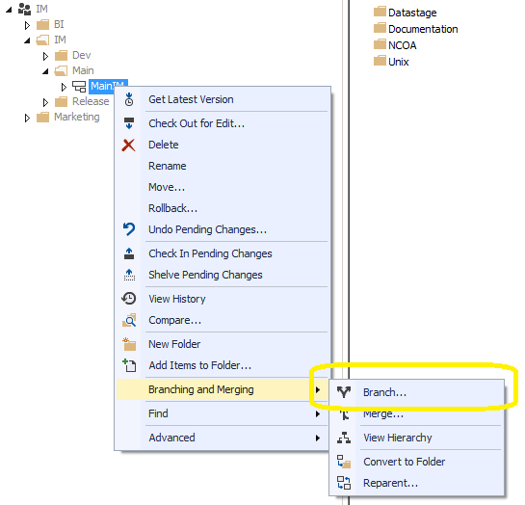

You will now have a pop up titled “Branch from MainIM”. In the box, you will need to change the Target Branch Name by clicking the Browse Button and navigating to Development and the year you are in. For this example we want to put a branch into 2017. As the CR folder doesn’t exist yet, you will need to add it after you pick the main path. Then click the Branch button.

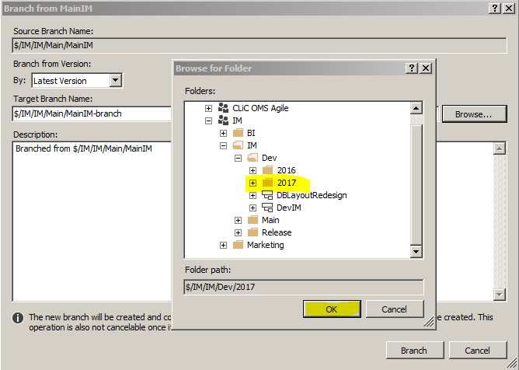 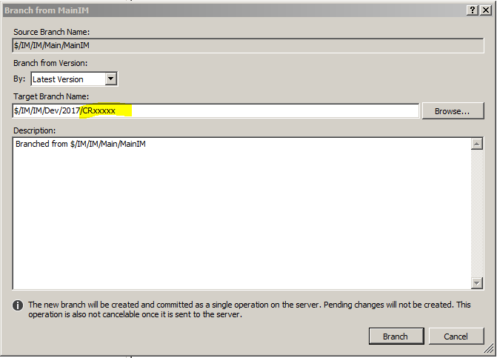

Once you do that, you will now see your CR under the Dev/2017 folder.

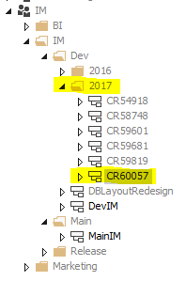

Now if you are adding something new, you will add those files to the directories in your workspace via Windows Explorer, then add them to the correct TFS folder, or if you are changing something existing, you will navigate to the folder and right-click and GET CURRENT VERSION so that you can modify it.

* New file, put local copy of file into windows directory.

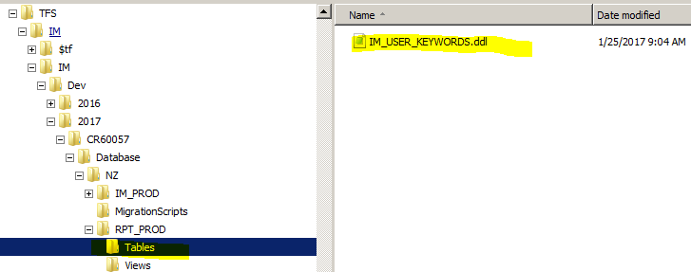

* Now add it to TFS by adding the file to the folder by right clicking and pick Add Items to Folder. Then at the pop up using Browse button in the upper right, navigate to the CR directory in windows where the new file is, then highlight the file to add and click the Finish button.

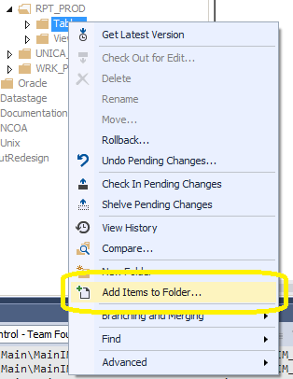 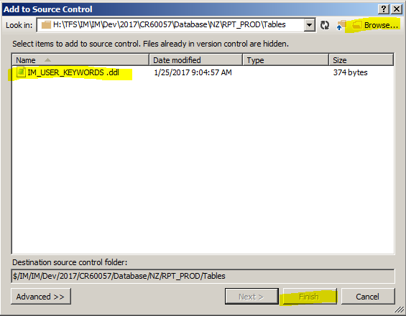

* You will now see the file within TFS so that it can be modified.

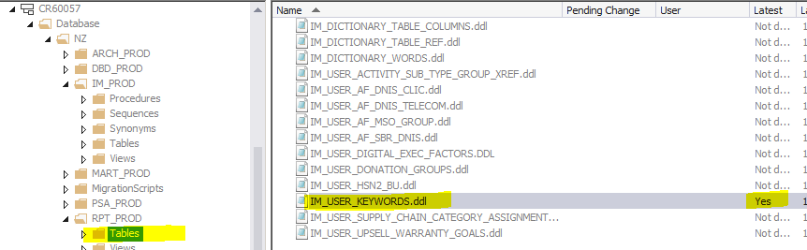

* If you are changing an existing file, navigate to the file, right click on it and pick “Get Latest Version”.

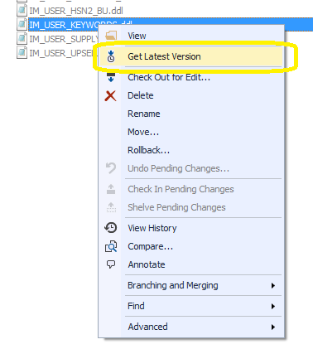

Now complete your work in TFS. (You can check in now, but if you have database components, you will need to create the deploy.sql file first.) To do this, follow the instructions (separately) to create the deploy.sql file and place the following directory, MigrationScripts, along with your “CR Named” deploy file in it. When done, add that file into TFS using the same instructions as above.

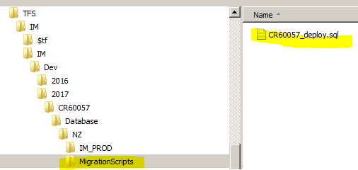 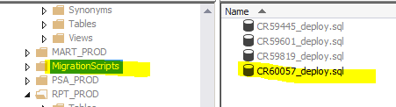

Now that you have completed your development, and you have added your migration script, check in your changes. After that, you will need to add all of your components, including the migration script, to the appropriate Release Excel sheet so they get migrated (follow separate instructions). Once everything is migrated to DEV / QA / UAT and you are happy with all changes, you are ready to move your changes to production.

First thing you want to do is ensure you don’t step on anyone else’s migration, so you will do a sanity check. To do this you are going to compare the existing Main with your CR branch to see if any changes have been made since you started. (If there are, you will need to gain those changes so your CR branch is up to date.)

* Click on MainIM folder, then right click and pick Compare. This will bring up the Compare pop up.

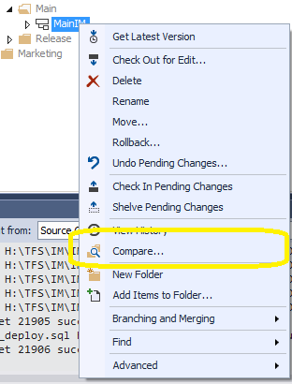 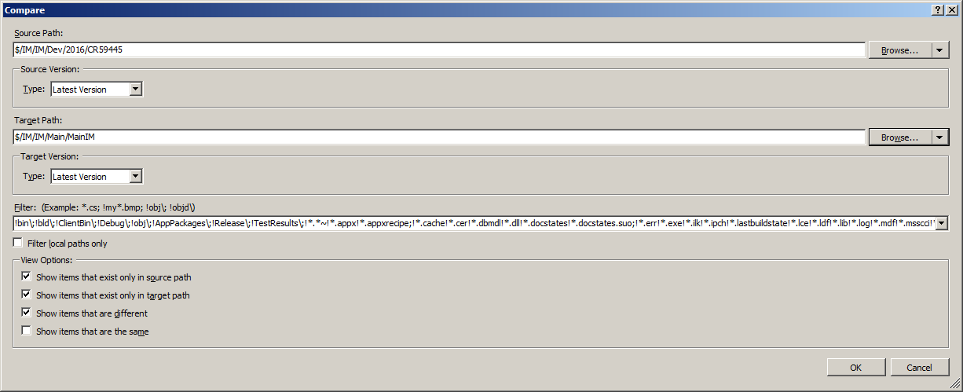

* Once you have the pop up, you will need to update the Target path to be your Dev CR directory. You will need to click the triangle icon next to Browse and click on Server Path, then navigate to your CR and press OK.

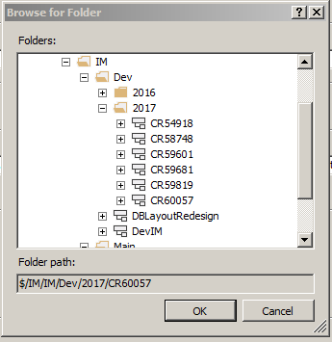

* TFS will now show you what is different from your branch to Main. You should see all of your changes, and any changes done by anyone else since you created your branch.

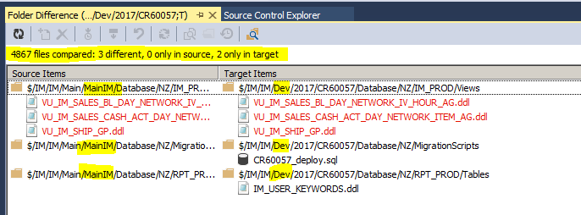

If there are changes other than yours when you compare, you will need to Merge those changes into your CR Branch before merging your changes to Main. This is so you don’t step on toes. To do that, click on the MainIM folder, then right click and pick Branching and Merging, then Merge.

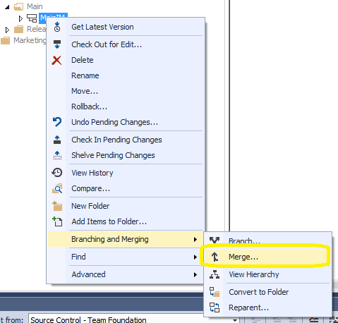

* This will bring up the Merge pop up window. To check all, leave the radio buttons the way they are. You will need to update the Target Branch to be your CR branch. Do this by clicking the Browse button and navigating to your CR branch.

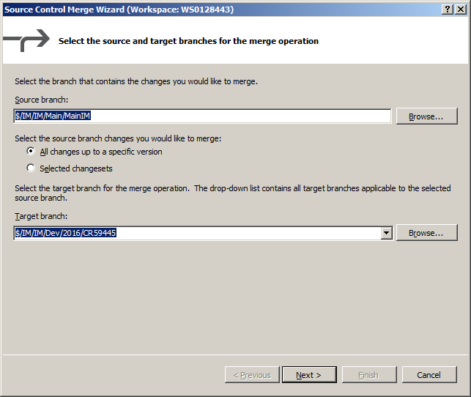 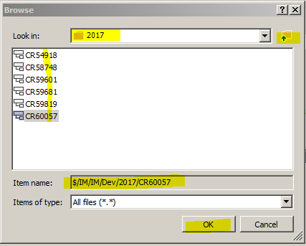

* When you click Next, leave the next screen at “Latest Version” and click Next. Finally click the Finish button so it does the check.

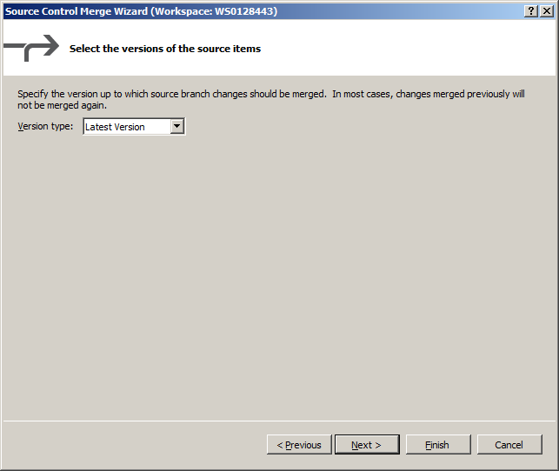 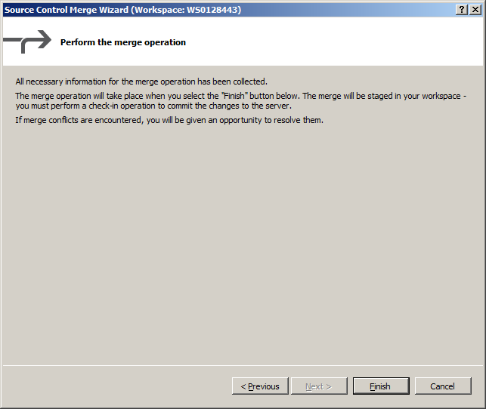

* At this point, it is either going to give you a message that no changes were made, or it will show changes in TFS on lower right, or it will tell you there is a conflict because the same file you modified was also modified by someone else.

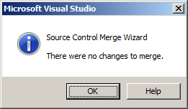

* If changes were made they will appear in the pending list on the lower right. Glance through that list and make sure that it appears to be reasonable. Then add a comment and check the changes into your branch.

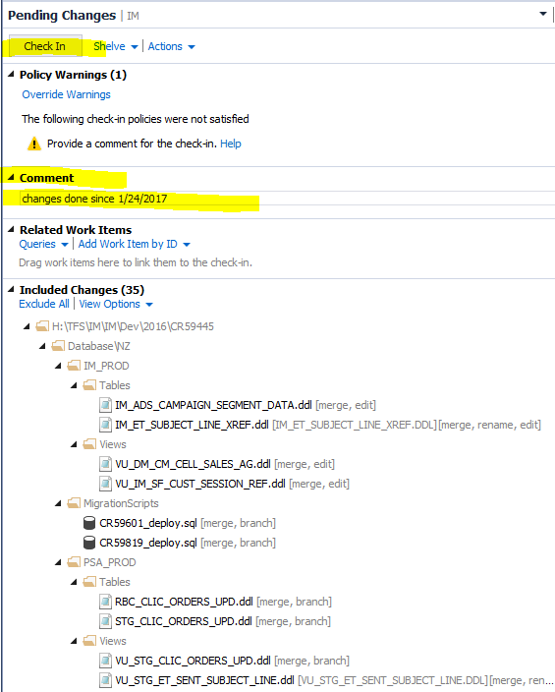

Finally, you will need to migrate your changes to Main.

* To do this right click on your CR folder in Dev, then right click and pick Branching and Merging, then Merge.

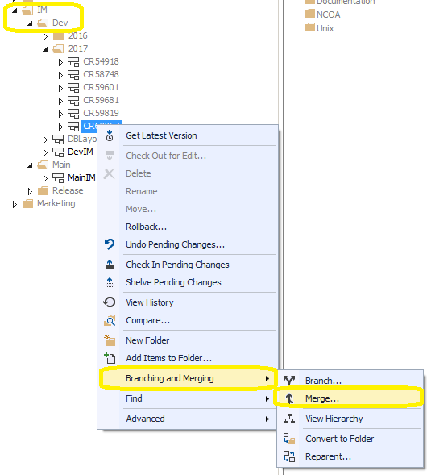

* You will see the now familiar Merge pop up. The source branch should be filled out as your dev CR branch. The Target branch should show as MainIM. Click Next, leave Latest Version, and click Next, finally click Finish to perform the merge.

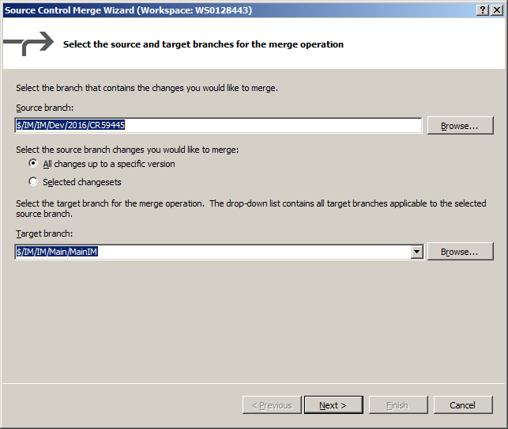 



* The result should show your changes in the lower right side in TFS. You will need to enter a comment, preferably the CR number with a real comment to what was done. Then click check in.

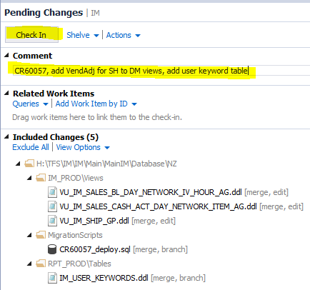 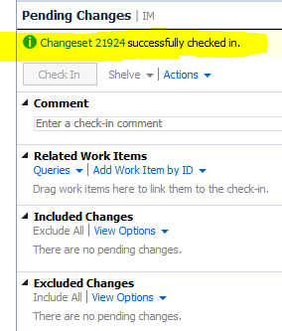

* Don’t make any additional TFS changes. Update your CR’s components tab with the proper changeset number and directory.