
PULSE BY SKILLED SAPIENS
SapiensPulse Club GTM and Product Penetration Challenge
Three Page Case Brief
Building long-term club adoption across Indian MBA colleges
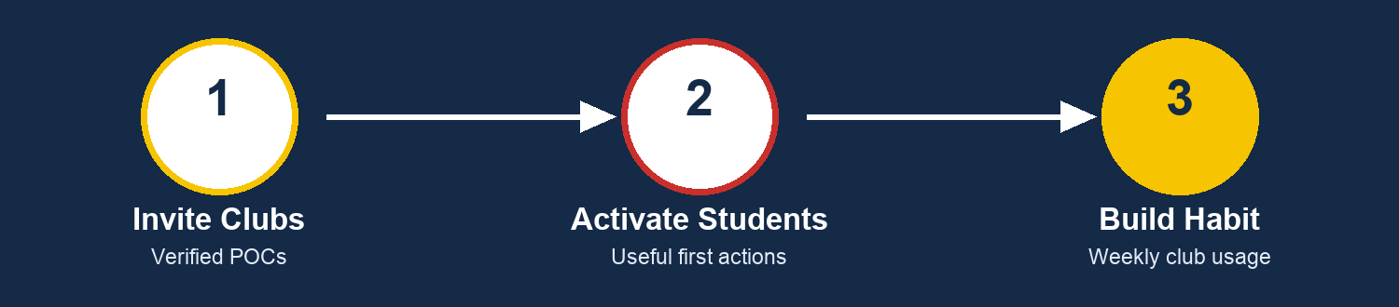
Beta product adoption case | Invite-only club onboarding | India MBA-first focus

1. Case Background and Strategic Context
CASE CONTEXT
◆ Skilled Sapiens is building Pulse as a beta student community and career ecosystem for Indian MBA students.
◆ The challenge is not to redesign Pulse from scratch. Teams must define how clubs, committees, cells, councils, and student-led bodies can adopt Pulse and make it part of their operating rhythm.
◆ Participants will receive access to the current Pulse beta and should use it as real users before forming recommendations.

WHAT PULSE IS AND IS NOT
◆ Pulse is a personalized student community layer for intra-campus and inter-campus interaction, networking, workshops, projects, opportunities, PDFs, career readiness, mentorship, and contribution back to the community.
◆ Pulse is not another Unstop. Unstop is known for event hosting, registrations, competitions, and listings. Pulse should complement such tools by becoming the ongoing community and engagement home for clubs.

Current Club Workflow | Pulse Opportunity
Clubs use WhatsApp, Google Forms, Unstop, Instagram, Drive, LinkedIn, sheets, email, and manual follow-ups. The result is scattered communication, weak discoverability, poor continuity, and repeated operational work. | Pulse can give clubs a verified home to invite students, share posts and PDFs, promote workshops and opportunities, start discussions, connect with alumni and peers, and build repeated student engagement.

First Target Clubs | Primary Adoption Pitch
Placement committees | Organize preparation visibility, opportunities, resources, readiness activity, and student participation.
Consulting finance marketing clubs | Run domain discussions, sessions, resources, cases, market updates, and cross-campus learning communities.
E-cells alumni cells student councils | Promote projects, founder sessions, alumni interactions, campus initiatives, and multi-club discovery.
Placement prep cells | Bring students into structured career readiness, profile building, peer discussion, and resource usage loops.

2. Core GTM Challenge and Adoption Design
CENTRAL CASE QUESTION
◆ How can Pulse by Skilled Sapiens become the preferred platform for clubs and committees to manage visibility, engagement, opportunities, resources, networking, and student participation across Indian MBA colleges within 30 days?

WHY A CLUB SHOULD JOIN PULSE
◆ Better visibility among students and other campuses. | ◆ A premium verified club identity inside a Skilled Sapiens-backed ecosystem.
◆ Simpler promotion of events, workshops, resources, PDFs, and opportunities. | ◆ Better student engagement beyond WhatsApp groups and one-time forms.
◆ Access to existing Pulse opportunities, career readiness, mentorship, and community features. | ◆ A stronger bridge between club POCs, members, interested students, alumni, mentors, and peer communities.

First Club Actions | Purpose
Create or claim club page | Give the club a visible identity with description, links, POCs, and domain context.
Get verified | Build trust through an official or approved club marker.
Invite first members | Bring current members and interested students into the club’s Pulse community.
Share one useful item | Post a PDF, resource, workshop, opportunity, or discussion prompt.
Activate one engagement loop | Ask students to comment, explore, save, share, complete profiles, or join a discussion.

Lightweight Missing Feature | Adoption Value
Verified club badge | Trust signal for official club presence.
Basic club profile page | A single home for description, POCs, links, resources, and activity.
Club invite link | Simple, trackable onboarding for members and interested students.
Resource section | Share PDFs, templates, guides, workshop material, and prep content.
Announcement post type | Clean format for sessions, opportunities, updates, and events.
Basic analytics | Views, joins, clicks, engagement, and first-action completion for POCs.

FEATURE BOUNDARY
◆ Teams may propose practical missing features, but should avoid a full product redesign, complex ERP, full ticketing system, payment platform, or generic social media ideas not tied to club adoption.

3. GTM Plan Research Metrics and Deliverable
30 Day Phase | Action Focus
Week 1 Targeting | Prioritize clubs and colleges, define invite criteria, POC lists, verification meaning, and club-specific pitches.
Week 2 Outreach | Run demos, help clubs create or claim pages, verify first clubs, invite members, and guide first useful posts.
Week 3 Activation | Push club-led invites, resources, discussion prompts, opportunity discovery, profile completion, and repeat usage rituals.
Week 4 Retention | Measure active clubs, gather POC feedback, convert proof points into outreach assets, and plan the next expansion wave.

REQUIRED PRIMARY RESEARCH
◆ Speak with 3 to 5 club or committee POCs and 3 to 5 students who follow or participate in club activities.
◆ Study current workflows across WhatsApp, Google Forms, Unstop, Instagram, Google Drive, LinkedIn, email, and manual follow-ups.
◆ Identify why clubs would adopt Pulse, what would make them invite students, what first workflow creates value, and what missing features matter most.

Metric Area | Example KPIs
Club onboarding | Clubs contacted, onboarded, verified pages, club categories, colleges represented, first action completion.
Student activation | Students invited, onboarded through clubs, profile completion, post/resource/opportunity engagement.
Content and engagement | Club posts, discussions, PDFs, workshops, opportunities viewed, comments, saves, and shares.
Retention and quality | Clubs active after 7 and 30 days, repeat posts, POC satisfaction, usefulness rating, organic referrals.

EXPECTED 10 SLIDE SUBMISSION
◆ Problem understanding and club workflow pain points.
◆ Target club prioritization and club-specific GTM playbooks.
◆ Pulse positioning, including why Pulse is not another Unstop.
◆ Club value proposition and reason to invite students.
◆ 30-day rollout plan, onboarding journey, and activation loops.
◆ Lightweight missing features, if needed, with clear adoption logic.
◆ KPI dashboard, risks, tradeoffs, and next steps.

STRONG SOLUTION CHECKLIST
◆ Research-backed club insight, clear differentiation, practical invite-only onboarding, verified-club trust thinking, personalized GTM by club type, lightweight product suggestions, privacy awareness, and measurable activation goals.

FINAL CASE QUESTION
◆ How can Pulse become the default personalized community platform for Indian MBA clubs and committees by onboarding clubs, activating students, enabling intra-campus and inter-campus interaction, and creating repeated usage within 30 days?

