Electrical Engineering (ENE) Graduation Project
G11 · Term 3 · Capstone Project Proposal
Advanced Camel Crossing Hazard Detection & Highway Safety System
“Camel Guard” — an ESP32 smart-highway miniature simulator with live IoT dashboard
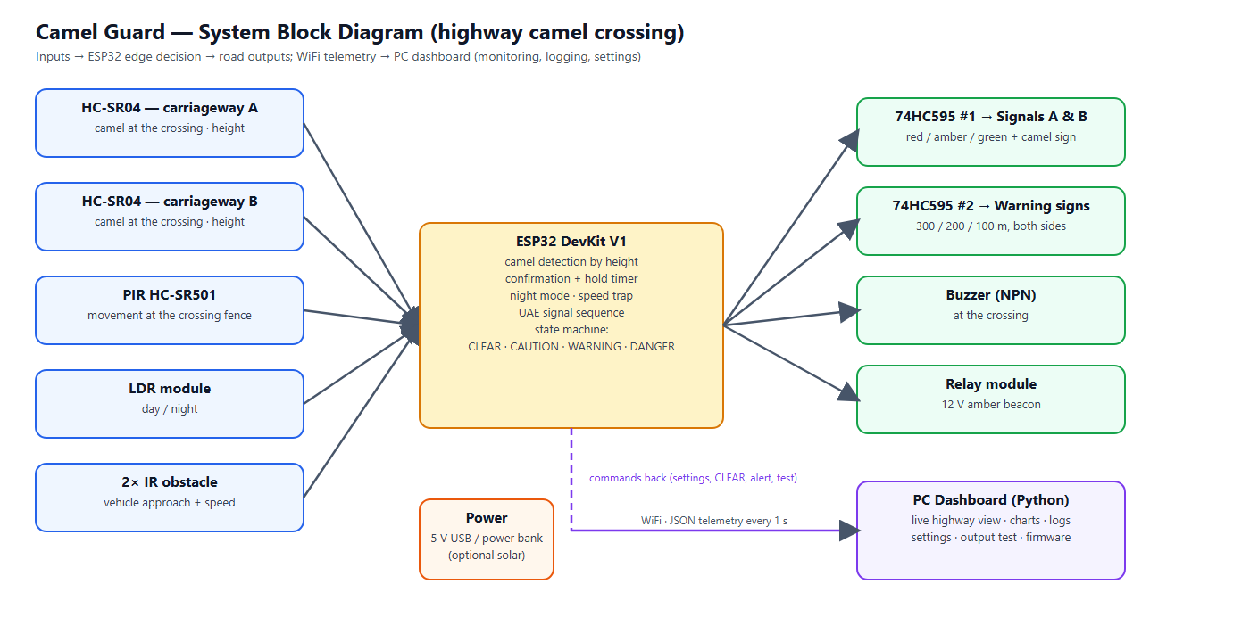
Figure 0 — System overview
Project Information
School | ATS-DHF
Supervisor | Haitham Zein
Students | 1. Mohamed Mubarak Almansoori 2. Mohammed Jumaa 3. Mansoor Abdulla 4. Ibrahim Jumaa
Project type | Miniature simulator (table-top road model) — not a field installation
Document | Full proposal: design, wiring, firmware, dashboard, budget, timeline and testing plan

Contents

(If the list above is empty, right-click it in Word and choose “Update Field”.)

1. Overview
The Engineering Capstone Project allows students to apply engineering knowledge and practical skills to solve real-world problems. This project focuses on improving road safety on UAE highways through the development of a smart warning system for camel crossings.
Because the project is a school capstone, the system is built and demonstrated as a miniature simulator: a table-top desert highway model with toy camels and toy cars. There are no pedestrians on a highway, so the system concentrates entirely on camels. The electronics, firmware and dashboard are real and complete; only the scale of the road is reduced. Everything in this proposal — sensor thresholds, speeds and tests — is therefore specified for the model, with real-world equivalents shown where useful (for example vehicle speed is converted using the model scale). The warning signs at 300, 200 and 100 m are placed in the correct order but not to scale.

2. Project Title and Description
Title: Advanced Camel Crossing Hazard Detection & Highway Safety System (“Camel Guard”).
The system watches a camel crossing on a divided highway and warns drivers automatically. An ESP32 microcontroller measures the height of anything that enters the crossing with two ultrasonic sensors — one above each carriageway, mounted on a small gantry — and recognises a camel by its height. While a camel is crossing, advance warning signs 300 m, 200 m and 100 m before the crossing flash in both directions, the camel-crossing sign and an external amber beacon flash, and two traffic signals stop the traffic with the UAE sequence: solid green, flashing green for 3 seconds, amber for 3 seconds, then red. Two infrared sensors detect approaching vehicles and measure their speed; when a vehicle approaches while a camel is on the road, the system escalates to DANGER: the warning signs flash fast and a buzzer at the crossing warns the camel herder. A light sensor enables a night mode and a PIR sensor at the crossing fence gives an early caution.
All decisions are made on the ESP32 itself, so the warnings keep working without WiFi. In addition, the ESP32 sends its data every second to a PC dashboard that shows a live animated view of the road, charts, a hazard history, a vehicle speed log and a settings page from which every threshold can be changed without re-programming the board.

3. Problem Statement
On UAE highways camels may cross unexpectedly, especially at night and in low visibility. Collisions with camels are particularly severe because of the animal’s height and weight: at highway speed the body strikes the windscreen of a car. Drivers need time to slow down, but traditional warning signs are static — they are always shown, so drivers become used to them, and they give no information about whether a camel is actually on the road right now. There is a need for a smart, automated system that detects a camel at the crossing, warns approaching drivers early enough (hundreds of metres before the crossing) only when it matters, stops the traffic, and records what happened so the road authority can see how often and when camels cross.

4. Abstract
The Camel Guard system is an embedded IoT prototype designed to improve safety at camel crossings on UAE highways. It is demonstrated on a 150 × 60 cm miniature highway model. Two HC-SR04 ultrasonic sensors — one above each carriageway — measure the height of objects on the crossing; a height-classification algorithm with confirmation readings and a hold timer recognises camels and ignores small objects. A PIR sensor at the crossing fence gives early caution, an LDR switches to night mode, and a pair of IR sensors forms a speed trap that detects approaching vehicles and calculates their speed. An ESP32 runs a five-state machine (WARMUP, CLEAR, CAUTION, WARNING, DANGER) and drives, through two chained 74HC595 shift registers, six advance warning signs at 300 / 200 / 100 m (both directions) that flash while a camel is crossing, the camel-crossing sign and two traffic signals that follow the UAE sequence green → flashing green (3 s) → amber (3 s) → red — plus a buzzer and a relay-controlled beacon.
The ESP32 sends JSON telemetry over WiFi to a local Python dashboard that provides a live road view, charts, event and hazard logs, a vehicle-speed log with speeding detection, remote configuration stored in the ESP32’s flash, output tests, multi-crossing overview and over-the-air-free firmware tools. A software simulator reproduces the firmware logic so the dashboard can be developed and demonstrated without hardware. The expected outcome is a reliable, low-cost and energy-efficient smart-road demonstrator that shows how sensing, embedded decision making and IoT monitoring can reduce accident risk and support the UAE’s smart-city initiatives.

5. Background Research
Camel-related road accidents are a known problem on desert highways in the UAE and the wider Gulf region. Current countermeasures are fences along highways, designated camel crossings with static signs, and awareness campaigns. Fences guide animals to crossings, which makes the crossing points the right place for active detection. At highway speed a driver needs several hundred metres to slow down safely, which is why this system warns with flashing signs at 300, 200 and 100 m before the crossing.

5.1 Detection technologies considered
Technology | Strengths | Limitations | Use in this project
PIR (passive infrared) | Cheap, low power, wide angle | Detects heat change only; weak when ground is near body temperature (desert summer); cannot classify | Early CAUTION; full WARNING only at night
Ultrasonic (HC-SR04) | Measures distance → object height; works day and night | Short range (≤ 4 m); needs calibration | Main detector: camel by height, one per carriageway
IR obstacle / beam | Fast, precise timing | Short range, affected by sunlight | Speed trap and vehicle approach
Radar / LiDAR | Long range, all weather | Costly, complex | Future work (real road)
AI camera | Can recognise animals | Needs computing power, privacy, night lighting | Out of scope (future work)

Microcontroller: the ESP32 was chosen instead of the Arduino Uno used in the first draft because it has built-in WiFi (needed for the dashboard), two processor cores (sensing on one core, networking on the other), more memory, a 12-bit ADC and flash storage for settings — at a similar cost.

6. Aims and Objectives
Aim: to design, build and test a miniature smart highway-safety system that detects camels at a camel crossing and warns drivers automatically from 300 m before the crossing, with remote monitoring.
- Detect a camel figure on either carriageway of the crossing in at least 90 % of trials, and ignore smaller objects.
- Flash all six advance warning signs (300 / 200 / 100 m, both directions) within 0.5 s of a camel entering the crossing.
- Stop the traffic for every hazard with the UAE signal sequence (green → flashing green 3 s → amber 3 s → red), never skipping a phase.
- Detect an approaching vehicle and escalate to DANGER (fast-flashing signs + buzzer) within 0.3 s.
- Measure vehicle speed with an error of at most ±10 % and log speeding during a hazard.
- Keep all warnings working when WiFi or the PC is unavailable (edge decision on the ESP32).
- Provide a dashboard with live view, logs, history and remote settings, updated every second.
- Complete the project within 12 weeks and within the budget in Section 11.

7. Project Scope

7.1 Included
- A working miniature highway model (about 1:24 scale) with one camel crossing, a gantry, two traffic signals, the camel-crossing sign and six advance warning signs.
- Electronics: ESP32, 2 ultrasonic sensors, PIR, LDR, 2 IR sensors, two 74HC595 with 13 LED outputs, buzzer, relay and beacon.
- Firmware with detection, state machine, WiFi telemetry, settings in flash, setup access point and USB configuration.
- PC dashboard (Python, runs on the school laptop) and a simulator for testing without hardware.
- Wiring diagram, testing plan with results, report, poster and demonstration.

7.2 Not included
- Installation on a real road, certification or approval by road authorities.
- AI camera recognition, radar or long-range sensors (listed as future improvements).
- Mobile phone notifications to drivers (future improvement).
- Pedestrians: a highway has no pedestrian crossings, so pedestrian detection is not part of this system.

8. System Design

8.1 Block diagram
Figure 1 — System block diagram

8.2 How the camel crossing is monitored
A gantry about 20 cm above the model road carries two ultrasonic sensors, one above each carriageway, both looking straight down. When the road is empty the distance equals the empty-road value that the system learns during calibration. When an object stands under a sensor the distance becomes shorter, and the difference is the height of the object:
object height = empty-road distance − measured distance
Measured height (model) | Class | Confirmation | Real-world meaning (1:24)
≥ 8 cm (adjustable) | CAMEL | 3 readings in a row (0.3 s) | ≈ 1.9 m and taller — camel
< 8 cm | ignored | – | small animal, debris, noise

A camel walking across the highway is seen first on one carriageway and then on the other; it is counted once. A detection is held for a hold time (default 5 s) after the camel was last seen, so the signs do not flicker while the animal moves. A median filter of three readings removes single wrong echoes, and the two sensors are triggered in turns every 50 ms so they cannot hear each other.

8.3 State machine and outputs
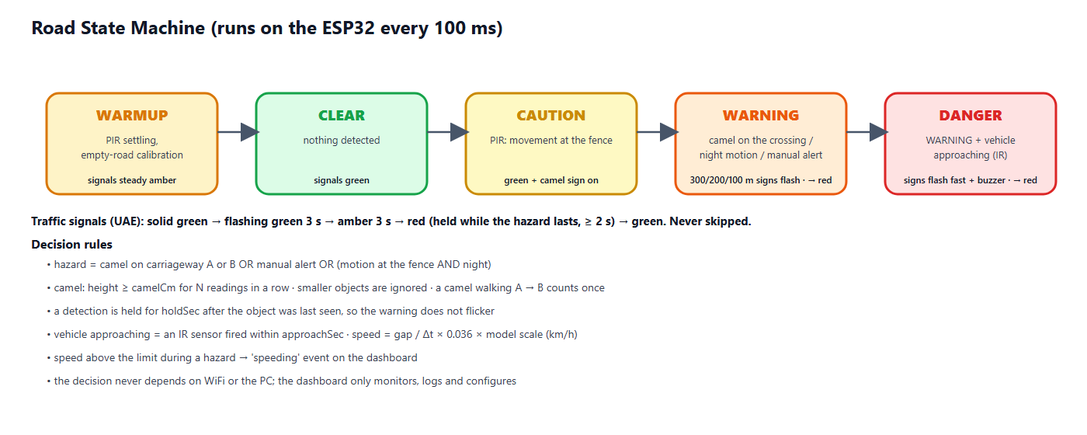
Figure 2 — Road state machine
State | Condition | Signals A & B | Warning signs | Buzzer | Beacon
WARMUP | first 20 s / calibration | steady amber | off | off | off
CLEAR | nothing detected | green | off | off | off
CAUTION | PIR: movement at the crossing fence in daylight | green | camel sign steady on | off | off
WARNING | camel on the crossing, night motion or manual alert | sequence to red (8.5) | 300/200/100 m signs + camel sign flash (1 Hz) | off | on
DANGER | WARNING + vehicle approaching | sequence to red (8.5) | all signs flash fast (4 Hz) | fast beeps | on

8.4 Advance warning signs (300 / 200 / 100 m)
Drivers on a highway need time to react, so the first warning appears long before the crossing. Three warning signs stand before the crossing on each approach, 300 m, 200 m and 100 m away. Each sign shows a camel and the distance, and has two amber flasher lamps on top. While a camel is crossing, all six signs flash with the two lamps alternating (wig-wag, 1 Hz); when a vehicle is approaching the camel (DANGER) they flash fast (4 Hz). In the model the signs keep the correct order and spacing ratio but not the real distance.
Output | Sign | Direction | Behaviour
Q8 / Q9 / Q10 | 300 m / 200 m / 100 m | traffic from side A | off → flashing while a camel is crossing → fast in DANGER
Q11 / Q12 / Q13 | 300 m / 200 m / 100 m | traffic from side B | same
Q6 | Camel crossing sign | at the crossing | steady on in CAUTION, flashing in WARNING, fast in DANGER

8.5 Traffic signal sequence (UAE)
Whenever a hazard appears the traffic is stopped with the same sequence that UAE drivers know from normal junctions. A phase is never skipped: jumping straight to red in front of a moving car would be more dangerous than the hazard itself, so a vehicle that approaches during the sequence is handled by the fast-flashing warning signs and the buzzer instead.
Phase | Signal | Duration | Meaning
1 | Solid green | while the road is clear | Vehicles may pass
2 | Flashing green | 3 s (about 3 flashes, adjustable 1–10 s) | Early warning: the signal is about to change
3 | Amber | 3 s (adjustable 1–10 s) | Prepare to stop
4 | Red | while the hazard lasts, at least 2 s | Vehicles must stop completely
→ | Solid green | after the crossing is clear | Back to phase 1

Once the flashing green has started, the sequence always runs on to red, even if the hazard disappears in the meantime — a driver who has seen flashing green must not get green again without a red phase. Both signals (A and B) show the same aspect. The remaining seconds of each phase are shown on the dashboard.

8.6 Vehicle speed
Two IR obstacle sensors are placed across the road 10 cm apart. The ESP32 records the exact time (in microseconds, using interrupts) when each beam is broken. The order tells the direction and the time difference gives the speed:
speed (km/h) = gap (cm) ÷ Δt (s) × 0.036 × model scale
Example: a toy car crossing the 10 cm gap in 0.2 s moves at 50 cm/s; at scale 1:24 this is 50 × 0.036 × 24 ≈ 43 km/h. A vehicle faster than the speed limit (default 60 km/h) while a hazard is active is logged as “speeding through a hazard”.

9. Hardware Design

9.1 Components
Component | Function | Key specification
ESP32 DevKit V1 | Main controller, WiFi | 240 MHz dual-core, 520 KB RAM, 3.3 V logic
HC-SR04 ×2 | Object height on carriageway A and B at the crossing | 2–400 cm, 5 V, ECHO needs 1 k / 2 k divider
HC-SR501 PIR | Movement at the crossing fence | 3.3 V output, 3–7 m range
LDR module | Day / night detection | Analog output to ADC1 (GPIO 34)
FC-51 IR ×2 | Vehicle detection and speed | Digital output, active LOW
74HC595 ×2 (chained) | 16 outputs: signals A/B (R, A, G), camel sign, 6 warning signs | Still only 3 GPIO, 3.3 V supply
LEDs + 220 Ω | Traffic signals, camel sign, warning-sign flashers | Red, amber, green 5 mm
Active buzzer + NPN | Warns the camel herder at the crossing | 5 V, driven via 2N2222 + 1 kΩ
Relay module + 12 V beacon | External amber warning light | Active LOW (configurable)

9.2 Pin assignment
ESP32 pin | Connected to | ESP32 pin | Connected to
GPIO 13 | HC-SR04 A — TRIG | GPIO 23 | 74HC595 #1 DS (data)
GPIO 14 | HC-SR04 A — ECHO (divider) | GPIO 18 | 74HC595 SH_CP (both chips)
GPIO 16 | HC-SR04 B — TRIG | GPIO 19 | 74HC595 ST_CP (both chips)
GPIO 17 | HC-SR04 B — ECHO (divider) | GPIO 25 | Buzzer (via NPN)
GPIO 27 | PIR OUT | GPIO 26 | Relay IN (beacon)
GPIO 32 | IR sensor 1 | GPIO 2 | Onboard status LED
GPIO 33 | IR sensor 2 | GPIO 34 | LDR AO (analog)
#1 Q7′ | → 74HC595 #2 DS (chain) | GPIO 35 | Battery sense (optional)

9.3 Wiring diagram
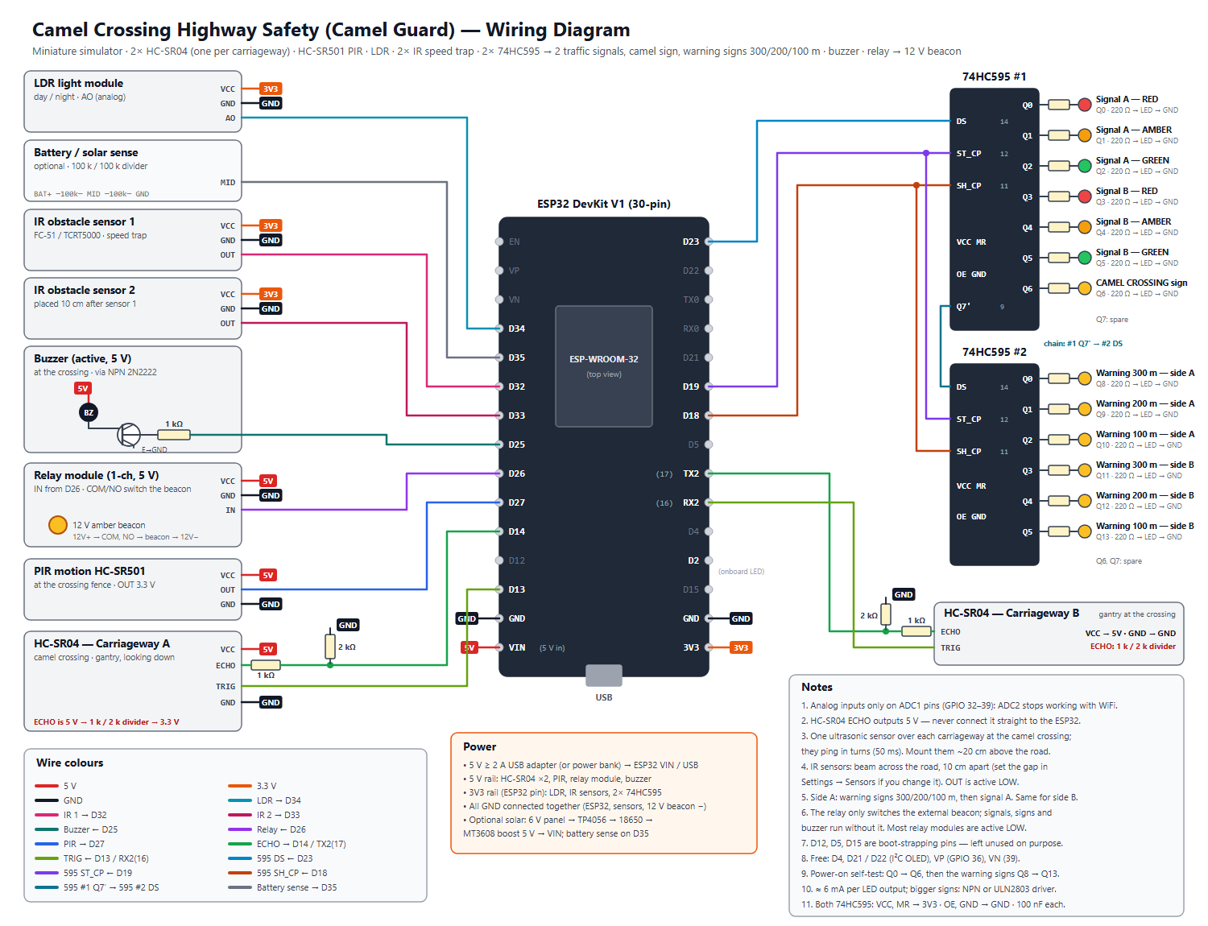
Figure 3 — Wiring diagram (docs/wiring_diagram.svg)

9.4 Miniature highway model
- Base: 150 × 60 cm MDF board, desert sand texture, divided highway: carriageway A and carriageway B with a median, about 34 cm wide in total.
- One camel crossing in the middle with a camel fence along the road that guides the camels to it; a gantry 20 cm high carries one HC-SR04 above each carriageway.
- On each approach: warning signs 300 m, 200 m and 100 m before the crossing (evenly spaced, not to scale), then the camel-crossing sign and the traffic signal.
- IR speed trap on the side-A approach, two beams 10 cm apart; a small ramp gives repeatable car speeds for testing.
- PIR at the fence next to the crossing; LDR on top of the model (open to room light); electronics box under the board.

10. Software Design

10.1 ESP32 firmware
- Edge decision: sensing, classification and the state machine run on core 1 every 100 ms, independent of the network.
- Telemetry: a network task on core 0 sends JSON to the dashboard every second; the reply may carry one command.
- Settings in flash (NVS): thresholds, hold time, speed settings, calibration, device name and up to five WiFi networks survive a power cycle.
- Commands: clear, calibrate empty road, change settings, change WiFi, manual alert, output test, reboot, factory reset.
- Network recovery: finds the dashboard PC automatically by UDP broadcast; starts its own setup WiFi (CamelGuard-Setup-XXXX) if no network works; can also be configured over the USB cable.
- Safety of settings: every value is clamped to a safe range on both the PC and the ESP32, so a typing mistake cannot make the system blind.

10.2 PC dashboard
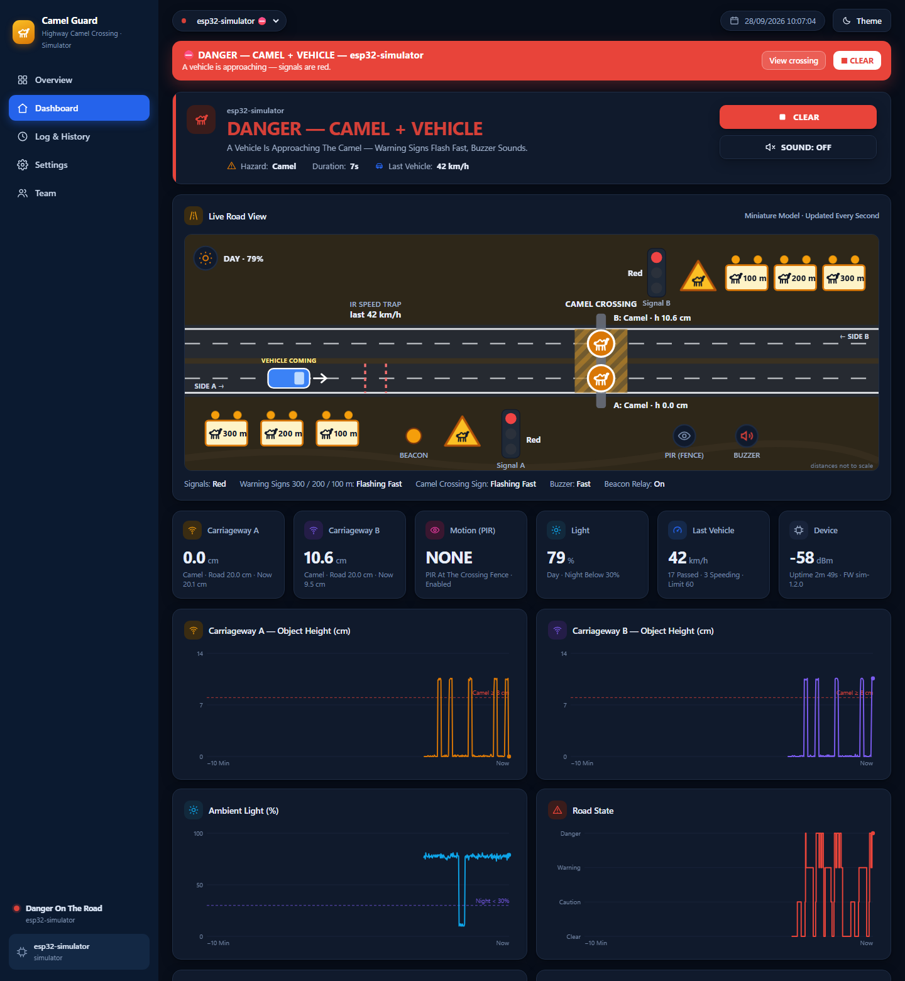
Figure 4 — Dashboard: live highway view during a DANGER event (simulator)
- Overview: every camel crossing as a card, hazards first; CLEAR ALL and ALERT ALL; today’s camel crossings, vehicles and speeding count.
- Dashboard: animated live highway view (signals, 300/200/100 m warning signs, camel sign, camel per carriageway, cars, beacon, buzzer, day/night), six live tiles, four 10-minute charts, “why the system decided this” and recent vehicles with speed.
- Log & History: filtered event log, hazard history (duration, peak level, vehicles, max speed) and vehicle log, each exportable to CSV.
- Settings: detection thresholds, calibration, motion & light, vehicle speed, signal timing, sensors fitted, WiFi, device, output test, wiring diagram, firmware compile/upload and ports.
- Team: authors and supervisor with photos.

10.3 Simulator
A Python simulator reproduces the firmware exactly (same thresholds, confirmation, hold, speed calculation and command handling) and plays scenarios: auto tour, clear road, camel (walking over carriageway A then B), danger, night, speeding and three crossings at once. It allows the dashboard to be developed and demonstrated before the hardware arrives.

11. Materials and Budget
Prices are estimates in UAE dirham (AED) from local electronics and hobby suppliers and online stores; final prices depend on the supplier.
Item | Specification / purpose | Qty | Unit (AED) | Total (AED)
ESP32 DevKit V1 (30-pin) | Dual-core 240 MHz, WiFi, 12-bit ADC | 1 | 35 | 35
Ultrasonic sensor HC-SR04 | 2–400 cm, 5 V, one per carriageway | 2 | 12 | 24
PIR motion sensor HC-SR501 | Adjustable delay & sensitivity | 1 | 15 | 15
LDR light module | Analog output, day / night | 1 | 6 | 6
IR obstacle sensor FC-51 | Speed trap on the road | 2 | 6 | 12
74HC595 shift register | 2 chained: signals, camel sign, 6 warning signs (+1 spare) | 3 | 3 | 9
LED kit 5 mm (red/amber/green) | Traffic signals and warning signs | 1 | 12 | 12
Resistor kit (220 Ω, 1 k, 2 k, 100 k) | LED limiting, ECHO dividers | 1 | 20 | 20
Active buzzer 5 V + NPN 2N2222 | Warning at the crossing (herder) | 1 | 10 | 10
Amber LEDs 5 mm (extra) | Flashers on the 300/200/100 m warning signs | 1 | 8 | 8
Relay module 1-channel 5 V | Switches the external beacon | 1 | 12 | 12
12 V amber LED beacon | External warning light | 1 | 30 | 30
12 V 1 A adapter | Beacon supply | 1 | 20 | 20
5 V 2 A USB adapter + cable | ESP32 and sensors | 1 | 25 | 25
Breadboard 830 points | Prototyping | 2 | 15 | 30
Jumper wire set (M-M, M-F) | Connections | 1 | 20 | 20
Perfboard + pin headers | Final soldered circuit | 1 | 15 | 15
MDF base board 150 × 60 cm | Miniature highway base | 1 | 55 | 55
Toy camels (≈ 1:24) | Camel figures, 10–12 cm tall | 3 | 10 | 30
Warning sign boards ×6 (300/200/100 m) | Printed faces on sticks, two flasher LEDs each | 1 | 25 | 25
Toy cars (≈ 1:24–1:32) | Vehicles for the speed trap | 3 | 8 | 24
Paint, sand texture, road tape, median, fence | Desert highway scenery with camel fence | 1 | 40 | 40
Gantries & sign boards (3D print / acrylic) | Sensor mounts, sign faces | 1 | 40 | 40
Consumables (glue, heat-shrink, screws, tape) | Assembly | 1 | 25 | 25
Subtotal |  |  |  | 542
Contingency (10 %) | spares, shipping, price changes |  |  | 54
TOTAL (required) |  |  |  | 596

11.1 Optional: solar power kit
Item | Qty | Unit (AED) | Total (AED)
6 V 2 W solar panel | 1 | 30 | 30
TP4056 charger module | 1 | 5 | 5
18650 cell + holder | 1 | 20 | 20
MT3608 5 V boost converter | 1 | 5 | 5
Optional total |  |  | 60

Tools already available in the school workshop (not budgeted): laptop, Arduino IDE 2, soldering station, multimeter, hot-glue gun, 3D printer / laser cutter.

12. Project Timeline
Duration: 12 weeks (Term 3). Shaded cells show when each task is carried out.
Task | W1 | W2 | W3 | W4 | W5 | W6 | W7 | W8 | W9 | W10 | W11 | W12
Research, proposal & approval
System design: block diagram, schematic, BOM
Order & receive components
Sensor tests on breadboard (US, PIR, LDR, IR)
Output tests (74HC595 signals, signs, buzzer, relay)
Firmware: detection + state machine
Firmware: WiFi, telemetry, settings (NVS)
Dashboard + simulator integration
Miniature road model build
Install electronics in the model, solder board
Calibration & unit / integration tests
System tests, fixes, data collection
Report, poster, demo video
Final presentation & exhibition

12.1 Milestones
Week | Milestone / deliverable
1 | Proposal approved by the supervisor
3 | All components received; bill of materials checked
4 | All sensors and outputs working on the breadboard
6 | Firmware with detection, state machine and dashboard connection
8 | Miniature road model built
10 | Integrated system calibrated; unit and integration tests passed
11 | System tests passed; report and poster drafts
12 | Final presentation and exhibition demonstration

13. Testing Plan
Testing goes from single parts to the whole system: unit tests (each sensor and output), integration tests (detection with outputs) and system tests (dashboard, network, endurance), ending with an acceptance demonstration. Each test is repeated the stated number of times and recorded in the test log; a test passes only if the pass criterion is met.
ID | Level | Test | Method | Pass criterion
T-01 | Unit | Ultrasonic distance accuracy | Measure 5, 10, 15, 20 cm targets, 10 readings each | Error ≤ ±1 cm (miniature range)
T-02 | Unit | Empty-road calibration | Dashboard → Calibrate Empty Road with the road clear | Baseline 18–22 cm stored; survives a reboot
T-03 | Unit | Camel detection | Walk a camel figure across carriageway A then B, 20 times | ≥ 18/20 detected on each carriageway (≥ 90 %); counted once per crossing
T-04 | Unit | Warning signs 300/200/100 m | Place a camel on the crossing 10 times; watch all six signs | All six flash (wig-wag) within 0.5 s, both directions, 10/10
T-05 | Unit | Small-object rejection | Pass a 3–5 cm object (toy goat / hand edge) 10 times | No warning (height < camel threshold)
T-06 | Unit | PIR motion | Walk past the model at 1 m, 10 times | CAUTION in daylight within 2 s, 10/10
T-07 | Unit | Day / night (LDR) | Cover the LDR / use a torch; read Light % on the dashboard | Night flag below the set %, day above
T-08 | Unit | Speed trap | Roll a car 20 times; compare with a phone slow-motion video | Speed within ±10 % of the video value
T-09 | Unit | Camel on one carriageway only | Stand the camel only under gantry B, 10 times | WARNING every time; dashboard shows carriageway B
T-10 | Unit | Outputs | Settings → Output Test: buzzer, relay, signals, signs | Each output works; test stops after the set time
T-11 | Integration | Detection latency | Place a camel figure; timestamp video of sign LED | Sign flashing ≤ 0.5 s after placement
T-12 | Integration | DANGER escalation | Camel on road, then roll a car through IR 1 | Fast signs + buzzer ≤ 0.3 s after IR 1
T-13 | Integration | Signal sequence timing | Place a camel 10 times; film signal A and B | Green → flashing green 3 s ± 0.2 → amber 3 s ± 0.2 → red; never skipped, A = B
T-14 | Integration | Hold & clear | Remove the figure and time the return to CLEAR | Clear after hold time ±0.5 s; red ≥ 2 s then green; no flicker
T-15 | Integration | Night mode | Darken the model and trigger the PIR only | WARNING (unknown hazard), both signs alternate
T-16 | System | Works without WiFi | Switch the WiFi off, repeat T-03 and T-12 | Local warnings still work; dashboard shows OFFLINE
T-17 | System | Dashboard telemetry | Compare dashboard with serial monitor for 10 min | ≤ 2 s delay; no missing hazard in the log
T-18 | System | Settings from the dashboard | Change thresholds, hold time, signal timing, speed limit | Applied on the ESP32 and confirmed ('Applied')
T-19 | System | Manual alert (all crossings) | Overview → ALERT ALL, then STOP ALERT | All online crossings warn within 2 s and stop
T-20 | System | Endurance | Run the model for 2 hours with random scenarios | No reset, no false DANGER, log complete
T-21 | Acceptance | Full demonstration | Scripted demo: clear → fence motion → camel A → B → car → night | All states shown correctly on model and dashboard

13.1 Test equipment
- Ruler / calipers, stopwatch and a phone with slow-motion video (240 fps) for timing and speed checks.
- Serial Monitor (115200 baud) and the dashboard event log for time stamps.
- A ramp with fixed start heights for repeatable toy-car speeds; a torch and a cover for the LDR.

13.2 Test record (template)
Test ID | Date | Trials | Passed | Result / measured value | Pass? | Tester
T-03 |  | 20
T-08 |  | 20

14. Safety Considerations
- Low voltage only: 5 V USB supply for the electronics; the 12 V beacon has its own adapter and is switched by an insulated relay module.
- Voltage dividers protect the 3.3 V ESP32 inputs from the 5 V ultrasonic ECHO signals.
- All wires insulated, no exposed connections; the final circuit is soldered on perfboard inside an enclosure under the model.
- Hot-glue gun, soldering iron and cutting tools used only with teacher supervision and eye protection.
- The system is a demonstrator: it must not be installed on a real road without professional engineering and authority approval.

14.1 Risk assessment
Risk | Likelihood | Mitigation
Ultrasonic echoes from the gantry or road texture | Medium | Calibrate the empty road; median filter; confirmation readings
PIR false triggers from people around the model | High | PIR only gives CAUTION in daylight; can be disabled on the dashboard
The two ultrasonic sensors interfere | Medium | Sensors ping in turns every 50 ms (firmware)
HC-SR04 5 V ECHO damages the ESP32 input | High | 1 k / 2 k voltage divider on both ECHO lines
Component delivery delay | Medium | Order in week 2; simulator allows firmware/dashboard work meanwhile
School WiFi (Enterprise) cannot be used by the ESP32 | High | Phone hotspot / router; ESP32 works fully offline
Toy car speed not repeatable | Low | Use a ramp with a fixed start height for tests

15. Advanced Innovative Features
- Advance warning at 300 / 200 / 100 m: six signs flash in both directions while a camel is crossing, so drivers slow down early.
- Detection per carriageway: one ultrasonic sensor above each carriageway follows the camel across the highway and ignores small objects.
- UAE signal sequence: every hazard stops the traffic with green → flashing green → amber → red, exactly as drivers know it.
- Vehicle-aware escalation: warnings become DANGER (fast-flashing signs, buzzer) only when a vehicle is really approaching.
- Speed trap with speeding log: real-world-equivalent speed of every vehicle; speeding during a hazard is highlighted.
- Night mode: in the dark, motion alone raises a warning because camels are hard to see.
- Edge decision + IoT dashboard: works without WiFi; live road view, history and remote settings when connected.
- Several crossings: one dashboard monitors many crossings and can alert all of them at once.
- Low power & solar ready: about 1 W total; optional solar/battery supply with voltage monitoring.

16. Expected Outcomes
- A working miniature smart highway that detects camels at the crossing and warns drivers automatically from 300 m before it.
- Measured results for classification accuracy, detection latency and speed accuracy (Section 13).
- A dashboard showing live status, history and speed statistics that a road authority could use.
- Documentation: wiring diagram, source code, test results, report and poster.

17. Limitations
- HC-SR04 range (≤ 4 m) suits the model; a real road needs radar, LiDAR or thermal cameras.
- PIR sensors lose sensitivity when the ground is close to body temperature (desert summer), which is why the PIR is only used for early caution in daylight.
- Height alone cannot separate every case (for example a tall vehicle stopped on the crossing, or a camel lying down).
- The model uses room lighting; real sunlight and sand can affect IR sensors.

18. Future Improvements
- AI camera recognition of camels (edge AI) combined with the height sensor.
- Mobile warnings to nearby drivers and navigation apps; connection to smart road / V2X systems.
- Radar or thermal sensing for real road distances; solar-powered roadside unit.
- Variable message sign showing distance to the hazard and the advised speed.

19. Team Roles
Student | Main responsibility | Shared tasks
Mohamed Mubarak Almansoori | Project leader, hardware design and wiring | Testing, report
Mohammed Jumaa | Firmware (ESP32) and calibration | Testing, presentation
Mansoor Abdulla | Miniature road model and mechanical parts | Poster, video
Ibrahim Jumaa | Dashboard, simulator and data analysis | Testing, report
Roles are a proposal and can be changed by the team with the supervisor.

20. References
- Espressif Systems — ESP32 Series Datasheet and ESP32 Technical Reference Manual.
- HC-SR04 Ultrasonic Ranging Module — user guide / datasheet.
- HC-SR501 PIR Motion Detector — datasheet.
- 74HC595 8-bit serial-in / parallel-out shift register — datasheet (Texas Instruments / Nexperia).
- Arduino-ESP32 core documentation (WiFi, Preferences, HTTPClient, WebServer).
- ATS Electrical Engineering Capstone Project Workbook.

Prepared according to the ATS Electrical Engineering Capstone Project Workbook requirements.

