Electrical Engineering (ENE) Graduation Project
G11 · Term 3 · Capstone Project Proposal
Advanced Camel Crossing Hazard Detection & Highway Safety System
“Camel Guard” — an ESP32 smart-highway miniature simulator with live IoT dashboard
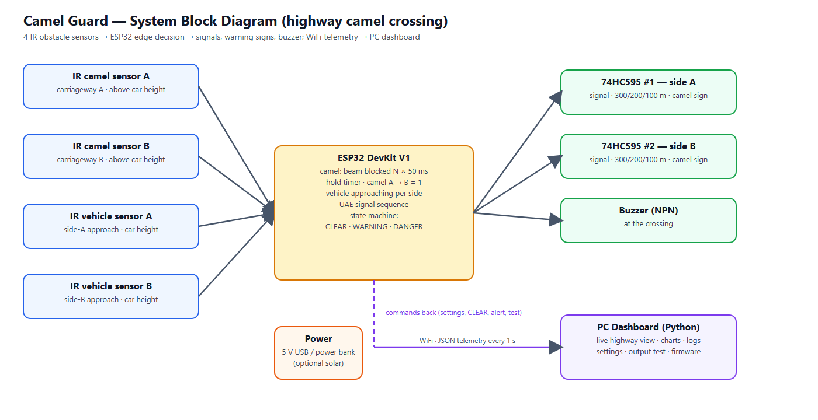
Figure 0 — System overview
Project Information
School | ATS-DHF
Supervisor | Haitham Zein
Students | 1. Mohamed Mubarak Almansoori 2. Mohammed Jumaa 3. Mansoor Abdulla 4. Ibrahim Jumaa
Project type | Miniature simulator (table-top road model) — not a field installation
Document | Full proposal: design, wiring, firmware, dashboard, budget, timeline and testing plan

Contents

(If the list above is empty, right-click it in Word and choose “Update Field”.)

1. Overview
The Engineering Capstone Project allows students to apply engineering knowledge and practical skills to solve real-world problems. This project focuses on improving road safety on UAE highways through the development of a smart warning system for camel crossings.
Because the project is a school capstone, the system is built and demonstrated as a miniature simulator: a table-top desert highway model with toy camels and toy cars. There are no pedestrians on a highway, so the system concentrates entirely on camels. The electronics, firmware and dashboard are real and complete; only the scale of the road is reduced. Everything in this proposal — sensor positions, timings and tests — is therefore specified for the model. The warning signs at 300, 200 and 100 m are placed in the correct order but not to scale.

2. Project Title and Description
Title: Advanced Camel Crossing Hazard Detection & Highway Safety System (“Camel Guard”).
The system watches a camel crossing on a divided highway and warns drivers automatically. An ESP32 microcontroller reads four infrared (IR) obstacle sensors with a simple digital output. Two camel sensors, one per carriageway at the crossing, are mounted above the roof height of the cars and look across the carriageway: a camel breaks the beam, while cars pass underneath. While a camel is crossing, advance warning signs 300 m, 200 m and 100 m before the crossing flash in both directions, the camel-crossing sign flashes, and two traffic signals stop the traffic with the UAE sequence: solid green, flashing green for 3 seconds, amber for 3 seconds, then red. Two further IR sensors, one on each approach at car height, detect approaching vehicles; when a vehicle approaches while a camel is on the road, the system escalates to DANGER: the warning signs flash fast and a buzzer at the crossing warns the camel herder.
All decisions are made on the ESP32 itself, so the warnings keep working without WiFi. In addition, the ESP32 sends its data every second to a PC dashboard that shows a live animated view of the road, charts, a hazard history, a vehicle log and a settings page from which every setting can be changed without re-programming the board.

3. Problem Statement
On UAE highways camels may cross unexpectedly, especially at night and in low visibility. Collisions with camels are particularly severe because of the animal’s height and weight: at highway speed the body strikes the windscreen of a car. Drivers need time to slow down, but traditional warning signs are static — they are always shown, so drivers become used to them, and they give no information about whether a camel is actually on the road right now. There is a need for a smart, automated system that detects a camel at the crossing, warns approaching drivers early enough (hundreds of metres before the crossing) only when it matters, stops the traffic, and records what happened so the road authority can see how often and when camels cross.

4. Abstract
The Camel Guard system is an embedded IoT prototype designed to improve safety at camel crossings on UAE highways. It is demonstrated on a 150 × 60 cm miniature highway model. Four low-cost IR obstacle sensors with digital outputs do all the sensing: one camel sensor per carriageway, mounted above car height so that only a camel can break its beam, and one vehicle sensor on each approach. Confirmation readings and a hold timer make the camel detection stable and reject short interruptions. An ESP32 runs a four-state machine (WARMUP, CLEAR, WARNING, DANGER) and drives, through two chained 74HC595 shift registers (one per direction), six advance warning signs at 300 / 200 / 100 m (both directions) that flash while a camel is crossing, the camel-crossing sign and two traffic signals that follow the UAE sequence green → flashing green (3 s) → amber (3 s) → red — plus a buzzer at the crossing.
The ESP32 sends JSON telemetry over WiFi to a local Python dashboard that provides a live road view, charts, event and hazard logs, a vehicle log per direction, remote configuration stored in the ESP32’s flash, output tests, multi-crossing overview and firmware tools. A software simulator reproduces the firmware logic so the dashboard can be developed and demonstrated without hardware. The expected outcome is a reliable, low-cost and energy-efficient smart-road demonstrator that shows how sensing, embedded decision making and IoT monitoring can reduce accident risk and support the UAE’s smart-city initiatives.

5. Background Research
Camel-related road accidents are a known problem on desert highways in the UAE and the wider Gulf region. Current countermeasures are fences along highways, designated camel crossings with static signs, and awareness campaigns. Fences guide animals to crossings, which makes the crossing points the right place for active detection. At highway speed a driver needs several hundred metres to slow down safely, which is why this system warns with flashing signs at 300, 200 and 100 m before the crossing.

5.1 Detection technologies considered
Technology | Strengths | Limitations | Use in this project
IR obstacle sensor (FC-51) | Cheap, fast, simple digital output, adjustable range, 3.3 V | Short range (2–30 cm); affected by strong sunlight and dark surfaces | All four sensors: camel per carriageway (mounted high), vehicle per approach
Ultrasonic (HC-SR04) | Measures distance / height | Needs calibration, 5 V echo divider, slower; sensors can hear each other | Not used — IR is simpler for the model
PIR (passive infrared) | Cheap, low power, wide angle | Weak when the ground is near body temperature (desert summer); cannot tell a camel from a person | Not used
Radar / LiDAR | Long range, all weather | Costly, complex | Future work (real road)
AI camera | Can recognise animals | Needs computing power, privacy, night lighting | Out of scope (future work)

Microcontroller: the ESP32 was chosen instead of the Arduino Uno used in the first draft because it has built-in WiFi (needed for the dashboard), two processor cores (sensing on one core, networking on the other), more memory, a 12-bit ADC and flash storage for settings — at a similar cost.

6. Aims and Objectives
Aim: to design, build and test a miniature smart highway-safety system that detects camels at a camel crossing and warns drivers automatically from 300 m before the crossing, with remote monitoring.
- Detect a camel figure on either carriageway of the crossing in at least 90 % of trials, and never detect a passing car or a short interruption as a camel.
- Flash all six advance warning signs (300 / 200 / 100 m, both directions) within 0.5 s of a camel entering the crossing.
- Stop the traffic for every hazard with the UAE signal sequence (green → flashing green 3 s → amber 3 s → red), never skipping a phase.
- Detect an approaching vehicle and escalate to DANGER (fast-flashing signs + buzzer) within 0.3 s.
- Count every vehicle passing a vehicle sensor on the correct side (at least 95 % of trials) and log the vehicles that approached during a hazard.
- Keep all warnings working when WiFi or the PC is unavailable (edge decision on the ESP32).
- Provide a dashboard with live view, logs, history and remote settings, updated every second.
- Complete the project within 12 weeks and within the budget in Section 11.

7. Project Scope

7.1 Included
- A working miniature highway model (about 1:24 scale) with one camel crossing, camel-sensor posts, two traffic signals, the camel-crossing sign and six advance warning signs.
- Electronics: ESP32, 4 IR obstacle sensors (2 camel, 2 vehicle), two 74HC595 (one per direction, 7 LED outputs each) and a buzzer.
- Firmware with detection, state machine, WiFi telemetry, settings in flash, setup access point and USB configuration.
- PC dashboard (Python, runs on the school laptop) and a simulator for testing without hardware.
- Wiring diagram, testing plan with results, report, poster and demonstration.

7.2 Not included
- Installation on a real road, certification or approval by road authorities.
- AI camera recognition, radar or long-range sensors (listed as future improvements).
- Mobile phone notifications to drivers (future improvement).
- Vehicle speed measurement: one vehicle sensor per side detects presence and direction only (future improvement).
- Pedestrians: a highway has no pedestrian crossings, so pedestrian detection is not part of this system.

8. System Design

8.1 Block diagram
Figure 1 — System block diagram

8.2 How the camel crossing is monitored
Each carriageway has one IR obstacle sensor at the crossing. It sits on a small post at the road edge about 8 cm high — above the roof of a toy car (about 5 cm) but below the back of a toy camel (10–12 cm) — and looks across its own carriageway. Its potentiometer is set so that it sees only as far as the median. The output is digital: LOW while something is in front of the sensor.
Situation | Camel sensor beam | Result
Camel on the carriageway | blocked for ≥ 3 readings (0.15 s) | CAMEL → WARNING
Car passing | not blocked (the car passes under the beam) | ignored by the camel sensor; counted by the vehicle sensor
Hand, insect, flicker < 0.15 s | blocked briefly | ignored (confirmation)
Beam blocked for more than 2 minutes | stuck | still treated as a hazard; fault shown on the dashboard

The ESP32 reads each sensor every 50 ms. A camel is confirmed after 3 blocked readings in a row (adjustable) and is held for a hold time (default 5 s) after its beam was last blocked, so the signs do not flicker while the animal moves. A camel walking across the highway breaks beam A and then beam B; it is counted once. There is nothing to calibrate: each sensor simply says “something is here” or “nothing is here”.

8.3 State machine and outputs
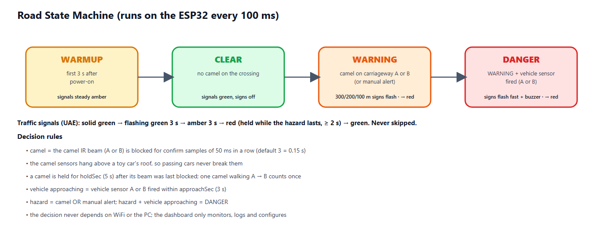
Figure 2 — Road state machine
State | Condition | Signals A & B | Warning signs | Buzzer
WARMUP | first 3 s after power-on | steady amber | off | off
CLEAR | no camel on the crossing | green | off | off
WARNING | camel on the crossing or manual alert | sequence to red (8.5) | 300/200/100 m signs + camel sign flash (1 Hz) | off
DANGER | WARNING + vehicle sensor fired within the approach time | sequence to red (8.5) | all signs flash fast (4 Hz) | fast beeps

8.4 Advance warning signs (300 / 200 / 100 m)
Drivers on a highway need time to react, so the first warning appears long before the crossing. Three warning signs stand before the crossing on each approach, 300 m, 200 m and 100 m away. Each sign shows a camel and the distance, and has two amber flasher lamps on top. While a camel is crossing, all six signs flash with the two lamps alternating (wig-wag, 1 Hz); when a vehicle is approaching the camel (DANGER) they flash fast (4 Hz). In the model the signs keep the correct order and spacing ratio but not the real distance. Each direction has its own 74HC595 with the same layout — chip #1 serves side A and chip #2 side B — so the two sides are wired identically and can be tested one after the other.
Output (both chips) | Sign | Direction | Behaviour
Q0 / Q1 / Q2 (pins 15, 1, 2) | Traffic signal red / amber / green | own direction | UAE sequence (8.5)
Q3 / Q4 / Q5 (pins 3, 4, 5) | Warning signs 300 m / 200 m / 100 m | own direction | off → flashing while a camel is crossing → fast in DANGER
Q6 (pin 6) | Camel crossing sign | at the crossing | flashing in WARNING, fast in DANGER
Q7 (pin 7) | spare | – | not connected; chip #1 Q7′ (pin 9) feeds chip #2 DS (pin 14)

8.5 Traffic signal sequence (UAE)
Whenever a hazard appears the traffic is stopped with the same sequence that UAE drivers know from normal junctions. A phase is never skipped: jumping straight to red in front of a moving car would be more dangerous than the hazard itself, so a vehicle that approaches during the sequence is handled by the fast-flashing warning signs and the buzzer instead.
Phase | Signal | Duration | Meaning
1 | Solid green | while the road is clear | Vehicles may pass
2 | Flashing green | 3 s (about 3 flashes, adjustable 1–10 s) | Early warning: the signal is about to change
3 | Amber | 3 s (adjustable 1–10 s) | Prepare to stop
4 | Red | while the hazard lasts, at least 2 s | Vehicles must stop completely
→ | Solid green | after the crossing is clear | Back to phase 1

Once the flashing green has started, the sequence always runs on to red, even if the hazard disappears in the meantime — a driver who has seen flashing green must not get green again without a red phase. Both signals (A and B) show the same aspect. The remaining seconds of each phase are shown on the dashboard.

8.6 Vehicle detection
One IR obstacle sensor stands on each approach before the crossing, at car height, looking across its own carriageway only. Every car that passes is counted for its side; a debounce of 0.3 s prevents one car from being counted twice. After a car has passed, it is treated as approaching the crossing for the approach time (default 3 s, adjustable 1–20 s) — about the time a toy car needs to reach the crossing. If a camel is on the road during that time, the state becomes DANGER. With one sensor per side the system knows that a vehicle is coming and from which side, but it does not measure speed; a second sensor per side (speed trap) is listed as a future improvement.

9. Hardware Design

9.1 Components
Component | Function | Key specification
ESP32 DevKit V1 | Main controller, WiFi | 240 MHz dual-core, 520 KB RAM, 3.3 V logic
IR obstacle sensor ×2 (camel) | Camel on carriageway A / B at the crossing | FC-51, digital OUT active LOW, 2–30 cm (pot), mounted ≈ 8 cm high
IR obstacle sensor ×2 (vehicle) | Car approaching from side A / B | FC-51, digital OUT active LOW, mounted at car height
74HC595 ×2 (chained) | one per direction: signal R/A/G, 300/200/100 m signs, camel sign | Still only 3 GPIO, 3.3 V supply
LEDs + 220 Ω | Traffic signals, camel sign, warning-sign flashers | Red, amber, green 5 mm
Active buzzer + NPN | Warns the camel herder at the crossing | 5 V, driven via 2N2222 + 1 kΩ

9.2 Pin assignment
ESP32 pin | Connected to | ESP32 pin | Connected to
GPIO 13 | IR camel sensor A — OUT | GPIO 23 | 74HC595 #1 DS (pin 14)
GPIO 14 | IR camel sensor B — OUT | GPIO 18 | 74HC595 SH_CP, pin 11 (both chips)
GPIO 32 | IR vehicle sensor A — OUT | GPIO 19 | 74HC595 ST_CP, pin 12 (both chips)
GPIO 33 | IR vehicle sensor B — OUT | GPIO 25 | Buzzer (via NPN)
3V3 / GND | VCC / GND of the 4 IR sensors and both 74HC595 | GPIO 2 | Onboard status LED
#1 Q7′ (pin 9) | → 74HC595 #2 DS (pin 14, chain) | GPIO 35 | Battery sense (optional)

9.3 Wiring diagram
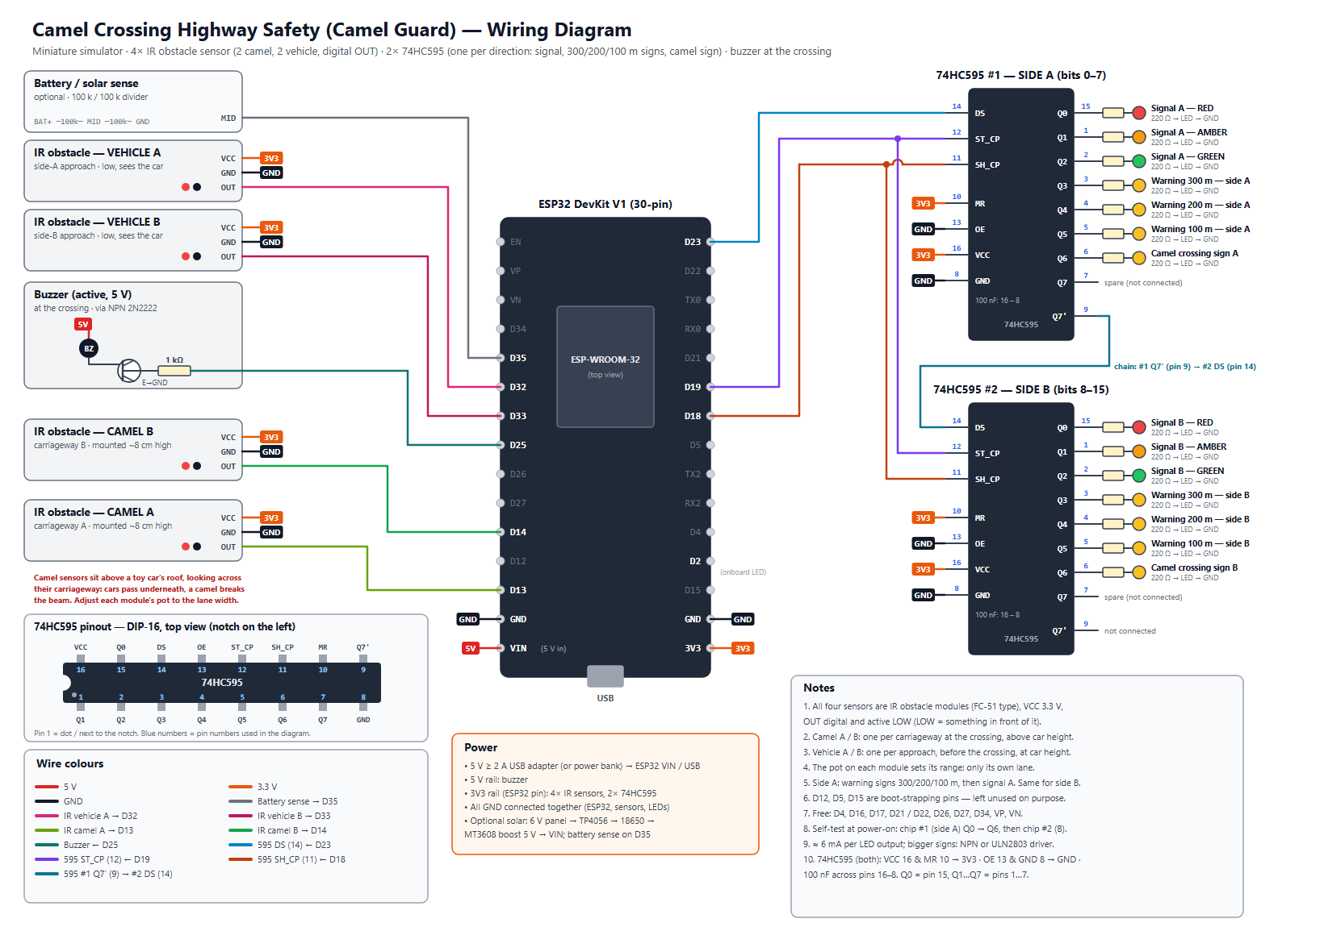
Figure 3 — Wiring diagram (docs/wiring_diagram.svg)

9.4 Miniature highway model
- Base: 150 × 60 cm MDF board, desert sand texture, divided highway: carriageway A and carriageway B with a median, about 34 cm wide in total.
- One camel crossing in the middle with a camel fence along the road that guides the camels to it; at the crossing a small post at the edge of each carriageway carries the camel IR sensor about 8 cm high, above the roofs of the toy cars.
- On each approach: warning signs 300 m, 200 m and 100 m before the crossing (evenly spaced, not to scale), then the camel-crossing sign and the traffic signal.
- One IR vehicle sensor on each approach at car height, before the crossing; a small ramp gives repeatable car runs for testing.
- Electronics box under the board; sensor wires run under the base.

10. Software Design

10.1 ESP32 firmware
- Edge decision: sensing, classification and the state machine run on core 1 every 100 ms, independent of the network.
- Telemetry: a network task on core 0 sends JSON to the dashboard every second; the reply may carry one command.
- Settings in flash (NVS): confirmation readings, hold time, approach time, signal timing, sensors fitted, device name and up to five WiFi networks survive a power cycle.
- Commands: clear, change settings, change WiFi, manual alert, output test, reboot, factory reset.
- Network recovery: finds the dashboard PC automatically by UDP broadcast; starts its own setup WiFi (CamelGuard-Setup-XXXX) if no network works; can also be configured over the USB cable.
- Safety of settings: every value is clamped to a safe range on both the PC and the ESP32, so a typing mistake cannot make the system blind.

10.2 PC dashboard
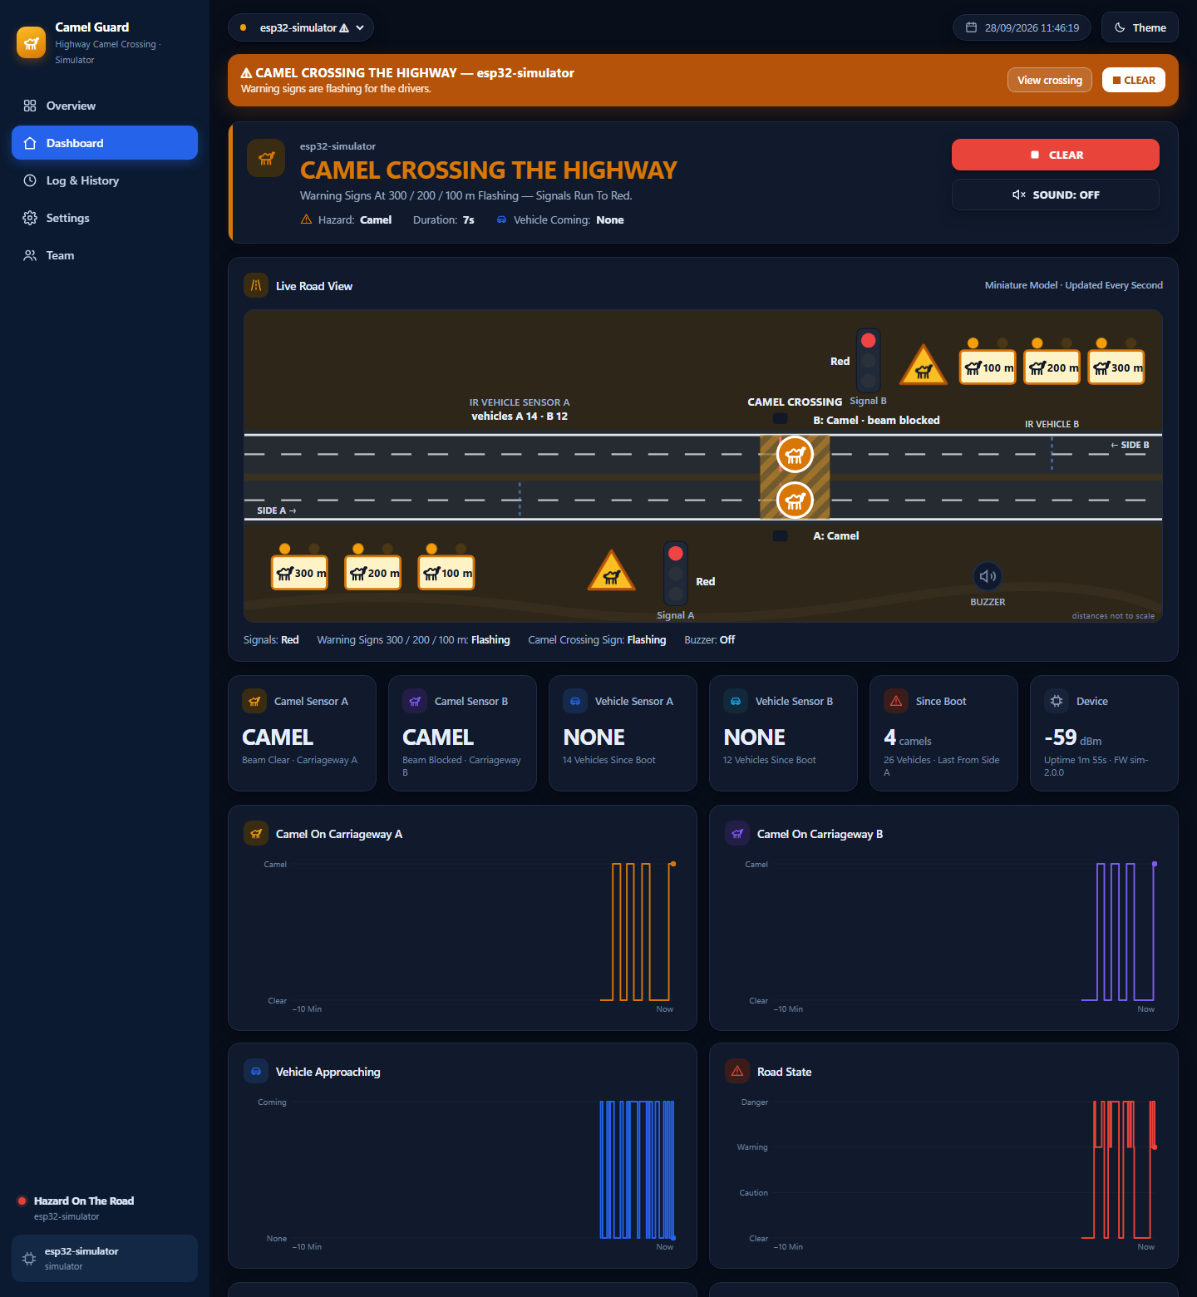
Figure 4 — Dashboard: live highway view while a camel is crossing (simulator)
- Overview: every camel crossing as a card, hazards first; CLEAR ALL and ALERT ALL; today’s camel crossings and vehicles.
- Dashboard: animated live highway view (signals, 300/200/100 m warning signs, camel sign, the four IR beams, camel per carriageway, cars from each side, buzzer), six live tiles, four 10-minute charts, “why the system decided this” and recent vehicles per side.
- Log & History: filtered event log, hazard history (duration, peak level, vehicles) and vehicle log, each exportable to CSV.
- Settings: detection (confirmation, hold time, approach time), live IR sensor view, camel sensors fitted, signal timing, WiFi, device, output test, wiring diagram, firmware compile/upload and ports.
- Team: authors and supervisor with photos.

10.3 Simulator
A Python simulator reproduces the firmware exactly (same confirmation, hold time, approach window and command handling) and plays scenarios: auto tour, clear road, camel (breaking beam A then beam B), danger (camel plus cars from both sides) and three crossings at once. It allows the dashboard to be developed and demonstrated before the hardware arrives.

11. Materials and Budget
Prices are estimates in UAE dirham (AED) from local electronics and hobby suppliers and online stores; final prices depend on the supplier.
Item | Specification / purpose | Qty | Unit (AED) | Total (AED)
ESP32 DevKit V1 (30-pin) | Dual-core 240 MHz, WiFi, 12-bit ADC | 1 | 35 | 35
IR obstacle sensor FC-51 (digital OUT) | 2 camel sensors (above car height) + 2 vehicle sensors | 4 | 6 | 24
74HC595 shift register | one per direction (chained): signal, 3 warning signs, camel sign (+1 spare) | 3 | 3 | 9
LED kit 5 mm (red/amber/green) | Traffic signals and warning signs | 1 | 12 | 12
Resistor kit (220 Ω, 1 k, 100 k) | LED limiting, buzzer transistor, battery divider | 1 | 15 | 15
Active buzzer 5 V + NPN 2N2222 | Warning at the crossing (herder) | 1 | 10 | 10
Amber LEDs 5 mm (extra) | Flashers on the 300/200/100 m warning signs | 1 | 8 | 8
5 V 2 A USB adapter + cable | ESP32 and sensors | 1 | 25 | 25
Breadboard 830 points | Prototyping | 2 | 15 | 30
Jumper wire set (M-M, M-F) | Connections | 1 | 20 | 20
Perfboard + pin headers | Final soldered circuit | 1 | 15 | 15
MDF base board 150 × 60 cm | Miniature highway base | 1 | 55 | 55
Toy camels (≈ 1:24) | Camel figures, 10–12 cm tall | 3 | 10 | 30
Warning sign boards ×6 (300/200/100 m) | Printed faces on sticks, two flasher LEDs each | 1 | 25 | 25
Toy cars (≈ 1:24–1:32) | Vehicles for the vehicle sensors | 3 | 8 | 24
Paint, sand texture, road tape, median, fence | Desert highway scenery with camel fence | 1 | 40 | 40
Sensor posts & sign boards (3D print / acrylic) | Camel-sensor posts above car height, sign faces | 1 | 35 | 35
Consumables (glue, heat-shrink, screws, tape) | Assembly | 1 | 25 | 25
Subtotal |  |  |  | 437
Contingency (10 %) | spares, shipping, price changes |  |  | 44
TOTAL (required) |  |  |  | 481

11.1 Optional: solar power kit
Item | Qty | Unit (AED) | Total (AED)
6 V 2 W solar panel | 1 | 30 | 30
TP4056 charger module | 1 | 5 | 5
18650 cell + holder | 1 | 20 | 20
MT3608 5 V boost converter | 1 | 5 | 5
Optional total |  |  | 60

Tools already available in the school workshop (not budgeted): laptop, Arduino IDE 2, soldering station, multimeter, hot-glue gun, 3D printer / laser cutter.

12. Project Timeline
Duration: 12 weeks (Term 3). Shaded cells show when each task is carried out.
Task | W1 | W2 | W3 | W4 | W5 | W6 | W7 | W8 | W9 | W10 | W11 | W12
Research, proposal & approval
System design: block diagram, schematic, BOM
Order & receive components
Sensor tests on breadboard (4× IR obstacle)
Output tests (2× 74HC595 signals, signs, buzzer)
Firmware: detection + state machine
Firmware: WiFi, telemetry, settings (NVS)
Dashboard + simulator integration
Miniature road model build
Install electronics in the model, solder board
Sensor alignment & unit / integration tests
System tests, fixes, data collection
Report, poster, demo video
Final presentation & exhibition

12.1 Milestones
Week | Milestone / deliverable
1 | Proposal approved by the supervisor
3 | All components received; bill of materials checked
4 | All sensors and outputs working on the breadboard
6 | Firmware with detection, state machine and dashboard connection
8 | Miniature road model built
10 | Integrated system aligned; unit and integration tests passed
11 | System tests passed; report and poster drafts
12 | Final presentation and exhibition demonstration

13. Testing Plan
Testing goes from single parts to the whole system: unit tests (each sensor and output), integration tests (detection with outputs) and system tests (dashboard, network, endurance), ending with an acceptance demonstration. Each test is repeated the stated number of times and recorded in the test log; a test passes only if the pass criterion is met.
ID | Level | Test | Method | Pass criterion
T-01 | Unit | IR sensor range adjustment | Adjust each module's potentiometer; hold a figure at the far edge of its lane and just beyond | Each sensor sees its own lane only; module LED and dashboard 'IR Sensors Now' agree
T-02 | Unit | Camel sensor ignores cars | Roll a toy car past camel sensor A and B, 20 times each | 0 camel detections (cars pass under the beam)
T-03 | Unit | Camel detection | Walk a camel figure across carriageway A then B, 20 times | ≥ 18/20 detected on each carriageway (≥ 90 %); counted once per crossing
T-04 | Unit | Warning signs 300/200/100 m | Place a camel on the crossing 10 times; watch all six signs | All six flash (wig-wag) within 0.5 s, both directions, 10/10
T-05 | Unit | Short-interruption rejection | Pass a hand or thin stick quickly (< 0.15 s) through a camel beam, 10 times | No warning (shorter than the confirmation time)
T-06 | Unit | Vehicle counting | Roll a car past vehicle sensor A 20 times, then past B 20 times | 20/20 counted on the correct side, no double counts
T-07 | Unit | Stuck-sensor fault | Block camel beam A with tape for more than 2 minutes | Fault IR-CAMEL-A shown on the dashboard; clears when the beam is free
T-08 | Unit | Sensor disabled | Settings → Camel Sensors Fitted: switch B off, then block beam B | No warning from B; sensor A still works
T-09 | Unit | Camel on one carriageway only | Stand the camel only in beam B, 10 times | WARNING every time; dashboard shows carriageway B
T-10 | Unit | Outputs | Settings → Output Test: buzzer, signals, signs | Each output works; test stops after the set time
T-11 | Integration | Detection latency | Place a camel figure; timestamp video of sign LED | Sign flashing ≤ 0.5 s after placement
T-12 | Integration | DANGER escalation | Camel on the road, then roll a car past vehicle sensor A, then B | Fast signs + buzzer ≤ 0.3 s after the sensor fires, both sides
T-13 | Integration | Signal sequence timing | Place a camel 10 times; film signal A and B | Green → flashing green 3 s ± 0.2 → amber 3 s ± 0.2 → red; never skipped, A = B
T-14 | Integration | Hold & clear | Remove the figure and time the return to CLEAR | Clear after hold time ±0.5 s; red ≥ 2 s then green; no flicker
T-15 | Integration | Approach window | Camel on the road; one car passes a vehicle sensor; time the DANGER state | DANGER for the approach time (3 s) ±0.3 s, then back to WARNING
T-16 | System | Works without WiFi | Switch the WiFi off, repeat T-03 and T-12 | Local warnings still work; dashboard shows OFFLINE
T-17 | System | Dashboard telemetry | Compare dashboard with serial monitor for 10 min | ≤ 2 s delay; no missing hazard in the log
T-18 | System | Settings from the dashboard | Change confirmation, hold time, approach time and signal timing | Applied on the ESP32 and confirmed ('Applied')
T-19 | System | Manual alert (all crossings) | Overview → ALERT ALL, then STOP ALERT | All online crossings warn within 2 s and stop
T-20 | System | Endurance | Run the model for 2 hours with random scenarios | No reset, no false DANGER, log complete
T-21 | Acceptance | Full demonstration | Scripted demo: clear → camel A → B → car from side A → car from side B → clear | All states shown correctly on model and dashboard

13.1 Test equipment
- Ruler, stopwatch and a phone with slow-motion video (240 fps) for timing checks.
- Serial Monitor (115200 baud) and the dashboard event log for time stamps.
- A ramp for repeatable toy-car runs, a small screwdriver for the IR potentiometers and masking tape to block a beam.

13.2 Test record (template)
Test ID | Date | Trials | Passed | Result / measured value | Pass? | Tester
T-03 |  | 20
T-06 |  | 40

14. Safety Considerations
- Low voltage only: one 5 V USB supply for all electronics; no mains or 12 V parts.
- All IR sensors and both shift registers run from 3.3 V, so every ESP32 input stays at its own 3.3 V logic level.
- All wires insulated, no exposed connections; the final circuit is soldered on perfboard inside an enclosure under the model.
- Hot-glue gun, soldering iron and cutting tools used only with teacher supervision and eye protection.
- The system is a demonstrator: it must not be installed on a real road without professional engineering and authority approval.

14.1 Risk assessment
Risk | Likelihood | Mitigation
A passing car triggers a camel sensor | Medium | Camel sensors mounted above toy-car roof height; checked by test T-02
IR sensors disturbed by sunlight or shiny / dark surfaces | Medium | Indoor demo; matt road surface; small shield tube on each module; adjust the pot
Short false triggers (hand, insect, flicker) | Low | Confirmation readings (3 × 50 ms) on camel sensors, 0.3 s debounce on vehicle sensors
A sensor fails or stays blocked | Low | Stuck-beam fault on the dashboard after 2 min; each camel sensor can be disabled
A camel standing still between the two beams is not seen | Medium | Beams in the middle of each carriageway; 5 s hold time; figures walked across in demos
Component delivery delay | Medium | Order in week 2; simulator allows firmware/dashboard work meanwhile
School WiFi (Enterprise) cannot be used by the ESP32 | High | Phone hotspot / router; ESP32 works fully offline

15. Advanced Innovative Features
- Advance warning at 300 / 200 / 100 m: six signs flash in both directions while a camel is crossing, so drivers slow down early.
- Detection per carriageway: one IR sensor per carriageway, mounted above car height, follows the camel across the highway and never mistakes a car for a camel.
- UAE signal sequence: every hazard stops the traffic with green → flashing green → amber → red, exactly as drivers know it.
- Vehicle-aware escalation: warnings become DANGER (fast-flashing signs, buzzer) only when a vehicle is really approaching.
- Simple, robust sensing: four identical low-cost digital IR sensors — nothing to calibrate, with stuck-sensor fault detection.
- Edge decision + IoT dashboard: works without WiFi; live road view, history and remote settings when connected.
- Several crossings: one dashboard monitors many crossings and can alert all of them at once.
- Low power & solar ready: about 1 W total; optional solar/battery supply with voltage monitoring.

16. Expected Outcomes
- A working miniature smart highway that detects camels at the crossing and warns drivers automatically from 300 m before it.
- Measured results for detection accuracy, detection latency and vehicle counting (Section 13).
- A dashboard showing live status, history and vehicle statistics that a road authority could use.
- Documentation: wiring diagram, source code, test results, report and poster.

17. Limitations
- IR obstacle sensors reach only about 30 cm, which suits the model; a real highway needs radar, LiDAR or thermal cameras.
- A camel sensor reacts to anything taller than a car in its beam (for example a truck or a person); it cannot classify what blocked it.
- With one vehicle sensor per side the system knows that a vehicle is coming, but not its speed.
- Strong sunlight and dark or shiny surfaces affect IR sensors, so the model is demonstrated under room lighting.

18. Future Improvements
- AI camera recognition of camels (edge AI) combined with the IR sensors.
- A second IR sensor on each approach to measure vehicle speed and log speeding during a hazard.
- Mobile warnings to nearby drivers and navigation apps; connection to smart road / V2X systems.
- Radar or thermal sensing for real road distances; solar-powered roadside unit.
- Variable message sign showing distance to the hazard and the advised speed.

19. Team Roles
Student | Main responsibility | Shared tasks
Mohamed Mubarak Almansoori | Project leader, hardware design and wiring | Testing, report
Mohammed Jumaa | Firmware (ESP32) and sensor alignment | Testing, presentation
Mansoor Abdulla | Miniature road model and mechanical parts | Poster, video
Ibrahim Jumaa | Dashboard, simulator and data analysis | Testing, report
Roles are a proposal and can be changed by the team with the supervisor.

20. References
- Espressif Systems — ESP32 Series Datasheet and ESP32 Technical Reference Manual.
- FC-51 IR obstacle avoidance sensor module (LM393 comparator) — datasheet.
- 74HC595 8-bit serial-in / parallel-out shift register — datasheet (Texas Instruments / Nexperia).
- Arduino-ESP32 core documentation (WiFi, Preferences, HTTPClient, WebServer).
- ATS Electrical Engineering Capstone Project Workbook.

Prepared according to the ATS Electrical Engineering Capstone Project Workbook requirements.

