Electrical Engineering (ENE) Graduation Project
G11 · Term 3 · Capstone Project Proposal
Advanced Camel Crossing Hazard Detection & Highway Safety System
“Camel Guard” — an ESP32 smart-highway miniature simulator with live IoT dashboard
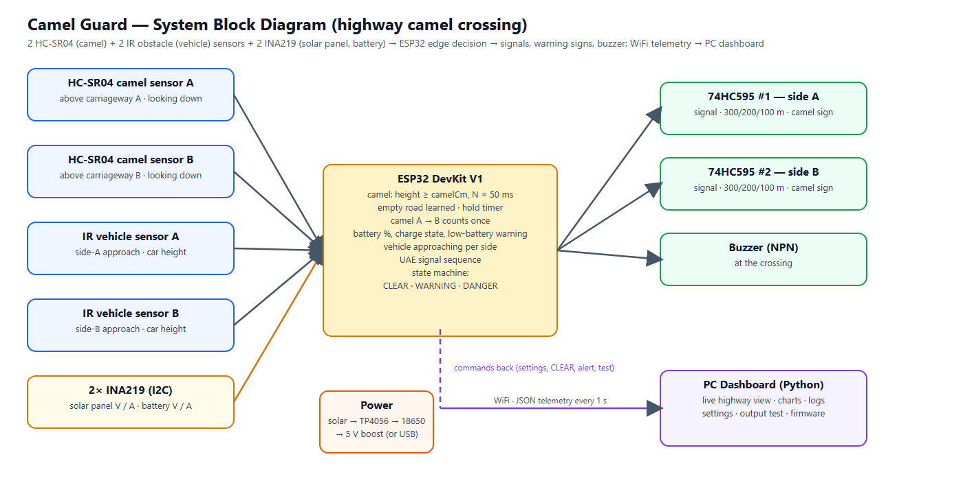
Figure 0 — System overview
Project Information
School | ATS-DHF
Supervisor | Haitham Zein
Students | 1. Mohamed Mubarak Almansoori 2. Mohammed Jumaa 3. Mansoor Abdulla 4. Ibrahim Jumaa
Project type | Miniature simulator (table-top road model) — not a field installation
Document | Full proposal: design, wiring, firmware, dashboard, budget, timeline and testing plan

Contents

(If the list above is empty, right-click it in Word and choose “Update Field”.)

1. Overview
The Engineering Capstone Project allows students to apply engineering knowledge and practical skills to solve real-world problems. This project focuses on improving road safety on UAE highways through the development of a smart warning system for camel crossings.
Because the project is a school capstone, the system is built and demonstrated as a miniature simulator: a table-top desert highway model with toy camels and toy cars. There are no pedestrians on a highway, so the system concentrates entirely on camels. The electronics, firmware and dashboard are real and complete; only the scale of the road is reduced. Everything in this proposal — sensor positions, timings and tests — is therefore specified for the model. The warning signs at 300, 200 and 100 m are placed in the correct order but not to scale.

2. Project Title and Description
Title: Advanced Camel Crossing Hazard Detection & Highway Safety System (“Camel Guard”).
The system watches a camel crossing on a divided highway and warns drivers automatically. An ESP32 microcontroller measures the height of anything that enters the crossing with two ultrasonic (HC-SR04) sensors — one above each carriageway, mounted on a small gantry and looking down — and recognises a camel by its height: a toy car or another small object is lower than the camel limit and is ignored. While a camel is crossing, advance warning signs 300 m, 200 m and 100 m before the crossing flash in both directions, the camel-crossing sign flashes, and two traffic signals stop the traffic with the UAE sequence: solid green, flashing green for 3 seconds, amber for 3 seconds, then red. Two infrared (IR) obstacle sensors, one on each approach at car height, detect approaching vehicles; when a vehicle approaches while a camel is on the road, the system escalates to DANGER: the warning signs flash fast and a buzzer at the crossing warns the camel herder.
All decisions are made on the ESP32 itself, so the warnings keep working without WiFi. In addition, the ESP32 sends its data every second to a PC dashboard that shows a live animated view of the road, charts, a hazard history, a vehicle log and a settings page from which every setting can be changed without re-programming the board. The model is powered by a solar panel and a battery; two INA219 sensors measure the panel and the battery, so the dashboard also shows the battery charge, the charging condition and a low-battery warning.

3. Problem Statement
On UAE highways camels may cross unexpectedly, especially at night and in low visibility. Collisions with camels are particularly severe because of the animal’s height and weight: at highway speed the body strikes the windscreen of a car. Drivers need time to slow down, but traditional warning signs are static — they are always shown, so drivers become used to them, and they give no information about whether a camel is actually on the road right now. There is a need for a smart, automated system that detects a camel at the crossing, warns approaching drivers early enough (hundreds of metres before the crossing) only when it matters, stops the traffic, and records what happened so the road authority can see how often and when camels cross.

4. Abstract
The Camel Guard system is an embedded IoT prototype designed to improve safety at camel crossings on UAE highways. It is demonstrated on a 150 × 60 cm miniature highway model. Two HC-SR04 ultrasonic sensors — one above each carriageway — measure the distance to whatever is under them; subtracting it from the empty-road distance (learned once and kept in flash memory) gives the height of the object. A height limit with confirmation readings and a hold timer recognises camels and ignores small objects such as a toy car. Two IR obstacle sensors with digital outputs, one on each approach, detect vehicles. An ESP32 runs a four-state machine (WARMUP, CLEAR, WARNING, DANGER) and drives, through two chained 74HC595 shift registers (one per direction), six advance warning signs at 300 / 200 / 100 m (both directions) that flash while a camel is crossing, the camel-crossing sign and two traffic signals that follow the UAE sequence green → flashing green (3 s) → amber (3 s) → red — plus a buzzer at the crossing. The device is powered by a solar panel and an 18650 battery; two INA219 sensors on the I2C bus measure the panel and the battery (voltage, current, charging condition).
The ESP32 sends JSON telemetry over WiFi to a local Python dashboard that provides a live road view, charts, event and hazard logs, a vehicle log per direction, remote configuration stored in the ESP32’s flash, output tests, multi-crossing overview and firmware tools. A software simulator reproduces the firmware logic so the dashboard can be developed and demonstrated without hardware. The expected outcome is a reliable, low-cost and energy-efficient smart-road demonstrator that shows how sensing, embedded decision making and IoT monitoring can reduce accident risk and support the UAE’s smart-city initiatives.

5. Background Research
Camel-related road accidents are a known problem on desert highways in the UAE and the wider Gulf region. Current countermeasures are fences along highways, designated camel crossings with static signs, and awareness campaigns. Fences guide animals to crossings, which makes the crossing points the right place for active detection. At highway speed a driver needs several hundred metres to slow down safely, which is why this system warns with flashing signs at 300, 200 and 100 m before the crossing.

5.1 Detection technologies considered
Technology | Strengths | Limitations | Use in this project
Ultrasonic (HC-SR04) | Measures distance → object height; works day and night; cheap | Range ≤ 4 m; needs the empty-road distance (calibration); ECHO is a 5 V signal | Main camel detector: one above each carriageway
IR obstacle sensor (FC-51) | Cheap, fast, simple digital output, adjustable range, 3.3 V | Short range (2–30 cm); cannot measure height; affected by strong sunlight | Vehicle sensors: one per approach
INA219 (I2C) | Measures voltage and current (0.1 mA steps with a 0.1 Ω shunt); two addresses share one bus | Shunt must be in series with the supply; up to 3.2 A | Solar panel and battery monitoring
PIR (passive infrared) | Cheap, low power, wide angle | Weak when the ground is near body temperature (desert summer); cannot measure height | Not used
Radar / LiDAR | Long range, all weather | Costly, complex | Future work (real road)
AI camera | Can recognise animals | Needs computing power, privacy, night lighting | Out of scope (future work)

Microcontroller: the ESP32 was chosen instead of the Arduino Uno used in the first draft because it has built-in WiFi (needed for the dashboard), two processor cores (sensing on one core, networking on the other), more memory, a 12-bit ADC and flash storage for settings — at a similar cost.

6. Aims and Objectives
Aim: to design, build and test a miniature smart highway-safety system that detects camels at a camel crossing and warns drivers automatically from 300 m before the crossing, with remote monitoring.
- Detect a camel figure on either carriageway of the crossing in at least 90 % of trials, and ignore objects shorter than the camel limit (for example a toy car).
- Flash all six advance warning signs (300 / 200 / 100 m, both directions) within 0.5 s of a camel entering the crossing.
- Stop the traffic for every hazard with the UAE signal sequence (green → flashing green 3 s → amber 3 s → red), never skipping a phase.
- Detect an approaching vehicle and escalate to DANGER (fast-flashing signs + buzzer) within 0.3 s.
- Count every vehicle passing a vehicle sensor on the correct side (at least 95 % of trials) and log the vehicles that approached during a hazard.
- Measure the solar panel and the battery (voltage, current, charging condition) and warn on the dashboard when the battery is low.
- Keep all warnings working when WiFi or the PC is unavailable (edge decision on the ESP32).
- Provide a dashboard with live view, logs, history and remote settings, updated every second.
- Complete the project within 12 weeks and within the budget in Section 11.

7. Project Scope

7.1 Included
- A working miniature highway model (about 1:24 scale) with one camel crossing, a gantry over it, two traffic signals, the camel-crossing sign and six advance warning signs.
- Electronics: ESP32, 2 HC-SR04 ultrasonic sensors (camel), 2 IR obstacle sensors (vehicle), two 74HC595 (one per direction, 7 LED outputs each) and a buzzer.
- Power: solar panel, TP4056 charger with protection, 18650 battery, MT3608 boost converter and two INA219 monitors (I2C).
- Firmware with detection, state machine, WiFi telemetry, settings in flash, setup access point and USB configuration.
- PC dashboard (Python, runs on the school laptop) and a simulator for testing without hardware.
- Wiring diagram, testing plan with results, report, poster and demonstration.

7.2 Not included
- Installation on a real road, certification or approval by road authorities.
- AI camera recognition, radar or long-range sensors (listed as future improvements).
- Mobile phone notifications to drivers (future improvement).
- Vehicle speed measurement: one vehicle sensor per side detects presence and direction only (future improvement).
- Pedestrians: a highway has no pedestrian crossings, so pedestrian detection is not part of this system.

8. System Design

8.1 Block diagram
Figure 1 — System block diagram

8.2 How the camel crossing is monitored
A small gantry about 20 cm above the model road carries two ultrasonic sensors, one above each carriageway, both looking straight down. When the road is empty the distance equals the empty-road value that the system learns once (automatically at the first start, later with the Calibrate button on the dashboard) and keeps in flash memory. When an object stands under a sensor the distance becomes shorter, and the difference is the height of the object:
object height = empty-road distance − measured distance
Measured height (model) | Class | Confirmation | Real-world meaning (1:24)
≥ 8 cm (adjustable) | CAMEL | 3 readings in a row (0.15 s) | ≈ 1.9 m and taller — camel
< 8 cm | ignored | – | toy car (≈ 5 cm), small animal, debris, noise

A camel walking across the highway is seen first on one carriageway and then on the other; it is counted once. A detection is held for a hold time (default 5 s) after the camel was last seen, so the signs do not flicker while the animal moves. Each sensor is read every 50 ms (the two sensors take turns, 25 ms apart, so they cannot hear each other) and the echo is timed by an interrupt, so the program never waits for it. A median filter of three readings removes single wrong echoes. The dashboard shows a sensor fault if a sensor receives no echo for one second (US), if the empty road was never learned (CAL) or if an object stays under a sensor for two minutes (OBJ).

8.3 State machine and outputs
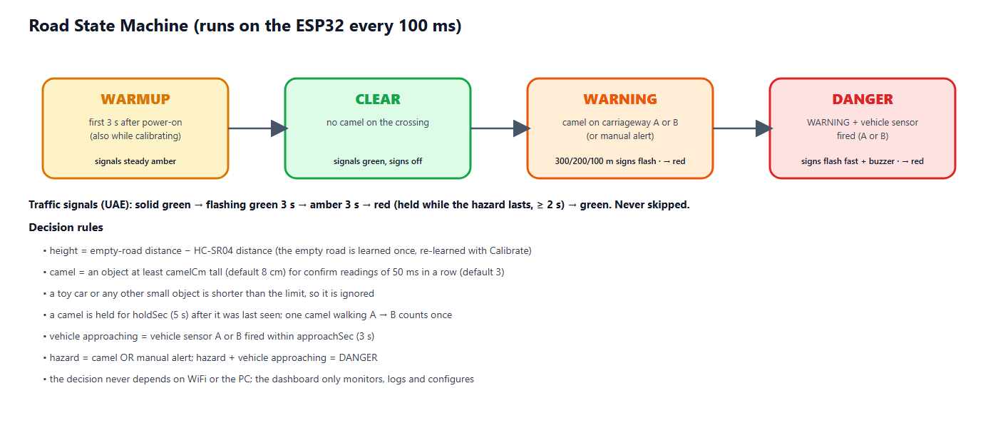
Figure 2 — Road state machine
State | Condition | Signals A & B | Warning signs | Buzzer
WARMUP | first 3 s after power-on, and while learning the empty road | steady amber | off | off
CLEAR | no camel on the crossing | green | off | off
WARNING | camel on the crossing or manual alert | sequence to red (8.5) | 300/200/100 m signs + camel sign flash (1 Hz) | off
DANGER | WARNING + vehicle sensor fired within the approach time | sequence to red (8.5) | all signs flash fast (4 Hz) | fast beeps

8.4 Advance warning signs (300 / 200 / 100 m)
Drivers on a highway need time to react, so the first warning appears long before the crossing. Three warning signs stand before the crossing on each approach, 300 m, 200 m and 100 m away. Each sign shows a camel and the distance, and has two amber flasher lamps on top. While a camel is crossing, all six signs flash with the two lamps alternating (wig-wag, 1 Hz); when a vehicle is approaching the camel (DANGER) they flash fast (4 Hz). In the model the signs keep the correct order and spacing ratio but not the real distance. Each direction has its own 74HC595 with the same layout — chip #1 serves side A and chip #2 side B — so the two sides are wired identically and can be tested one after the other.
Output (both chips) | Sign | Direction | Behaviour
Q0 / Q1 / Q2 (pins 15, 1, 2) | Traffic signal red / amber / green | own direction | UAE sequence (8.5)
Q3 / Q4 / Q5 (pins 3, 4, 5) | Warning signs 300 m / 200 m / 100 m | own direction | off → flashing while a camel is crossing → fast in DANGER
Q6 (pin 6) | Camel crossing sign | at the crossing | flashing in WARNING, fast in DANGER
Q7 (pin 7) | spare | – | not connected; chip #1 Q7′ (pin 9) feeds chip #2 DS (pin 14)

8.5 Traffic signal sequence (UAE)
Whenever a hazard appears the traffic is stopped with the same sequence that UAE drivers know from normal junctions. A phase is never skipped: jumping straight to red in front of a moving car would be more dangerous than the hazard itself, so a vehicle that approaches during the sequence is handled by the fast-flashing warning signs and the buzzer instead.
Phase | Signal | Duration | Meaning
1 | Solid green | while the road is clear | Vehicles may pass
2 | Flashing green | 3 s (about 3 flashes, adjustable 1–10 s) | Early warning: the signal is about to change
3 | Amber | 3 s (adjustable 1–10 s) | Prepare to stop
4 | Red | while the hazard lasts, at least 2 s | Vehicles must stop completely
→ | Solid green | after the crossing is clear | Back to phase 1

Once the flashing green has started, the sequence always runs on to red, even if the hazard disappears in the meantime — a driver who has seen flashing green must not get green again without a red phase. Both signals (A and B) show the same aspect. The remaining seconds of each phase are shown on the dashboard.

8.6 Vehicle detection
One IR obstacle sensor stands on each approach before the crossing, at car height, looking across its own carriageway only. Every car that passes is counted for its side; a debounce of 0.3 s prevents one car from being counted twice. After a car has passed, it is treated as approaching the crossing for the approach time (default 3 s, adjustable 1–20 s) — about the time a toy car needs to reach the crossing. If a camel is on the road during that time, the state becomes DANGER. With one sensor per side the system knows that a vehicle is coming and from which side, but it does not measure speed; a second sensor per side (speed trap) is listed as a future improvement.

8.7 Power supply and battery monitoring
The miniature highway runs from a small solar panel and a Li-ion battery; a USB adapter serves as bench supply and backup. The panel charges the 18650 cell through a TP4056 module that has a protection circuit, and an MT3608 boost converter turns the battery voltage into the 5.1 V that the ESP32, the HC-SR04 sensors and the buzzer need. Two INA219 modules measure the system over the I2C bus (two wires, SDA and SCL, shared by both): INA219 #1 sits between the panel and the charger and gives the panel voltage and current; INA219 #2 sits between the battery node and the cell and gives the battery voltage and the current into (+) or out of (−) the cell.
State shown | Condition measured | Meaning
Charging | battery current > +20 mA | the panel charges the battery
Full | battery ≥ 4.10 V and almost no current | the TP4056 has finished charging
On battery | battery current < −20 mA | no sun: the battery supplies the system
Idle | none of the above | for example a USB supply or a balanced load
Battery low | battery below 3.45 V (until 3.60 V) | warning on the dashboard and in the log
No power tiles | no INA219 answers at power-on | USB-powered device: not fitted, no fault

The battery charge is estimated from the cell voltage (3.30 V ≈ 0 %, 4.20 V = 100 %); under load the voltage sags, so the value is approximate. The ESP32 reads both sensors every 250 ms and smooths the values. A module that is not fitted is simply skipped, so the same firmware also runs on a USB-powered device; a module that answered once and then stops raises a sensor fault (INA-S or INA-B).
Power budget (an estimate, to be confirmed in test T-25): the electronics draw about 1 W (≈ 200 mA at 5 V). A 2600 mAh cell holds about 9.6 Wh, which gives roughly 8 hours without sun after the boost-converter losses. A 6 V / 2 W panel in full light delivers up to about 330 mA at 6 V, enough to run the system and charge the cell.

9. Hardware Design

9.1 Components
Component | Function | Key specification
ESP32 DevKit V1 | Main controller, WiFi | 240 MHz dual-core, 520 KB RAM, 3.3 V logic
HC-SR04 ultrasonic ×2 (camel) | Height of what is under carriageway A / B at the crossing | 2–400 cm, 5 V, ECHO needs a 1 kΩ / 2 kΩ divider
IR obstacle sensor ×2 (vehicle) | Car approaching from side A / B | FC-51, digital OUT active LOW, mounted at car height
74HC595 ×2 (chained) | one per direction: signal R/A/G, 300/200/100 m signs, camel sign | Still only 3 GPIO, 3.3 V supply
LEDs + 220 Ω | Traffic signals, camel sign, warning-sign flashers | Red, amber, green 5 mm
Active buzzer + NPN | Warns the camel herder at the crossing | 5 V, driven via 2N2222 + 1 kΩ
INA219 ×2 (I2C) | #1 solar panel, #2 battery: voltage and current | 26 V / 3.2 A, 0.1 Ω shunt, addresses 0x40 and 0x41, 3.3 V
Solar panel + TP4056 + 18650 | Daylight charging with battery protection | 6 V 2 W panel, 1 A charger, ≈ 2600 mAh cell
MT3608 boost converter | Battery 3.7 V → 5.1 V supply | up to 2 A, set to 5.1 V

9.2 Pin assignment
ESP32 pin | Connected to | ESP32 pin | Connected to
GPIO 32 | HC-SR04 A — TRIG | GPIO 23 | 74HC595 #1 DS (pin 14)
GPIO 33 | HC-SR04 A — ECHO (divider) | GPIO 18 | 74HC595 SH_CP, pin 11 (both chips)
GPIO 26 | HC-SR04 B — TRIG | GPIO 19 | 74HC595 ST_CP, pin 12 (both chips)
GPIO 27 | HC-SR04 B — ECHO (divider) | GPIO 25 | Buzzer (via NPN)
GPIO 13 | IR vehicle sensor A — OUT | GPIO 2 | Onboard status LED
GPIO 14 | IR vehicle sensor B — OUT | GPIO 21 / 22 | free
GPIO 17 | I2C SDA → INA219 #1 and #2 | GPIO 16 | I2C SCL → INA219 #1 and #2
#1 Q7′ (pin 9) | → 74HC595 #2 DS (pin 14, chain) | VIN / 3V3 | 5 V: HC-SR04, buzzer · 3.3 V: IR, 74HC595, INA219

9.3 Wiring diagram
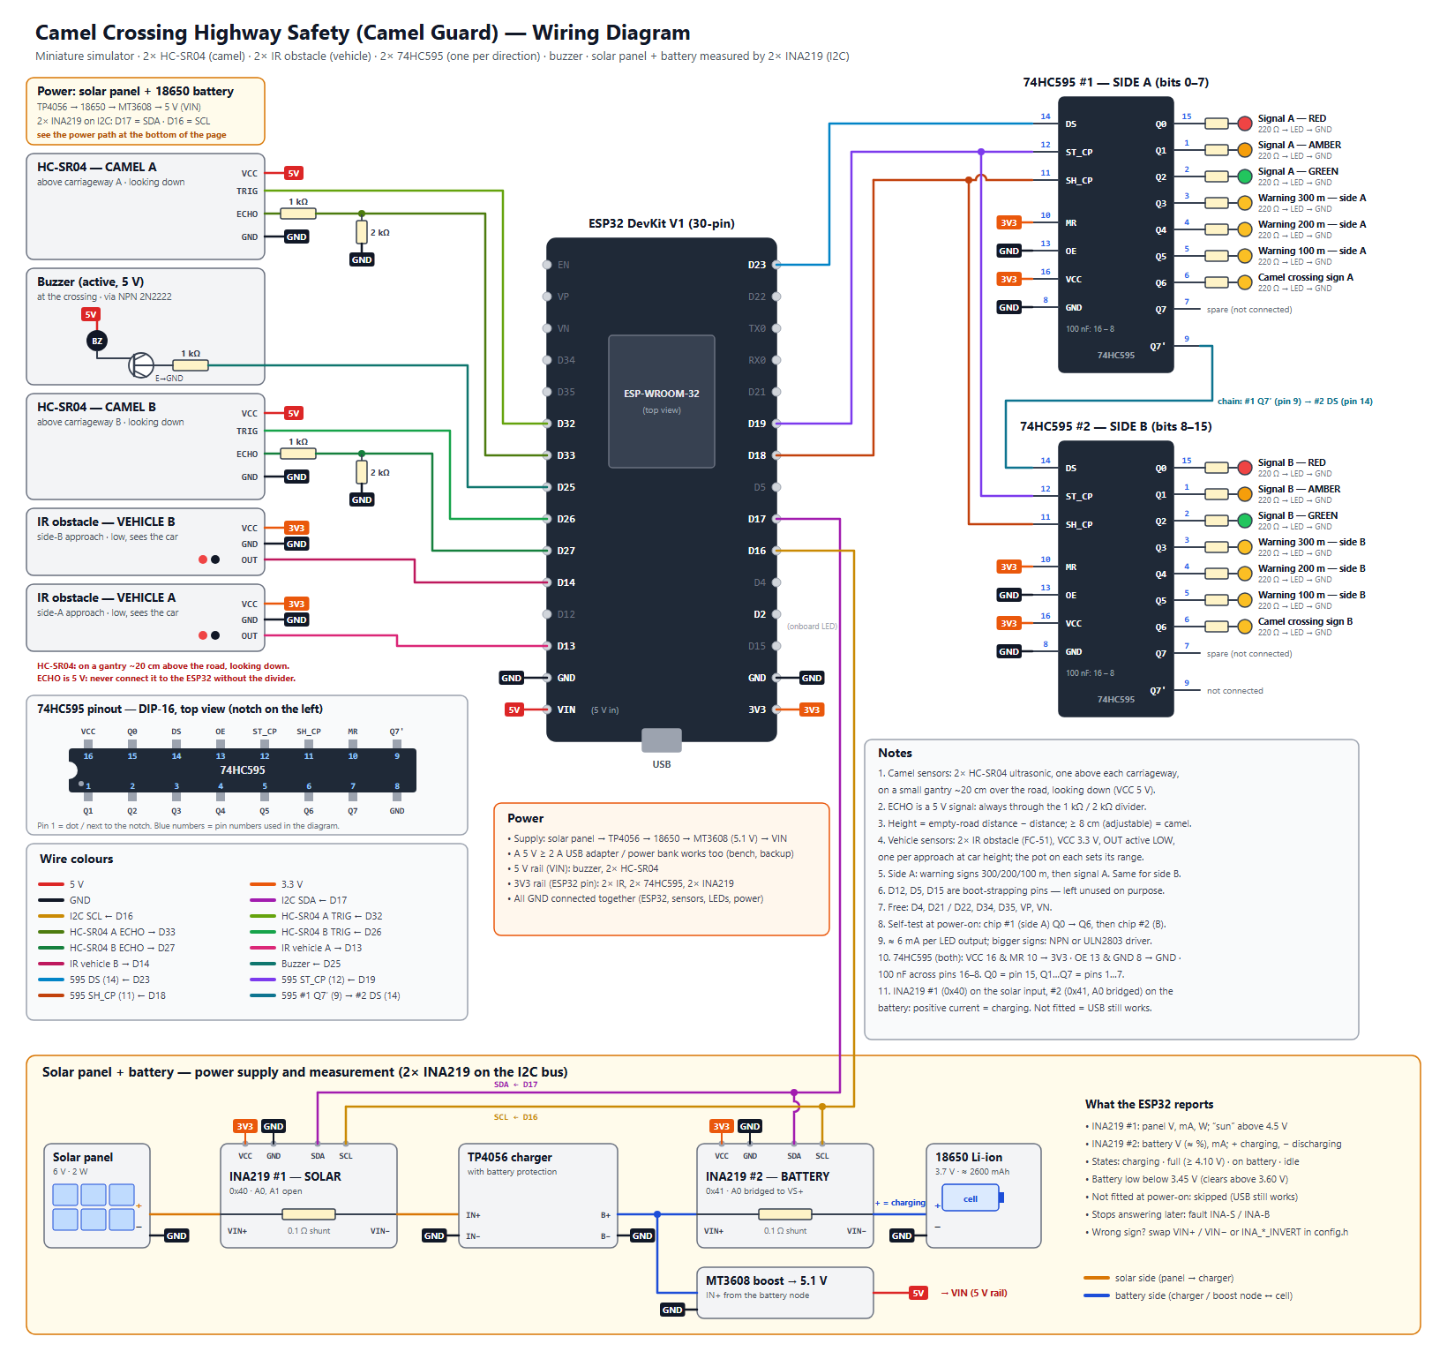
Figure 3 — Wiring diagram (docs/wiring_diagram.svg)

9.4 Miniature highway model
- Base: 150 × 60 cm MDF board, desert sand texture, divided highway: carriageway A and carriageway B with a median, about 34 cm wide in total.
- One camel crossing in the middle with a camel fence along the road that guides the camels to it; a gantry about 20 cm high carries one HC-SR04 above each carriageway, looking down.
- On each approach: warning signs 300 m, 200 m and 100 m before the crossing (evenly spaced, not to scale), then the camel-crossing sign and the traffic signal.
- One IR vehicle sensor on each approach at car height, before the crossing; a small ramp gives repeatable car runs for testing.
- Electronics box under the board; sensor wires run under the base. A small solar panel stands at the edge of the model, the battery and the power modules sit in the box.

10. Software Design

10.1 ESP32 firmware
- Edge decision: sensing, classification and the state machine run on core 1 every 100 ms, independent of the network.
- Telemetry: a network task on core 0 sends JSON to the dashboard every second; the reply may carry one command.
- Settings in flash (NVS): camel height, confirmation readings, hold time, approach time, signal timing, sensors fitted, the learned empty-road distances, device name and up to five WiFi networks survive a power cycle.
- Commands: clear, calibrate the empty road, change settings, change WiFi, manual alert, output test, reboot, factory reset.
- Network recovery: finds the dashboard PC automatically by UDP broadcast; starts its own setup WiFi (CamelGuard-Setup-XXXX) if no network works; can also be configured over the USB cable.
- Power monitoring: reads the two INA219 every 250 ms and derives the battery charge, the charging condition and a low-battery warning; works without them (USB-powered).
- Safety of settings: every value is clamped to a safe range on both the PC and the ESP32, so a typing mistake cannot make the system blind.

10.2 PC dashboard
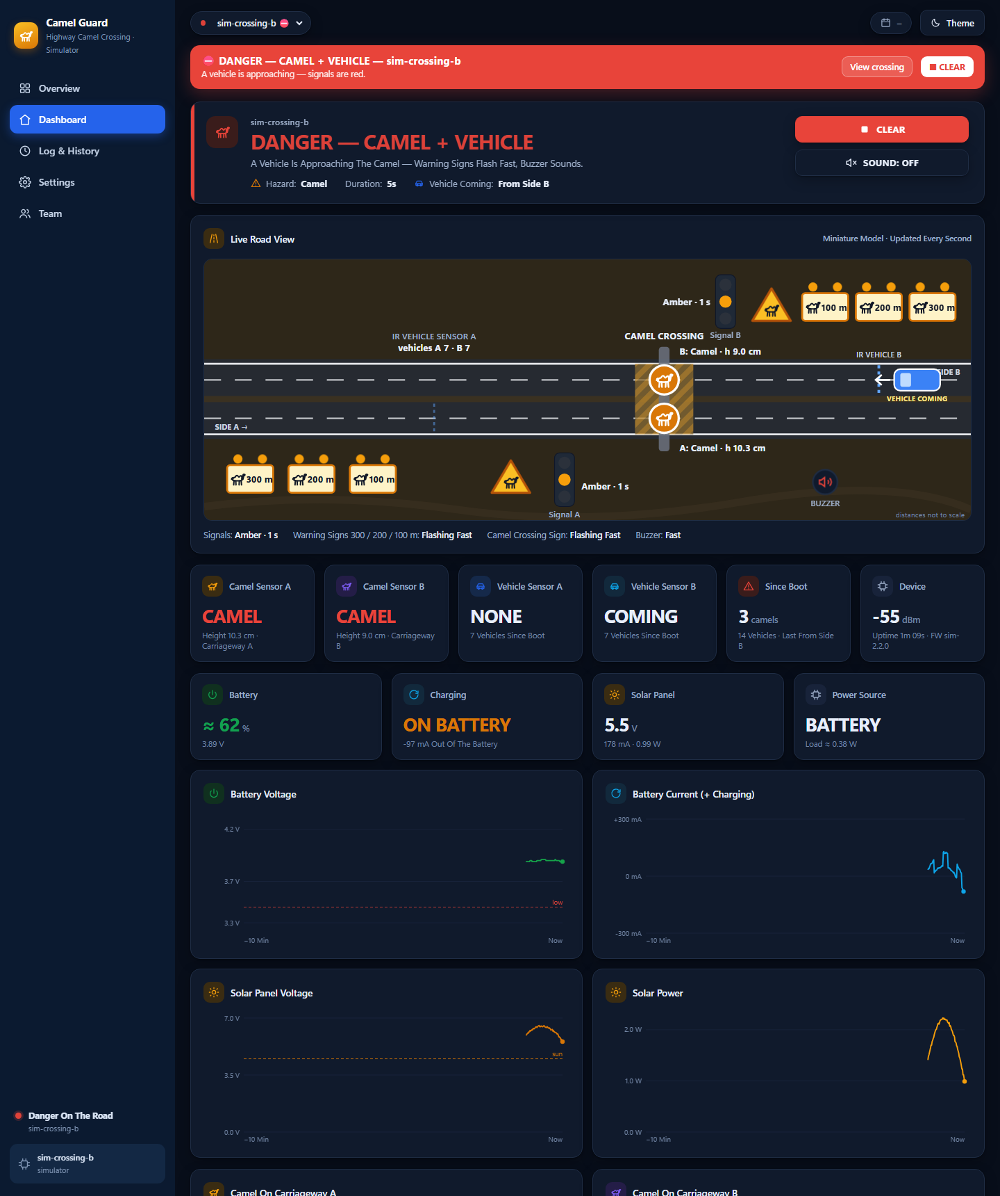
Figure 4 — Dashboard: live highway view and battery / solar monitoring (simulator)
- Overview: every camel crossing as a card, hazards first; CLEAR ALL and ALERT ALL; today’s camel crossings and vehicles.
- Dashboard: animated live highway view (signals, 300/200/100 m warning signs, camel sign, the HC-SR04 gantry with the height under each sensor, the IR vehicle beams, cars from each side, buzzer), six live tiles, four battery / solar tiles, eight 10-minute charts (four of them for the power), “why the system decided this” and recent vehicles per side.
- Log & History: filtered event log, hazard history (duration, peak level, vehicles) and vehicle log, each exportable to CSV.
- Settings: detection (camel height, confirmation, hold time, approach time), live sensor view with the empty-road Calibrate button, camel sensors fitted, signal timing, WiFi, device, output test (including each LED one by one), wiring diagram, firmware compile/upload and ports.
- Team: authors and supervisor with photos.

10.3 Simulator
A Python simulator reproduces the firmware exactly (same height calculation, empty-road calibration, confirmation, hold time, approach window and command handling) and plays scenarios: auto tour (with a small object that must be ignored), clear road, camel (walking under sensor A, then B), danger (camel plus cars from both sides) and three crossings at once. It also plays a 4-minute day / night cycle for the solar panel and the battery. It allows the dashboard to be developed and demonstrated before the hardware arrives.

11. Materials and Budget
Prices are estimates in UAE dirham (AED) from local electronics and hobby suppliers and online stores; final prices depend on the supplier.
Item | Specification / purpose | Qty | Unit (AED) | Total (AED)
ESP32 DevKit V1 (30-pin) | Dual-core 240 MHz, WiFi, 12-bit ADC | 1 | 35 | 35
Ultrasonic sensor HC-SR04 | Camel sensors: one above each carriageway, 2–400 cm, 5 V | 2 | 12 | 24
IR obstacle sensor FC-51 (digital OUT) | Vehicle sensors: one per approach, at car height | 2 | 6 | 12
74HC595 shift register | one per direction (chained): signal, 3 warning signs, camel sign (+1 spare) | 3 | 3 | 9
LED kit 5 mm (red/amber/green) | Traffic signals and warning signs | 1 | 12 | 12
Resistor kit (220 Ω, 1 k, 2 k, 100 k) | LED limiting, ECHO dividers, buzzer transistor, battery divider | 1 | 20 | 20
Active buzzer 5 V + NPN 2N2222 | Warning at the crossing (herder) | 1 | 10 | 10
Amber LEDs 5 mm (extra) | Flashers on the 300/200/100 m warning signs | 1 | 8 | 8
INA219 current / voltage sensor module (I2C) | One on the solar panel, one on the battery | 2 | 12 | 24
Solar panel 6 V 2 W | Charges the battery in daylight | 1 | 30 | 30
TP4056 charger module with battery protection | 1 A Li-ion charger, over-discharge protection | 1 | 6 | 6
18650 Li-ion cell + holder | ≈ 2600 mAh, 3.7 V | 1 | 25 | 25
MT3608 boost converter | Battery 3.7 V → 5.1 V for the ESP32, HC-SR04 and buzzer | 1 | 5 | 5
5 V 2 A USB adapter + cable | Bench supply and backup | 1 | 25 | 25
Breadboard 830 points | Prototyping | 2 | 15 | 30
Jumper wire set (M-M, M-F) | Connections | 1 | 20 | 20
Perfboard + pin headers | Final soldered circuit | 1 | 15 | 15
MDF base board 150 × 60 cm | Miniature highway base | 1 | 55 | 55
Toy camels (≈ 1:24) | Camel figures, 10–12 cm tall | 3 | 10 | 30
Warning sign boards ×6 (300/200/100 m) | Printed faces on sticks, two flasher LEDs each | 1 | 25 | 25
Toy cars (≈ 1:24–1:32) | Vehicles for the vehicle sensors | 3 | 8 | 24
Paint, sand texture, road tape, median, fence | Desert highway scenery with camel fence | 1 | 40 | 40
Gantry, sensor posts & sign boards (3D print / acrylic) | HC-SR04 gantry over the crossing, IR posts, sign faces | 1 | 40 | 40
Consumables (glue, heat-shrink, screws, tape) | Assembly | 1 | 25 | 25
Subtotal |  |  |  | 549
Contingency (10 %) | spares, shipping, price changes |  |  | 55
TOTAL (required) |  |  |  | 604

Tools already available in the school workshop (not budgeted): laptop, Arduino IDE 2, soldering station, multimeter, hot-glue gun, 3D printer / laser cutter.

12. Project Timeline
Duration: 12 weeks (Term 3). Shaded cells show when each task is carried out.
Task | W1 | W2 | W3 | W4 | W5 | W6 | W7 | W8 | W9 | W10 | W11 | W12
Research, proposal & approval
System design: block diagram, schematic, BOM
Order & receive components
Sensor tests on breadboard (HC-SR04, IR obstacle)
Output tests (2× 74HC595 signals, signs, buzzer)
Solar panel + battery build, INA219 tests
Firmware: detection + state machine
Firmware: WiFi, telemetry, settings (NVS)
Dashboard + simulator integration
Miniature road model build
Install electronics in the model, solder board
Calibration & unit / integration tests
System tests, fixes, data collection
Report, poster, demo video
Final presentation & exhibition

12.1 Milestones
Week | Milestone / deliverable
1 | Proposal approved by the supervisor
3 | All components received; bill of materials checked
4 | All sensors and outputs working on the breadboard
6 | Firmware with detection, state machine and dashboard connection
8 | Miniature road model built
10 | Integrated system calibrated; unit and integration tests passed
11 | System tests passed; report and poster drafts
12 | Final presentation and exhibition demonstration

13. Testing Plan
Testing goes from single parts to the whole system: unit tests (each sensor and output), integration tests (detection with outputs) and system tests (dashboard, network, endurance), ending with an acceptance demonstration. Each test is repeated the stated number of times and recorded in the test log; a test passes only if the pass criterion is met.
ID | Level | Test | Method | Pass criterion
T-01 | Unit | Ultrasonic distance accuracy | Hold blocks of 5, 10, 15, 20 cm under each sensor, 10 readings each (dashboard: Sensors → Sensors Now) | Height error ≤ ±1 cm on both sensors
T-02 | Unit | Empty-road calibration | Settings → Sensors → Calibrate Empty Road with the road clear; then reboot the device | Empty road A / B 18–22 cm, unchanged after the reboot; calibration refused while a hazard is active
T-03 | Unit | Camel detection | Walk a camel figure across carriageway A then B, 20 times | ≥ 18/20 detected on each carriageway (≥ 90 %); counted once per crossing
T-04 | Unit | Warning signs 300/200/100 m | Place a camel on the crossing 10 times; watch all six signs | All six flash (wig-wag) within 0.5 s, both directions, 10/10
T-05 | Unit | Small-object rejection | Roll a toy car and pass a 3–5 cm object under both sensors, 10 times each | No warning (height below the camel limit)
T-06 | Unit | Vehicle counting (IR) | Roll a car past vehicle sensor A 20 times, then past B 20 times | 20/20 counted on the correct side, no double counts
T-07 | Unit | Sensor fault detection | Unplug the ECHO wire of sensor A for 5 s; later leave an object under it for more than 2 minutes | Fault US-A within 2 s and OBJ-A after 2 min on the dashboard; both clear when fixed
T-08 | Unit | Camel height setting | Settings → Camel Height From: set 14 cm and walk the camel; set 8 cm and walk it again | 14 cm: not detected; 8 cm: detected; both changes show 'Applied'
T-09 | Unit | Camel on one carriageway only | Stand the camel only under sensor B, 10 times | WARNING every time; dashboard shows carriageway B
T-10 | Unit | Outputs | Settings → Output Test: buzzer, signals, signs, each LED one by one | Each output works; each LED lights in the order named by the dashboard; test stops after the set time
T-11 | Integration | Detection latency | Place a camel figure; timestamp video of sign LED | Sign flashing ≤ 0.5 s after placement
T-12 | Integration | DANGER escalation | Camel on the road, then roll a car past vehicle sensor A, then B | Fast signs + buzzer ≤ 0.3 s after the sensor fires, both sides
T-13 | Integration | Signal sequence timing | Place a camel 10 times; film signal A and B | Green → flashing green 3 s ± 0.2 → amber 3 s ± 0.2 → red; never skipped, A = B
T-14 | Integration | Hold & clear | Remove the figure and time the return to CLEAR | Clear after hold time ±0.5 s; red ≥ 2 s then green; no flicker
T-15 | Integration | Approach window | Camel on the road; one car passes a vehicle sensor; time the DANGER state | DANGER for the approach time (3 s) ±0.3 s, then back to WARNING
T-16 | System | Works without WiFi | Switch the WiFi off, repeat T-03 and T-12 | Local warnings still work; dashboard shows OFFLINE
T-17 | System | Dashboard telemetry | Compare dashboard with serial monitor for 10 min | ≤ 2 s delay; no missing hazard in the log
T-18 | System | Settings from the dashboard | Change camel height, confirmation, hold time, approach time and signal timing | Applied on the ESP32 and confirmed ('Applied')
T-19 | System | Manual alert (all crossings) | Overview → ALERT ALL, then STOP ALERT | All online crossings warn within 2 s and stop
T-20 | System | Endurance | Run the model for 2 hours with random scenarios | No reset, no false DANGER, log complete
T-22 | System | Power measurement (INA219) | Compare the dashboard with a multimeter: battery voltage and current, panel voltage and current | Voltage within ±0.05 V and current within ±10 % of the multimeter
T-23 | System | Charge-state detection | Panel under a lamp; then cover it; then leave the full battery in the light | Charging (+ current) in light; On battery (− current) when covered; Full at ≥ 4.10 V; changes logged
T-24 | System | Low-battery warning | Lower the battery voltage below 3.45 V (variable supply or discharge), then raise it above 3.60 V | “Battery low” on the dashboard and in the log below 3.45 V; clears above 3.60 V
T-25 | System | Battery runtime and INA fault | Run on the battery only until the low-battery warning; unplug the SDA wire of INA219 #2 | Runtime ≥ 4 h; fault INA-B within 2 s, cleared when reconnected; no INA fitted = no fault
T-21 | Acceptance | Full demonstration | Scripted demo: clear → camel A → B → car from side A → car from side B → small object → clear | All states shown correctly on model and dashboard

13.1 Test equipment
- Ruler, stopwatch and a phone with slow-motion video (240 fps) for timing checks.
- Serial Monitor (115200 baud) and the dashboard event log for time stamps.
- Blocks of known height (5, 10, 15, 20 cm) and a ruler for the ultrasonic tests, a multimeter (voltage and current) for the INA219 tests, a lamp for the solar panel, a ramp for repeatable toy-car runs, a small screwdriver for the IR potentiometers and masking tape.

13.2 Test record (template)
Test ID | Date | Trials | Passed | Result / measured value | Pass? | Tester
T-03 |  | 20
T-06 |  | 40

14. Safety Considerations
- Low voltage only: 5 V from a USB adapter, or from the battery through a boost converter; no mains or 12 V parts.
- The 18650 cell is only used with a charger module that has a protection circuit; it is never short-circuited, punctured or left charging unattended.
- The IR sensors and both shift registers run from 3.3 V; the 5 V ECHO signal of each HC-SR04 goes through a 1 kΩ / 2 kΩ divider, so every ESP32 input stays at its own 3.3 V logic level.
- All wires insulated, no exposed connections; the final circuit is soldered on perfboard inside an enclosure under the model.
- Hot-glue gun, soldering iron and cutting tools used only with teacher supervision and eye protection.
- The system is a demonstrator: it must not be installed on a real road without professional engineering and authority approval.

14.1 Risk assessment
Risk | Likelihood | Mitigation
Echoes from the gantry or road texture disturb the ultrasonic sensors | Medium | Learn the empty road with the gantry in place; median filter; confirmation readings
The two ultrasonic sensors hear each other | Medium | Sensors ping in turns, 25 ms apart (firmware)
HC-SR04 5 V ECHO damages the ESP32 input | High | 1 kΩ / 2 kΩ voltage divider on both ECHO lines, checked with a multimeter before connecting
Toy cars are taller than the camel limit, or the camel figure is too low | Medium | Camel limit adjustable on the dashboard (default 8 cm); checked by tests T-05 and T-08
The empty road is learned with something on it | Medium | Learned only at the first start or by the Calibrate button; refused during a hazard; faults CAL / OBJ are shown
IR vehicle sensors disturbed by sunlight or shiny / dark surfaces | Medium | Indoor demo; matt road surface; small shield tube on each module; adjust the pot
Li-ion cell damaged by over-discharge, over-charge or a short circuit | High | TP4056 module with protection circuit; insulated wiring; battery-low warning at 3.45 V; never leave it charging unattended
Too little light to charge the battery indoors | Medium | Use a lamp for the demo; USB adapter as backup; charge state shown on the dashboard
INA219 reads the current with the wrong sign | Low | Swap VIN+ / VIN− or set the invert flag in config.h; checked by test T-23
Component delivery delay | Medium | Order in week 2; simulator allows firmware/dashboard work meanwhile
School WiFi (Enterprise) cannot be used by the ESP32 | High | Phone hotspot / router; ESP32 works fully offline

15. Advanced Innovative Features
- Advance warning at 300 / 200 / 100 m: six signs flash in both directions while a camel is crossing, so drivers slow down early.
- Detection per carriageway: one ultrasonic sensor above each carriageway follows the camel across the highway and ignores smaller objects such as a toy car.
- UAE signal sequence: every hazard stops the traffic with green → flashing green → amber → red, exactly as drivers know it.
- Vehicle-aware escalation: warnings become DANGER (fast-flashing signs, buzzer) only when a vehicle is really approaching.
- Height classification with a stored empty road: the empty-road distance is learned once and kept in flash; one button re-learns it; sensor faults (no echo, not calibrated, object left on the road) are shown on the dashboard.
- Edge decision + IoT dashboard: works without WiFi; live road view, history and remote settings when connected.
- Several crossings: one dashboard monitors many crossings and can alert all of them at once.
- Solar powered with live monitoring: two INA219 sensors show the battery charge, the charging condition and the solar power on the dashboard and warn when the battery is low.

16. Expected Outcomes
- A working miniature smart highway that detects camels at the crossing and warns drivers automatically from 300 m before it.
- Measured results for detection accuracy, detection latency and vehicle counting (Section 13).
- A dashboard showing live status, history and vehicle statistics that a road authority could use.
- Documentation: wiring diagram, source code, test results, report and poster.

17. Limitations
- HC-SR04 range (≤ 4 m) and its 15° beam suit the model; a real highway needs radar, LiDAR or thermal cameras.
- The ultrasonic sensor sees height only: it cannot tell a camel from another object that is as tall (for example a person or a tall vehicle).
- With one vehicle sensor per side the system knows that a vehicle is coming, but not its speed.
- A 2 W panel indoors or in shade charges slowly, and the battery charge is estimated from its voltage, so the runtime is approximate.
- Soft, angled or very absorbent surfaces can give a weak echo (the sensor then reports “no echo”); IR sensors are affected by strong sunlight, so the model is demonstrated under room lighting.

18. Future Improvements
- AI camera recognition of camels (edge AI) combined with the height sensor.
- A second IR sensor on each approach to measure vehicle speed and log speeding during a hazard.
- Mobile warnings to nearby drivers and navigation apps; connection to smart road / V2X systems.
- Radar or thermal sensing for real road distances; a larger solar panel and battery for a real roadside unit.
- Variable message sign showing distance to the hazard and the advised speed.

19. Team Roles
Student | Main responsibility | Shared tasks
Mohamed Mubarak Almansoori | Project leader, hardware design and wiring | Testing, report
Mohammed Jumaa | Firmware (ESP32) and sensor calibration | Testing, presentation
Mansoor Abdulla | Miniature road model and mechanical parts | Poster, video
Ibrahim Jumaa | Dashboard, simulator and data analysis | Testing, report
Roles are a proposal and can be changed by the team with the supervisor.

20. References
- Espressif Systems — ESP32 Series Datasheet and ESP32 Technical Reference Manual.
- HC-SR04 Ultrasonic Ranging Module — user guide / datasheet.
- FC-51 IR obstacle avoidance sensor module (LM393 comparator) — datasheet.
- INA219 Zero-Drift, Bidirectional Current/Power Monitor With I2C Interface — datasheet (Texas Instruments).
- 74HC595 8-bit serial-in / parallel-out shift register — datasheet (Texas Instruments / Nexperia).
- Arduino-ESP32 core documentation (WiFi, Preferences, HTTPClient, WebServer).
- ATS Electrical Engineering Capstone Project Workbook.

Prepared according to the ATS Electrical Engineering Capstone Project Workbook requirements.

