Electrical Engineering (ENE) Graduation Project
G11 · Term 3 · Capstone Project Proposal
Advanced Camel Crossing Hazard Detection & Highway Safety System
“Camel Guard” — an ESP32 smart-highway miniature simulator with live IoT dashboard
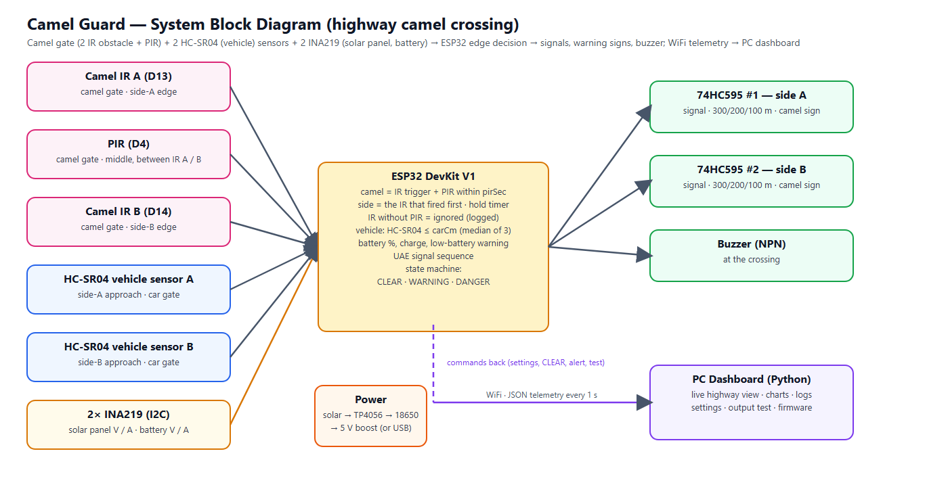
Figure 0 — System overview
Project Information
School | ATS-DHF
Supervisor | Haitham Zein
Students | 1. Mohamed Mubarak Almansoori 2. Mohammed Jumaa 3. Mansoor Abdulla 4. Ibrahim Jumaa
Project type | Miniature simulator (table-top road model) — not a field installation
Document | Full proposal: design, wiring, firmware, dashboard, budget, timeline and testing plan

Contents

(If the list above is empty, right-click it in Word and choose “Update Field”.)

1. Overview
The Engineering Capstone Project allows students to apply engineering knowledge and practical skills to solve real-world problems. This project focuses on improving road safety on UAE highways through the development of a smart warning system for camel crossings.
Because the project is a school capstone, the system is built and demonstrated as a miniature simulator: a table-top desert highway model with toy camels and toy cars. There are no pedestrians on a highway, so the system concentrates entirely on camels. The electronics, firmware and dashboard are real and complete; only the scale of the road is reduced. Everything in this proposal — sensor positions, timings and tests — is therefore specified for the model. The warning signs at 300, 200 and 100 m are placed in the correct order but not to scale.

2. Project Title and Description
Title: Advanced Camel Crossing Hazard Detection & Highway Safety System (“Camel Guard”).
The system watches a camel crossing on a divided highway and warns drivers automatically. A camel gate at the crossing has two infrared (IR) obstacle sensors — one at the side-A edge and one at the side-B edge — and a passive-infrared (PIR) motion sensor in the middle between them. An ESP32 microcontroller accepts a camel only when an IR sensor is triggered and the PIR confirms a moving animal within a short window (3 s); the IR sensor that fired first tells from which side the camel is coming, and an IR trigger without motion (a hand, a toy car, a reflection) is ignored. While a camel is crossing, advance warning signs 300 m, 200 m and 100 m before the crossing flash in both directions, the camel-crossing sign flashes, and two traffic signals stop the traffic with the UAE sequence: solid green, flashing green for 3 seconds, amber for 3 seconds, then red. Two ultrasonic (HC-SR04) sensors, one on each approach before the crossing, detect approaching vehicles by their distance; when a vehicle approaches while a camel is on the road, the system escalates to DANGER: the warning signs flash fast and a buzzer at the crossing warns the camel herder.
All decisions are made on the ESP32 itself, so the warnings keep working without WiFi. In addition, the ESP32 sends its data every second to a PC dashboard that shows a live animated view of the road, charts, a hazard history, a vehicle log and a settings page from which every setting can be changed without re-programming the board. The model is powered by a solar panel and a battery; two INA219 sensors measure the panel and the battery, so the dashboard also shows the battery charge, the charging condition and a low-battery warning.

3. Problem Statement
On UAE highways camels may cross unexpectedly, especially at night and in low visibility. Collisions with camels are particularly severe because of the animal’s height and weight: at highway speed the body strikes the windscreen of a car. Drivers need time to slow down, but traditional warning signs are static — they are always shown, so drivers become used to them, and they give no information about whether a camel is actually on the road right now. There is a need for a smart, automated system that detects a camel at the crossing, warns approaching drivers early enough (hundreds of metres before the crossing) only when it matters, stops the traffic, and records what happened so the road authority can see how often and when camels cross.

4. Abstract
The Camel Guard system is an embedded IoT prototype designed to improve safety at camel crossings on UAE highways. It is demonstrated on a 150 × 60 cm miniature highway model. A camel gate with two IR obstacle sensors (one at each edge of the crossing) and a PIR motion sensor between them recognises camels: an IR trigger must be confirmed by PIR motion within a short window, the first IR gives the direction, and a hold timer keeps the warning on while the animal crosses; IR triggers without motion are ignored and logged. Two HC-SR04 ultrasonic sensors, one on each approach, detect vehicles by their distance (median of three readings). An ESP32 runs a four-state machine (WARMUP, CLEAR, WARNING, DANGER) and drives, through two chained 74HC595 shift registers (one per direction), six advance warning signs at 300 / 200 / 100 m (both directions) that flash while a camel is crossing, the camel-crossing sign and two traffic signals that follow the UAE sequence green → flashing green (3 s) → amber (3 s) → red — plus a buzzer at the crossing. The device is powered by a solar panel and an 18650 battery; two INA219 sensors on the I2C bus measure the panel and the battery (voltage, current, charging condition).
The ESP32 sends JSON telemetry over WiFi to a local Python dashboard that provides a live road view, charts, event and hazard logs, a vehicle log per direction, remote configuration stored in the ESP32’s flash, output tests, multi-crossing overview and firmware tools. A software simulator reproduces the firmware logic so the dashboard can be developed and demonstrated without hardware. The expected outcome is a reliable, low-cost and energy-efficient smart-road demonstrator that shows how sensing, embedded decision making and IoT monitoring can reduce accident risk and support the UAE’s smart-city initiatives.

5. Background Research
Camel-related road accidents are a known problem on desert highways in the UAE and the wider Gulf region. Current countermeasures are fences along highways, designated camel crossings with static signs, and awareness campaigns. Fences guide animals to crossings, which makes the crossing points the right place for active detection. At highway speed a driver needs several hundred metres to slow down safely, which is why this system warns with flashing signs at 300, 200 and 100 m before the crossing.

5.1 Detection technologies considered
Technology | Strengths | Limitations | Use in this project
Ultrasonic (HC-SR04) | Measures distance; works day and night; cheap | Range ≤ 4 m; soft surfaces echo weakly; ECHO is a 5 V signal | Vehicle sensors: one per approach
IR obstacle sensor (FC-51) | Cheap, fast, simple digital output, adjustable range, 3.3 V | Short range (2–30 cm); reacts to any object; affected by strong sunlight | Camel gate: one at each edge (gives the direction)
INA219 (I2C) | Measures voltage and current (0.1 mA steps with a 0.1 Ω shunt); two addresses share one bus | Shunt must be in series with the supply; up to 3.2 A | Solar panel and battery monitoring
PIR (passive infrared) | Cheap, low power, wide angle; reacts only to warm moving bodies | Weak when the ground is near body temperature (desert summer); slow to reset; no position | Camel gate: confirms an IR trigger (between IR A and B)
Radar / LiDAR | Long range, all weather | Costly, complex | Future work (real road)
AI camera | Can recognise animals | Needs computing power, privacy, night lighting | Out of scope (future work)

Microcontroller: the ESP32 was chosen instead of the Arduino Uno used in the first draft because it has built-in WiFi (needed for the dashboard), two processor cores (sensing on one core, networking on the other), more memory, a 12-bit ADC and flash storage for settings — at a similar cost.

6. Aims and Objectives
Aim: to design, build and test a miniature smart highway-safety system that detects camels at a camel crossing and warns drivers automatically from 300 m before the crossing, with remote monitoring.
- Detect a camel figure crossing in either direction in at least 90 % of trials, report the side it came from, and ignore IR triggers that the PIR does not confirm (for example a hand or a toy car).
- Flash all six advance warning signs (300 / 200 / 100 m, both directions) within 0.5 s of a camel entering the crossing.
- Stop the traffic for every hazard with the UAE signal sequence (green → flashing green 3 s → amber 3 s → red), never skipping a phase.
- Detect an approaching vehicle and escalate to DANGER (fast-flashing signs + buzzer) within 0.3 s.
- Count every vehicle passing a vehicle sensor on the correct side (at least 95 % of trials) and log the vehicles that approached during a hazard.
- Measure the solar panel and the battery (voltage, current, charging condition) and warn on the dashboard when the battery is low.
- Keep all warnings working when WiFi or the PC is unavailable (edge decision on the ESP32).
- Provide a dashboard with live view, logs, history and remote settings, updated every second.
- Complete the project within 12 weeks and within the budget in Section 11.

7. Project Scope

7.1 Included
- A working miniature highway model (about 1:24 scale) with one camel crossing and its camel gate, two car-sensor gates, two traffic signals, the camel-crossing sign and six advance warning signs.
- Electronics: ESP32, a camel gate with 2 IR obstacle sensors and a PIR, 2 HC-SR04 ultrasonic sensors (vehicle), two 74HC595 (one per direction, 7 LED outputs each) and a buzzer.
- Power: solar panel, TP4056 charger with protection, 18650 battery, MT3608 boost converter and two INA219 monitors (I2C).
- Firmware with detection, state machine, WiFi telemetry, settings in flash, setup access point and USB configuration.
- PC dashboard (Python, runs on the school laptop) and a simulator for testing without hardware.
- Wiring diagram, testing plan with results, report, poster and demonstration.

7.2 Not included
- Installation on a real road, certification or approval by road authorities.
- AI camera recognition, radar or long-range sensors (listed as future improvements).
- Mobile phone notifications to drivers (future improvement).
- Vehicle speed measurement: one vehicle sensor per side detects presence and direction only (future improvement).
- Pedestrians: a highway has no pedestrian crossings, so pedestrian detection is not part of this system.

8. System Design

8.1 Block diagram
Figure 1 — System block diagram

8.2 How the camel crossing is monitored
The camel fence guides the animals into a camel gate at the crossing. IR sensor A watches the side-A edge of the crossing, IR sensor B the side-B edge, and a PIR motion sensor on the median between them sees the warm, moving body of the animal. The ESP32 reads all three every 50 ms and combines them:
camel = IR trigger (A or B) + PIR motion within the PIR window
What the sensors see | Result | Confirmation | Shown on the dashboard
IR A, then PIR motion within 3 s | CAMEL from side A | IR blocked 3 readings in a row (0.15 s) + PIR | WARNING · From Side A
IR B, then PIR motion within 3 s | CAMEL from side B | same | WARNING · From Side B
IR A or B, no PIR motion within 3 s | ignored | – | event “IR without PIR — ignored”
PIR motion only | no warning | – | PIR shown as Motion

The PIR motion may come shortly before or after the IR trigger (window adjustable 1–10 s). The IR sensor that fired first gives the direction; when the camel leaves the gate through the other IR sensor it is the same camel and is counted once. The warning is held while an IR sensor or the PIR still sees the animal and for a hold time (default 5 s) after that, so the signs do not flicker while it moves. If no PIR is fitted, the dashboard can switch it off and a single IR trigger then confirms a camel (less accurate). The dashboard shows a sensor fault if a camel IR stays blocked for two minutes (OBJ) or the PIR reports motion for two minutes (PIR).

8.3 State machine and outputs
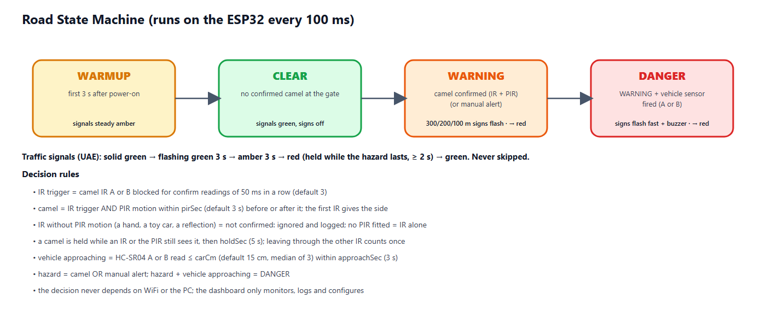
Figure 2 — Road state machine
State | Condition | Signals A & B | Warning signs | Buzzer
WARMUP | first 3 s after power-on | steady amber | off | off
CLEAR | no confirmed camel at the gate | green | off | off
WARNING | camel confirmed (IR + PIR) or manual alert | sequence to red (8.5) | 300/200/100 m signs + camel sign flash (1 Hz) | off
DANGER | WARNING + vehicle sensor fired within the approach time | sequence to red (8.5) | all signs flash fast (4 Hz) | fast beeps

8.4 Advance warning signs (300 / 200 / 100 m)
Drivers on a highway need time to react, so the first warning appears long before the crossing. Three warning signs stand before the crossing on each approach, 300 m, 200 m and 100 m away. Each sign shows a camel and the distance, and has two amber flasher lamps on top. While a camel is crossing, all six signs flash with the two lamps alternating (wig-wag, 1 Hz); when a vehicle is approaching the camel (DANGER) they flash fast (4 Hz). In the model the signs keep the correct order and spacing ratio but not the real distance. Each direction has its own 74HC595 with the same layout — chip #1 serves side A and chip #2 side B — so the two sides are wired identically and can be tested one after the other.
Output (both chips) | Sign | Direction | Behaviour
Q0 / Q1 / Q2 (pins 15, 1, 2) | Traffic signal red / amber / green | own direction | UAE sequence (8.5)
Q3 / Q4 / Q5 (pins 3, 4, 5) | Warning signs 300 m / 200 m / 100 m | own direction | off → flashing while a camel is crossing → fast in DANGER
Q6 (pin 6) | Camel crossing sign | at the crossing | flashing in WARNING, fast in DANGER
Q7 (pin 7) | spare | – | not connected; chip #1 Q7′ (pin 9) feeds chip #2 DS (pin 14)

8.5 Traffic signal sequence (UAE)
Whenever a hazard appears the traffic is stopped with the same sequence that UAE drivers know from normal junctions. A phase is never skipped: jumping straight to red in front of a moving car would be more dangerous than the hazard itself, so a vehicle that approaches during the sequence is handled by the fast-flashing warning signs and the buzzer instead.
Phase | Signal | Duration | Meaning
1 | Solid green | while the road is clear | Vehicles may pass
2 | Flashing green | 3 s (about 3 flashes, adjustable 1–10 s) | Early warning: the signal is about to change
3 | Amber | 3 s (adjustable 1–10 s) | Prepare to stop
4 | Red | while the hazard lasts, at least 2 s | Vehicles must stop completely
→ | Solid green | after the crossing is clear | Back to phase 1

Once the flashing green has started, the sequence always runs on to red, even if the hazard disappears in the meantime — a driver who has seen flashing green must not get green again without a red phase. Both signals (A and B) show the same aspect. The remaining seconds of each phase are shown on the dashboard.

8.6 Vehicle detection
One HC-SR04 ultrasonic sensor stands on each approach before the crossing, on a small car-sensor gate over its own lane, looking down. Each sensor is read every 50 ms (the two take turns, 25 ms apart, so they cannot hear each other), the echo is timed by an interrupt and a median of three readings removes single wrong echoes. A reading at or below the vehicle distance (default 15 cm, adjustable 3–150 cm; the dashboard shows the live distance) is a vehicle. Every car that passes is counted for its side; a debounce of 0.3 s prevents one car from being counted twice. If a sensor gives no echo pulse at all for one second the dashboard shows fault US; if it reports a vehicle for two minutes, fault CAR. After a car has passed, it is treated as approaching the crossing for the approach time (default 3 s, adjustable 1–20 s) — about the time a toy car needs to reach the crossing. If a camel is on the road during that time, the state becomes DANGER. With one sensor per side the system knows that a vehicle is coming and from which side, but it does not measure speed; a second sensor per side (speed trap) is listed as a future improvement.

8.7 Power supply and battery monitoring
The miniature highway runs from a small solar panel and a Li-ion battery; a USB adapter serves as bench supply and backup. The panel charges the 18650 cell through a TP4056 module that has a protection circuit, and an MT3608 boost converter turns the battery voltage into the 5.1 V that the ESP32, the HC-SR04 sensors, the PIR and the buzzer need. Two INA219 modules measure the system over the I2C bus (two wires, SDA and SCL, shared by both): INA219 #1 sits between the panel and the charger and gives the panel voltage and current; INA219 #2 sits between the battery node and the cell and gives the battery voltage and the current into (+) or out of (−) the cell.
State shown | Condition measured | Meaning
Charging | battery current > +20 mA | the panel charges the battery
Full | battery ≥ 4.10 V and almost no current | the TP4056 has finished charging
On battery | battery current < −20 mA | no sun: the battery supplies the system
Idle | none of the above | for example a USB supply or a balanced load
Battery low | battery below 3.45 V (until 3.60 V) | warning on the dashboard and in the log
No power tiles | no INA219 answers at power-on | USB-powered device: not fitted, no fault

The battery charge is estimated from the cell voltage (3.30 V ≈ 0 %, 4.20 V = 100 %); under load the voltage sags, so the value is approximate. The ESP32 reads both sensors every 250 ms and smooths the values. A module that is not fitted is simply skipped, so the same firmware also runs on a USB-powered device; a module that answered once and then stops raises a sensor fault (INA-S or INA-B).
Power budget (an estimate, to be confirmed in test T-25): the electronics draw about 1 W (≈ 200 mA at 5 V). A 2600 mAh cell holds about 9.6 Wh, which gives roughly 8 hours without sun after the boost-converter losses. A 6 V / 2 W panel in full light delivers up to about 330 mA at 6 V, enough to run the system and charge the cell.

9. Hardware Design

9.1 Components
Component | Function | Key specification
ESP32 DevKit V1 | Main controller, WiFi | 240 MHz dual-core, 520 KB RAM, 3.3 V logic
IR obstacle sensor ×2 (camel gate) | Something at the side-A / side-B edge of the crossing | FC-51, digital OUT active LOW, 3.3 V
PIR HC-SR501 (camel gate) | Warm moving body between IR A and IR B: confirms the camel | 5 V supply, 3.3 V digital OUT, time pot at minimum
HC-SR04 ultrasonic ×2 (vehicle) | Car approaching from side A / B | 2–400 cm, 5 V, ECHO needs a 1 kΩ / 2 kΩ divider
74HC595 ×2 (chained) | one per direction: signal R/A/G, 300/200/100 m signs, camel sign | Still only 3 GPIO, 3.3 V supply
LEDs + 220 Ω | Traffic signals, camel sign, warning-sign flashers | Red, amber, green 5 mm
Active buzzer + NPN | Warns the camel herder at the crossing | 5 V, driven via 2N2222 + 1 kΩ
INA219 ×2 (I2C) | #1 solar panel, #2 battery: voltage and current | 26 V / 3.2 A, 0.1 Ω shunt, addresses 0x40 and 0x41, 3.3 V
Solar panel + TP4056 + 18650 | Daylight charging with battery protection | 6 V 2 W panel, 1 A charger, ≈ 2600 mAh cell
MT3608 boost converter | Battery 3.7 V → 5.1 V supply | up to 2 A, set to 5.1 V

9.2 Pin assignment
ESP32 pin | Connected to | ESP32 pin | Connected to
GPIO 13 | Camel IR A (side-A edge) — OUT | GPIO 23 | 74HC595 #1 DS (pin 14)
GPIO 14 | Camel IR B (side-B edge) — OUT | GPIO 18 | 74HC595 SH_CP, pin 11 (both chips)
GPIO 4 | PIR (between IR A / B) — OUT | GPIO 19 | 74HC595 ST_CP, pin 12 (both chips)
GPIO 32 | Vehicle HC-SR04 A — TRIG | GPIO 25 | Buzzer (via NPN)
GPIO 33 | Vehicle HC-SR04 A — ECHO (divider) | GPIO 2 | Onboard status LED
GPIO 26 | Vehicle HC-SR04 B — TRIG | GPIO 21 / 22 | free
GPIO 27 | Vehicle HC-SR04 B — ECHO (divider) | GPIO 17 / 16 | I2C SDA / SCL → INA219 #1 and #2
#1 Q7′ (pin 9) | → 74HC595 #2 DS (pin 14, chain) | VIN / 3V3 | 5 V: HC-SR04, PIR, buzzer · 3.3 V: IR, 74HC595, INA219

9.3 Wiring diagram
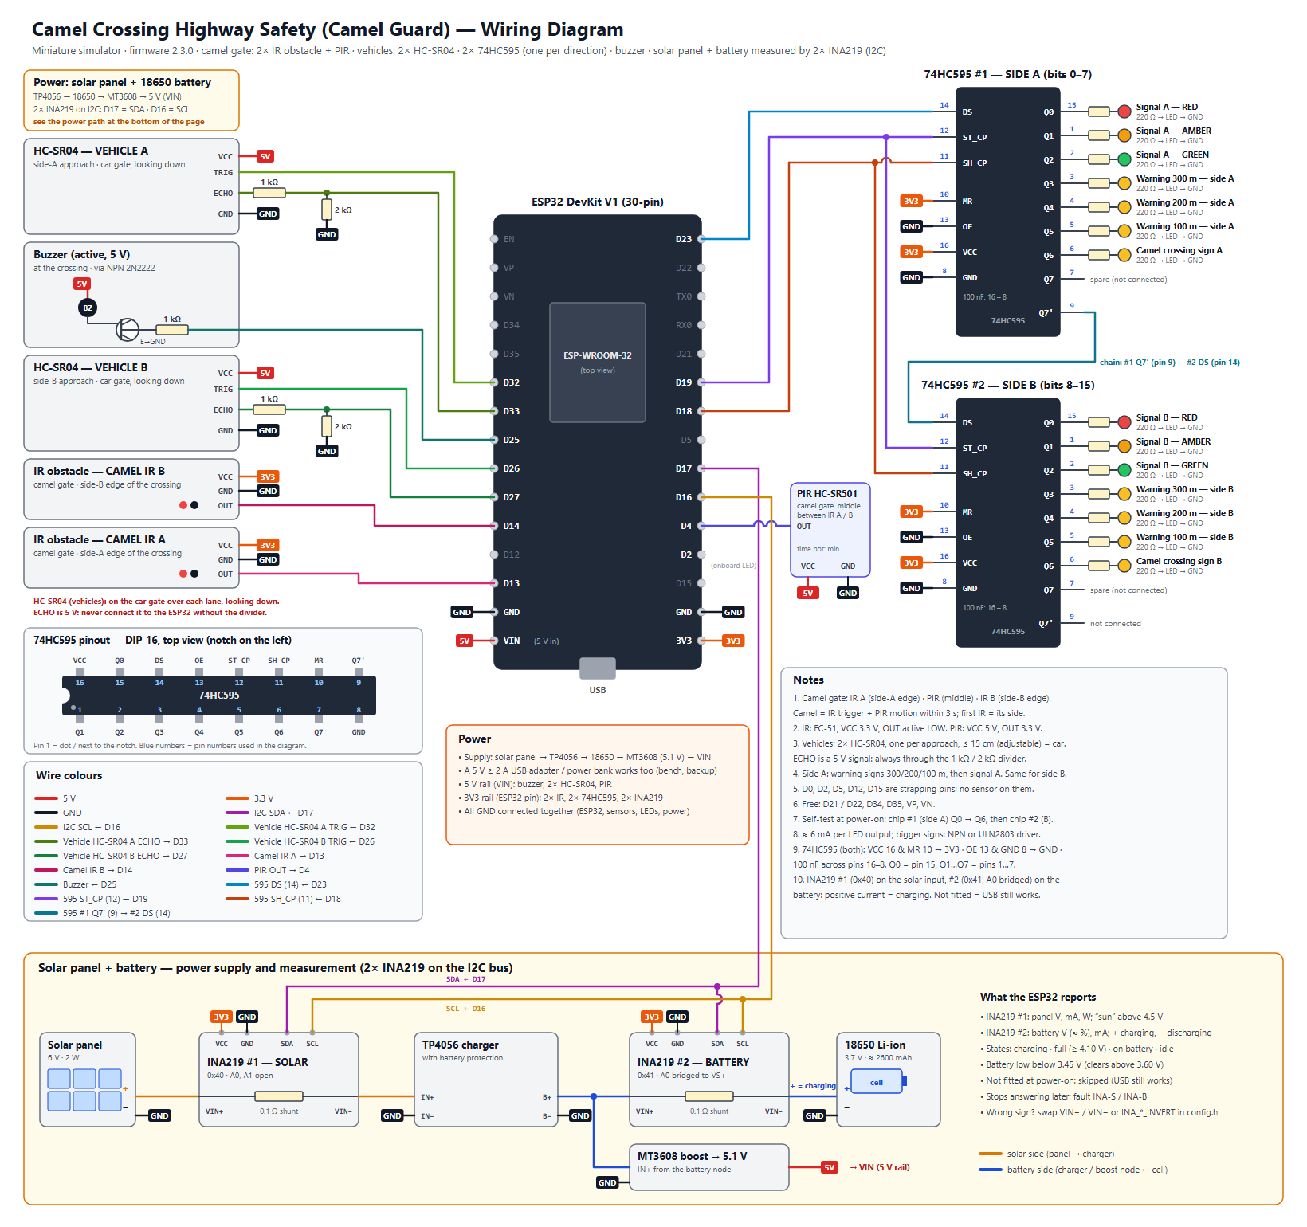
Figure 3 — Wiring diagram (docs/wiring_diagram.svg)

9.4 Miniature highway model
- Base: 150 × 60 cm MDF board, desert sand texture, divided highway: carriageway A and carriageway B with a median, about 34 cm wide in total.
- One camel crossing in the middle with a camel fence along the road that guides the camels to it; the camel gate has an IR sensor post at each edge of the crossing and the PIR on the median between them.
- On each approach: warning signs 300 m, 200 m and 100 m before the crossing (evenly spaced, not to scale), then the camel-crossing sign and the traffic signal.
- One HC-SR04 vehicle sensor on a small car-sensor gate over each approach, before the crossing; a small ramp gives repeatable car runs for testing.
- Electronics box under the board; sensor wires run under the base. A small solar panel stands at the edge of the model, the battery and the power modules sit in the box.

10. Software Design

10.1 ESP32 firmware
- Edge decision: sensing, classification and the state machine run on core 1 every 100 ms, independent of the network.
- Telemetry: a network task on core 0 sends JSON to the dashboard every second; the reply may carry one command.
- Settings in flash (NVS): IR confirmation readings, PIR window, vehicle distance, hold time, approach time, signal timing, sensors fitted (IR A, IR B, PIR), device name and up to five WiFi networks survive a power cycle.
- Commands: clear, change settings, change WiFi, manual alert, output test, reboot, factory reset.
- Network recovery: finds the dashboard PC automatically by UDP broadcast; starts its own setup WiFi (CamelGuard-Setup-XXXX) if no network works; can also be configured over the USB cable.
- Power monitoring: reads the two INA219 every 250 ms and derives the battery charge, the charging condition and a low-battery warning; works without them (USB-powered).
- Safety of settings: every value is clamped to a safe range on both the PC and the ESP32, so a typing mistake cannot make the system blind.

10.2 PC dashboard
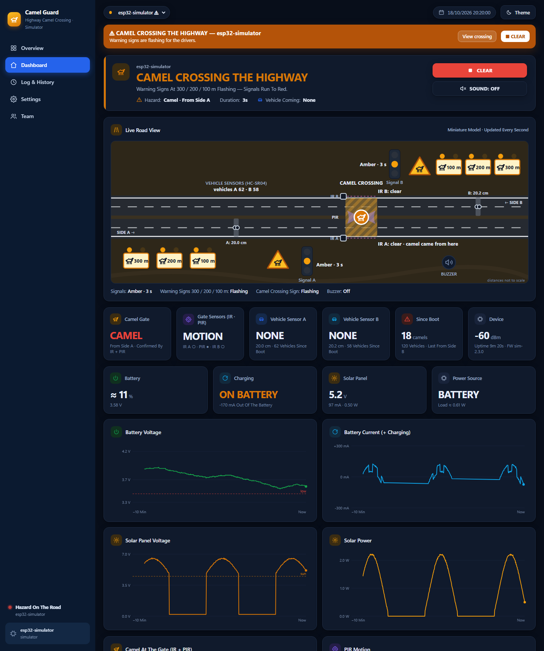
Figure 4 — Dashboard: live highway view and battery / solar monitoring (simulator)
- Overview: every camel crossing as a card, hazards first; CLEAR ALL and ALERT ALL; today’s camel crossings and vehicles.
- Dashboard: animated live highway view (signals, 300/200/100 m warning signs, camel sign, the camel gate with IR A / PIR / IR B and the side the camel came from, the HC-SR04 vehicle sensors with their distance, cars from each side, buzzer), six live tiles, four battery / solar tiles, eight 10-minute charts (four of them for the power), “why the system decided this” and recent vehicles per side.
- Log & History: filtered event log, hazard history (duration, peak level, vehicles) and vehicle log, each exportable to CSV.
- Settings: detection (IR confirmation, PIR window, approach time, hold time), live sensor view (IR, PIR, distances, IR-only triggers ignored), vehicle distance, gate sensors fitted, signal timing, WiFi, device, output test (including each LED one by one), wiring diagram, firmware compile/upload and ports.
- Team: authors and supervisor with photos.

10.3 Simulator
A Python simulator reproduces the firmware exactly (same IR + PIR confirmation, direction, hold time, ultrasonic median filter, vehicle distance, approach window and command handling) and plays scenarios: auto tour (with an IR-only trigger that must be ignored), clear road, camel (from side A, later from side B), danger (camel plus cars from both sides) and three crossings at once. It also plays a 4-minute day / night cycle for the solar panel and the battery. It allows the dashboard to be developed and demonstrated before the hardware arrives.

11. Materials and Budget
Prices are estimates in UAE dirham (AED) from local electronics and hobby suppliers and online stores; final prices depend on the supplier.
Item | Specification / purpose | Qty | Unit (AED) | Total (AED)
ESP32 DevKit V1 (30-pin) | Dual-core 240 MHz, WiFi, 12-bit ADC | 1 | 35 | 35
Ultrasonic sensor HC-SR04 | Vehicle sensors: one per approach, 2–400 cm, 5 V | 2 | 12 | 24
IR obstacle sensor FC-51 (digital OUT) | Camel gate: one at each edge of the crossing (side A / side B) | 2 | 6 | 12
PIR motion sensor HC-SR501 | Camel gate: between the two IR sensors, confirms a moving animal | 1 | 10 | 10
74HC595 shift register | one per direction (chained): signal, 3 warning signs, camel sign (+1 spare) | 3 | 3 | 9
LED kit 5 mm (red/amber/green) | Traffic signals and warning signs | 1 | 12 | 12
Resistor kit (220 Ω, 1 k, 2 k, 100 k) | LED limiting, ECHO dividers, buzzer transistor | 1 | 20 | 20
Active buzzer 5 V + NPN 2N2222 | Warning at the crossing (herder) | 1 | 10 | 10
Amber LEDs 5 mm (extra) | Flashers on the 300/200/100 m warning signs | 1 | 8 | 8
INA219 current / voltage sensor module (I2C) | One on the solar panel, one on the battery | 2 | 12 | 24
Solar panel 6 V 2 W | Charges the battery in daylight | 1 | 30 | 30
TP4056 charger module with battery protection | 1 A Li-ion charger, over-discharge protection | 1 | 6 | 6
18650 Li-ion cell + holder | ≈ 2600 mAh, 3.7 V | 1 | 25 | 25
MT3608 boost converter | Battery 3.7 V → 5.1 V for the ESP32, HC-SR04, PIR and buzzer | 1 | 5 | 5
5 V 2 A USB adapter + cable | Bench supply and backup | 1 | 25 | 25
Breadboard 830 points | Prototyping | 2 | 15 | 30
Jumper wire set (M-M, M-F) | Connections | 1 | 20 | 20
Perfboard + pin headers | Final soldered circuit | 1 | 15 | 15
MDF base board 150 × 60 cm | Miniature highway base | 1 | 55 | 55
Toy camels (≈ 1:24) | Camel figures, 10–12 cm tall | 3 | 10 | 30
Warning sign boards ×6 (300/200/100 m) | Printed faces on sticks, two flasher LEDs each | 1 | 25 | 25
Toy cars (≈ 1:24–1:32) | Vehicles for the vehicle sensors | 3 | 8 | 24
Paint, sand texture, road tape, median, fence | Desert highway scenery with camel fence | 1 | 40 | 40
Sensor gates, posts & sign boards (3D print / acrylic) | Car-sensor gates (HC-SR04), camel gate posts (IR + PIR), sign faces | 1 | 40 | 40
Consumables (glue, heat-shrink, screws, tape) | Assembly | 1 | 25 | 25
Subtotal |  |  |  | 559
Contingency (10 %) | spares, shipping, price changes |  |  | 56
TOTAL (required) |  |  |  | 615

Tools already available in the school workshop (not budgeted): laptop, Arduino IDE 2, soldering station, multimeter, hot-glue gun, 3D printer / laser cutter.

12. Project Timeline
Duration: 12 weeks (Term 3). Shaded cells show when each task is carried out.
Task | W1 | W2 | W3 | W4 | W5 | W6 | W7 | W8 | W9 | W10 | W11 | W12
Research, proposal & approval
System design: block diagram, schematic, BOM
Order & receive components
Sensor tests on breadboard (HC-SR04, IR obstacle, PIR)
Output tests (2× 74HC595 signals, signs, buzzer)
Solar panel + battery build, INA219 tests
Firmware: detection + state machine
Firmware: WiFi, telemetry, settings (NVS)
Dashboard + simulator integration
Miniature road model build
Install electronics in the model, solder board
Sensor adjustment & unit / integration tests
System tests, fixes, data collection
Report, poster, demo video
Final presentation & exhibition

12.1 Milestones
Week | Milestone / deliverable
1 | Proposal approved by the supervisor
3 | All components received; bill of materials checked
4 | All sensors and outputs working on the breadboard
6 | Firmware with detection, state machine and dashboard connection
8 | Miniature road model built
10 | Integrated system adjusted; unit and integration tests passed
11 | System tests passed; report and poster drafts
12 | Final presentation and exhibition demonstration

13. Testing Plan
Testing goes from single parts to the whole system: unit tests (each sensor and output), integration tests (detection with outputs) and system tests (dashboard, network, endurance), ending with an acceptance demonstration. Each test is repeated the stated number of times and recorded in the test log; a test passes only if the pass criterion is met.
ID | Level | Test | Method | Pass criterion
T-01 | Unit | Ultrasonic distance accuracy | Hold a block at 5, 10, 15, 20 cm from each vehicle sensor, 10 readings each (dashboard: Sensors → Sensors Now) | Distance error ≤ ±1 cm on both sensors
T-02 | Unit | Camel gate sensors | Pass a hand / figure through IR A and IR B 10 times each; move in front of the PIR 10 times (adjust the pots) | IR blocked only while something is in the gate; PIR shows motion every time; nothing shown when the gate is empty
T-03 | Unit | Camel detection and direction | Walk a camel figure through the gate from side A to B 20 times, then from B to A 20 times | ≥ 18/20 confirmed in each direction (≥ 90 %); correct side shown; counted once per crossing
T-04 | Unit | Warning signs 300/200/100 m | Place a camel on the crossing 10 times; watch all six signs | All six flash (wig-wag) within 0.5 s, both directions, 10/10
T-05 | Unit | IR-only rejection | Cover the PIR; break IR A and IR B with a hand or a toy car, 10 times each | No warning; each trigger logged as 'IR without PIR — ignored'
T-06 | Unit | Vehicle counting (HC-SR04) | Roll a car past vehicle sensor A 20 times, then past B 20 times | 20/20 counted on the correct side, no double counts
T-07 | Unit | Sensor fault detection | Unplug the ECHO wire of vehicle sensor A for 5 s; later keep IR A blocked for more than 2 minutes | Fault US-A within 2 s and OBJ-A after 2 min on the dashboard; both clear when fixed
T-08 | Unit | PIR window setting | Settings → PIR Confirmation Window: 1 s, then 3 s; each time break IR A and move in front of the PIR 2 s later | 1 s: not confirmed (ignored); 3 s: camel confirmed; both changes show 'Applied'
T-09 | Unit | Camel from side B | Walk the camel into the gate from side B only, 10 times | WARNING every time; dashboard shows 'From Side B'
T-10 | Unit | Outputs | Settings → Output Test: buzzer, signals, signs, each LED one by one | Each output works; each LED lights in the order named by the dashboard; test stops after the set time
T-11 | Integration | Detection latency | Place a camel figure; timestamp video of sign LED | Sign flashing ≤ 0.5 s after placement
T-12 | Integration | DANGER escalation | Camel on the road, then roll a car past vehicle sensor A, then B | Fast signs + buzzer ≤ 0.3 s after the sensor fires, both sides
T-13 | Integration | Signal sequence timing | Place a camel 10 times; film signal A and B | Green → flashing green 3 s ± 0.2 → amber 3 s ± 0.2 → red; never skipped, A = B
T-14 | Integration | Hold & clear | Remove the figure and time the return to CLEAR | Clear after hold time ±0.5 s; red ≥ 2 s then green; no flicker
T-15 | Integration | Approach window | Camel on the road; one car passes a vehicle sensor; time the DANGER state | DANGER for the approach time (3 s) ±0.3 s, then back to WARNING
T-16 | System | Works without WiFi | Switch the WiFi off, repeat T-03 and T-12 | Local warnings still work; dashboard shows OFFLINE
T-17 | System | Dashboard telemetry | Compare dashboard with serial monitor for 10 min | ≤ 2 s delay; no missing hazard in the log
T-18 | System | Settings from the dashboard | Change IR confirmation, PIR window, vehicle distance, hold time, approach time and signal timing | Applied on the ESP32 and confirmed ('Applied')
T-19 | System | Manual alert (all crossings) | Overview → ALERT ALL, then STOP ALERT | All online crossings warn within 2 s and stop
T-20 | System | Endurance | Run the model for 2 hours with random scenarios | No reset, no false DANGER, log complete
T-22 | System | Power measurement (INA219) | Compare the dashboard with a multimeter: battery voltage and current, panel voltage and current | Voltage within ±0.05 V and current within ±10 % of the multimeter
T-23 | System | Charge-state detection | Panel under a lamp; then cover it; then leave the full battery in the light | Charging (+ current) in light; On battery (− current) when covered; Full at ≥ 4.10 V; changes logged
T-24 | System | Low-battery warning | Lower the battery voltage below 3.45 V (variable supply or discharge), then raise it above 3.60 V | “Battery low” on the dashboard and in the log below 3.45 V; clears above 3.60 V
T-25 | System | Battery runtime and INA fault | Run on the battery only until the low-battery warning; unplug the SDA wire of INA219 #2 | Runtime ≥ 4 h; fault INA-B within 2 s, cleared when reconnected; no INA fitted = no fault
T-21 | Acceptance | Full demonstration | Scripted demo: clear → camel from side A → car from side A → camel from side B → car from side B → hand through IR only → clear | All states shown correctly on model and dashboard

13.1 Test equipment
- Ruler, stopwatch and a phone with slow-motion video (240 fps) for timing checks.
- Serial Monitor (115200 baud) and the dashboard event log for time stamps.
- A block and a ruler (5, 10, 15, 20 cm) for the ultrasonic tests, a multimeter (voltage and current) for the INA219 tests, a lamp for the solar panel, a ramp for repeatable toy-car runs, a small screwdriver for the IR and PIR potentiometers and masking tape.

13.2 Test record (template)
Test ID | Date | Trials | Passed | Result / measured value | Pass? | Tester
T-03 |  | 20
T-06 |  | 40

14. Safety Considerations
- Low voltage only: 5 V from a USB adapter, or from the battery through a boost converter; no mains or 12 V parts.
- The 18650 cell is only used with a charger module that has a protection circuit; it is never short-circuited, punctured or left charging unattended.
- The IR sensors and both shift registers run from 3.3 V and the PIR output is 3.3 V; the 5 V ECHO signal of each HC-SR04 goes through a 1 kΩ / 2 kΩ divider, so every ESP32 input stays at its own 3.3 V logic level.
- All wires insulated, no exposed connections; the final circuit is soldered on perfboard inside an enclosure under the model.
- Hot-glue gun, soldering iron and cutting tools used only with teacher supervision and eye protection.
- The system is a demonstrator: it must not be installed on a real road without professional engineering and authority approval.

14.1 Risk assessment
Risk | Likelihood | Mitigation
A hand, a toy car or a reflection breaks a camel IR beam | Medium | An IR trigger needs PIR motion within 3 s; IR-only triggers are ignored and logged (test T-05)
PIR triggered by people moving next to the model, or slow to settle after power-on | Medium | The PIR only confirms an IR trigger, never alone; sensitivity pot; 30–60 s settling time; time pot at minimum
Echoes from the car gate or road texture disturb the ultrasonic vehicle sensors | Medium | Median of three readings; vehicle distance adjustable with the live distance shown; fault CAR after 2 min
The two ultrasonic sensors hear each other | Medium | Sensors ping in turns, 25 ms apart (firmware)
HC-SR04 5 V ECHO damages the ESP32 input | High | 1 kΩ / 2 kΩ voltage divider on both ECHO lines, checked with a multimeter before connecting
IR camel sensors disturbed by sunlight or shiny / dark surfaces | Medium | Indoor demo; matt surfaces; small shield tube on each module; adjust the pot
Li-ion cell damaged by over-discharge, over-charge or a short circuit | High | TP4056 module with protection circuit; insulated wiring; battery-low warning at 3.45 V; never leave it charging unattended
Too little light to charge the battery indoors | Medium | Use a lamp for the demo; USB adapter as backup; charge state shown on the dashboard
INA219 reads the current with the wrong sign | Low | Swap VIN+ / VIN− or set the invert flag in config.h; checked by test T-23
Component delivery delay | Medium | Order in week 2; simulator allows firmware/dashboard work meanwhile
School WiFi (Enterprise) cannot be used by the ESP32 | High | Phone hotspot / router; ESP32 works fully offline

15. Advanced Innovative Features
- Advance warning at 300 / 200 / 100 m: six signs flash in both directions while a camel is crossing, so drivers slow down early.
- Two-sensor camel confirmation with direction: an IR trigger counts only when the PIR confirms a moving animal; the first IR shows from which side the camel comes, and false IR triggers are logged.
- UAE signal sequence: every hazard stops the traffic with green → flashing green → amber → red, exactly as drivers know it.
- Vehicle-aware escalation: warnings become DANGER (fast-flashing signs, buzzer) only when a vehicle is really approaching.
- Self-checking sensors: sensor faults (no ultrasonic echo, vehicle sensor always occupied, IR blocked or PIR active for minutes) are shown on the dashboard.
- Edge decision + IoT dashboard: works without WiFi; live road view, history and remote settings when connected.
- Several crossings: one dashboard monitors many crossings and can alert all of them at once.
- Solar powered with live monitoring: two INA219 sensors show the battery charge, the charging condition and the solar power on the dashboard and warn when the battery is low.

16. Expected Outcomes
- A working miniature smart highway that detects camels at the crossing and warns drivers automatically from 300 m before it.
- Measured results for detection accuracy, detection latency and vehicle counting (Section 13).
- A dashboard showing live status, history and vehicle statistics that a road authority could use.
- Documentation: wiring diagram, source code, test results, report and poster.

17. Limitations
- IR (2–30 cm) and HC-SR04 (≤ 4 m) ranges suit the model; a real highway needs radar, LiDAR or thermal cameras.
- IR + PIR confirm a warm moving body at the gate but cannot tell a camel from another large animal or a person.
- With one vehicle sensor per side the system knows that a vehicle is coming, but not its speed.
- A 2 W panel indoors or in shade charges slowly, and the battery charge is estimated from its voltage, so the runtime is approximate.
- Soft, angled or very absorbent surfaces can give a weak echo (the sensor then reports “no echo”); IR and PIR sensors are affected by strong sunlight and heat, so the model is demonstrated under room lighting.

18. Future Improvements
- AI camera recognition of camels (edge AI) combined with the IR + PIR gate.
- A second ultrasonic sensor on each approach to measure vehicle speed and log speeding during a hazard.
- Mobile warnings to nearby drivers and navigation apps; connection to smart road / V2X systems.
- Radar or thermal sensing for real road distances; a larger solar panel and battery for a real roadside unit.
- Variable message sign showing distance to the hazard and the advised speed.

19. Team Roles
Student | Main responsibility | Shared tasks
Mohamed Mubarak Almansoori | Project leader, hardware design and wiring | Testing, report
Mohammed Jumaa | Firmware (ESP32) and sensor adjustment | Testing, presentation
Mansoor Abdulla | Miniature road model and mechanical parts | Poster, video
Ibrahim Jumaa | Dashboard, simulator and data analysis | Testing, report
Roles are a proposal and can be changed by the team with the supervisor.

20. References
- Espressif Systems — ESP32 Series Datasheet and ESP32 Technical Reference Manual.
- HC-SR04 Ultrasonic Ranging Module — user guide / datasheet.
- FC-51 IR obstacle avoidance sensor module (LM393 comparator) — datasheet.
- HC-SR501 PIR motion detector module (BISS0001) — datasheet.
- INA219 Zero-Drift, Bidirectional Current/Power Monitor With I2C Interface — datasheet (Texas Instruments).
- 74HC595 8-bit serial-in / parallel-out shift register — datasheet (Texas Instruments / Nexperia).
- Arduino-ESP32 core documentation (WiFi, Preferences, HTTPClient, WebServer).
- ATS Electrical Engineering Capstone Project Workbook.

Prepared according to the ATS Electrical Engineering Capstone Project Workbook requirements.

