Introduction to Asynchronous JavaScript

Day 01

Whenever you hear this term, asynchronous, immediately think about time or specifically time delays. This term involves how we manage multiple events where one event has to wait for another event to complete. It is especially important in networking and communications but essentially anywhere an event or task involves some kind of a delay. Think about opening a file, accessing a database or even about a button click.
Asynchronous programming involves applying strategies that enables your program to start a task that may take some time to complete, but at the same time be able to respond to other events happeining simultaneously. If you did not manage this properly, the risk is that the application or OS itself may become non-responsive and lead to poor user experience.
Some of the more advanced programming languages like Java, C++ and C# have the ability to spawn multiple threads. JavaScript needs an environment to operate such as the browser or the NodeJS environment. JS therefore is single-threaded and has to manage multiple tasks on one single tread or processing stream. The bootcamp is about how JS uses its environment to manage multiple tasks going on at the same time.
Note, all the code in this boot camp was produced using VS Code, it is a free code editor.

Part 1 – Callback Functions

A callback function can be an anonymous function that is passed to some other function, as a parameter. When the original function finishes what it was built for, it fires off the callback function (the one passed in).
For this first part, use the template provided, it is called HTML_Template.zip. Once you unzip that file, you will find four individual files, open the index and scripts files in your favorite editor or just use Notepad.
Most of the HTML based examples in this bootcamp uses the Live Server plugin for VS Code. This is a plugin from Ritwick Dey. You may install it anytime, but the earlier the better. This is for users of VS Code. If you are using a different code editor, then a browser refresh may be necessary.
There is no code for this part but there is a starter zip file called HTML_Day01_Part1_Starter.zip if you wish to use that.

- In this first demo, on the left you see some JS code and on the right you see the result of running that code in a browser. The image on the right is the browser’s developer console which can usually be opened by hitting the F12 key on the keypad:
function A() {  console.log("A")  }  function B() {  console.log("B")  }  function C() {  console.log("C")  }  A();  B();  C(); | 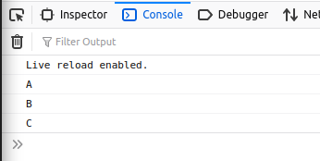

Note: if you are using VS Code, you can open the HTML file with Live Server, it’s a plugin for VSCode
- Now what will happen if say, function B is delayed. In this case we have delayed its return for 1 second. The result is that C runs before B:
}  function B() {  setTimeout(() => {  console.log("B")  },1000);  }  function C() {  console.log("C")  } | 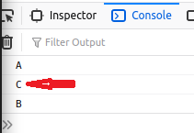

- What we need is to preserve the order. In other words we want to make sure that C does NOT run Before B.
This is where asynchronous programming comes in.
Before modern methods of dealing with this situation existed, we used callback functions to solve the problem.
A callback function simply means, go and run this piece of code, then when you are done running that code execute this other function (the callback function).
Of course we could simply move the C line to just below the B line and that would solve the problem. In a complex application however this may not be possible.

- We could re-architect the B() function to accept another function to be executed, once B is done with it’s task. We could pass this other function into B as a parameter, then have B execute that function that was passed in. It does not matter what the function is, once it is passed in, that passed in function gets executed, AFTER B is done.
…  function B(cb) {  setTimeout(() => {  console.log("B");  cb();  },1000);  }  … | Notice that cb represents a function. That cb function is now called after B is done its work. This is the reason that the passed in function is called a callback function, it is called back once the current function finishes.

- So, now that cb is inside of B, when we call B we can pass in C!
…  function C() {  console.log("C");  }  //  A(); B(C);  … | Notice when we pass C into B, we do NOT add the (). Adding the () will execute C, we don’t want that here, we want C to be executed inside of B where it belongs.

- Here is the entire code:
function A() {  console.log("A")  };  function B(cb) {  setTimeout(() => {  console.log("B");  cb();  },1000);  };  function C() {  console.log("C")  };  //  A(); B(C); //two functions one line | 

End of section

Part 2 –Example with Promise Object

In this section we take a look at a different example and a different solution. This example creates a new Promise object. The function that does the creation will therefore return a Promise object that must be handled. In most cases however, you will be working with ordinary JS functions that return Promisses. All you have to do is handle the promise.
The code for this part is called HTML_Day01_Part2.zip. It contains the code in a completed state, so if you wanted to follow along, you can cope the code in the box on the left below.

- In this next demo, on the left you see some JS code and on the right you see the result of running that code in a browser. The image on the right is the browser’s developer console which can usually be opened by hitting the F12 key on the keypad:
let el = document.getElementById("response");  const doFirst = function() {  el.innerHTML = el.innerHTML + "I was first..."  };  doFirst();  el.innerHTML = el.innerHTML + "<br />And I am second!" | 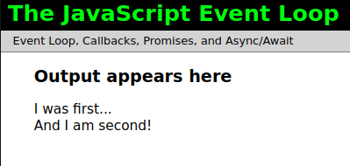  Note, in the previous example we used the developer’s console window to view the result, here we use the DOM.

Note: for this example you could use the HTML_More_Complex_Example_Starter_Code.zip file

- Now, if we add a setTimeout() function to the doFirst() function, we could delay the output from that function. This forces the next output to print first, but it should be second!
…  let el = document.getElementById("response");  const doFirst = function() {  setTimeout(function(){  el.innerHTML = el.innerHTML + "<br />I was first..."  }, 2000);  };  doFirst();  el.innerHTML = el.innerHTML + "<br />And I am second!"  … | 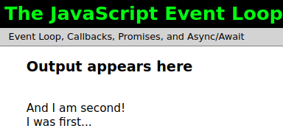

Now that the order is affected, we could promissify the doFirst() function by returnin a Promise object.

- One way to solve the order issue, is to return a Promise object from the doFirst() function:
…  let el = document.getElementById("response");  const doFirst = function() {  const pf = new Promise();  setTimeout(function(){  el.innerHTML = el.innerHTML + "<br />I was first..."  }, 2000);  };  doFirst();  el.innerHTML = el.innerHTML + "<br />And I am second!"  … | 

- The reason we got the error in #3 is that we did not supply the handler function. The architecture of promises is that once we use them, we have to immediately provide a function to run after the promise completes. A promise can be in one and only one of three states, pending, fulfilled or rejected. Lets pass in an empty function that will get rid of the error:
…
let el = document.getElementById("response");
const doFirst = function() {
const pf = new Promise( () => {

} );
setTimeout(function(){
el.innerHTML = el.innerHTML + "<br />I was first..."
}, 2000);
};
doFirst();

el.innerHTML = el.innerHTML + "<br />And I am second!"
…

- However, the handler function inside the Promise constructor, has to supply two variables that would represent two functions, resolve() and reject(). These are parameters but they each represent a function.
…  let el = document.getElementById("response");  const doFirst = function() {  const pf = new Promise( (resolve, reject) => {  } );  setTimeout(function(){  el.innerHTML = el.innerHTML + "<br />I was first..."  }, 2000);  };  doFirst();  el.innerHTML = el.innerHTML + "<br />And I am second!"  … | You will see how these two parameters come into the story a bit later.

- Now we need to insert the setTimeout() into the Promise object, via the handler function. Basically once the setTimeout() function expires, the handler function will take over and handle the result of the setTimeout() function.
let el = document.getElementById("response");  const doFirst = function() {  const pf = new Promise((resolve, reject)=>{  setTimeout(function(){  el.innerHTML = el.innerHTML + "<br />I was first..."  }, 2000);  });  };  doFirst();  el.innerHTML = el.innerHTML + "<br />And I am second!" | Although this setup will work in this case, it is not the proper way to handle output. We need to engage the resolve parameter, which remember, is a method.

- Now we need to wrap our output, normally this would be data, into the resolve() function:
let el = document.getElementById("response");  const pf = new Promise((resolve, reject)=>{  setTimeout(function(){  resolve(el.innerHTML = el.innerHTML + "<br />I was first...");  }, 2000);  });  doFirst();  el.innerHTML = el.innerHTML + "<br />And I am second!" |   The output is still the same and we still have not yet solved the problem.

- Lets continue by returning the promise, pf:
const doFirst = function() {  const pf = new Promise((resolve, reject)=>{  setTimeout(function(){  resolve(el.innerHTML = el.innerHTML + "<br />I was first...")  }, 2000);  });  return pf;  }; |   Still no changes in output.

- Now that doFirst() returns a promise, it means that we have to handle the result of that promise when we make the call to the doFirst() method. We now have to supply a then() method, chain it on to the doFirst() method and then provide a function to handle any output from the doFirst() method. In this case we don’t actually have data to handle, the doFirst() function simply prints some data to the DOM:
let el = document.getElementById("response");  const doFirst = function() {  setTimeout(function(){  el.innerHTML = el.innerHTML + "<br />I was first..."  }, 2000);  };  doFirst().then();  … | 

- Notice that at this point, the output still has not changed. The change happens in the architectural design of our program. Before we change the structure of the program let us supply an anonymous function to the then() method.
doFirst().then( () => {  } );  … |   This wont do anything to the output but it will give us the architectural structure in which to change the output.

- With this strucutural change, we can move the last output line into the function that runs after the doFirst() function. This is the line that prints “And I am second!”
doFirst().then(()=>{  el.innerHTML = el.innerHTML + "<br />And I am second!";  }); |   Finally we see some change

- Usually though, you would return data from the promise then do whatever you want with that data
const doFirst = function() {
const pf = new Promise((resolve, reject)=>{
setTimeout(function(){
resolve("I was first...")
}, 2000);
});
return pf;
};
doFirst().then((data)=>{
el.innerHTML = el.innerHTML + data;
});

- With this structural change we simply add on the rest of the data that we wish to be part of this promise architecture:
const doFirst = function() {
const pf = new Promise((resolve, reject)=>{
setTimeout(function(){
resolve("I was first...")
}, 2000);
});
return pf;
};
doFirst().then((data)=>{
el.innerHTML = el.innerHTML + data + "<br />And I am second!";
});

- (Optional) In this particular example, it is NOT necessary to actually create a new Promise object, we can have the object created automatically by simply returning a Promise:
const doFirst = function() {
return new Promise((resolve, reject)=>{
setTimeout(function(){
resolve("I was first...")
}, 2000);
}); …

- Here is the final code for this section:
let el = document.getElementById("response");
const doFirst = function() {
return new Promise((resolve, reject)=>{
setTimeout(()=>{
resolve("<br />I was first...");
}, 500);
});
//return pf;
};
doFirst().then((data)=>{
el.innerHTML = data + "<br />And I am second!"
});
- Here is the final code for this section, using regular functions:
let el = document.getElementById("response");
const doFirst = function() {
const pf = new Promise(
function(resolve, reject){
setTimeout(function(){
resolve("I was first...");
}, 2000);
}
);
return pf;
};
//
doFirst().then(function(data){
el.innerHTML = el.innerHTML + data + "<br />And I am second!"
});

End of section

Part 3 – Async and Await

In this section we take a look at a more recent addition to the asynchronous JS world.
The code for this part is called HTML_Day01_Part3.zip. It contains the code in a completed state, so if you wanted to follow along, you can cope the code in the box on the left below.

- We will continue with the previous example, but in the form shown in #15. Either comment out the call to doFirst() or delete it completely, so all you should have on the program is this code:
let el = document.getElementById("response");
const doFirst = function() {
return new Promise((resolve, reject)=>{
setTimeout(function(){
resolve("I was first...")
}, 2000);
});
};

- Below the doFirst() function create a new function and decorate it with async:
async function showMessages(){

}

We will use this function to do exactly what we did in the previous section, display two messages in order onto the browser window.

- Call the doFirst() method from within showMessages(), but wait for it to finish so decorate the call with await keyword:
async function showMessages(){
await doFirst();
}

- After waiting for the doFirst() function to complete, we need to do something with the data being returned, so we could simply add it to a variable:
async function showMessages(){
let firstMessage = await doFirst();
}

- Now just show the message from the Promise onto the DOM:
async function showMessages(){
let firstMessage = await doFirst();
el.innerHTML = firstMessage;
}

- Nothing happens as yet because we have not called showMessages(), so lets do that now with a new line:
async function showMessages(){
let firstMessage = await doFirst();
el.innerHTML = firstMessage;
}
showMessages();

Well we got the first message but what about the second?

- With this new architecture, all we have to do now is plug-in the second message:
async function showMessages(){
let firstMessage = await doFirst();
el.innerHTML = firstMessage + "<br />And I am second!";
}
showMessages();

- Here is the entire code for this program:
let el = document.getElementById("response");
const doFirst = function() {
return new Promise((resolve, reject)=>{
setTimeout(function(){
resolve("I was first...")
}, 2000);
});
};
//
async function showMessages(){
let firstMessage = await doFirst();
el.innerHTML = firstMessage + "<br />And I am second!";
}
//
showMessages();

End of section

Part 4 – Error Handling

In this section we handle the negative side of Promisses, the errors that might be thrown during the execution of a Promise.
The code for this part is called HTML_Day01_Part4.zip. It contains the code in a completed state, so if you wanted to follow along, you can cope the code in the box on the left below. It would be better to follow along using the code at the end of Part3.

- Actually in order to handle errors with the async/await construct, well it will be just like normal JS error handling, use a try…catch structure. Here is the code from the async and await section:
try{
let firstMessage = await doFirst();
el.innerHTML = firstMessage;
el.innerHTML = firstMessage + "<br />And I am second!";
} catch(err){
el.innerHTML = "An Error Occured!";
}

If an error occurred, the err variable will hold that error object generated.

- Here is the entire code for async/await
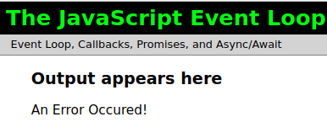let el = document.getElementById("response");
const doFirst = function() {
return new Promise((resolve, reject)=>{
setTimeout(function(){
//resolve("I was first...");
reject("An error occured");
}, 2000);
});
};
//
async function showMessages(){
try{
let firstMessage = await doFirst();
el.innerHTML = firstMessage;
el.innerHTML = firstMessage + "<br />And I am second!";
} catch(err){
el.innerHTML = "An Error Occured!";
}
}
//
showMessages();

In this case, I am purposely generating an error in the try block, using the reject parameter.

- Lets now return to the code from the part2 #15, so start with this code:
let el = document.getElementById("response");
const doFirst = function() {
return new Promise((resolve, reject)=>{
setTimeout(function(){
resolve("I was first...")
}, 2000);
});
};
//
doFirst().then((data)=>{
el.innerHTML = data + "<br />And I am second!"
});

For this example, just replace the current code with the code from #3

- From the code above notice that we only used the resolve parameter, what about reject? Well, lets replace the resolve() function with a reject() function
let el = document.getElementById("response");
const doFirst = function() {
return new Promise((resolve, reject)=>{
setTimeout(function(){
reject("Oops we have a problem!")
}, 2000);
});
};
//
doFirst().then((data)=>{
el.innerHTML = data + "<br />And I am second!"
});

Notice that immediately we get an error in the Console window.

- The error occurred in the Browser because we as programmers did not handle it. Luckily the Promise architecture has a built in error handling mechanism. This error handler must be called once the function that return the promise is called, so basically we add another method to the call (chaining), the catch() method:
doFirst()
.then((data)=>{
el.innerHTML = data + "<br />And I am second!"
})
.catch(err => {
console.log("An error occured!");
el.innerHTML = "An error occured!"
});

This is called chaining. The catch() method is chained to the first then() method which is chained to the Promise call.

- Here is the entire block of code so far:
let el = document.getElementById("response");
const doFirst = function() {
return new Promise((resolve, reject)=>{
setTimeout(function(){
//resolve("I was first...");
reject("Oops we have a problem!");
}, 2000);
});
};
//
doFirst()
.then((data)=>{
el.innerHTML = data + "<br />And I am second!";
})
.catch(err => {
el.innerHTML = err;
});

- There is a different way to handle the then() method, basically pass in an object with two parameters, one for the positive and one for negative. This is the recommended way according to the documentation.
doFirst()
.then(
resolve => { },
reject => { }
);
Each parameter represents functions so here we have empty functions for now.

- Now we can complete each function
doFirst()
.then(
resolve=>{
el.innerHTML = resolve + "<br />And I am second!"
},
reject => {
el.innerHTML = "<p style='color:red;'>" + reject + "...check with your Administrator";
}
);

So, now if we have data returned, it goes into the resolve block and if an error occurred, it goes into the reject block. Also I added a red font to the reject output.

- Here is the entire program with the reject commented out:
let el = document.getElementById("response");
const doFirst = function() {
return new Promise((resolve, reject)=>{
setTimeout(function(){
resolve("I was first...");
//reject("Oops we have a problem!");
}, 2000);
});
};
//
doFirst()
.then(
resolve=>{
el.innerHTML = resolve + "<br />And I am second!"
},
reject => {
el.innerHTML = "<p style='color:red;'>" + reject + "...check with your Administrator";
}
);

End of section

Part 5 – API Calls with fetch()

In this section we will make an API call using fetch() method which is part of JS. This function returns a Promise object and will have to be handled using one of the promise architecture.
There is a fresh starter code for this section, its called “Starter for Fetch.zip”..

- Once you get the starter code loaded, press the button to see that the code behind works. Now replace the code in the showData() function with the code below:
function showData(){
fetch('https://jsonplaceholder.typicode.com/posts/1');
};

- The fetch() method did its job but we have not provided the structure to accept the data and show it on the browser window, so one step at a time. First apply a then() method to handle the returned promise
function showData(){
fetch('https://jsonplaceholder.typicode.com/posts/1')
.then();
};

- Now inside the then() method, provide a function to handle any data being returned
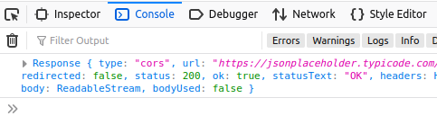fetch('https://jsonplaceholder.typicode.com/posts/1')
.then( (data) => {
console.log(data)
} );

The return is a cryptic blob of a stream of data that id not recognizable

- However, if we apply the json() method to the data object, we will parse the original object to extract just the json data from it
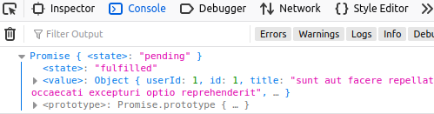fetch('jsonplaceholder.typicode.com/posts/1')
.then( (data) => {
console.log(data.json() )
} );
Notice that the json() method also produces a Promise object but the data we seek is inside

- What we have to do is return the original data via the json() method, then we will get the actual data:
fetch('https://jsonplaceholder.typicode.com/posts/1')
.then( (data) => {
return data.json()
} );

- Now that we returned the data, we have to chain on another then() method and supply another function to handle the data returned by the previous then() method:
fetch('https://jsonplaceholder.typicode.com/posts/1')
.then((data)=>{
return(data.json())
})
.then(()=>{

})

- At this point we supply a variable to hold the actual data, then we can show that data in the console window:
.then((data)=>{
return(data.json())
})
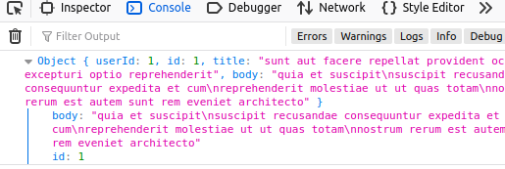 .then((data)=>{
console.log(data);
})

- Actually since we have a handle onto the DOM, we could start throwing our data onto the browser window via the div tag that we have access to:
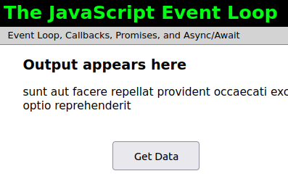 .then((data)=>{
return(data);
})
.then((post)=>{
el.innerHTML = post.title;
})

Remember title is part of the post available via the JSONPlaceholder data. What is returned to us is an Object. In order to interact with this object, we interact with it’s name/value pairs like title, body etc.

- The only thing left is to cater for errors, so like before simply chain on the catch() method for that:
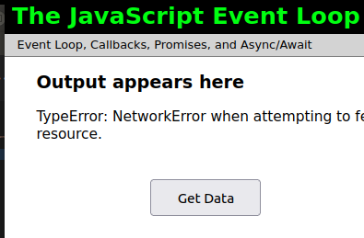 .then((post)=>{
el.innerHTML = post.title;
})
.catch(err => {
el.innerHTML = err;
})

To reproduce this error, just change the URL to something that does not exist, for example I simply removed the m from com and it produced this error

- Here is the entire program with error handling, on the right is the same code but with regular functions:
let el = document.getElementById("response");  //  function showData(){  fetch('https://jsonplaceholder.typicode.com/posts/1')  .then((data)=>{  return(data.json())  })  .then((data)=>{  return(data);  })  .then((post)=>{  el.innerHTML = post.title;  })  .catch(err => {  el.innerHTML = err;  })  }; | let el = document.getElementById("response");  //  function showData(){  fetch('https://jsonplaceholder.typicode.com/posts/1')  .then(function(data){  return(data.json())  })  .then(function(data){  return(data);  })  .then(function(post){  el.innerHTML = post.title;  })  .catch(function(){  el.innerHTML = err;  });  };

- To use async/await, first remove all the then methods but leave the fetch, also change the function name and add the async decoration to the function name:
async function getData(){
fetch('https://jsonplaceholder.typicode.com/posts/1');
};

- Since we will now wait for the response from the fetch method, lets add a variable to hold that data in and at the same time decorate the fetch method with the await keyword:
async function getData(){
const postData = await fetch('https://jsonplaceholder.typicode.com/posts/1');
};

Note: this is one long line but it looks like 2 lines, I will show you the entire line in smaller font so that it fits on this page:
const postData = await fetch('https://jsonplaceholder.typicode.com/posts/2');

- We still have to run the returned object through the json() method:
async function getData(){
const postData = await fetch('https://jsonplaceholder.typicode.com/posts/1');
const finalData = await postData.json();
};

- Check your html file and make sure you are calling the getData() function once the button is clicked:
<p></p>
<div style="font-size: larger;" id="response"></div>
<button id="button1" onclick="getData()">Get Data</button>
</main>

- At this point, if you now include a line to log the data you will see the data appear in the console window
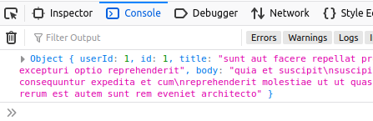async function getData(){
const postData = await fetch('jsonplaceholder.typicode.com/posts/1');
const finalData = await postData.json();
console.log(finalData);
};

- In order to get data such as the title or body of the post, we will pass finalData to the DOM:
async function getData(){
const postData = await fetch('https://jsonplaceholder.typicode.com/posts/1');
const finalData = await postData.json();
el.innerHTML = finalData.title;
};

- Lets go further and add in error handling:
let el = document.getElementById("response");
//
async function getData(){
try{
const postData = await fetch('https://jsonplaceholder.typicode.com/posts/1');
const finalData = await postData.json();
el.innerHTML = finalData.title;
}catch(err){
el.innerHTML = "Oops " + err;
}
};

End of section

Part 6 – JSON Server

Lets configure a server so that we can make a post request to the server and test out the Promise in that situation. You may continue with the same project from Part5 or start a new one. For this part, you will need to be in a NodeJS environment. If you do not have access this, just follow along.

- Install the JSON Server using the command: npm install json-server
Make sure that you are in an appropriate folder when you do this. If you started working with the HTML folder, then navigate to that folder before you install this code.
- This server will need a database file to work with, lets simulate a database with just a plain text file holding JSON data in it. Back in the editor, create a new folder under the app folder called data. Inside of the data folder create a new text file called db.json.

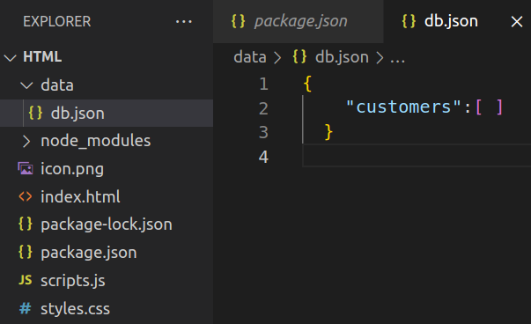

Note: after you install the json-server using npm, you will see a few new folders and files, we can ignore most of this for now

- From #2 above noticed that I started the .json file, it is configured with a pair of curly braces and an array inside of those braces. We can now define what our customer should look like:
{
"customers":[
{
"username":"Axle",
"password":"1234"
}
]
}

So now we have one customer, the Axle customer

- Lets now start the server and point it to our customers database:
npx json-server --watch data/db.json --port 3030

Run this code from your terminal window, check that the path is correct. Although you can run this code from VS Code, it is not recommended.

- If you do not get an erro running this code, open a browser and navigate to the localhost address and add port 3030 at the end:
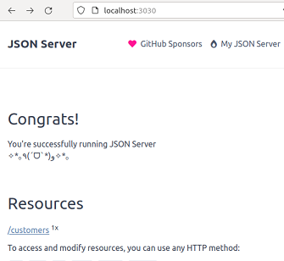

- If you click on the customers link, it should show you the one customer we have in the database. The server and mock database is now setup for use.

- Lets now reconfigure our code to hit the json-server instead of the public json placeholder website. If you already have the code from #17 part 5, then simply change the url:
async function getData(){
try{
const postData = await fetch('http://localhost:3030/customers');
const finalData = await postData.json();
el.innerHTML = finalData[0].username;
}catch(err){
el.innerHTML = "Oops " + err;
}
};

Notice that finalData is an array, so we just interrogate the first element.

End of section

Part 7 – Post Requests

The fetch() method also can be configured to make POST requests. The json-server that we just implemented into our project has the capability to accept data from the browser. We would need to configure the server itself as well as the code that hits that server with loaded data. Note, a POST request is also an asynchronous operation.

- The json-server in its current configuration is not designed to accept data, we need to add a unique field. It’s a simple task, just add an id field:
{
"id":"1",
"username":"Axle",
"password":"1234"
}

Remember to insert a coma after the id field.

- Now we need to configure the fetch() method. We do this by adding an object as the second parameter:
try{
const postData = await fetch(
'http://localhost:3030/customers',
{
method:"POST"
}
);
const data = await postData.json();
console.log(data);

So, the fetch() method, takes two arguments inside of the parentheses.

- Now all we have to do is supply the data that will be posted. Of course this should match what we already have:
const postData = await fetch(
'http://localhost:3030/customers',
{
method:"POST",
body:{"username":"Jennifer", "password":"1234"}
}

Notice that the data goes as part of the body property. However this still wont work completely.

- It is better to wrap the data using a JSON.stringify() method:
const postData = await fetch(
'http://localhost:3030/customers',
{
method:"POST",
body:JSON.stringify({"username":"Jennifer", "password":"1234"})
}

This will ensure that the data reaches the server in the format it requires.

- The above code did not throw any errors but it did not work properly. We now have to inform the server about the type of data we are supplying it with:
{
method:"POST",
headers: {
'Content-Type': 'application/json',
},
body:JSON.stringify({"username":"Jennifer", "password":"1234"})
}

This code should now post Jennifer and 1234 properly

- The final code for this part includes how the server responds. Remembe the server in this case is the Json Server.

Appendix A – Promise Object in Theory

A Promise is an object which represents the result of an asynchronous operation, either the success of that operation or its failure.

Promisses require handler functions and it is suggested that you attach these funtions to the function that returns the promise object.

A Promise can be in one and only one of these states:

pending: initial state, it has not been resolved.
fulfilled: meaning that the operation was completed successfully, it is resolved
rejected: meaning that the operation failed, an error object may be returned

After the pending state, a promise can either be fulfilled with the expected value or rejected as an error.

As soon as one of these two states are realized, the associated handler functions passed into the promise mechanism and stored in the promise's then method are called.

Appendix B – Node Projects

When working with a Node project such as the one in #6 above, there are a few steps that you need to take to get the project up to date.

- If you download the zipped file HTML_Day01_Part6.zip you will notice that it is NOT like the one in the document. This is because Node projects are designed to be slim and contain a very small footprint. It is up to us to re-create the original project.
- First unzip the file and put it into a folder. Navigate into that folder and run the command npm install. The folder will re-create itself and you will see the node_modules folder re-appear.

- Once the folders have been reconstructed, you may continue following the instructions from #6, section 5.

Appendix C – Technologies Used

- HTML – any modern browser will work
- JavaScript - any modern browser will work
- Code Editor – instructor will use Visual Studio Code (free version)
- NodeJS – environment to run JavaScript code

APPENDIX D – FILE WATCHERS LIMIT REACHED (ENOSPC)
- If you are on Linux you may get an error about file watchers limit, this is due to the OS being not configured to handle heavy applications. Hidden from view is a package called inotify that Linux systems use to track this sort of activity. You would need to adjust this value using the steps below:
Run the following command at any terminal prompt: sudo gedit /etc/sysctl.conf

This would bring up the sysctl.conf file for editing

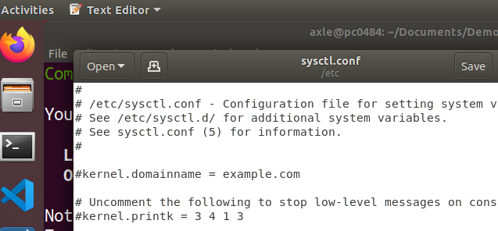

Add a new line with this value: fs.inotify.max_user_watches=524288
Make sure that there is no # sign in front of the line.
Save the file and try restarting the app with npm start

Or, temporarily:
sudo sysctl -w fs.inotify.max_user_watches=524288

Appendix E – Technologies Used

From part 6, and any of the zipped files involving NodeJS, the unzipped code and the code that I show in the bootcamp will be different. The zipped code has to be built. Here are the steps to follow:
- Unzip the file in a folder
- Using a terminal window, navigate to the root folder. For example if you unzipped part6, the final code will be in a folder called HTML. Naviagate to that folder using the CD command.
- Once you are at the folder, you will notice a package.json file. This is the manifest that Node will use to build your app. Run the command following command:
npm install
- After that command is executed, you may or may not have a node_modules folder created along with a package-lock.json file. Your folder is now ready for further development.

