**Project B: An Exciting Journey**

Sarah Miller – skm102

**Part 1: User Guide**

My primary goal in this project was to create some shapes I found interesting, and animate some of them. These include a jointed/animated/interactive flower (from project A), an abstract shape reminiscent of the stage in Millennium Park (but more colorful), a rotating star, a diamond, and a stack of boxes.

There are also world axes in the middle of the screen, as well as on the tip of one flower petal.

To explore the scene use the arrow keys to navigate/walk through the scene, and the WASD keys to pivot the camera/”turn your head”.

To interact with the flower (right of initial camera position) press “p” to add petals and remove the drawing axes, and press “o” to remove petals. This removes the axes as well.

To start/stop the rotation of the star, press “space”. You can also click and drag to rotate the star quaternion style.

You can also control all 6 frustum parameters! Unfortunately, it takes a lot of unintuitive buttons. The first key in each set lowers the parameter, the second raises it:

1&2 for Left, 3&4 for Right, 5&6 for Bottom, 7&8 for Top, R&T for Near, Y&U for Far.

**Part 2: Images**

Below: The full scene (as seen by walking backwards and angling camera slightly in Perspective and Ortho views)

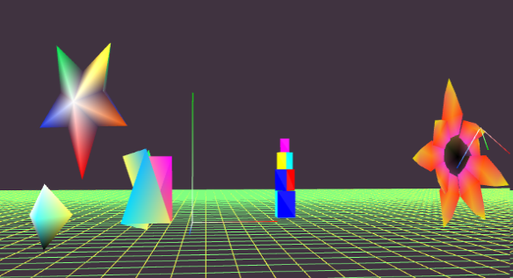

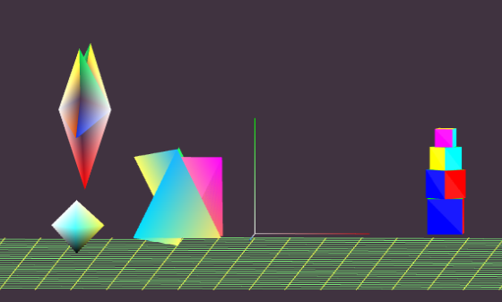

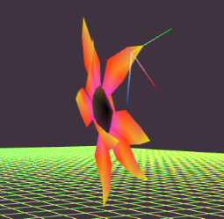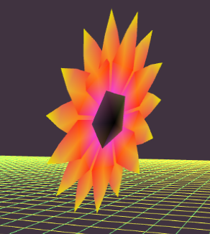

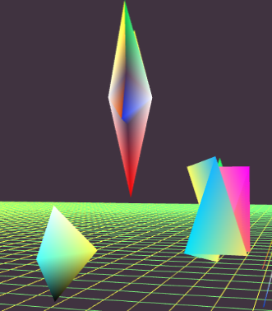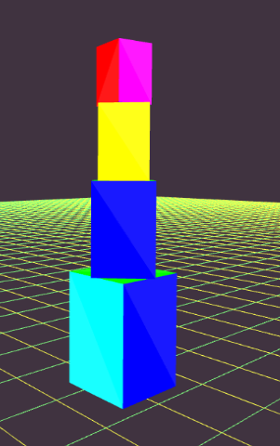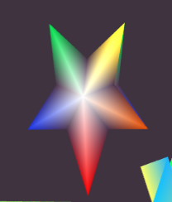

Above left: Flower pictured mid-rotation, including drawing axes.

Above right: Flower with additional petals, and drawing axes removed.

Below: Close-ups of various shapes in perspective view

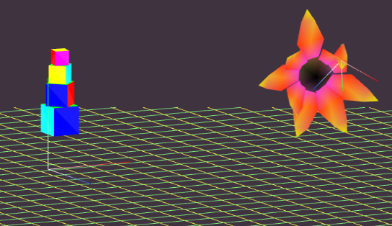

Left: an orthographic view of the box stack

**Part 3: Scene Graph**

