Paper Reference(s)
1385/04 1386/04
Edexcel GCSE
Mathematics A – 1385
Mathematics B – 1386

Paper 4 – Calculator Paper
Intermediate Tier
Tuesday 11 June 2002 − Morning
Time: 2 hours

Materials required for examination Items included with question papers
Ruler graduated in centimetres Formulae sheets
and millimetres, protractor,
compasses, pen, HB pencil, eraser.
Tracing paper may be used.

Instructions to Candidates
In the boxes on the answer book, write your centre number, candidate number, your surname and initials, the paper reference and your signature.
The paper reference is shown above. If more than one paper reference is shown, you should write the one for which you have been entered.
Answer ALL questions in the spaces provided in this book.
Supplementary answer sheets may be used.

Information for Candidates
The total mark for this paper is 100. The marks for the various parts of questions are shown in round brackets: e.g. (2).
If your calculator does not have a π button, take π to be 3.142 unless the question instructs otherwise.
Calculators may be used.
This paper has 22 questions. There is one blank page.

Advice to Candidates
Show all stages in any calculations.
Work steadily through the paper.
Do not spend too long on one question.
If you cannot answer a question leave it out and attempt the next one.
Return at the end to those you have left out.

This publication may only be reproduced in accordance with Edexcel copyright policy.
Edexcel Foundation is a registered charity. ©2002 Edexcel
Answer ALL TWENTY TWO questions.

Write your answers in the spaces provided.

You must write down all stages in your working.

1. Bill goes on holiday to New York.
The exchange rate is £1 = 1.545 dollars.
He changes £800 into dollars.

(a) How many dollars should he get?

…………dollars
(2)
After his holiday, Bill changes 120 dollars back into pounds.
The exchange rate is the same.

(b) How much money should he get?
Give your answer to the nearest penny.

£………………
(2)

(Total 4 marks)

2. Bronze is made from copper and tin.
The ratio of the weight of copper to the weight of tin is 3:1.

(a) What weight of bronze contains 36 grams of copper?

……………………g
(1)
(b) Work out the weight of copper and the weight of tin in 120 grams of bronze.

copper……………g

tin……………g
(2)

(Total 2 marks)

3. (a) Change 10 kilograms into pounds.

…………… pounds
(2)
(b) Change 7 pints to litres.

……………….litres
(2)

(Total 4 marks)

4. Linford runs in a 100 metres race.
The graph shows his speed, in metres per second, during the race.
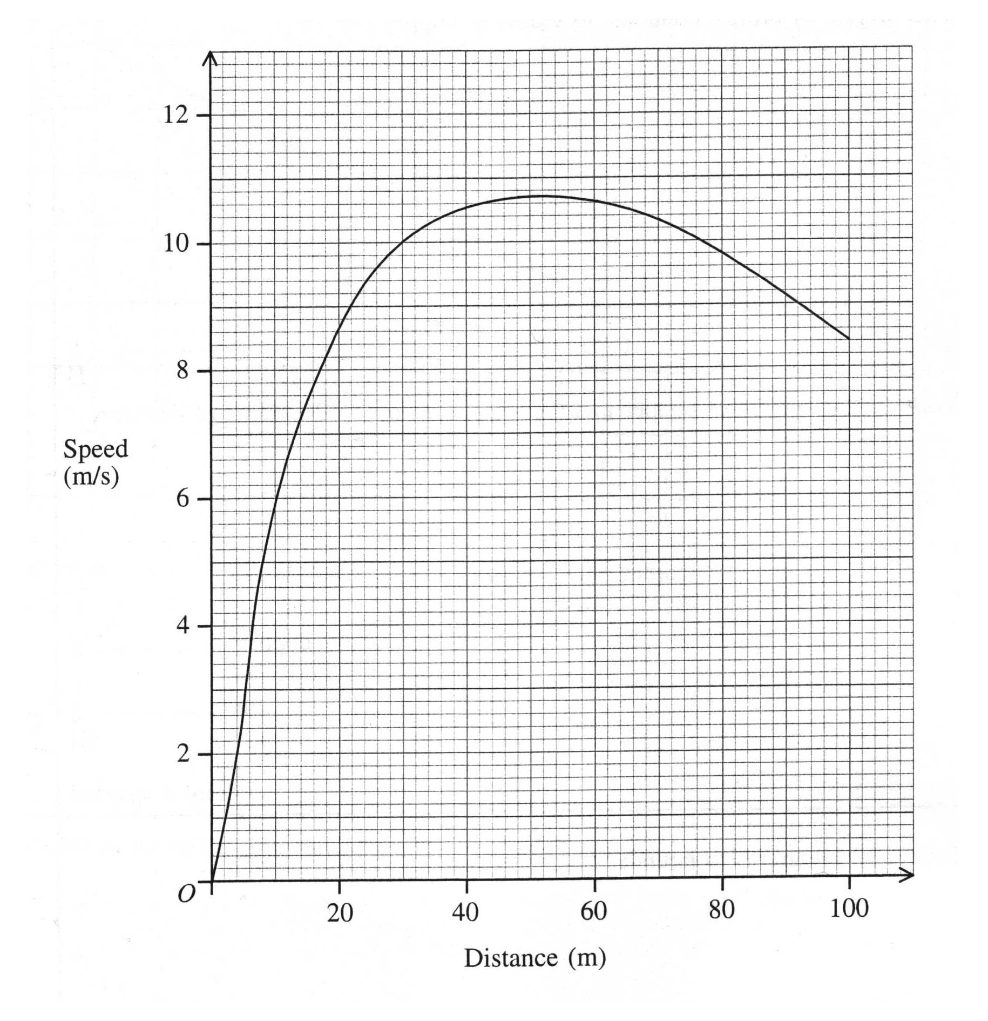

(a) Write down Linford’s speed, after he has covered a distance of 10 m.

………………. m/s
(1)
(b) Write 20 down Linford’s greatest speed.

………………. m/s
(1)

(c) Write down the distance Linford has covered when his speed is 7.4 m/s,

…………… m
(1)

There are two times when Linford’s speed is 9 m/s.

(d) Find the distance he covers between these two times.

…………… m
(2)

(Total 5 marks)

5. The diagram shows some shapes.

(a) Complete the table to show the number of shapes in each category.

 | White | Black
Circle
Square
(2)

One of the shapes in the diagram is chosen at random.

(b) Write down the probability that the shape will be

(i) a black square,

………………

(ii) a white square or a black circle.

………………
(4)

(Total 6 marks)

6. 12 m

7m Diagram NOT
accurately drawn

3m

2m 6m

2m
The diagram shows a paved surface.
All the corners are right angles.
Work out the area of the paved surface.

…………… m²

(Total 3 marks)

7. The price of a telephone is £36.40 plus VAT.
VAT is charged at a rate of 17.5%.

(a) Work out the amount of VAT charged.

£……………
(2)

In a sale, normal prices are reduced by 12%.
The normal price of a camera is £79.

(a) Work out the sale price of the camera.

£……………
(3)

(Total 5 marks)
8.

D
x°
y°

C E
119°
Diagram NOT
accurately drawn

82° 74°

A B

The diagram shows a quadrilateral ABCD and a straight line CE.
AB is parallel to CE.
(a) Work out the size of the angle marked x°.

………………°
(2)

(b) (i) Write down the size of the angle marked y°.

………………°

(ii) Give a reason for your answer.

………………………………………………………………………………………….

…………………………………………………………………………………………
(2)

(Total 4 marks)

9. Use you calculator to work out the value of 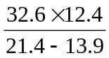.

(a) Write down all the figures on your calculator display.

…………………
(2)

(b) Write your answer to part (a) to an appropriate degree of accuracy.

…………………
(1)

(Total 3 marks)

10. Kim has to carry out a survey into the part-time jobs of all the 16 year olds in her school. She has to find out

- what proportion of these 16 year olds have part-time jobs
- whether more boys than girls have part-time jobs.

Design two questions which she could include in her questionnaire.

(Total 2 marks)

11. The scatter graph shows some information about seven children.
It shows the age of each child and the number of hours sleep each child had last night.
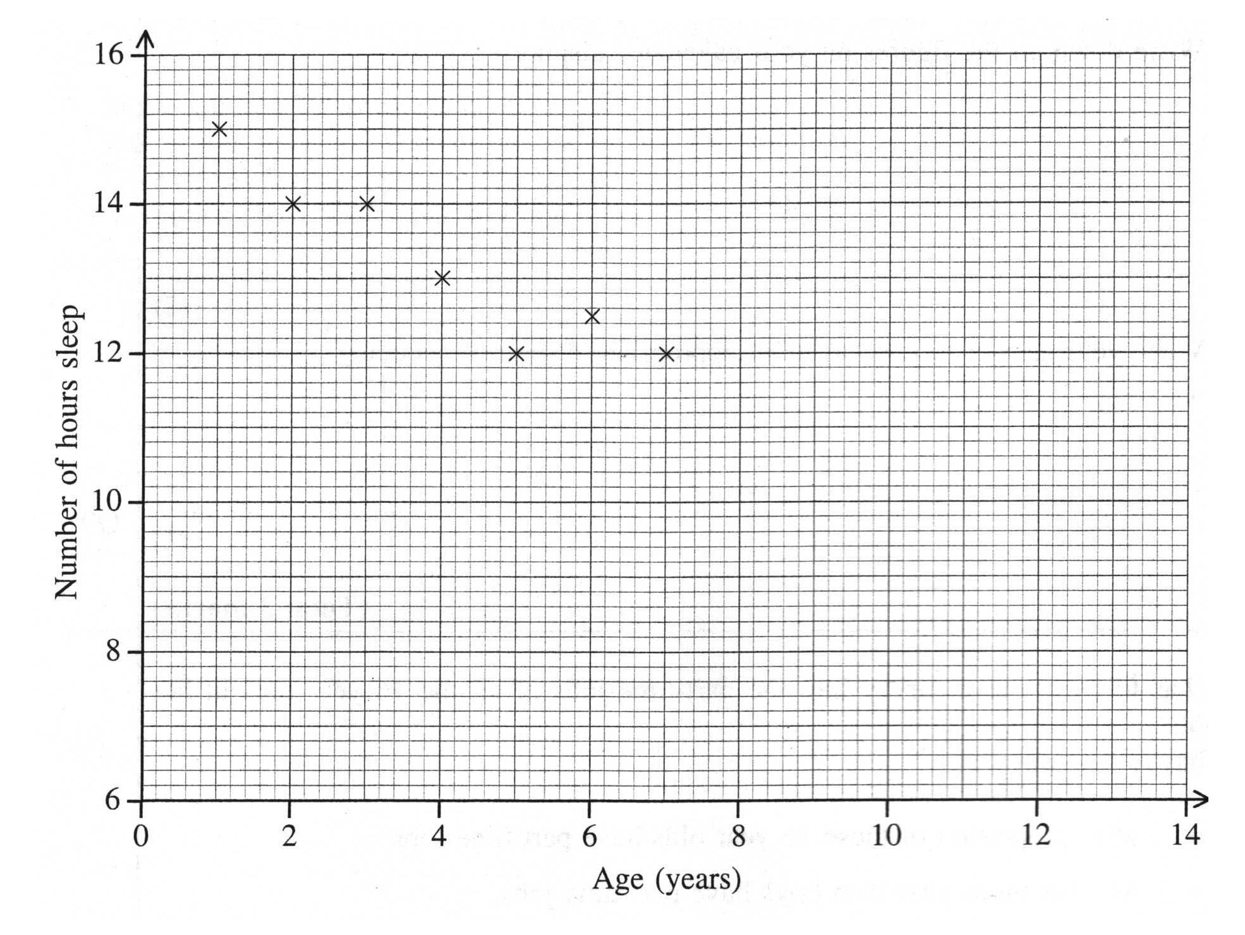

The table shows the ages of four more children and the number of hours sleep each of them had last night.

Ages (years) | 10 | 11 | 12 | 13
Number of hours sleep | 11 | 10 | 10.5 | 9.6

(a) On the scatter graph, plot the information from the table.

(b) Describe the correlation between the age, in years, of the children and the number of hours sleep they had last night.

……………………
(1)

(c) Draw a line of best fit on the diagram.

(d) Use your line of best fit to estimate the number of hours sleep for an 8 year old child.

……………………
(1)

(Total 5 marks)

12. (a) Solve 5w + 2 = 37.

w = ………………
(2)

(b) Solve 4(x + 3) = 26.

x = ………………
(3)

(c) Solve 5y – 7 = 2y + 11.

y = ………………
(3)

(Total 8 marks)

13. The equation

x³ + 3x = 47.

has a solution between 3 and 4.
Use a trial and improvement method to find this solution.
Give your answer correct to one decimal place.
You must show ALL your working.

x = ………………

(Total 4 marks)

14. 27 boys and 34 girls took the same test.
The mean mark of the boys was 76.
The mean mark of the girls was 82.

Calculate the mean mark of all these students.
Give your answer correct to one decimal place.

………………

(Total 3 marks)

15. 14 cm

12 cm Diagram NOT
accurately drawn

The diagram shows a shape, made from a semi-circle and a rectangle.
The diameter of the semi-circle is 12 cm.
The length of the rectangle is 14 cm.

Calculate the perimeter of the shape.
Give your answer correct to 3 significant figures.

………………… cm

(Total 3 marks)

16. Wasim opened an account with £650 at the London Bank.
After one year, the bank paid him interest.
He then had £676 in his account.

(a) Work out, as a percentage, London Bank’s interest rate.

…………………%
(3)

Holly opened an account at the Anglia Bank.
Anglia Bank’s interest rate was 5%.
After one year, the bank paid her interest.
The total amount in her account was then £1029.

(b) Work out the amount with which she opened her account.

£…………………
(3)

(Total 6 marks)

17. Solve the simultaneous equations

4x + y = 8
2x – 3y = 11

x = …………………

y = …………………

(Total 4 marks)

18. A sheet of A5 paper is a rectangle 210 mm long and 148 mm wide.

(a) Calculate the area of a sheet of A5 paper.
Give your answer in square centimetres.

……………… cm²
(2)

210 mm Diagram NOT
accurately drawn

148 mm

(b) Calculate the length of a diagonal of the rectangle.
Give your answer correct to 3 significant figures.

……………… mm
(3)

A sheet of drawing paper is mathematically similar to a sheet of A5 paper.
A sheet of A5 paper is a rectangle 210 mm long and 148 mm wide.
The sheet of drawing paper is 450 mm long.

(c) Calculate the width of the sheet of drawing paper.
Give your answer correct to 3 significant figures.

……………… mm
(3)

(Total 8 marks)

19. The probability that it will snow in London on Christmas Day in any year is 0.08.

(a) Work out the probability that it will not snow in London on Christmas Day.

………………
(1)

(b) Work out an estimate for the number of Christmas Days in the next 50 years on which it will snow in London.

………………
(2)
(c) Work out the probability that it will snow in London on both Christmas Day 2002 and Christmas Day 2003.

………………
(2)
(d) Work out the probability that it will snow in London on either Christmas Day 2002 or Christmas Day 2003, but not on both.

………………
(2)

(Total 8 marks)

20. The line with equation x + 2y = 6 has been drawn on the grid.

 |  |  |  | y
-5 |  |  |  | O |  |  |  |  | 5 |  |  |  |  |  | x

(a) Rearrange the equation x + 2y = 6 to make y the subject.

y = …………………
(2)
(b) Write down the gradient of the line with equation x + 2y = 6.

…………………
(2)

(c) Write down the equation of the line which is parallel to the line with equation x + 2y = 6 and passes through the point with coordinates (0, 7).

…………………
(1)

(Total 5 marks)

21. 420 000 carrot seeds weigh 1 gram.
Each carrot seed weighs the same.

(a) Write the number 420 000 in standard form.

……………………
(1)

(b) Calculate the weight, in grams, of one carrot seed.
Give your answer in standard form, correct to 2 significant figures.

……………………g
(2)

(Total 3 marks)

22.

D 8 cm C

Diagram NOT
6 cm accurately drawn

A 13 cm B

The diagram shows a trapezium.
AB is parallel to DC.
Angle A = 90°.
AB = 13 cm, AD = 6 cm and CD = 8 cm.

Calculate the size of angle B.
Give your answer correct to 1 decimal place.

……………………°

(Total 4 marks)

TOTAL FOR PAPER: 100 MARKS

END

