GCSE in Mathematics B
Modular 2544
Unit 2 Handling Data
Practice Paper B
Higher
(Non – Calculator)
1. Three rock bands played at a music festival.
The names of the bands were The Rebels, ATC and Wand.

100 teenagers were asked which band they had enjoyed most.
The two way table gives information about their replies.

Complete the two-way table.

 | The Rebels | ATC | Wand | Total
Male | 11 | 0 | 15 | 32
Female |  | 18
Total | 33 |  |  | 100

(Total 3 marks)

2. Angela asked 20 people in which country they spent their last holiday.
Here are their answers

France | Spain | Italy | England
Spain | England | France | Spain
Italy | France | England | Spain
Spain | Italy | Spain | France
England | Spain | France | Italy

In the space below, design and complete a suitable data collection sheet that Angela could have used to show this information.

(Total 4 marks)

3.
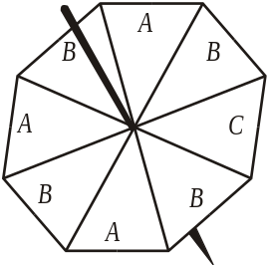

The diagram shows a fair spinner in the shape of a regular octagon.
The spinner can land on A or B or C.
Marc spins the spinner.

Write down the probability that the spinner will land on A.

…………………….
(Total 2 marks)

4. Shirin recorded the number of students late for school each day for 21 days.
The stem and leaf diagram shows this information.

Number of students late
1 | 4 | 5 | 7 | 8 | 8 | 9
2 | 2 | 2 | 5 | 6 | 6 | 7 | 7 | 9 | 9 | 9
3 | 0 | 1 | 3 | 4 | 6

(a) Find the median number of students late for school.

…………………….
(1)

(b) Work out the range of the number of students late for school.

…………………….
(1)
(Total 2 marks)

5. A company makes hearing aids.

A hearing aid is chosen at random.
The probability that it has a fault is 0.09

Work out the probability that a hearing aid, chosen at random, will not have a fault.

…………………….
(Total 1 marks)

6. This histogram gives information about the books sold in a bookshop one Saturday.
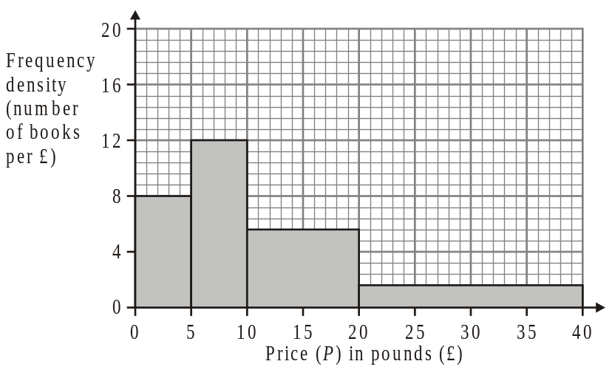
Use the histogram to complete the table.

Price (P) in pounds (£) | Frequency
0 < P ≤ 5
5 < P ≤ 10
10 < P ≤ 20
20 < P ≤ 40
(Total 2 marks)

