GCSE in Mathematics B
Modular 2544
Unit 2 Handling Data
Practice Paper D
Higher
(Non – Calculator)
1. Asif has a box of 25 pens.

12 of the pens are blue.
8 of the pens are black.
The rest of the pens are red.

Asif chooses one pen at random from the box.

What is the probability that Asif will choose

(i) a blue pen,

………………..

(ii) a red pen.

………………..
(Total 2 marks)

2. Pablo is an artist.

The scatter graph, below, gives information about the area and the cost of some of his pictures.

The line of best fit has been drawn on the graph.

All Pablo’s pictures are rectangles.
One of his pictures costs £1000
Its length is 48 cm.

Use the line of best fit to estimate the width of the picture.

.......................cm
(Total 3 marks)
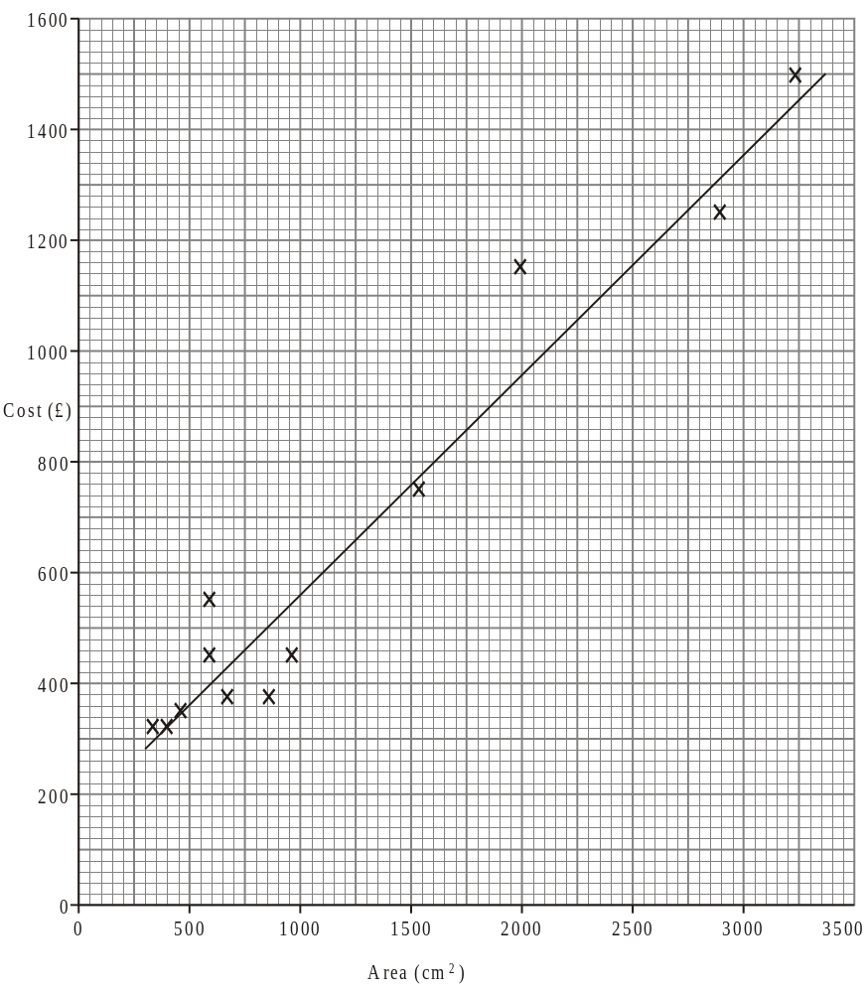

3. The table shows the frequency distribution of students absences for a year.

Absences d (days) | Frequency
0 < d < 5 | 4
5 ≤ d < 10 | 6
10 ≤ d < 15 | 8
15 ≤ d < 20 | 5
20 ≤ d < 25 | 4
25 ≤ d < 30 | 3

Draw a frequency polygon for this frequency distribution.

(Total 2 marks)
4. Hamid wants to find out what people in Melworth think about the sports facilities in the town.
Hamid plans to stand outside the Melworth sports centre one Monday morning.
He plans to ask people going into the sports centre to complete a questionnaire.

Carol tells Hamid that his survey will be biased.

(i) Give one reason why the survey will be biased.

………………………………………………………………………………………………

………………………………………………………………………………………………

………………………………………………………………………………………………

(ii) Describe one change Hamid could make to the way in which he is going to carry out his survey so that it will be less biased.

………………………………………………………………………………………………

………………………………………………………………………………………………

………………………………………………………………………………………………
(Total 2 marks)

5 Some students took a test.
The table shows information about their marks

Minimum mark | 10
Lower quartile | 33
Interquartile range | 35
Median mark | 43
Range | 65

Use this information to draw a box plot.
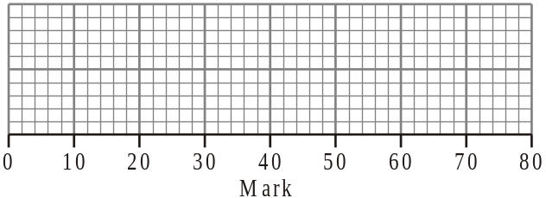
(Total 3 marks)

