GCSE in Mathematics B
Modular 2544
Unit 2 Handling Data
Practice Paper E
Higher
(Calculator)
1. The pie chart gives information about the bills paid by a Water Company

Bills paid by a Water Company

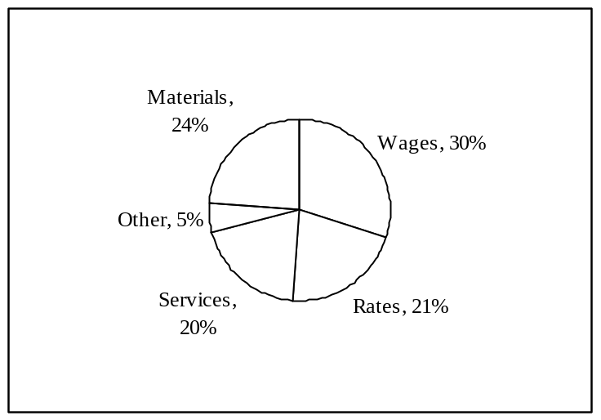

(a) Work out the size of the angle representing Wages.

………………..°
(2)
The Water Company spent £18 000 on Materials.

(b) Work out the amount it spent on Rates.

£………………..
(2)
(Total 4 marks)

2. Charles found out the length of reign of each of 41 kings.
He used the information to complete the frequency table.

Length of reign  (L years) | Number of kings
0 < L ≤ 10 | 14
10 < L ≤ 20 | 13
20 < L ≤ 30 | 8
30 < L ≤40 | 4
40 < L ≤ 50 | 2

(a) Write down the class interval that contains the median.

.......................cm
(2)
(b) Calculate an estimate for the mean length of reign.

....................... years
(4)
(Total 6 marks)

3. Here is a scatter graph. One axis is labelled “Height”.

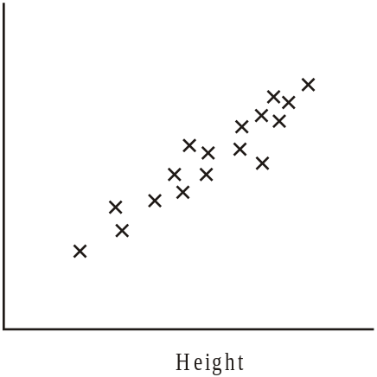

(a) For this graph, state the type of correlation.

………………………………………………………………………………………..
(1)

(b) From the list below, choose the most appropriate label for the other axis.

Length of hair | Number of sisters | Length of legs | GCSE French mark

……………………………………………………………………………………………..
(1)
(Total 2 marks)
4. The manager at “Fixit Exhausts” records the time, to the nearest minute later to repair the
exhaust on a car.

Here are his results.

32, | 29, | 34, | 28, | 22, | 41, | 57, | 43, | 28, | 33,
35, | 25, | 52, | 47, | 39, | 27, | 36, | 48, | 53, | 44,

Draw a stem and leaf diagram to show this information.

(Total 4 marks)

