GCSE in Mathematics B
Modular 2544
Unit 2 Handling Data
Practice Paper F
Higher
(Calculator)
1. Here is a 4-sided spinner.
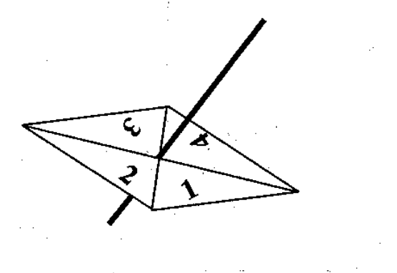

The sides are labelled 1, 2, 3, 4.
The spinner is biased.

The probability that the spinner will land on each of the numbers 1 to 3 is given in the table.

Number | 1 | 2 | 3 | 4
Probability | 0.3 | 0.4 | 0.1

Sabia spins the spinner once.

(a) (i) Work out the probability that the spinner will land on the number 4.

………………..

(ii) Write down the number that the spinner is most likely to land on.

………………..

(iii) Work out the probability that the spinner will land on an odd number.

………………..
(5)
Nick spins the spinner 100 times.

(b) Work out an estimate for the number of times the spinner will land on the number 2.

………………..
(2)
(Total 7 marks)

2. There are 800 pupils at Hightier School.
The table shows information about the pupils.

Year group | Number of boys | Number of girls
7 | 110 | 87
8 | 98 | 85
9 | 76 | 74
10 | 73 | 77
11 | 65 | 55

An inspector is carrying out a survey into pupil’s views about the school. She takes a sample, stratified both by Year group and by gender, of 50 of the 800 pupils.

(a) Calculate the number of Year 9 boys to be sampled.

............................
(2)
Toni stated “There will be twice as many Year 7 boys as Year 11 girls to be sampled.”

(b) Is Toni’s statement correct?
You must show how you reached your decision.

(2)
(Total 4 marks)

3. Here is a scatter graph. One axis is labelled “Height”.

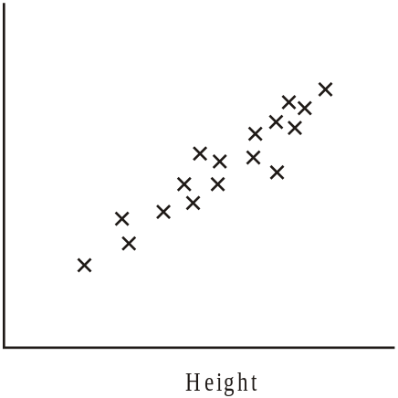

(a) For this graph, state the type of correlation.

………………………………………………………………………………………..
(1)

(b) From the list below, choose the most appropriate label for the other axis.

Length of hair | Number of sisters | Length of legs | GCSE French mark

……………………………………………………………………………………………..
(1)
(Total 2 marks)
4. The manager at “Fixit Exhausts” records the time, to the nearest minute later to repair the
exhaust on a car.

Here are his results.

32, | 29, | 34, | 28, | 22, | 41, | 57, | 43, | 28, | 33,
35, | 25, | 52, | 47, | 39, | 27, | 36, | 48, | 53, | 44,

Draw a stem and leaf diagram to show this information.

(Total 4 marks)

