GCSE in Mathematics B
Modular 2544
Unit 3 Number, Algebra, Shape Space and Measures 1
Practice Paper B
Higher
(Calculator and Non – Calculator)EDEXCEL
GCSE Mathematics 2540/2544
Formulae sheet — Higher tier

Volume of prism = area of cross-section × length

Volume of sphere = π r³

Surface area of sphere = 4π r²

Volume of cone = π r²h
Curved surface area of cone = π rl

In any triangle ABC

Sine Rule: 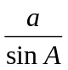 = 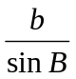 = 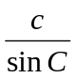
Cosine Rule: a² = b² + c² –2bc cos A
Area of a triangle =  ab sin C
The Quadratic Equation
The solutions of ax² + bx + c = 0, where a ≠ 0, are given by x = 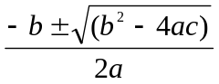
Higher – Section A – Calculator

1. Calculate the value of

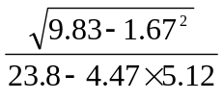

...................................
(Total 3 marks)

2. Here are the first five terms of an arithmetic sequences.

−1 3 7 11 15

(a) Find, in terms of n, an expression for the nth term of this sequence.

……..……………………..
(2)

In another arithmetic sequence the nth term is 8n − 16

John says that there is a number that is in both sequences.

(b) Explain why John is wrong.

………………………………………………………………..…………………………………
…………………………………………………………………………………………………..
…………………………………………………………………………………………………..
(2)
(Total 4 marks)

3. (a) Simplify k⁵ ÷ k²

........................
(2)
(b) Expand and simplify

(i) 4(x + 5) + 3(x − 7)

........................
(2)
(ii) (x + 3y)(x + 2y)

........................
(2)
(c) Simplify (m⁻⁴)⁻²

........................
(1)
(d) Simplify 2t² × 3r²t⁴

........................
(2)
(Total 9 marks)

4. Daniel leaves his house at 07 00.

He drives 87 miles to work.
He drives at an average speed of 36 miles per hour.

At what time does Daniel arrive at work?

...........................
(Total 3 marks)

5.
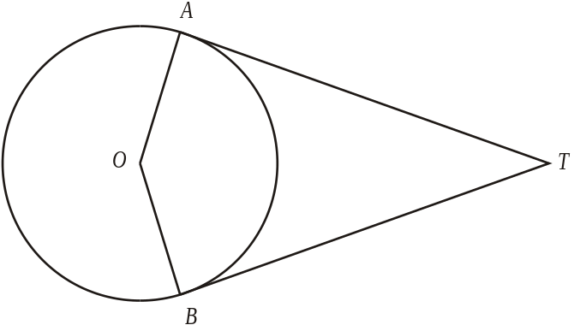
A and B are points on the circumference of a circle, centre 0.
TA and TB are tangents to the circle.

Calculate the size of the angle ATO when angle AOT = 56°
Give a reason for each stage in your working.

………………….°
(Total 3 marks)

6. The diagram shows a trapezium ABCD.

AB is parallel to DC.

AB = 4.8m, DC = 5.2m, AD = 1.6m,
Angle BAD = 90°,
Angle ADC = 90°
Calculate the area of trapezium ABCD.
State the units of your answer.

…………………... ..................
(Total 3 marks)

Total: 25 marks
Higher –Section B – Non-Calculator

1. 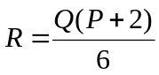

P = −5
Q = 20

Work out the value of R.

R = ……..…………
(Total 3 marks)

2.

(a) Find the size of the angle marked x°

………………..°
(2)
(b) Give a reason for your answer.

………………………………………………………………………………………………….
(1)
(Total 3 marks)

3. (a) Find the highest common factor of 18 and 24

………………..
(1)
(b) Find the lowest common multiple of 18 and 24

………………..
(1)
(Total 2 marks)

4. Write the fractions 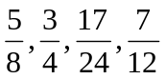 in ascending order.

………………….……
(Total 2 marks)

5. Work out 45% of £24

£…………………
(Total 2 marks)

6. Evaluate
(i) 3⁻²

………………
(ii) 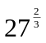

………………
(Total 2 marks)

7. Work out the value of

8.4 ÷ 0.04

….………….…….
(Total 2 marks)

8. (a) (i) Write the number 5.01 × 10⁴ as an ordinary number.

….………..…….
(2)

(ii) Write the number 0.0009 in standard form.

….………..…….
(2)
(Total 4 marks)

9. (a) Factorise
9x² − 6x + 1

….………..…….
(2)
(b) Simplify
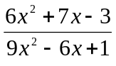

….………..…….
(3)
(Total 5 marks)
Total 25 marks

