GCSE in Mathematics B
Modular 2544
Unit 3 Number, Algebra, Shape Space and Measures 1
Practice Paper C
Higher
(Calculator and Non – Calculator)EDEXCEL
GCSE Mathematics 2540/2544
Formulae sheet — Higher tier

Volume of prism = area of cross-section × length

Volume of sphere = π r³

Surface area of sphere = 4π r²

Volume of cone = π r²h
Curved surface area of cone = π rl

In any triangle ABC

Sine Rule: 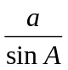 = 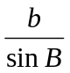 = 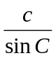
Cosine Rule: a² = b² + c² –2bc cos A
Area of a triangle =  ab sin C
The Quadratic Equation
The solutions of ax² + bx + c = 0, where a ≠ 0, are given by x = 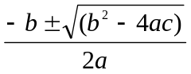
Higher – Section A – Calculator

1. Here are the first five terms of an arithmetic sequences.

1, 5, 9, 13, 17.

(a) Write down the next two numbers of the sequence.

……..………, …………..
(1)

(b) Write down, in terms of n, an expression for the nth term of this sequence.

........................
(2)
(Total 3 marks)

2.
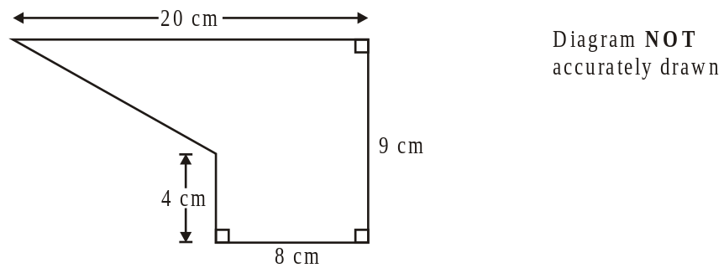

The diagram shows a shape.
Work out the area of the shape.

........................cm²
(Total 4 marks)

3. Change 28 miles to kilometres.

........................... km
(Total 2 marks)

4. Jennifer made x cakes.
She put 4 sweets on top of each cake.

(a) Write down an expression, in terms of x, for the number of sweets she used.

.................................
(1)

Paul made 3 more cakes than Jennifer.
(b) Write down an expression, in terms of x, for the number of cakes Paul made.

.................................
(1)

Paul also put 4 sweets on each of his cakes.

(c) Write down an expression, in terms of x, for the number of sweets Paul used.

………………………
(1)
(Total 3 marks)

5. Jane drove 320 km from her home to the airport.
The travel graph shows Jane’s journey.

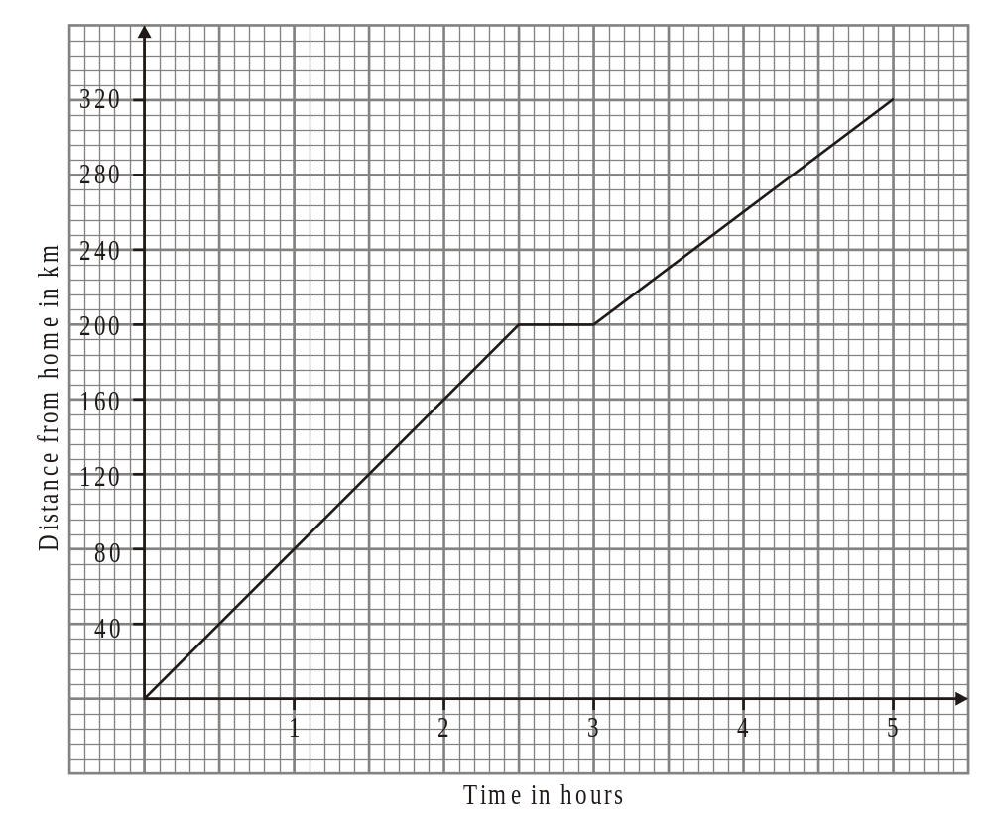

During the journey, Jane stopped for lunch.

(a) (i) For how long did Jane stop for lunch?

…………...................

(ii) How far had Jane travelled in the first 90 minutes?

……..................... km
(2)

(b) Work out the steady speed that Jane travelled at after lunch.

…….....................km/h
(2)
(Total 4 marks)
6. (a) Simplify

(i) t² × t⁵

…………...................
(1)

(ii) 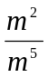

…………...................
(1)

(iii) 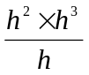

…………...................
(1)

(b) Expand and simplify

(i) 4(2x + 5) − 3(x − 1)

…………...................
(2)

(ii) (2x + 3)(x − 2)

…………...................
(2)

(iii) (3x − 2)²

…………...................
(2)
(Total 9 marks)

Total: 25 marks
Higher – Section B – Non - Calculator

1. Using the information that:

73 × 154 = 11 242

write down the value of

(i) 7.3 × 1.54

…………...................

(ii) 112 420 ÷ 0.73

…………...................
(Total 2 marks)

2. (a) Find the Highest Common Factor of 75 and 90

………………..
(2)
(b) Find the Lowest Common Multiple of 75 and 90

………………..
(2)
(Total 4 marks)

3. Work out 60% of 5300 kg.

……………….. kg
(2)
(Total 2 marks)

4.

(a) (i) Work out the value of x°.

x = ……….……
(ii) Explain how you worked out your answer.

……………………………………………………………………….……….…

……………………………………………………………………….….………
(2)
(b) (i) Work out the value of y°.

y = ……….……
(ii) Explain how you worked out your answer.

……………………………………………………………………….……….…

……………………………………………………………………….….………
(2)
(Total 4 marks)

5. (a) Complete the table of values for y = 2x − 3

x | −3 | −2 | −1 | 0 | 1 | 2 | 3
y | −9 |  | −5 |  |  |  | 3

(2)

(b) On the grid, draw the graph of y = 2x − 3

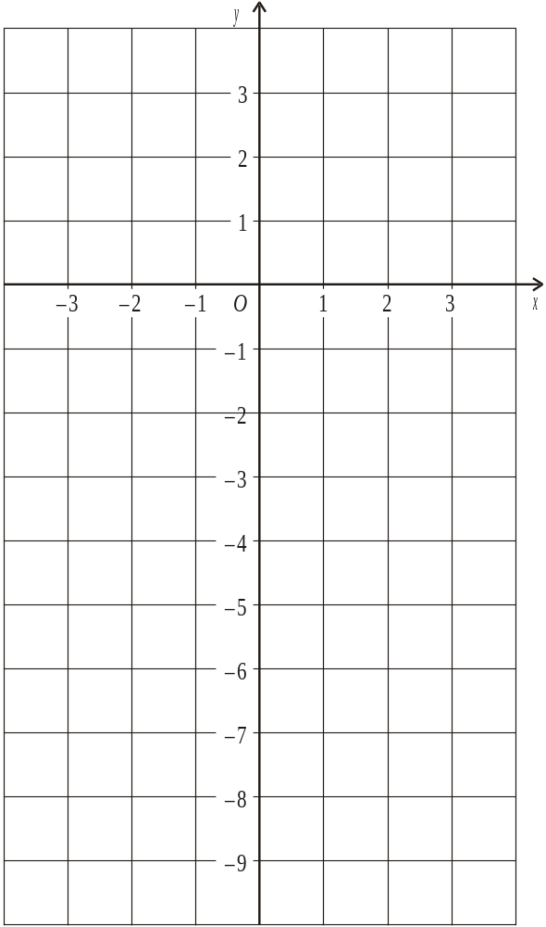
(2)
(Total 4 marks)

6. Convert the recurring decimal 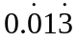 to a fraction.

………………
(Total 3 marks)

7. Find the value of

(i) 10⁻²

………………
(ii) 7⁰

………………
(iii) 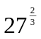

………………
(Total 3 marks)

8. Express

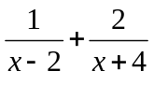

as a single algebraic fraction.

….………….…….
(Total 3 marks)

Total 25 marks

