GCSE in Mathematics B
Modular 2544
Unit 3 Number, Algebra, Shape Space and Measures 1
Practice Paper D
Higher
(Calculator and Non – Calculator)EDEXCEL
GCSE Mathematics 2540/2544
Formulae sheet — Higher tier

Volume of prism = area of cross-section × length

Volume of sphere = π r³

Surface area of sphere = 4π r²

Volume of cone = π r²h
Curved surface area of cone = π rl

In any triangle ABC

Sine Rule: 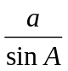 = 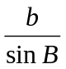 = 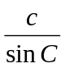
Cosine Rule: a² = b² + c² –2bc cos A
Area of a triangle =  ab sin C
The Quadratic Equation
The solutions of ax² + bx + c = 0, where a ≠ 0, are given by x = 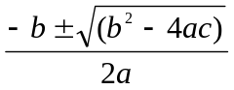
Higher – Section A – Calculator

1. Here are the first four terms of an arithmetic sequences.

3 7 11 15

Write down, in terms of n, and expression for the nth term of the sequence.

……..…………..
(Total 2 marks)

2. (a) Express 120 as the product of powers of its prime factors.

..........................
(3)
(b) Find the Lowest Common Multiple of 120 and 150

.........................
(2)
(Total 5 marks)

3. The point P lies on the circumference of a circle, centre O.

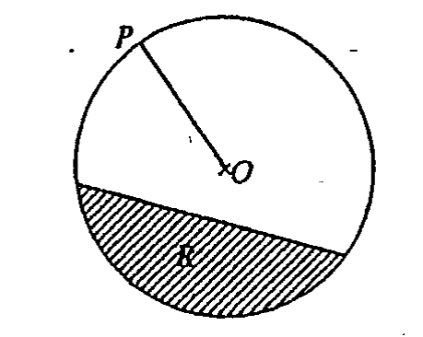

Write down the special name for

(i) the line OP,

................................

(ii) the shaded region marked R.

................................
(Total 2 marks)

4. (a) Expand

4a(2a + 3)

.................................
(2)

(b) Simplify

2x³y² × 3x²y³

.................................
(2)
(Total 4 marks)

5. 9.8 has been rounded to 1 decimal place.

(a) Write down the maximum value of 9.8

…………...................
(1)

(b) Write down the minimum value of 9.8

…….........................
(1)
(Total 2 marks)

6. (a) Factorise x² − 10x

…………...................
(1)

(b) Factorise x² + 2x − 15

…………...................
(2)
(Total 3 marks)

6. Change the decimal 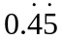 into a fraction in its lowest terms.

…………...................
(1)
(Total 3 marks)

8.
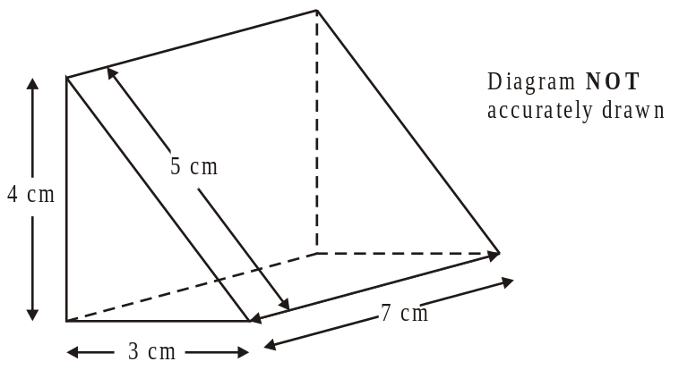

Calculate the volume of the triangular prism.
Write the units for your answer.

….…………. ..................
(Total 4 marks)

Total: 25 marks
Higher –Section B – Non-Calculator

1.

Azia and Jean answered the same question.

Azia said that 5 + 3 × (6 − 4) is 11
Jean said that 5 + 3 × (6 − 4) is 16

Explain who is correct.

……………………………………………………………………..……………………

…………………………………………………………………….…………….………

………………………………………………………………………………..…………

(Total 2 marks)

2. 32 × 129 = 4128

Write down the value of

(i) 3.2 × 1.29

………………..
(2)
(ii) 0.32 × 129 000

………………..
(2)
(Total 4 marks)

3. x = −4
y = 5

Work out the value of 3x + 2y

………………..
(Total 2 marks)

4. Write these numbers in order of size.
Start with the smallest number.

0.4 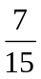 35% 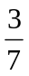

……………..…….……
(Total 2 marks)

5. Work out 20% of 1 800

……………..…….……
(Total 2 marks)
6. (a) Write 3.8 × 10³ as an ordinary number.

…………………..…
(1)
(b) Write the number 0.00045 in standard form.

…………………..…
(1)
(Total 2 marks)

7. (a) Simplify

(i) 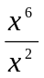

………………
(ii) (y⁴)³

………………
(2)
(b) Expand and simplify (t + 4)(t − 2)

………………
(2)
(Total 4 marks)

8.

Find the size of the angle marked y.
Give your reason for your answer.

y = …….…….°

…………………………………………………………………………………………………..

…………………………………………………………………………………………………..
(Total 2 marks)

9. (a) Change 5.7 kilometres to metres.

……………… m
(1)

(b) Change 8.31 mm to cm.

……………… cm
(1)
(Total 2 marks)

10. Write as a single fraction in its simplest form.

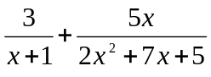

…….…………………..…..
(Total 3 marks)

Total 25 marks

