GCSE in Mathematics B
Modular 2544
Unit 3 Number, Algebra, Shape Space and Measures 1
Practice Paper G
Higher
(Calculator and Non – Calculator)EDEXCEL
GCSE Mathematics 2540/2544
Formulae sheet — Higher tier

Volume of prism = area of cross-section × length

Volume of sphere = π r³

Surface area of sphere = 4π r²

Volume of cone = π r²h
Curved surface area of cone = π rl

In any triangle ABC

Sine Rule: 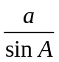 = 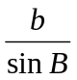 = 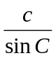
Cosine Rule: a² = b² + c² –2bc cos A
Area of a triangle =  ab sin C
The Quadratic Equation
The solutions of ax² + bx + c = 0, where a ≠ 0, are given by x = 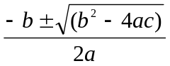
Higher – Section A – Calculator

1. Simplify
(a) 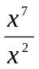

……..………….………..
(1)
(b) 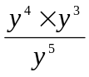

……..………….………..
(1)
(c) Simplify (3xy³)⁴

……..………….………..
(2)
(Total 4 marks)

2.

Work out the area of the shape.

……..………….m²
(Total 4 marks)

3. .

The diagram shows a cuboid.

(a) Work out the volume of the cuboid.

.......................... cm³
(1)
A rectangular box measures 80 cm by 90 cm.
The rectangular box is packed with cuboids like the one above.

(b) Work out the greatest number of cuboids the box can hold.

……..………….
(2)
(Total 3 marks)

4. Draw the graph of y = 5x − 2 on the grid below.

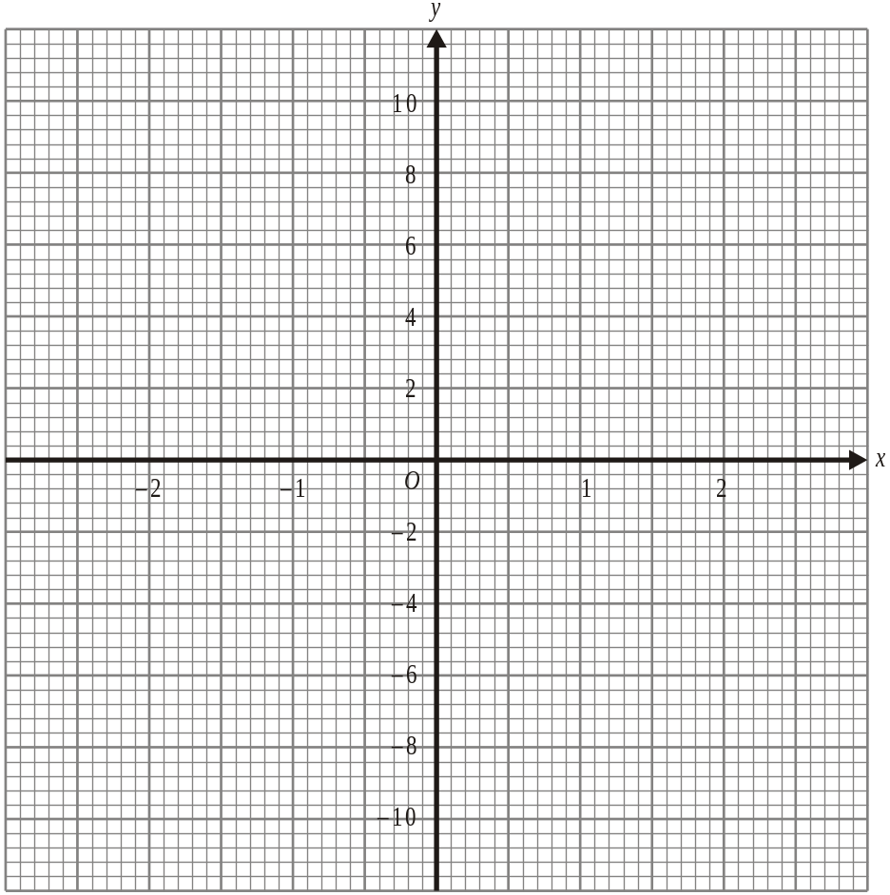

(Total 3 marks)

5.
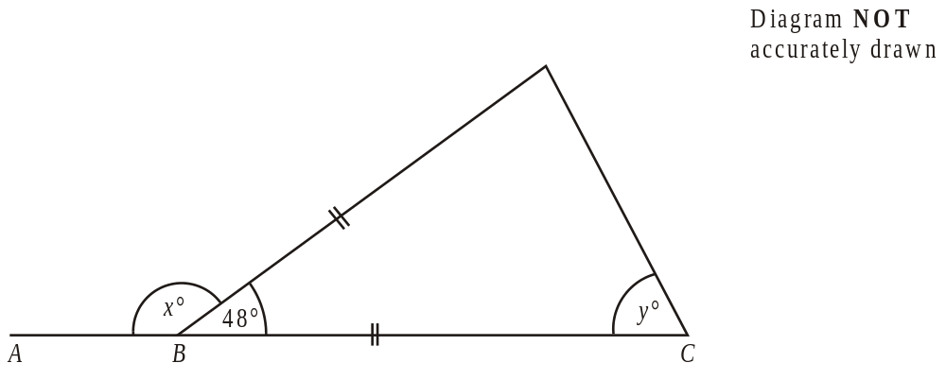
ABC is a straight line.

(a) Work out the size of the angle marked x°

.................................°
(1)
(b) (i) Work out the size of the angle marked y°

................................°

(ii) Give reasons for your answer.

………………………………………………………………………………………….

………………………………………………………………………………………….
(3)
(Total 4 marks)

6. Using the information that 17 × 19 = 323

write down the value of

(i) 0.17 × 1.9

.................................
(1)

(ii) 323 ÷ 0.019

.................................
(1)
(Total 2 marks)

7. (i) Write 0.053 in standard form.

......................
(1)

(ii) Write 672 × 10⁸ in standard form.

.......................
(1)
(Total 2 marks)

8. Simplify fully

(i) m⁴ × m⁵

…........................
(1)

(ii) 5x³y × 2xy⁸

…........................
(1)

(iii) 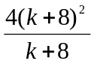

…........................
(1)
(Total 3 marks)
Total: 25 marks
Higher –Section B – Non-Calculator

1. P = Q² − 2Q

Find the value of P when Q = −3

P = ………………..
(Total 2 marks)

2. Work out

2.56 × 4.5

………………..
(Total 3 marks)

3. Here are some patterns made with crosses.

 |  | X |  |  |  |  | X |  | X |  |  |  | X |  | X |  | X
 | X |  | X |  |  | X |  | X |  | X |  | X |  | X |  | X |  | X
 | X |  | X |  |  | X |  | X |  | X |  | X |  | X |  | X |  | X
Pattern number 1 |  |  |  |  |  | Pattern number 2 |  |  |  |  |  | Pattern number 3

 | X |  | X |  | X |  | X
X |  | X |  | X |  | X |  | X
X |  | X |  | X |  | X |  | X
Pattern number 4

The table shows the number of crosses in Pattern Numbers 1, 2, 3 and 4.

Pattern Number (n) | 1 | 2 | 3 | 4
Number of crosses (C) | 5 | 8 | 11 | 14

Write down the formula for the number of crosses, C in terms of the Pattern Number, n.

C = ………………..
(Total 2 marks)

4. Simplify 2pq + pq

…..…….……
(1)

Expand and simplify 3(2x − 1) − 2(2x − 3)

…..…….……
(2)
(Total 3 marks)

5.
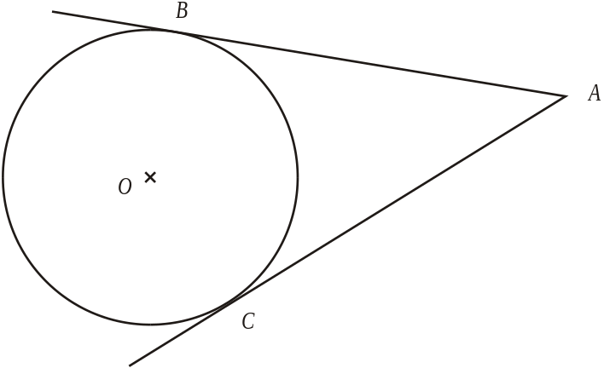
B and C are points on a circle, centre O.
AB and AC are tangents to the circle.
Angle BOC = 108°.
Work out the size of angle BAO.
Give a reason for each stage in your working.

............................°
(Total 3 marks)

6. Work out (9.88 × 10⁸) ÷ (2.6 × 10²)
Give your answer in standard form.

…………………..…
(Total 2 marks)

7. Fred runs 200 meters in 21.2 seconds.

Work out Fred’s average speed.
Write down all the figures on your calculator display.

…………………………….. meters per second
(Total 2 marks)

8. The number 1104 can be written as 3 × 2^{c} × d, where c is a whole number and d is a prime number.

Work out the value of c and the value of d.

c = ……….…………
d = ……….…………

(Total 2 marks)

9. Simplify fully:

(i) p⁶ ÷ p

…........................
(1)

(ii) 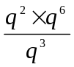

…........................
(2)
(Total 3 marks)

10. Use your calculator to work out the value of

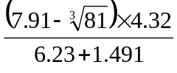

Give your answer correct to 3 significant figures.

………………
(Total 3 marks)

Total 25 marks

