CT942 — Cyber Security Project
Tutorial 2 · Week 2 Workshop
Business & Problem Analysis — Current Situation and Root Cause
Unit | ICT942 — Cyber Security Project | Assessment | Assessment 1 — Group Report & Portfolio (20%)
Mode | Group + Individual | Feeds into | Week 5 portfolio (Weeks 1–5 deliverables)
This week's focus | Week 2 — Business & Problem Analysis | Submission | Weekly Teams evidence + final Word report via Turnitin

How to use this template
This workshop builds the Week 2 (Business & Problem Analysis) section of your Assessment 1 portfolio. Wherever you see a blue [ ... ] prompt, replace it with your own text, figure or link — keep the surrounding structure.
Every claim needs a source and date. Carry your Week 1 charter scope and stakeholders forward so the analysis stays aligned.
AI note: you may use AI for research only. The report itself must be written by your team.

Where Week 2 sits in Assessment 1
Week 2 turns your Week 1 charter into an evidence-based analysis of the organisation and the problem. Together with Week 1 it is assessed under Rubric Criterion 1 (Project Charter & Business Problem Analysis, Weeks 1–2).
Week | Deliverable produced | Portfolio / rubric section
1 | Project Charter & Stakeholder Analysis | Charter, stakeholders — Rubric 1
2 | Business & Problem Analysis (today) | Organisation, root cause, SWOT — Rubric 1
3 | Requirements Elicitation Report | Stakeholder / functional / NFRs — Rubric 2
4 | Software Requirements Specification (SRS) | Use cases, acceptance criteria — Rubric 2
5 | Feasibility & Risk Analysis + full portfolio | Feasibility, risk register — Rubric 3 & 4

Tutorial learning outcomes
- Describe the organisation, business process and cybersecurity context.
- Develop an evidence-based problem statement and root-cause analysis.
- Use SWOT carefully without turning it into four boxes of random adjectives.
- Translate findings into preliminary business requirements.

Suggested class plan (3 hours)
Time | Activity | Evidence produced
0–25 min | Lecturer demonstration: current-state analysis, symptoms versus causes, evidence quality. | Worked example
25–75 min | Group task: organisation and current-process analysis. | Current-state narrative / process map
75–115 min | Root-cause analysis using 5 Whys or fishbone. | Root-cause diagram
115–145 min | Cybersecurity-focused SWOT and problem statement. | SWOT + revised statement
145–165 min | Draft business requirements and Jira updates. | Requirement summary
165–180 min | Individual analysis and submission. | Personal evidence paragraph

Part 1 — Evidence collection
Use the client briefing, supplied documents, supervisor guidance and credible external sources. Separate facts, assumptions and unanswered questions. Record the source and date for each important claim.
“We think” is not an evidence category
Fact: something a source confirms — cite it (source + date).
Assumption: something you believe but must validate — flag it.
Unknown: a question you still need answered — track it for Week 3 elicitation.

Evidence log
Claim / finding | Type (fact/assumption/unknown) | Source & date
MedTalk integrates with Best Practice via the Halo Connect tool, using the FHIR data standard | Fact | FAZ Australia project brief, 2026
No synthetic (fake) test environment currently exists for validating MedTalk's integrations before release | Assumption | Inferred from project brief scope, 2026 — to confirm with mentor
Failure conditions (slow response, malformed data, dropped connection) are not currently tested in a structured way | Unknown | To confirm with FAZ Australia mentor, Week 3
SNOMED CT-AU to ICD-10-AM/MBS code mapping is not currently verified through an automated test process | Assumption | Inferred from brief — to validate at kickoff meeting
No documented architecture diagram of MedTalk's external connections currently exists | Assumption | Inferred from brief listing this as a new Stage 1 deliverable

Part 2 — Group tasks

Task 2.1 — Organisation & Process Profile
Summarise the industry sector, business model, critical services, key information assets and the business process affected by the cybersecurity problem.
Industry sector | Health technology / digital health software, serving Australian medical practices; operates within the regulated healthcare sector governed by the Privacy Act 1988 (APPs) and the My Health Records Act
Business model | FAZ Australia licenses its MedTalk AI clinical-documentation product (an “AI medical scribe”) to medical practices on a subscription basis; the product's value depends on it reliably and accurately exchanging data with the practice-management and hospital systems clinics already run
Critical services / products | MedTalk AI scribe (automated clinical note drafting); integration connectors to clinic systems such as Best Practice (via Halo Connect) and hospital record systems; SNOMED CT-AU to ICD-10-AM/MBS code translation
Key information assets | Clinical documentation content, FHIR message exchanges with clinic/hospital systems, coded clinical terminology mappings, and the reliability of the connection between MedTalk and practice systems
Affected business process | The process by which MedTalk's integrations with external clinic and hospital systems are validated and tested before a new connector or update is released to a live clinic

Current-state process diagram
Create a simple diagram of how the affected process currently operates.
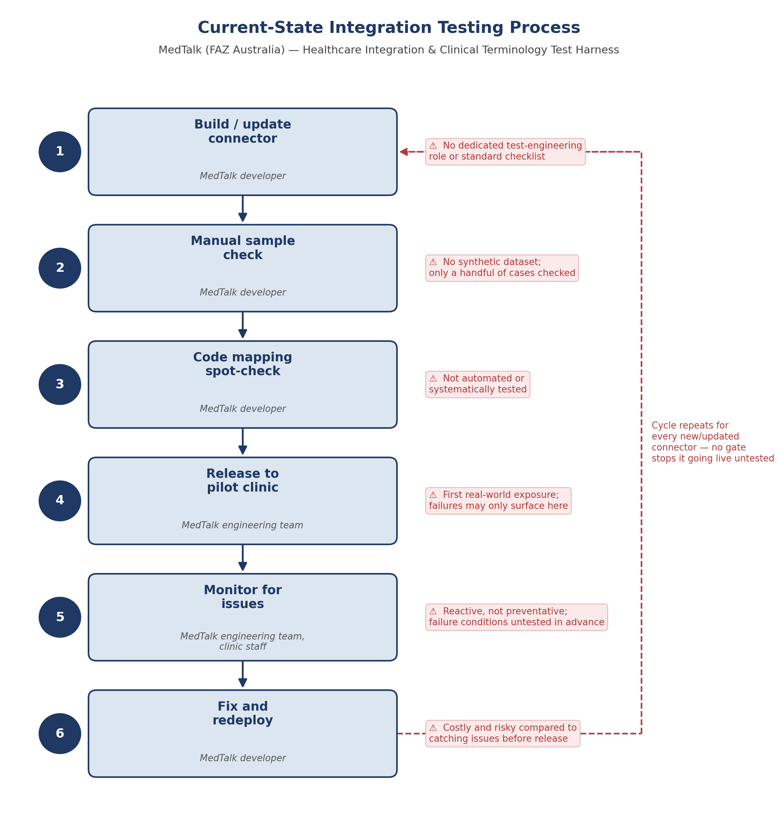
Figure 1. Current-state process

Task 2.2 — Challenge & Impact Table
Record each observed issue with its supporting evidence, the affected stakeholder, the business/cyber impact and any unknowns still to resolve.
Observed issue | Evidence | Affected stakeholder | Business / cyber impact | Unknowns
No synthetic test environment exists to validate integrations before release | Project brief states testing today would otherwise touch real systems, implying no dedicated safe test environment currently exists | MedTalk engineering team | New integration bugs can only be caught in a live clinic, risking clinical data errors and compliance exposure | How integration issues have historically been identified pre-launch — to confirm with mentor
Failure conditions (slow response, malformed data, dropped connection) are not systematically tested | Brief explicitly calls for a new test plan covering what should happen when things go wrong, as a Stage 1 deliverable | MedTalk engineering team; clinics using MedTalk | An unhandled failure during a live consultation could disrupt clinical documentation or lose data | Frequency/severity of past failure incidents — to ask at kickoff
SNOMED CT-AU to ICD-10-AM/MBS code translation is not automatically tested | Brief requires working out this translation as new project work, implying no current automated verification | Clinics (billing accuracy); Medicare/compliance | Incorrect code mapping could cause billing errors or clinical miscoding | Current manual QA process for code mapping, if any
No synthetic (made-up) patient dataset currently exists for safe testing | Brief specifies designing a synthetic SNOMED CT-AU dataset as a new deliverable | MedTalk engineering team; FAZ Australia compliance | Any interim testing today likely risks touching real or production-like data | Whether any test data currently exists in any form
No documented architecture diagram of MedTalk's external connections currently exists | Brief requires an architecture diagram as a new Stage 1 deliverable, implying none exists yet | MedTalk engineering team; new team members/contractors | Onboarding and troubleshooting integration issues is harder without a clear reference diagram | Whether any informal/internal diagrams already exist

Task 2.3 — Root-Cause Analysis
Choose one major problem and apply either 5 Whys or a fishbone diagram. Categorise causes across people, process, technology, governance and external environment. Distinguish root causes from consequences.

Problem selected
MedTalk's connections to clinic and hospital systems cannot be validated safely before going live, because no synthetic test environment, failure-mode test plan, or automated code-mapping checks currently exist.

Method & diagram
Paste your 5 Whys chain or fishbone diagram.
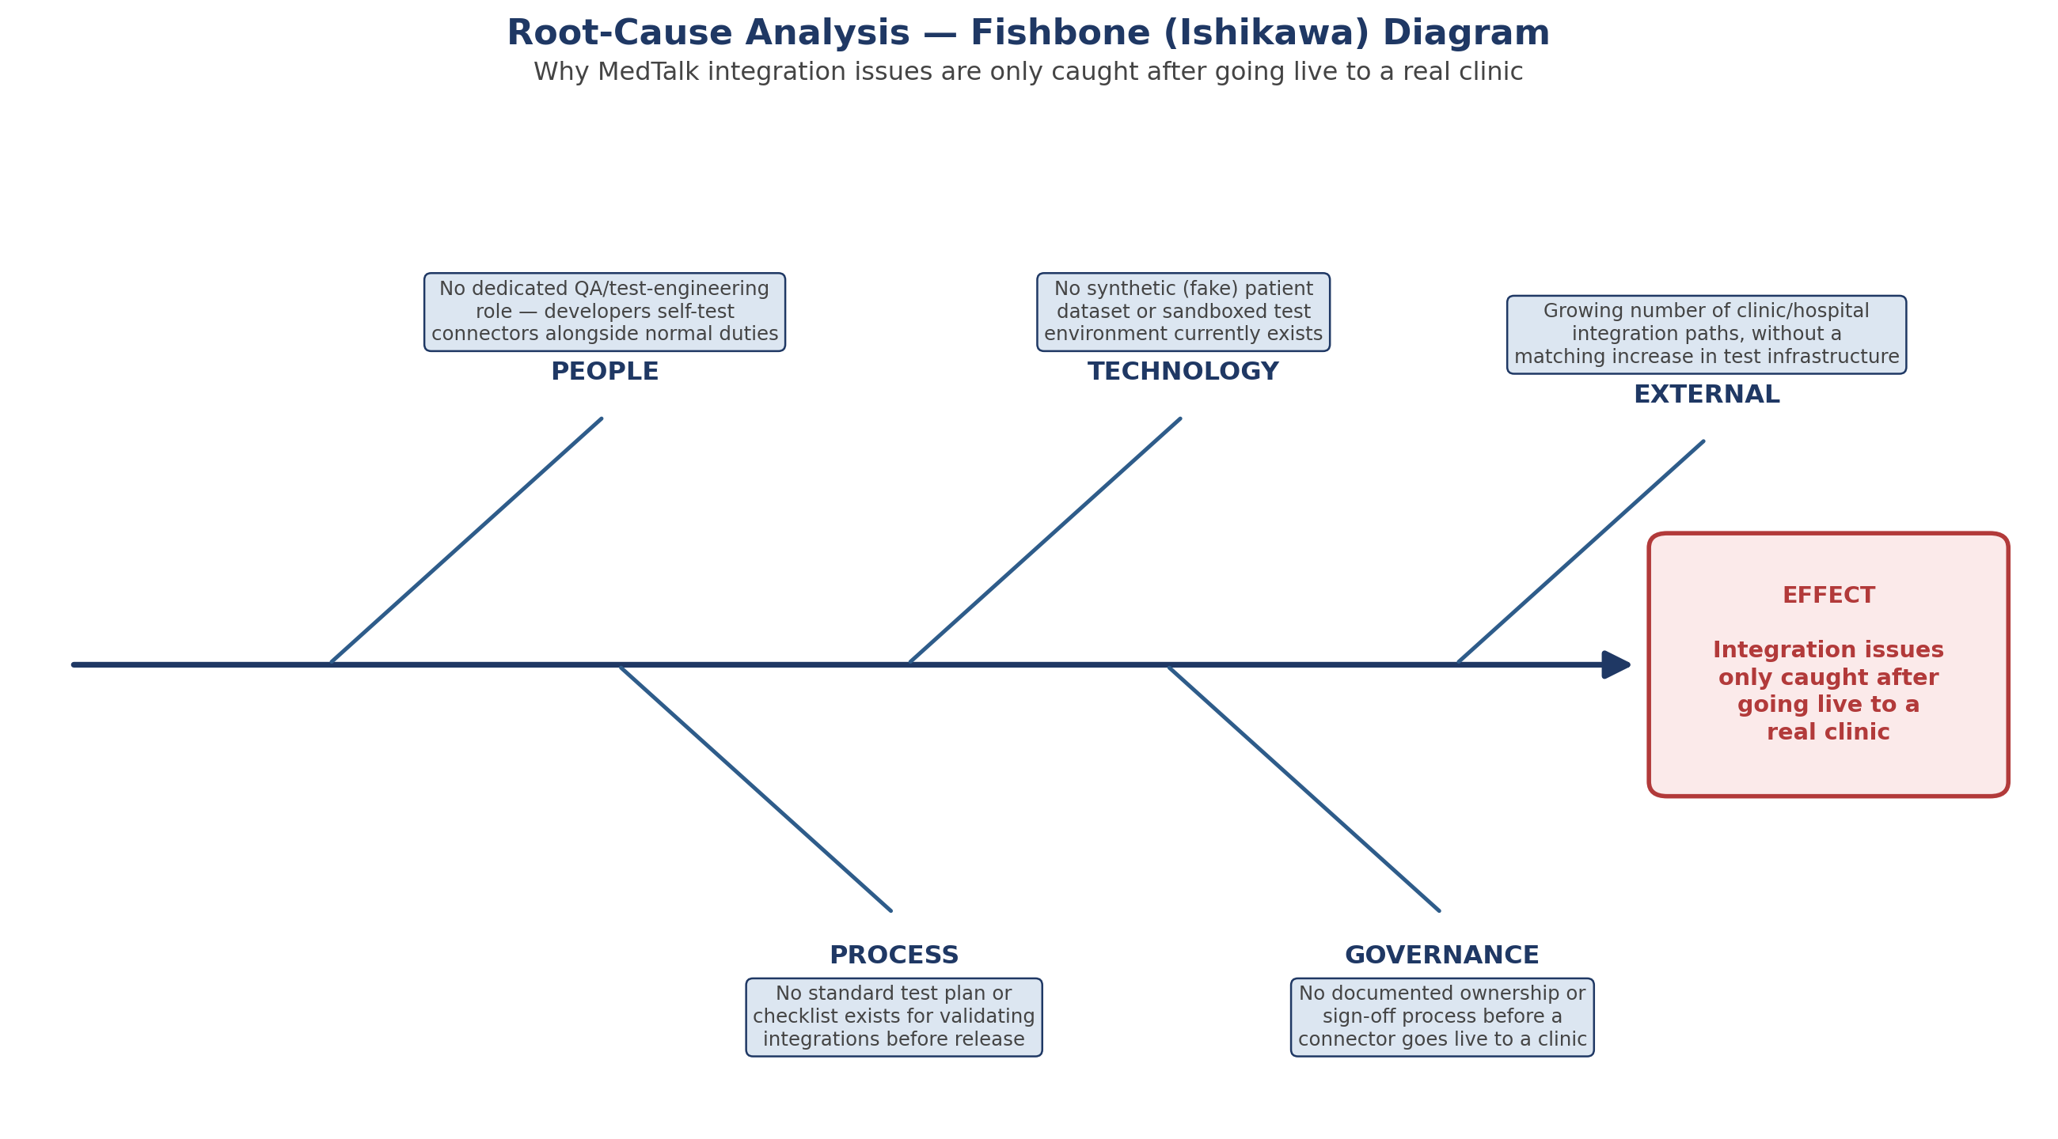
Figure 2. Root-cause analysis

Causes by category
Category | Root cause(s) identified
People | No dedicated QA/test-engineering role; developers self-test connectors alongside normal feature-development duties
Process | No standard test plan or checklist exists for validating new or updated integrations before release
Technology | No synthetic (fake) patient dataset or sandboxed test environment currently exists
Governance | No documented ownership or sign-off process for integration testing before a connector goes live to a clinic
External environment | A growing number of clinic and hospital-system partners increases the number of integration paths to test, without a matching increase in test infrastructure

Task 2.4 — Cybersecurity SWOT
Each item must be specific to the organisation and linked to evidence — not a generic adjective. Then add a short interpretation of which factors most affect the proposed project.
Strengths | Weaknesses
MedTalk is already a working, in-market product used by real medical practices across Australia (project brief)  Existing use of standard, well-documented integration formats (FHIR) and code sets (SNOMED CT-AU) gives a clear technical foundation to test against | No current synthetic test environment or made-up patient dataset, so new integrations are effectively tested against real-world conditions  No documented failure-mode test plan for slow responses, bad data, or dropped connections
Opportunities | Threats
FHIR and SNOMED CT-AU are established Australian/international standards with public documentation, so a synthetic dataset and test harness can be built without guessing at undocumented APIs  A reusable test harness could later help FAZ Australia onboard new clinic and hospital partners faster, beyond this project's scope | Healthcare is one of the most-breached and heavily regulated sectors under the Privacy Act 1988 (APPs) and My Health Records Act, so any real-data mishandling carries high compliance risk  Incorrect SNOMED CT-AU to ICD-10-AM/MBS mapping could cause billing or clinical coding errors affecting a clinic's Medicare claims

Interpretation
Explain which SWOT factors most affect the proposed project — do not leave the four boxes to speak for themselves.
The weaknesses and threats matter most to this project. The absence of a synthetic test environment and failure-mode test plan (Weaknesses) directly explains why the project exists, and both are made urgent by the Threats: healthcare's high regulatory exposure under the Privacy Act and My Health Records Act means any testing mistake involving real data would be serious, and incorrect code mapping could cause real billing errors for a clinic. The Strengths and Opportunities — an already-working product and well-documented standards like FHIR and SNOMED CT-AU — are what make the project achievable within a single semester, since the team is not designing these standards from scratch, only building a safe way to test against them.

Task 2.5 — Preliminary Business Requirements
Draft 6–10 high-level business requirements. Express outcomes, not products, using the format below. Avoid detailed system functions until Week 3 elicitation.
Required format
“The organisation needs the capability to ______ so that ______.”
ID | Business requirement (capability … so that …)
BR1 | The organisation needs the capability to test new and updated MedTalk integrations against a safe, synthetic patient dataset, so that real patient data is never exposed during testing.
BR2 | The organisation needs the capability to validate FHIR message exchange with clinic and hospital systems, including Best Practice's Halo Connect, so that integration errors are caught before a connector goes live.
BR3 | The organisation needs the capability to verify how MedTalk behaves when a connection is slow, sends malformed data, or drops entirely, so that failures during a live consultation do not go unnoticed or unhandled.
BR4 | The organisation needs the capability to automatically test SNOMED CT-AU to ICD-10-AM and MBS code mapping, so that clinical coding and billing errors are caught before reaching a real clinic.
BR5 | The organisation needs the capability to reference a clear architecture diagram of MedTalk's external connections, so that engineers and new team members can understand and troubleshoot integrations quickly.
BR6 | The organisation needs the capability to produce a repeatable pass/fail test report for each integration release, so that the team has documented evidence of what was tested before going live.

Part 3 — Individual task
Select one identified challenge and write 200 words critically explaining its cause, impact and evidence. Add one reference or client evidence item and identify one assumption that must be validated. (This supports the Part B individual reflection due in Week 5.)

Your 200-word critical analysis
One of the clearest gaps identified in FAZ Australia's current integration process is the absence of systematic testing for failure conditions — for example, what happens when a connected system such as Best Practice's Halo Connect responds slowly, sends malformed data, or drops the connection mid-exchange. The project brief explicitly calls for a dedicated test plan covering these scenarios, which strongly suggests no such plan exists today. The underlying cause traces back to FAZ Australia's small team size: as a fast-growing startup, engineering effort has understandably been prioritised toward shipping new MedTalk features rather than building dedicated test infrastructure, and there is no specific role responsible for integration test engineering. The business impact is significant: an unhandled failure during a live doctor–patient consultation could interrupt clinical note-taking or, worse, silently lose or corrupt data being sent to a clinic's record system, creating both a clinical safety risk and a compliance exposure under the Privacy Act. One assumption I need to validate with our mentor is whether any informal failure-handling logic already exists inside MedTalk's connectors, since the brief describes this as a gap to close rather than stating it is entirely absent.

Your evidence this week
Your name | Sonam Pelden
Reference / client evidence item | FAZ Australia Healthcare Integration & Clinical Terminology Test Harness project brief, 2026
Assumption to be validated | Whether any informal failure-handling logic already exists inside MedTalk's connectors today
Jira task (title + link) | https://student-team-siuckpgv.atlassian.net/jira/software/projects/HITH/boards/34/backlog?epics=visible&atlOrigin=eyJpIjoiY2FjMzcwMzM0NmFmNDQxNTkwZDExZjZmYzg0YjMxOTUiLCJwIjoiaiJ9
GitHub contribution (commit / PR link) | https://github.com/SkinnySeal17/HEAALTHCARE_SYSTEM.git

Teams Classroom submission — before leaving class
Submit each item to the Week 2 Teams Classroom assignment
☐ Organisation and current-process analysis
☐ Current-state process diagram
☐ Challenge and impact table
☐ Root-cause diagram
☐ Cybersecurity SWOT with interpretation
☐ Preliminary business requirements
☐ Each member's 200-word individual analysis

Lecturer facilitation guide
- Ask students what evidence supports each claimed challenge. “We think” is not an evidence category, despite its alarming popularity.
- Ensure the problem statement includes who is affected, what is occurring, why it matters and the current gap.
- Challenge SWOT items that are generic or duplicated.
- Check that business requirements express outcomes rather than specific products.

Common problems to correct
Students describe instead of analyse.
Claims are not linked to client evidence.
Requirements are vague, untestable or solution-biased.
Jira tasks do not match report sections.
One student completes all documentation while others leave only decorative footprints in the activity log.

How today's work feeds the Week 5 report
Tutorial output | Assessment section | Refinement before final submission
Organisation profile and process map | Week 2: Organisation Overview and Current Situation | Use concise prose and caption the process diagram.
Root-cause analysis | Week 2: Root Cause Analysis | Explain why selected causes are credible and how they relate.
SWOT and business requirements | Week 2: SWOT and Business Requirements Summary | Interpret implications rather than presenting isolated lists.

Marks this week's work supports
Rubric Criterion 1 — Project Charter & Business Problem Analysis (4 marks).
Rubric Criterion 4 — Portfolio Quality, Integration & Professional Communication (3 marks).
Rubric Criterion 5 — Individual Reflection & Professional Development (4 marks), via your evidence.

