Minutes Of Meeting
Project: White-Label Healthcare Integration Test harness
Meeting Type: Project Discussion and Team workshop
Date: 10Aug2026
Duration: Approximately 115min
Attendees:
- Project Supervisor- Md Ashraf Uddin
- Rikesh Aryal
- Charity Gwese
- Sonam Pelden
- Zubair Adil Soomro

Agenda
- Understanding project product.
- Identifying required skill set and steps to develop the test harness
- Team roles defined
- GitHub structure setup
- Project roadmap defined

Understanding Project product
- Along with the help of the Supervisor to analyse the project brief, the team aligned on the purpose of the test harness it should validate synthetic clinal data and integration workflows using FHIR interoperability standards.
- Synthethis dataset generation coded using SNOMED-ACT-AU.
- Integration execution, automated or semi-automated validation.
- Failure mode simulation and reporting.

Skill Set
- The team discussed the required skillset which are:
- Backend developer (API orchestration, workflows, data handling)
- Healthcare interoperability familiarity (FHIR basics, mapping concepts)
- Testing skills and documentation.
- Error handling

Team roles
- Sonam (BA & Documentation Lead)
- Charity (Clinical Data Specialist)
- Rikesh (Integration & FHIR Specialist)
- Zubair (Testing & QA Lead)

GitHub structure
- The team agreed to organise the repository in a clear separation folders/ components like meeting minutes, diagrams, weekly tutorials, documents for all research.
- Everyone would also have branch which we would merge at each assignment submission or if not required not to merge them.

Roadmap
- The team defined the roadmap of the project for stage 1 into 10weeks according to the objectives provided in the project brief.
- Below is a screenshot of the roadmap.
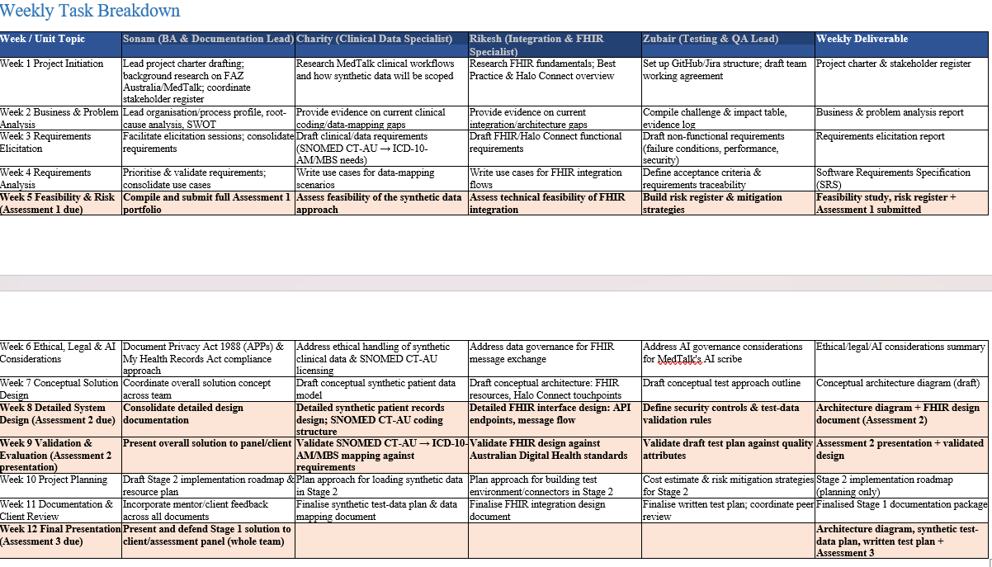

Next meeting
Weekly project progress meeting 17 August 2026

