ICT942 — Cyber Security Project
Tutorial 1 · Week 1 Workshop
Establishing the Project, Team Evidence and Governance
Unit | ICT942 — Cyber Security Project | Assessment | Assessment 1 — Group Report & Portfolio (20%)
Mode | Group + Individual | Feeds into | Week 5 portfolio (Weeks 1–5 deliverables)
This week's focus | Week 1 — Project Charter & Stakeholder Analysis | Submission | Weekly Teams evidence + final Word report via Turnitin

How to use this template
This workshop builds the Week 1 section of your Assessment 1 portfolio. Wherever you see a blue [ ... ] prompt, replace it with your own text, figure or link — keep the surrounding structure.
Save your evidence links (Jira, GitHub) as you go: the same links are reused in Weeks 2–5 and in your final submission.
AI note: you may use AI for research only. The report itself must be written by your team.

Assessment 1 at a glance — the five-week journey
Assessment 1 is a portfolio built one week at a time. Today (Week 1) you produce the first section. Keep every artefact in GitHub and Jira so it can be refined into the final 4,000-word report due in Week 5.
Week | Deliverable produced | Portfolio / rubric section
1 | Project Charter & Stakeholder Analysis (today) | Charter, stakeholders — Rubric 1 (Weeks 1–2)
2 | Business & Problem Analysis Report | Organisation, root cause, SWOT — Rubric 1
3 | Requirements Elicitation Report | Stakeholder / functional / non-functional reqs — Rubric 2
4 | Software Requirements Specification (SRS) | Use cases, acceptance criteria — Rubric 2
5 | Feasibility & Risk Analysis + full portfolio | Feasibility, risk register — Rubric 3 & 4

Tutorial learning outcomes
- Interpret the industry project brief and define the cybersecurity problem in context.
- Create a project charter with measurable objectives, boundaries and success criteria.
- Identify and prioritise stakeholders using interest and influence.
- Establish the Jira and GitHub evidence required for Assessment 1 and invite your supervisor.

Suggested class plan (3 hours)
Time | Activity | Evidence produced
0–20 min | Lecturer briefing: assessment structure, rubric, portfolio evidence and examples of strong/weak project scope. | Annotated assessment map
20–45 min | Group formation and role allocation. | Team agreement and role table
45–95 min | Group workshop: project background, objectives, scope and success criteria. | Draft project charter
95–125 min | Stakeholder mapping and power–interest analysis. | Stakeholder register and matrix
125–155 min | Jira/GitHub setup; invite supervisor; create initial backlog and repository folders. | Links and screenshots
155–180 min | Individual checkpoint and Teams submission. | Individual contribution statement

Part 1 — Lecturer mini-lesson
Explain the difference between a business symptom, a cybersecurity problem and a proposed solution. Students should not jump directly from “the organisation has phishing incidents” to “build an AI platform”.
Worked example — symptom vs problem vs solution
Symptom: “Staff keep clicking malicious links.”
Problem (analytical): “The onboarding process lacks mandatory phishing-awareness controls, so new staff can action external payment requests without verification, creating a business-email-compromise risk.”
Solution (comes later): a specific control or system — do not decide this yet.

Your notes from the mini-lesson
Key takeaways from the Week 1 mini-lesson: a project charter is a short (1–3 page), stable document that authorises a project and states why and what — never how it will be built (PMBOK® 7). It has six sections: overview, background, objectives, scope, stakeholder analysis and success criteria, matching our report template exactly. Objectives must be SMART — e.g. "improve security and make staff more aware" is weak, while a strong objective names one outcome, a measurable target, a realistic 12-week scope and a deadline. Scope needs an explicit out-of-scope list, since scope creep (uncontrolled, unapproved expansion) is described as the number-one killer of student and industry projects alike; any change should be logged in Jira and approved before work starts. Stakeholder analysis uses a register (role, interest, influence, engagement approach) plus Mendelow's power–interest grid to decide how to engage each quadrant — manage closely, keep satisfied, keep informed, or monitor. Success criteria are distinct from objectives: objectives state what we will achieve, success criteria state how everyone will agree we achieved it, and should be observable/verifiable at project close — including a criterion for professional practice evidenced through weekly GitHub commits and Jira activity from every member. The worked example (SecureCare Health, a phishing-resilience project) showed this structure end-to-end and is the model we followed when drafting our own Healthcare Integration & Clinical Terminology Test Harness charter below.

Part 2 — Group tasks

Task 1.1 — Team Working Agreement
Complete a one-page agreement covering roles, communication channel, meeting frequency, expected response time, decision process, file naming, Jira update rules, GitHub commit expectations and conflict escalation.
Item | Agreed by team
Communication channel (e.g. Teams / Discord) | Microsoft Teams (primary), with a group chat for urgent updates
Meeting frequency & day/time | Weekly, Thursdays 6:00–7:00 PM, plus ad hoc calls as needed
Expected response time | Within 24 hours on weekdays
Decision-making process | Majority agreement after discussion; supervisor consulted if unresolved
File naming convention | ICT942_[DeliverableName]_[Version]_[DDMMYY], e.g. ICT942_ProjectCharter_v1_270726
Jira update rules (when tasks are moved) | Tasks moved to “In Progress” when started and “Done” within 24 hours of completion, with a comment describing the work done
GitHub commit expectations | At least two commits per week per member, with clear descriptive messages; no direct commits to the main branch without review
Conflict escalation path | Raised within the team first; if unresolved within 48 hours, escalated to the project supervisor

Roles & responsibilities
Team member | Primary role | This week's outputs
Sonam Pelden | Project Lead & Architecture | Project charter draft, background research, stakeholder register
Charity Gwese | Clinical Data Specialist | Synthetic patient dataset design and SNOMED CT-AU coding plan
Rikesh Aryal | Integration & FHIR Specialist | Research on MedTalk's FHIR implementation and Best Practice/Halo Connect integration, feeding into the architecture diagram
Zubair Adil Soomro | Testing & Documentation Lead | Draft failure-mode test ideas and formatting/proofreading support for the Week 1 report

Task 1.2 — Project Charter
This becomes the “Week 1 – Project Overview” section of your report. Fill in each field below.

1. Project Overview
Project Title | Healthcare Integration & Clinical Terminology Test Harness
Industry Partner | FAZ Australia (MedTalk)
Team Members | Sonam Pelden, Charity Gwese, Rikesh Aryal, Zubair Adil Soomro
Project Supervisor | Md Ashraf Uddin
Date | 27 July 2026

2. Project Background
Brief description of the organization and the business problem (write as academic prose, not bullet notes).
FAZ Australia is a Canberra-based health-technology company whose flagship product, MedTalk, is an AI clinical documentation platform that listens to doctor–patient consultations and automatically drafts structured clinical notes. MedTalk is already used by medical practices across Australia and must connect reliably to the clinical software those practices depend on daily, including practice-management systems such as Best Practice (via its Halo Connect integration tool) and broader hospital record systems, exchanged using the FHIR data standard. As MedTalk's customer base grows, FAZ Australia needs a safe way to test these integrations without risking real patient data. Verifying that MedTalk correctly sends and receives clinical information, correctly maps clinical terminology (SNOMED CT-AU) to billing and diagnostic codes (ICD-10-AM and MBS), and fails gracefully when connections are slow, incorrect, or dropped, would otherwise require testing against live systems, creating unacceptable privacy, compliance and reliability risk. This project addresses that gap by designing and building a synthetic integration test harness: a safe environment populated entirely with made-up patient records that mirrors MedTalk's real-world connections, allowing FAZ Australia's engineers to validate data exchange, code mapping and failure handling before anything goes near a real clinic.

3. Project Objectives (3–5 SMART objectives)
Use measurable verbs and observable outcomes. Avoid naming a solution.
Identify and document all data exchange points between MedTalk and external clinical/hospital systems, including the FHIR standard and Best Practice's Halo Connect tool, by the end of Week 6.
Design a set of synthetic patient records coded in SNOMED CT-AU, with documented mappings to ICD-10-AM and MBS billing codes covering at least 15 clinical scenarios, by Week 10.
Produce a written test plan specifying at least five failure conditions (e.g. slow response, malformed data, dropped connection) and expected system behaviour for each, by Week 12.
Build and execute an automated test suite that validates MedTalk's integration behaviour against the synthetic environment, producing a pass/fail report, by the end of Semester 2.
Present the completed synthetic test environment, test results and documentation to FAZ Australia through a final demonstration and report by the end of Semester 2.

4. Scope
In scope | Out of scope
Design and development of a synthetic (non-real) patient data set and test environment  Mapping and testing of the FHIR-based interface between MedTalk and external systems, including Best Practice/Halo Connect  Translation testing between SNOMED CT-AU, ICD-10-AM and MBS billing codes, including edge cases | Use, storage or processing of any real patient data  Direct integration with live production hospital or clinic systems  Clinical decision-making or diagnostic features of the MedTalk product itself

5. Deliverables for Weeks 1–5
List what your team will hand over each week (aligns with the roadmap above).
Week 1: Project charter & stakeholder analysis | Week 2: Business & problem analysis report | Week 3: Requirements elicitation report | Week 4: Software Requirements Specification (SRS) | Week 5: Feasibility & risk analysis and full portfolio

6. Success Criteria (measurable)
The test environment operates entirely on synthetic data, with zero use of real patient records.
The FHIR-based interface mapping is validated against Best Practice/Halo Connect documentation and reviewed by the industry supervisor.
The automated test suite achieves documented coverage of all agreed failure-mode scenarios, with a clear pass/fail report generated at final demonstration.

Task 1.3 — Stakeholder Analysis
Identify at least six stakeholders. For each, record role, needs, influence, interest, communication method and evidence source. Then plot them on a power–interest matrix and explain how engagement differs across quadrants.

Stakeholder register
Stakeholder | Role | Needs | Interest | Influence | Comms / evidence
Client | Sponsor | Solution meets brief | High | High | Weekly meeting (example row)
Atif Nisar | Industry Supervisor / CTO, FAZ Australia | Reliable, well-documented integration testing that reduces compliance risk | High | High | Weekly video call
MedTalk Engineering Team | Technical stakeholder | Clear test coverage and a usable, documented test harness | High | Medium | Async via email/Slack, referenced in weekly call notes
CIHE Academic Supervisor | Project supervisor / assessor | Project meets rubric requirements and academic standards | Medium | High | Weekly Teams check-in
Project Team Members | Delivery team | Clear task allocation, workable scope and shared understanding | High | Medium | Daily Teams/Discord updates
Future MedTalk Clinician Users | Indirect end user | Assurance that integration changes will not disrupt daily clinical use | Low | Low | Represented via FAZ Australia; no direct contact
Best Practice / Hospital System Vendors | External technical stakeholder | Correct, standards-compliant use of their published APIs (FHIR, Halo Connect) | Low | Medium | Via published API / vendor documentation

Power–interest matrix
Paste your matrix figure (a screenshot or drawn diagram). The four quadrants are: Manage closely (high power/high interest), Keep satisfied (high power/low interest), Keep informed (low power/high interest), Monitor (low power/low interest).
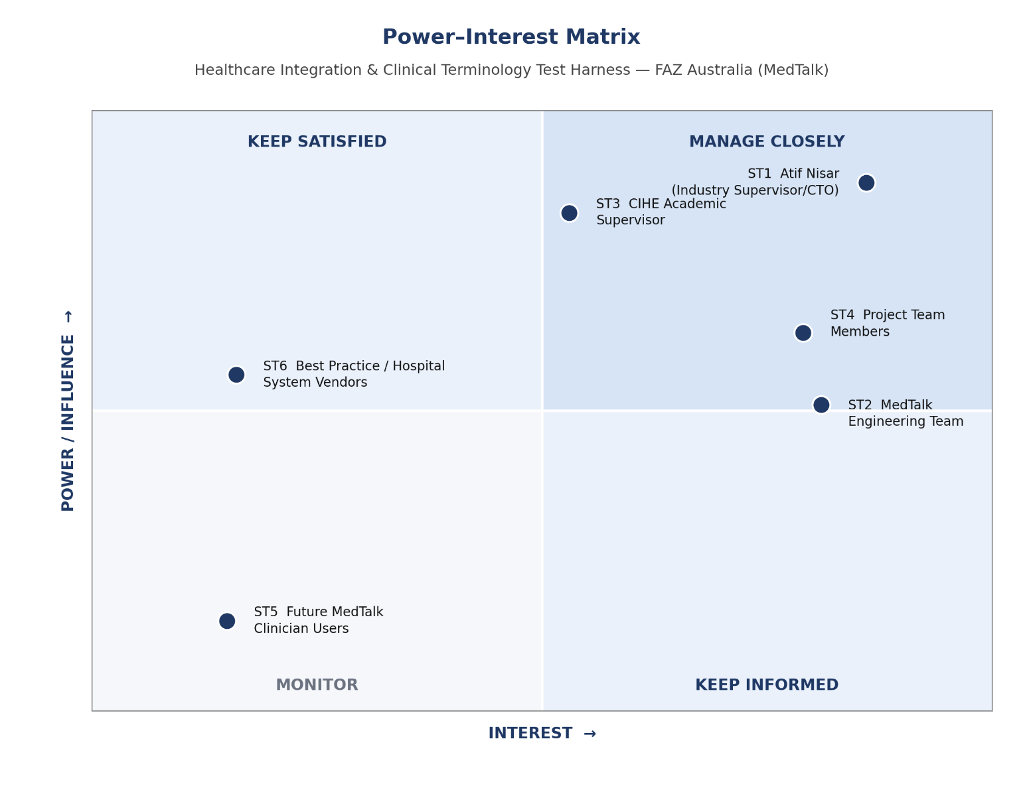
Figure 1. Power–interest matrix, Week 1

Engagement strategy
Explain how engagement differs across quadrants — do not merely list names.
Stakeholders are engaged differently depending on their position in the power–interest matrix. High-power, high-interest stakeholders — the FAZ Australia industry supervisor and the CIHE academic supervisor — are managed closely through weekly video calls and written progress notes, so they can raise concerns early and approve key decisions such as scope changes. High-interest, lower-power stakeholders, such as the MedTalk engineering team and the project team itself, are kept informed through regular asynchronous updates in Slack/Teams and shared Jira boards, so they stay aligned without attending every meeting. Lower-interest stakeholders with moderate influence, such as Best Practice and hospital system vendors, are monitored rather than actively consulted, since the project only needs to comply with their published standards. Low-power, low-interest stakeholders, such as future clinician end-users, are represented indirectly through FAZ Australia and require no direct engagement at this stage.

Task 1.4 — Jira & GitHub Setup
Create one Jira epic for each Assessment 1 weekly deliverable, add initial tasks, assign owners and due dates, and create a GitHub folder structure for charter, minutes, requirements, diagrams, risk and final report. Invite your supervisor to both platforms by the end of Week 1.
Required folder structure (GitHub)
/charter /meeting-minutes /requirements /diagrams /risk /final-report
Commit little and often — the commit history is assessed as individual evidence.

Evidence links (reused in Weeks 2–5)
Jira project link | https://student-team-siuckpgv.atlassian.net/jira/software/projects/HITH/boards/34/backlog?epics=visible&atlOrigin=eyJpIjoiY2FjMzcwMzM0NmFmNDQxNTkwZDExZjZmYzg0YjMxOTUiLCJwIjoiaiJ9
GitHub repository link | https://github.com/SkinnySeal17/HEAALTHCARE_SYSTEM.git
Supervisor invited to Jira? | Not yet
Supervisor invited to GitHub? | Not yet, to invite Md Ashraf Uddin to https://github.com/SkinnySeal17/HEAALTHCARE_SYSTEM.git

Screenshots
Paste captioned screenshots showing your Jira board with assigned tasks, and your GitHub folder structure.
[ 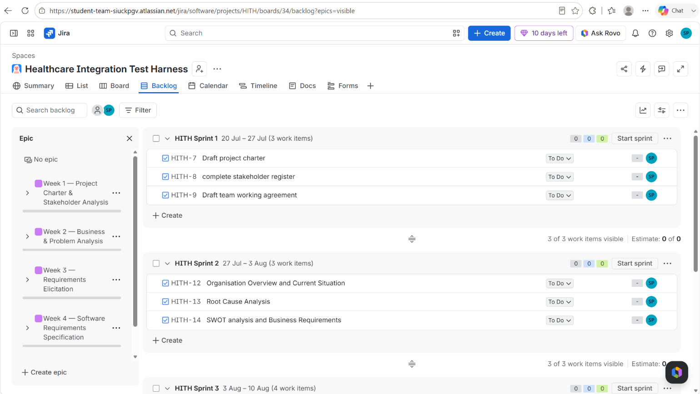
Figure 2. Jira board, Week 1

Pending — GitHub folder structure (/charter /meeting-minutes /requirements /diagrams /risk /final-report) has been created at the repository link above; a screenshot will be added here as Figure 3 once captured.

Part 3 — Individual task
Write 150–200 words explaining your assigned role, the specific outputs you will own this week, and one risk to effective teamwork. Add one Jira task assigned to yourself and make one meaningful GitHub contribution. (This supports the Part B individual reflection due in Week 5.)

Your contribution statement (150–200 words)
This week, my role is Business Analyst and Documentation Lead for the Healthcare Integration & Clinical Terminology Test Harness project with FAZ Australia (MedTalk). My outputs this week are the project charter, including background research on FAZ Australia and MedTalk, the SMART objectives, and the scope boundaries, as well as leading the stakeholder analysis and drafting the engagement strategy. I am also responsible for setting up the shared documentation structure in GitHub so the team's evidence stays organised from Week 1 onward. One risk to effective teamwork this week is uneven participation: because documentation tasks can be completed quickly by one person, there is a risk that I end up doing most of the written work while other members' contributions are less visible in Jira and GitHub. To manage this, I plan to assign clearly separated Jira tasks to each member early and check in during our weekly meeting to make sure everyone's evidence is being logged individually.

Your evidence this week
Your name | Sonam Pelden
Jira task you created (title + link) | "Draft Week 1 project charter and stakeholder register" — https://student-team-siuckpgv.atlassian.net/jira/software/projects/HITH/boards/34/backlog?epics=visible&atlOrigin=eyJpIjoiY2FjMzcwMzM0NmFmNDQxNTkwZDExZjZmYzg0YjMxOTUiLCJwIjoiaiJ9
GitHub contribution (commit / PR link) | Initial commit of Week 1 project charter and stakeholder register to https://github.com/SkinnySeal17/HEAALTHCARE_SYSTEM.git — commit link to be added once pushed

Teams Classroom submission — before leaving class
Submit each item to the Week 1 Teams Classroom assignment
☐ Project charter draft (Task 1.2 completed above)
☐ Stakeholder register and power–interest matrix (Task 1.3)
☐ Team working agreement (Task 1.1)
☐ Jira project link and screenshot showing assigned tasks
☐ GitHub repository link and screenshot showing folder structure
☐ Each member's 150–200 word contribution statement
☐ Supervisor invited to both Jira and GitHub

Lecturer facilitation guide
- Model one strong and one weak problem statement. A strong statement identifies the affected process, threat, consequence and evidence without prescribing a solution.
- Require objectives to use measurable verbs and observable outcomes.
- Check that scope boundaries are realistic for the semester and aligned with the client brief.
- Verify every student has a visible Jira assignment and GitHub activity before class ends.

Common problems to correct
Students describe instead of analyse.
Claims are not linked to client evidence.
Requirements are vague, untestable or solution-biased.
Jira tasks do not match report sections.
One student completes all documentation while others leave only decorative footprints in the activity log.

How today's work feeds the Week 5 report
Tutorial output | Assessment section | Refinement before final submission
Project charter | Week 1: Overview, Background, Objectives, Scope, Success Criteria | Convert notes into coherent academic prose and verify all claims with client evidence.
Stakeholder analysis | Week 1: Stakeholder Analysis | Explain prioritisation and engagement strategy, not merely list names.
Tool setup evidence | Appendices and portfolio evidence | Include links, screenshots and activity records with captions.

Marks this week's work supports
Rubric Criterion 1 — Project Charter & Business Problem Analysis (4 marks).
Rubric Criterion 4 — Portfolio Quality, Integration & Professional Communication (3 marks).
Rubric Criterion 5 — Individual Reflection & Professional Development (4 marks), via your contribution evidence.

