MedTalk Research Repository — Member 2 Research (v2, Scope-Confirmed)
Compiled from:
- MedTalk Connect Research Summary (AI generated)(synthesis of Documents 1, 3, 4 — Final Capstone Report, Connector Catalogue, Enterprise Product and Deployment Playbook)
- MedTalk Connect: Developer and Enterprise Implementation Guide (Document 2 of 4)
- Project System Context Diagram (Figure 1 — synthetic FHIR sandbox scope)
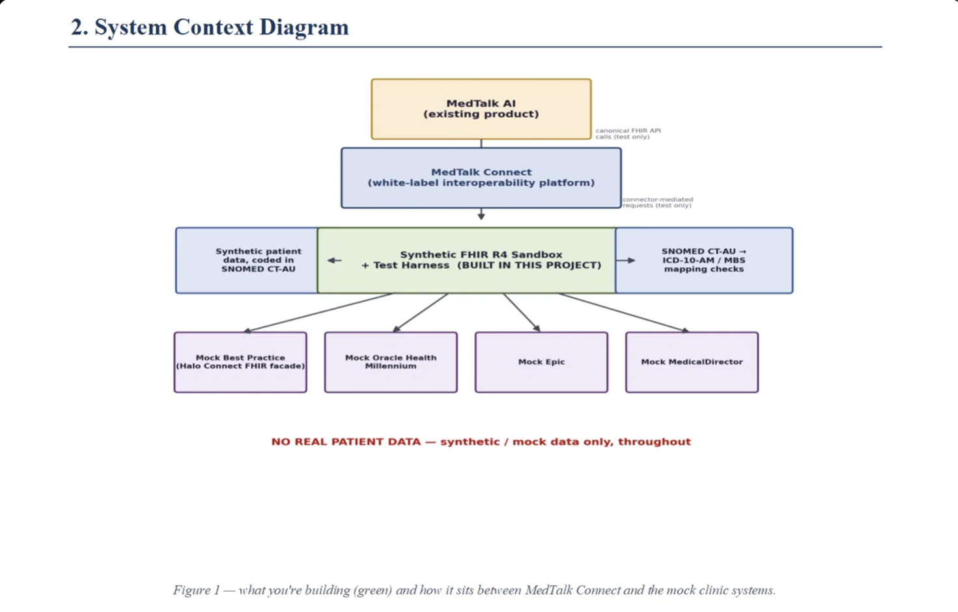
- Confirmed project scope, boundaries, and infrastructure decisions agreed with the mentor (this revision)
Evidence convention: claims from the MedTalk Connect documents remain labelled Implemented, Sandbox-validated, Planned, or Pathway. Anything labelled Project-in-scope is our own deliverable, confirmed below, not an inherited MedTalk Connect capability.

CONFIRMED SCOPE BOUNDARIES (applies to all sections below)
Area | Status | Detail
Upstream AI (MedTalk AI) | Out of scope | Existing, independent product. We do not build or touch ambient capture, transcription, or audio processing. Our entry boundary begins at the text/FHIR level — i.e., wherever a DocumentReference or other FHIR resource would already exist as structured data.
Commercial & production hosting | Out of scope | No scalable production rollout, commercial domains, or full identity/authentication management (tenant onboarding, SMART production credentials, etc.) is required of this project.
Testing-phase hosting | In scope | The test harness and synthetic FHIR sandbox must be deployed to a designated testing environment (school cant provide, a developer staging platform such as Render/Railway/Supabase) to support the live demo.
Data infrastructure | In scope | PostgreSQL is the confirmed database for the local synthetic environment. Data volume must be "robust and deep enough to mimic real clinic scale" (exact target to be confirmed with mentor — see Section 2, Q2).

This confirms and narrows the System Context Diagram (Figure 1): the amber "MedTalk AI (existing product)" box and its "canonical FHIR API calls (test only)" arrow are explicitly out of scope for build work; the green "Synthetic FHIR R4 Sandbox + Test Harness (BUILT IN THIS PROJECT)" box, and the SNOMED CT-AU → ICD-10-AM/MBS mapping-checks box beside it, are our confirmed deliverable.

1. MedTalk

1.1 Workflow
Scope note: MedTalk AI's ambient-capture-to-draft-note workflow (Section 1.1 of the original repository) is now formally out of scope. It is retained below only as upstream context, so the sandbox's entry point is understood correctly.
Full documented MedTalk AI workflow (context only, not built by us):
- Clinician conducts a consultation (ambient capture — internal to MedTalk AI, not documented, not our concern).
- MedTalk AI generates a draft consultation note.
- Clinician approves the draft.
- Approved note submitted as a DocumentReference to MedTalk Connect's canonical FHIR API (Mockup).
- MedTalk Connect performs connector-specific transformation and writes back to the target clinical system.
Our project's actual entry boundary begins at step 4/5: we simulate the canonical FHIR API and connector layer that MedTalk AI would call, using synthetic FHIR R4 resources and mock clinic systems, without needing MedTalk AI itself to be running or reachable.

1.2 Inputs
- Out of scope: ambient audio, speech-to-text, or any voice modality.
- In scope: structured FHIR R4 resource payloads (JSON) representing what MedTalk AI would send — DocumentReference, Patient, Encounter, Condition, Observation — submitted directly to our sandbox's canonical FHIR-shaped API, bypassing the need for a live MedTalk AI instance.

1.3 Outputs
- Draft/approved consultation notes as DocumentReference resources (LOINC 11488-4), consistent with the original MedTalk Connect contract — used as fixture/test data, not generated by us.
- Project-in-scope output: structured test reports (see Section 7.3) covering pass/fail results, coverage, and mapping-edge-case outcomes.

1.4 Integrations
- Out of scope: any live integration with the real MedTalk AI product, real Oracle Health Millennium, real Best Practice/Halo Connect, real Epic, or real MedicalDirector systems.
- In scope: our sandbox stands in for MedTalk Connect's canonical FHIR API and connector-mediated requests (both marked "test only" on the System Context Diagram), talking to four mock clinic systems we control: Mock Best Practice (Halo Connect FHIR façade), Mock Oracle Health Millennium, Mock Epic, Mock MedicalDirector.

1.5 Data Flow
Revised to reflect confirmed scope — the upstream MedTalk AI leg is dotted/test-only and not exercised by our build:
[OUT OF SCOPE] MedTalk AI
| canonical FHIR API calls (test only)
v
[SIMULATED] MedTalk Connect (white-label interoperability platform)
| connector-mediated requests (test only)
v
[BUILT BY US] Synthetic FHIR R4 Sandbox + Test Harness
| | |
v v v
Synthetic patient SNOMED CT-AU → ICD-10-AM Mock clinic systems:
data (SNOMED CT-AU) / MBS mapping checks Best Practice (Halo Connect façade),
Oracle Health Millennium, Epic, MedicalDirector
No real patient data flows through any part of this pipeline — synthetic/mock data only, throughout (per Figure 1 caption).

2. Existing Systems
Revised framing: every system in this section is now explicitly mocked, not integrated live. The documented MedTalk Connect behaviour below is retained as the behavioural specification our mocks must faithfully imitate — this is what makes the sandbox's test results meaningful (i.e., our mocks fail/succeed the same way the real connectors are documented to).

2.1 Mock Best Practice (Halo Connect FHIR facade)
Behavioral spec to imitate (from source docs, status: Implemented in the real platform):
- FHIR-native connectivity.
- Practice-level pairing and authorisation (not a direct SMART launch).
- Dependent on a specific Halo Link deployment version and its permitted operations.
- Practice/practitioner/location identifiers mapped into canonical FHIR.
- Structurally AU Core-conformant; formal AU Core test-suite validation historically pending.
Our mock exposes a FHIR façade reproducing this shape and its documented AU CDI coverage (demographics, documents) without a real Halo Connect dependency.

2.2 Mock Oracle Health Millennium (Hospital EMR)
Behavioural spec to imitate (status: Implemented reference connector in the real platform):
- HL7 v2.4 over MLLP, message types of ADT^A01/A02/A03, ORM^O01, ORU^R01.
- SMART on FHIR EHR launch and standalone launch.
- Resources: Patient, Practitioner, Encounter, Observation, DocumentReference.
- Known limitation carried into our mock: Condition and AllergyIntolerance are not implemented on the real connector — our mock should reproduce this gap explicitly (see Section 4.4) rather than "fixing" it, unless the mentor confirms otherwise.

2.3 Mock Epic
Behavioural spec to imitate (status: Sandbox-validated only on the real platform — i.e., never production-proven): SMART on FHIR discovery and authorisation handling demonstrated against Epic's non-production sandbox. Our mock should therefore be built to the same "sandbox-only" maturity level — no production-only Epic behaviours should be assumed or fabricated.

2.4 Mock MedicalDirector
Behavioural spec to imitate (status: Planned — the real connector has not been built at all). Because no implementation evidence exists in the source documents, our mock for MedicalDirector is necessarily a best-effort approximation built to the common connector contract described for the other three systems, clearly labelled as speculative/unvalidated against any real MedicalDirector behaviour.

3. Healthcare Standards

3.1 FHIR (R4 / AU Core / AU CDI)
Unchanged from prior findings — FHIR R4 is the canonical shape; AU Core is the conformance target; AU CDI defines minimum exchangeable data classes. Project-in-scope implication: our sandbox's mocked resources should carry AU Core-style profile references (e.g., http://hl7.org.au/fhir/core/StructureDefinition/aucore-patient) even though we are not required to run a live AU Core validator or achieve certified conformance — we are reproducing the shape, not obtaining certification.

3.2 SNOMED CT-AU
Confirmed as the coding system for all synthetic patient/condition data (per Figure 1 and the confirmed FHIR data shape below). Concept tracking format to be confirmed: e.g.
{ "concept": "44054006", "display": "Type 2 diabetes mellitus", "system": "http://snomed.info" }

3.3 ICD-10-AM
Project-in-scope, confirmed via the mapping-checks component in Figure 1. No ICD-10-AM detail exists in the MedTalk Connect source documents — the cross-map itself is original project work (see Section 5).

3.4 MBS (Medicare Benefits Schedule)
Project-in-scope, confirmed via the same mapping-checks component. As with ICD-10-AM, no MBS logic exists in the source documents — this mapping is original project work, scoped as "mapping checks" (validation-style, not a full billing/claims engine).

4. FHIR Design

4.1 Patient
Unchanged: mapped from HL7 v2 PID segments per the original PID→Patient table (identifier, name, birthDate, gender, address). Carries the AU Core Patient profile reference.

4.2 Encounter
Unchanged: mapped from HL7 v2 PV1 segments (class, location, participant, serviceType).

4.3 Observation
Unchanged: sourced from OBR/OBX in the real platform's documented behaviour; no field-level mapping table was ever supplied, and this remains a gap for our mock's Observation fixtures.

4.4 Condition — To be Confirmed Mocked Payload Shape
Project-in-scope. Condition is "Planned" (not implemented) across every real MedTalk Connect connector, but our sandbox must still model it, since SNOMED → ICD-10-AM/MBS mapping is meaningless without a Condition resource to carry the SNOMED code. E.g. Confirmed shape:
{
"resourceType": "Condition",
"code": {
"coding": [
{ "system": "http://snomed.info", "code": "44054006", "display": "Type 2 diabetes mellitus" }
]
},
"subject": { "reference": "Patient/example" },
"recordedDate": "2026-03-14"
}
This is the canonical fixture shape all synthetic Condition test data in Section 6 and all mapping-edge-case tests in Section 7 should conform to.

4.5 Other Required Resources
Practitioner, DocumentReference, AllergyIntolerance, MedicationRequest, Organization — unchanged from prior findings. AllergyIntolerance remains Planned/unimplemented on the real platform and, per Section 2.2, should be mirrored as an intentional gap in the Oracle Health mock unless the mentor directs otherwise.

5. Data Mapping

5.1 SNOMED → ICD-10-AM
Project-in-scope confirmed original deliverable. No cross-mapping logic exists in the MedTalk Connect source documents — this is a mapping table/ruleset our team must design and implement as part of the "mapping checks" component in Figure 1. The Condition payload shape in Section 4.4 is the input; the output is an ICD-10-AM code with an explicit expected-vs-actual comparison captured in the automated test report (see Section 7.3).

5.2 SNOMED → MBS
Project-in-scope confirmed original deliverable, same status as above. Scoped as "mapping checks" per Figure 1 — i.e., validating that a given SNOMED-coded condition/encounter resolves to a plausible MBS item, not a full billing/claims workflow.
Architectural precedent retained from the source documents: the real platform's own terminology-translation pattern (local code → AU Core-preferred coding via a versioned, independently auditable value-set table, decoupled from mapping code) is a reasonable model to follow for our own SNOMED → ICD-10-AM/MBS value-set tables, so that mapping corrections can be made without redeploying test-harness code.

6. Synthetic Data
Confirmed: PostgreSQL is the system of record for the local synthetic environment; no real patient data appears anywhere. Data volume must be "robust and deep enough to mimic real clinic scale" — the concrete numeric target is unresolved and is the subject of Question 2 in Section "Questions for the Mentor" below.

6.1 Patient Examples
Retained fixture pattern (SNOMED CT-AU coded, AU Core-profiled):
{
"resourceType": "Patient",
"meta": { "profile": ["http://hl7.org.au/fhir/core/StructureDefinition/aucore-patient"] },
"identifier": [{ "system": "http://acthealth.example/mrn", "value": "MRN00123456" }],
"name": [{ "use": "official", "family": "Citizen", "given": ["Jane"] }],
"gender": "female",
"birthDate": "1985-06-14"
}
Under the new scale requirement, this single-patient fixture becomes one row-template in a PostgreSQL-backed patient generation set, not a one-off example — the sandbox needs a repeatable generator (or seed script) producing many such records at "clinic scale."

6.2 Clinical Data
Retained: synthetic HL7 v2 ADT-A01 message (ward/practitioner/admission detail) for Encounter fixtures, plus the confirmed Condition payload shape (Section 4.4) for diagnosis-coded fixtures. Both should be storable as rows in PostgreSQL tables backing the mock clinic systems, not only as static JSON files.

6.3 Coding Examples (Paired SNOMED/ICD-10/MBS)
Now concretely scoped, still to be populated. At minimum, the dataset must include:
- The confirmed Type 2 diabetes mellitus example (SNOMED 44054006) as a worked case.
- Enough additional paired SNOMED/ICD-10-AM/MBS records to exercise the automated test suite's mapping-edge-case requirement (Section 7.3), including at least one deliberately ambiguous or edge-case mapping (see Question 3).

7. Testing

7.1 Valid Data (Happy Path)
- Patient/Encounter/Condition/DocumentReference reads and searches against the sandbox's mocked canonical FHIR API return well-formed, AU Core-shaped resources.
- A valid SNOMED-coded Condition resolves to a correct ICD-10-AM and MBS mapping via the mapping-checks component.

7.2 Invalid Data (Validation Boundaries)
Retained from the real platform's documented failure-mode table, reproduced as behaviour our mocks must simulate:
- Malformed HL7 v2 segment → rejected with an AR ACK, logged as a redacted parse-failure event, not forwarded downstream.
- AU Core-shape validation failure → resource held in a quarantine state, structured OperationOutcome returned.

7.3 Automated Test Suite & Reporting Criteria (confirmed requirements)
Project-in-scope, newly specified. The test harness must exercise valid data, invalid data, and structural error handling — specifically slow, malformed, and dropped connections across all four mock clinic systems (Best Practice/Halo Connect, Oracle Health Millennium, Epic, MedicalDirector).
The automated test report must explicitly capture:
Report field | Description
Total tests run | Count of all executed test cases in the run
Pass rate (%) | Passed / total, as a percentage
Failures by severity | Failures grouped (e.g., critical / major / minor) rather than a flat list
Resource/endpoint coverage | Which FHIR resource types and endpoints (Patient, Encounter, Condition, Observation, DocumentReference; per mock system) were exercised
Run timestamp | When the automated run occurred
Mapping edge case | At least one documented SNOMED → ICD-10-AM/MBS mapping edge case, showing expected vs. actual result

7.4 Missing Data (Null/Optional Value Logic)
Still not specified by the real platform's documentation (unchanged gap). Under the confirmed scope, our test harness should define its own null/optional-field rules against AU Core's mandatory/must-support element requirements for each mocked resource, since no external specification is available.

7.5 API Failure / Structural Error Handling (Resiliency)
Confirmed in-scope test categories, extending the original failure-mode table with the newly required connection-quality scenarios:
Scenario | Expected mock behaviour
Slow connection (mock clinic system) | Request eventually times out per a configured threshold; timeout is logged and reported as a distinct failure category, not conflated with a hard failure
Malformed connection/payload | Rejected as per the real platform's documented pattern (structured error, no silent acceptance)
Dropped connection | Circuit-breaker-style behaviour: operation queued/retried with backoff, and an operational alert/log entry raised, mirroring the real platform's "upstream connector unavailable" behaviour
Invalid/expired auth token (where modelled) | Rejected with a standard error response; no session established
Reused idempotency key | Original result returned rather than a duplicate resource created

7.6 Integration Failure (System Disconnection Handling)
Unchanged in principle from the original findings (cross-tenant access rejection, upstream-unavailable circuit breaker) — now explicitly tested against all four mock clinic systems individually, since coverage-by-endpoint is a required report field (Section 7.3).

7.7 Deployment: Test-Harness and Database to a Testing Environment
Project-in-scope, newly specified. The sandbox, mock clinic systems, and PostgreSQL database must be deployed — not just run locally — to support the live demo and grading phase. Recommended approach:
- Containerise each component with Docker:
  - One container (or service) for the synthetic FHIR R4 sandbox + test harness application.
  - One container per mock clinic system (Best Practice/Halo Connect façade, Oracle Health Millennium, Epic, MedicalDirector), or a single configurable mock service exposing four endpoint profiles — whichever keeps the deployment simplest without losing per-system test coverage.
  - One PostgreSQL container (or managed instance) as the shared data store.
- Orchestrate locally with Docker Compose for development and CI, mirroring the environment-separation pattern the real MedTalk Connect platform itself uses (sandbox → staging → production), scaled down to just a testing environment for this project.
- Deploy to a designated testing environment — either:
  - a school-provided virtual machine (Docker Compose or equivalent deployed directly to the VM); or
  - a free/developer-tier cloud platform (e.g., Render or Railway for the application containers, Supabase or the platform's managed Postgres for the database) — the specific choice is unresolved and is Question 1 below.
- Keep configuration environment-driven (database connection string, mock-system base URLs, timeout/retry thresholds for the slow/dropped-connection tests) so the same containers run unmodified locally and in the deployed testing environment.
- Automated test report as a deployment artefact: the Section 7.3 report should be generated on each run in the testing environment and be retrievable (e.g., as a downloadable file or a simple served page) for the live demo, rather than only existing in a local console log.

