Assessment Cover Sheet
Unit Code and Title | ICT942 Cybersecurity Project | Semester 2 2026
Assessment Name and Number | Assessment 2
Teaching Period / Year | Semester 2/ 2026
Lecturer / Unit Coordinator | Professor Md Ashraf Uddin
Students Full Names | Charity Gwese, Sonam Pelden, Rikesh Aryal, Zubari Adil Soomro
Submission Date | 13/09/2026
Submission Type | ☐ Individual þ Group

Members (Complete ONLY for group assessments)
Student Name | Student ID | Contribution (%) | Responsibilities for the Assessment
Sonam Pelden | CIHE23321 | 25%
Charity Gwese | CIHE250948 | 25%
Rikesh Aryal | CIHE251435 | 25% | Solution Design/Tech Justification/security design/ threat model/cost estimation.
Zair Adil Soomro | CIHE250922 | 25%

Declaration
By submitting this assessment, I/we confirm that this work is my/our own and complies with the CIHE Academic Integrity Policy and the QA70 Use of GenAI in Teaching, Learning, Assessment and Research Policy. Any use of AI or other tools has followed the assessment instructions and guidance provided in the CIHE Student Guide on the Use of AI and has been fully acknowledged in the AI/Tool Use Declaration Table below. I/we understand that inappropriate or unacknowledged use of AI, or submission of work that is not my/our own, may constitute academic misconduct. I/we also confirm that this assessment has not been previously submitted unless approved, and I/we consent to its use for standard academic integrity, quality assurance, and AI governance review processes.
Student(s) Signature:
Date:
GenAI Tool | Description

Contents
Executive Summary 3
1. Introduction 3
1.1 Business Context and Problem Statement 3
1.2 Project Goals, Objectives, and Success Criteria 3
1.3 Project Scope, Assumptions, and Constraints 3
1.4 Stakeholders and User Requirements 3
2. Project Planning and Management 3
2.1 Project Charter 3
2.2 Project Roadmap / Gantt Chart 3
2.3 Team Roles and RACI Matrix 3
2.4 Risk Register 3
2.5 Feasibility Study 3
3. Industry and Technology Landscape Analysis 3
3.1 Current State Assessment: As-Is Analysis 3
3.2 Technology and Market Survey 3
3.3 Comparative Analysis of Existing Solutions 3
3.4 Gap Analysis: As-Is to To-Be 3
4. Solution Design 3
4.1 Proposed Solution Architecture 3
4.2 Technology Stack and Justification 3
4.3 Security Design and Control Mapping 3
4.4 Capital and Non-Capital Cost Estimation 3
5. Proof of Concept, and Evaluation 4
5.1 Sprint Plan 4
5.2 Proof of Concept Description 4
5.3 Testing, Validation, and Cybersecurity Evaluation/evaluate ethical and privacy issues 4
6. Conclusion and Recommendations 4
References 4
Appendices 4

Executive Summary

Introduction
MedTalk Connect, the interoperability layer developed by FAZ Australia, currently has no method to reliably test or validate FHIR-enabled data exchange and clinical terminology mapping with the EMRs that MedTalk Connect interfaces with, prior to implementation into production (FAZ Australia, 2026b). This gap presents a direct cybersecurity, privacy and clinical-safety issue because as systems change, connector and terminology-mapping changes are informally tested with systems near to or overlapping with real clinical data; this is not in line with obligations under the Privacy Act 1988 (Cth) and the My Health Records Act 2012 (Cth).
This is important because MedTalk Connect is located between an AI-generated clinical note and a patient's medical record any error in FHIR exchange or in the translation of the clinical note from SNOMED CT-AU to ICD-10-AM/MBS could lead to incorrect clinical documentation or billing, while any chance of real patient data being accidentally exposed during testing constitutes a reportable privacy breach. Addressing this, the Healthcare Integration & Clinical Terminology Test Harness project will be designing and subsequently build, a fully synthetic FHIR R4 test environment aligned with the AU Core Implementation Guide (HL7 Australia, 2025) that enables safe and repeatable testing of interoperability and terminology mapping.
As part of this, the project directly lowers the cybersecurity and compliance risk for FAZ Australia, elevates MedTalk Connect's security stance in the context of data exchange, enhances operational efficiency by eliminating reliance on production adjacent testing, and builds business resilience by providing the FAZ Australia with a reusable validation asset before it begins with new EMR connectors and practices.

1.1 Business Context and Problem Statement
FAZ Australia is a Canberra-based health technology, with its flagship product MedTalk, an artificial intelligence clinical scribe tool that is used by doctors in clinics all over Australia to turn doctor–patient conversations into structured clinical notes. MedTalk integrates with practice EMR systems via MedTalk Connect, a white label interoperability layer based on the HL7 FHIR standard, which currently supports Oracle Health Millennium and Best Practice/Halo Connect at production and supports Epic in sandbox.
Currently MedTalk Connect does not provide for a secure and safe environment to validate data exchange with EMR systems, or validate clinical terminology mapping between SNOMED CT-AU, ICD-10-AM and Medicare Benefits Schedule (MBS) coding. Some new connectors and FHIR terminology mappings are subject to informal validation with ad hoc scripts and manual review of FHIR payloads in some environments sufficiently similar to production that they pose a real data risk. This puts the organisation at risk of clinical-safety, privacy and compliance issues with the Privacy Act 1988 (Cth) and the My Health Records Act 2012 (Cth) and delays the adoption of new connectors and practices.
The size of this problem is illustrated by the quantified evidence from Stage 1 analysis: there is no repeatable process to validate terminology mapping, and the error-handling behaviour (slow responses, malformed data and dropped connections) is not systematically tested with a significant risk of undetected errors affecting real clinical scenarios, especially for Epic (sandbox-only); and test coverage varies widely by connector maturity, with Epic (sandbox-only) receiving significantly less validation than the two production-grade connectors.
This project aims to solve the problem by creating the FHIR test harness, a fully synthetic standard based test harness that will allow FAZ Australia's engineers to test interoperability and terminology translations without the involvement of real patient data (Stage 1) and constructing the FHIR test harness (Stage 2). The project directly lowers cybersecurity and privacy risk, enhances the organisation's security around data exchange, boosts efficiency by eliminating reliance on production-adjacent testing, and helps ensure adherence to Australian privacy and health-data laws and, of course, speeds MedTalk Connect's development and onboarding process.
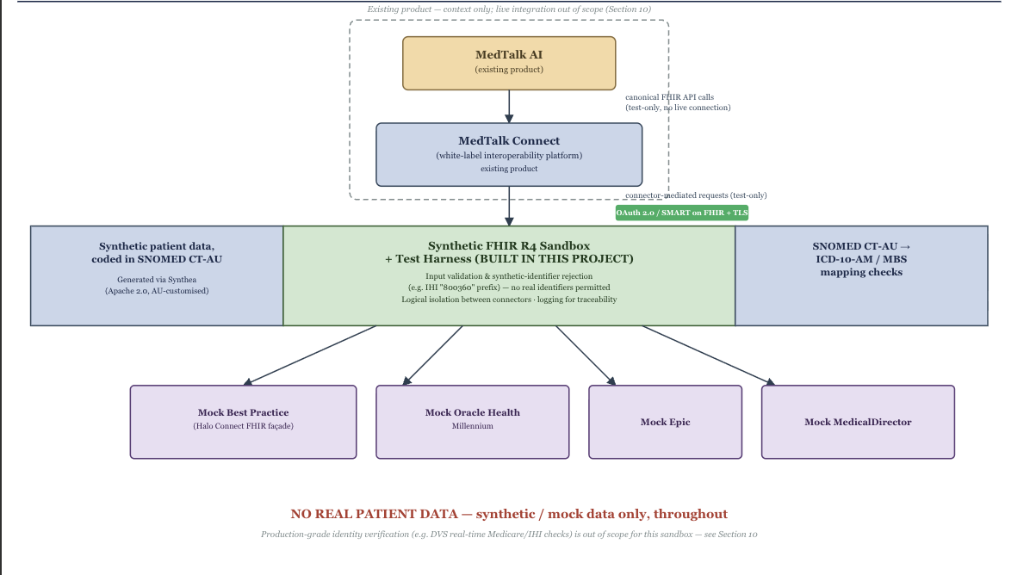
Figure X: System context Diagram.

1.2 Project Goals, Objectives, and Success Criteria
Project Goals: Design and validate a synthetic, standards-based FHIR test harness to help FAZ Australia to safely test interoperability and clinical terminology mapping between MedTalk Connect and the FHIR standard before going to production to protect patient data.
SMART Objectives:
- By end of Stage 1, create a synthetic FHIR R4 test environment that supports MedTalk Connect's EMR connectors for production (Oracle Health Millennium and Best Practice/Halo Connect) and sandbox (Epic), and can be validated with peer review by mentors.
- Create and test a model for mapping a defined synthetic dataset of 50 patient records with 3 clinical conditions between the SNOMED CT-AU and ICD-10-AM coding systems, including against expected results, including edge cases.
- Produce a written test plan for normal, error handling and degraded connection to implement and execute in Stage 2 (slow response, malformed data, drop connections).
- Fully avoid real patient data during the project, with all use of real patient data blocked by automatic validation rules for synthetic data (e.g., Luhn check rejection of realistic identifiers).
Measurable Success Criteria:
- Architecture diagram of the test harness reviewed and approved by the industry mentor.
- A synthetic test-data plan generated and validated, representing a variety of patient scenarios coded in SNOMED CT-AU and with corresponding ICD-10-AM/MBS translations.
- A written, connector-weighted test plan covering happy-path, error-handling and degradation scenarios for all three connectors.
- All test data were synthetic, and there were no real patient identifiers at any point.

1.3 Project Scope, Assumptions, and Constraints
In Scope:
- Design of a synthetic FHIR test harness for REST/JSON FHIR exchanges, where applicable, HL7v2 messaging and SMART on FHIR (OAuth 2.0) authentication, according to the AU Core FHIR Implementation Guide.
- Design level mapping logic for the translation of SNOMED CT-AU → ICD-10-AM for a representative set of synthetic clinical scenarios.
- Test-data plan and written test plan (functional, negative/error-handling and performance-style scenarios) of connectors defined in FAZ Australia's Connector Catalogue based on connector maturity.
Out of Scope:
- Implementation or coding of the test harness (extended to Stage 2).
- Use of real patient data or connection to real production EMR environments.
- This project is about interoperability and not about the functionality of the scribe, it's not about changes to the core AI transcription/NLP engine of MedTalk.
Assumptions:
- Halo Connect will publish a specific set of FHIR resources/endpoints that are enough for the test harness to exchange data.
- The mapping logic to map SNOMED CT-AU to ICD-10-AM/MBS agreed in Stage 1 is correct, because the wrong mapping would result in misleading outcomes of the test.
- The test harness will also be able to simulate and detect good, bad, and dropped/slow responses to ensure its robustness.
Constraints:
- Requirements, analysis and design as per the waterfall model is only enough for Stage 1 and till Stage 2 proposed design is validated by implementing it.
- The College have no budget or cloud services provided, and the team must use free tier and open source tools.
- The test harness is exclusively based on synthetic patient records, which if not well-designed, may not represent all the variety of typical clinical data.
- If there is any delay in FHIR, Halo Connect or connector documentation from FAZ Australia, project start may be delayed.

1.4 Stakeholders and User Requirements
Stakeholder | Role | Interest | Influence
Atif Nisar (FAZ Australia) | Project Sponsor / Industry Mentor | High | High
Md Ashraf Uddin | Academic Supervisor | Medium | High
Project Team (Sonam, Charity, Rikesh, Zubair) | Delivery Team | High | High
MedTalk Connect Engineering Team | End users of the test harness | High | Medium
Medical Practices (Best Practice / Oracle Health users) | Indirect beneficiaries | Medium | Low
EMR Vendors (Oracle Health, Best Practice/Halo Connect, Epic) | Technical interface owners | Medium | Medium

Functional and Non-Functional Requirements Summary:
- Security requirements: Control access of authorized test environment users; ensure tenant isolation to limit exposure of data from cross-connector or cross-tenant.
- Privacy needs: Only use synthetic patient data, with automated validation (e.g., Luhn-check rejection) to prevent accidental use of real identifiers
- Usability requirements: Users should be able to perform tests and understand the results without requiring extensive technical expertise, and in a few simple steps.
- Scalability requirements: Have a specific, scalable synthetic data set (for the first few years – at least 50 records on 3 conditions without redesign).
- Performance criteria: Under normal test conditions, return standard test results in an acceptable response time.
- Compliance requirements: Ensure the harness does not process real patient or health information and align with the Privacy Act 1988 (Cth), My Health Records Act 2012 (Cth) and the AU Core FHIR Implementation Guide.

2. Project Planning and Management

2.1 Project Charter
Project Purpose: Develop and provide a synthetic, standards-based FHIR test harness, to help FAZ Australia test MedTalk Connect's interoperability and clinical terminology mapping without real patient data.
Project Scope: Architecture design, terminology mapping logic (SNOMED CT-AU to ICD-10-AM to MBS); and a written test plan for the 3 EMR connectors (Stage 1); build and demonstration of the harness (Stage 2).
Key Stakeholders: Atif Nisar (FAZ Australia, Project Sponsor/Industry Mentor), Md Ashraf Uddin (Academic Supervisor), Project Team, MedTalk Connect Engineering Team, Connected EMR Vendors.
Key Deliverables: Architecture diagram; synthetic test-data plan; written test plan for happy path, error handling and degradation scenarios; feasibility and risk analysis; working proof-of-concept test harness (Stage 2).
Acceptance Criteria: Architecture is reviewed and approved by the industry mentor, test-data plan is validated to provide representative SNOMED CT-AU scenarios, test plan includes all three connectors, weighted according to the maturity, with zero real patient data used at any stage.
Project Authority: The scope changes, stage-gate deliverables are approved by Project Authority comprising Md Ashraf Uddin (Academic Supervisor) and Atif Nisar (Industry Mentor).
Expected Business Value: Clinical-safety and compliance risk minimised, speeds up connector onboarding, and provides the business with a reusable CI/CD testing asset for FAZ Australia.

2.2 Project Roadmap / Gantt Chart
Phase | Weeks | Key Milestone
Requirements & Charter | 1–2 | Charter, stakeholder analysis, business/problem analysis approved
Requirements Elicitation & SRS | 3–4 | Functional/non-functional requirements and use cases signed off
Feasibility & Risk Analysis | 5 | Risk register, feasibility study, mentor sign-off (Stage 1 complete)
Report Drafting (2A/2B) | 6 | Sections 1–3 drafted; architecture diagram started
Solution Design & PoC Planning | 7 | Sections 4–6 drafted; sprint plan finalised; first full draft compiled
Finalisation & Submission | 8 | References, proofreading, slides, rehearsal; submission by 13 Sept

2.3 Team Roles and RACI Matrix
Deliverable | Sonam (Lead/Arch.) | Charity (Clinical) | Rikesh (Integration) | Zubair (Testing/Docs)
Project Charter & Planning | R/A | C | C | I
Business/Clinical Context (1.1–1.4) | A | R | I | I
Industry & Technology Analysis (Ch. 3) | C | R (3.1) | R/A (3.2–3.4) | I
Solution Architecture (4.1–4.2) | R/A | I | C | I
Security Design & Cost (4.3–4.4) | C | I | R/A | C
PoC & Testing Evaluation (5.1–5.3) | I | R (5.2) | C | R/A (5.1, 5.3)
Final Report Compilation | A | C | C | R
Presentation Delivery | A | R | R | R

R = Responsible, A = Accountable, C = Consulted, I = Informed.
Sonam holds overall accountability as Project Lead, chairing check-ins and resolving scope conflicts; Charity leads clinical-data accuracy decisions; Rikesh leads technical/integration trade-offs; Zubair leads quality assurance and documentation standards. Leadership was distributed by domain rather than centralised, which kept decisions close to the person with the relevant expertise and reduced review bottlenecks going into Stage 2.

2.4 Risk Register
ID | Risk | Likelihood | Impact | Score | Rating | Response | Owner
R1 | Undetected connector crash/hang on slow FHIR response (>5s) | Medium | High | 6 | High | Automated slow-response test with timeout/retry validation | Zubair
R2 | Unhandled parser exception from invalid HL7 segment | Medium | High | 6 | High | Automated malformed-HL7 rejection test | Zubair
R3 | Malformed FHIR data accepted and written to clinic system | Medium | High | 6 | High | Automated malformed-FHIR validation test | Zubair
R4 | Cross-tenant data leakage via missing tenant scoping | Low | Critical | 4 | High | Row-level tenant isolation, gateway validation, dedicated test layer | Zubair
R5 | Real patient identifier accidentally used in synthetic dataset | Low | Critical | 4 | High | Luhn-check rejection rule + automated negative test | Zubair
R9 | Team's limited healthcare-semantics experience delays build | Medium | Medium | 4 | Medium | Curated SNOMED subset, weekly mentor guidance | Team
R10 | Scope creep from broad project brief | Medium | Medium | 4 | Medium | Fixed endpoint list, agreed exclusions | Team Lead

Score = Likelihood × Impact (Low=1, Medium=2, High=3, Critical=4). The register carries forward all ten risks identified in Stage 1, condensed here to the highest-scoring items. High/Critical risks (R1–R5) directly threaten clinical safety, data integrity or privacy and are mitigated through automated test cases tied to specific failure modes; Medium risks (R9–R10) are operational and are managed through scope discipline and mentor engagement rather than technical controls.

2.5 Feasibility Study
Technical feasibility is high: The proposed stack (FHIR R4 (Health Level Seven International, 2019), AU Core (HL7 Australia, 2025), HL7 v2.4 (Standards Australia, 2007), SNOMED CT-AU, HAPI FHIR, FastAPI/Node.js, PostgreSQL, Docker) is mature, open-source, and familiar to the team. The key difficulty is correctly implementing healthcare-specific semantics rather than tool availability
Operational feasibility is medium-high: Mentor commitment is confirmed; Reference architecture documents; Team tooling (GitHub, Jira & Teams) is established for delivery. Primary operational risk is from competing demands other University Units, addressed in a Team Working Agreement.
Economic feasibility is high: estimated overall cost is around $150 AUD, both using open source tools and free tier hosting under the WIL arrangement, and the expected value for FAZ Australia is great, as defect escape rate will be reduced and onboarding of connectors will be accelerated.
Legal feasibility is high: the project also doesn't include real patient data, which is the primary exposure under the Privacy Act 1988 (Cth) and My Health Records Act 2012 (Cth). Automated synthetic-data validation rules (such as Luhn-check rejection) offer technical protection, but do not require manual compliance.
Ethical feasibility is high: the design poses no risk of actual harm to patients as a result of construction as no actual clinical data are ever processed. Other ethical issues include the ethical use of AI for creating and verifying synthetic clinical scenarios, and the appropriate mapping of the terminology without inadvertently introducing coding errors into the downstream billing or clinical use.
Cybersecurity feasibility is high: as each identified threat is reduced to a Low residual risk by the following layers of controls: tenant isolation, rate limiting, structured error handling, and immutable audit logging, which are validated by automated test cases as opposed to assumptions.
The project is feasible across all six dimensions, the biggest risk is the team's learning curve with FHIR/SNOMED, this is addressed by limiting the scope of the data set at the start of the project and reviewing data with the mentor weekly.

3. Industry and Technology Landscape Analysis

3.1 Current State Assessment: As-Is Analysis
Faz Australia Flagship product is MedTalk. MedTalk is an artificial intelligence clinical documentation that listens to doctor-patient consultation producing a live transcription during the consultation. MedTalk connects to clinical systems or Best Practice (BP) where the completed EMR (electronic medical record) is stored and shared to other systems exposing integration interfaces via FHIR (Fast Healthcare Interoperability Resources). Halo Connect handles transformation of FHIR data to underlying systems formats. The EMR is coded using SNOMED CT-AU (Systematized Nomenclature of Medicine – Clinical Terms – Australian Extension) which is the Australian standard of comprehensive clinical vocabulary used in electronic health records. The EMR coded with SNOMED CT-AU is then mapped ICD-10-AM (International Statistical Classification of Diseases and Related Health Problems, Tenth Revision, Australian Modification) using MedTalk Internal Infrastructure. For billing purposes MedTalk partners with MediBetter BOSS (Billing Optimisation and Support Software) by sharing the translated ICD-10-AM to be mapped to the MBS (Medicare Benefits Schedule) system (MediBetter, 2026).
Faz Australia also utilise the HL7 FHIR R5 (Fast Healthcare Interoperability Resources) and SMART on FHIR protocols to test, map and synchronise data to the BPs exact data architecture that it is being integrated to (MedTalk AI, 2020). One of the developing platforms that MedTalk uses is Epic. Epic sandbox provides platform for developers to test integration first using mock patient data before EHR (Electronic Health Records) exchange. According to Choudhary (2026), for a company to upload their application on Epic is split into three main categories for charging fees. There is Connection Hub listing fee approximately USD$500, vendor services membership charging up to USD$1 900 and build Labour ranging from USD$40000 for read only FHIR and USD$350000 for full bidirectional (Choudhary, 2026). MedTalk and MediBetter partnership tech-tech API prices are not publicly available but according to MarkiTech.AI (2025), a flat fee ranges from $100 to $500. This excludes the subscription of the MediBetter professional suite which unlocks the BOSS engine and browser extensions for clinical workflow. These integration and subscription costs represent a significant financial pain point for MedTalk, focusing on the high upfront investment required for full bidirectional FHIR integration with Epic. These costs burden the scalability of Medtalk.
Apart from the financial burden on Faz Australia, the main operational inefficiency is lack of a reusable safe test environment. The restricted access to sandboxes slows development and harder to reproduce issues consistently to improve MedTalk overall. Due to strong privacy and compliance requirements, there is also limited flexibility in testing live connection with other BPs since Epic requires the application to be load on first to test it. These limitations clearly indicate the business pain on high costs in expansion, delayed integration tests and higher compliance exposure if problems are found late. These pain points are affecting engineering efficiency and confidence in releases, which this project of a test harness is designed to solve.
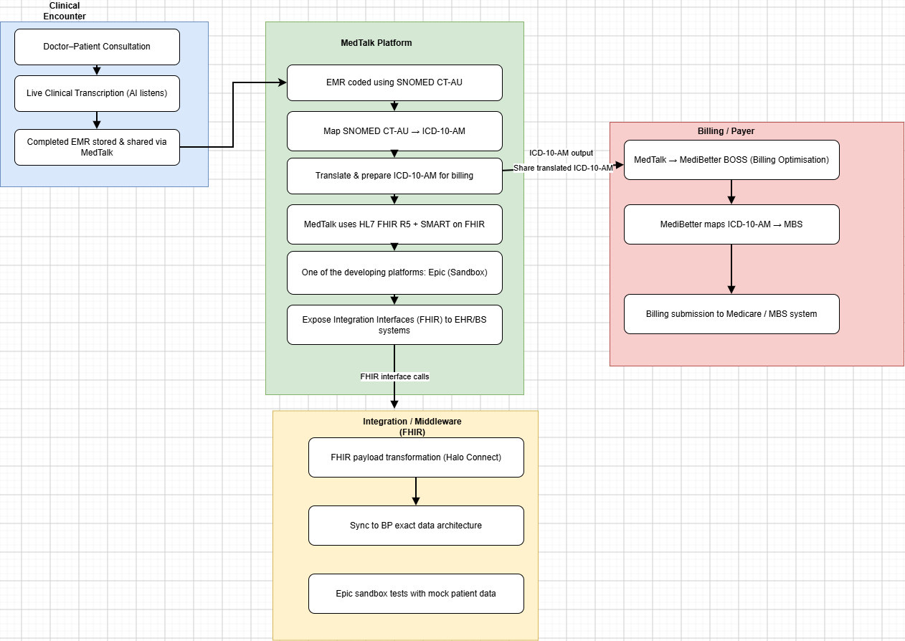
Fig 3.1.1 Current AS-IS flow

3.2 Technology and Market Survey
MedTalk is part of the Australian health interoperability market. The main technical challenge in this market is not only generating accurate clinical notes but safe exchange of the clinical notes and correct translation of the data to the receiving system. The most relevant technologies for the test harness are HL7 FHIR, SMART, vendor integration layers and Australian clinical terminology. These are all essential for the project as it has to reflect the same standards as production systems.

FHIR (Fast Healthcare Interoperability Resources) is the central exchange standard that defines resources meaning patient data, appointments, clinical notes and related information structure and transferred between systems (eCQI, 2025). It also depicts interaction patterns including real time representation state Transfer (RESTful) application programming interfaces (APIs), document based and messaging. The RESTful APIS use HTTP operations to create, read, update and search for FHIR resources to enable real time data exchange. FHIR framework is free to build commercial and open-source tools while HL7 is registered trademark that cannot be used without permission. FHIR is a necessity for the project to mimic structured clinical document exchange and be able to test it.
Australian clinical terminology and classification is vital which include SNOMED CT-AU and ICD-10-AM. SNOMED CT-AU is the preferred clinical terminology in Australia which is an extension of the global SNOMED CT standard. It combines international core clinical data with Australian-specific terms, spellings, local reference sets and the Australian Medicines Terminology (AMT). SNOMED CT-AU contains numerous clinical concepts organized into hierarchies like body structures, procedures and clinical findings. SNOMED CT-AU is then mapped to ICD-10-AM which is classification of diseases and diagnosis tailored to match Australian clinical terminology, practice and health-tracking need. The ICD-10-AM is mapped to MBS for billing in Australia. These terms need to be coded in the synthetic patient record correctly as the test harness will validate them. These terminologies are free access to code in synthetic data.

Synthea is currently one of the most credited synthetic patient generator as it creates realistic realistic mock medical histories and electronic health records lifespan from birth to death. Synthea is an open source but produces mock patients based on Unites States of America demographics. CSIRO have created Australian mock data using Australian demographics, but the synthea tool is not available for public. The mock data is available which would be used for this project to ensure compliance and mimics real clinical system. SMART on FHIR is the authentication and authorising secure system that lets third-party health apps log users in, access electronic health record (EHR) data using standard OAuth 2.0 protocols. This security is necessary to ensure that there is no authorised access to the Test harness.
Vendor integration layers include Halo connect to be implemented in the project. Halo connect is an Australian healthcare platform that safely links local medical practice systems to cloud-based software. It has two main components Halo Link and Halo Cloud. Halo Link is used to link the database to Halo cloud and Halo Cloud would be required for sharing data using standard formats like SQL and FHIR with approved external software. This integration is necessary as when the integration (another system) requires data from the server’s database, it sends this enquiry to the Halo Cloud then forwards it to the Halo Link agent. The agent sends the enquiry to the local system database and run the query and send back results.
The main gap in the current market is that existing standards and vendors solve only part of the problem. Standards define how data should be exchanged, vendor products expose endpoints and terminology systems define how meaning should be coded. This still then requires a synthetic test harness that utilises all these tools, standards and frameworks to form a repeatable automation testing, failure simulation and validation of edge cases.

3.3 Comparative Analysis of Existing Solutions
Table 3.3.1 Comparative analysis of existing solutions
Technology | Core Functionality | Deployment Model | Limitations | Relevance to project
SMART Health IT Sandbox | Provides simulated EHR environ for testing HL7 FHIR APIs and OAuth 2.0 authentication and patient data exchange (SMART on FHIR, n.d.). | Cloud based sandbox | Testing in the sandbox does not guarantee compatibility with HER implementation | Partly relevant test FHIR interoperability and SMART on FHIR.
Epic on Epic App Orchard | Developer ecosystem for building and distributing applications that integrate with Epic EHR. Provides APIs based on HL7 FHIR, testing environments, documentation and integration capabilities (Bonami Software, 2026). | Cloud/EHR integrated | Integration can involve significant development, certification and commercial costs.  Access is to production data and APIs is restricted. | Relevant but does not validate the terminology.
MediRecords Developer Sandbox | Provides developers with an environment to test applications and integrations with MediRecords (MediRecords Connect, 2026) | Cloud based developer sandbox | Sandbox data and functionality may differ from the production environment. | Moderately Relevant but does not validate the terminology.
Synapxe HealthX innovation sandbox | Provides an innovation and experimentation environment for healthcare technologies, supporting testing, prototyping and validation of digital health solutions and interoperability concepts within a healthcare ecosystem (Synapxe, 2023) | Innovation sandbox/ testing environment | Primarily focused on Singapore’s healthcare ecosystem different from Australian. | Moderately relevant as a reference model for testing healthcare technologies
The comparison of existing healthcare sandbox platforms demonstrates that solutions such as SMART Health IT Sandbox, Epic on Epic App Orchard, Medi Records Developer Sandbox and Synapxe HealthX innovation sandbox provide valuable environments for testing interoperability. Each solution has its limitations in scope of either accessibility or platform dependency. These environments are primarily designed around specific HER ecosystems or organisational requirements rather than providing a vendor neutral solution for comprehensive healthcare integration testing. Medtalk requires an effective test harness that extends beyond basic API connectivity, validation of accurate data exchange and interpretation across the different healthcare systems. This includes validating terminology to ensure that clinical concepts retain their intended meaning between different systems. The proposed Test Harness would be a centralised and independent harness that allows integration of workflows, FHIR resources, authentication, data mapping and terminology validation to be tested before and after production deployment. The harness would reduce reliance on many vendors for testing multiple components.

3.4 Gap Analysis: As-Is to To-Be
The test harness would address a challenge which includes unsafe or restricted testing versus a reusable fully synthetic test environment. In the current state Medtalk rely on partners, restricted or manual testing to validate integrations. That creates privacy, high financial costs and operational risk because real patient data cannot be used to test during live production. The proposed solution closes this gap by creating a complete (100%) synthetic system that MedTalk connects to, to ensure that all testing occurs without exposing real patient records.
The second gap is basic API connectivity as to standard aligned interoperability. A system can technically send or receive data but still fail to meet Australian expectations if it does not align FHIR, SNOMED CT-AU and ICT-10-AM. This could result in rejected messages and incorrect information shared. The proposed harness address this explicitly by mapping what MedTalk sends and receives using FHIR standard making integration behavior testable and reusable.
The third gap is clinical text generation as to code clinical meaning. MedTalk does not only document doctor patient conversation, but it must also support structured output that can be coded using SNOMED CT-AU and translated where necessary into ICD-10-AM for MBS. The existing integration approach does not provide an independent verification mechanism for consistently detecting semantics that are mismatches or dropped between the layers. The proposed dataset will close this gap by using synthetic records with known terminology mapping and checking the translation outcomes.
The fourth gap is happy path testing as to resilience testing. In real world healthcare integrations fail because of delays, malformed payloads, dropped connections and incomplete data. If failure conditions are not tested before deployment, MedTalk may behave unpredictably when connected to external systems like failed transactions. This requires a testing environment that does repeatable error simulations. The test harness will test robustness by simulating slow systems, bad data and connection loss.

The fifth gap is manual validation as to reusable automation testing. When there is no automation, each release requires human checks which is slow and prone to errors. The proposed solution introduces automatic test suite, making it easy to repeat scenarios, compare results and identify regression. This boosts engineering efficiency and release confidence.
The final gap is fragmented tooling as to a single validation workflow. Existing standards, terminology mapping and vendor interfaces each solve a separate problem, while MedTalk requires a unified controlled environment that brings them all together. Fragmented testing increases complexity and makes it difficult to establish consistent validation processes. The proposed test harness closes this gap by merging standards-based messaging, terminology validation and performing automated testing.

4. Solution Design
This chapter presents the proposed technical solution for the Healthcare Integration & Clinical Terminology Test Harness. The design addresses the cybersecurity and clinical-safety risks identified in the current-state analysis (FAZ Australia, n.d.) by providing a controlled environment for testing interoperability, terminology mapping and connector behaviour without using real patient information. The proposed solution is based on synthetic data, FHIR R4 (HL7 International, 2019), Australian healthcare interoperability requirements (HL7 Australia, n.d.) and simulated EMR integrations. Stage 1 focuses on architecture and design, while implementation and deployment of the complete test harness are planned for Stage 2.

4.1 Proposed Solution Architecture
The solution architecture will be a system architecture comprising the synthetic test data layer, validation and terminology mapping modules, the test execution layer, simulated EMR connectors, and a test reporting module. The architecture of the proposed solution is shown in Figure 4.1.1: Proposed Solution Architecture, while the system context is depicted separately in Figure X: System Context Diagram. Both figures can be found in the project repository.
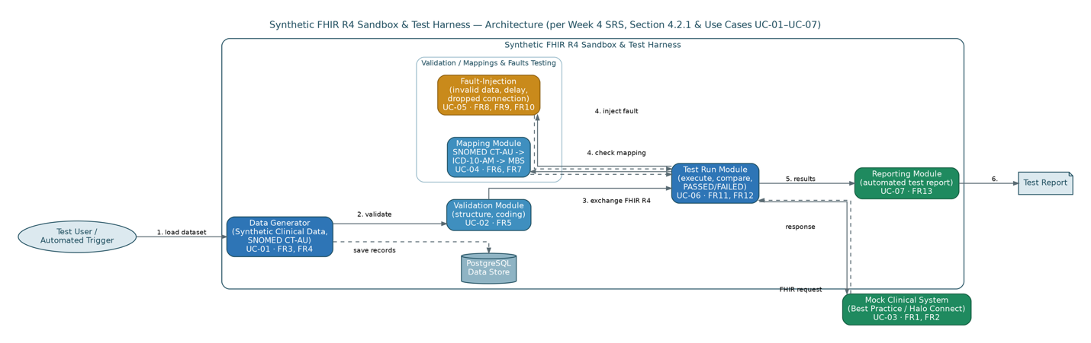
Figure 4.1.1: Proposed Solution Architecture
The primary end-user of the proposed test harness is the authorised MedTalk Connect engineering or testing end-user (e.g. Doctors or clinics as an actors). The end-user creates a test scenario and selects the appropriate connector and test parameters. The system creates synthetic patients and clinical encounter records based on this information (Walonoski et al., 2018). Before these records are used for testing purposes, they go through validation control checks to ensure that they satisfy the necessary synthetic data constraints and do not include any realistic patient identifiers.
Validated data is represented using FHIR R4 objects and passed to the interoperability testing layer (Gruendner et al., 2021). In addition, HL7 v2 messages can be simulated in case it is required. Data will go through the terminology mapping stage, where representative clinical concepts will be mapped on SNOMED CT-AU, ICD-10-AM and MBS (Giannangelo et al., 2012). Repository will provide a special terminology mapping chain that depicts this process.
Figure 4.1.2 Terminology Mapping Chain
Test execution layer performs normal, negative and degraded scenarios. These involve successful message exchange, malformed data, slow responses and dropped connections. The response from test execution layer is evaluated according to the expected outcome and stored for future analysis. Simulated connector layer provides simulated EMR integrations relevant to MedTalk Connect, which will allow testing connector behavior without having to connect the test harness to production clinical systems.
The primary trust boundaries are thus established between the authorized user and the test harness, between unvalidated and validated synthetic data and between internal test environment and simulated connectors. The authentication, access control, data validation, connector isolation and secure communication are proposed as a protection measure at these trust boundaries. Such design allows implementing all the necessary requirements of the project directly.

4.2 Technology Stack and Justification
The technology stack is chosen taking into consideration interoperability standards, needs of Australian healthcare system, security and cheapness of implementation. The selected technologies will enable implementing the Stage 1 architecture, laying a foundation for the Stage 2.
React technology is used as the frontend framework because of the requirement to use the stateful and component-based interface (scenario builder, results of the live test, connector statuses) instead of several static pages; React technology, along with its ecosystem, will enable developing such an interface without paying license costs, which is possible due to the limitations of the project budget. There are both Python (FastAPI) and Node.js (Express) suggested as the backend languages, not as the single option, because any of these frameworks will be able to implement the sandbox FHIR API with equal level of efficiency and community; the actual choice will be decided by the knowledge of the team, not by any technological requirement.
Table: 4.2.1: Technology Stack and Justification
Layer / Standard | Technology / Tool | Purpose | Justification (vs. alternative)
Backend / API | FastAPI (Python) or Express (Node.js) | Implements the sandbox FHIR API and test-harness logic | Mature, well-documented frameworks with strong REST support; either is fine as a starting point
FHIR test server | HAPI FHIR (open source) | Reference server to bootstrap the mock FHIR endpoints | Saves building a FHIR server from scratch; widely used, well-supported reference implementation
Data exchange standard | FHIR R4 (REST/JSON) | Primary standard for healthcare data exchange and interoperability testing | Required for REST/JSON-based interoperability testing; HL7 v2 alone doesn't support this
Implementation guide | AU Core | Shapes FHIR resources to the Australian context | Generic FHIR lacks Australian-specific alignment
Legacy messaging | HL7 v2 | Simulates applicable legacy messaging scenarios | Retained only where relevant; FHIR R4 is preferred for the primary workflow
Frontend | React | Builds the test-harness UI (scenario builder, results dashboard, connector configuration) | Component-based structure suits a dashboard with repeating elements (test cards, result rows); large ecosystem and free tooling keep it within the no-budget constraint; plain HTML/JS would require more manual work for the same interactivity
Terminology | SNOMED CT-AU, ICD-10-AM / MBS | Clinical terminology and Medicare/billing mapping scenarios | Required for Australian clinical/billing context; non-AU code sets wouldn't meet project requirements
Auth | SMART on FHIR / OAuth 2.0 | Authentication and authorisation for FHIR interfaces | More granular access control than static API keys
Database | PostgreSQL | Stores synthetic patients, conditions, and mappings | Relational integrity suits structured, linked clinical data
Test data | Synthetic data only | All test records | Prevents exposure of real patient data; enables safe, repeatable testing

The combination of FHIR R4 and AU Core is right since the solution needs to check the interoperability in an Australian healthcare environment (HL7 Australia, n.d.). HL7 v2 remains part of the complementary simulation capabilities but not a substitute for FHIR. The terminology standards (SNOMED CT-AU, ICD-10-AM, MBS) serve as the foundation for clinical and billing mapping testing, whereas SMART on FHIR and OAuth 2.0 become the proposed authentication approach (SMART Health IT, n.d.). Docker becomes a Stage 2 implementation technology and not the pre-existing solution due to the scope of work, where no test harness implementation takes place in Stage 1. Postman/Newman becomes part of the solution besides the unit-testing platform since the API validation comes from an external protocol level that the unit testing cannot handle (Gruendner et al., 2021).

4.3 Security Design and Control Mapping
Security will be integrated in the recommended solution using preventive, protective and monitoring controls. The most important prevention control is the utilization of only synthetic patients, which must be created separately from any patient record data. As a long-term prevention mechanism fit for production with actual patient data, the system should integrate with the Document Verification Service (DVS) – the federal government system that verifies the information in the identity documents, such as the Medicare card, on real-time basis from the records of the issuing authority. It is an authentic verification mechanism instead of structural one, since a real identifier can be verified for its actual issuance instead of good formatting. However, in the sandbox of stage 1 where there is no access to DVS, the equivalent testing-time prevention control would be to reject any identifier that matches any real-world identifier prefix/ranges (such as the IHI prefix ‘800360’) and generate identifiers from the synthetic data generator only.
Authentication will be employed for authorised users of the test harness. This would restrict who could define test scenarios, run tests and access their results. Authentication and delegation for FHIR interfaces would be achieved using SMART on FHIR and OAuth 2.0. Secure transfer should be implemented for implemented interfaces to ensure the security of data in transit. Moreover, logical separation is also needed for connectors and test environments. This helps to minimize chances that the test data or results corresponding to one connector is accessed by another connector. Input validation needs to be performed for the FHIR resources and other message formats to identify any mal-formed input data. Test log will help in providing traceability.
For Stage 2, the vulnerability management process should cover the dependency and container checking, secure configuration and updating of the deployed components. The incident response plan will be necessary to specify the containment, investigation and documentation process of any suspicious security events. Backup and recovery controls will be needed for important configuration and test result data.
These controls have been mainly mapped to NIST Cybersecurity Framework (CSF) since its functions of Identify, Protect, Detect, Respond and Recover help establish a definite framework for the suggested cybersecurity controls (National Institute of Standards and Technology, 2024).
Table 4.3.1: Security Design and Control Mapping (section 10 – planning)
Security Control | Proposed Design | NIST CSF Mapping | Status
Authentication | Basic OAuth 2.0 / SMART on FHIR token-based access for FHIR interfaces | Protect | Implemented (basic)
Data protection | Synthetic data only; real-identifier prefix rejection (e.g. IHI '800360') at input | Protect | Implemented (basic)
Encryption | Encrypted transport (HTTPS/TLS) for implemented interfaces | Protect | Implemented (basic)
Input validation | FHIR resource/message format validation before processing | Protect | Implemented (basic)
Logging and monitoring | Test execution and security-event logging for traceability | Detect | Implemented (basic)
Secure configuration | Baseline hardened configuration for application/containers | Protect | Implemented (basic)
Vulnerability management | Dependency and container security checks | Identify / Protect | Planned — Stage 2
Backup and recovery | Backup of configuration and test-result data | Recover | Planned — Stage 2
Incident response | Defined containment, investigation and reporting process | Respond | Documented only (process, not tooling)
Identity verification (production) | DVS-style real-time verification against issuing records (e.g. Medicare/Services Australia) | Protect | Out of scope — future/production only
Privacy/compliance | No real patient data; alignment with Privacy Act 1988, My Health Records Act 2012, AU Core | Identify / Protect | Implemented (basic)
These controls support the project's stated privacy and compliance objectives, including alignment with the Privacy Act 1988 (Cth) (Australian Government, 1988), My Health Records Act 2012 (Cth) and AU Core requirements (HL7 Australia, n.d.).

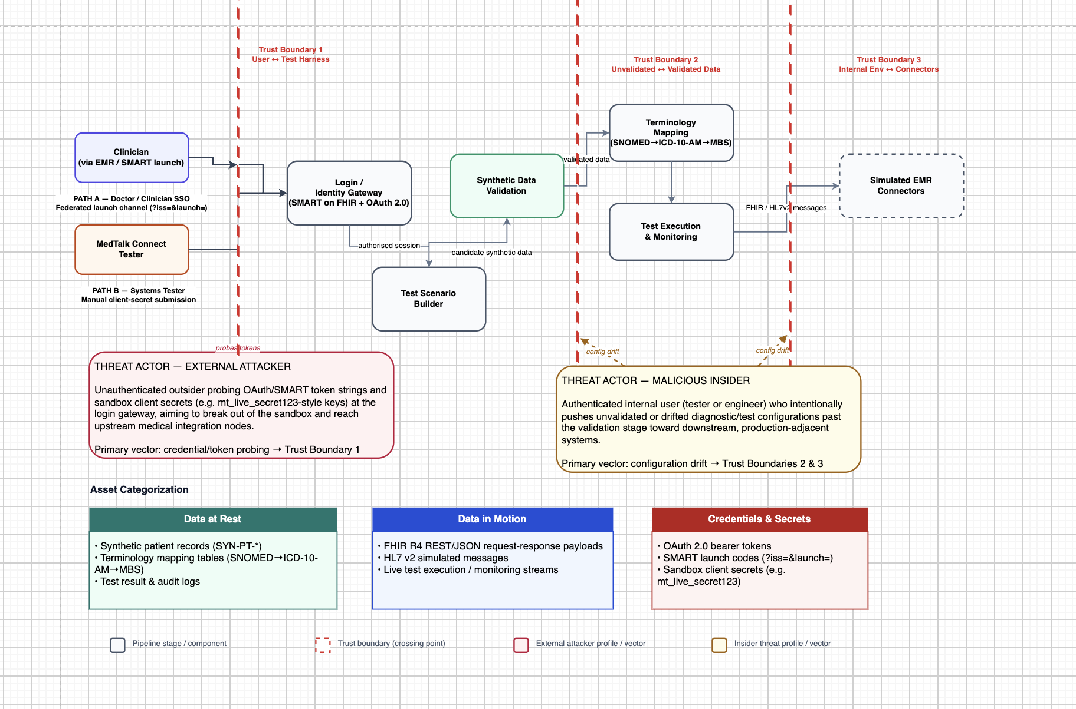
Figure 4.3.0: Threat model
This figure extends the design presented in Section 4.1 by assigning the STRIDE threats across the three trust boundaries that have been defined previously. Clinicians and testers access the design via two separate but authenticated methods: a federated SMART on FHIR launch and a sandbox token login, both traversing Trust Boundary 1 via the identity gateway. The data travels through the scenario building, validating synthetic data (Boundary 2), terminology mapping, and tests, finally arriving at simulated EMR connectors (Boundary 3). The two threat actors used for analysis in the design — an external attacker testing credentials and a malicious insider posing a risk of configuration drift — are represented with vectors pointing at the threatened boundaries. A panel showing asset categorisation lists data at rest, data in transit, and credentials/secrets, and STRIDE matrix (R-01-R-05) is included linking risks with their assets and mitigations as shown in the table below.

Table 4.3.2 Stride Table
ID | Risk Description | STRIDE Category | Boundary | Asset(s) Affected | Mitigation
R-01 | Fake or replayed credential reaches the identity gateway | Spoofing | B1 | Credentials & Secrets  (OAuth token) | SMART on FHIR + OAuth 2.0; short-lived tokens
R-02 | Tester's sandbox token reused to perform clinician-only actions | Elevation of Privilege | B1 | Credentials & Secrets  (sandbox client secret) | Role-based access control; tenant isolation
R-03 | Untrusted or drifted scenario/mapping configuration passed downstream | Tampering | B2 | Data in Motion  (FHIR scenario payload) | Input validation on FHIR resources before execution
R-04 | Real-world identifier pattern slips into the synthetic data set | Information Disclosure | B2 | Data at Rest  (synthetic patient records) | Luhn-check rejection of real AU IHI ranges (e.g. 800360 prefix)
R-05 | Malformed or flooded response from a simulated connector | Denial of Service | B3 | Data in Motion  (FHIR / HL7v2 messages) | Structured error handling; rate limiting; connector isolation

4.4 Capital and Non-Capital Cost Estimation
The solution suggested has an indirect financial impact as stage 1 is related to design, and it can be implemented using only free-tier and open-source tools, according to the report. As stated in the report, there is no budget allocated for any client or College, and there is also no allocation of cloud services, so students must use free-tier and open-source software.
Table 4.4.1: Cost category and estimation
Cost Category | Stage 1 Estimate (AUD) | Future / Stage 2 Consideration | Basis
Development hardware | $0 | $0–$2,000 if dedicated hardware is required | Existing team equipment
Software & platform tools (stack, GitHub, Docker) | $0 | $0, or vendor-dependent if paid tiers are needed | Open-source technologies preferred throughout
Cloud / hosting services | $0 | TBD | Not required for Stage 1; dependent on Stage 2 deployment model
Labor | $0* | TBD | Student project labour excluded from direct expenditure
Post-deployment (training, maintenance, operational support, scalability) | $0 | TBD | Only relevant after production adoption; not applicable at Stage 1
Labour is not considered as part of the expense for the student project; an organisational implementation will require accounting for labour associated with engineering and support.
The solution will have a number of cost advantages beyond its low cost to implement. For instance, the creation of a synthetic reusable testing environment can limit testing near production and make repeat testing of the connectors possible, while reducing risks of privacy incidents or unknown issues of interoperability. It might also help to decrease testing efforts with the addition of new connectors. But it is not possible to determine a reliable financial return on investment or break-even point, as there is no information about the costs related to testing or incidents in the available project data, labour rates or expected savings of the implementation – the invention of such a number would be inappropriate.

5. Proof of Concept, and Evaluation

5.1 Sprint Plan

5.2 Proof of Concept Description

5.3 Testing, Validation, and Cybersecurity Evaluation/evaluate ethical and privacy issues

6. Conclusion and Recommendations

References
Attorney-General's Department. (n.d.). Document Verification Service (DVS). Australian Government. https://www.idmatch.gov.au/resources/identity-verification-services-privacy-statement
Australian Government. (1988). Privacy Act 1988 (Cth). https://www.legislation.gov.au/Details/C2022C00361
Australian Government. (2012). My Health Records Act 2012 (Cth). https://www.legislation.gov.au/Details/C2017C00313
Bonami Software. (2026). Epic Integration & Implementation. Bonami Software. https://www.bonamisoftware.com/epic-integration
Choudhary, J. (2026). How to Get Your App Into Epic (2026). Nirmitee.Io. https://nirmitee.io/blog/how-to-get-your-app-into-epic/
eCQI. (2025). FHIR® - Fast Healthcare Interoperability Resources® - About | eCQI Resource Center. Healthit.Gov. https://ecqi.healthit.gov/fhir/about
FAZ Australia. (n.d.). Project brief and requirements specification [Unpublished internal document].
For practices - Halo Connect Documentation. (2026). Haloconnect.Io. https://docs.haloconnect.io/guides/practice-guide/

Giannangelo, K., et al. (2012). Mapping SNOMED CT to ICD-10. Studies in Health Technology and Informatics, 180, 83–87. https://pubmed.ncbi.nlm.nih.gov/22874157/
Gruendner, J., Gulden, C., Kampf, M., Mate, S., Prokosch, H.-U., & Zierk, J. (2021). A framework for criteria-based selection and processing of Fast Healthcare Interoperability Resources (FHIR) data for statistical analysis: Design and implementation study. JMIR Medical Informatics, 9(4), e25645. https://doi.org/10.2196/25645
HL7 Australia. (n.d.). AU Core Implementation Guide (v1.0.0). HL7 International. http://hl7.org.au/fhir/core/
HL7 International. (2019). HL7 FHIR Release 4 (R4). https://hl7.org/fhir/R4/
MarkiTech.AI. (2025, ). MarkiTech. https://markitech.ca/our-work-healthcare/ accessed 09 September 2026.
MediBetter | Integrations. (2026). Medibetter.Com.Au. https://medibetter.com.au/ integrations/
MediRecords Connect: Getting Started with Connect & FHIR APIs. (2026). Knowledge Base. https://support.medirecords.com/hc/en-us/articles/13936381648399-MediRecords-Connect-Getting-Started-with-Connect-FHIR-APIs
MedTalk AI. (2020). AI Medical Scribe Features in Australia. MedTalk AI. https://medtalk.co/au/product

National Institute of Standards and Technology. (2024). The NIST Cybersecurity Framework (CSF) 2.0 (NIST CSWP 29). U.S. Department of Commerce. https://doi.org/10.6028/NIST.CSWP.29
SMART Health IT. (n.d.). SMART App Launch Framework. HL7 International. https://hl7.org/fhir/smart-app-launch/
SMART on FHIR. (n.d.). Docs.Smarthealthit.Org. Retrieved September 11, 2026, from https://docs.smarthealthit.org/
SNOMED CT-AU and Australian Medicines Terminology May 2022 Release. (2022). Digitalhealth.Gov.Au. https://www.digitalhealth.gov.au/healthcare-providers/product-releases/snomed-ct-au-and-australian-medicines-terminology-may-2022-release
Synapxe - HealthX Innovation Sandbox. (2023). Healthx.Sg. https://innovation.healthx.sg/
Walonoski, J., Kramer, M., Nichols, J., Quina, A., Moesel, C., Hall, D., Duffett, C., Dube, K., Gallagher, T., & McLachlan, S. (2018). Synthea: An approach, method, and software mechanism for generating synthetic patients and the synthetic electronic health care record. Journal of the American Medical Informatics Association, 25(3), 230–238. https://doi.org/10.1093/jamia/ocx079

Appendices

