Framework / Standard | Status & Scope
ACSC Essential Eight | Fully supports all 8 cyber mitigation strategies outlined by the Australian Cyber Security Centre.
IRAP | Assessment is currently In Progress to handle Australian Government PROTECTED-level data.
HIPAA | Fully compliant with U.S. health data privacy regulations.
GDPR & PIPEDA | Fully compliant with European and Canadian privacy mandates.
Australian Privacy Principles (APP) | Completely compliant with all 13 APPs under the Privacy Act 1988.
requirements
Table needs caption and name of table
INCLUDE sitemap and wireframes

Current As-is
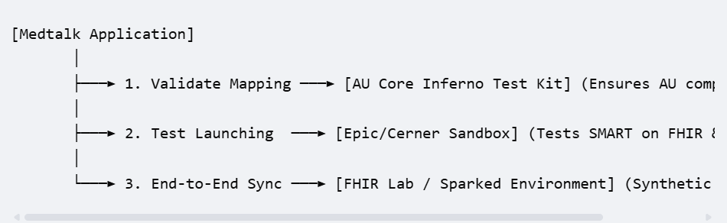

Comparative
Inferno AU core testing kits(Hornback, Marteau et al. 2025)
FHIR Lab Sandbox

Reference
Security at MedTalk. (2026). MedTalk AI. https://medtalk.co/security
Hornback, A., et al. (2025). "FHIR in focus: enabling biomedical data harmonization for intelligent healthcare systems." IEEE Reviews in Biomedical Engineering.

