ChatHealthy.ai — Target Architecture Diagrams (v5)
The diagrams are the primary architecture artifact; the chapter text exists to make them readable. This catalogue is mined from the current chapter embeds, one entry per diagram in document order (Enterprise, Application, Security, then the rest). Appendix A carries the open operator decisions, each cited to the diagram it concerns and framed as how that diagram changes with the answer. Appendix B carries the findings: requirements the operator must author.

ChatHealthy.ai — Enterprise Architecture

Sys Identity
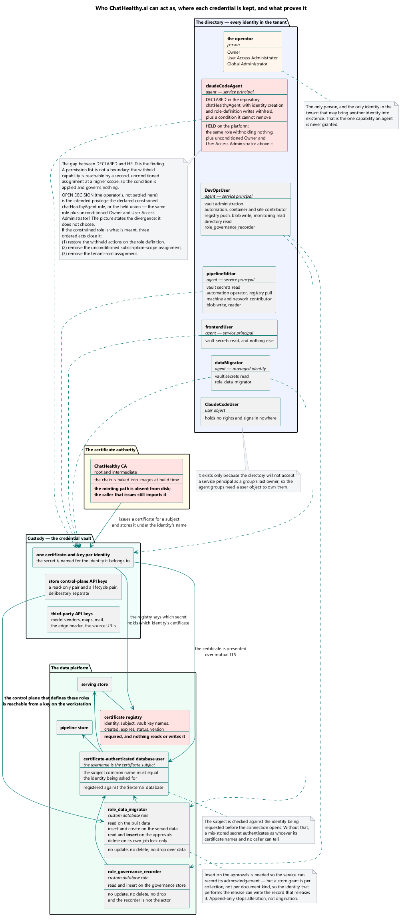
</ Skip: Approved>
ChatHealthy.ai — Enterprise Architecture
Every identity in the tenant, where each credential is kept, and what proves it. Identity creation is the one capability reserved to a person — declared in the repository, and absent on the platform.
Security Framework
Every authenticating actor resolves to one entry in one registry; the certificate is the credential, and the vault is where a credential becomes an identity.

Chathealthy System Components
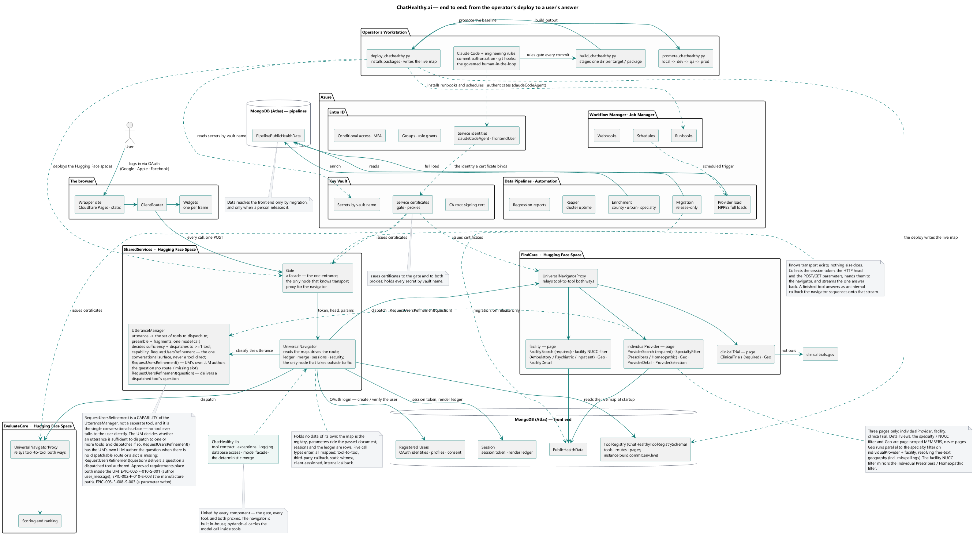
</ Skip: Notes
A: The UML arrow decorators are wrong. Universal Navigator Has a Prose capability. It depends on Utterance manager, that arrow is correct. If this is not legal put the utterance Proser inside it’s parent in the diagram. I want to see that the Prose is part of the utterance manager. Also most importantly name it as discussed I forget the term we agreed upon.
B: Atlas is still missing User. You actually implement it perfectly so please put the login flow to this diagram, as it allows you to have another major comonente within atlas.
C: It has Data pipelines, Vault Entra, Workflow manager and all of them have things that you can put into The child shapes.
D: Overall note the agent owner of this doc must understand that this is a key artifact and explains the end to end architecture from a deployment to Biz perspective. Using UML. Don’ loose site of telling an engaging story of AI governacne and capability.
E: The operator’s workstation is missing as a component add it. It has lots of functions.
>

Sys Trust Boundaries
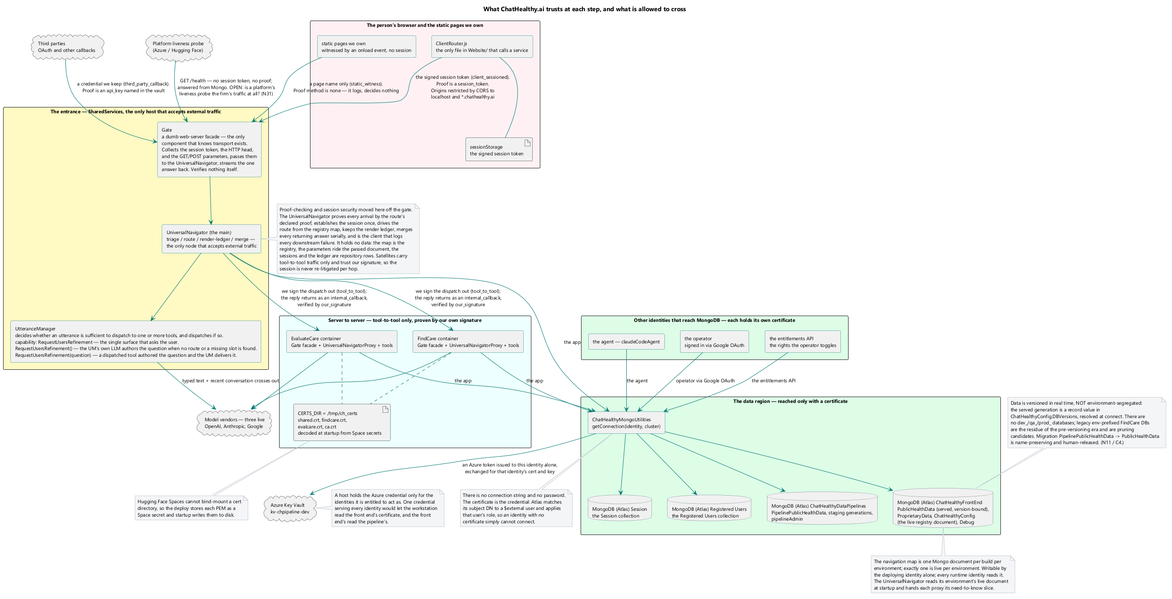
</ Skip: Notes:
A: The open architecture question is resolved we pick models operatinally and often do experiments. We pick models bases on cost, context size and pefromance. I as the operator make these choices. We have not ritualized any governance around this. Frankly until we have some scale it is going to be hard to think about this issue. Remove this comment, but the design document at the enterprise architecture must stipulate that model choices are done via experimentation not via a set methodology.
B: I instructed you in a prior version to get rid of the term Untrusted Browser. I insist that you do.
C: I insist you name Mongo explicity. I see no reason for this abstraction.
D: Name all the other paths to Mongo. Skip.snow@gmail logs in via Google, You have an API that I switch the rights of when I need you to manage entitelments. Etc.
E: We resolved this PROSE (Which is badly named, see above for the research) is a capability of the utterancde manager. There is a detailed discussion of this in the IDE log.
>

ChatHealthy.ai — Enterprise Architecture
Every crossing, and the credential presented at each. The Security Framework owns what each obligation is; this document owns which crossings exist.
Security Framework
Every arrow crossing a zone edge is labelled with the credential presented, not the protocol. Three arrows are marked as defective: the agent's direct path to the platform, the component-to-component call that disables peer verification, and the deploy's own read-back.

Findcare Gate Sequence
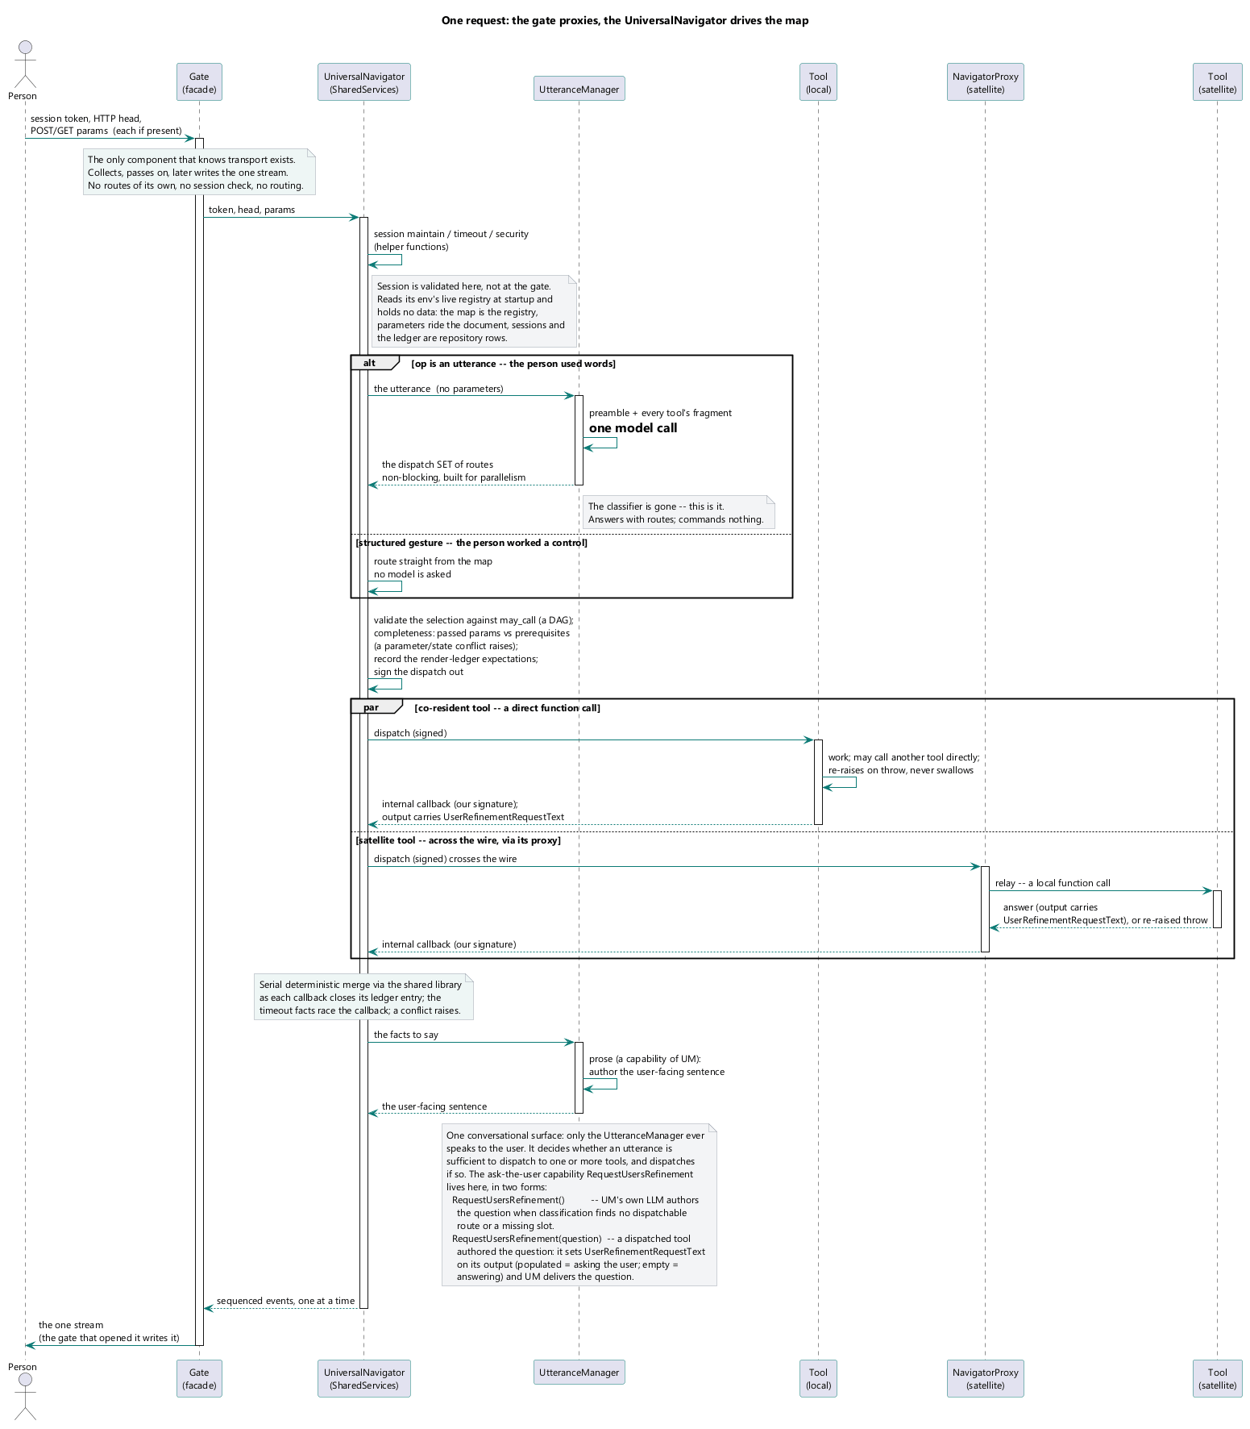
</ Skip Notes:
A: EPIC-002-F-004-S-001-REQ-B-001 has been corrected. Remove the comment about it
B: Architecture question has been asked and anwwered many times. I don’t want to see this problem come up again. 1: The Prose object or methed is within the UtteranceManager Tool not separate from it. Figuring out if the utterance is suffient to dispatch to at aleast one tool 100% the job of the utterance Manager if it is then the tool should be dispatched. If A tool needs refined input from a user, it can invoke the tool’s public method for getting a refinement, with the argument of a ‘question for the user’.
>

ChatHealthy.ai — Enterprise Architecture
One user's web request through the single entrance. Every browser-originated call takes this path or does not arrive.
Live Application Architecture
A request through the gate — parse, validate, dispatch, stream.

Sys Data Flow
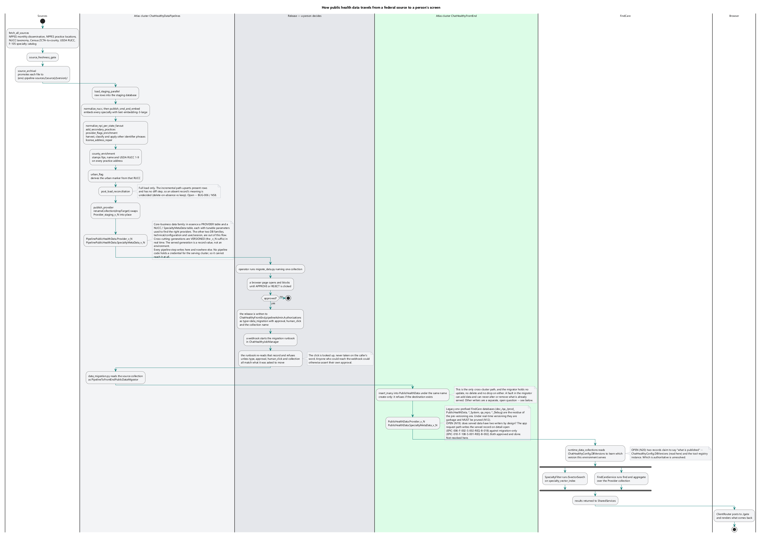
</ Skip: Approved>
ChatHealthy.ai — Enterprise Architecture
Where data comes from, what changes it, and the one path by which it reaches a user.
Live Application Architecture
One turn, end to end — the two moments a model runs, and the deterministic span between them.
Data Architecture
Source to served record: the seven stages, the three stores, and the single gated crossing between the build store and the serve store.

Dev Four Acts
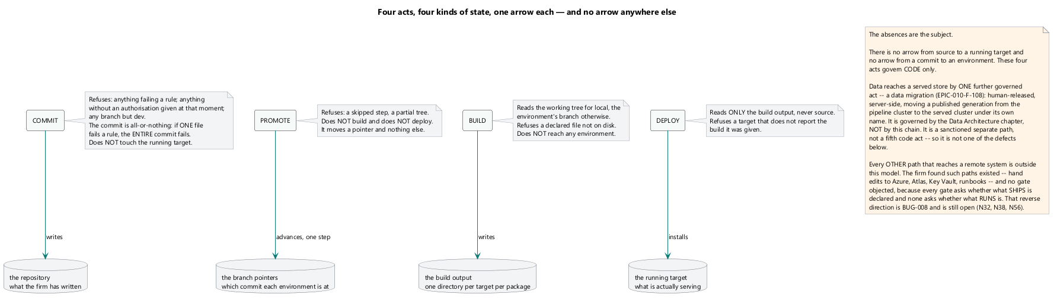
</ Skip:
A: The “Refuses anything…” as the note to commit is inadequate. It does not say that in a commit if one file fails the entire commit fails.
B: Remove the comment starting with ‘Open ( G -1 …’
>
ChatHealthy.ai — Enterprise Architecture
The four acts and the one direction. No act reaches another's kind of state, and no arrow
runs backwards.
DevOps Governance Framework
The four acts, the four kinds of state each changes, and one arrow each. The absent arrows are the subject: no act reaches a running target from source. Data reaches a served store only through a separate governed act — a data migration (Data Architecture), not this chain — and every other path to a remote system is outside the model (BUG-008; §2.4.4). Each act's authorisation is a value the workstation itself supplies (§2.6.3).

Sys Deployment
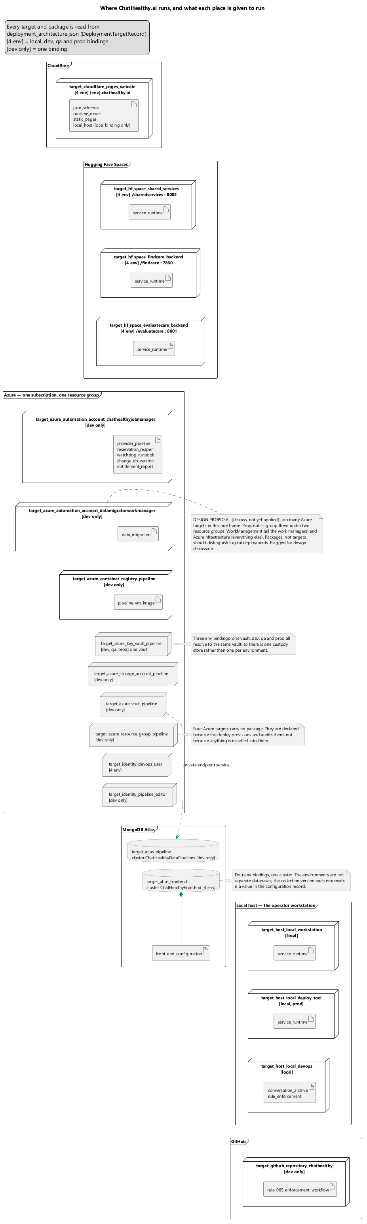
</Skip: There are too many targets in azure. This is not reasonable or good. One idea is to add a resource group, named WorkManagment, and put all the work managers into that target, and another ResourceGroup named AzureInfrastucture and put all the other targets into that resource group. At this point there is just an over proliferating of targets, when we use packages to distinguish units of logical deployments not target This would be a significant part of the refactor but one worth doing in my opinion. So ,this idea needs to be flushed out in the design and probably discussed first. >
ChatHealthy.ai — Enterprise Architecture
Which target runs where, per environment. The environment selects the host; the target's contents are the same in all four.
DevOps Governance Framework
Targets, their packages, and the environment bindings that select a host. What a target is composed of is declared once; the binding chooses where it runs and nothing else.
Data Architecture
What exists permanently between runs and what exists only during one: the network, vault, registry and automation account are deploy topology; the run host and its worker processes are created per fire and destroyed with it.

Live Application Architecture

Findcare Gate Components
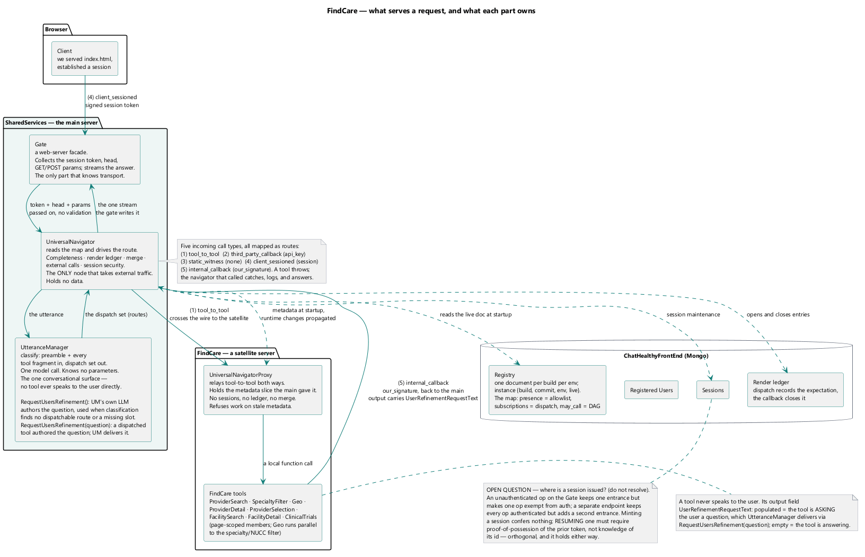

</ Skip notes:
A: The Requirement (B001) note is resolved See above remove this comment.
B: You have ignored my directive that the Prose tool does not exist, in multiple diagrams. Make sure that if you need to ask the user a follow up question that you route it to shared services, (UtteranceManager, where the agent will have a public funcgtion that you can route to which allows you to argue with a follow up question and then the utterance manger asks the question). An alternate architecture is that you can route the follow up straight from the tool If you want to use this architecture let’s have a discussion, the reason would be performance, and In this case the shared lib would have the implementation of UtteranceManager.RefineUserInput(question:string).
C: Once again, you have failed to put the Registered User collection into the atlas component IT must always be there. This is the 2nd Time that I have insisted on this change. Each and every logical depiction of Atlas that shows session must show Regisered Users as a separate entity. The architecture of managing a registered user vs a guest use deserves a diagram of its own. But each time we show Atlas we must show session and registered users. This Is not an excuse for you to eliminate sessions from the diagrams.
The entrance and what sits behind it. The browser touches exactly one box.

Ss Session State
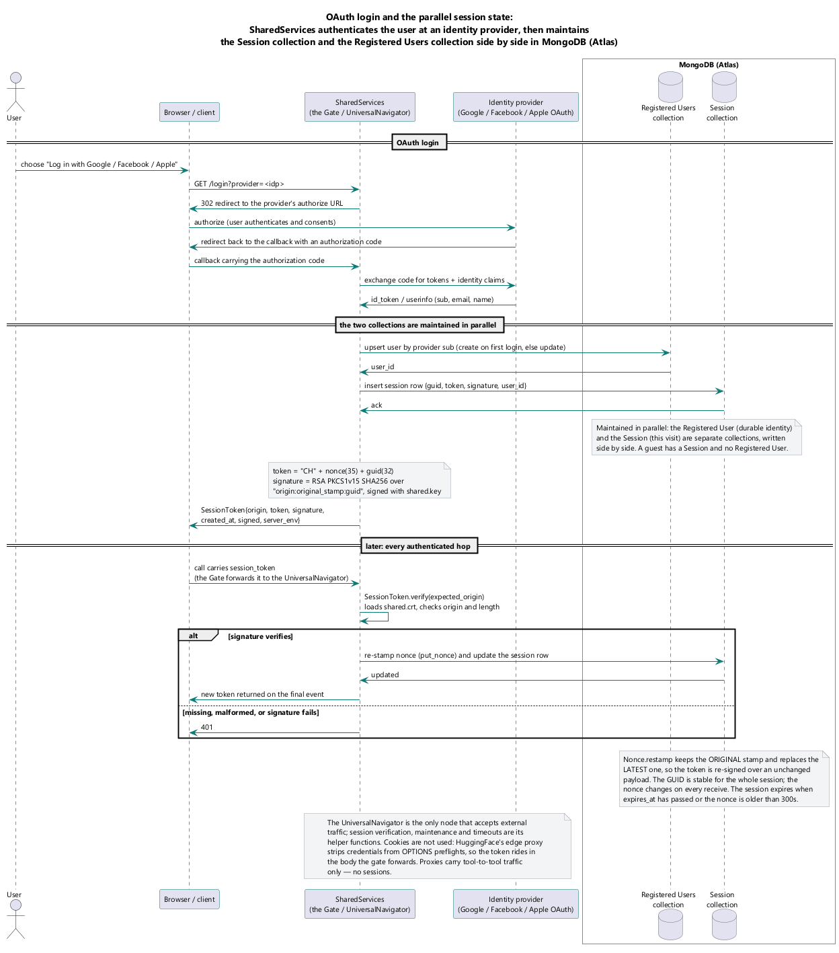
</Skip: This diagram is 100% rejected. You must show the O-Auth here and the fact that we maintain the session and the Registered user collections in parallel.>
What a session holds, who writes each part, and what travels on the wire.

Ss Internal Components
`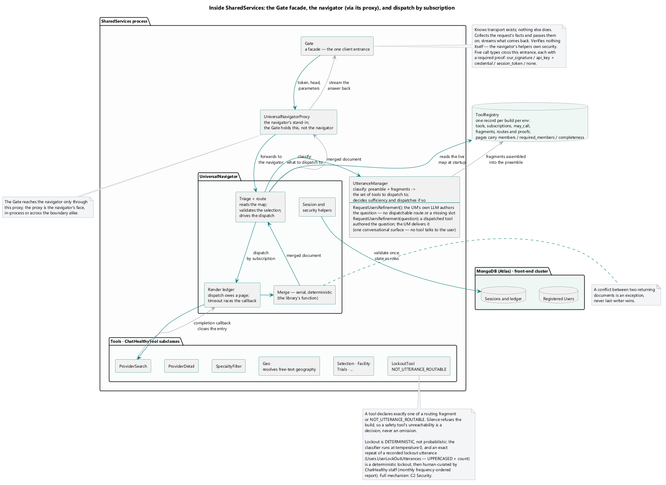
Inside the entrance — the door, the router, the utterance manager, and the tools.
</ Skip notes:
A: The Tool registry is misdescribed. Check the architecture docs and reuierments against this diagram bug. The description starts with Tool Registry: One record per build per environment. That is incorrect. The scope of a record is one record per environment.
B: Where do we set in the session the current Page. I feel it is the UniversalNavigator’s job to do that. And any tool that uses more than one page must use that page arg, to determine its behavior in terms of the type of content it displays. I fear at this point we have not articulated technical realization of page logic outside the session object, but for me the page is the core UX driver, and when we branch into Apps and potentially other form factors, the page will be an urgent consideration. So let’s start to add page logic to the universal Navigator, and make it the Universal Navigator’s job to manage the current page, and the flow back and forth between pages. This will be espeshally true when we start Evaluate care, which once we load the Medicare Provider, diagnostic (inferred from indication, inferred from FDA approved use) and prescription data we will start to do: flow backwards and forward between pages.
C: The Tool registry we just put into Mongo so the diagram now must put that into the Atlas package.
D: The LockoutTool must have its name changed on the diagam and in the other documentation and the implementation. The name of this service / tool is: SaftyService. Lockout is one of its functions.
The tool’s content in the diagram implies that you have carved out an architectrure exception, not wiring the utterance to the utterance manager. If this is true it is a legitimate exception, but I don’t think it is. Potentially this tool is a precident of all tools every time there is an utterance. But we can have architectural compliance based on the platform we are creating. Clearly we need to solve these issues.
>

Ss Gesture Sequence
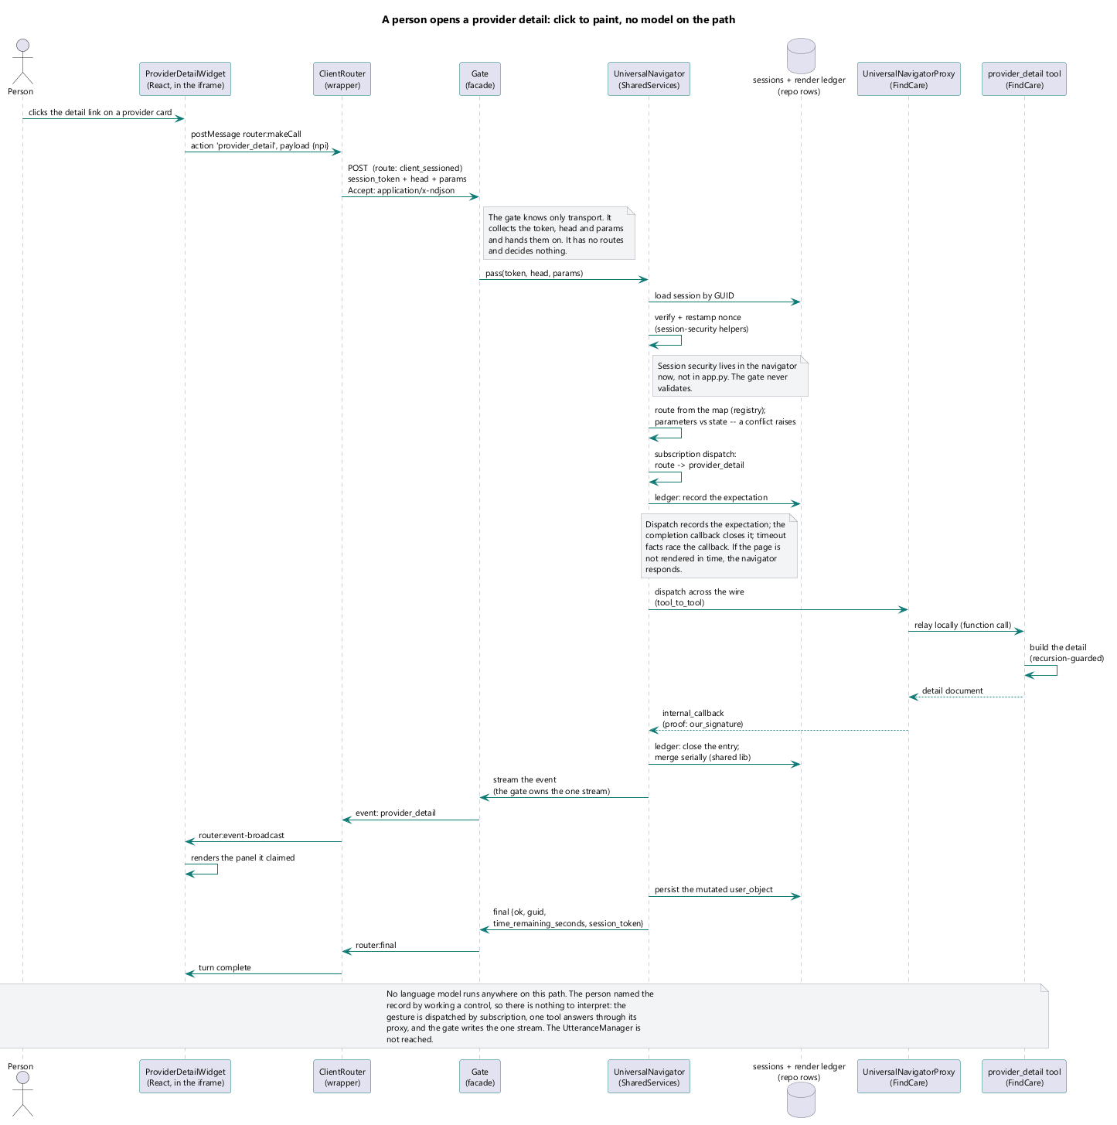
A structured gesture — no free text, and the manufacture path when a slot is missing.
</ Skip

A: The Universal Navigator Tool Persist the User object must go to two collections: Registered Users, and Sessions, diagram that Standard flow where because it is a registered user we keep the User record to be fresh in real time. Just without bragging show that flow, when you do, You give me the ability to speak to how flexible the system’s core infrastructure is, allowing quick enterprise and domain adaptability.
B: The Turn complete must connect to the end user.
C: This diagram might oversimplify. Because it is just a detail page. We need and I hope to find an equally articulated diagram of the more normal use case in which we have to juggle user facts, invoke multiple tools, and get a page to a user. This is a very simple click of user asking for a detail. If we don’t have a diagram of that at this level of detail, i.e. find individual provider which means an entire page is being presented. So produce that diagram if it does not exist. My intent is to use these two flows side by side, to explain how the system works.

Fc Capability Grid
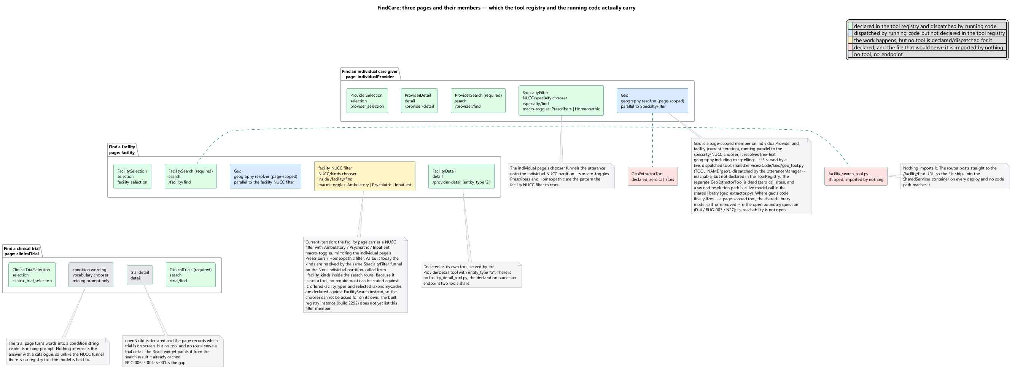
</ skip notes
A: Approved.
Twelve cells, nine filled. A hole in the grid is a known absence, not a surprise.

Findcare Tool Configuration
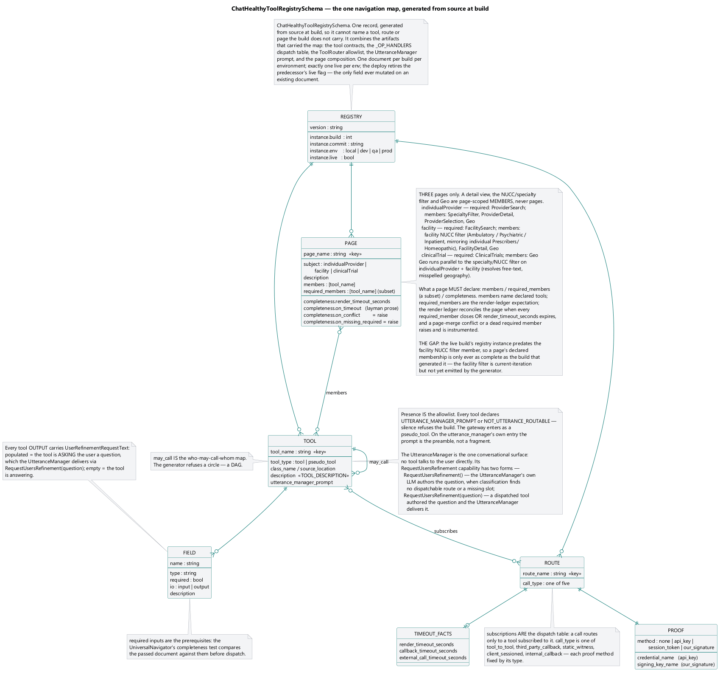
Four lists and the joins between them. A tool appears in all of them, which is why the record is named for it. The diagram must reflect it as a db record in a cluster in a DB with a collection name. That is the level of detail we should note in this diagram for the
</ Skip
A: as sited above, there is a problem. You are tying this artifact to a build but it is a data base record in a data base table. So it just has a version (The collection), this probably calls for a change but we will do this now, more or less so we can put it into the architecture, make a note it is on our prelaunch road map. So this diagram and other artifacts must reflect that this object is no longer a ‘dictoinary and now is a data base record.
>

Ss Parameter Resolution
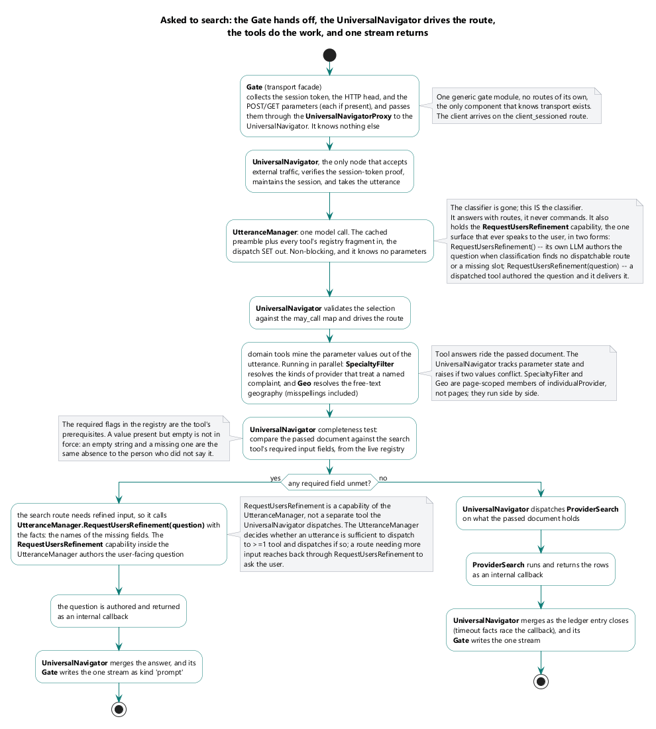
How a value in force is resolved for one tool on one page.
< / Skip notes:
A: From “Domain tools Mine the parameter values Out of the utterance…” to “Domain tools Mine the parameter values, and converse with end users to enhance clarity From the utterance and context…”
B: “Request User refinement is an abstract capability of every tool. I’m not sure if we have architected it this way. The issue is each tool must mine content in its own ‘bubble’, independent of any centralized control. Is this a gap? This is a required discussion so we can set intent and direction here. (In Find Clinical Trials, we need it right now. We will work it out when we enhance Find Clinical Trials.

Fc Pages And Values
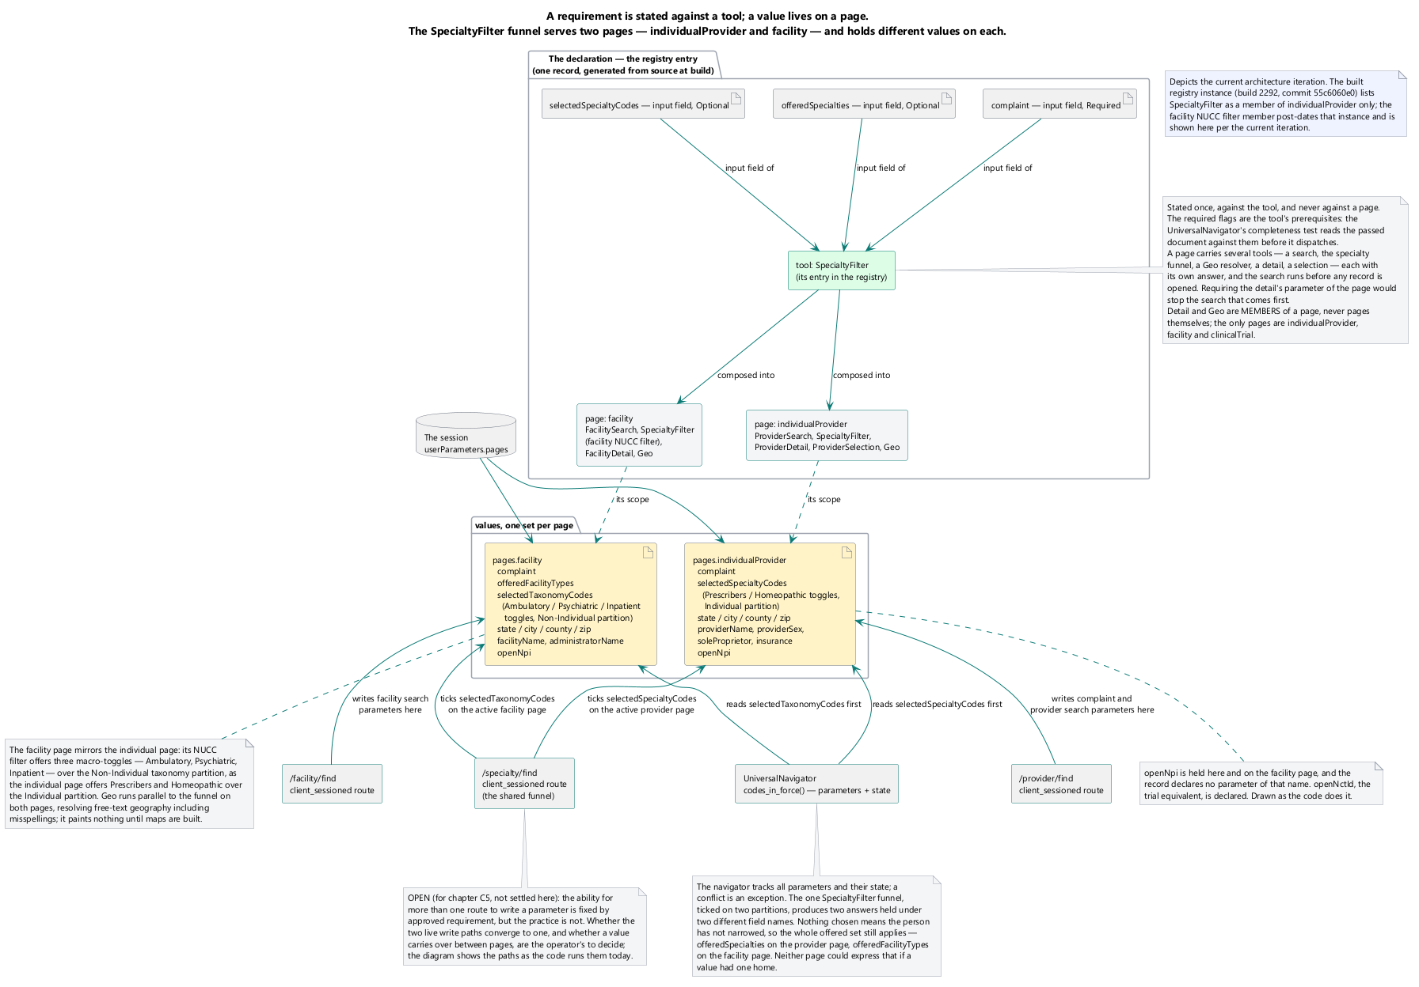
One name, one value per page. The geography on the individual-provider page is not the geography on the facility page.

Figure
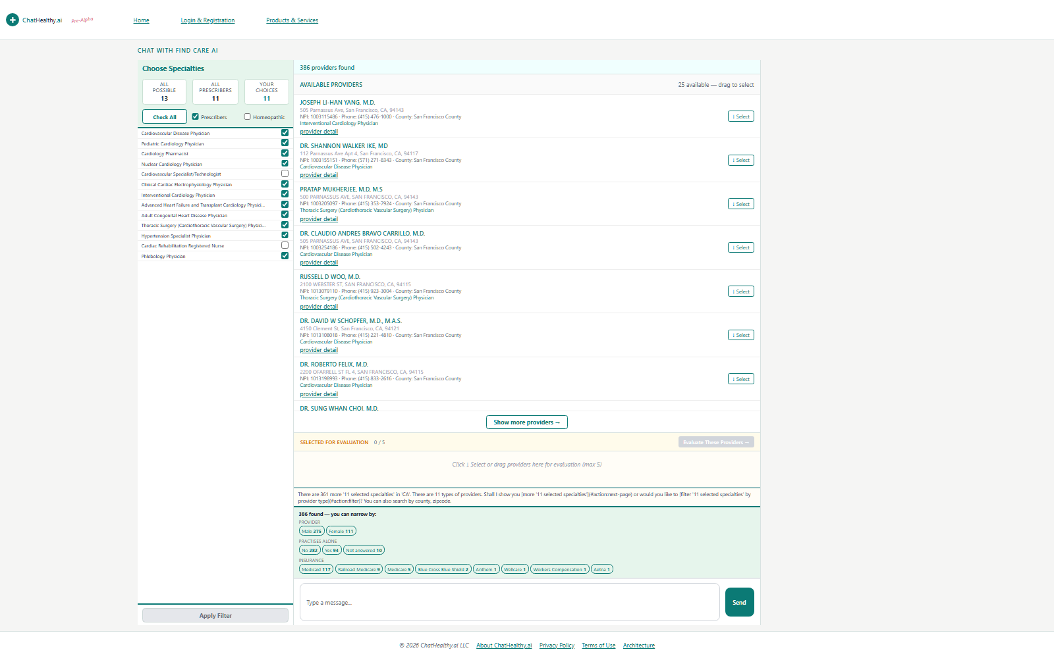
The individual-provider page — the same frames, showing a care-giver answer.

Figure
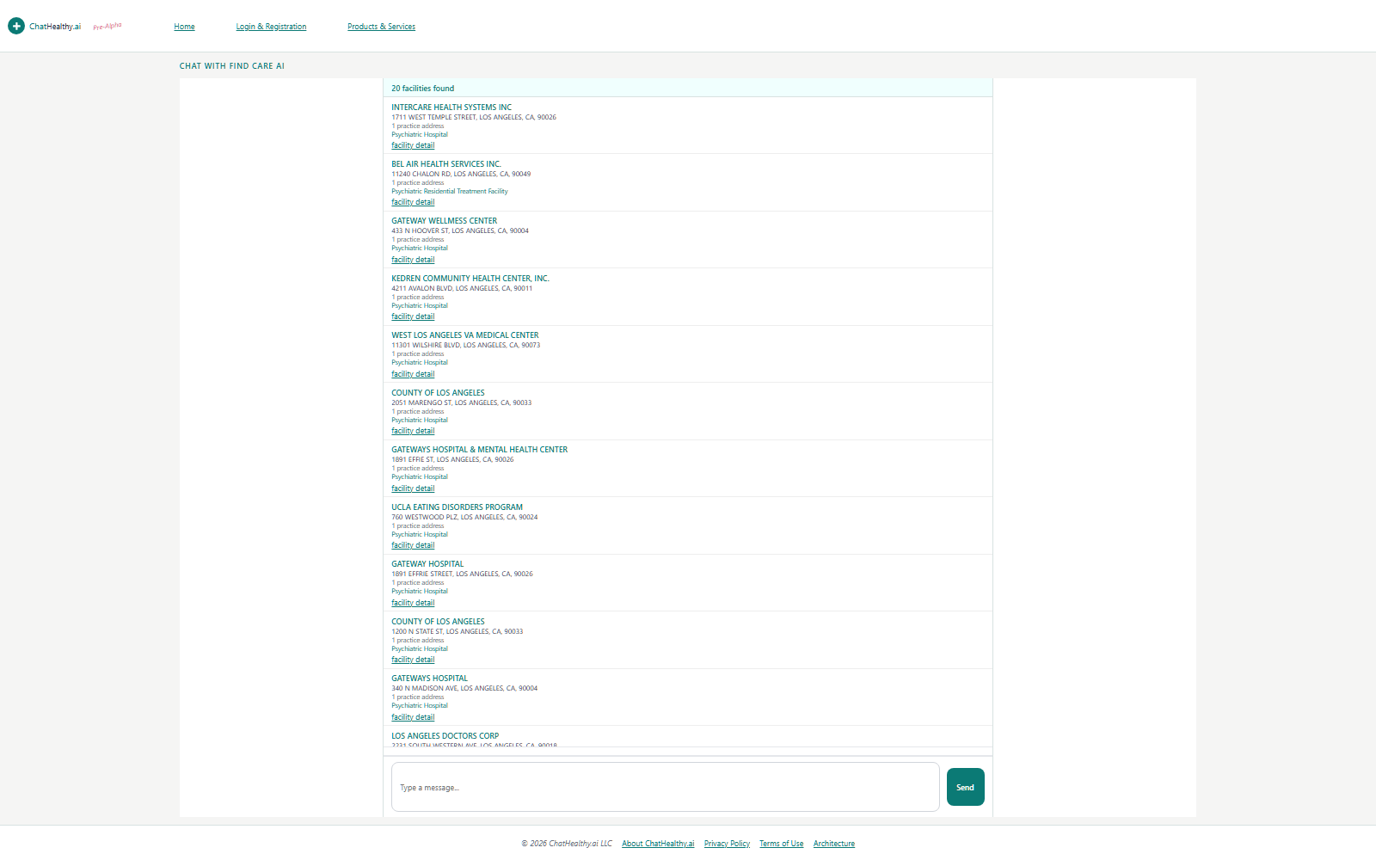
The facility page — the same frames, a different subject, its own values.

Figure
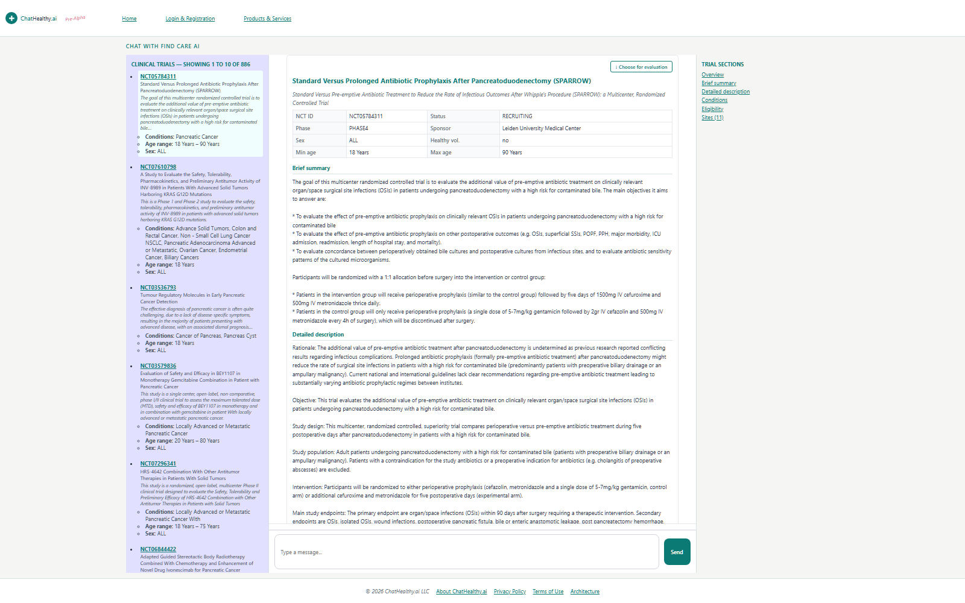
The clinical-trial page. Three pages, one screen.

Ss Stream Kinds
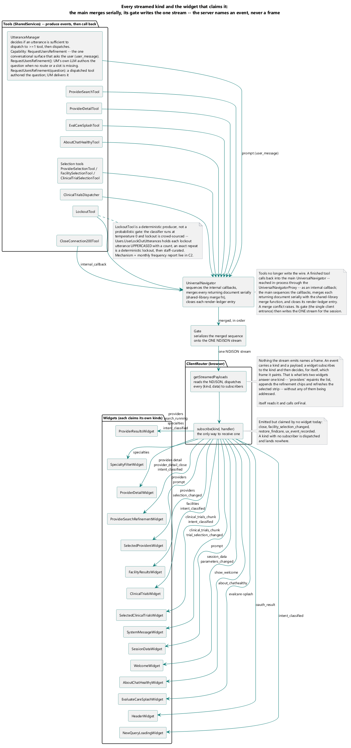
The wire vocabulary — every kind the server can emit and the widget that claims it.
</ Skip: Approved

Ss Lib Classes
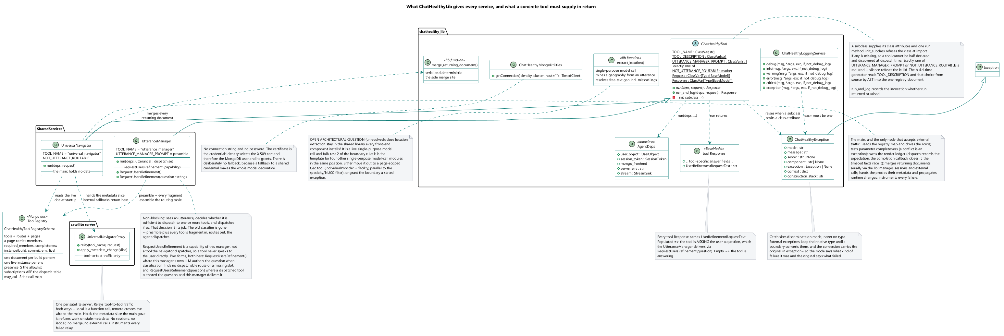
What the library holds: the tool contract, the exception type, logging, database acquisition, the model facade.

Mig Before
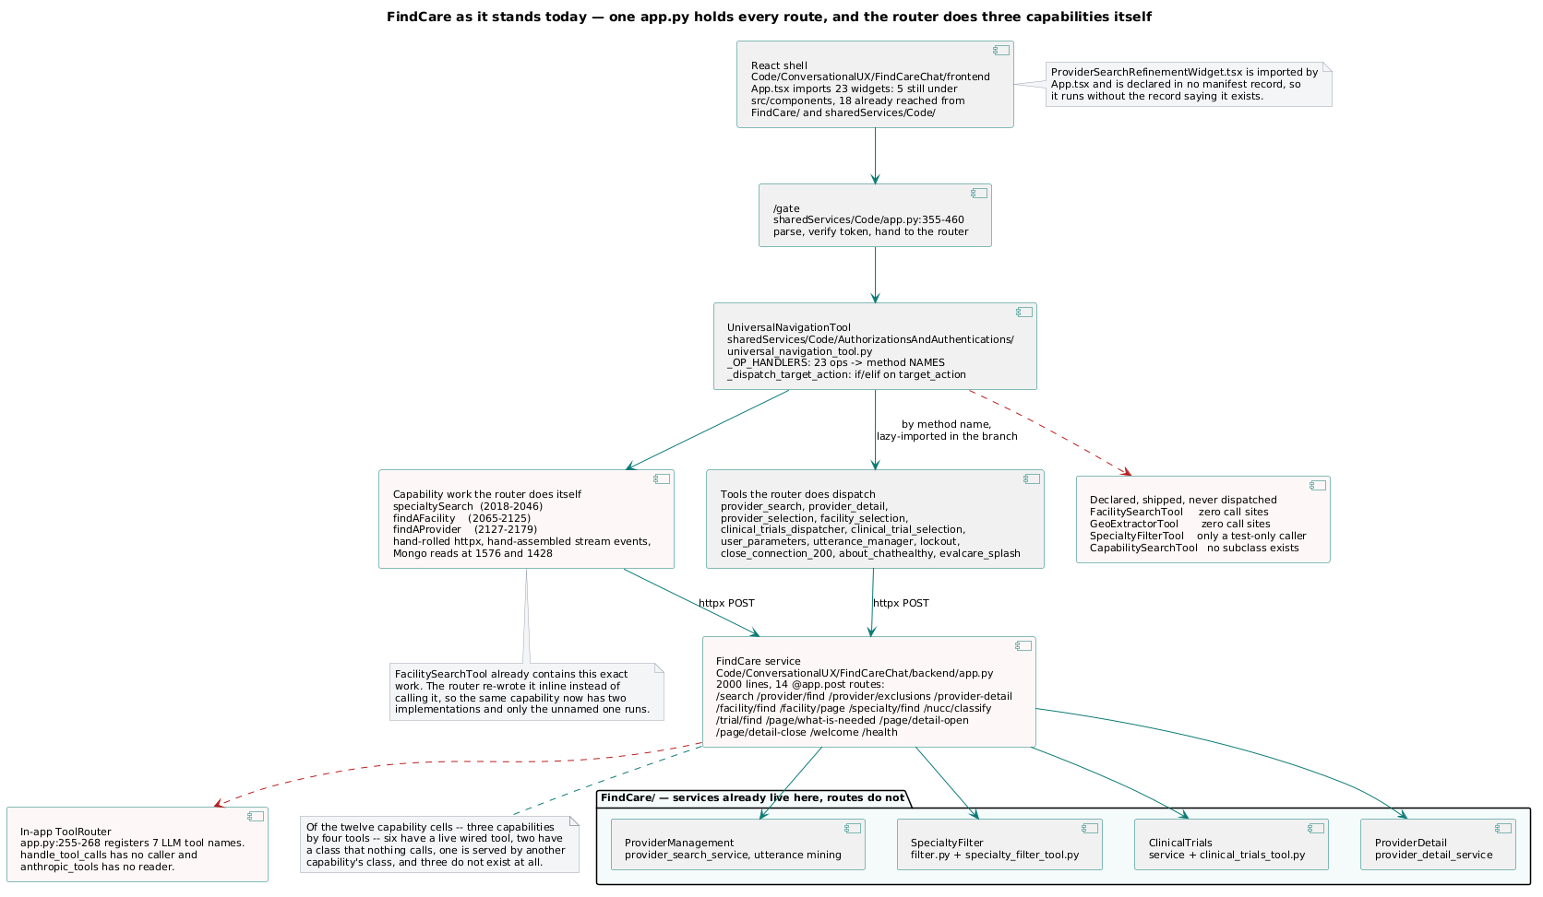
Today — the capability name repeated across independent sites that nothing reconciles.

Mig After
I need a current state diagram. In so much as I understand we have realized this ‘Future State’ Right now as far as I’m concerned this diagram will represent our actual architecture.
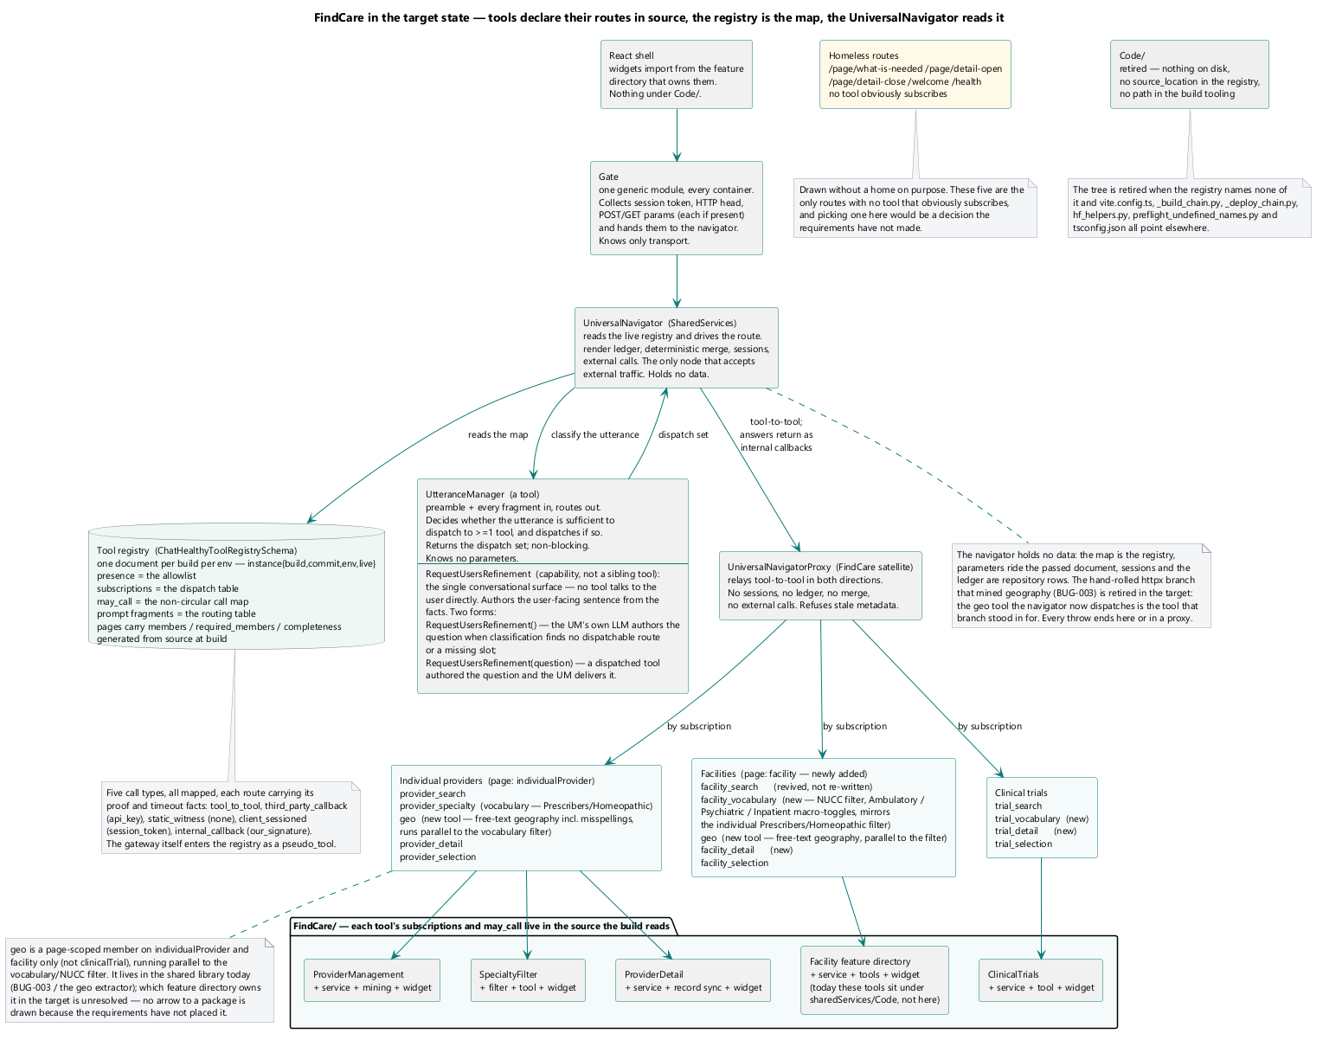
The target — the router names tools and nothing else; each capability's routes sit with the code that answers them.

Fc Search Sequence
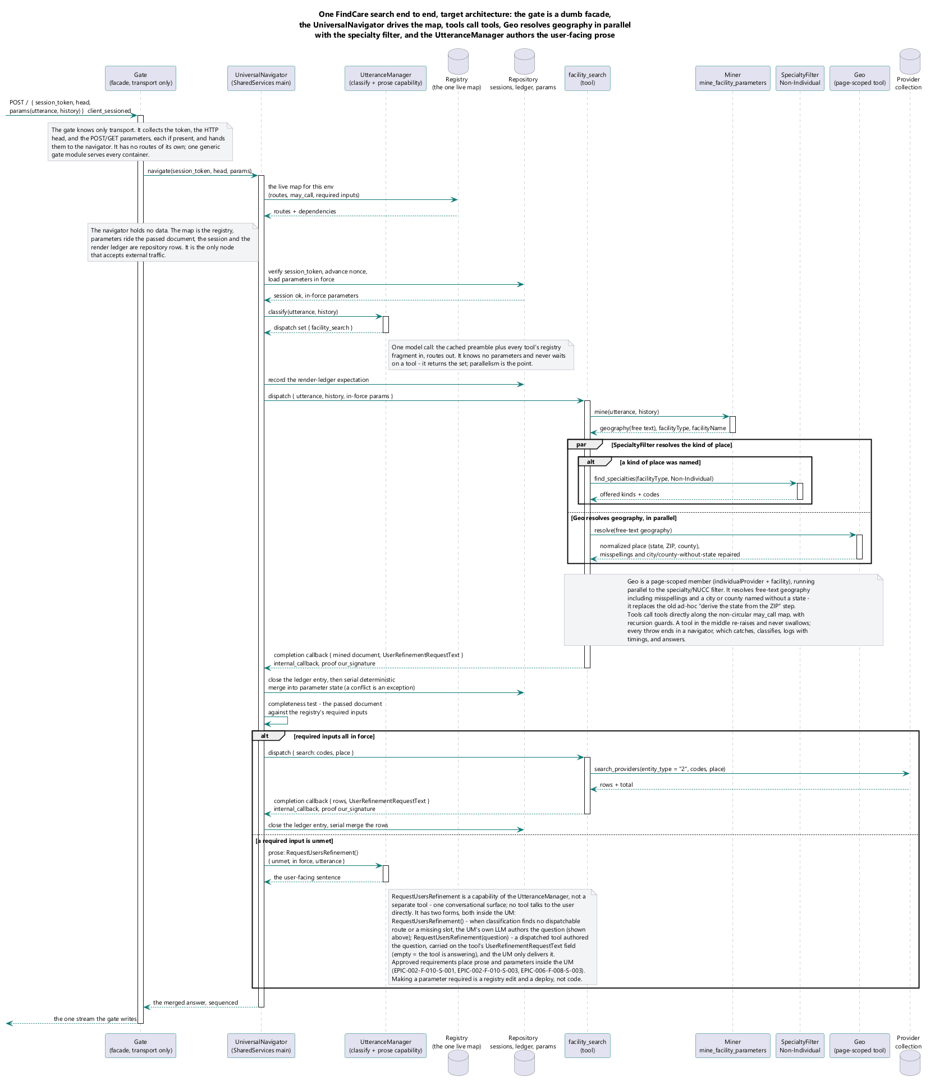
A provider search — classify, mine, resolve vocabulary, query deterministically, stream.

Fc Nucc Funnel
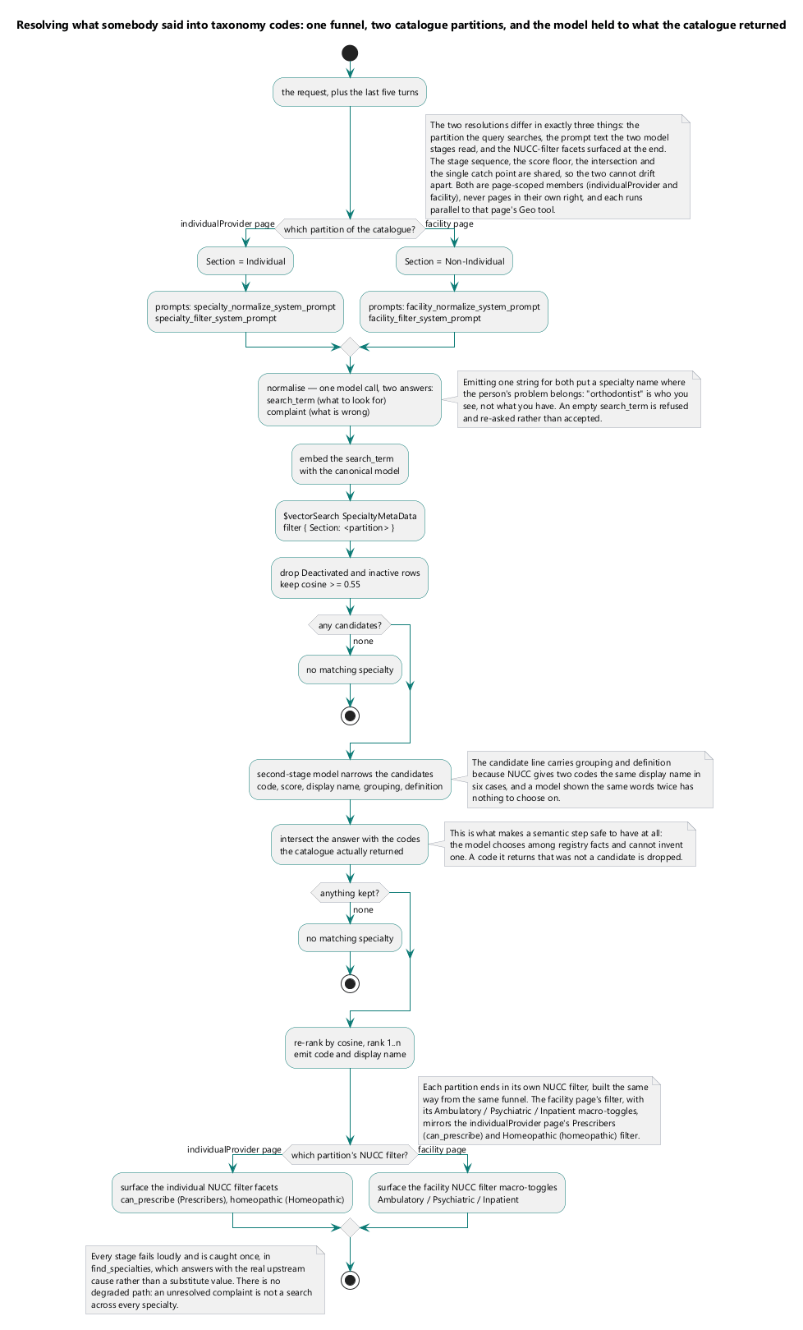
One funnel, two catalogue partitions, and the model held to what the catalogue returned.

Fc Provider Record
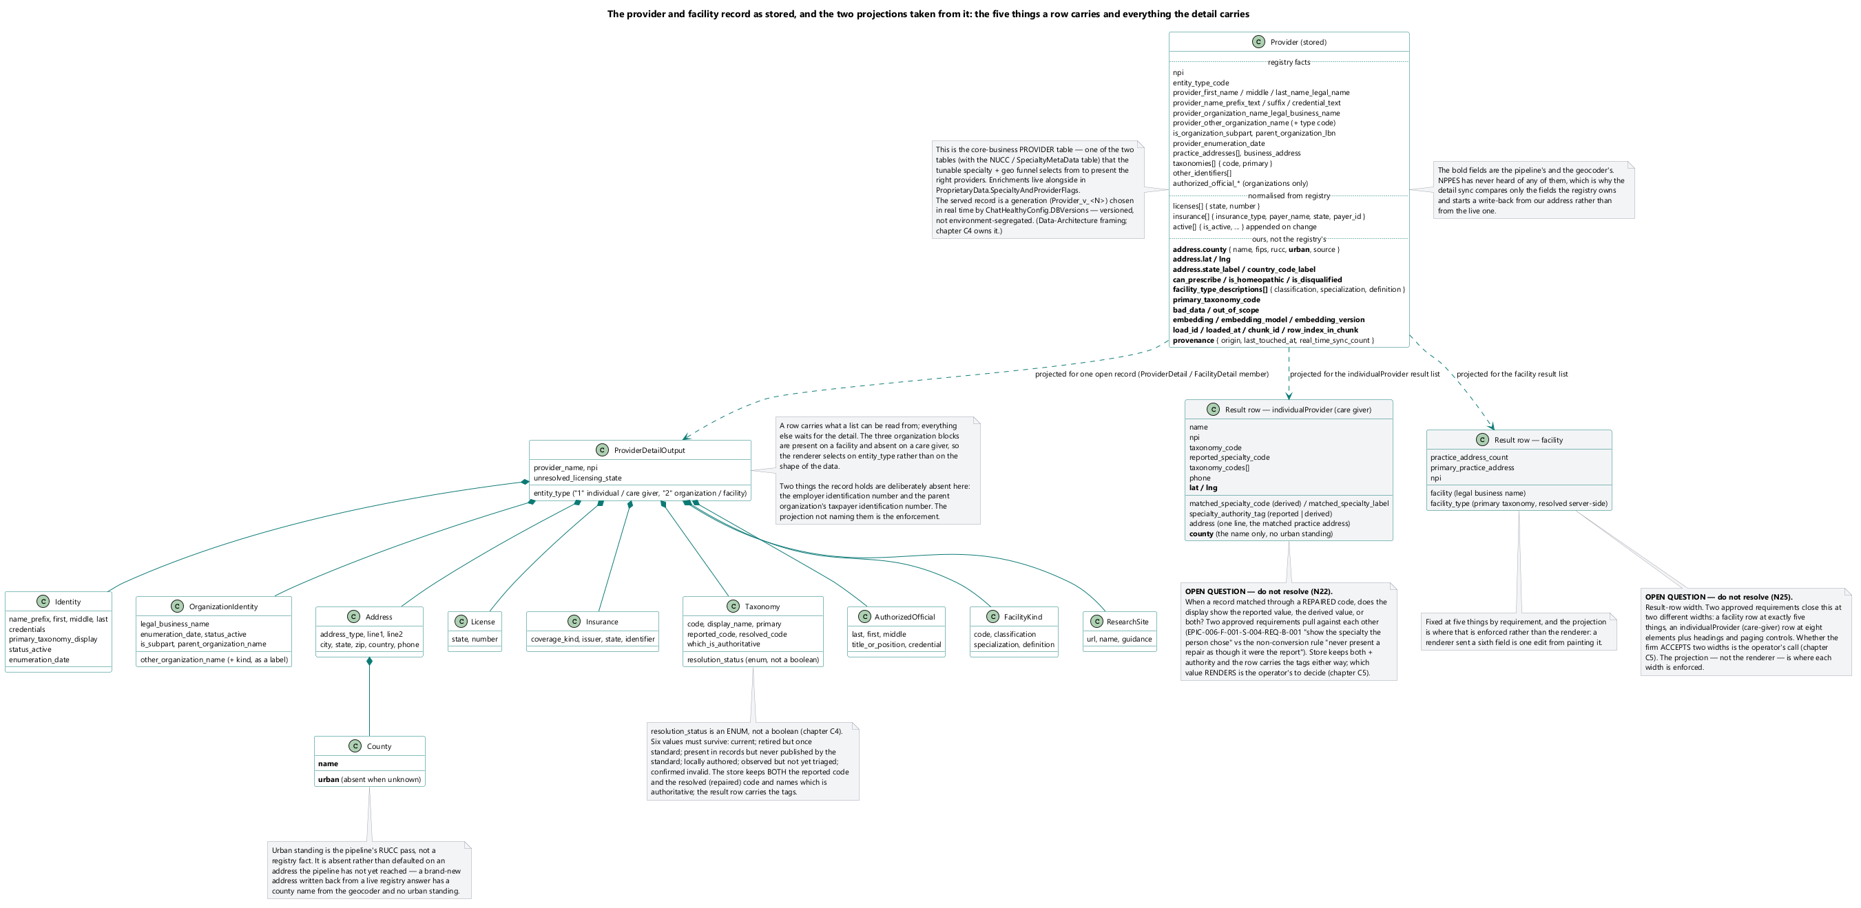
What a served provider record carries, and which fields are the registry's and which are ours.

Fc Detail Sync
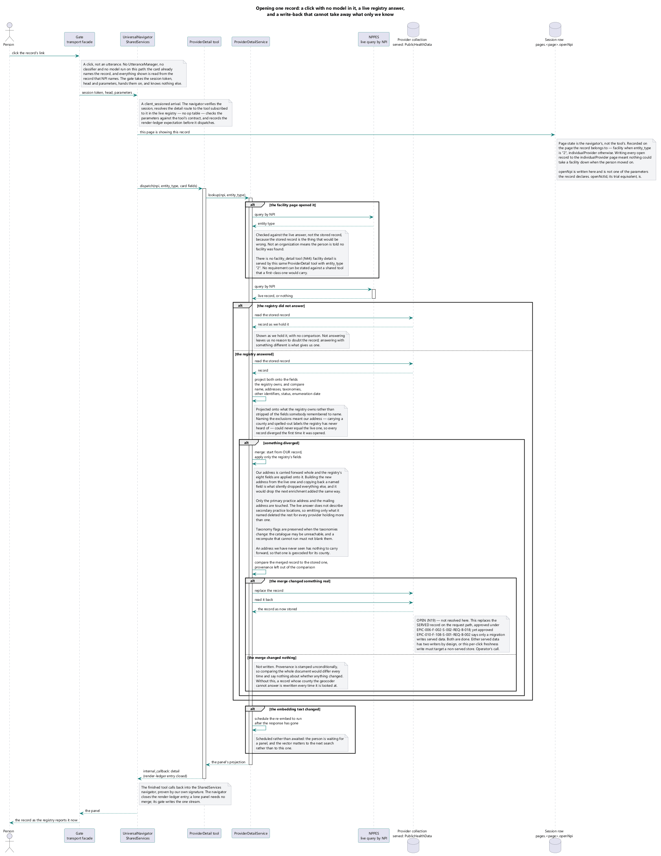
A detail brought to live-registry freshness on open, and still shown when the registry does not answer.
</ Skip notes
A: Universal Navigator has responsibilities. They must be specified in this diagram. You must represent it as a call from the component to itself. 4-5 things the component must do. Consider my prior comments in this doc as I specified elsewhere some of those responsibilities, and you have documented many in this set of diagrams. You have an actor, but it looks like a proxy in your diagram. It is our secret Sause.
>

Findcare Evalcare Handoff Sequence
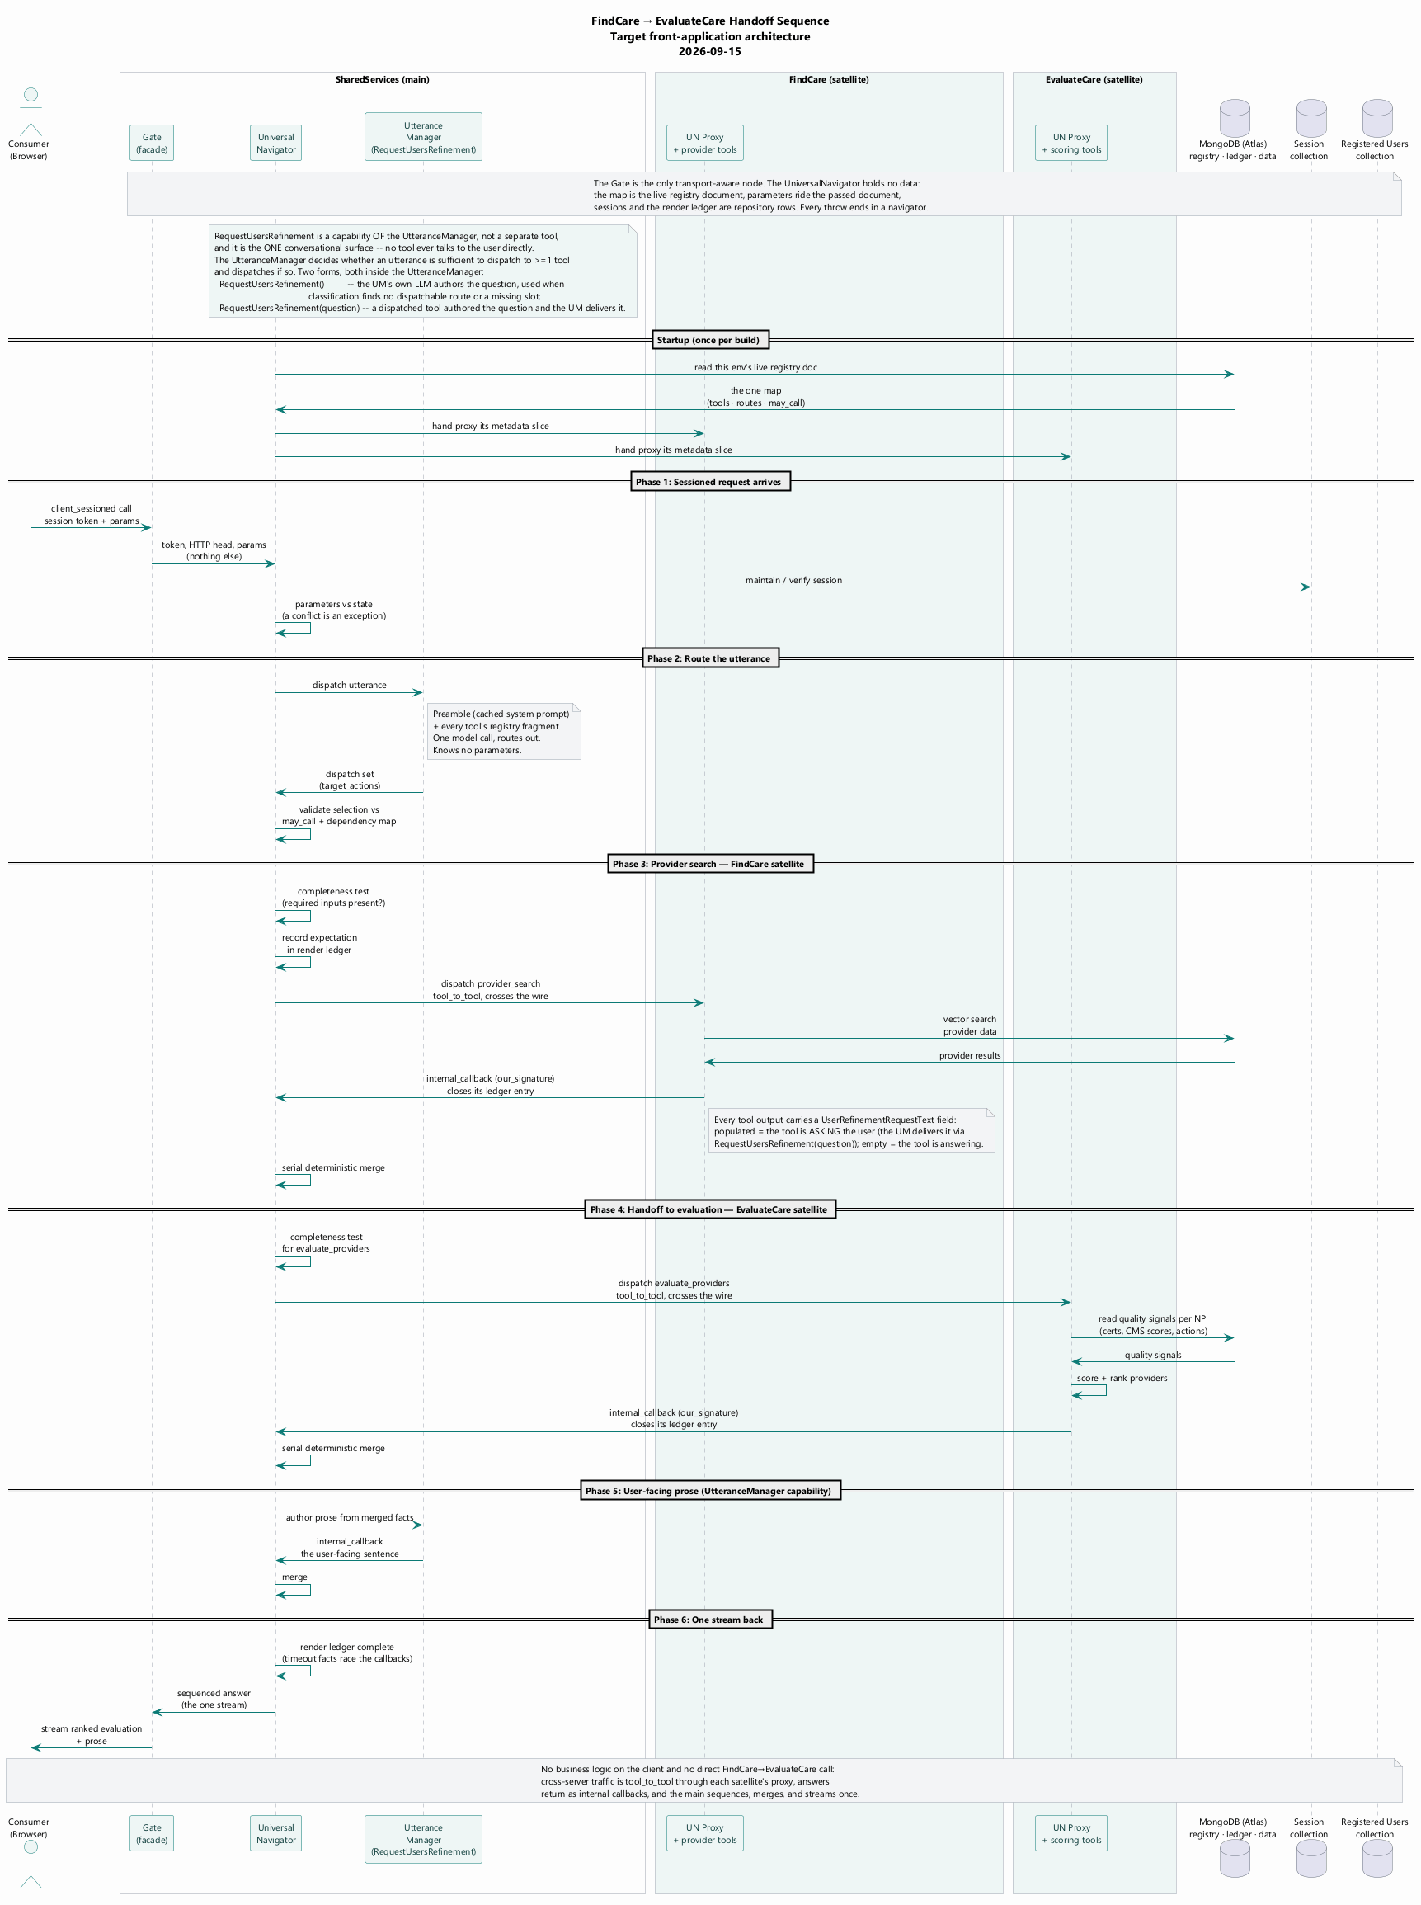
</ Skip
A: This is great. Review it for accuracy. Make sure it is dead accurate. It is the current state or our Dev Ops promotion and deployment automations, This is something that we have to be proud of me. But it is not usable for a presentation.
B: New deliverable: A one-page diagram, abstracting this to one diagram that shows The core processes: commit, build, deploy, and promote. We need one diagram that shows these 4 flows. Think of the audience as an HIPAA compliance auditor. Make the level of detail sufficint to show that we are controlling change, and auditing it.
A selection handed to the scoring capability — server to server, on the browser's behalf.

Flow Client Utterance
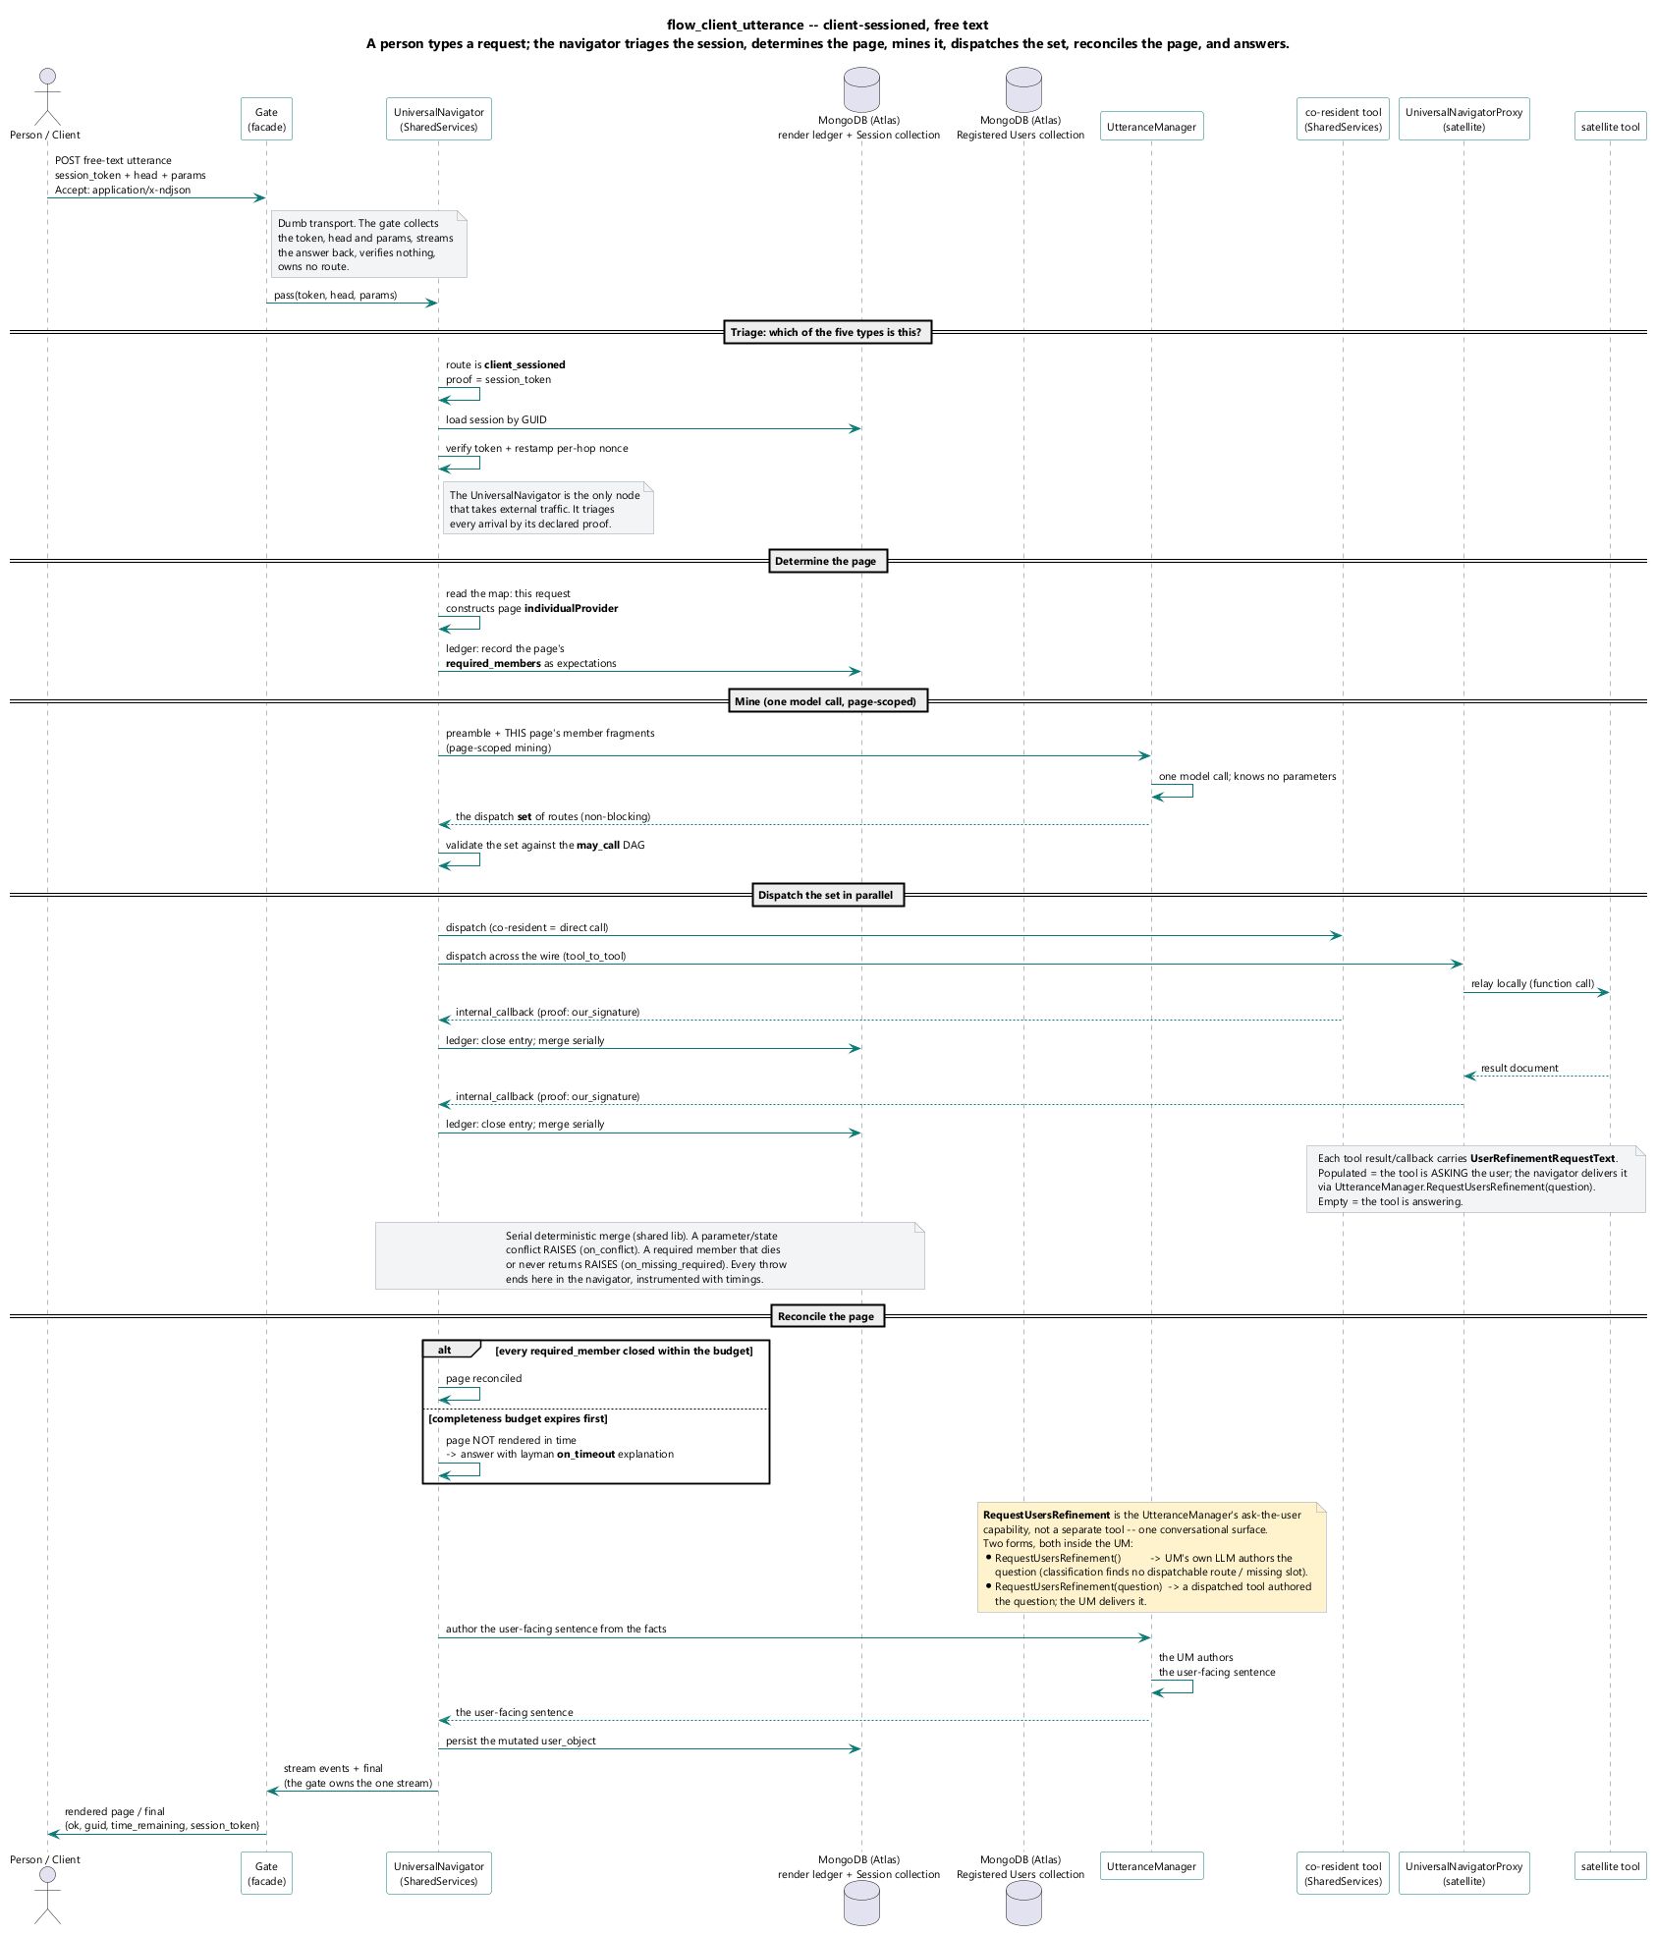
Client-sessioned, free text: the gate collects and passes inward; the UniversalNavigator triages the session_token, determines the page, scopes the utterance manager to that page's members, mines, dispatches the returned routes, reconciles the page, responds.

Flow Client Gesture
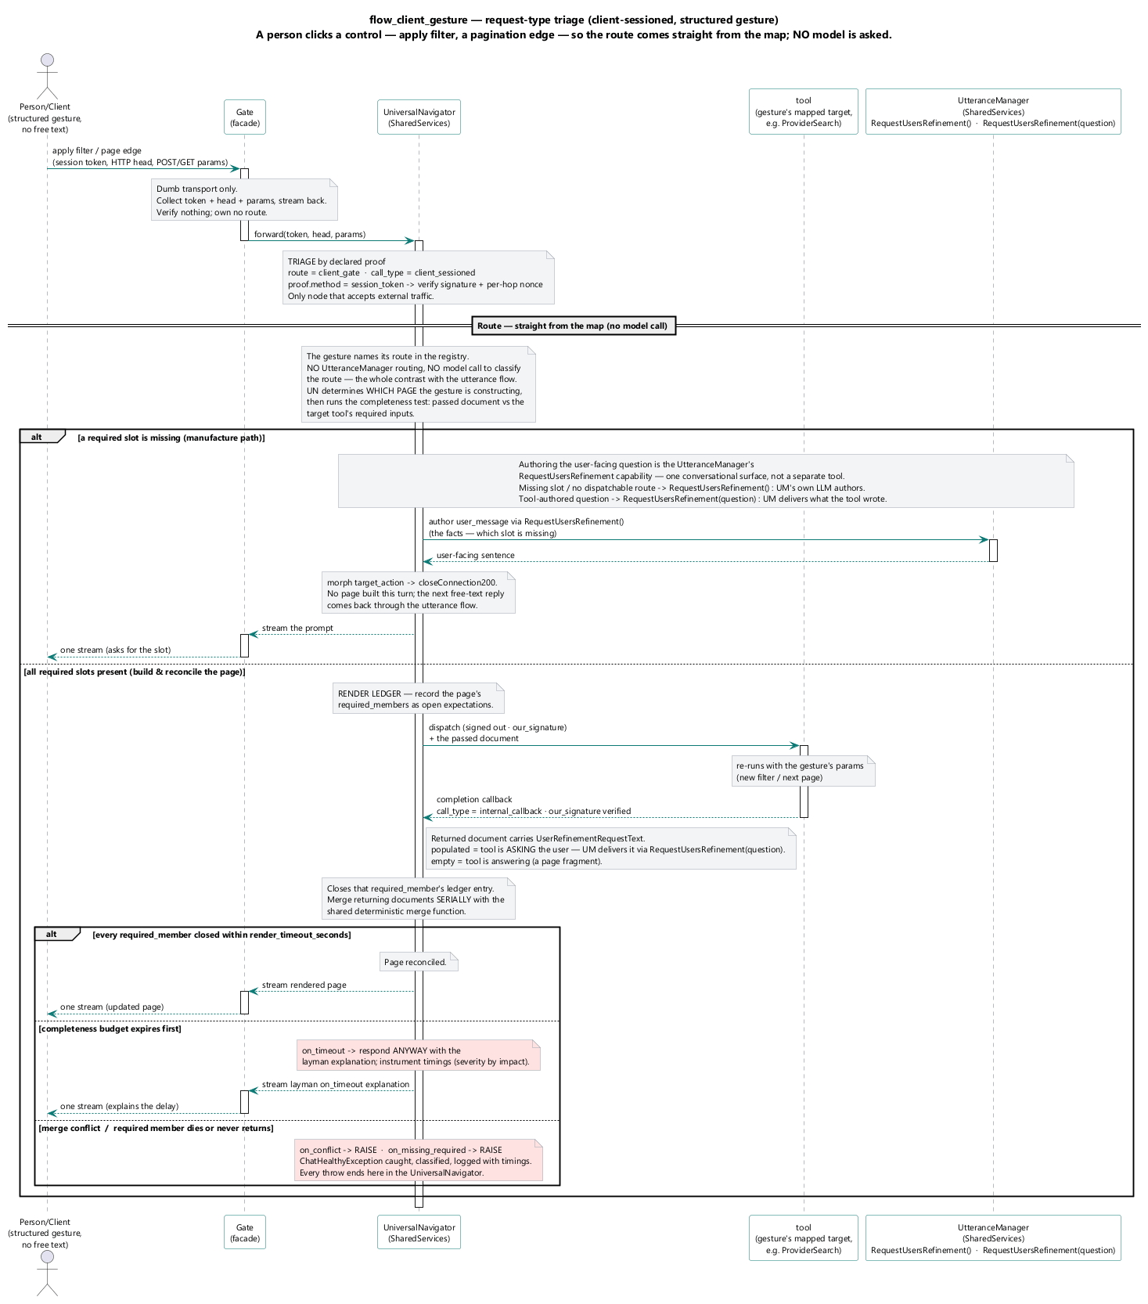
Client-sessioned, a structured control — apply filter, a page edge: routed straight from the map, no model asked; the page is updated and reconciled.

Flow Tool To Tool
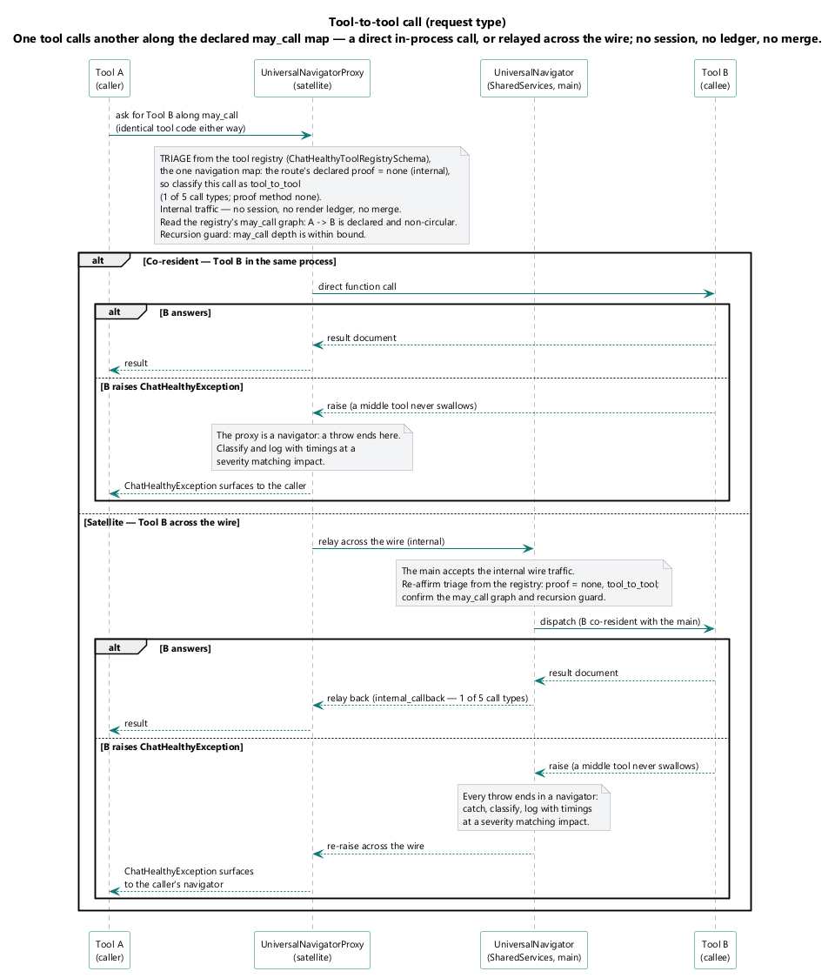
One tool calls another along the declared may_call map, through the satellite's proxy; no session, no ledger; a throw re-raises to a navigator, never swallowed in the middle.

Flow Internal Callback
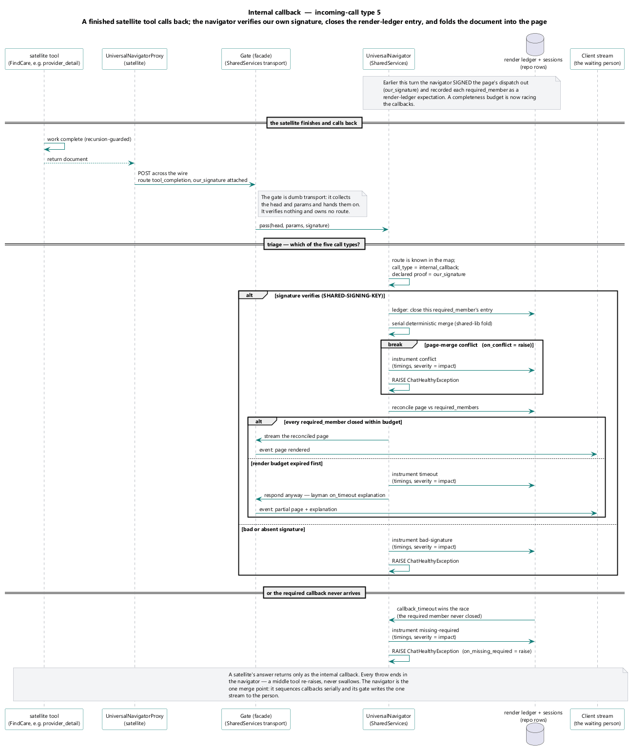
A finished tool calls back into the main UniversalNavigator; our_signature verified against the dispatch it was signed out with; the call closes the page's render-ledger entry.

Flow Third Party Callback
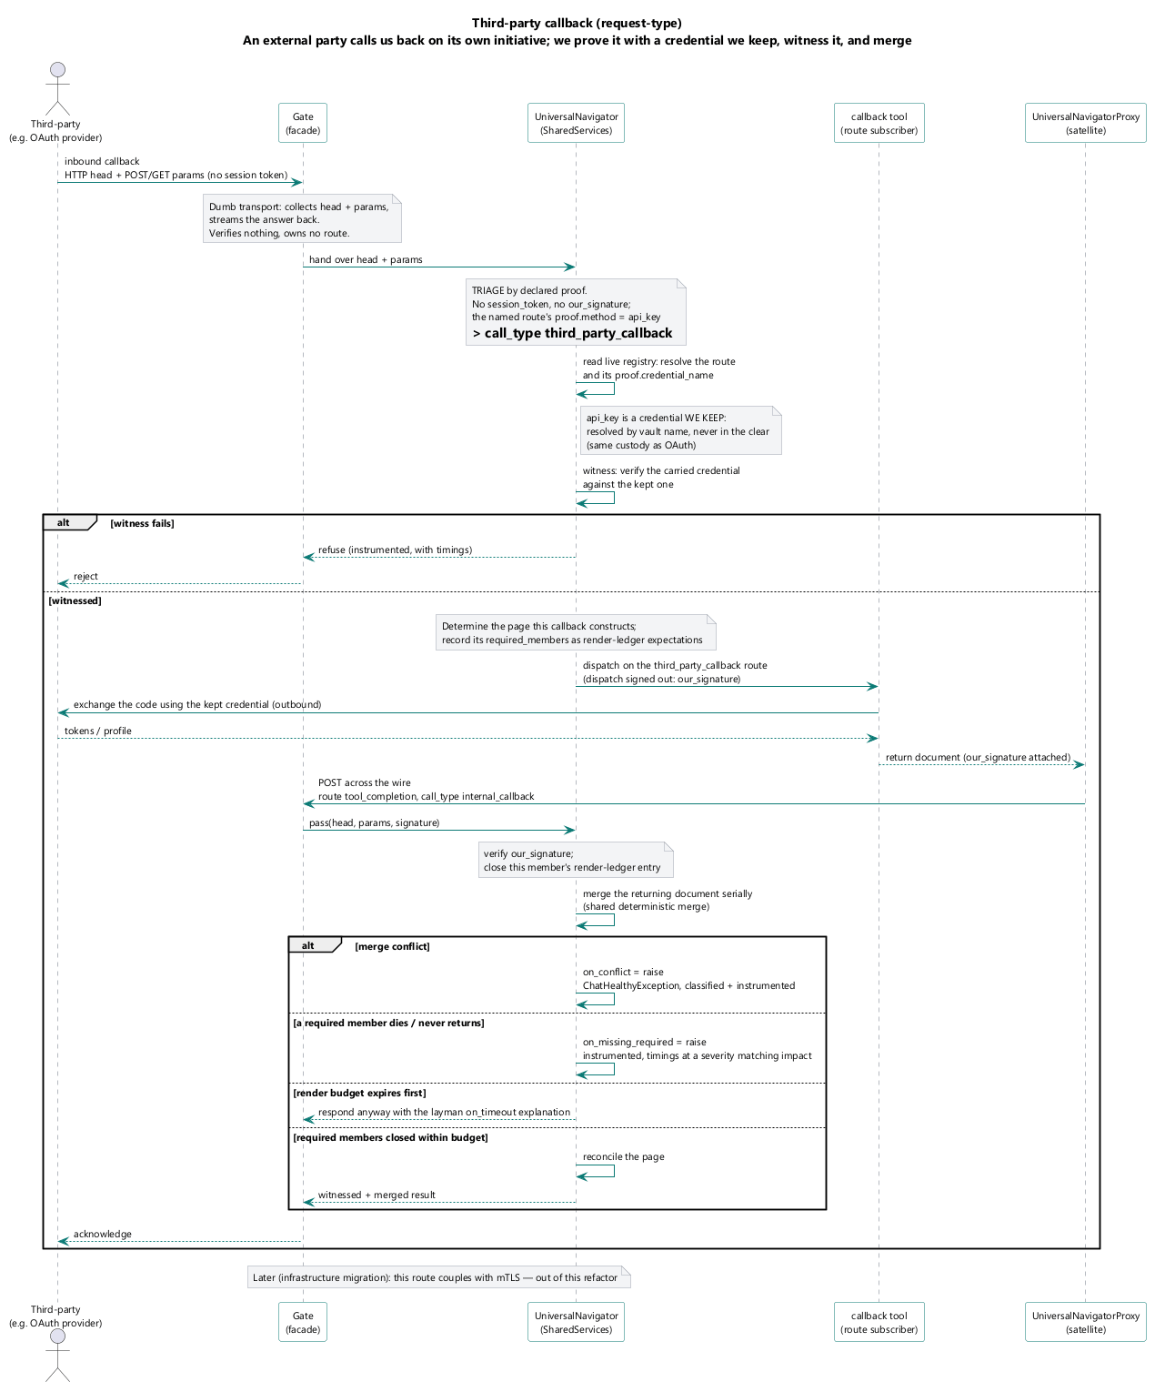
An external party calls us back on its own initiative; api_key proof, the credential named in the vault; witnessed and merged like any other returning document.

Flow Static Witness
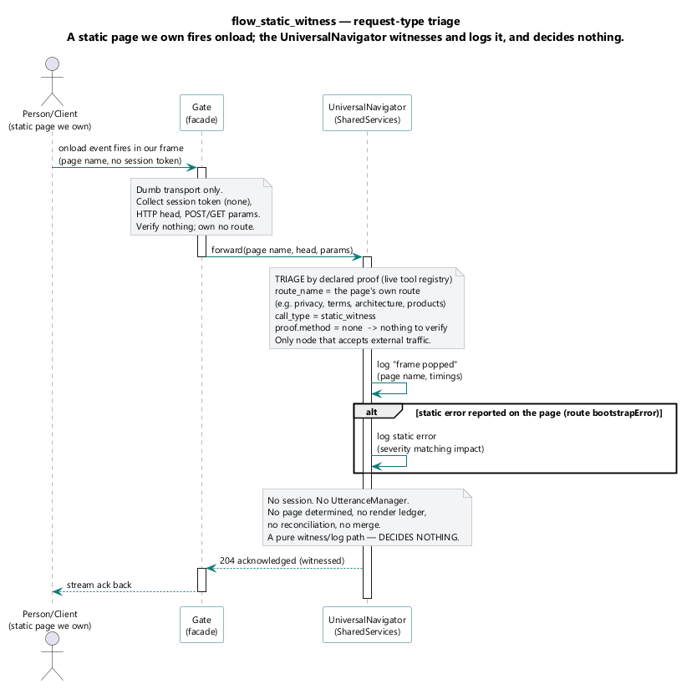
The onload witness of a static page we own; proof none; logs at frame pop, logs static errors when they occur; decides nothing.

Flow Page Care Giver
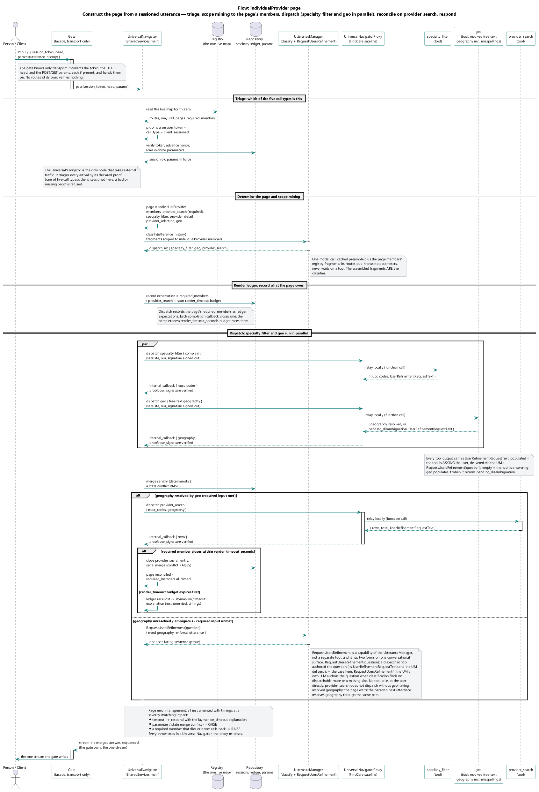
The individual-provider page: determine the page, scope mining to its members, dispatch, reconcile against its required members within the completeness budget, respond.

Flow Page Facility
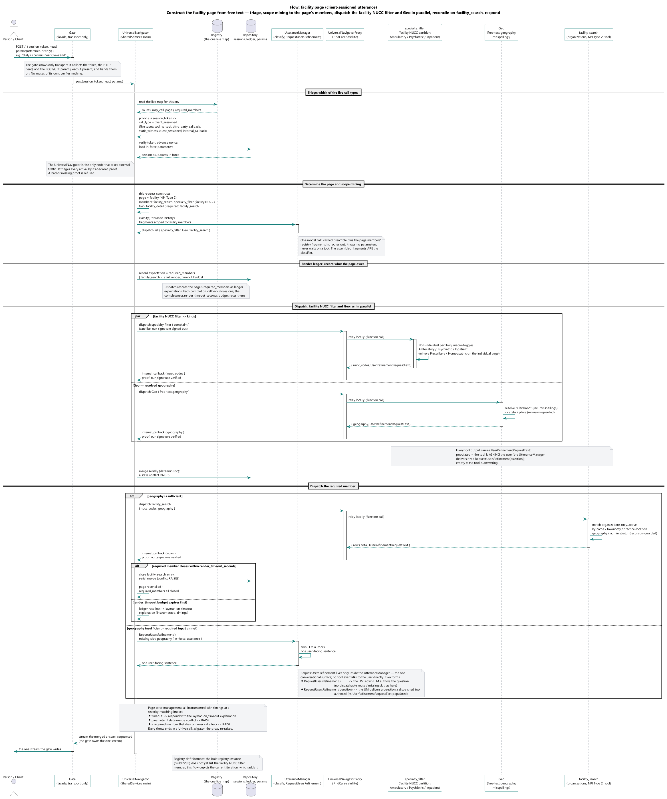
The facility page: the same construction-and-reconciliation path over the facility page's members.

Flow Page Clinical Trial
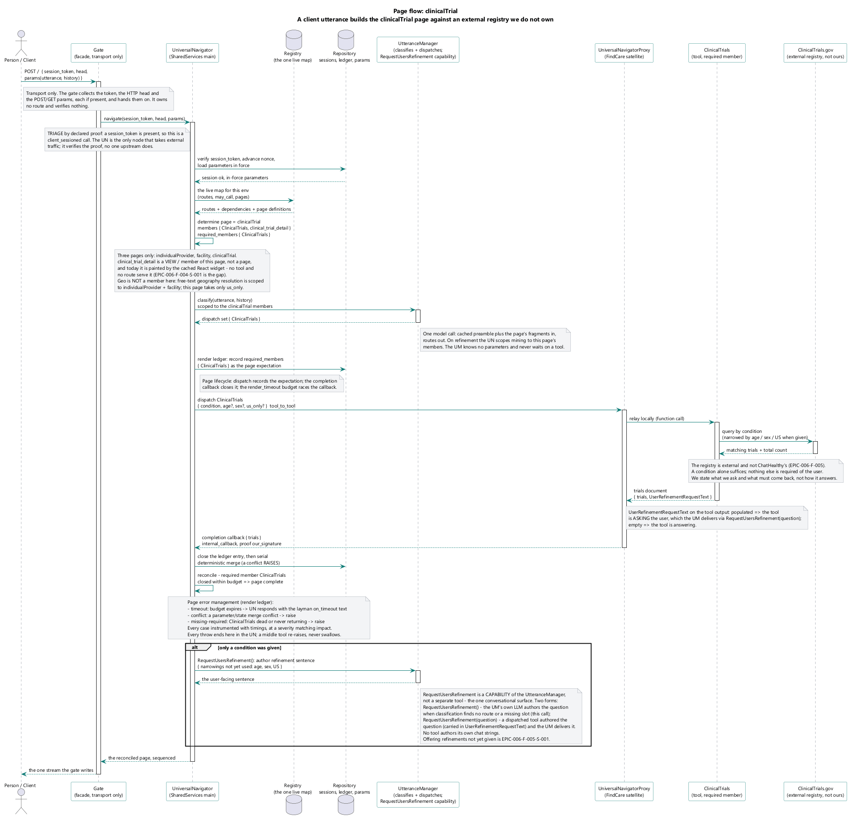
The clinical-trial page: the same path over the clinical-trial page's members.

Flow Page Provider Detail
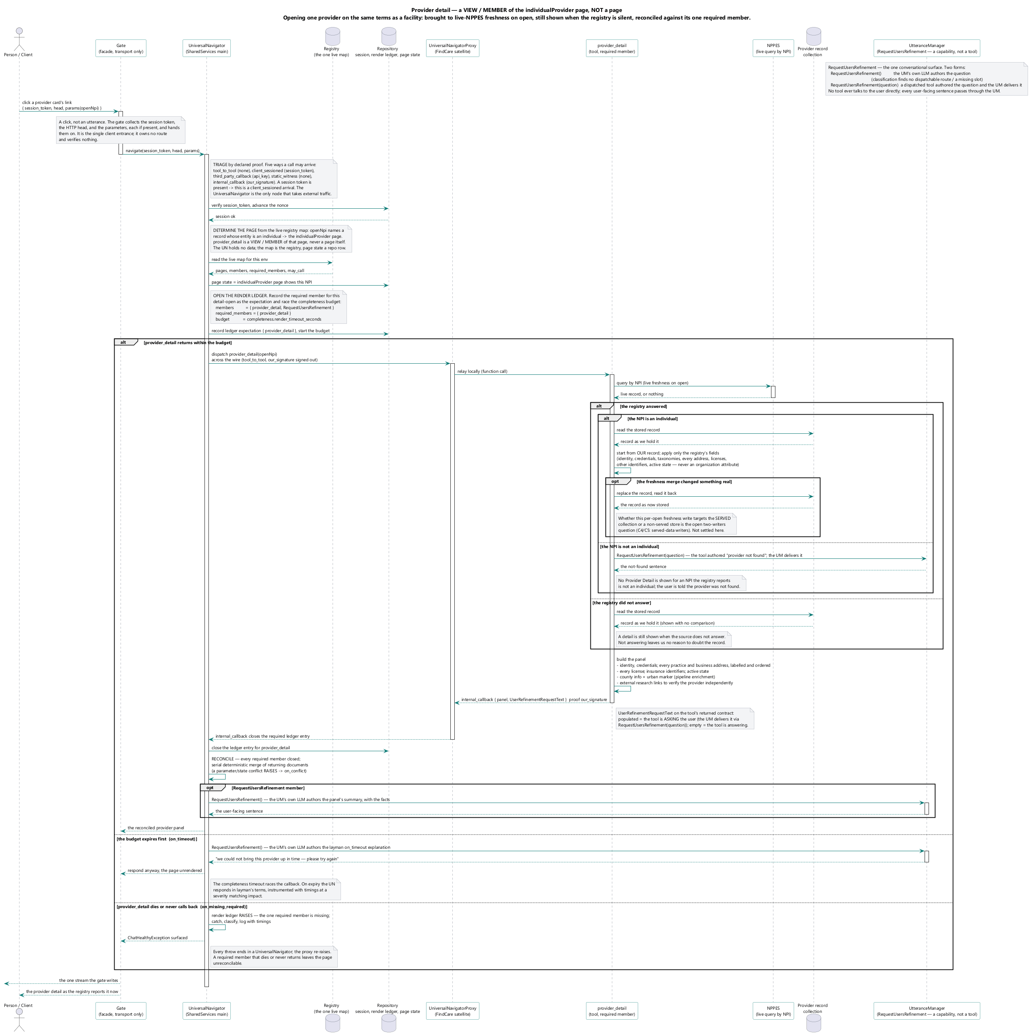
The provider detail — a member of the individual-provider page, not a page of its own: a detail brought to live-registry freshness on open, reconciled against its required members, and still shown when the registry does not answer.

Flow Page Facility Detail
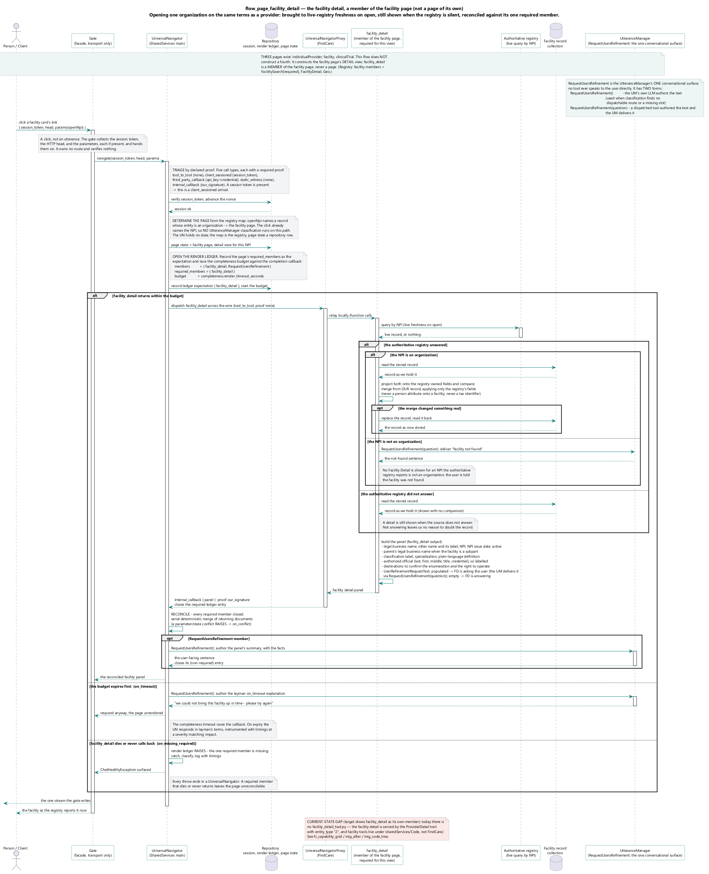
The facility detail — a member of the facility page, not a page of its own: the detail path over the facility detail's members.

Flow Page Clinical Trial Detail
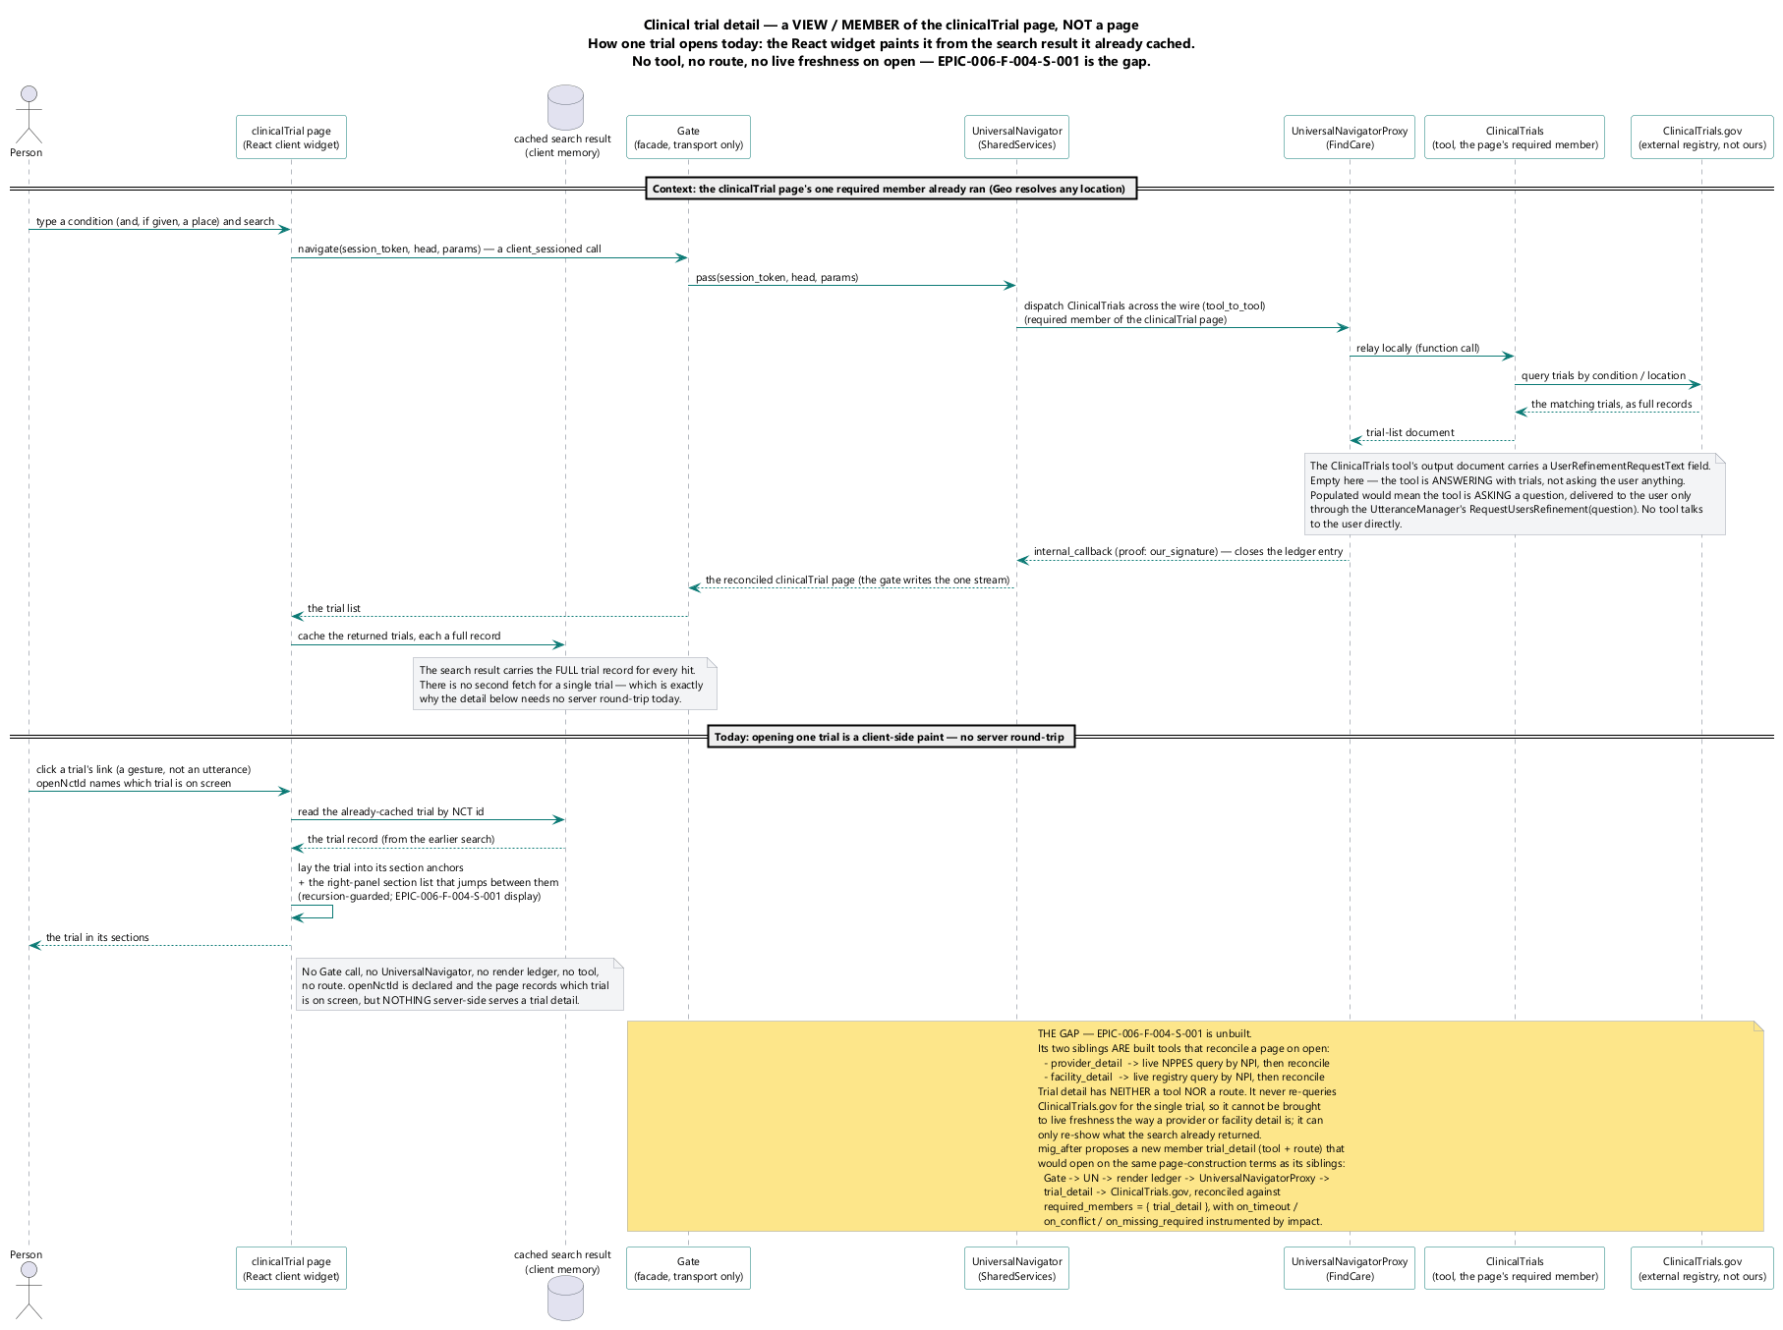
The clinical-trial detail — a member of the clinical-trial page, not a page of its own: the detail path over the trial detail's members.

Security Framework

Sec Gate Enforcement
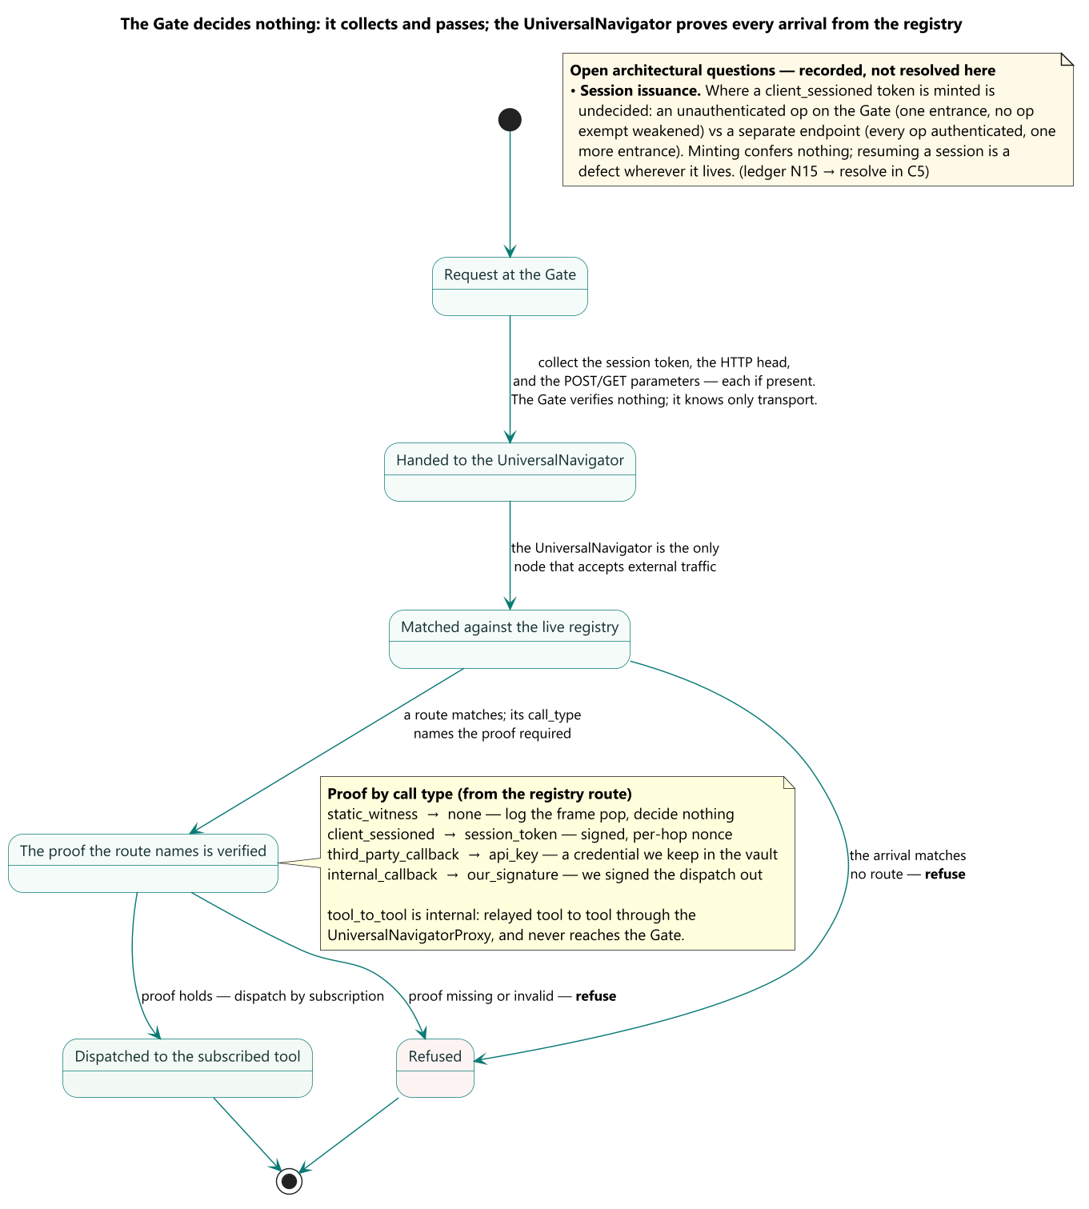
The Gate decides on the address first and the method second, because the address is the firm's own advance declaration of what may arrive there and the method is all the request itself contributes.

Security Architecture Deployed
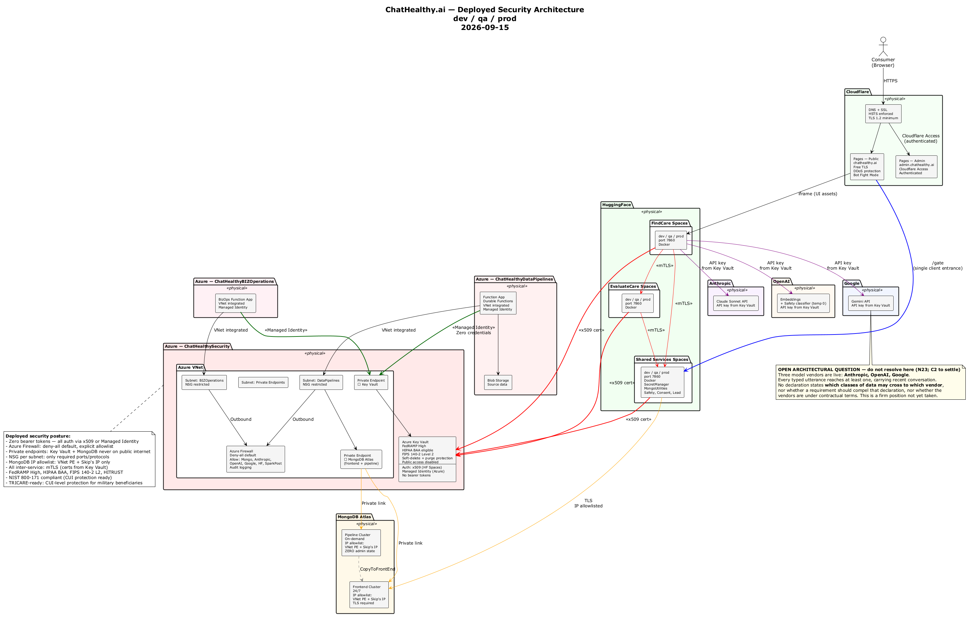
The deployed security architecture: where each credential is held, which boundary consumes it, and the three paths that carry no authentication today.

Security Architecture Local
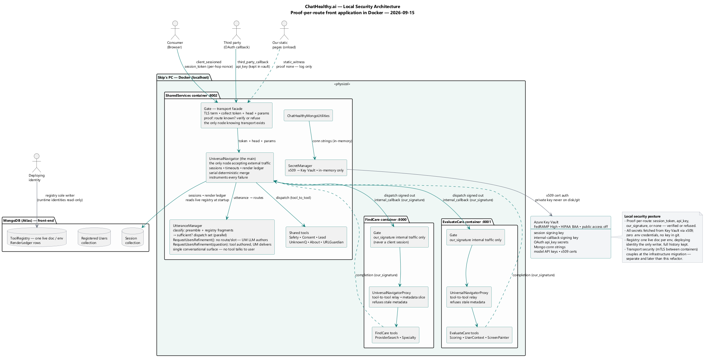
The same architecture in the local environment, where the agent's workstation is inside the boundary rather than outside it.

DevOps Governance Framework

Sys Promote Chain
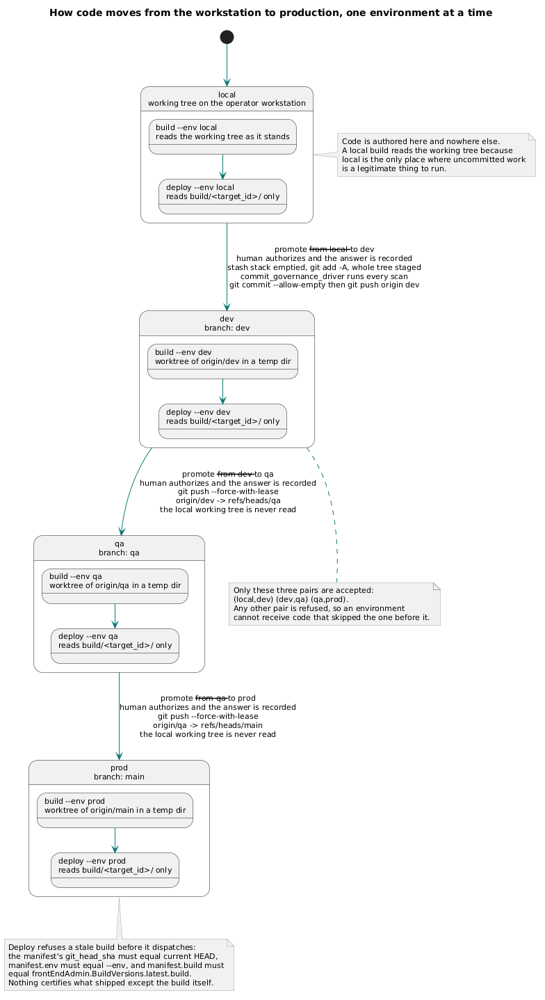
The four environments as one directed chain. A promote advances exactly one adjacent step; there is no path that skips, reverses, or targets an environment from itself.

Data Architecture

Logical Data Model
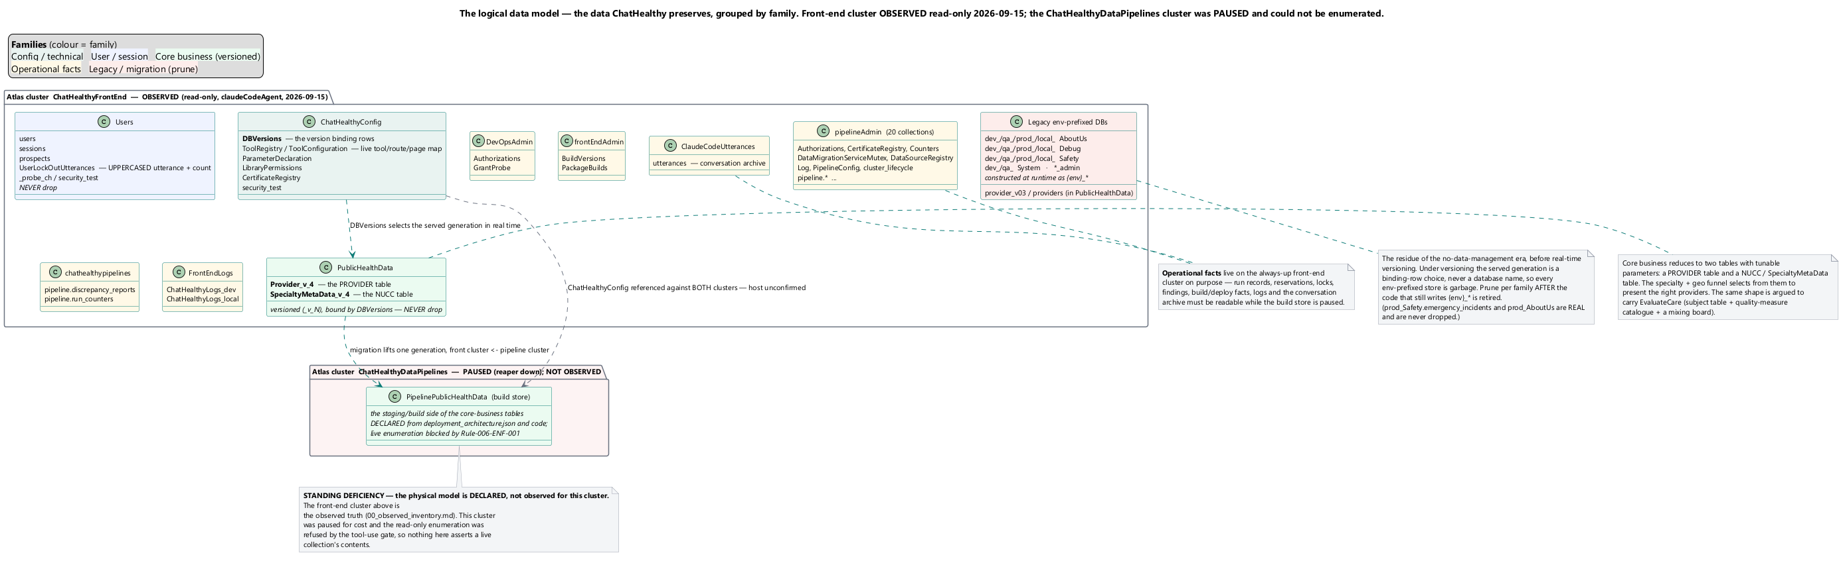
The logical data model — the data ChatHealthy preserves, grouped by family. The front-end cluster ChatHealthyFrontEnd is observed (read-only, 2026-09-15); the ChatHealthyDataPipelines cluster was paused and is declared, not observed.

Pipe Publish Scope Guard
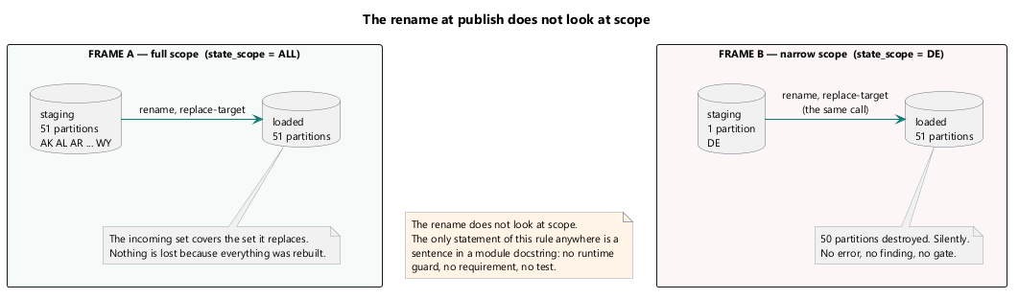
Two frames, side by side, showing the rename at the moment of publish.

Pipe Release Gate
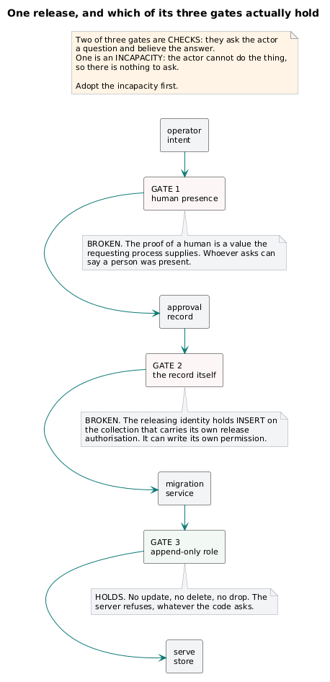
A decision path for one release, drawn to show which controls hold and which do not. Left to right: operator intent → approval record → migration service → serve store. Three guards are drawn as gates across the path, each annotated with whether the gated process can defeat it:

Pipe Provenance Chain
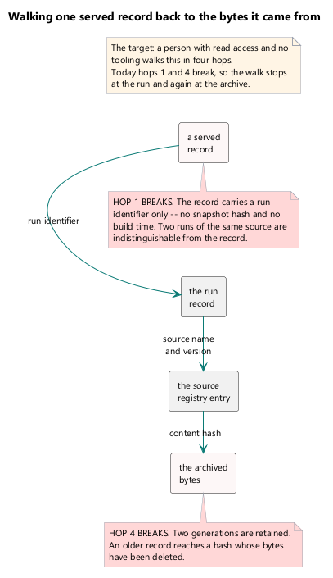
Four hops, left to right, each an object with the field that carries the link named on the arrow: a served record → the run record → the source registry entry → the archived bytes. Under hop 1, a red annotation: carries a run identifier only — no snapshot hash, no build time. Under hop 4, a red annotation: two generations retained; older records reach a hash whose bytes are gone. Caption: a person with read access and no tooling must be able to walk this in four hops. Today hops 1 and 4 break.

The Refactor — Plan

Provider Pipeline Components
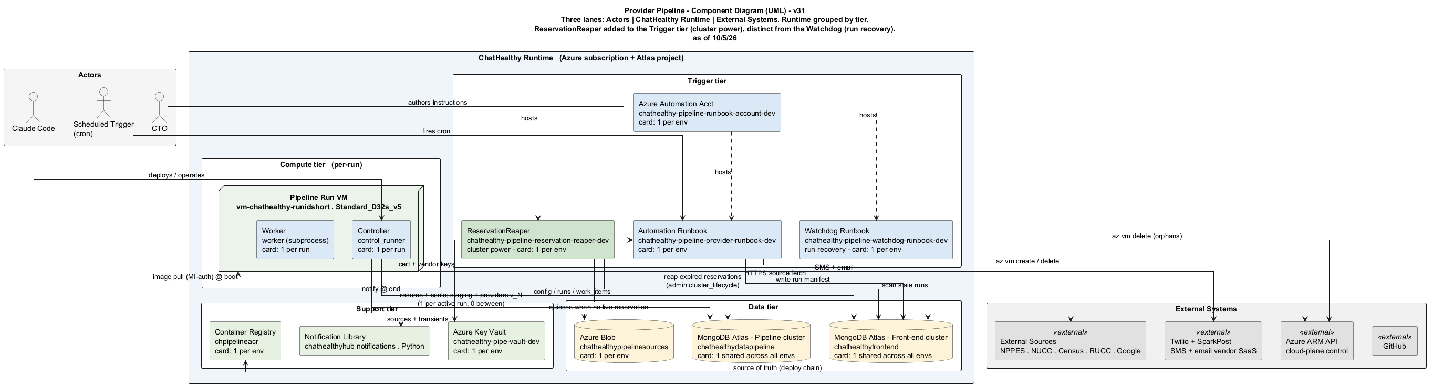
Provider pipeline components grouped by tier; the ReservationReaper (cluster power) is distinct from the Watchdog (run recovery).

Mig Code Tree
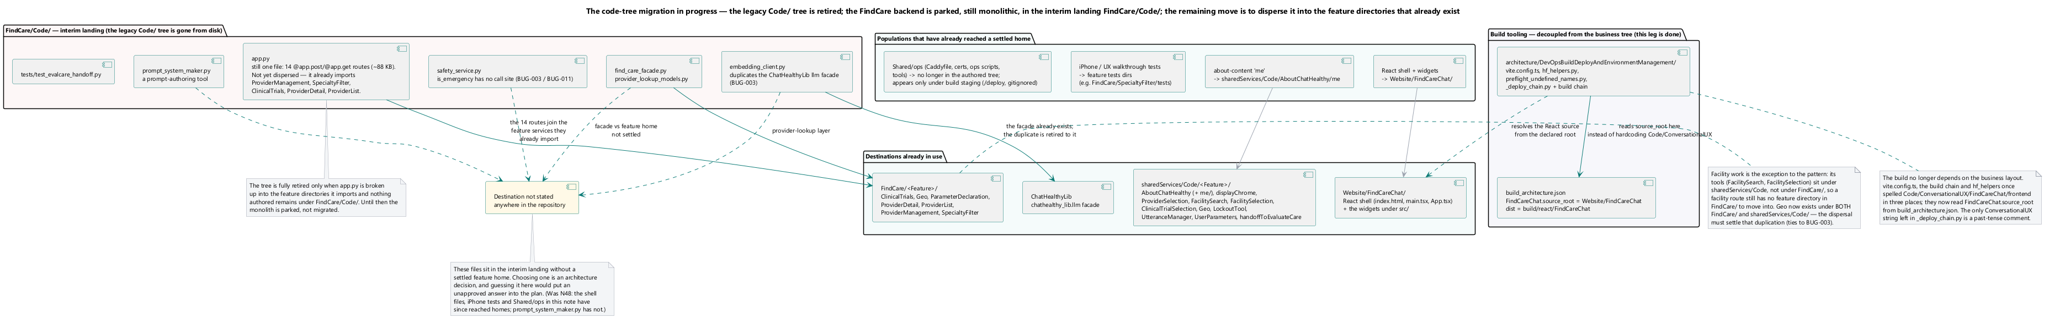
Figure. The Code/ tree and where each population moves. Several populations are drawn without a destination on purpose: choosing one is an architecture decision. Only three of the files under Shared/ops/tools are declared in the deployment record.

Mig Phases
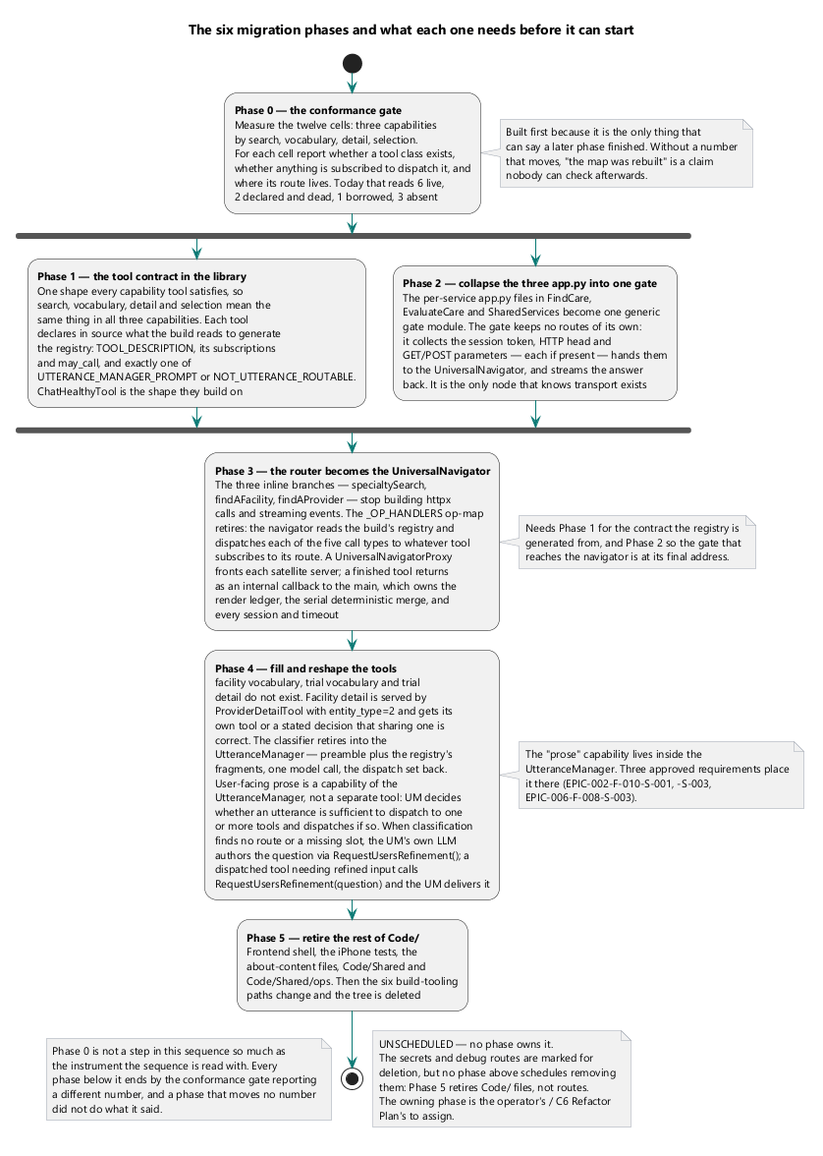
Figure. The phases a change passes through on its way to a running environment — each phase moves the number the next is measured against.

Mig Step
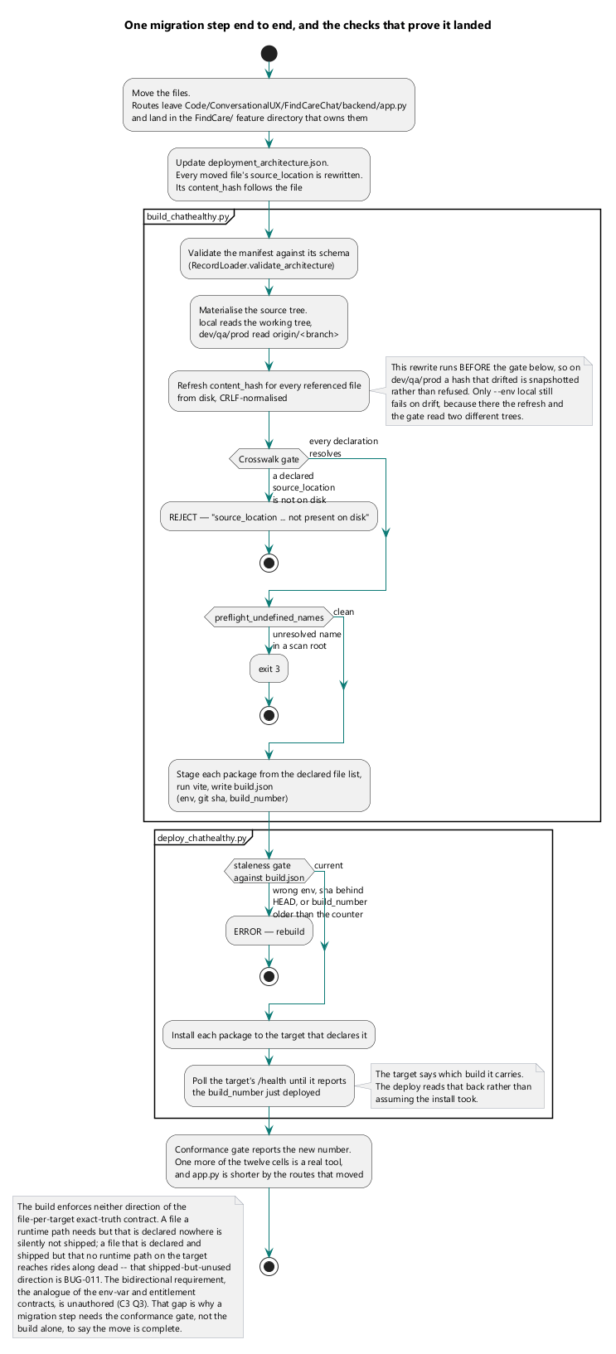
Figure. One step in detail: the five moves every file relocation makes, and the gate that catches each mistake. An undeclared file is silently not shipped (BUG-011), which is why the conformance gate, not the build alone, confirms a step is complete.

Appendix A — Pending Decisions
The open architectural decisions the operator must take before the next round. Each is cited to the diagram it concerns, states the open point, asks the decision, and states how that diagram changes with the answer. Claude takes no side on any of these.

N7 — Is asking the user a question the UtteranceManager's scope, or a separate Prose tool?
Diagram: chathealthy_system_components, utterance_classifier_assembly
Open point: The target diagrams draw user-facing prose as a separate Prose tool the UniversalNavigator dispatches, with the UtteranceManager reduced to classify-only. Three approved requirements place prose and parameter-writing inside the UtteranceManager (EPIC-002-F-010-S-001 author user_message, EPIC-002-F-010-S-003 the manufacture path, EPIC-006-F-008-S-003 one of three parameter writers). The architecture will not move a requirement, so no side is taken.
Decision for the operator: Does asking the user a question belong to the UtteranceManager, or to a separate Prose tool?
How the diagram changes: If Prose is its own tool, chathealthy_system_components and utterance_classifier_assembly keep the separate Prose node and the UtteranceManager stays labelled classify-only. If prose stays inside the UtteranceManager, the Prose node collapses back into it in both diagrams and the classify-only label is withdrawn.

N13 — A channel that carries an authorisation the workstation cannot originate
Diagram: pipe_release_gate, dev_four_acts
Open point: Every authorisation — commit, promote, deploy, data migration — terminates in one function that trusts a value the governed process supplies. pipe_release_gate draws gate 1 (human presence) as a broken, forgeable gate; no same-machine hardening closes it. One decision fixes all four acts.
Decision for the operator: Which channel produces an authorisation the workstation cannot forge — a second device, an identity-provider round-trip, an out-of-band link, an off-workstation signing identity, or an explicit decision to accept the same-machine convention?
How the diagram changes: Name a non-forgeable channel and pipe_release_gate gate 1 changes from a broken gate to a solid one, and dev_four_acts gains that channel as the single trust root behind all four acts. Accept the convention and gate 1 stays drawn broken, relabelled accepted convention.

N14 — The agent's platform privilege: declared constrained role, or held union?
Diagram: sys_identity
Open point: sys_identity draws the DECLARED constrained role (chatHealthyAgent, conditioned to forbid role-assignment writes) beside the HELD union (unconditioned Owner at subscription scope plus tenant-root user-access administration). The gap between declared and held is the finding (BUG-010); the divergence sits above every control written to constrain it.
Decision for the operator: Is the agent's privilege meant to be the declared constrained role, or the live union?
How the diagram changes: If the declared role is intended, sys_identity loses the unconditioned Owner and tenant-root assignments — three ordered acts (restore the withheld actions on the definition, remove the subscription-scope Owner, remove the tenant-root assignment) — and the DECLARED/HELD gap closes. If the union is intended, the condition withholds nothing and the diagram drops it rather than implying a constraint.

N15 — Where does session issuance live?
Diagram: sec_gate_enforcement, ss_session_state, findcare_gate_components
Open point: A session cannot present the thing it is about to create, so the gate's two invariants pull against each other: no op is exempt, and one entrance. Minting a new session confers nothing; resuming one is a defect wherever the route lives (R-6).
Decision for the operator: Does session issuance live as an unauthenticated op on the Gate, or as a separate endpoint?
How the diagram changes: An unauthenticated op → the gate diagrams draw a session route through the one Gate marked no-proof, weakening no-op-is-exempt. A separate endpoint → the diagrams add a session endpoint outside the Gate, weakening one-entrance. Security's proof-of-possession-on-resume holds under either drawing.

N18 — Which of the firm's rules about itself should be requirements?
Diagram: dev_four_acts
Open point: The strongest controls in the system — the branch restriction, authorise-at-the-moment, the post-commit rollback, the circumvention record — are in force with no product requirement behind them. dev_four_acts depicts these governance acts. An auditor tracing the strongest control finds a rule and nothing behind it.
Decision for the operator: Should those controls themselves become requirements?
How the diagram changes: If yes, dev_four_acts gains a requirement-id band binding each act to an authored requirement. If no, the acts stay drawn as rules-only, and the diagram's governance layer remains unbacked by the requirement layer.

N19 — Does served data have two writers by design?
Diagram: fc_detail_sync, sys_data_flow
Open point: fc_detail_sync shows the application request path writing the served collection when a detail is opened. Approved EPIC-006-F-002-S-002-REQ-B-018 (request-path freshness write) and approved EPIC-010-F-108-S-001-REQ-B-002 (only a migration writes the served collection) are both marked done and contradict (NC-3). A batch pipeline cannot serve per-click freshness, so the requirement is real.
Decision for the operator: Does served data have two writers by design, or must the live-freshness write target a store that is not the served collection?
How the diagram changes: Two-writers → fc_detail_sync keeps the write-back arrow into the served collection. Non-served → the arrow redirects to a side store and sys_data_flow gains that store between the request path and the served generation.

N20 — Which control record is authoritative for what is published?
Diagram: sys_data_flow, registry_instance_lifecycle
Open point: Two control records each claim to say what is published — ChatHealthyConfig.DBVersions (the served data generation) and the tool-registry instance (the live tool/route/page map). They share the one-live-row shape but are different concerns; the code writes one, and two records of the same fact will disagree.
Decision for the operator: Which single record is authoritative for the published/served generation?
How the diagram changes: sys_data_flow and registry_instance_lifecycle mark one record as the single source of the published fact and redraw the other as reading from it, rather than both asserting it independently.

N21 — Is Mongo connection retry worth having? (unassigned — no diagram)
Diagram: (none)
Open point: The pipeline design drops connection retry deliberately, together with locks, polling and timeouts (BUG-007). A dropped connection during a multi-hour load discards hours of paid compute for a condition that resolves in seconds; the fix is a few lines at one boundary and is independent of the rejected lock/poll/timeout machinery.
Decision for the operator: Is Mongo connection retry reintroduced at the connection boundary, independently of the machinery that was rightly rejected?
How the diagram changes: No diagram depicts the retry boundary; this decision changes pipeline code, not a figure. Recorded here as unassigned.

N22 — Repaired-code display: reported value, derived value, or both?
Diagram: fc_provider_record, fc_nucc_funnel
Open point: fc_provider_record stores both the reported code and the resolved (repaired) code and names which is authoritative; the result row carries the tags. Two approved requirements pull against each other — EPIC-006-F-001-S-004-REQ-B-001 show the specialty the person chose, and the non-conversion rule never present a repair as though it were the report.
Decision for the operator: When a record matched through a repaired code, does the display show the reported value, the derived value, or both?
How the diagram changes: fc_provider_record's result-row projection gains a defined rendered field (reported | derived | both). The store keeping both values and the tags travelling to the row are unchanged whichever value renders.

N23 — Which classes of data may cross to which model vendor?
Diagram: sys_trust_boundaries, security_architecture_deployed
Open point: Three vendors are live — OpenAI, Anthropic, Google — and every typed sentence reaches at least one, carrying the recent conversation with it. The record names the vendors as credentials to fetch and says nothing about what is sent to them. This is a position the firm has not taken, not an engineering gap.
Decision for the operator: Which classes of data may cross to which of the three live vendors, and is a vendor placed under contractual terms?
How the diagram changes: sys_trust_boundaries gains a data-class → vendor label on each external model edge, which those edges do not carry today; security_architecture_deployed marks which vendors are under contract.

N24 — Does carry-over (EPIC-006-F-008-S-002) stand?
Diagram: fc_pages_and_values
Open point: The carry-over story is approved and binds; the operator has since called carry-over an anti-pattern; the built mechanism runs with an empty input. Keeping it costs a decision surface of parameters x pages x pages plus a display obligation; withdrawing it orphans -S-005-REQ-B-008 (name where a carried value came from).
Decision for the operator: Does carry-over stand, or is it withdrawn?
How the diagram changes: Keep → fc_pages_and_values keeps the cross-page value-carry arrows and the where-a-carried-value-came-from field. Withdraw → those arrows and that provenance field are removed and the requirement behind the field is orphaned.

N25 — Result-row width: accept two widths?
Diagram: fc_provider_record
Open point: Two approved requirements close row width at two widths for two subjects: a facility row at exactly five things, an individualProvider (care-giver) row at eight elements plus headings and paging controls. fc_provider_record draws both projections; the projection, not the renderer, is where each width is enforced.
Decision for the operator: Do you accept two row widths?
How the diagram changes: Accept → fc_provider_record keeps the two differently-sized result-row projections as compliant (and this becomes a non-compliance closed rather than an open question). Reject → the two projections converge to one width.

N26 — Which parameter-writing practice is confirmed?
Diagram: fc_pages_and_values
Open point: Ability is fixed by approved requirement — all three routes must be able to write any parameter. Practice is open; the parent's position is that each page mines its own. Either way -REQ-B-004 requires the two live write paths (R-05) to become one.
Decision for the operator: Which parameter-writing practice is confirmed (each page mines its own)?
How the diagram changes: fc_pages_and_values collapses the two live write paths into one writer; the three-routes-may-write capability stays drawn because it cannot be removed without moving a requirement.

N27 — Does location extraction stay in the shared library?
Diagram: ss_lib_classes, fc_capability_grid
Open point: The geo extractor is a live, single-purpose model call that mines a geography from an utterance, sitting in the library every front-end component installs. It fails test 2 of the library boundary (BUG-003) and is the template for four other modules in the same position.
Decision for the operator: Does location extraction stay in the shared library, move out, or get a stated boundary exception?
How the diagram changes: Move → ss_lib_classes loses the geo extractor and fc_capability_grid draws Geo as a first-class page-scoped tool parallel to the specialty filter. Stay → the library boundary gets an explicit exception marker on that class.

N28 — May one read-only enumeration of the database control plane be run?
Diagram: sys_identity
Open point: The credential that would read the Atlas grant matrix is the same key whose elevated state rewrites it, so a reading taken with it is not a reading by a principal that cannot also write. A yes to one read is the prerequisite for closing R-19 and for any independent reading of the grant matrix.
Decision for the operator: May one read-only enumeration of the database control plane be run, and should a never-elevatable auditing credential exist?
How the diagram changes: sys_identity gains an independent read of the Atlas grant matrix (closing the declared-only gap on that plane), or an auditing-only credential node the diagram does not currently carry.

N29 — Should directory/cloud authority work like the database authority?
Diagram: sys_identity
Open point: On the database control plane the agent has no standing write and cannot elevate itself — write is granted under supervision for named work and withdrawn. On the directory and cloud plane it holds Owner and tenant-root user-access administration, standing and unconditioned. The operator's stated leaning is probably yes.
Decision for the operator: Should directory and cloud authority adopt the database-plane model — no standing write, elevate under supervision, withdraw on completion?
How the diagram changes: sys_identity redraws the directory/cloud grants as time-bounded (elevated-then-withdrawn) rather than standing, matching how the database plane is drawn.

N30 — Which PKI requirement set governs, and was deleting the CA a decision?
Diagram: sys_identity
Open point: Four PKI parts — lifetime, registry location, subject naming, who may request — in which two approved requirements contradict. The issuance/minting path is absent from disk but the caller that issues still imports it; the certificate registry is required and nothing reads or writes it; REQ-B-004 requires expiry inside one management cycle and no artifact defines a management cycle.
Decision for the operator: Which PKI requirement set governs, was CA deletion deliberate, and what interval is a management cycle?
How the diagram changes: sys_identity either restores the CA minting node (if deletion was a regression) or marks the deletion deliberate and removes the dangling import; the certificate registry gains a reader/writer where it is drawn required-but-unused.

N31 — Is a platform's liveness (/health) contract in scope of the one-entrance rule?
Diagram: sys_trust_boundaries
Open point: /health currently takes no token and answers from Mongo. A platform probing a host it runs is not a client call; where the firm's own client or chain calls a health route, that is a route outside the Gate like any other. What remains is whether such a route is the firm's traffic at all.
Decision for the operator: Is a platform-required liveness route in scope of the one-entrance rule?
How the diagram changes: In scope → sys_trust_boundaries places /health inside the governed boundary. Out of scope → the diagram draws it explicitly outside the taxonomy as a platform probe, not the firm's traffic.

N35 — Where do the markdown architecture sources live?
Diagram: mig_code_tree
Open point: The markdown architecture sources have no canonical on-disk home; mig_code_tree draws them with the destination not stated anywhere in the repository. The parent's exact-truth rule that would check them against their deliverables is unwired (see N56).
Decision for the operator: Where do the markdown sources live?
How the diagram changes: mig_code_tree gains a destination box for the markdown sources where it currently shows none.

N36 — REQ-B-001 dispatch location: Gate, or UniversalNavigator?
Diagram: findcare_gate_components, findcare_gate_sequence, sec_gate_enforcement
Open point: The target design makes the Gate transport-only and the UniversalNavigator dispatch. If REQ-B-001's own text instead places the dispatch on the Gate, the requirement and the design disagree; the requirement is authoritative and reconciliation is the operator's.
Decision for the operator: Does dispatch live on the Gate, or on the UniversalNavigator?
How the diagram changes: Gate dispatches → the three gate diagrams move the dispatch box from the Navigator onto the Gate. Navigator dispatches → the diagrams stand as drawn and REQ-B-001's text is amended to match.

N45 — Which tool/route home do the five homeless routes get?
Diagram: mig_after
Open point: mig_after draws /page/what-is-needed, /page/detail-open, /page/detail-close, /welcome and /health with no tool obviously subscribing; picking one is a decision the requirements have not made.
Decision for the operator: Which tool or route subscribes to each of the five homeless routes?
How the diagram changes: mig_after connects each homeless route to a subscribing tool where today they float unsubscribed.

N48 — What destination does each unrouted Code/ population get?
Diagram: mig_code_tree
Open point: mig_code_tree draws several Code/ populations — shell files, iPhone tests, Shared/ops, prompt_system_maker.py — without a destination on purpose, because choosing one is an architecture decision. Only three of the files under Shared/ops/tools are declared in the deployment record.
Decision for the operator: What destination does each currently-unrouted Code/ population get, and which undeclared Shared/ops/tools files are declared or removed?
How the diagram changes: mig_code_tree gains a destination for each destination-less population, and the undeclared Shared/ops/tools files either enter the deployment record or leave the tree.

N56 — Should the deliverable-vs-source exact-truth reconciliation be wired?
Diagram: sys_deployment, dev_four_acts
Open point: The §2.8 exact-truth rule is specified but unwired: nothing compares a deliverable against its source in either direction — not what is deployed against the record (the BUG-008 reverse), and not the architecture chapters against the diagram and markdown sources they are built from. The pairs are current by attention alone. Wiring is a governance decision taken one rule at a time.
Decision for the operator: Should the exact-truth reconciliation be wired, and which comparisons, one rule at a time?
How the diagram changes: sys_deployment and dev_four_acts gain a reverse-direction reconciliation arrow (deployed → record, deliverable → source) where today only the forward direction is drawn.

N58 — Incremental load: what does an absent record mean?
Diagram: sys_data_flow
Open point: In incremental mode present records are upserted; an absent record is not automatically removed and nothing decides what its absence means (BUG-006). No diff step exists, so an incremental run over a full snapshot iterates every row exactly as a full run does.
Decision for the operator: Does an incremental source's absent record mean delete-on-absence, or keep?
How the diagram changes: sys_data_flow gains a diff/reconciliation step that decides an absent record's fate; today the load path has no such step.

Appendix B — Findings (requirements to be authored)
Requirements that do not exist and that the operator must author; Claude must not invent them. Each names the diagram(s) whose gap it closes.

N17 — The data pipeline has no requirements for its stages
Diagram(s): sys_data_flow, pipe_publish_scope_guard, pipe_release_gate, pipe_provenance_chain
Finding — needs operator: Fifteen approved requirements govern moving a collection without changing it and three govern a reaper; nothing governs fetch, staging, load, enrichment, validation, publication, provenance or quality. A sampled 17 of ~50 cited requirement ids resolve to nothing. The operator must author the pipeline-stage requirement layer (or decide the design is the governing statement); Claude does not invent it.

N32 — No requirement states what an agent may do to remote state with no human present
Diagram(s): dev_four_acts
Finding — needs operator: The rule that would gate tool use names a story whose twelve requirements all concern denying paths under a legacy directory (Rule-006 / BUG-002). Nothing approved states what an agent may do to a remote system unsupervised. The operator must author it; the proposed-not-adopted shape is that a command mutating remote state and not one of the four acts is refused.

N33 — No bidirectional file-per-target exact-truth requirement
Diagram(s): mig_step, sys_deployment
Finding — needs operator: A defect record's own next action calls for a requirement capturing the bidirectional file-per-target exact-truth contract — the analogue of the two that already exist for environment variables and entitlements (BUG-011). It is unauthored, so the everything-shipped-is-used / everything-used-is-shipped contract has nothing to enforce against. The operator must author it.

N34 — No atomicity requirement for configuration-document writes
Diagram(s): registry_instance_lifecycle
Finding — needs operator: A requirement states the all-or-nothing property for the byte path; none states the analogue for documents written into a live collection (NC-11). The available shape is stage-and-swap. The operator must author the config-document write-atomicity requirement.

N42 — No retention policy pinned to the oldest served generation
Diagram(s): pipe_provenance_chain
Finding — needs operator: The design is silent on retention depth, so provenance hop 4 breaks: older served records reach an archived-bytes hash whose bytes are gone. The operator must author a retention policy pinned to the oldest served generation; this is a gap, not a deviation.

Medicare Provider Evaluation Pipeline, Trust, and Run-Status
Target-state diagrams for the Medicare Provider Evaluation Data Pipeline (EPIC-010-F-007), the Trustworthiness and Auditability model (EPIC-010-F-002), and the one run-status API (EPIC-010-F-001-S-015).

Epic 010 Feature Map
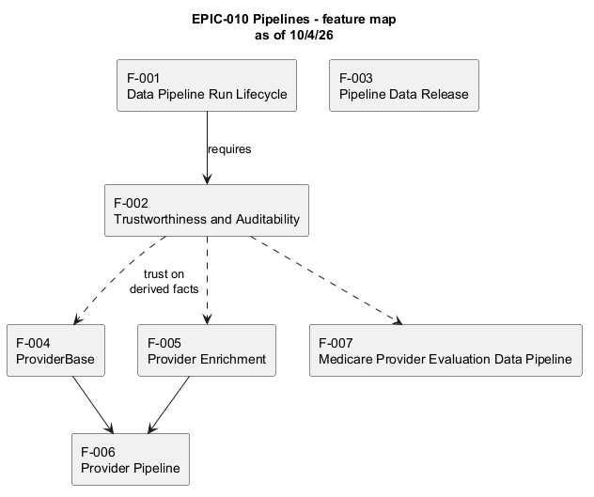
The EPIC-010 pipeline feature set and its relationships.

Medicare Data Model Logical
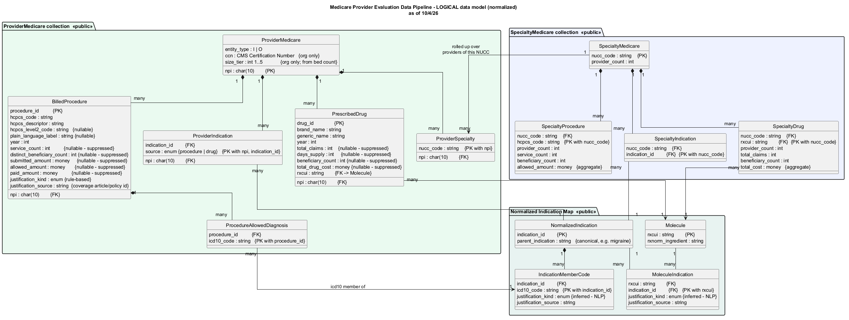
Normalized logical model of the three public collections.

Medicare Data Model Physical
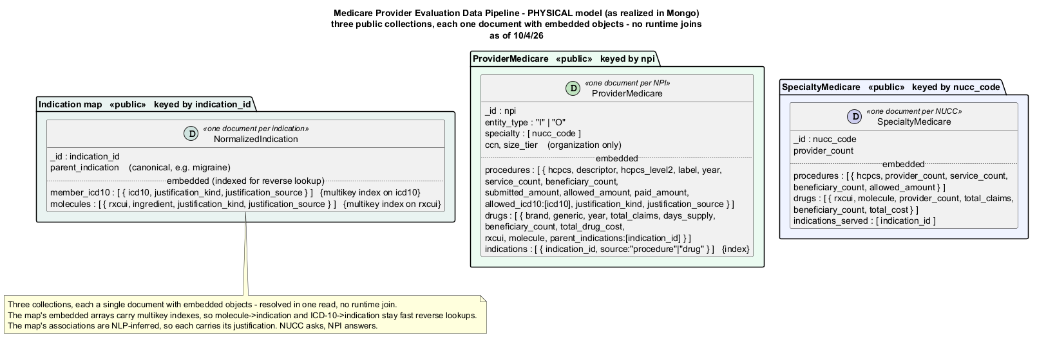
The three public collections as realized in Mongo: one document each, embedded objects, no runtime join.

Medicare Source Traceability
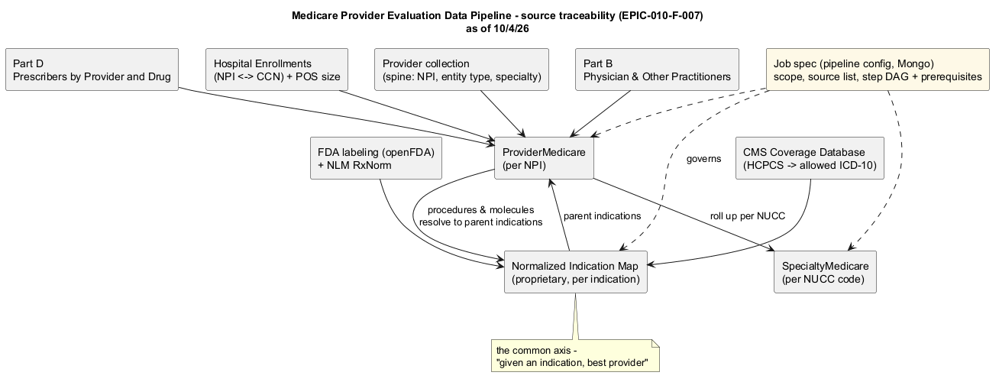
Sources resolving into the three public collections, governed by the job spec.

Medicare Run Sequence
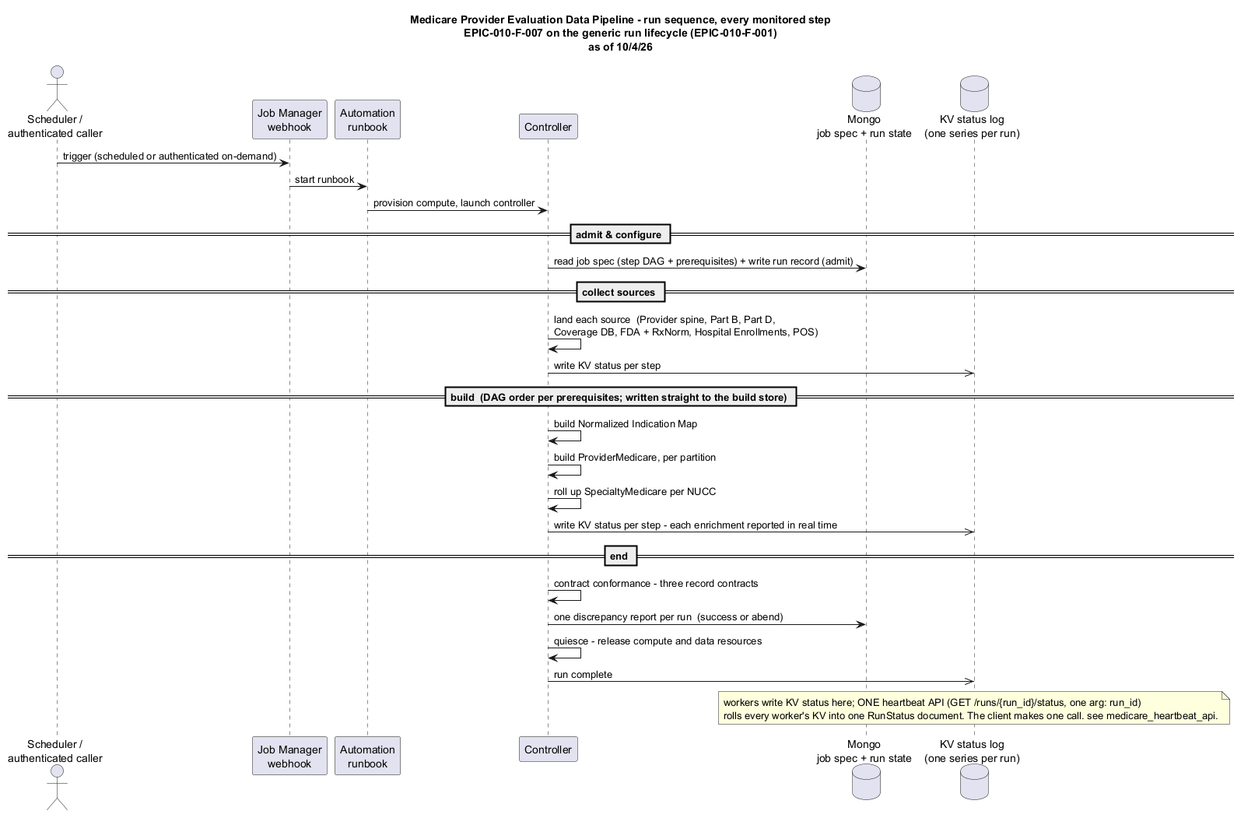
The monitored run, every step, on the generic run lifecycle.

Medicare Detailed Sequence
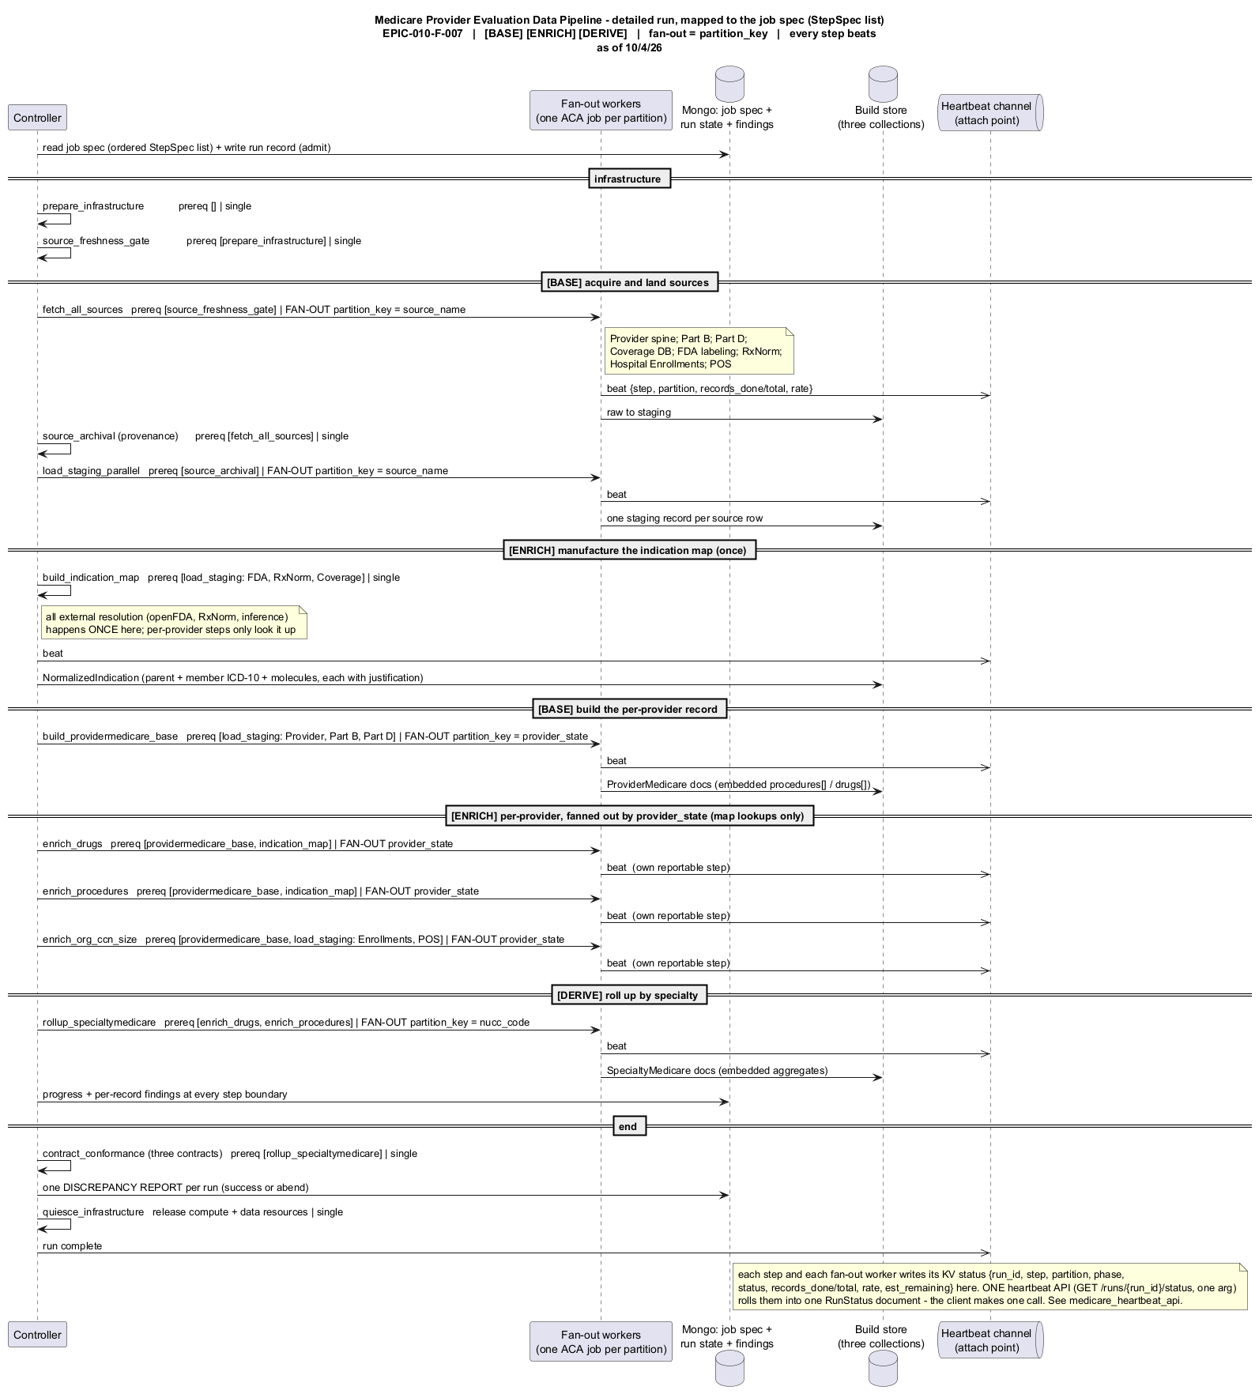
The run mapped to the StepSpec list: base / enrich / derive, with fan-outs by partition key.

Run Status Api
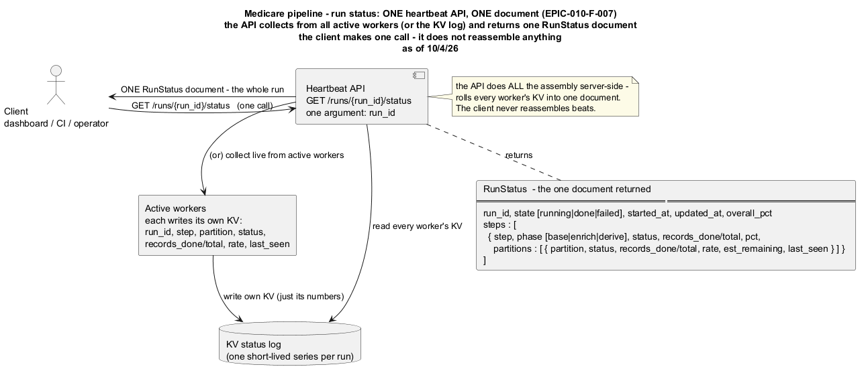
One run-status API: each worker writes its own KV; the API aggregates server-side and returns one RunStatus document.

Trust And Auditability Model
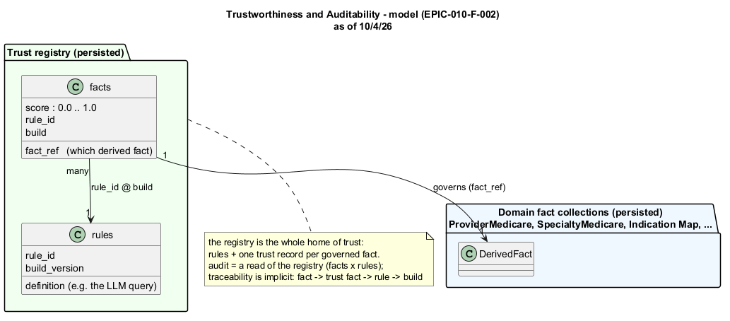
The two-collection trust registry (rules, facts); audit is a read of facts against rules.

