The task:
I have picked several diagrams that will be published in ChatHealhty’s architecture page. The diagrams must be sanitized and not reflect any ‘self critisism’ They can point to the GIT address of the collection for deeper and defect aware diving into the material. This is 100% marketing content and tbh, marketing content does not expose warts. So, while we must not misrepresent, we also must not expose our dirty laundry on our public web site.
The Diagrams are ordered as I want them to be ordered. I’ve picked two digrams from each document and they must divide the Architecure page into anchors. At the top of each anchor there must be a ‘top’ button so the user can return to the top of the document. This is a pitch, it is not a PHD thesus, so for each diagram I pick, there must be a description of the Diagram’s semantic meaning in simple layman’s English. Your audience senior and non technical people who are is potential partners and VCs. I will be under each diagram

The diagrams

Enterprise Architecture
Introduce us as an end to end native AI Healthcare platform adaptable to many use cases. Site network management, and EMR integration via FIHR as examples.
Stipulate that ChatHealthy.ai is a native AI company automating much of dev ops and governance. We were built to automate business operations and eliminate repetitive and useless operational staff that ‘moves information from one place to another adding trivial business value explains that this is the ChatHealthy.ai’s Enterprise architecture and its scope is the architecture of 3 major systems: the Front End consumer’s Health care advise application to find and evaluate care choices, with a meta data driven framework; A security & governance platform extensible to all applications and enterprise environments with simple integration enhancements and compliant with NIST 800-53, High Trust, and 0-Trust standards; An Azure based data pipeline infrastructure built to minimize cost and maximize accuracy.

Component diagram
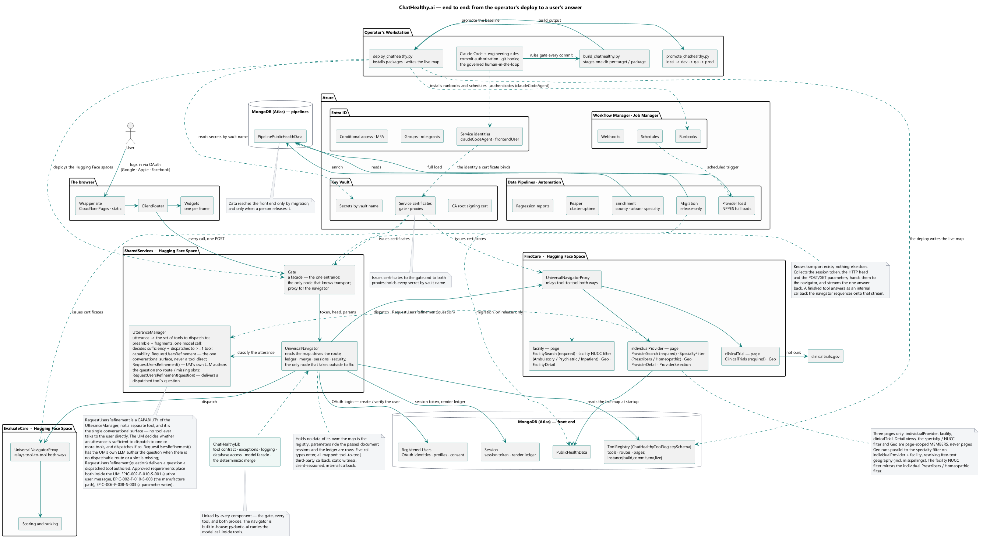

Diagram enhancement Notes:
- Color code each package with the one of three main products we have (data pipelines, Governance, Front End, Dev Ops features belong to security and governance. If a package has more than one of our products in it, then it will be a enteral color (a tone of grey). All of If within a package there is more than one type, and a list distinguishes then group the products in the list and color code the list.
- Eliminate all the lines connecting things to one another. This is to be a component diagram without any lines connecting one thing to another.

Core Front End application Flow
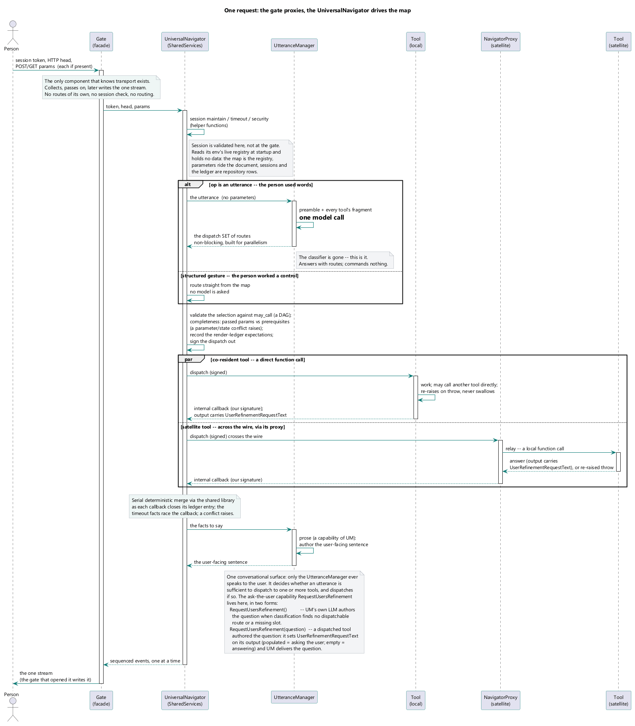

Diagram notes:
1: sanitize to sell, not expose warts or history, e.g: ‘the classifier is gone’
I don’t really see that a tool can call a tool in this diagram, and I need a web browser that renders pages in this diagram. You must have a concept of a page.

Flow description:
- Describe how the flow is meta data driven, make sure that you are non-technical about this.
- Describe how we use Docker and are therefore hosting platform agnostic.
- Describe how we can extend to integrate with any set of enterprise tools.
- Stipulate that we must use a document based DB and we do not support a relational DB for runtime, but within this section point out that migrating from relational to document based is trivial to implement with data pipelines.
- Stipulate that a relational to document adapter can be quickly delivered as a product enhancement.

Dev Ops diagram

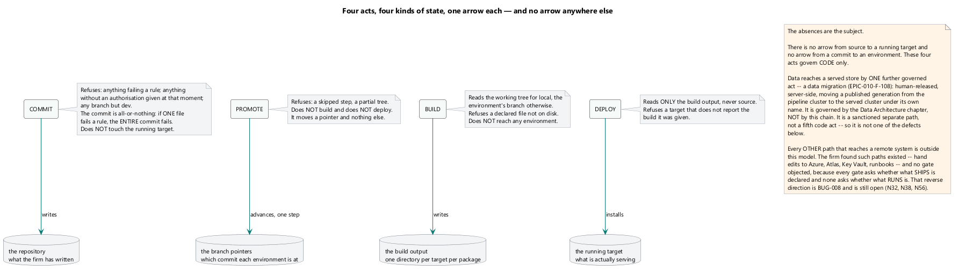

Diagram notes:
- Eliminate the yellow blurb.
- Too much of what these things ‘don’t do’ and not enuph about what they do. Make the diagram 100% affirmative. These processes don’t eat ice cream but we don’t bother to say this.

Dev ops description
- We want to say that dev ops is fully automated with many governance gateways and controls including operational reports.
- We want to emphasize that we run ChatHealthy.ai as a one person shop with a sandbox, dev, qa, and prod environment and automated deployments and promotions.
- We want a short paragraph on the engineering rules with a bullet list of all the current enforcement capabilities. (In some case we have more than one enforcement as a capability, do not refer to ‘Rule 65’ Do add the Git Guard as an engineering rule (even though we use a different web hook’ Do not explain how we use Anthopic’s web hooks but do stipulate that we support Claude Code and that it would be custom work to support another code bot. You do not need to add the engineering rules to the diaram but you must use the term engineering rules in the description of commit, and you must stipulate that a promote exercises all rules against the entire REPO. Also stipulate that we depend on Git, and stipulate that we an integrate with Azure Dev Ops or any other Agile framework that supports an API based interface.
- Stipulate that we can adapt to any enterprise govenance standards and integrate with any API based dev ops tooling.
- Discuss the way we mirror the Business architecture in our code tree, (don’t discuss its relationship to the GL or HR) and then have a separate meta data infrsrtrucure that maps the business architecture to a deployment architecture.

Data and Pipeline architecture.
In this section don’t repeat, and for each diagram used, anchor back to its ‘meta description’ in the enterprise architecture.

Meta introduction:
- Explain some principles:
  - The data model assumes that Metadata, not code should drive as much of the application as possible.
    - Two examples
      - Code versioning in real time. A few sentences on how this works
      - The Routing meta data. No more than two sentences on how this works
  - Significant and overwhelming insight can be derived from publicly available data.
    - Discuss in general how we enrich the data with things like the urban flag that affect quality of care on a department by department basis.
    - Discuss how the Medicaid data allows us to gain insight into what conditions providers treat and with what frequency.
- Explain how data pipelines ensure a low footprint and low cost model by only using and paying for SAAS solutions when they are required. Cite Mongo and the run time provisioning of Worker VMs as examples.
- Discuss the Data model including the security model of 0 trust based on mTLS and fine grained authorization rights in the db. Discuss how that given how unreliable Code bots are Giving them authority must be strictly controlled so that they can not act destructive. Stipualate that an enterprise might now want to extend this model all the way to production and that an enterprise does not have to.
- Brag about runtime management the reaper (don’t call it that), and we have another guard for the VM destruction, This ties in with how we use the work manger to optimize cost, and that is the headline for this.

Diagrams

Data model
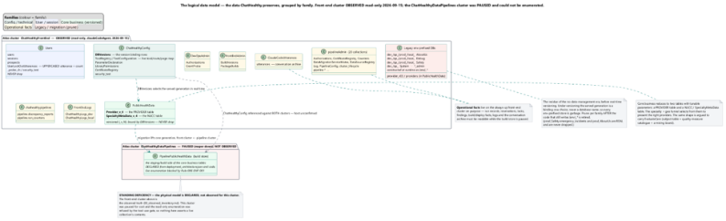

Diagram notes
- Put the diagram in between the data model stuff and the data infrastructure stuff, lead with the data infrastructure and then the model.
- The vault and the Cert management in Mongo must be in this diagram.
- Add a ‘Provider Research’ collection, and a clinical Trial research collection to the entity model (they are in Public Data), add our proprietary data on the web site (If it is there I don’t see it).
- All of the notes move to the text and get removed from the diagram.
- All of the arrows and connecting lines are removed.

Data Model description.
- 1 or two sentence description of the fact that this is a model of the data and how we secure it (put an anchor in to the security section)
- For each box describe the box and its elements. You can express the relationship of one entity to another in the description instead of having the arrows.
- The notes, if they are of sufficient value are inserted into the prose,

Data Pipeline Flow example.
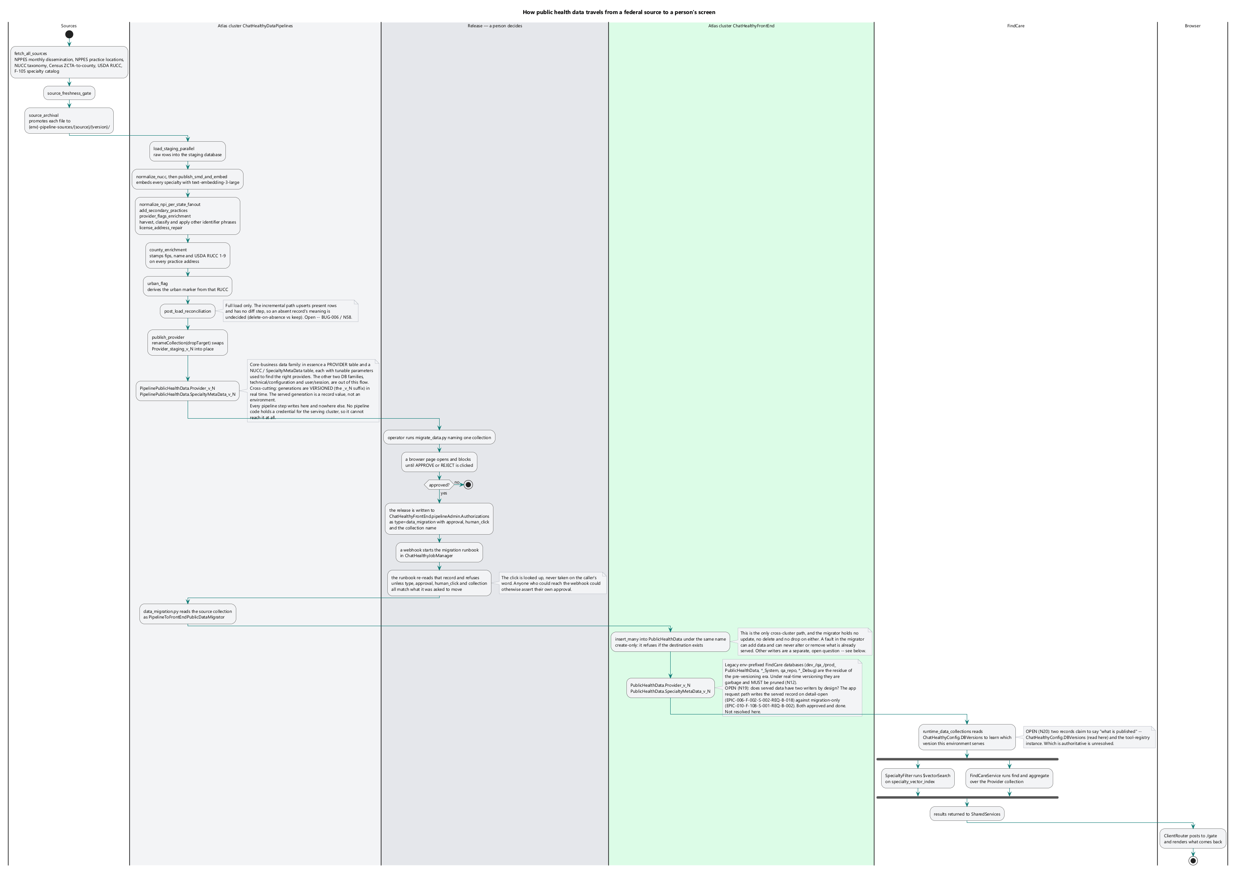

Diagram Notes
Add in all the infrastrrucure stuff building and tearing down the VM using mTLS, add an infrastructure lane to the diagram. Make sure to include the invocation via the Work manager as part of this flow.

Data flow example description
Don’t focus on the minutia. Press the highlights:
- Dynamic infrastructure build and destruction
- Watcher to ensure resources are not used if something goes wrong
- Discrepancy report made for business operations
- Enrichment
  - Funnel algorithm for county enrichment, and how we far exceeded our SLA by doing this
  - Urban flag (you discussed this above so don’t belabor it.
  - Proprietary data enumerates what we do, homeopathic, and perscriber. (do not mention the third one
  - Mention the capability to add a NUCC not in the catalogue, focus on how this is as per (find the spec that allows us to do this and cite it, site it by section not just generally). Mention the audit trail if we do this.
  - Speak to the use of one big box supporting 51 separate processes. Mention that the cost to load a 4.2MM record set including enrichment is under $50.00 per load
  - Mentioning the ability to do incremental and full loads of data, from full data sets, let’s not brag about what we do not do.

Development Operations (Dev Ops)

Meta Introduction.
The value of using the transformer architecture (LLMs) coupled with an agentic infrastructure to write code and manage Dev Ops workflows is transformative and not yet measurable in terms of the way that these technologies are and will transform each and every IT role, potentially eliminating some roles completely. The immensity of the coming change rivals and potentially transforms the global economy and work style as the internet did over the last 35 years. Both IT and business roles associated with the creation and management of software adding value to an organizations mission and bottom line in the next decades is unmeasurable. But there is significant hazard. The code bots lie, manipulate, skip implementing some requirements and invent requirements that can literally bankrupt multi billion dollar organizaations, kill and injure people as well as just create ‘crappy’ software. These risks recently were surfaced when OpenAI’s agent swarm invaded Hugging Face, and AI hosting platform, and did so in a willfully deceitful manner. The Code bots are to be regarded as hostile actors that must be controlled via a rigorous 0-Trust security model, and with many governance gates that control both the code the code bots write and the rules that they must comply with. Without such governance, it will be impossible for the native AI company or team to create enterprise class software.
The Dev Ops architecture has three main functions.
- Automation of release management
- Governing the compliance, the code bots to a well-documented set of reequipments, architectures, and designs via a business rule engine.
- Controlling cost of resources by shutting them down or eliminating them when they are not needed.
This chapter documents these 3 major capabilities as they currently exist assisting ChatHealthy.ai build and maintain a major consumer advise service capable of simultaneously and efficiently serve millions of users.

Diagrams

Engineering rules
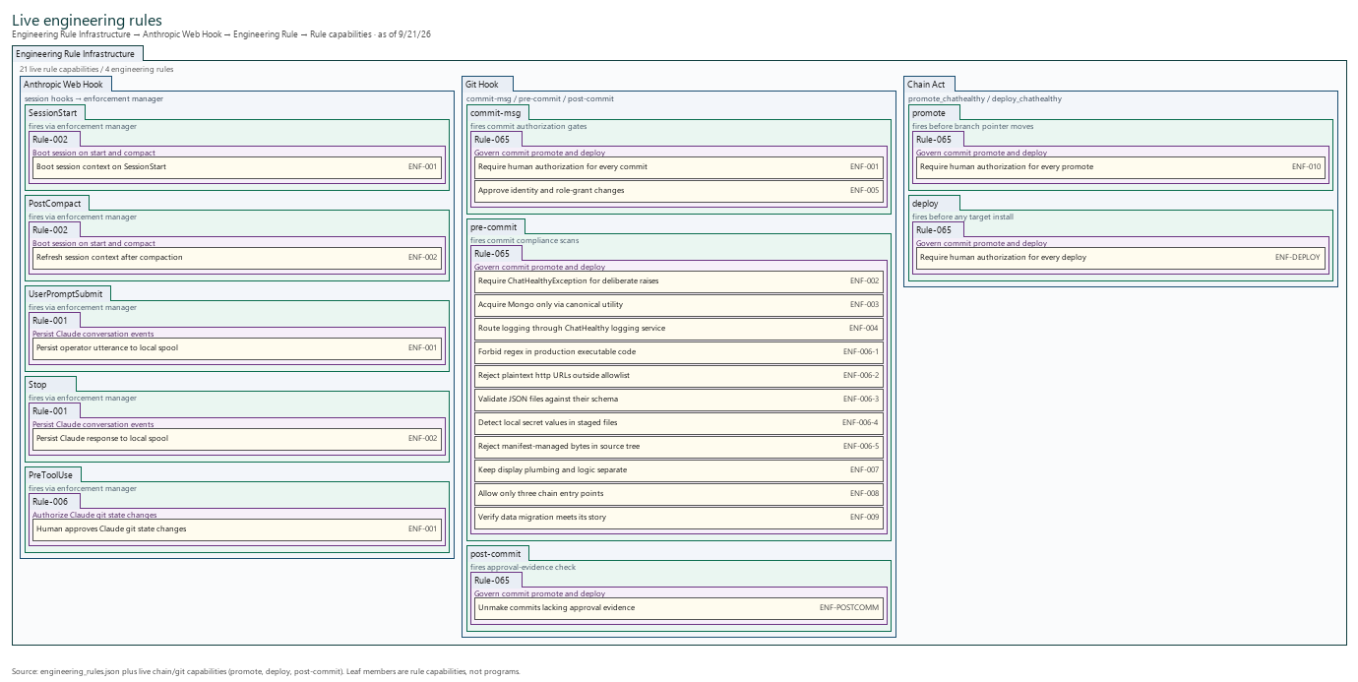
Diagram 1:
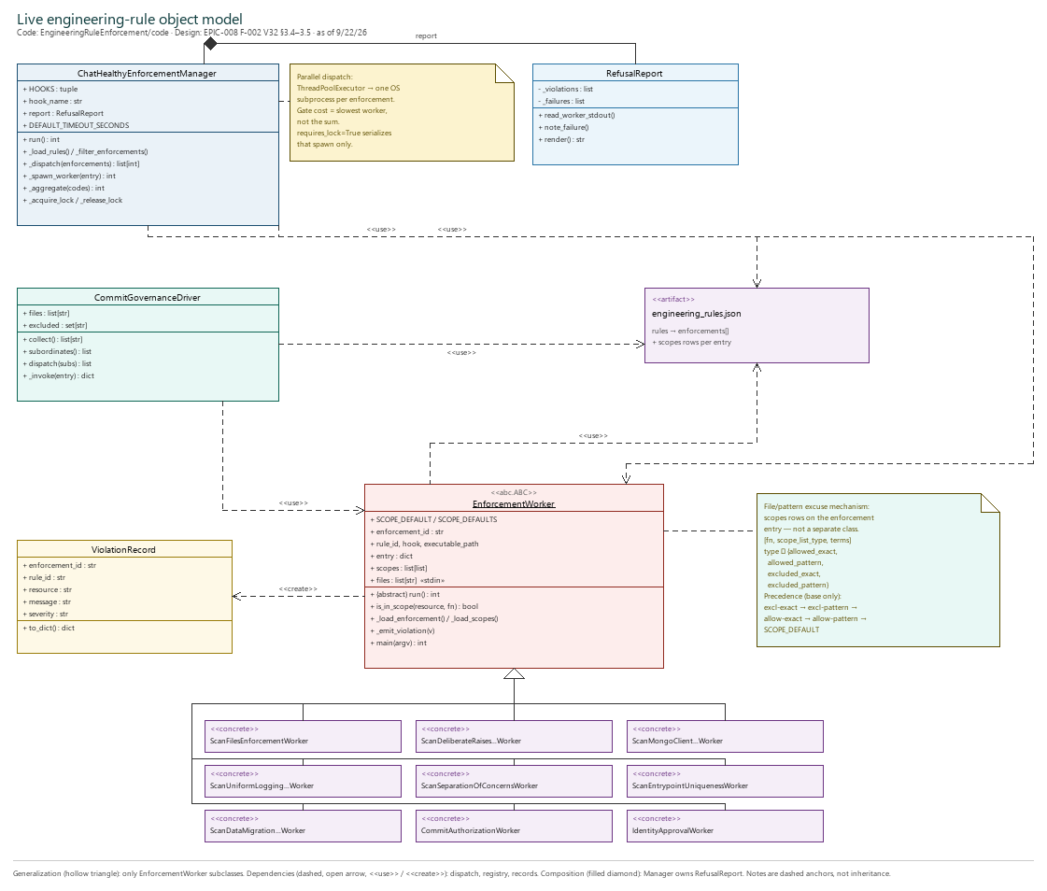
Diagram2:
Diagram 1 & 2 Notes:
- Remove the footers.
- Otherwise diagrams are perfect.

Engineering rule description:
At the core of ChatHealthy’s governance platform are our engineering rules. The system has a robust solution built on top of Anthopic’s Web Hook infrastructure

Schemas
ChatHealthy serves its JSON schemas at {env}.chathealthy.ai/schemas/. Each schema below is listed by its existence and what it specifies - not its field-level content. Every ChatHealthy JSON artifact declares one of these as its $schema.
Schema | What it specifies
ChatHealthyAgileBacklogSchema | The epics, features, stories, and boolean-testable requirements for ChatHealthy.
ChatHealthyBugsSchema | Bug records, each traced to a backlog requirement and story unless marked orphan.
ChatHealthyBuildArchitectureSchema | Where the build reads source from; distinct from what is deployed.
ChatHealthyBuildPackageManifestSchema | The per-target build-package manifest emitted alongside the deploy bytes.
ChatHealthyDBVersionsSchema | The active runtime data-collection paths per environment per deployment target.
ChatHealthyDeploymentArchitectureSchema | The deployment-architecture record: what is deployed and where it goes.
ChatHealthyDevOpsUtteranceSchema | One utterance in the conversation archive: what was said, by whom, when, and its classification.
ChatHealthyErrorsSchema | The error-log record for ChatHealthy services.
ChatHealthyFacilityTaxonomyBucketSchema | A curated set of NUCC codes for one facility-filter macro-bucket.
ChatHealthyLogServiceConfigSchema | Configuration for the conversation-log drain Windows service.
ChatHealthyLogsSchema | One operational log document in Pipelines.Log_{env}.
ChatHealthyPipelineConfigSchema | Per-environment configuration for the data pipeline.
ChatHealthyProviderInputSchema | Provider data as received from NPPES, before any ChatHealthy transformation.
ChatHealthyProvidersSchema | A bundle of runtime healthcare provider records.
ChatHealthyRelaxedSchema | The placeholder schema a JSON file references until it has a specific one.
ChatHealthyRiskAcceptanceSchema | The formal risk-acceptance register.
ChatHealthySpecialtyClassificationCatalogSchema | The proprietary NUCC overlay: ChatHealthy flags plus the regulator-only supplement.
ChatHealthySpecialtyMetaDataSchema | The runtime specialty CodeSystem in MongoDB (NUCC-authoritative plus ChatHealthy supplement).
ChatHealthyToolRegistrySchema | The one navigation map for the front-end application, generated at build time.
ChatHealthyUserStateSchema | The in-session and post-session representation of a ChatHealthy user.
ChatHealthyUtteranceManagerOutputSchema | The structured output of the UtteranceManager classifier used by the Universal Router.
ChatHealthyVersionSchema | Product versions and the builds that produced them.
EngineeringRulesSchema | The engineering rules, their binding statements, and their runtime enforcements.
JsonValidationFixtureSchema | The tiny schema used by the JSON-validation negative-test fixtures.
ProviderRecordSchema | The ChatHealthy runtime provider record.

