Target Architecture — Diagram Catalogue
Every diagram across the six target-architecture documents, each shown once. Where a diagram appears in more than one document under different captions, each document is named in bold with its own description beneath.

Enterprise Architecture
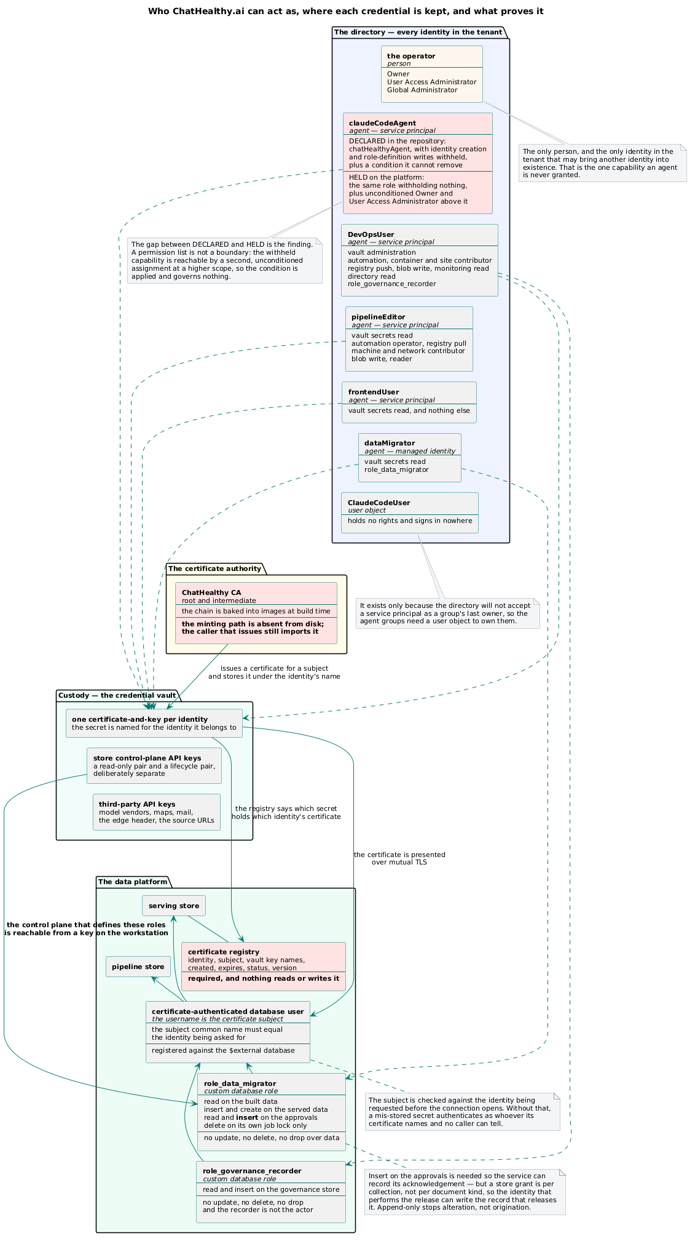
Enterprise Architecture
Every identity in the tenant, where each credential is kept, and what proves it. Identity creation is the one capability reserved to a person — declared in the repository, and absent on the platform.
Security Framework
Every authenticating actor resolves to one entry in one registry; the certificate is the credential, and the vault is where a credential becomes an identity.

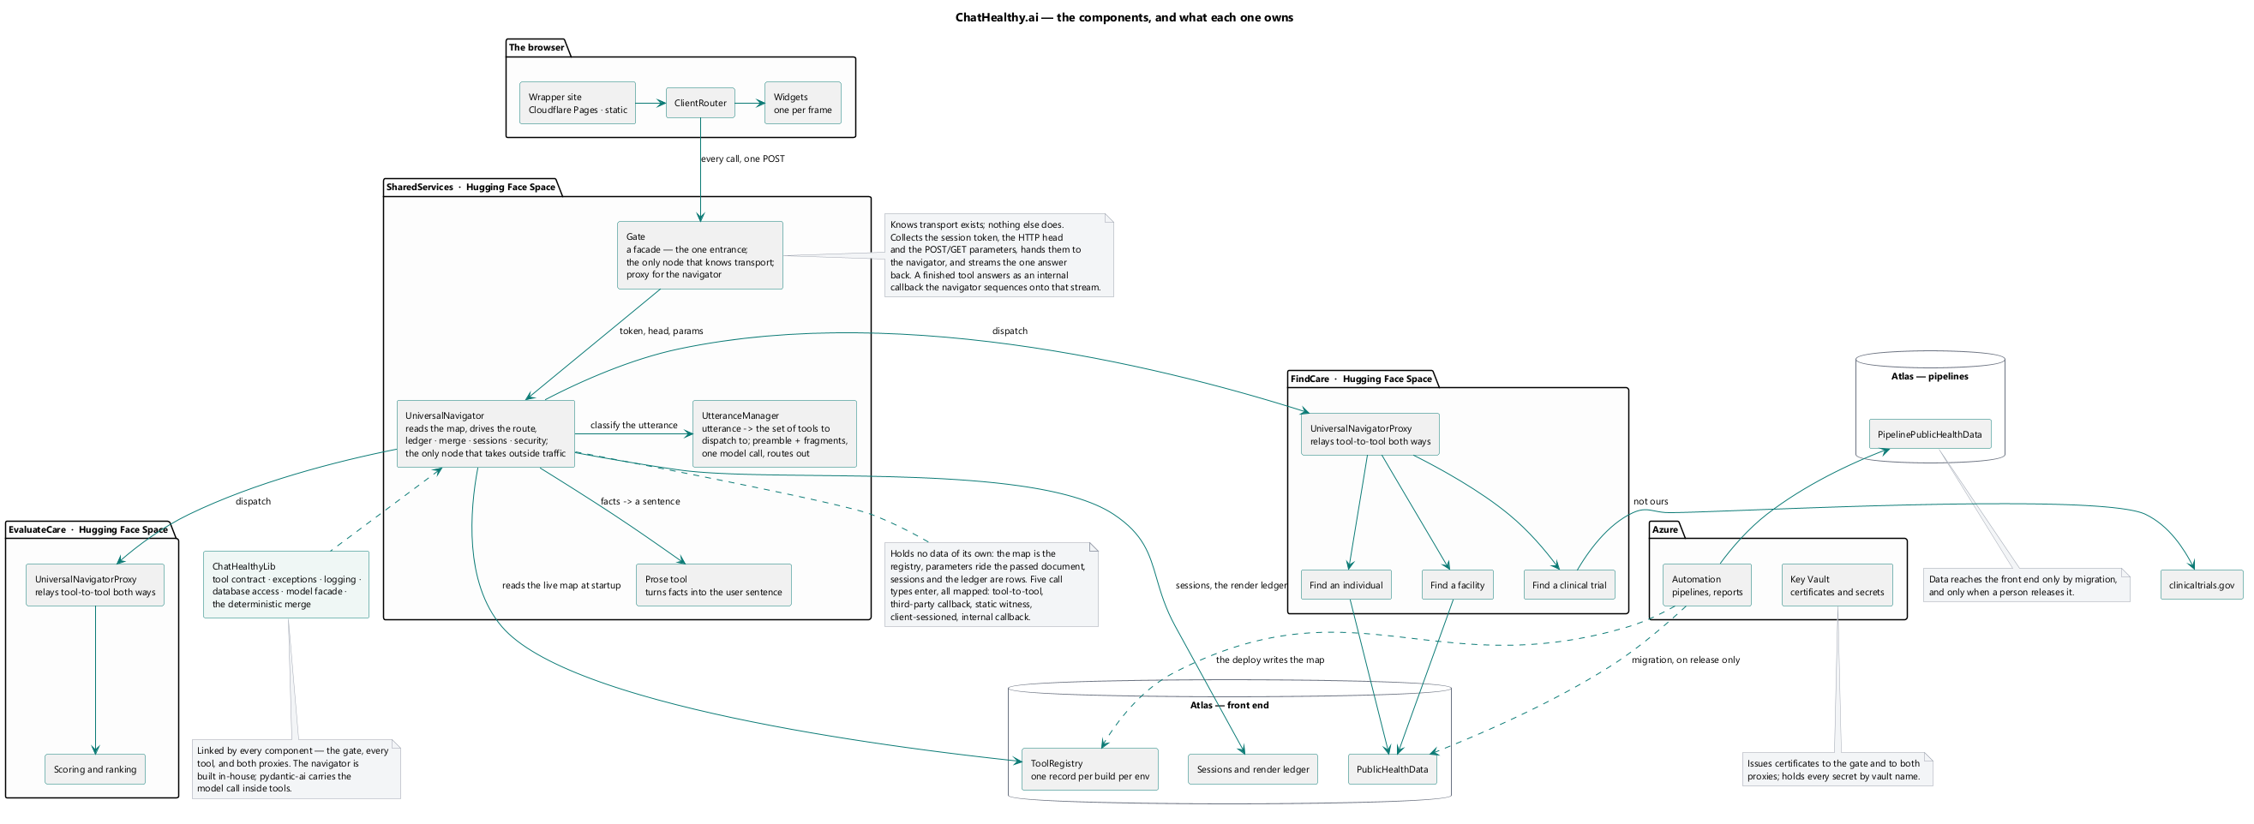
The components and what each owns. The browser touches exactly one box; the governance plane is not in the request path.

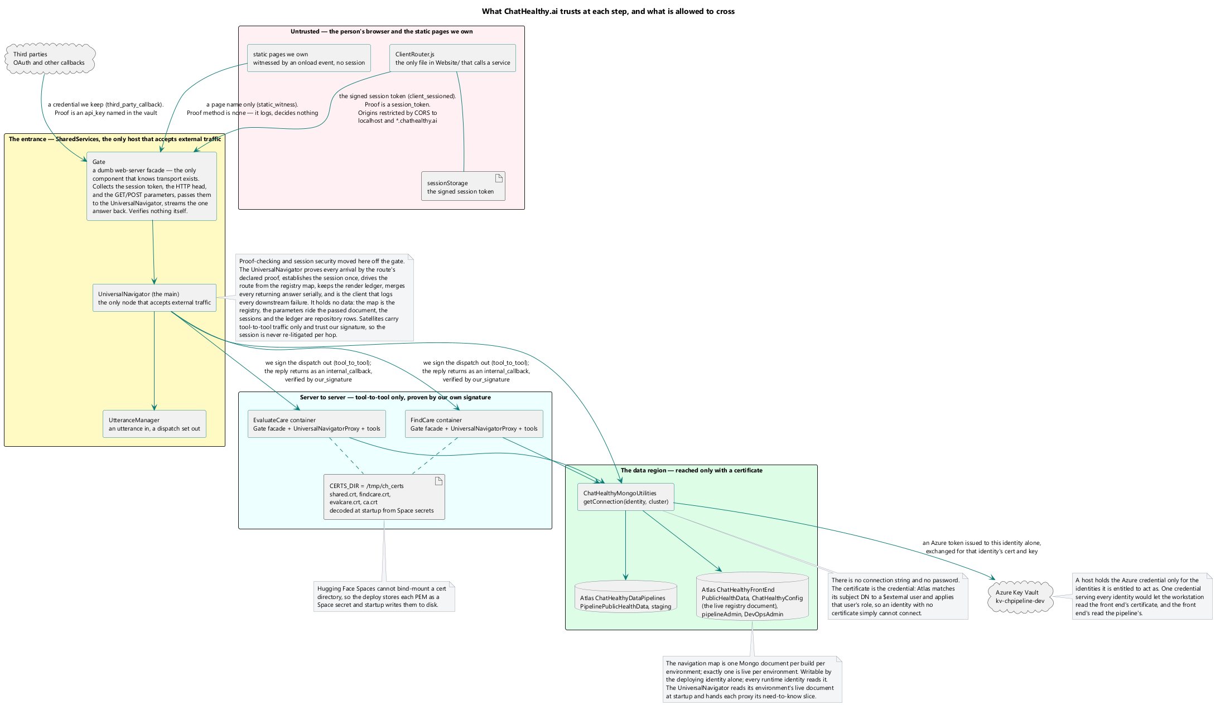
Enterprise Architecture
Every crossing, and the credential presented at each. The Security Framework owns what each obligation is; this document owns which crossings exist.
Security Framework
Every arrow crossing a zone edge is labelled with the credential presented, not the protocol. Three arrows are marked as defective: the agent's direct path to the platform, the component-to-component call that disables peer verification, and the deploy's own read-back.

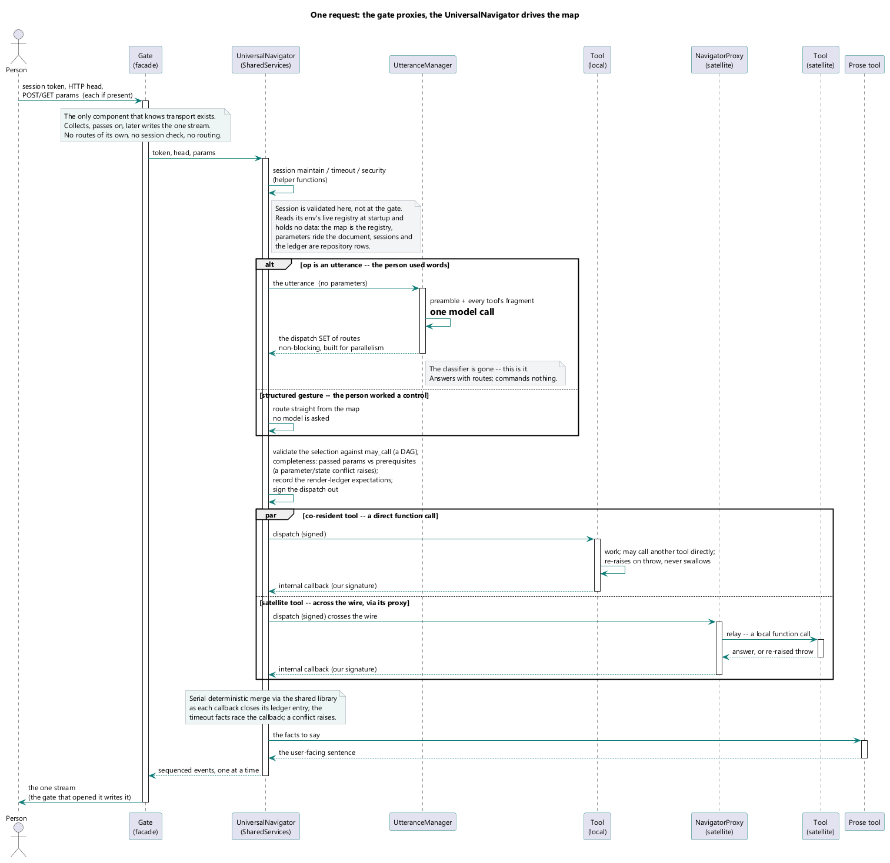
Enterprise Architecture
One user's web request through the single entrance. Every browser-originated call takes this path or does not arrive.
Live Application Architecture
A request through the gate — parse, validate, dispatch, stream.

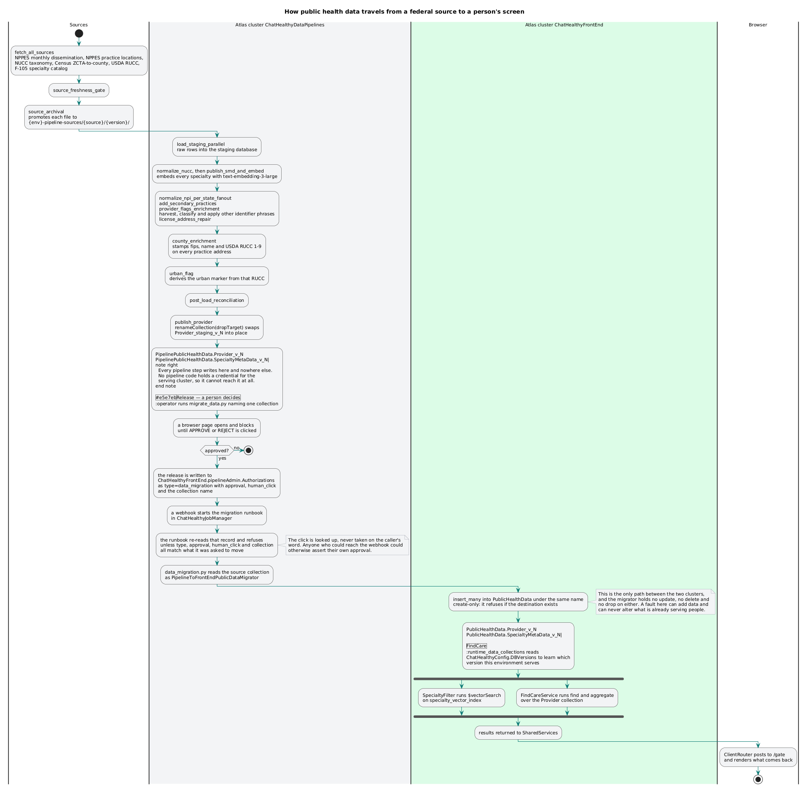
Enterprise Architecture
Where data comes from, what changes it, and the one path by which it reaches a user.
Live Application Architecture
One turn, end to end — the two moments a model runs, and the deterministic span between them.
Data Pipeline Framework
Source to served record: the seven stages, the three stores, and the single gated crossing between the build store and the serve store.

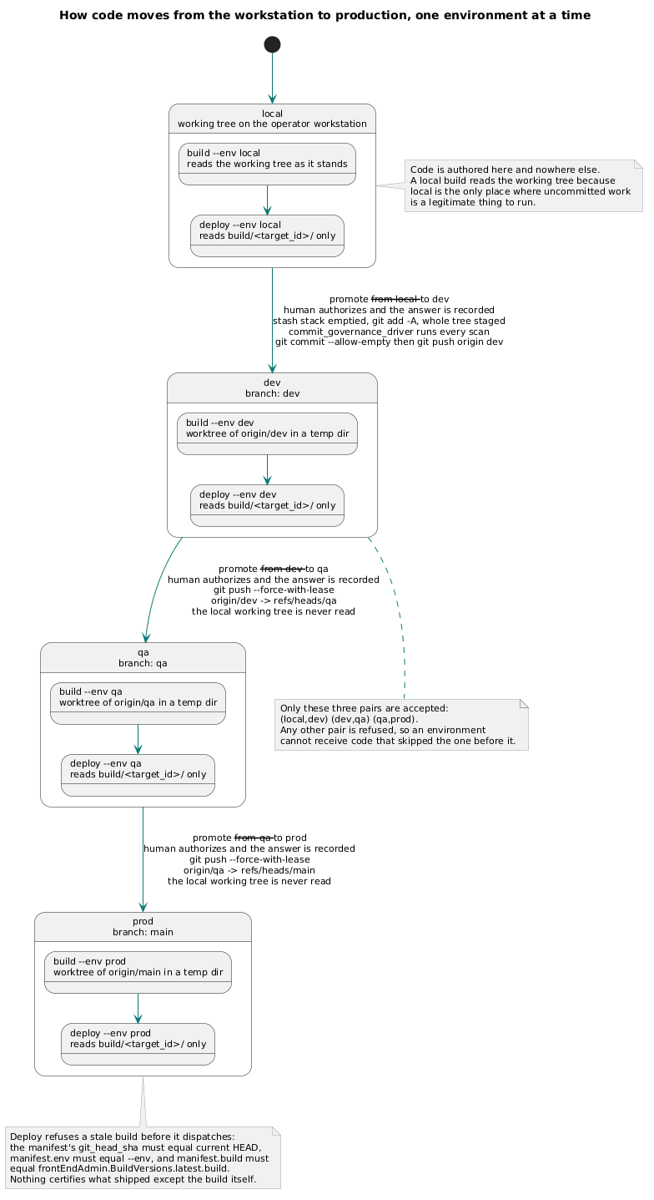
Enterprise Architecture
The four acts and the one direction. No act reaches another's kind of state, and no arrow runs backwards.
DevOps Governance Framework
The four environments as one directed chain. A promote advances exactly one adjacent step; there is no path that skips, reverses, or targets an environment from itself.

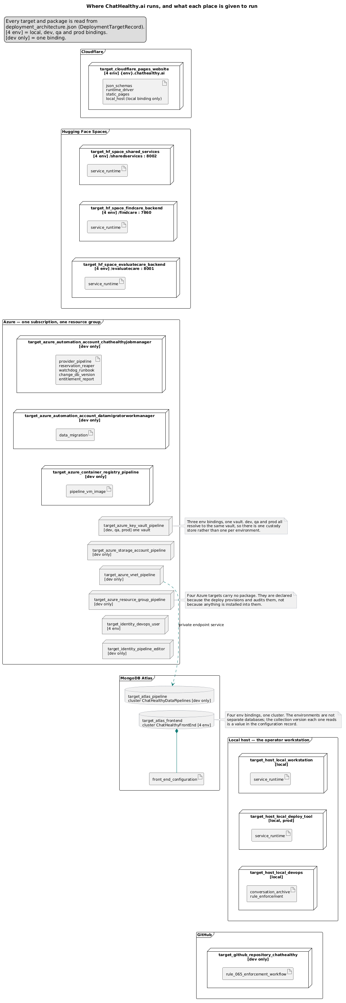
Enterprise Architecture
Which target runs where, per environment. The environment selects the host; the target's contents are the same in all four.
DevOps Governance Framework
Targets, their packages, and the environment bindings that select a host. What a target is composed of is declared once; the binding chooses where it runs and nothing else.
Data Pipeline Framework
What exists permanently between runs and what exists only during one: the network, vault, registry and automation account are deploy topology; the run host and its worker processes are created per fire and destroyed with it.

Live Application Architecture
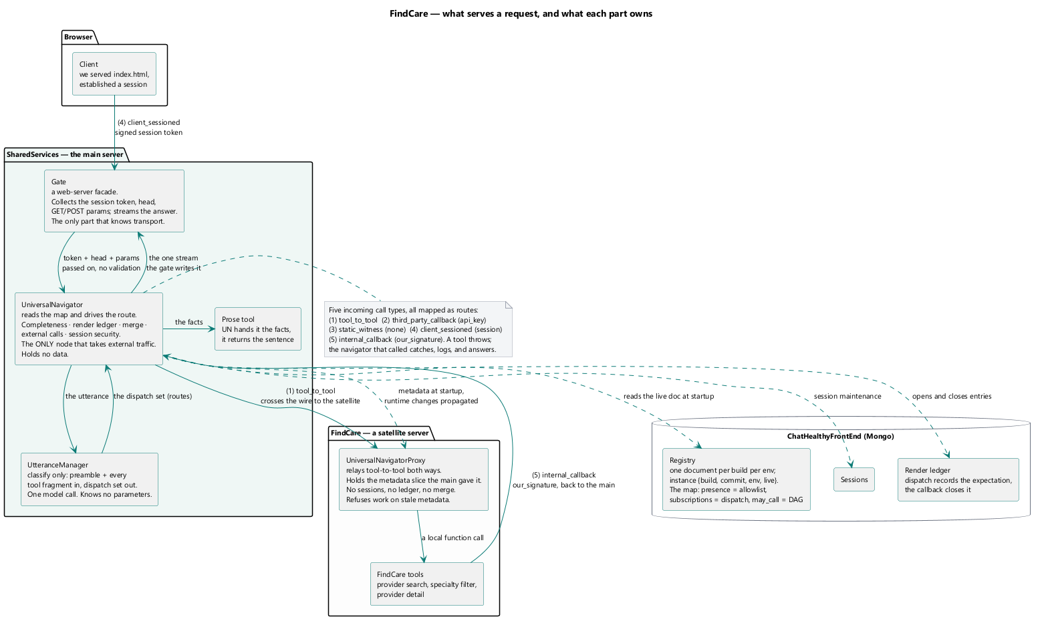
The entrance and what sits behind it. The browser touches exactly one box.

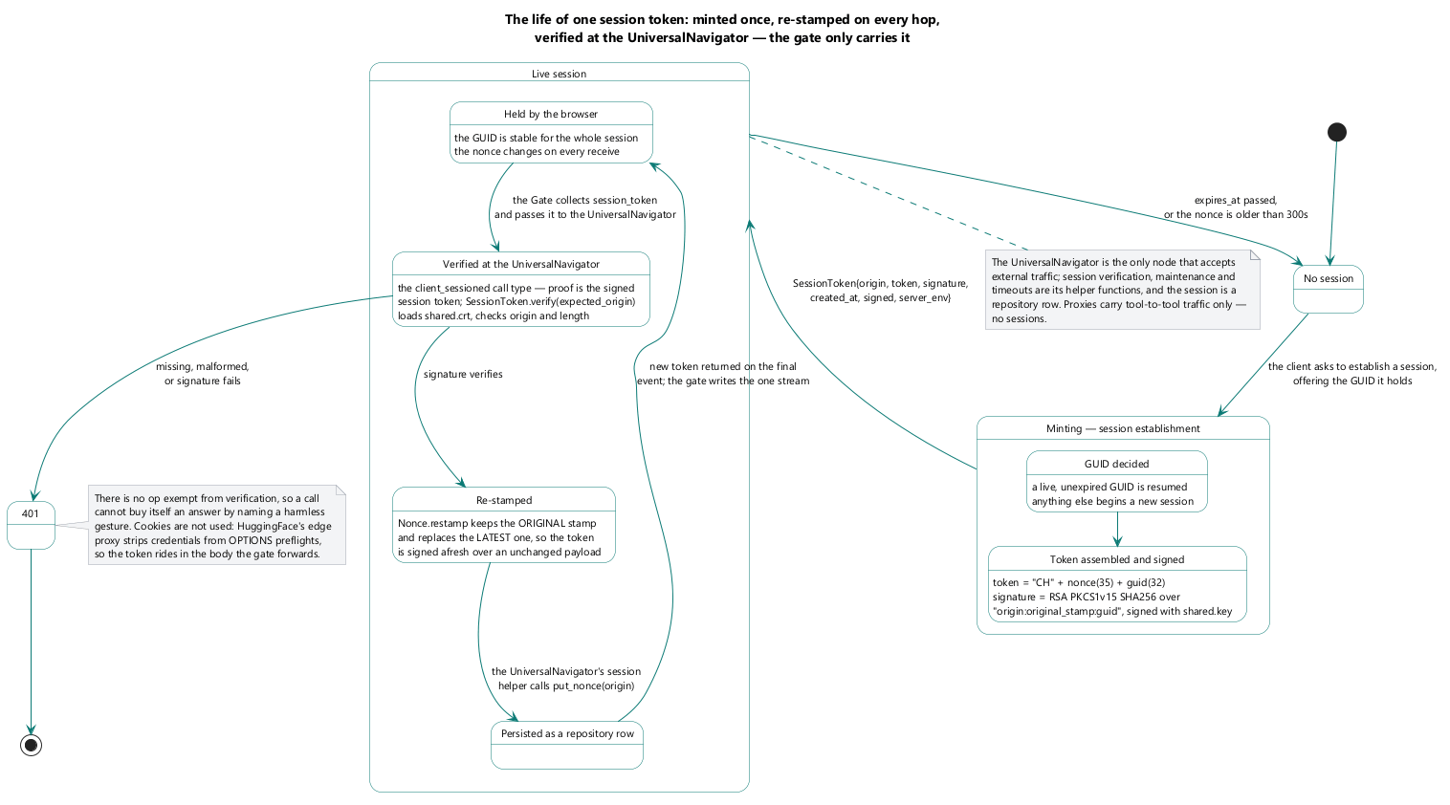
What a session holds, who writes each part, and what travels on the wire.

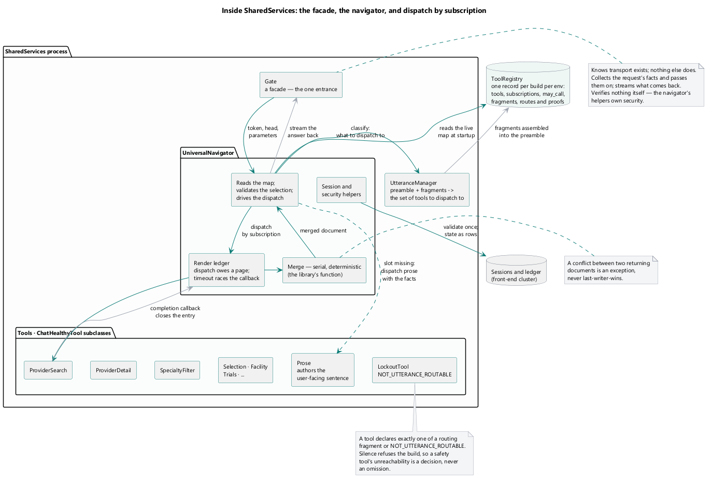
Inside the entrance — the door, the router, the utterance manager, and the tools.

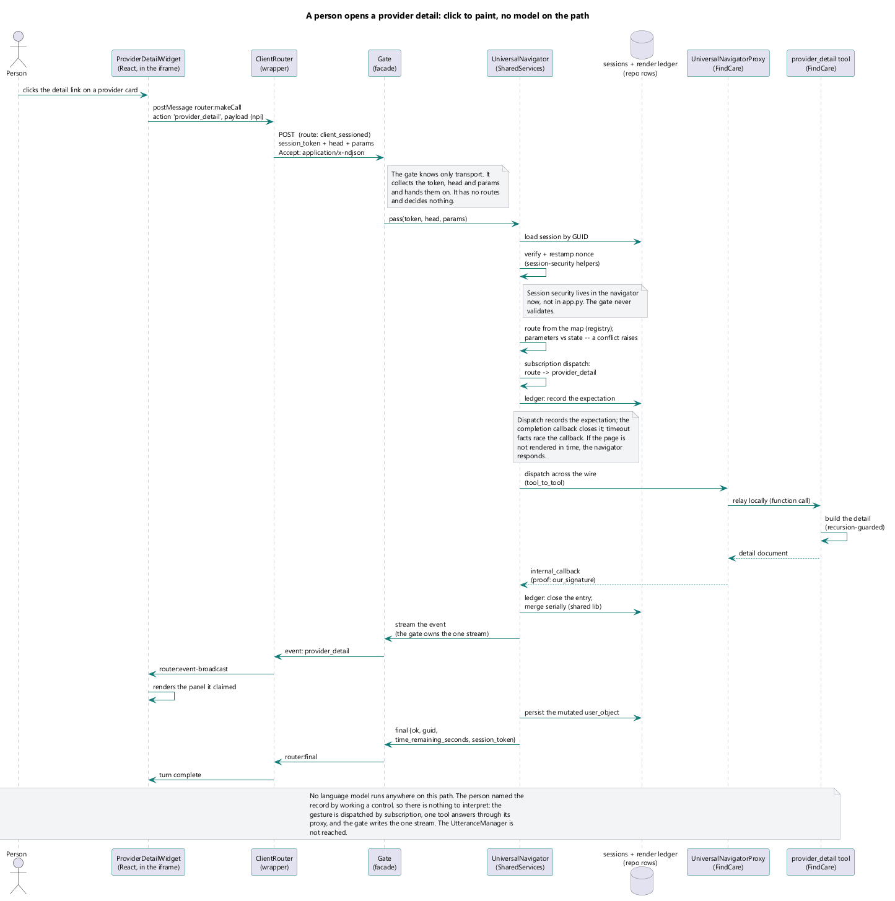
A structured gesture — no free text, and the manufacture path when a slot is missing.

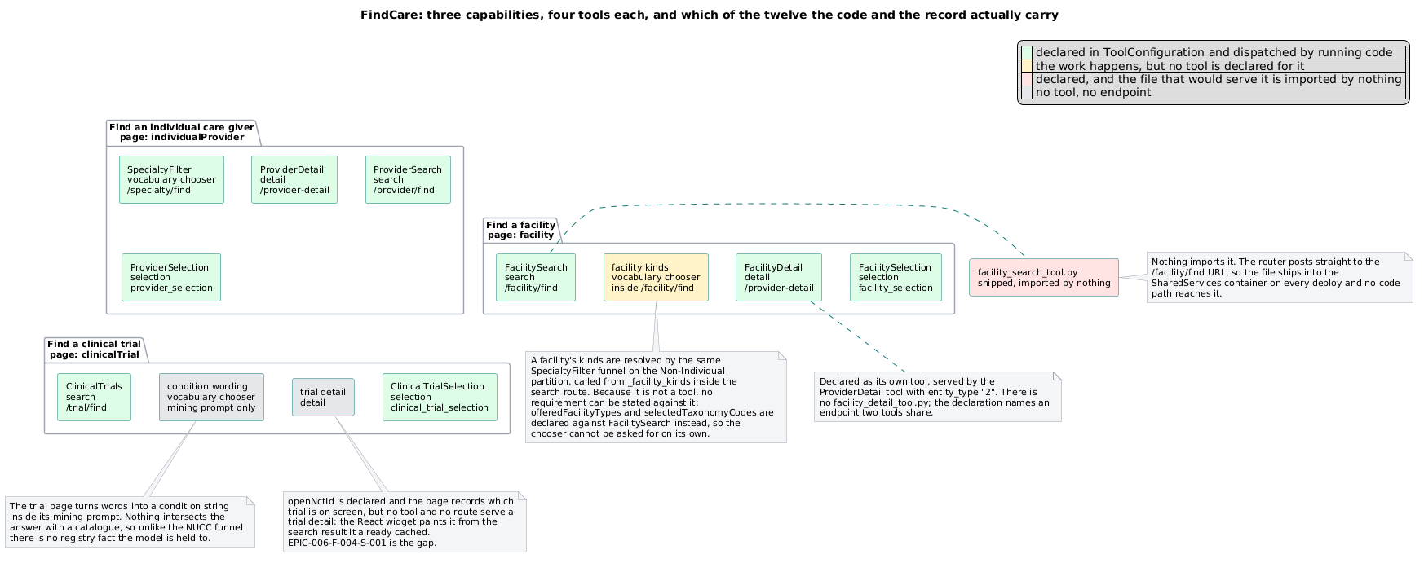
Twelve cells, nine filled. A hole in the grid is a known absence, not a surprise.

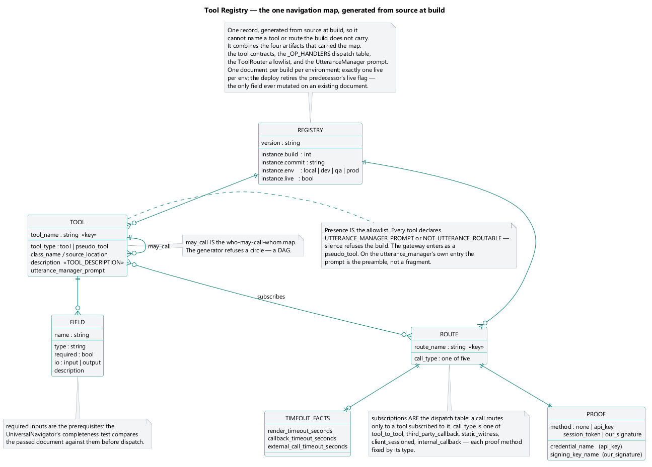
Four lists and the joins between them. A tool appears in all of them, which is why the record is named for it.

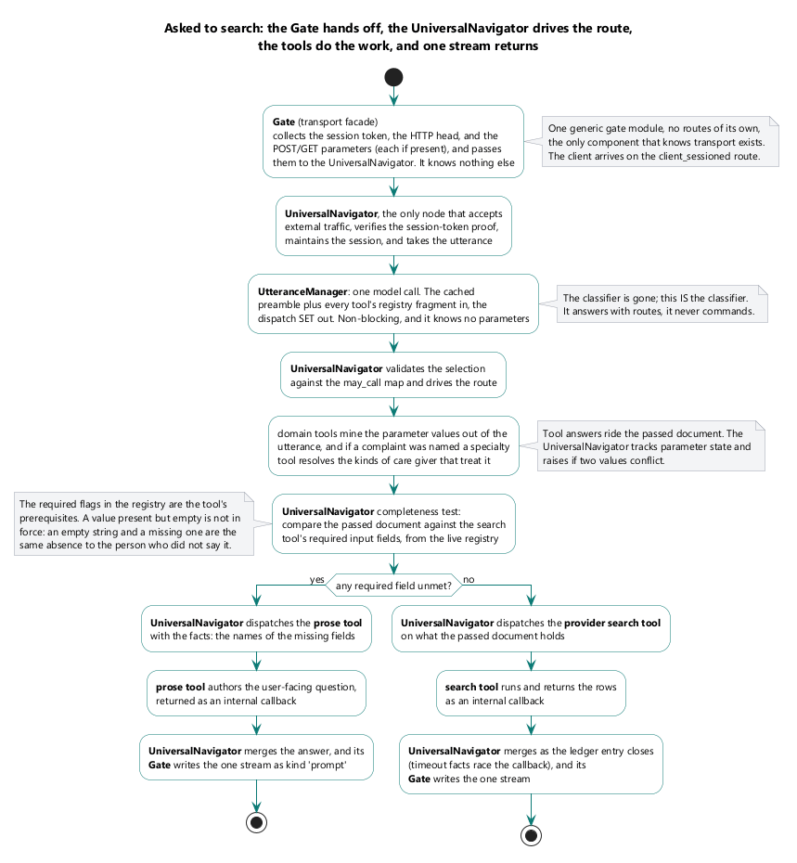
How a value in force is resolved for one tool on one page.

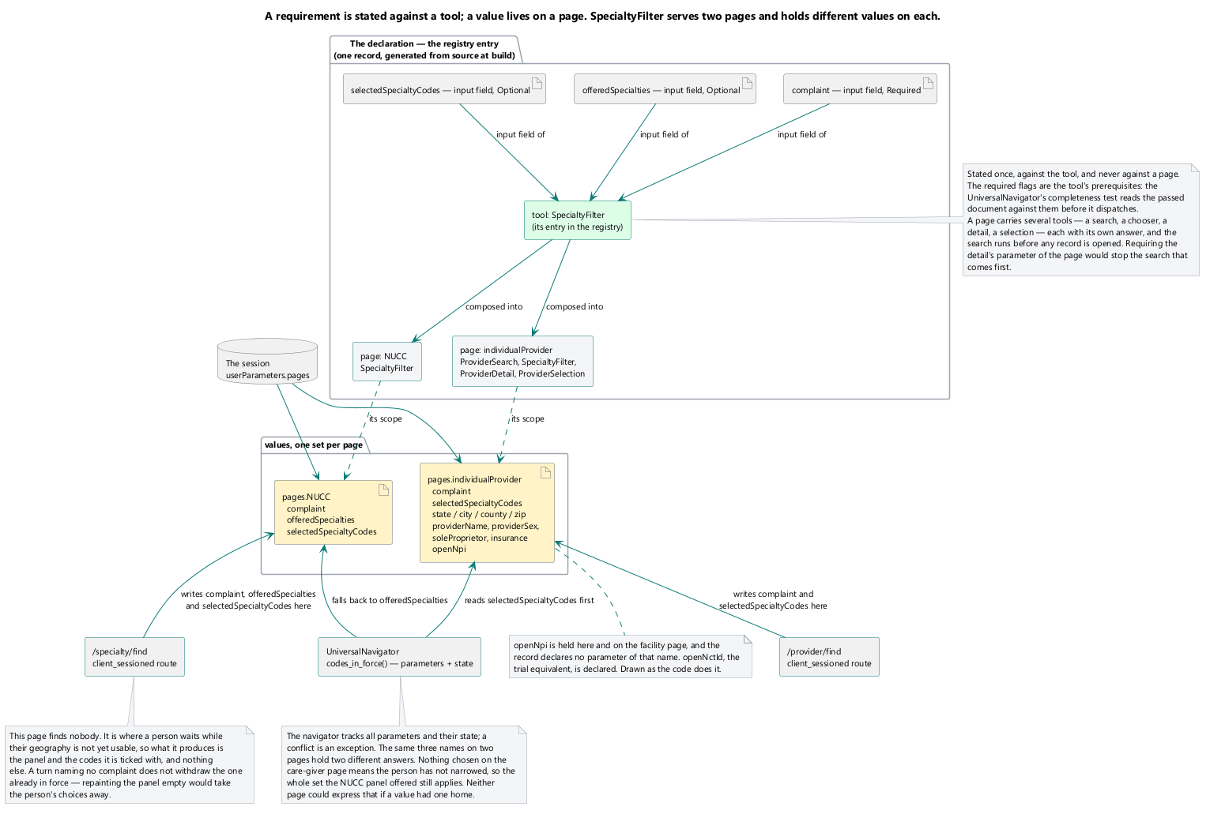
One name, one value per page. The geography on the care-giver page is not the geography on the facility page.

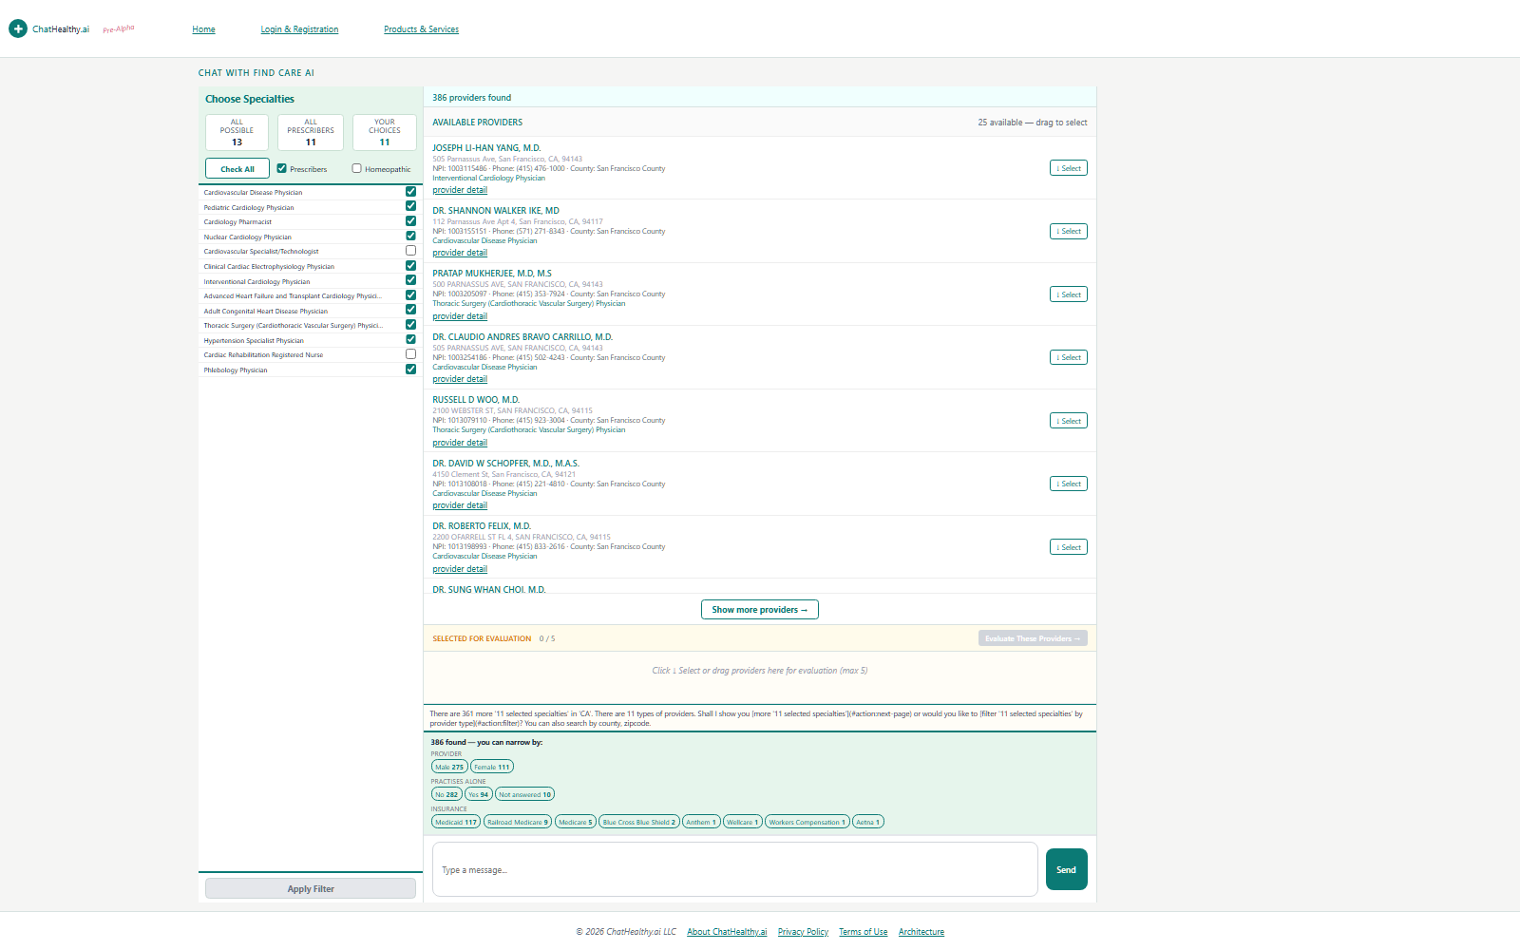
The individual-provider page — the same frames, showing a care-giver answer.

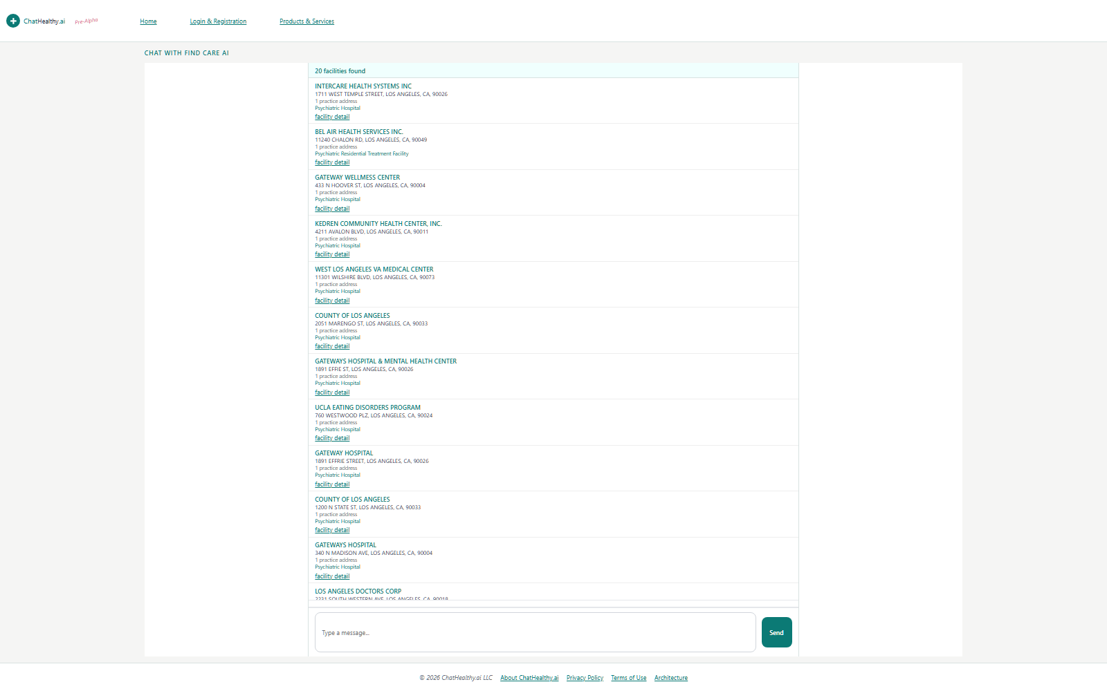
The facility page — the same frames, a different subject, its own values.

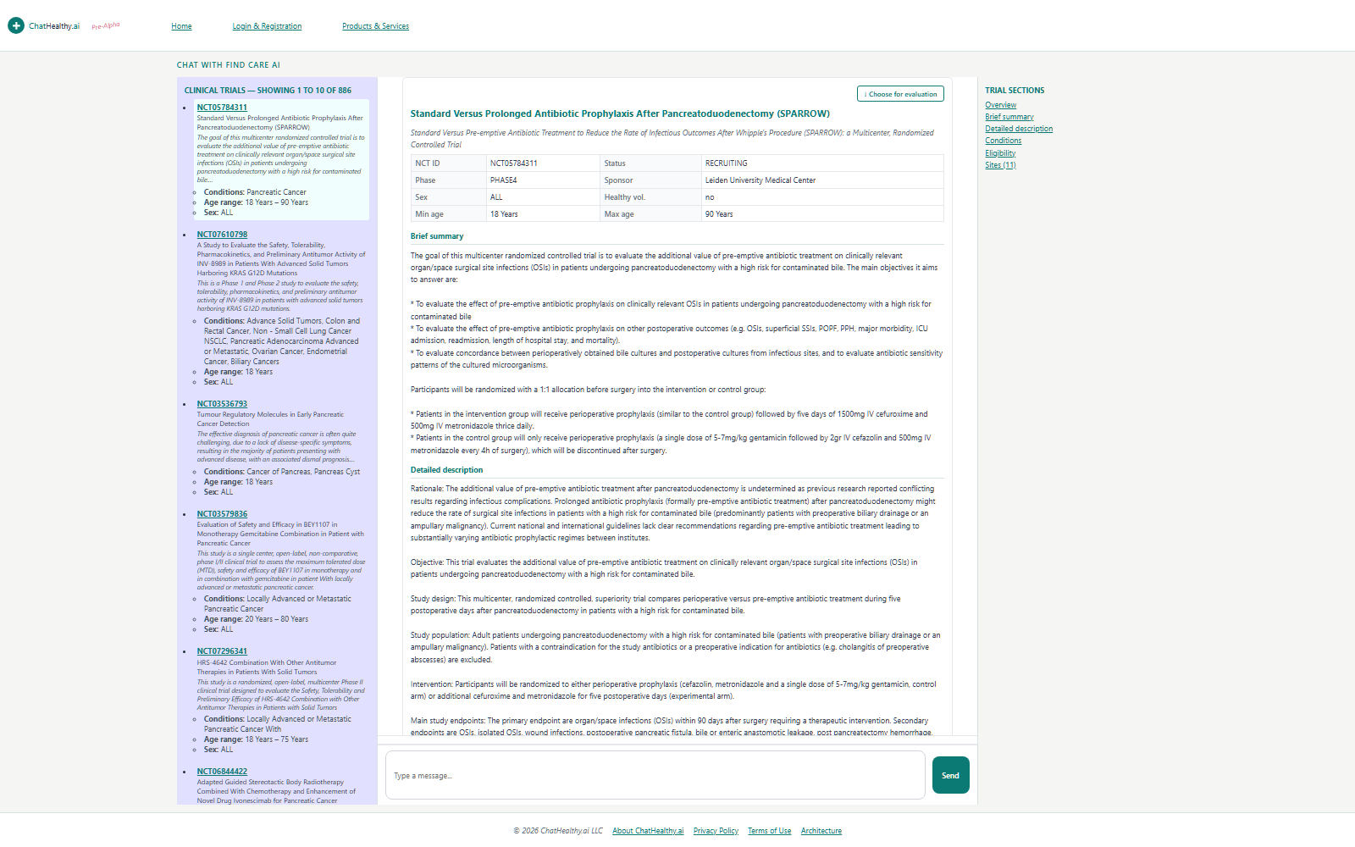
The clinical-trial page. Three pages, one screen.

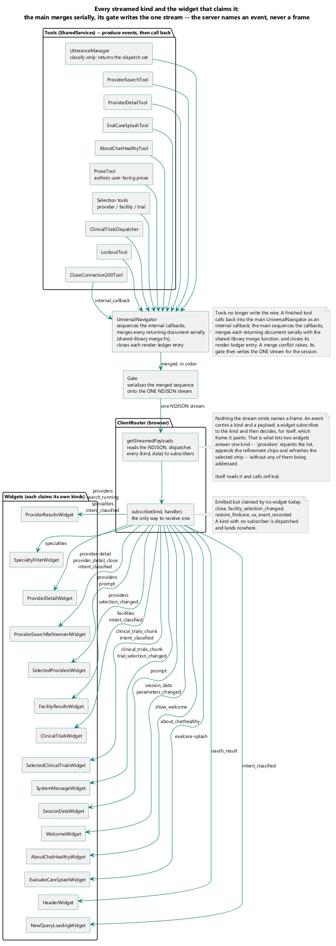
The wire vocabulary — every kind the server can emit and the widget that claims it.

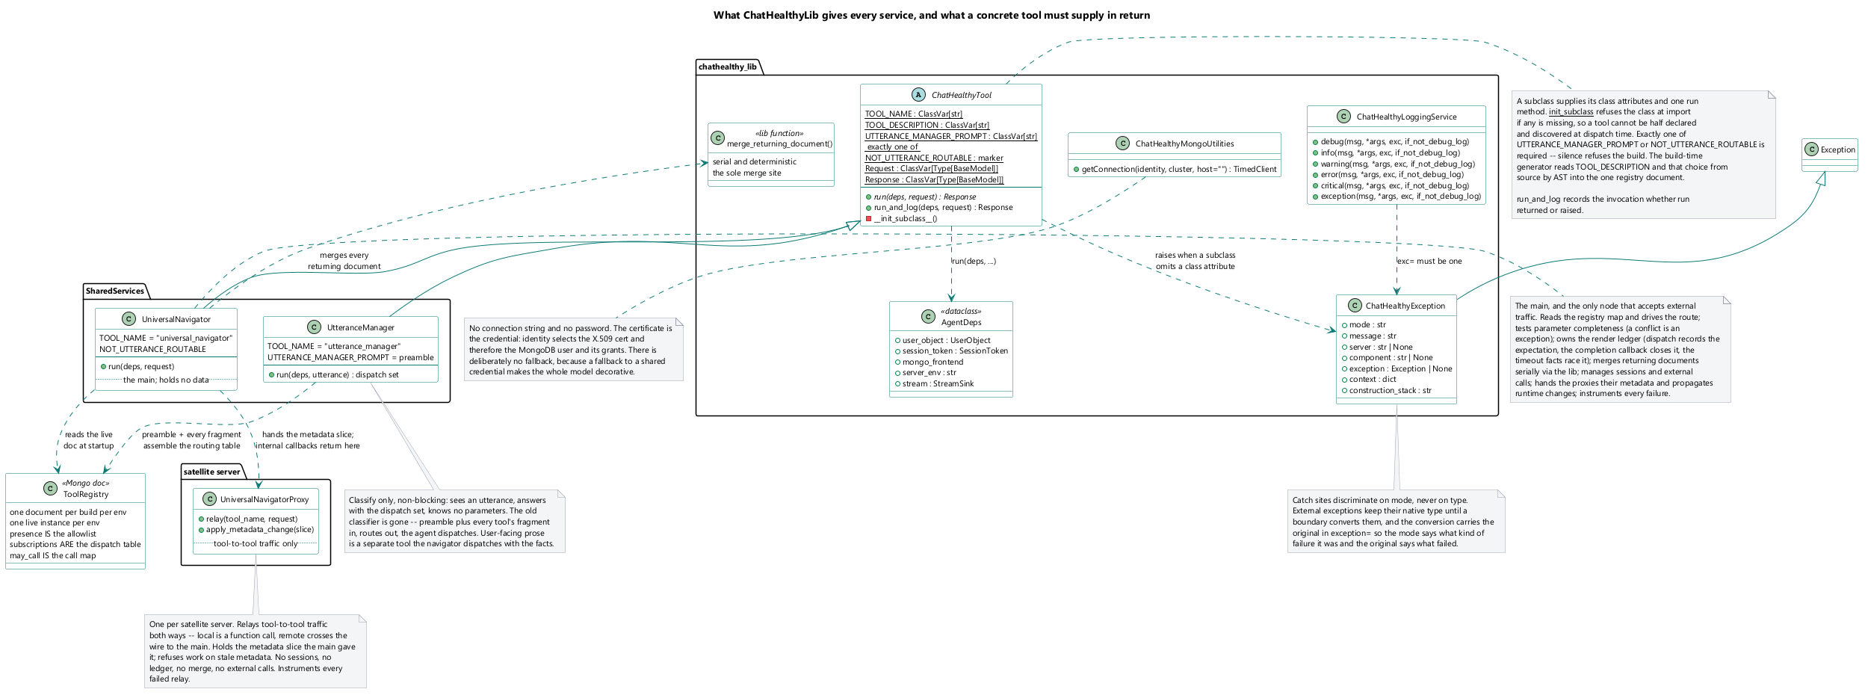
What the library holds: the tool contract, the exception type, logging, database acquisition, the model facade.

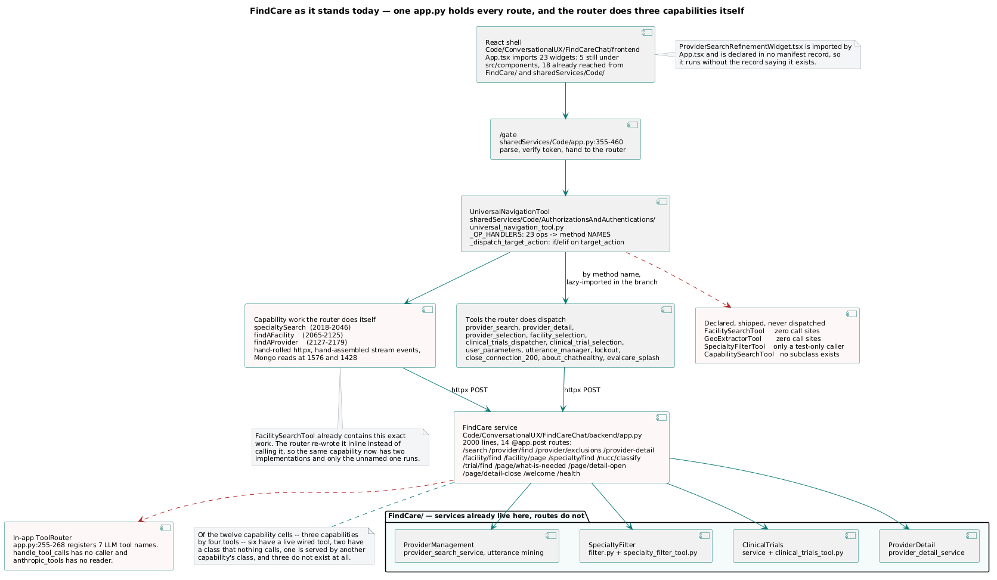
Today — the capability name repeated across independent sites that nothing reconciles.

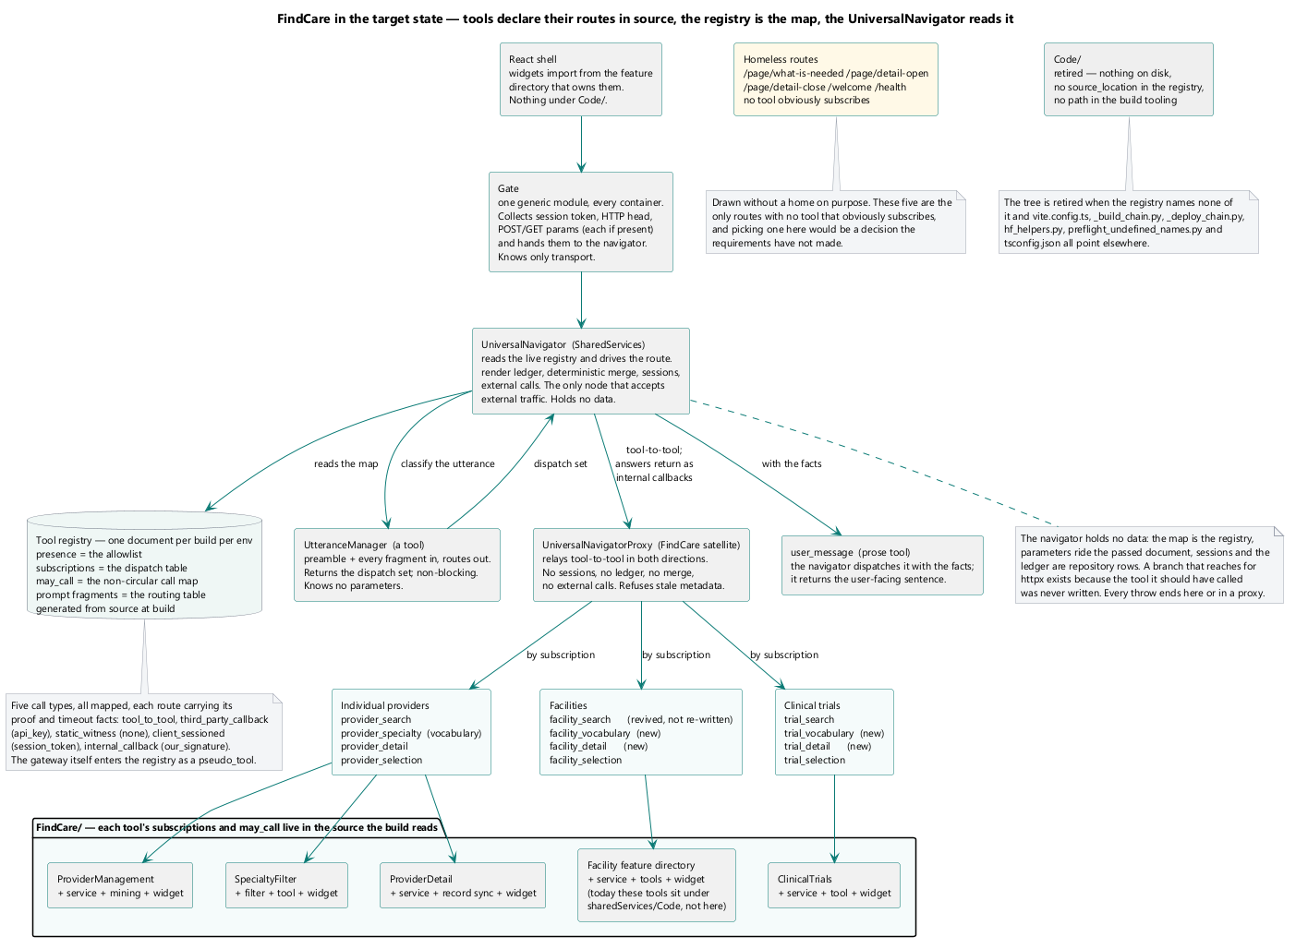
The target — the router names tools and nothing else; each capability's routes sit with the code that answers them.

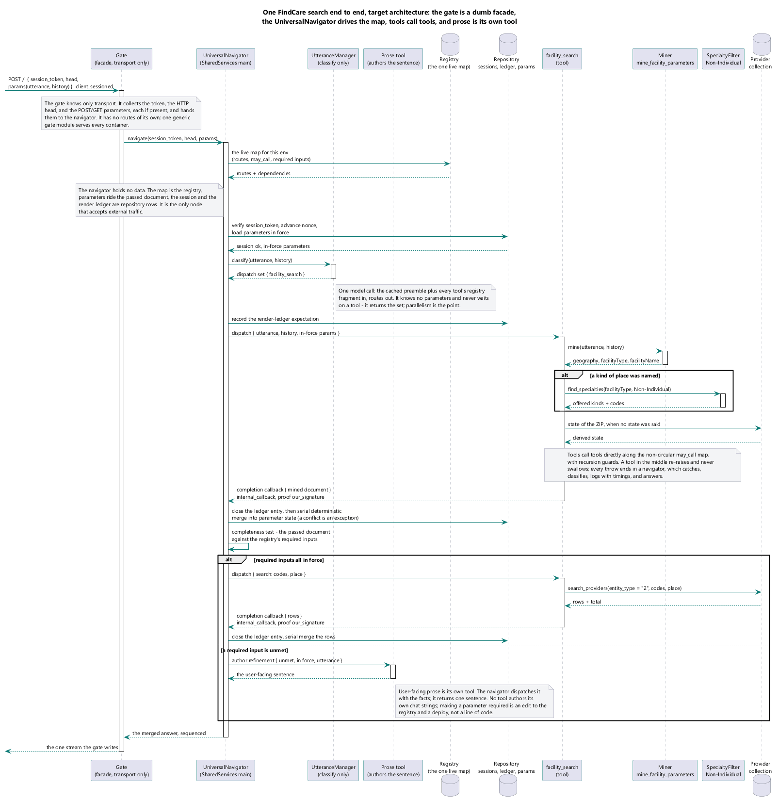
A provider search — classify, mine, resolve vocabulary, query deterministically, stream.

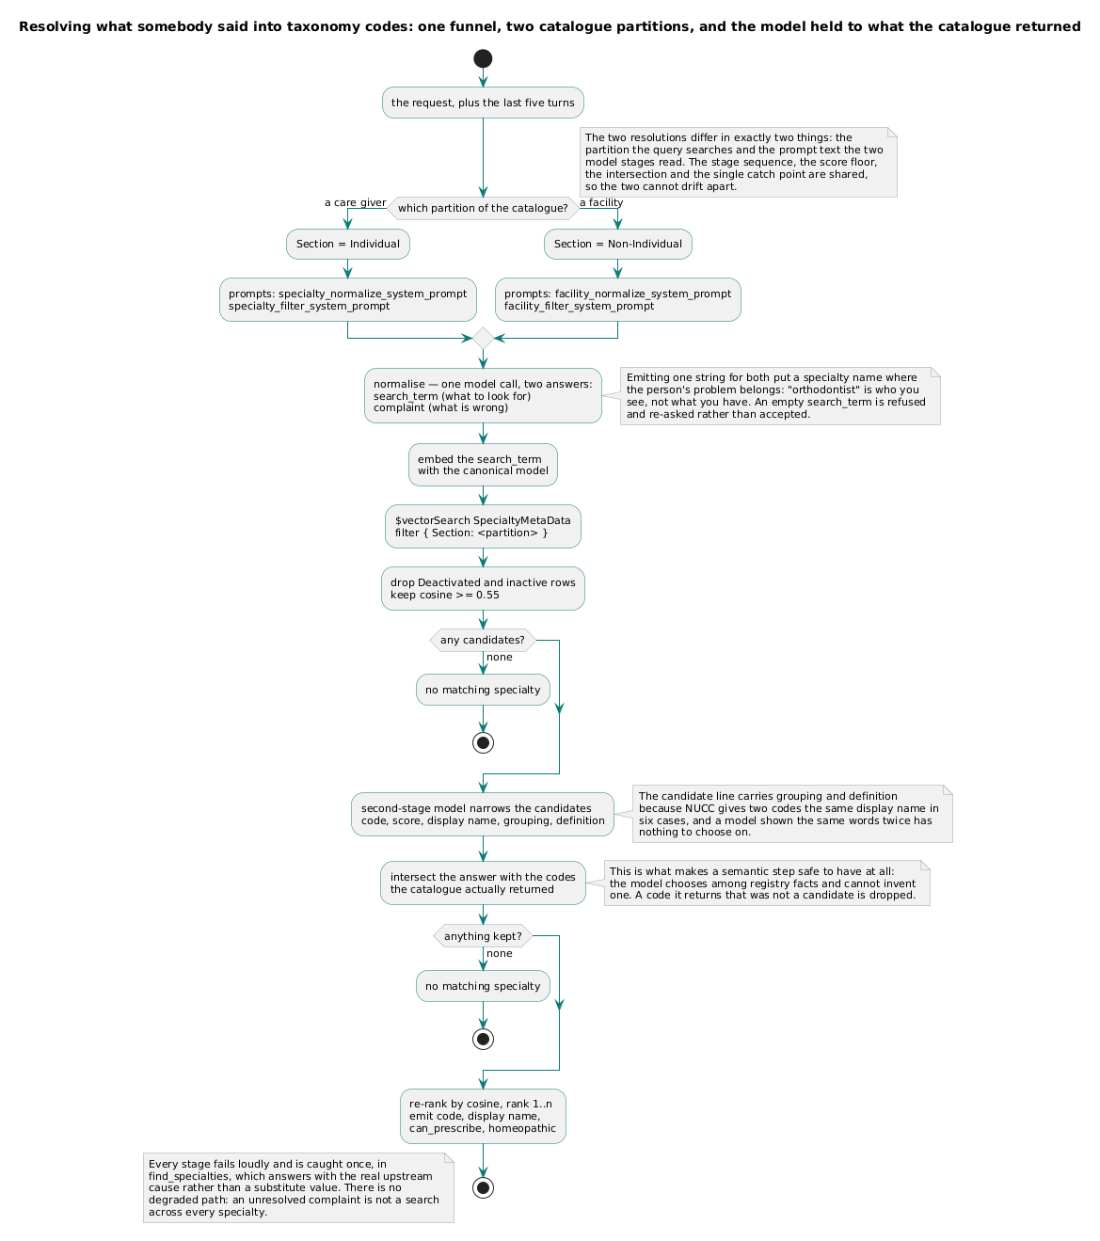
One funnel, two catalogue partitions, and the model held to what the catalogue returned.

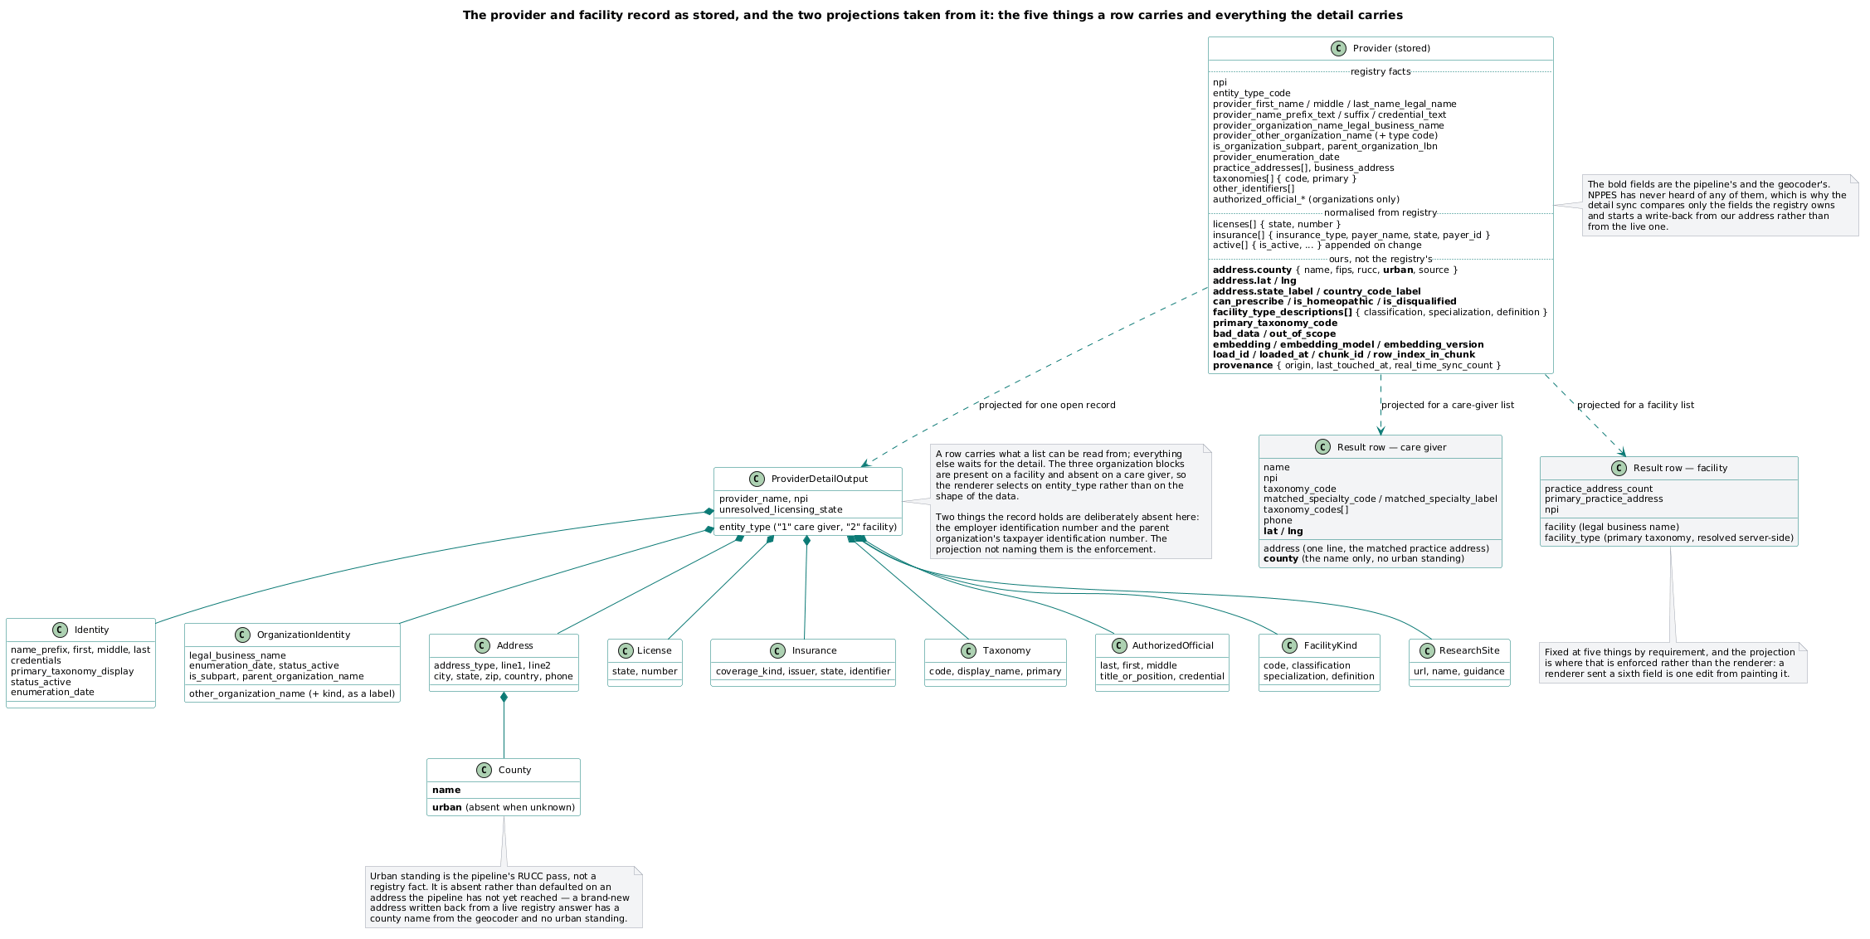
What a served provider record carries, and which fields are the registry's and which are ours.

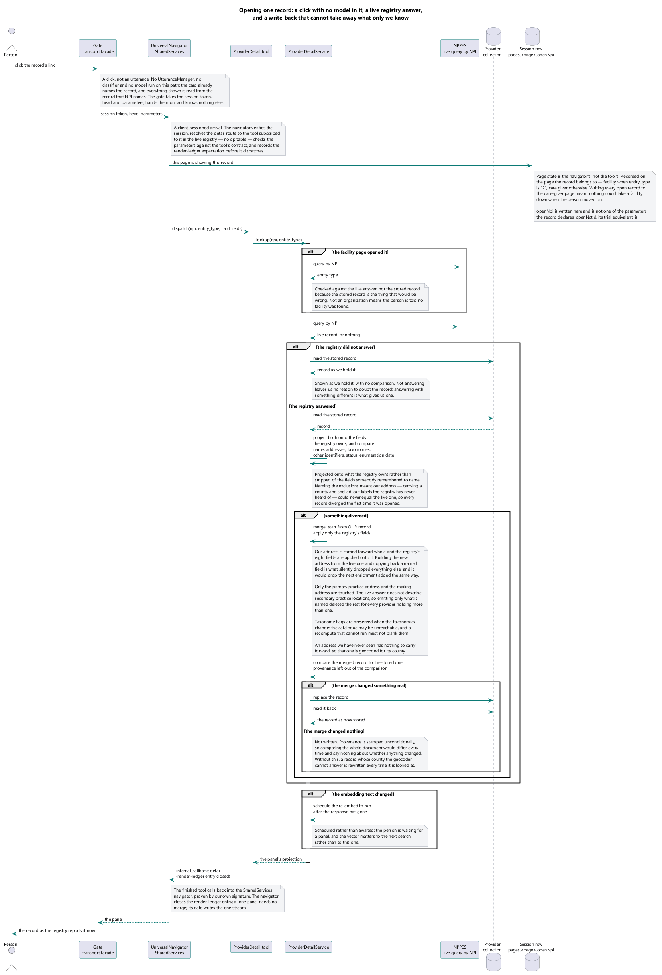
A detail brought to live-registry freshness on open, and still shown when the registry does not answer.

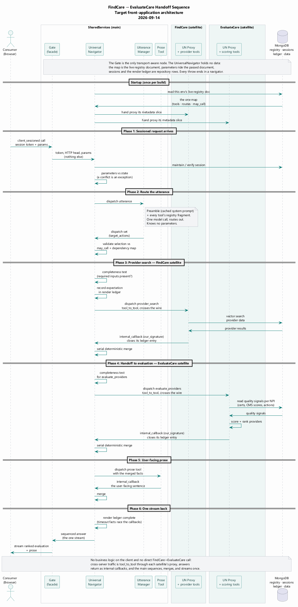
A selection handed to the scoring capability — server to server, on the browser's behalf.

Security Framework
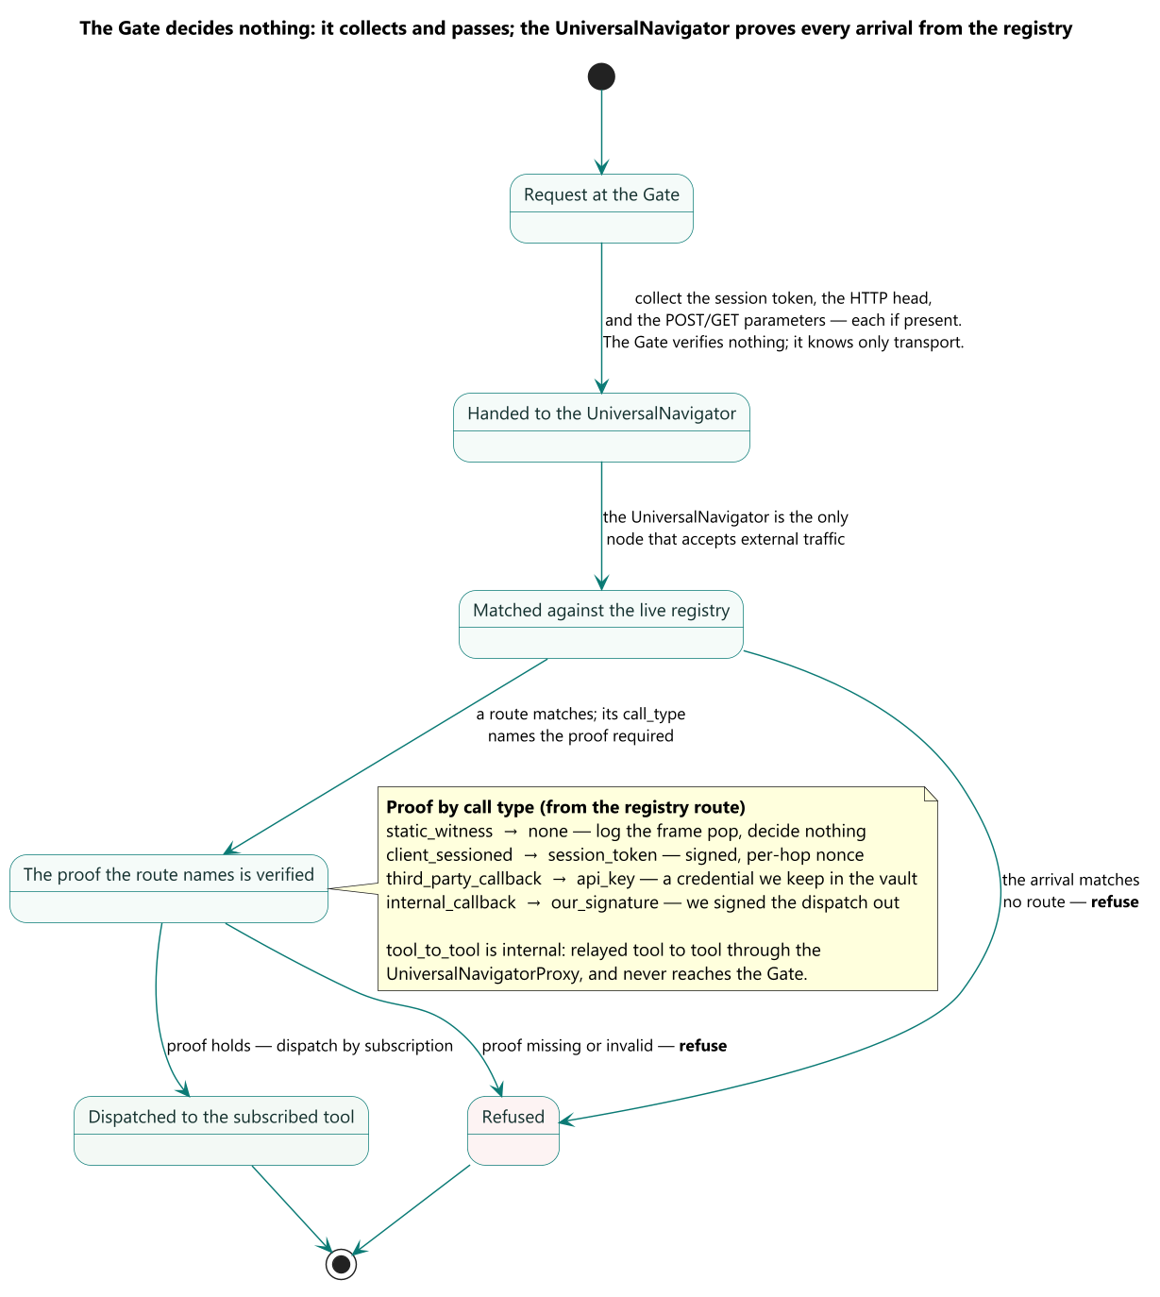
The Gate decides on the address first and the method second, because the address is the firm's own advance declaration of what may arrive there and the method is all the request itself contributes.

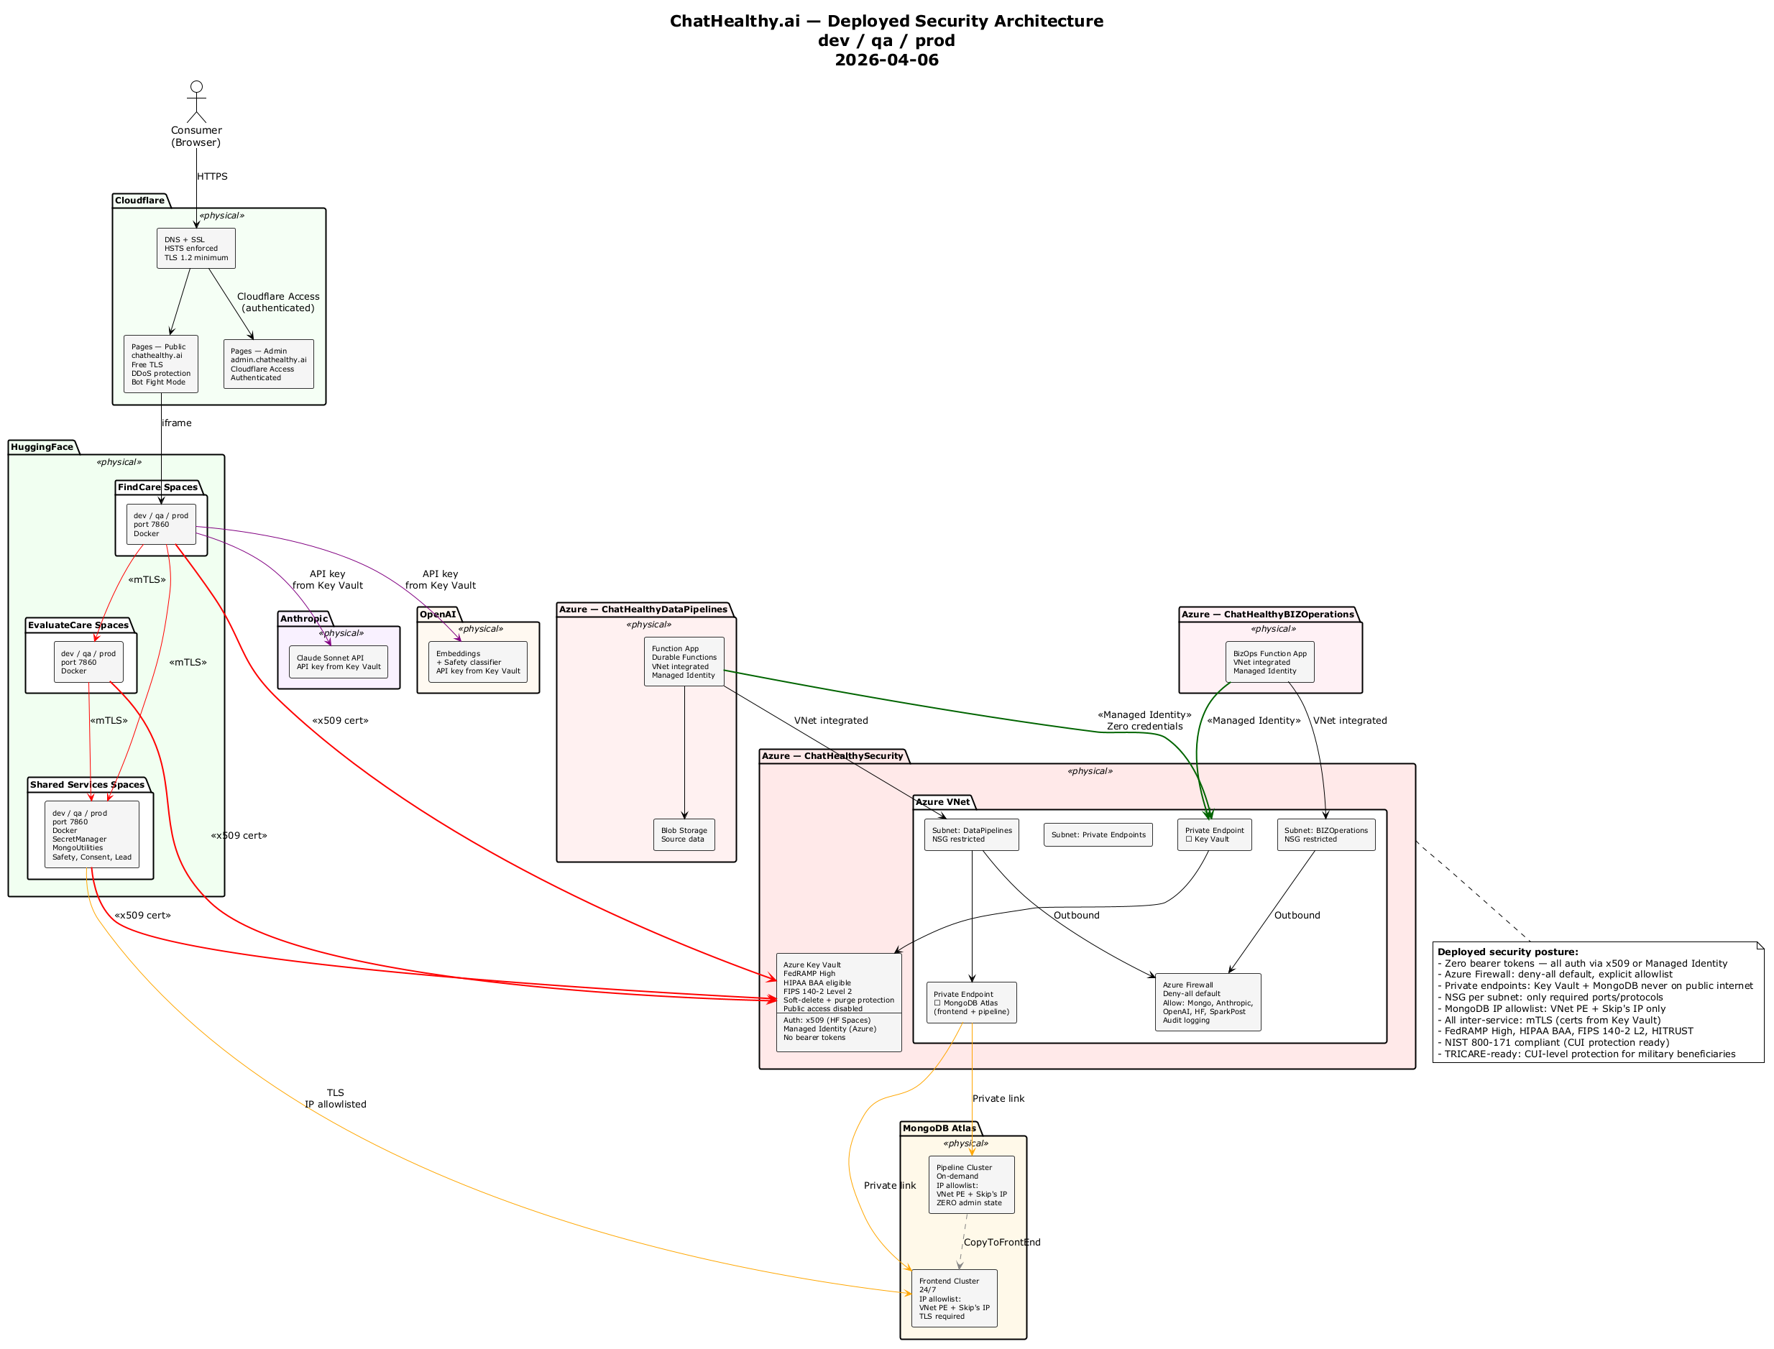
The deployed security architecture: where each credential is held, which boundary consumes it, and the three paths that carry no authentication today.

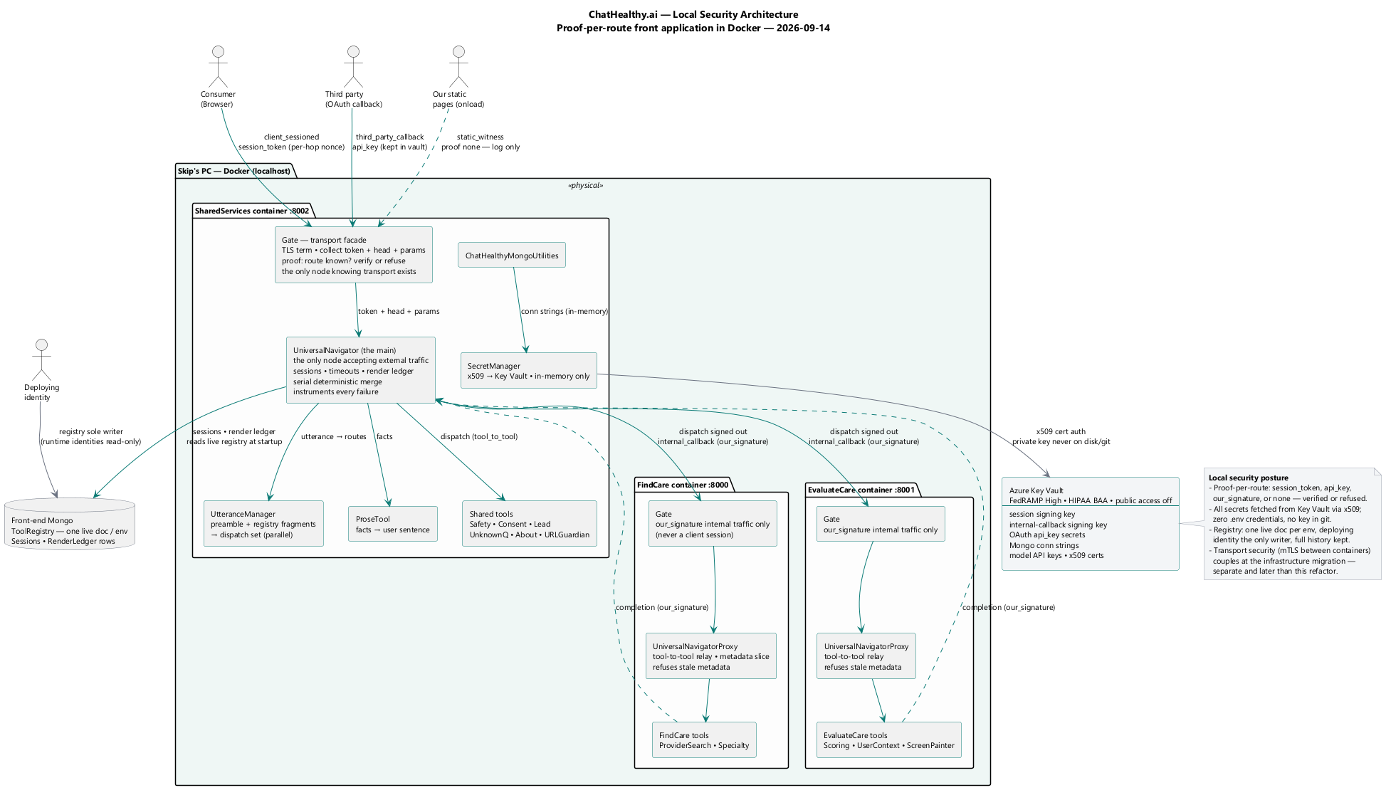
The same architecture in the local environment, where the agent's workstation is inside the boundary rather than outside it.

DevOps Governance Framework
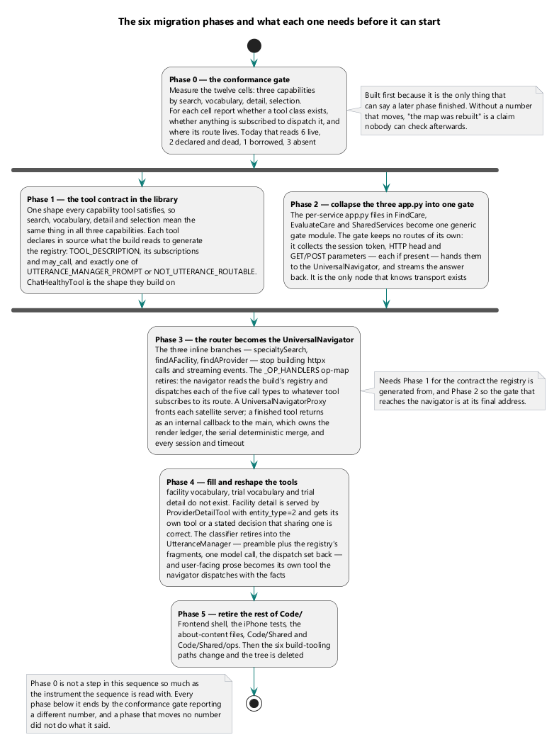
The phases a change passes through on its way to a running environment.

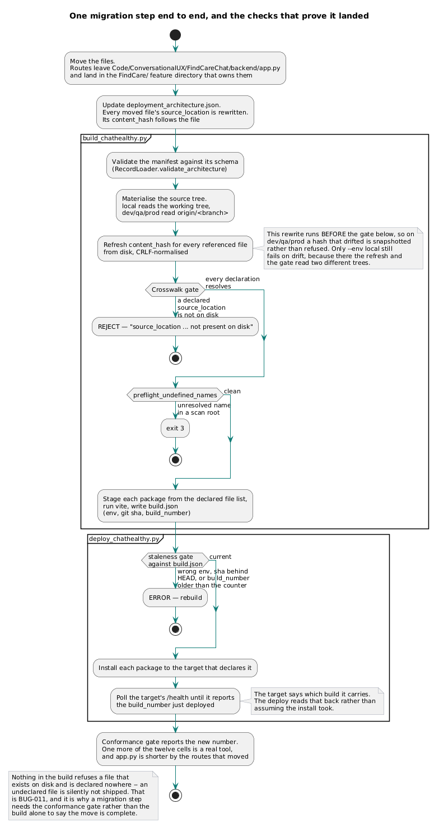
One phase in detail — what it reads, what it refuses, and what it hands to the next.

Data Pipeline Framework
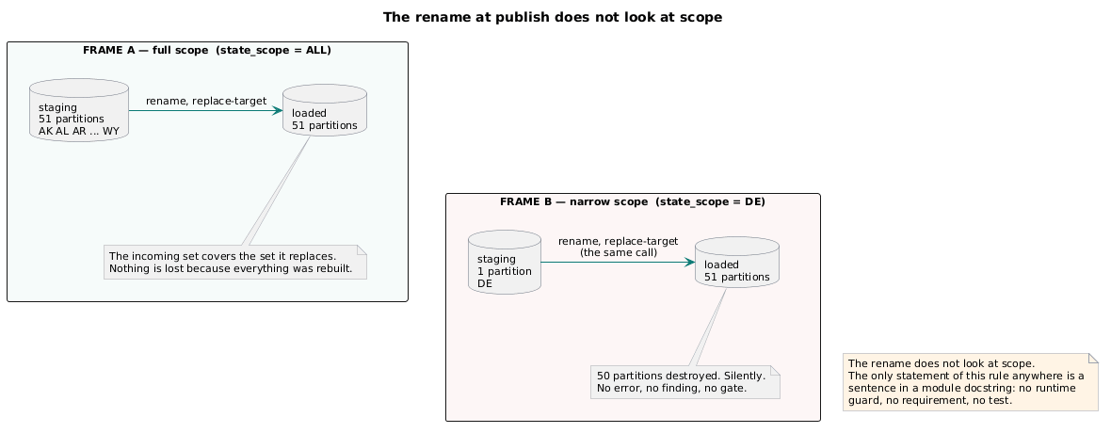
Two frames, side by side, showing the rename at the moment of publish.

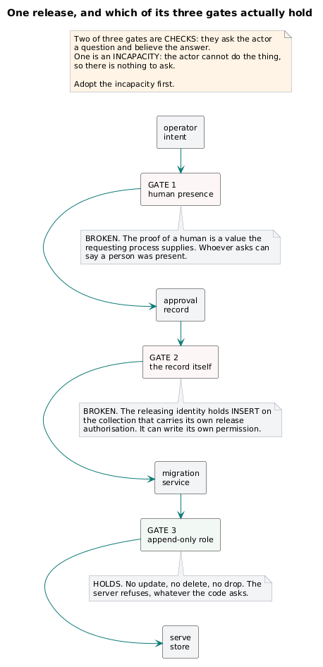
A decision path for one release, drawn to show which controls hold and which do not. Left to right: operator intent → approval record → migration service → serve store. Three guards are drawn as gates across the path, each annotated with whether the gated process can defeat it:

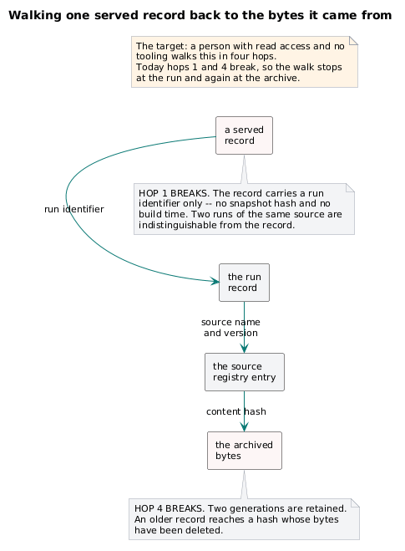
Four hops, left to right, each an object with the field that carries the link named on the arrow: a served record → the run record → the source registry entry → the archived bytes. Under hop 1, a red annotation: carries a run identifier only — no snapshot hash, no build time. Under hop 4, a red annotation: two generations retained; older records reach a hash whose bytes are gone. Caption: a person with read access and no tooling must be able to walk this in four hops. Today hops 1 and 4 break.

Refactor Plan
This document embeds no diagrams.

