Live Application Architecture
The running product: one entrance, one router, and the capability as the unit of everything.

Live Application Architecture
Artifact 5 of 5. The running product as one architecture: the browser, the entrance, the capability components and the shared library. Not a document per component.
01_system.md is the parent and rules on boundaries. This document is authoritative for what is inside them.

0. How to read this
Two kinds of sentence, marked.
mark | meaning
[R] | Reference. Transfers unchanged to any AI-native company building a model-mediated product.
[I] | Instance. True of ChatHealthy because of what it sells. Replaceable without touching an [R].

The code is evidence of what was learned. It is never the authority on what is right. Section 4 states every place this architecture is not yet true, and every row names the kind of evidence behind it — behaviour, data, requirement or intent. Prose is not an evidence type: not a comment, not a docstring, not a bug description, not another agent's report.

1. What this document decides, and what it defers
Decides: the request path from the entrance to an answer; the UniversalNavigator and its per-satellite proxy; what a capability is and how one is declared; the parameter model and session state; the render ledger and the one-record registry; where a model runs and where it does not; how display is authored and by what; the prose the product speaks; the shared library's boundary.
Defers:
to | what
01_system.md | Every boundary. One entrance (§6.1); the session validated once (§6.2); the model confined to the language boundary (§6.3); the entrance holding no domain knowledge (§6.4); the thirteen reference principles (§11).
02_security.md | Who may reach what. The session token's contents and signature. Certificate custody. What may cross to a model vendor.
03_devops.md | What governs a change. The four acts. Where a gate runs and what a rule is.
04_pipeline.md | How the data is produced, and the authority model that decides what a served record asserts.

2. The architecture

2.1 The sentence the rest of the document elaborates
[R]
**A model turns language into parameters, and parameters back into language. Between those
two moments, nothing a model produced decides anything.**
Everything below is a consequence of holding that line. It is why a search is a deterministic query, why the summary of a result set is written by the system and the sentence around it by a model, why a click costs nothing and a typed sentence costs several model calls, and why an answer can be reproduced without re-invoking a model.
It is also falsifiable, which is what makes it architecture rather than a slogan. The parent states the test at §6.3: no function both issues a model call and returns records to its caller.
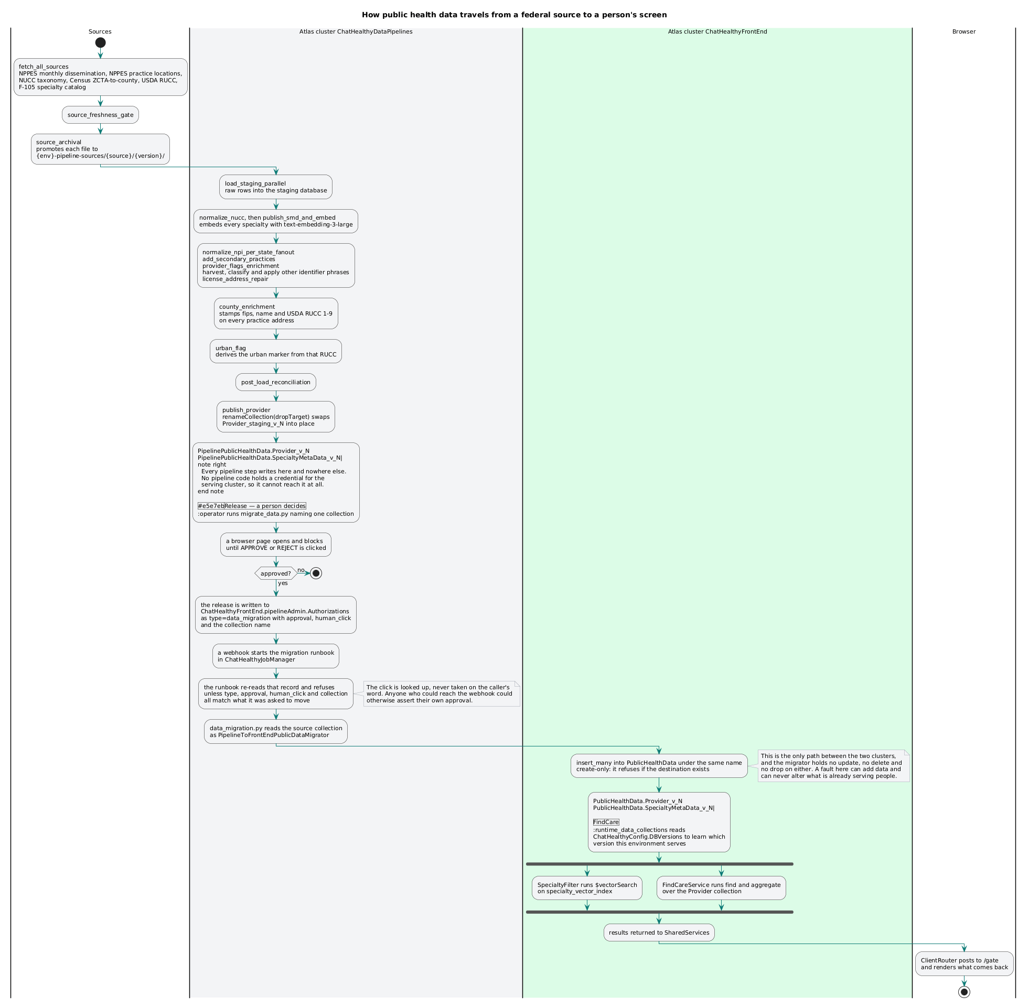
One turn, end to end — the two moments a model runs, and the deterministic span between them.

2.2 The spine of a turn

2.2.1 One entrance; two external classes within five mapped call types **[R]**
Every request reaches the application through the Universal Gate. Nothing is exempt.
The distinction that makes this achievable is not between traffic that may bypass the gate and traffic that may not. It is between traffic the firm originates and traffic it does not:
class | what it is | the rule
Originated | every call the firm's own client code makes — the wrapper site, the embedded capability iframes, future mobile webviews, native clients | POSTs to the gate. The firm writes the caller, so the firm sets the method.
Unoriginated | a request some other party sends us: an identity provider's redirect, a webhook, a callback | arrives at a URI the gate owns. The gate collects the request's facts and dispatches to the tool that handles it. The method is whatever the sender sends.

[R] The firm registers the address; the sender chooses the delivery. That is the whole of the second row. A browser redirect from an identity provider is a GET unless the provider implements a form post, which we may request and cannot compel — so a method clause is enforceable only against traffic we originate. That is a fact about methods, not a licence for a route outside the gate. The address is ours in both classes, and so is the dispatch.
[R] Two classes is the entrance's own view; the registry maps five. The closed set of ways a call arrives — the five call types — is client_sessioned (a client we served index.html and hold a session with — the originated row above), third_party_callback (an external party calling us back on its own initiative, carrying a credential we keep — the unoriginated row above), and three the two-class cut does not reach: tool_to_tool (one tool calling another), internal_callback (a tool that finished working calling back into the SharedServices UniversalNavigator), and static_witness (the onload witness of a static page we own, which logs at frame pop and logs static errors when they occur). Each is a route carrying its proof and its timeout facts. The proofs are four and mechanical: none for a static_witness, api_key for a third_party_callback, session_token for a client_sessioned, our_signature for an internal_callback. A tool_to_tool arrival proves nothing because it never left, reaching a tool through the proxy rather than the door. Triaging an incoming call to its type by the proof it declares is the UniversalNavigator's, not the gate's: the gate verifies nothing and owns no route; the three moves — route known, proof named, verify or refuse — happen at the first node behind the entrance, which is the only node that takes external traffic.
[I] EPIC-002-F-004-S-001-REQ-B-001 — "Every request reaches ChatHealthy.ai through the Universal Gate." Any other URL 404s, except the bare domains, which redirect. There are no exceptions and this document names none.
[R] A callback already carries everything the gate requires, differently shaped. In the registry a callback is a third_party_callback route, and its proof is stated in the registry's terms: proof.method api_key, naming — in the vault, the name only — the credential we keep for that party, exactly as we keep an OAuth client secret. (A signed session reference is another shape of the same fact; an OAuth state parameter, HMAC-signed over the session identifier and verified on return, is one.) The fact-collection step already accepts any request. The callback handler is already its own module — a tool in everything but registration. Routing it is one route subscription, one dispatch entry.
The entrance does three things and no fourth: collects the request's facts, passes them to the UniversalNavigator, and streams back what comes out. It holds no capability knowledge, no page knowledge and no parameter knowledge, so a capability that did not exist yesterday reaches it unchanged. The session it does not decide: it hands the token inward, and the UniversalNavigator behind it establishes, validates, times out and secures the session — the deciding moves off the transport door to the node that owns the state.
[R] One gate module, not three. The three per-service app.py files collapse into a single generic gate with no routes of its own; it serves every container, and moving the web server or the Docker host changes only it, because it holds nothing to differ over.
[R] The entrance is a door, not an answerer. When a gesture needs an answer — peer health, a token verification, a transfer between surfaces — that answer comes from an ordinary dispatched op, not from a branch inside the door. A door that answers questions accumulates the knowledge every other component was supposed to own.
[R] One thing outside this frame, because it is a different kind of thing. A platform's own liveness probe is not a client call. The host asks whether the process is up; it is not requesting the application do work, and it carries no session because there is no session to carry. It is not an exception to the gate and it is not non-compliance — it is not in this taxonomy at all. Treating it as a client call is a category error.
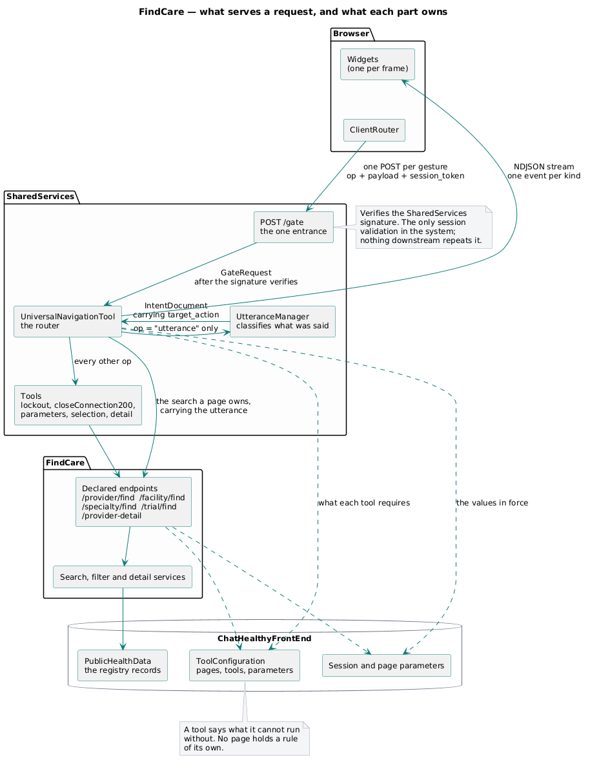
The entrance and what sits behind it. The browser touches exactly one box.
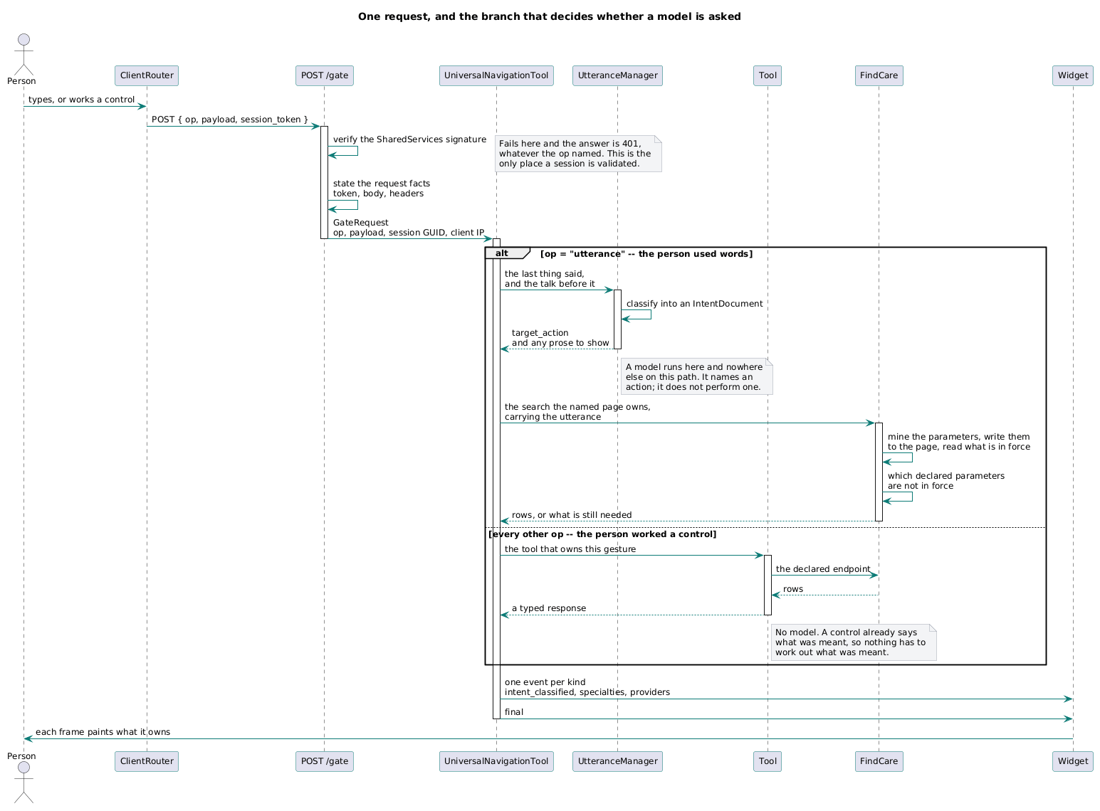
A request through the gate — parse, validate, dispatch, stream.

2.2.2 One session validation, N provenance checks **[R]**
Two obligations that are habitually conflated, and conflating them is what produces the recurring argument about whether validation happens once or many times. The parent settles it at §6.2 and security rules on it at §5.3; stated here only as the application's consequence:
- The session is validated once, at the first node behind the entrance — the UniversalNavigator.
- Provenance — did this request come through the entrance? — is checked on every inbound hop, by each receiving component, against a constant it holds.
A component performing the second is not performing the second half of the first. Security's ruling is the operative sentence: one decider, one answer, carried forward.
The application's consequence: after the UniversalNavigator has validated it, the session travels as a first-class field on every request and every response, in both directions (EPIC-003-F-006). No component re-reads the session from storage to learn who it is talking to, and the calling thread is the sole authority for merging a returned User State back into the current one (EPIC-002-F-004-S-004-REQ-B-001).
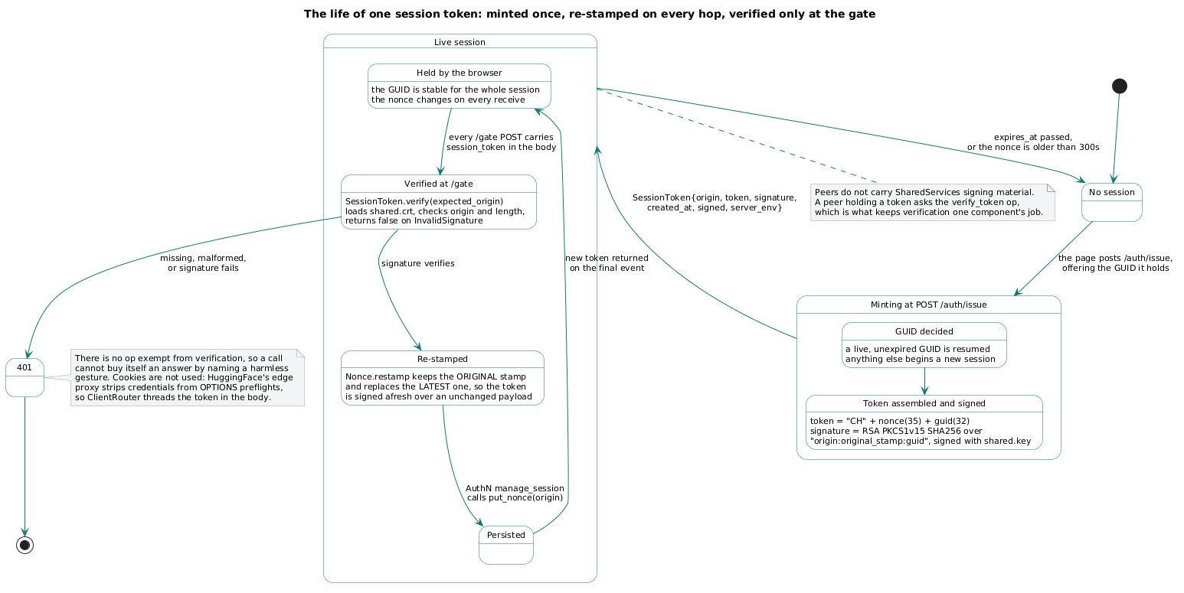
What a session holds, who writes each part, and what travels on the wire.

2.2.3 The router — the UniversalNavigator **[R]**
The router does one thing: it dispatches by name. It contains no HTTP client inside a branch, no database read, no hand-assembled stream event, and no knowledge of any capability. It looks up the capability the turn names, finds the tool declared to answer it, calls that tool at its declared server and endpoint, and streams the kinds that tool declares.
Everything the router knows about the application it reads from one record. §2.8 is how that is made true.
[R] The target names this node the UniversalNavigator — the main, resident in SharedServices — and loads it with more than name-dispatch. It is the only node that takes external traffic; behind the door it triages every incoming call to its type by the proof it declares, determines which page the request constructs and scopes the UtteranceManager's mining to that page's members, drives the route against the declared dependency map, holds every parameter and its state (a conflict is an exception), keeps the render ledger keyed on the page's required members, merges every returning document serially with the shared library's deterministic merge function, manages external calls, and owns session maintenance, timeouts and security through helper functions moved out of app.py. It makes the map known to every tool at startup, hands each proxy its slice, and propagates any runtime change to them. It holds no data of its own: the map lives in the registry, the parameters in the passed document, the sessions and the ledger as repository rows. And it is the client to every server and service it calls, so it instruments their failures — every dispatch that dies, callback that never comes, timeout or conflict, logged with timings, at a severity matching its impact, to the one repository the component logs all facts to.
Two behaviours are stated by approved requirement and are not the dispatcher's discretion:
- Upstream work is not redone. When a follow-up turn upgrades the target action because a pending disambiguation resolved, the router reads the cached upstream output off the intent entry and dispatches only the downstream tool that still needs to run (EPIC-002-F-004-S-001-REQ-B-002, -REQ-B-003). Asking a person a clarifying question does not cost a re-classification.
- Wire order on a partial turn is deterministic. The utterance manager streams its prompt and flushes before returning; the router then dispatches; each tool streams and flushes; the router emits its terminal event last. It does not chain to a close on a turn carrying a pending disambiguation, because the connection is logically still open across the person's next turn (-REQ-B-004).
[R] The render ledger is the mechanism behind that wire order. A dispatch records the page it owes; the tool's completion callback closes the entry; a configurable set of timeout facts — the route's render, callback and external-call budgets, declared on the route in the registry — races the callback, and if the page is not rendered in time the UniversalNavigator answers rather than hang. A governance timeout is fatal; a user-facing one explains itself in plain language. The page's own completeness declares the rest: the ledger reconciles the page when its required members have all closed, on_conflict raises when a merge conflicts, and on_missing_required raises when a required member dies or never returns — §2.2.5 states these in full.

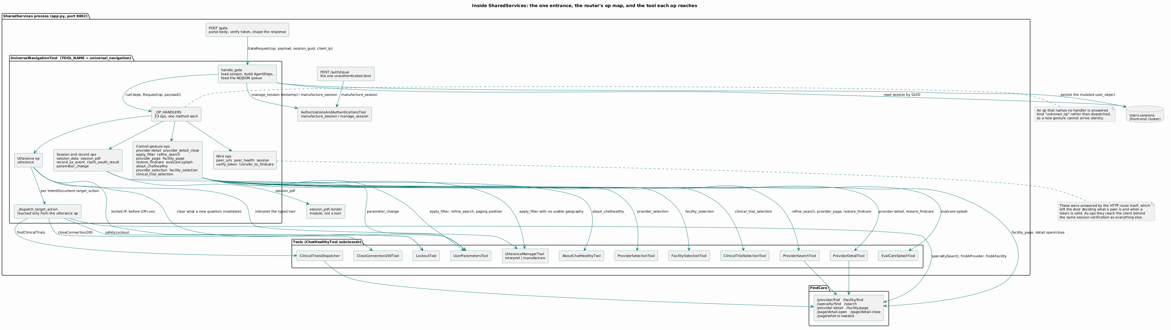
Inside the entrance — the door, the router, the utterance manager, and the tools.

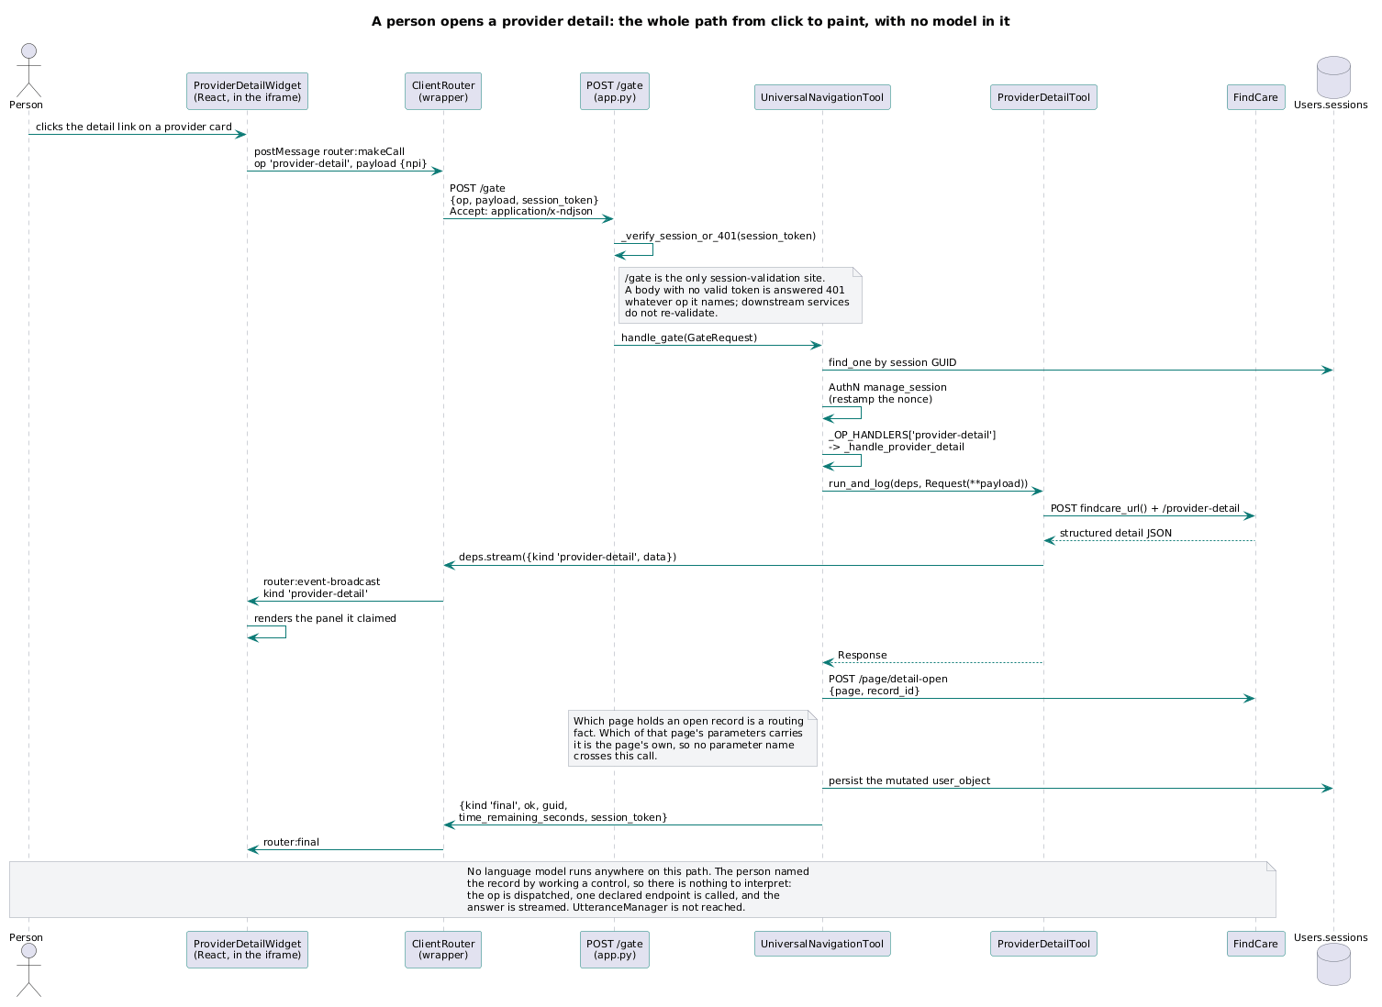
A structured gesture — no free text, and the manufacture path when a slot is missing.

2.2.4 The proxy — one per satellite server **[R]**
A satellite server does not talk to the main directly; a UniversalNavigatorProxy does it for the tools that live there. It is a separate component, one per satellite, and it relays tool-to-tool traffic in both directions: a tool asks it for tool X and hands it every answer, and whether X is co-resident (a local function call) or remote (across the wire to the main, returning as an internal_callback) the tool's code is identical either way. Placement is therefore a deployment fact, not a tool fact: tools are location-blind, so co-locate what is hot and satellite what is heavy, tuned from the ledger's dispatch-to-callback timings.
The proxy carries tool-to-tool traffic only — no sessions, no ledger, no merge, no external calls; those are the main's. It holds the metadata the main gave it and passes runtime changes to its local tools on a need-to-know basis, and it refuses work on stale metadata it cannot bring current — a stale proxy is an exception, not a best effort. Like the main, it is a client to what it calls and instruments its own failures: every failed relay, unreachable main, or dead local tool, logged with timings at a severity matching impact.
[R] A stream belongs to the gate that opened it. Answers travel server-to-server as internal callbacks; the main sequences them and its gate writes the one stream; the merge happens in the main, serially, through the shared library's deterministic merge function, as each callback closes its ledger entry — and a conflict raises rather than resolves.

2.2.5 The page — the unit the UniversalNavigator constructs and reconciles **[R]**
A page is the unit the UniversalNavigator constructs. From the facts the gate hands inward it determines which page the request is building, tracks it in the render ledger, and reconciles it — the same node that triages the call type also names the page behind it. The page is first-class in the registry, not inferred at runtime: page_name, subject and description say what it is; members names the tool_names that compose it; required_members names the subset it needs to be complete; and completeness carries the error management around it.
[R] The page scopes the mining. On a first pass the utterance manager mines broadly (§2.3); on refinement the UniversalNavigator scopes it to the requested page's members, so a page's own tools are the only fragments in play and the rigour rises pass over pass. The scoping is the dispatch code's, never the model's — the utterance manager knows no page, as it knows no parameter.
[R] The ledger is keyed on the page's required members. Dispatch records each required member as an expectation; every completion callback — an internal_callback carrying our_signature back — closes exactly one; the page reconciles when the last one closes or the completeness budget expires, whichever wins.
[R] Three ways a page fails, three declared answers. A render_timeout_seconds budget races the callbacks, and on expiry the UniversalNavigator responds anyway with the page's on_timeout explanation in layman's terms rather than hang — a governance timeout is fatal, a user-facing one explains. on_conflict is raise: a parameter or state conflict while merging the page's returning documents throws, and the merge is serial precisely so the conflict has one place to surface. on_missing_required is raise: a required member that dies or never calls back leaves the page unreconcilable, and the ledger raises rather than render half a page. All three are instrumented with timings at a severity matching impact, to the one repository the component logs every fact to.
[R] This page is not §2.5.6's page, under a shared word. §2.5.6's four — facility, individualProvider, NUCC, clinicalTrial — are the value-scopes a parameter lives in, closed by approved requirement. The registry's constructed pages are the render ledger's unit of completeness, and the six the application builds are named in §2.10. The two join different lists — value-scopes against parameters, member tools against a rendered answer — and share only the name, which §2.4.2's caution about the word subscription applies to here as well.

2.3 Where a model runs, and where it does not **[R]**
A model runs in five kinds of place, and nowhere else.
# | where | what it produces | what holds it
1 | the utterance classifier | which capability the turn asks for, and the slots it can fill | a declared, closed set of capability names
2 | the utterance manager's prose | every user-facing chat line | an output schema; the manufacture path must also read prior dialogue
3 | per-page mining | candidate parameter values from the utterance and the talk before it | the declared parameter list and its value types
4 | the vocabulary chooser | which catalogue entries a request implies | intersection with the real catalogue
5 | the refinement question | how to ask for a Required parameter that is not in force | the names the declaration returned

It does not run in: the search, which is a deterministic query over stored parameter values; paging; selection; detail assembly; the parameter store; the router's dispatch; or the search summary.
Two prose rules sit next to each other and are not in conflict. They govern different surfaces, and the distinction is reference-grade:
- Chat prose is written by the model. No hardcoded clarification or chat string appears on the dispatch path (EPIC-002-F-010-S-001-REQ-B-010).
- The summary of a result set is written by the system. "The system tells the user what the search returned and what they can do next. The system writes it; a language model does not" (EPIC-006-F-001-S-005). Counts, kinds, the geography used, the narrowings remaining — those are facts about a result set, and a model asked to state a count will sometimes state a different one.
[R] The honest limit of row 4. Intersecting a model's answer with a real catalogue buys soundness — nothing invented survives. It does not buy completeness: a candidate discarded by a score floor before the model saw it is not detectable in the answer, and the response carries no signal that anything was dropped. Any architecture that pre-filters candidates before a model call must say so.
[R] And soundness is against the catalogue, not against the world. The guarantee is only as good as what the catalogue contains. [I] ChatHealthy's taxonomy catalogue carries codes for roles that are not licensed clinical practitioners, so a sound intersection can return one. That is a data-authority problem and it belongs to 04_pipeline.md §7.9, which owns the curated flag that fixes it. The application must not add a second, undeclared vocabulary at query time to compensate.
[R] Cost is an architectural property here, not an optimisation. One typed sentence costs several model round-trips across more than one process and more than one vendor: classify, mine, normalise, embed, filter, then either a refinement question or authored prose. One gesture — a page click, a filter apply, a selection — costs zero. That a typed question is slow and a click is instant is a consequence of where the language boundary sits, and the architecture should say so rather than let it read as a defect.
[R] The classifier is not a second node. The target folds it into the utterance manager: the classifier goes away, and the utterance manager is the classifier. One model call — a cached preamble (the utterance manager's own registry entry, the frame it operates under) plus every tool's declared fragment in, the dispatch set out — and the agent running it dispatches. A first pass mines broadly; a refinement pass narrows to the requested page's members, with more specific fields and more rigorous prerequisites, and the intelligence of that scoping lives in the dispatch code, not in the model. §2.8.2 already half-states this: the prompt is assembled from the declared set rather than written beside it. What contends with this — that the same node also authors prose and writes parameters — is §5 Q8.

2.4 The capability is the unit **[R]**
A capability is one thing a person can ask the product to do, answered by exactly one tool.
The application is a grid. Down one axis the subject — what the answer is about. Across the other the capability kind — what is being done about it.
 | search | vocabulary | detail | selection
individual provider | ProviderSearch | SpecialtyFilter | ProviderDetail | ProviderSelection
facility | FacilitySearch | (inside the search route) | FacilityDetail | FacilitySelection
clinical trial | ClinicalTrials | — | — | ClinicalTrialSelection

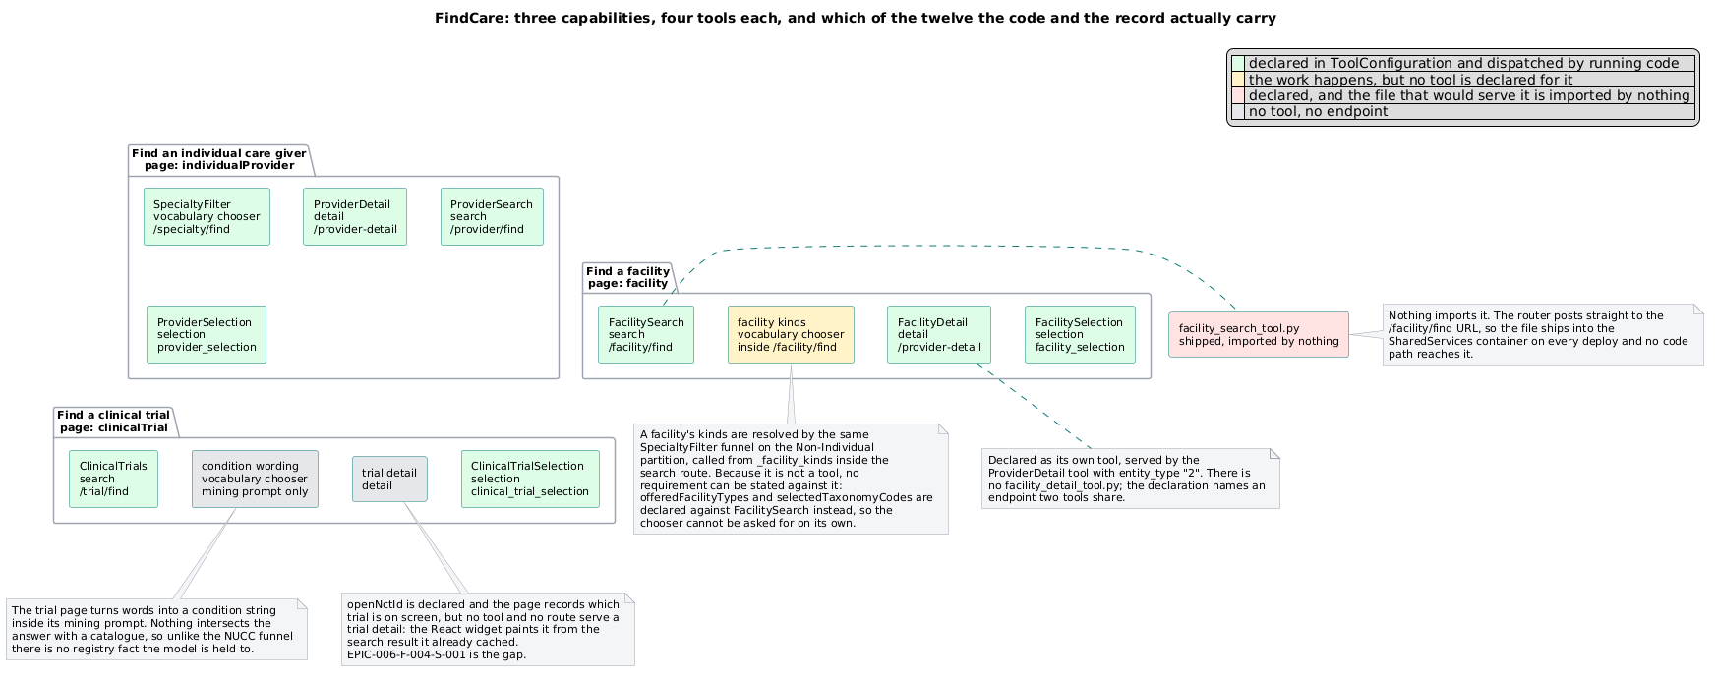
Twelve cells, nine filled. A hole in the grid is a known absence, not a surprise.

2.4.1 Why four kinds and not one **[R]**
The obvious alternative — one tool per subject that does everything — was tried and abandoned. Five independent reasons, each sufficient alone:
1. A merged tool's requirement is the union, and a union is a questionnaire nobody asked for. Search requires a state and a chosen code set; detail requires an identifier; selection requires a list of them; vocabulary requires a complaint. Merge them and the single tool refuses to run until the person has answered for work they never asked for. [I] This is not hypothetical: a trials tool treating age, sex, location and scope as though each were needed produced exactly that interrogation, and the correction was to declare that the condition alone is Required — which is also what EPIC-006-F-005-S-001-REQ-B-077 requires in its own words.
2. They run at different times. A search runs before any record is opened. A detail is a gesture on a result. A selection outlives both and stands until the person changes it (EPIC-006-F-001-S-002-REQ-B-018). One tool cannot have one moment.
3. Only one of the four resolves meaning. Vocabulary is the sole place a model decides what a person's words imply. Search, detail and selection are deterministic. Merging them puts a semantic step inside a path that has no business having one, and makes "was this determined or inferred?" unanswerable — a question the parameter model is required to answer per change (EPIC-006-F-008-S-003-REQ-B-006).
4. They fail independently and must be seen to. A detail must still be shown when the live registry query does not answer (EPIC-006-F-002-S-002-REQ-B-019). A search returning nothing is a different event from a vocabulary step resolving nothing, and the person must be told which (EPIC-006-F-005-S-002-REQ-B-009).
5. They paint different things. Each emits its own stream kinds, claimed by different widgets in different frames. A single tool would emit a bag and the browser would have to decide what it was — which is business logic in the browser, and forbidden.

2.4.2 What a capability declares **[R]**
One row, six fields:
field | meaning
capability | the name the classifier may emit and the router dispatches on
kind | search \ | vocabulary \ | detail \ | selection
page | the page whose parameter values it reads
tool | who answers it — which names its server and endpoint
emits | the stream kinds it may produce
gestures | the non-utterance controls that reach it directly

Everything else is derived, never declared twice: its required and optional parameters derive from the parameter subscriptions; a page's tool list inverts from page; the classifier's closed set and the published schema derive from capability over all rows; the browser's page manifest derives from page and emits.
[R] The registry states each tool in a fuller shape than this six-field row, and the mapping is worth naming. A tool entry carries tool_name, tool_type, class_name, source_location, docstring, description, its utterance_manager_prompt fragment, its input and output field contracts, its subscriptions, and its may_call. The capability's kind, page, emits and gestures project onto these. Input and output are the parameter contract, and a field's required flag is exactly §2.5.2's Required / Optional / absent. Subscriptions are the routes a tool serves — the dispatch table itself, and not to be confused with a parameter's subscription in §2.5, which is a different join with an unfortunately shared name. may_call is the declared, non-circular who-may-call-whom map. Routes are their own entries — route_name, call_type, proof, timeout_facts — and the gateway itself enters the registry as a pseudo_tool, so it can appear in routes without being dispatchable business logic.

2.5 The parameter model **[R]**

2.5.1 Three facts a "parameter" conflates
The long-running argument about whether a parameter is defined once or once per page was an argument in which both sides were right about different things. A parameter has three separable facts and the architecture keeps them separate:
fact | scope | held
the name and its type | the whole application, once | in the parameter list
who may use it, and whether they need it | per tool | in the subscription
its value | per page | in the session

Requirements are per tool and never per page. A page carries several tools — a search, a
filter, a detail, a selection — each with its own answer, and the search runs before any
record is opened. A page is the scope a parameter's value lives in, which is why a
geography on the care-giver page is not the geography on the facility page.
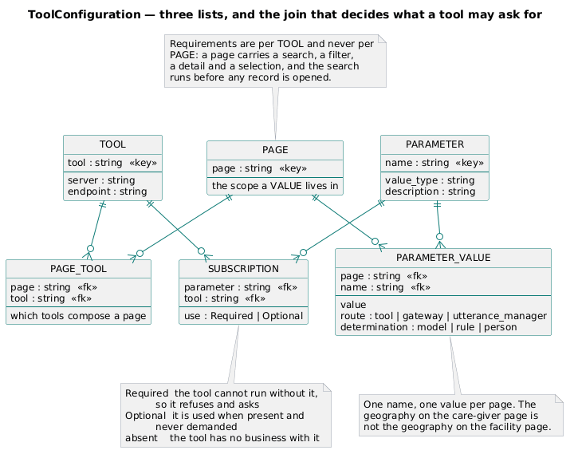
Four lists and the joins between them. A tool appears in all of them, which is why the record is named for it.
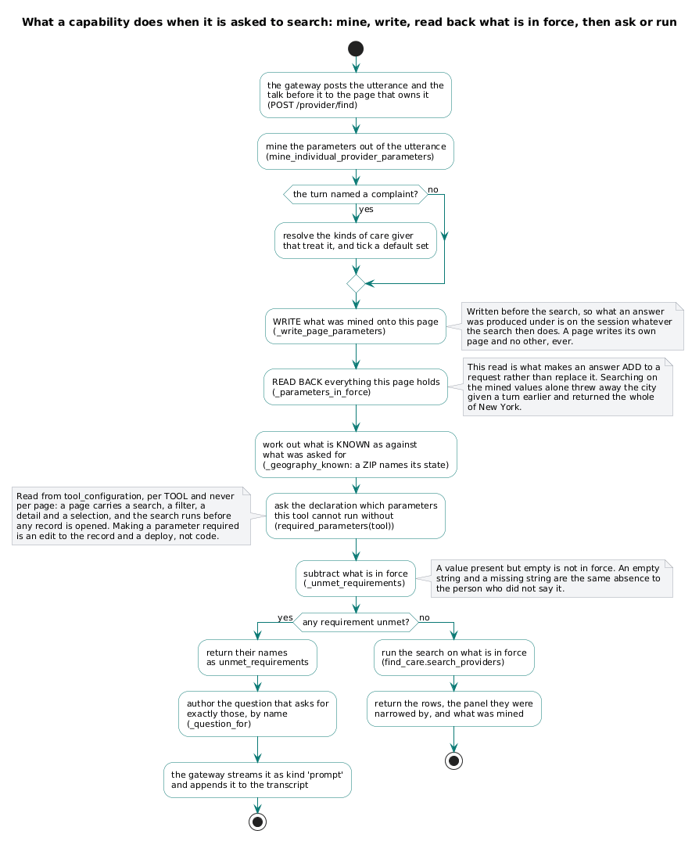
How a value in force is resolved for one tool on one page.

2.5.2 Required, Optional, and silence
Each parameter names the tools that subscribe to it and what each makes of it. Two declared values and one undeclared:
- Required — the tool cannot run without it. It refuses, and asks the person for it.
- Optional — the tool uses it when it has it and runs correctly without it. It is never asked for as though it were needed.
- absent — a tool that does not appear in a parameter's subscriptions has no business with it.
[R] Exclusion is the default, and the default is not written down. Listing every tool against every parameter to record the ones that must not touch it is a great deal of record for a fact that reads perfectly well as silence, and a register whose overwhelming majority of rows say "no" is a register nobody reads.
This is what makes a generic gateway possible. The gateway and the utterance manager do not know what any parameter means. They know that a tool Requires it, so if it is not in force the turn cannot run and the person must be asked. That is one piece of code, for every parameter and every tool, forever.

2.5.3 Provenance on every value
A stored value is addressed page.name and carries more than the value: the route that wrote it (EPIC-006-F-008-S-003-REQ-B-005) and whether it was determined by a rule or inferred by a model (-REQ-B-006).
[R] That second field is the parameter model's contribution to the reference principles. It is how "did a model decide this?" is answerable at the level of the individual fact rather than the level of the whole turn.

2.5.4 Exactly three writers
A parameter is set, cleared or read by exactly three routes and no fourth (EPIC-006-F-008-S-003): a tool, the gateway, and the utterance manager. The same request made by any of the three produces the same stored value and the same refusal (-REQ-B-004). The parameter panel is a surface, not a fourth writer (-S-005-REQ-B-009).
Ability and practice are different questions. All three routes must be able to write any parameter — that is fixed by approved requirement. Which one does for a given value is a design choice, and the parent settles it at §6.4: the component that owns the question mines its own parameters.

2.5.5 What the store guarantees
A change reported as made is still in force on the next request (-S-004-REQ-B-001). A change that did not take is not reported as made (-REQ-B-003), the prior value stands (-REQ-B-004), and the person is told which parameter failed (-REQ-B-005). A request changing more than one parameter leaves all of them changed or none (-REQ-B-006), which is why a change set is assembled and written once. Of two changes to one parameter, the later stands (-REQ-B-007).

2.5.6 Pages, and where the closed set lives
[I] The pages are exactly four — facility, individualProvider, NUCC, clinicalTrial — closed by EPIC-006-F-008-S-001-REQ-B-002. Pages are independent (-REQ-B-005) and more than one page's answer stands at a time (-REQ-B-006).
[R] The requirement constrains membership, not location. This deserves its own paragraph because getting it wrong is instructive. The set can live in the record and satisfy the requirement exactly as well as being compiled into source. Adding a fifth page needs the operator to move the requirement either way, so the location buys nothing and should be chosen on other grounds — and the other grounds are decisive: the parent's §5 puts the application's composition in the record, and a page set in code is the one part that would not be there.
[I] A comment on the compiled-in set cites the requirement id as its authority for the location. The requirement says nothing about location. An invented control carrying a requirement id reads as sourced, survives review, and propagates. What protects the membership is not the location; it is a gate — and §2.8.5 check 7 shows that gate has a trap of its own.
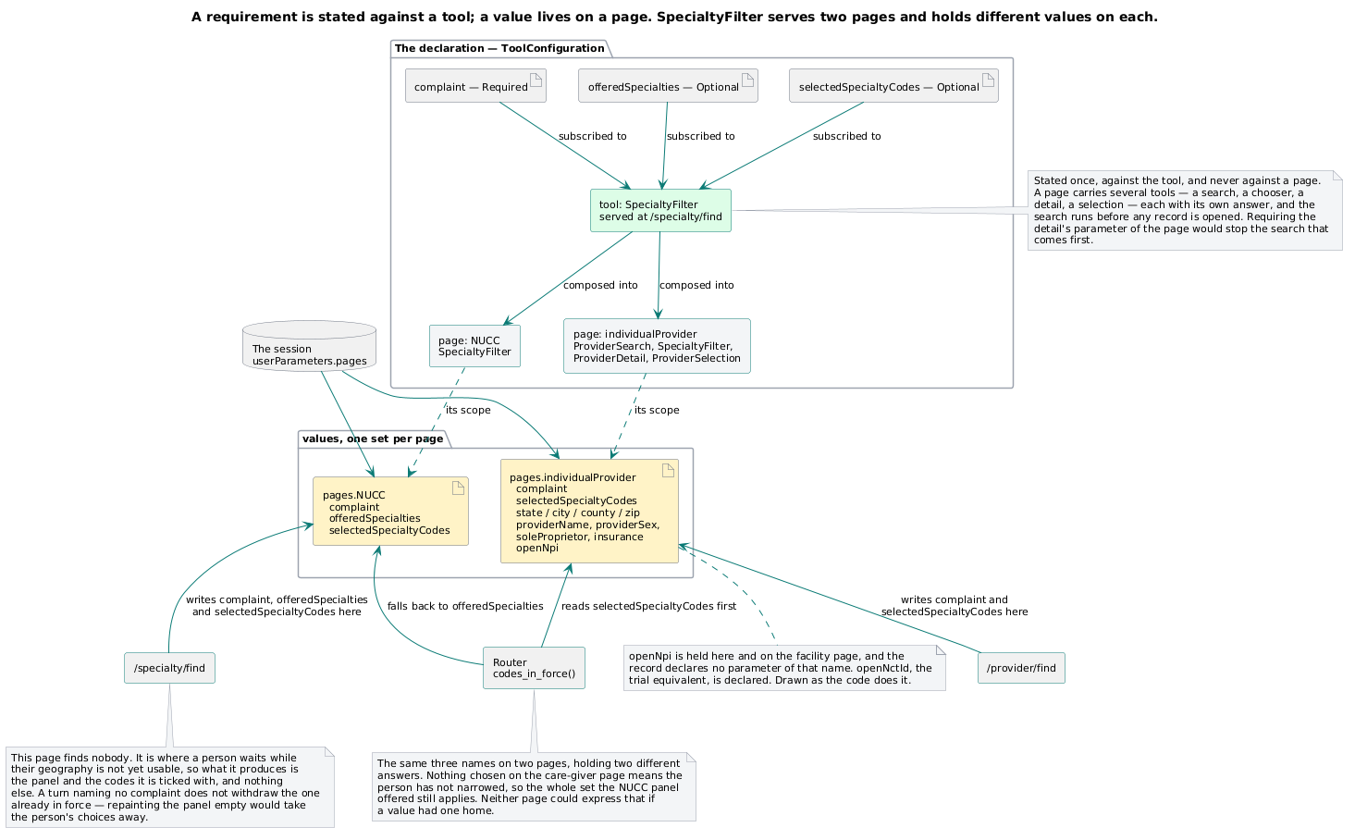
One name, one value per page. The geography on the care-giver page is not the geography on the facility page.
[R] The asymmetry that survives: a new capability is a row; a new page is a requirement change. Both live in the record. What differs is who may add one.

2.6 The display model **[R]**

2.6.1 A page is not a screen
The application is one screen of frames. A page is which frames are in force, what they are showing, and whose parameters are being read.
That is why four pages do not mean four screens; why a person can hold a facility answer and a provider answer at once (EPIC-006-F-008-S-001-REQ-B-006) without either being navigated away from; and why a turn about one page must leave no other page showing anything (-S-002-REQ-B-006) — clearing is a display act on a shared screen, not a navigation.
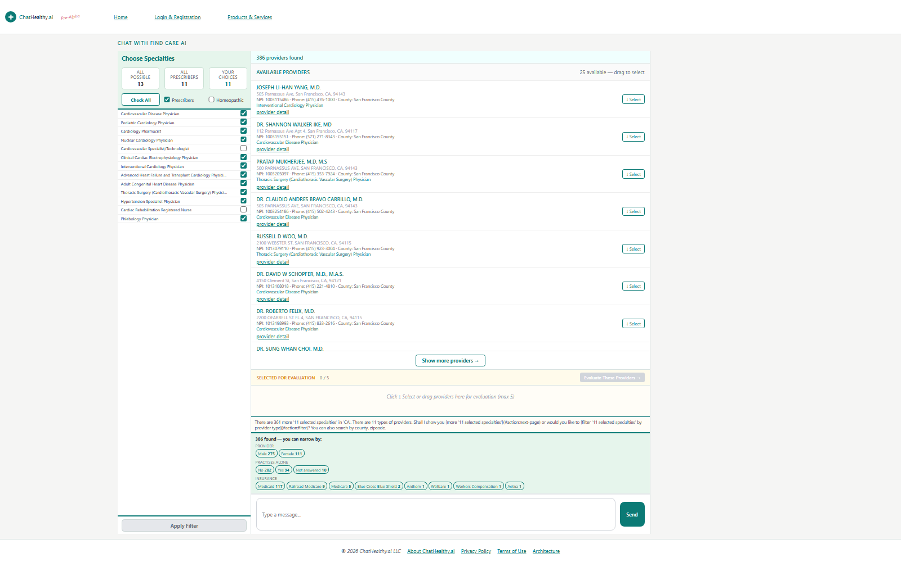
The individual-provider page — the same frames, showing a care-giver answer.
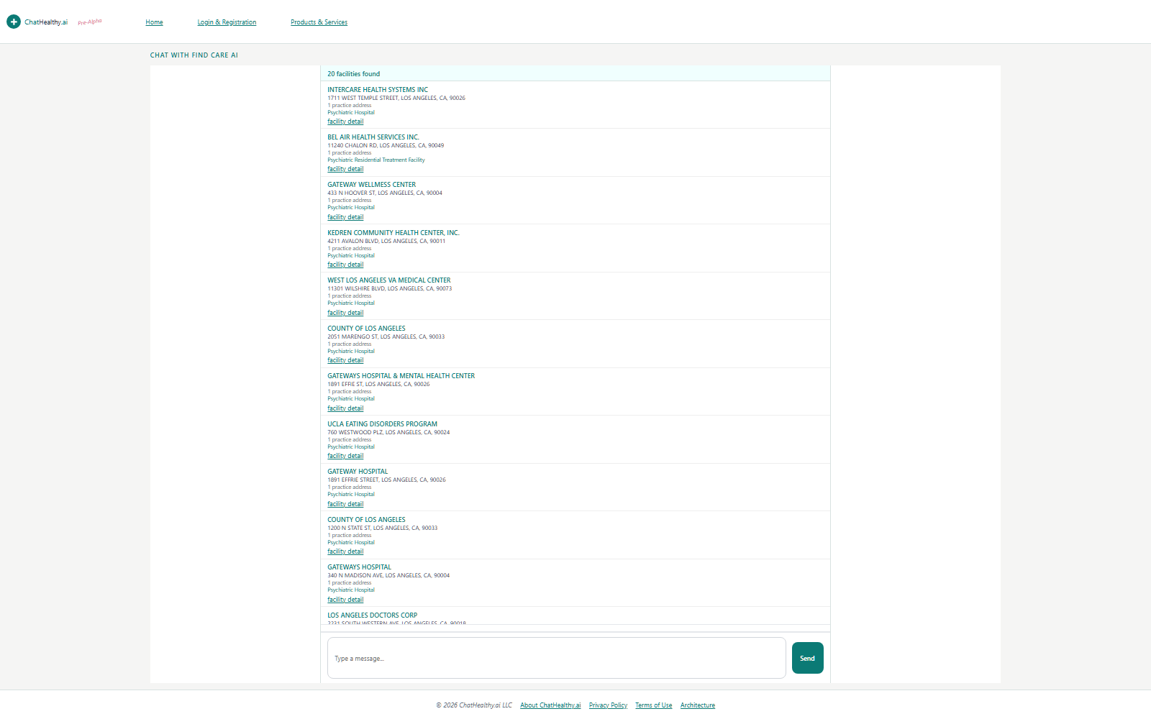
The facility page — the same frames, a different subject, its own values.
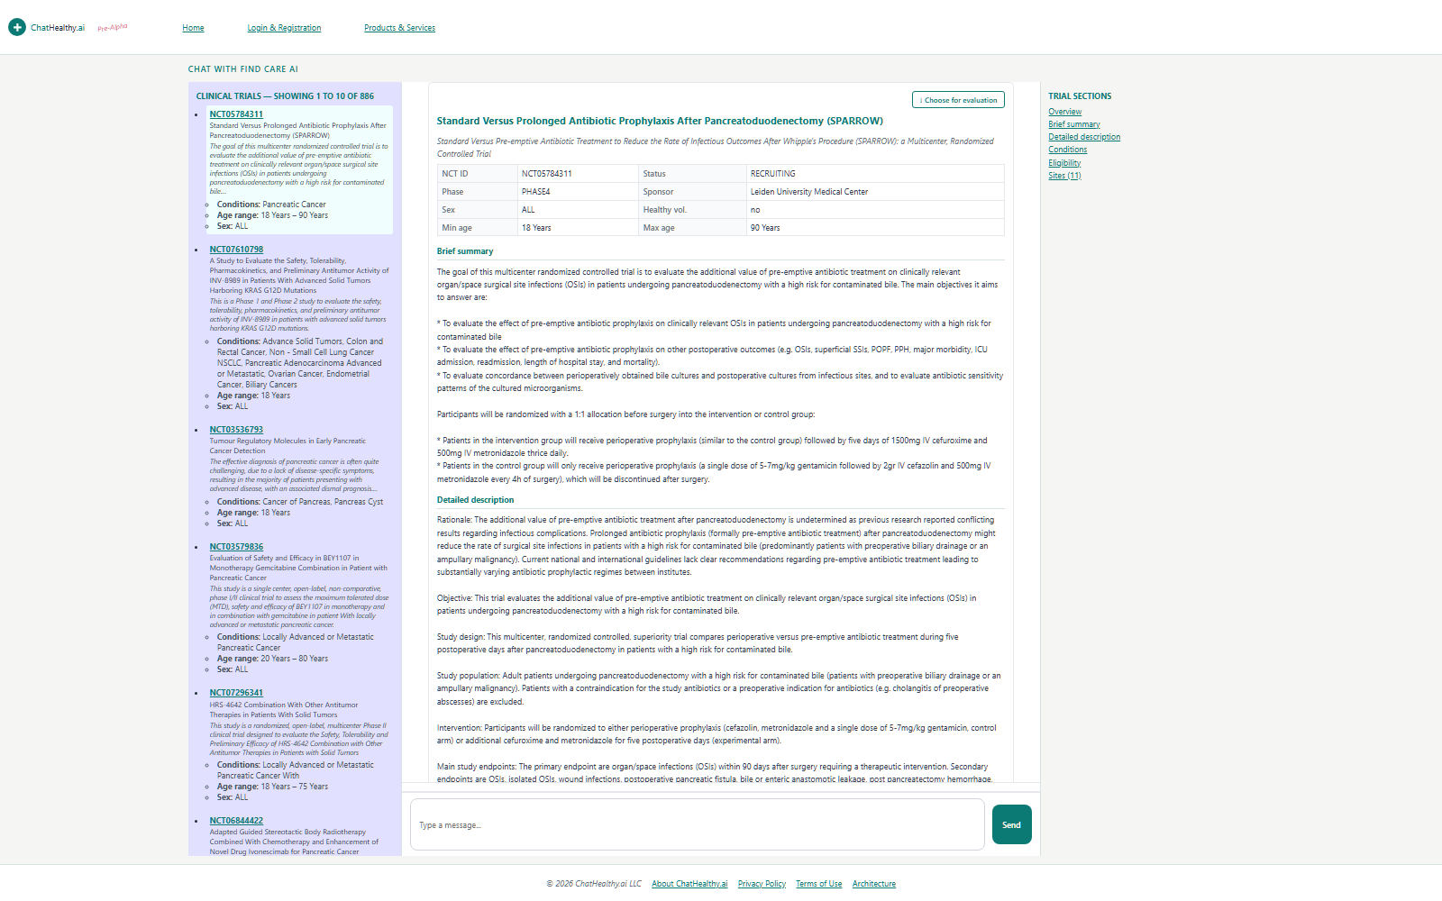
The clinical-trial page. Three pages, one screen.

2.6.2 The router addresses no frame
The server emits {kind, data} and nothing else. It never names a frame, a widget, a DOM node or a layout. Four consequences, each a thing that would otherwise need designing:
- One dispatch can light several frames at once. A provider search emits its specialties and its providers; two frames fill from one turn without the server knowing either exists.
- Adding a frame does not mean adding a tool. A new panel showing an existing kind is a browser change alone.
- Adding a capability does not touch the display transport. A new kind rides the same courier as every other.
- The display can be rearranged without a server release.
The corollary is a prohibition: a tool never authors display. A tool that composes markup has taken the browser's job.
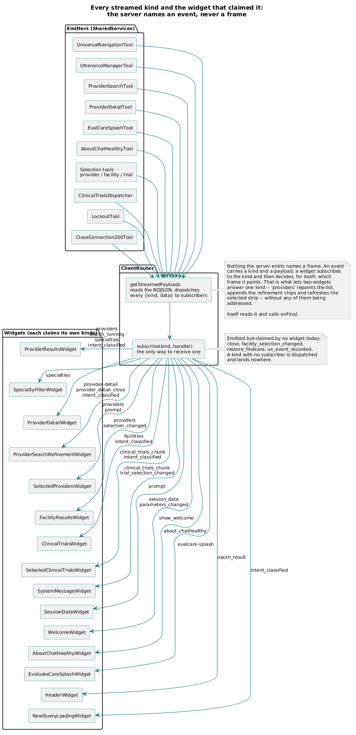
The wire vocabulary — every kind the server can emit and the widget that claims it.

2.6.3 Widgets claim kinds
A kind is the unit of subscription. A widget declares the kinds it consumes; the courier delivers each arriving kind to whoever claimed it; the widget renders and hands the result to the frame it owns.
[R] The target adds one word: a kind is claimed by exactly *one* widget on a given page. That word is the difference between a display model and a race. Ownership must be a lookup, not an act of restraint — a widget that decides for itself whether to stand down can decline when it should paint, or fail to decline when another paints too.
Two conventions the target keeps:
- Scaffold and merge. A widget paints a container carrying named regions; it and others fill regions independently. This is how a result list and a selection strip share a frame without either owning the other.
- The reverse channel is declarative. Controls in rendered content carry an action name and their data as attributes; the courier binds them and turns a click into a gesture. No widget wires an event handler to a server call by hand.
[R] A callback dispatches to a tool exactly as a gesture does — the callback tool, or the domain tool. This is the display model's half of §2.2.1's second inbound class, and it is why that class costs the architecture nothing.
A gesture is a person clicking a control: the courier turns it into a named op, the gate dispatches to the tool that handles it, and the tool streams kinds that widgets claim. An unoriginated request is a third party delivering something: the gate collects its facts, dispatches to the tool that handles it, and that tool streams kinds that widgets claim. Structurally these are the same event. The only difference is who caused it, and nothing downstream of the dispatch needs to know.
Two consequences worth stating because they are what make the second class ordinary rather than special:
- A callback needs no new machinery. It is a tool, reached through the dispatch map, that emits declared kinds. It requires no route of its own, no bespoke handler, no second transport, and no exception in the display model.
- A callback's answer paints through the same claim. Whatever a widget does with a sign-in result, it does because it claimed the kind that carries it — not because a callback route knew a frame's name. Which is §2.6.2 holding for the one class of traffic that might have been argued out of it.

2.6.4 The courier has one verb, and it is *render*
[R] This is stated as architecture because the live code makes the opposite case eloquently.
The display model's premise is that what crosses the frame boundary is opaque content a widget renders. A courier that also accepts code to execute has two content types under one contract, and the receiver distinguishes them only by a field the sender chose. That is not a display transport; it is an RPC channel that also paints.
[I] Website/ClientRouter.js:517-518 accepts a message of type router:exec and runs new Function(String(msg.code || ''))() in the top window, inside a try/catch that swallows the failure. The receiver at :421 registers a message listener and checks no origin, and outbound posts specify '*' as the target origin. So an arbitrary string, from any sender, executes in the parent window.
Security carries the severity (02_security.md). What it means here is narrower and is the architecture's own business: a display channel that can execute is not a display channel. The target is one verb — render — and no verb that executes; and the plumbing tier checks the origin of what it receives, because checking it is plumbing's job and nothing else's.

2.6.5 What a page must declare, and the gap that stops it
For a page to be a declared thing rather than an emergent one, the browser needs to know, per page: which frames are in force; which widget paints each; which kinds each widget claims; and which capability emits them.
Three of the four already derive from the capability declaration (§2.4.2). The fourth — the browser being *told* any of it — does not exist. Everything the browser knows about page structure is hard-coded in three unreconciled places: the frame elements in the wrapper page, a target-frame literal inside each widget, and the courier's lookup by name. A mismatch surfaces only at runtime, as a console error, in a browser nobody is watching.
Closing it needs a gate op returning the page's frame-and-kind manifest, a bootstrap step to fetch it, and — the expensive part, and the one most likely to be dropped — a build-time crosswalk proving the manifest, the frame skeleton and the widget set agree in all three directions. Without that third item the manifest becomes a fourth unreconciled place rather than the one true one.

2.6.6 The transport carries what the display may need to distinguish
[R] A display cannot render a distinction the transport threw away. So where the store distinguishes who asserted a fact — the source registry, a standards body, or the firm's own curated catalogue — those tags travel to the widget with the value, whatever is eventually done with them. Committing to this forecloses nothing and is the only part of the question that can be settled without a requirement.
[R] One consequence is a commitment, not a preference: where a record matched a query through a derived value rather than a reported one, the result says so. A person filtering on one code and receiving a record that carries a different one is owed the reason, and the reason exists only if the query's answer carries it out.
This is the display half of a boundary 04_pipeline.md §7.4 owns the other half of. That artifact holds the tag vocabulary; this one holds the rendering rule; which value a person is shown is neither artifact's to decide and is §5 Q4.

2.6.7 Display, plumbing and logic
[R] Three tiers. The display framework authors display. Plumbing carries opaque content between the display and the logic and authors none of it. Business logic lives in neither and changes persistent state through the entrance only.
The sharpest available statement of the boundary, and the one to use when the tiers are argued about: what separates display from logic is not the subject a file discusses but whether it decides. A display tier that tests a value it worked out, where the tier owning the fact could have sent the answer, has taken a decision. Boolean(first_npi) is worked out; data.has_previous is sent.

2.7 The library boundary **[R]**
**The shared library is what more than one front-end component needs and none of them should
own.** It is installed into each component rather than called across the wire. It holds no
domain knowledge and no business logic. It mints no credential — manufacture belongs to
the entrance alone; the library carries verification and parsing.
A thing belongs in it only if it passes all three:
- Shared — two or more front-end components need it. One component's helper is that
component's, however general it looks.
- Silent about the business — it names no business noun. A module whose name or purpose
identifies what the product is about carries domain knowledge, and shared domain knowledge is how a boundary dissolves.
- Mints no credential — it may verify, parse and advance a token. It may not make one.

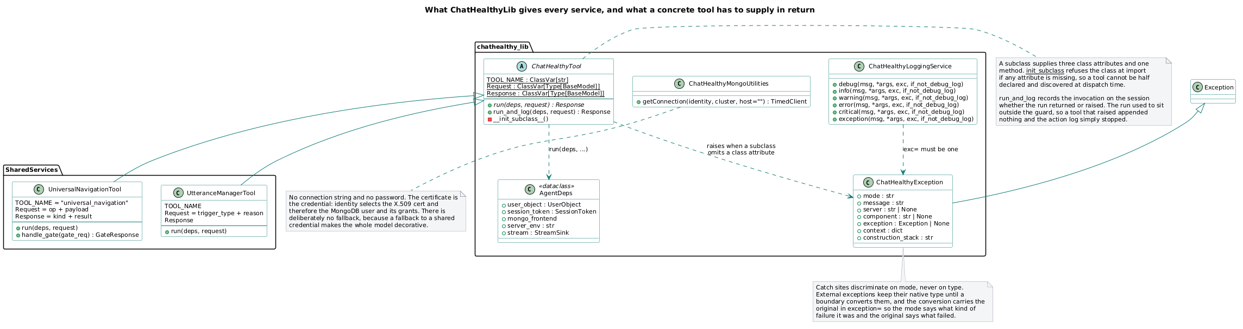
What the library holds: the tool contract, the exception type, logging, database acquisition, the model facade.

[R] Two corollaries worth stating because both were learned the hard way.
- A concrete tool names itself; the declaration says where it is served. No tool learns an address. A library that handed tools their peers' URLs would put deployment knowledge into every component.
- A library offers types and functions; it does not open doors. A library that mounts HTTP routes into whatever imports it gives every host a surface its own architecture never declared.
[R] And a third, which the live code teaches: a transport library may carry a transport; it may not carry a policy. A verification posture is a deployment fact and belongs in the record — never in a default argument on a base class that every component inherits, because a base class is the highest-leverage place in the system to put a mistake.

2.8 Rolling out a new capability **[R]**
The standard is the operator's: adding a capability should be as fast and as mechanical as build-and-deploy already are. Those are one command each, deterministic, gated, requiring no judgment once the operator has decided to run them.

2.8.0 Which object this is about
03_devops.md §2.9 carries a sequence called "How a new target is stood up", and it is a sequence for a different object — a new deployable target, with a host, packages, secrets and bindings. A product capability needs none of that. Its steps 3–5 (build, deploy, verify) run unchanged and unaware, which is the correct relationship and the best evidence either artifact has that the chain is well factored.

2.8.1 Why it is not mechanical today
A capability's name is not declared. It is agreed upon, in many places, by hand — a static type in the library, a second enumeration inside the classifier, a prompt that states the closed set in prose and repeats it as a schema enum, a published schema, an action-to-page table, an arm of a conditional dispatch chain, an op-to-handler table, a page-and-tool map, and a widget.
[I] The proof that this cannot hold: the set is stated in three independent places and all three disagree — a library type with 7 names (one of which has no model, no dispatch branch and no classifier entry, so it can be neither constructed nor routed); the classifier's own type with 6; and the published JSON schema, served to browsers, with 5 — missing two capabilities the product actually serves, while its own text advertises "this deploy's closed set." Every one of those files passes every gate, because nothing compares them.
[R] A closed set that three sources state differently is not closed — and closure is the property four of the thirteen reference principles rest on. Note also which copy is worst: the published schema, the one an external reader would trust, is the one missing two live capabilities while asserting its own completeness.
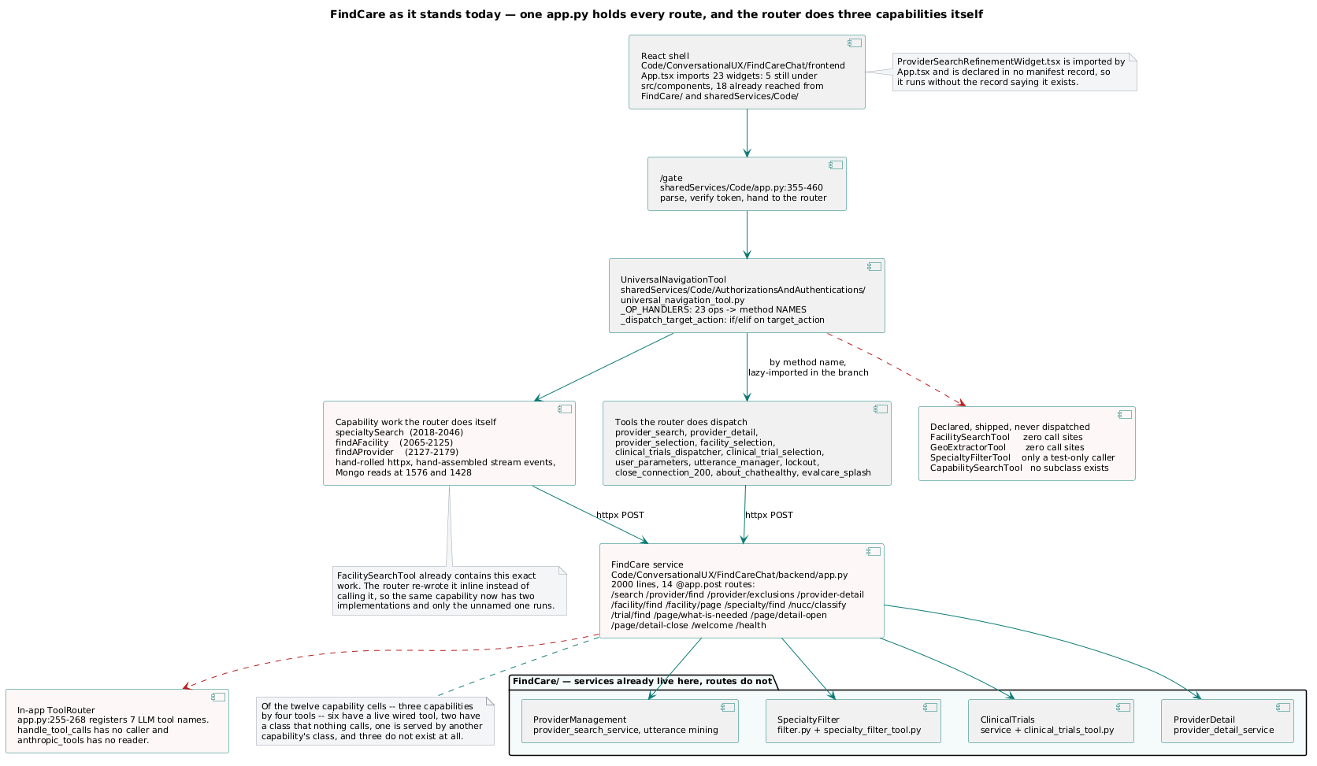
Today — the capability name repeated across independent sites that nothing reconciles.

2.8.2 The instrument, and why the current one is wrong
[R] A static type cannot express a set that differs per environment. The record is keyed by environment precisely so that one environment may carry a capability another does not — that is how a capability is tried before it ships. A type compiled into the artifact is identical everywhere by construction. So either the type is a lie in most environments, or capabilities can never differ, and then the environment key is decoration.
The target replaces the type with a validator against the declared set, read at every boundary where a name arrives: the classifier's output is validated against it; the classifier's prompt is assembled from it rather than written next to it; the published schema is generated from it; the router validates on dispatch. One set, read in four places, restated in none.

2.8.3 The declaration, and what the dispatcher becomes
Everything in §2.4.2 becomes one row in a fourth list on the composition record, beside parameters, tools and pages. One existing field is deleted: a page's tool list becomes derivable, so it goes, and the page list reduces to the closed membership set. That is the record's own no-fact-twice rule applied to the field the fourth list makes redundant.
[R] One registry, generated from source at build, is what every boundary reads. It cannot name a route the build does not carry, and it combines the four artifacts that carried the map's job in pieces: the tool contracts, the _OP_HANDLERS dispatch table, the ToolRouter allowlist, and the utterance manager's routing prompt. Presence in the registry is the allowlist; subscriptions are the dispatch table; may_call is the non-circular call map; the utterance_manager_prompt fragments assemble the routing table. No copy is maintained beside another to drift from it — the four are one record with four faces.
[R] The routing table admits nothing by accident. Every tool declares in source exactly one of a UTTERANCE_MANAGER_PROMPT fragment or a NOT_UTTERANCE_ROUTABLE marker; silence on both refuses the build, so absence from the router is always a decision and never an oversight. The UniversalNavigator declares NOT_UTTERANCE_ROUTABLE; on the utterance manager's own entry the value is the preamble, not a fragment. This is the generic branch's refusal-not-warning moved one level earlier, into the build: a capability half-declared does not deploy green.
[R] The conditional dispatch chain is not generated. It is deleted. "Generate the chain" is the obvious wrong answer: a generated chain is still one arm per capability, still drifts the moment anyone edits the generated file, and still makes a capability a code change. One generic branch replaces it:
Look up the tool for the action. Call it at its declared server and endpoint, handing it the
two things every tool is handed — what the person just said, and the talk before it. Stream
the kinds it declares.
A router that does that has no arm to add. A branch that reaches for an HTTP client exists because the tool it should have called was never written — which is a statement about missing tools, not about routing.
One point of hygiene: the generic branch's failure mode is a refusal, not a warning. An action naming no tool that logs and continues is how a capability gets half-added and deploys green.

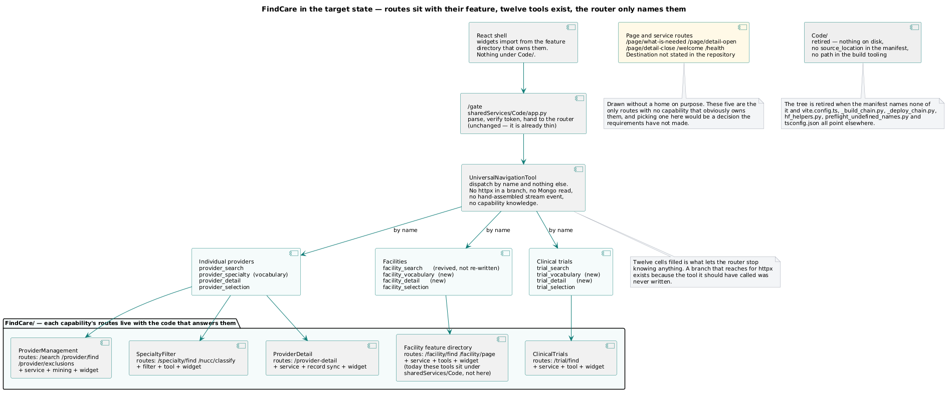
The target — the router names tools and nothing else; each capability's routes sit with the code that answers them.

2.8.4 The procedure
Seven steps. One requires judgment; six are mechanical.
# | step | who
1 | Author the requirement. What a person can now ask for, and what must come back. | operator
2 | Add the capability row and the parameter subscriptions it needs. | mechanical
3 | Write the tool. One class, one entry method, structured data out, declared kinds. | build
4 | Write the widget. Declares the frame it paints and the kinds it claims. | build
5 | Build. | the chain
6 | Deploy. The config reconciler writes the record. | the chain
7 | Verify. | the chain

Steps 3 and 4 are the only new code and neither mentions the capability's name — the tool is named by the record, and the widget is told its kinds by the page manifest.
[I] One honest qualification on step 6. "One writer" is the design and is not a control: the agent identity holds unconditioned Owner on the substrate, so the config collection can be written directly, bypassing the deploy. §2.8.6 is what would make it a control.
[R] What makes "one writer" a control rather than a hope is the registry's storage model, and it is worth stating in full. The registry lives in Mongo as one document per build per environment — the whole map is one record, and its instance object {build, commit, env, live} is its identity and state. The deploy appends a new live instance and retires the predecessor's live flag; that flag is the only field ever mutated on an existing document, and the full history is kept. Five invariants hold it. A unique partial index on instance.env where live is true, so the database itself refuses a second live per environment. The collection writable by the deploying identity alone, every runtime identity read-only. One canonical library function performing the whole write — validate, insert, retire the predecessor's flag — in a single transaction, with a pre-commit scan rejecting any other code that touches the collection. A $jsonSchema validator on the collection mirroring the registry schema. And the audit asserting the history invariant in its sweep. The Owner hole above is exactly the gap between this design and today: close the direct-write path and "one writer" becomes true.

2.8.5 The crosswalks — and which of them actually work
[R] The failure mode to test every check against. The parent's own vendor-SDK check names import <vendor> and reports green while the principle is violated in every live model call, because the mechanism moved to a framework wrapper that imports the vendor on the call site's behalf. Same violation, different letters, green check.
**A check that names a mechanism inherits that mechanism's lifetime. A check that names an
effect outlives it.**
That sentence is the most useful thing in this document. import <vendor> is a mechanism; "a vendor was contacted" is an effect. A gate written against the spelling of today's implementation goes green on the day the implementation changes — and goes green silently, which is worse than no gate, because a green gate is a reason not to look.
I proposed nine crosswalks. Audited against that test:
# | check | tests | survives
1 | no capability name as a literal outside the record | a spelling | no
2 | declared tool ↔ served endpoint, both ways | cannot be evaluated at all — see §2.8.5a | no
3 | declared kind ↔ producer ↔ claimant | a spelling, both sides | no
4 | one claimant per kind per page | a spelling | no
5 | every Required parameter has a route that can write it | not implementable as written | no
6 | manifest ↔ frame skeleton ↔ widget set | half structure, half spelling | half
7 | the record's page set is exactly the declared four | depends where the four come from | one way only
8 | every intra-record reference resolves | pure data | yes
9 | every declared tool is named by a capability; every page by one | pure data | yes

Two of nine survive on their own. Both are pure record integrity: they read one document and ask whether it is consistent with itself, so there is no mechanism to move out from under them.
Four things that follow, and they are the transferable part:
- Check 5 is not implementable as written, because the record declares which tools subscribe and never which routes write. One new field on the parameter row — the writer — converts the weakest of the nine into one of the strongest, because it becomes a pure record check like 8 and 9, and a separate behavioural check verifies the declaration is true.
- Check 7 has a trap, and it is the sharpest example in this document. The check refuses a record whose page set is not exactly the declared four. Where does the check get the four names? If they are hardcoded in the enforcement, the page set has been written into code a second time, with a requirement id attached — inside the very gate built to stop that. It is sound only if it reads the names out of the requirement text at gate time.
- Every surviving lexical check needs a behavioural twin, and the twin is what the claim rests on. The lexical check runs at pre-commit because it is instant and catches the honest mistake; the behavioural one runs against the deployed system and decides.
- [R] A check that has never gone red against a real violation is a hypothesis, not a control. Every new check ships with a seeded violation that makes it go red, or it ships unproven. This is the cheapest discipline available and no check in this system currently meets it.

2.8.5a A join that does not exist cannot be checked **[R]**
This generalises past this application to any declaration-driven architecture.
Check 2 — declared equals dispatched — joins the record's tool list to the tool modules on disk. That join has no key.
[I] What I read. The record's tools[] names its tools in one convention: ProviderSearch, ProviderDetail, FacilitySearch, FacilityDetail, SpecialtyFilter, ClinicalTrials, ProviderSelection, FacilitySelection, ClinicalTrialSelection — nine. Every tool module declares its own name in a different one: provider_search, provider_detail, facility_search, specialty_filter, clinical_trials, provider_selection, facility_selection, clinical_trial_selection, and eleven others — nineteen distinct names. Nothing anywhere declares the mapping between the two conventions. Under a string match the intersection of the two sets is zero: not one of the seven declared tools matches any module's declared name.
Three things follow, and the third is the general lesson.
- Check 2 is not a failing check. It is an unrunnable one. A crosswalk reports a
disagreement between two sets; when the join key is absent, every declared tool looks undispatched and every dispatched tool looks undeclared, in both directions, always. It cannot go green and it cannot go usefully red. Compare the two checks that survive (8 and 9): both read one document and ask whether it agrees with itself, so neither needs a join.
- It explains a dead reader. The record carries a function answering *where is this tool
served. Nothing calls it. That reads as neglect and is not: a caller looking up its own declared name in that table would never find itself.* The function is correct, the table is correct, and the lookup cannot succeed. A dead reader is sometimes evidence of a missing join rather than of a careless author.
- [R] A crosswalk is only as good as its join, and the join is part of the declaration.
An architecture that declares two sets and expects a gate to reconcile them owes the gate a key. Without one the gate is theatre — and worse than absent, because it appears in a plan as a control.
What closes it. One of two, and it is a small change either way: the record's tool row carries the module's declared name, or the module takes its name from the record. The second is better on the merits — it makes the record the source of the name rather than a second statement of it, which is §2.8.3's rule applied one level down — and it is the one that also revives the dead reader.
This is a prerequisite that `drafts/06_migration.md` Phase 0 does not yet state. That plan's gate 2 is "declared equals dispatched … fails in either direction", and its Phase 4 proof is "gate 2 goes green." Neither is reachable until the join exists. The gate cannot be demonstrated red against a real violation — the Phase 0 acceptance condition — because it is red against everything for a reason that is not a violation. Raised to that artifact on the board; it is a one-line addition to Phase 0, not a change to the plan.

2.8.6 What falsifies the closed-set claim from outside
Nine crosswalks written by the actor that writes the record are subject to the parent's §11.14.2 — the record's author cannot be its own checker. So:
Claim: the capability set is closed and one declaration is its only statement. Falsifier: read the running system, not the source, and not by the actor that deployed it.
read | compare to
the schema the website actually serves | the record's capability list
the prompt the running classifier actually assembled | the record's capability list
the tools the running router actually resolves | the record's capability list
the config collection as it actually stands | the manifest that was meant to write it

Four reads, one comparison, any pair disagreeing is the finding. The fourth row is the one that closes the Owner hole in §2.8.4, because it is the only check that detects a record written directly into the substrate.
Not built. Naming it precisely is what makes it a gap with a shape rather than a principle with no instance.
And one row is currently unexecutable, which is itself the finding. The coordinator's gate run reports that the published schema address returns HTTP 403. I did not issue that request and do not assert it first-hand; I record it as theirs, and what follows if it holds is mine: row 1 cannot be read at all. The copy of the capability set that an external reader would most trust — served, versioned, self-describing — is then not merely wrong by two capabilities (R-01) but unreachable, so the drift between it and the record is undetectable from outside the network by anyone, including a buyer's auditor.
That inverts the usual reading of a 403. It is not a small operational defect sitting beside an architectural one; it is the thing that makes the architectural one invisible. A falsifier whose first read is blocked is a falsifier with three rows.

2.9 How the capabilities compose in one turn **[I]**
[R] The funnel is one composition; direct tool-to-tool calls are the other. A tool may call another tool directly, along the declared may_call graph, which is a DAG — the generator refuses a registry whose call map contains a circle, and recursion guards are mandatory regardless. Every throw ends in a UniversalNavigator or a UniversalNavigatorProxy: a tool in the middle re-raises and never swallows, and the navigator that called catches, classifies, logs and answers. When the tool called lives on another server, the hop crosses the wire through that server's proxy and returns as an internal_callback, and the calling tool's code cannot tell the difference — which is why "server to server, on the browser's behalf" costs the caller nothing.
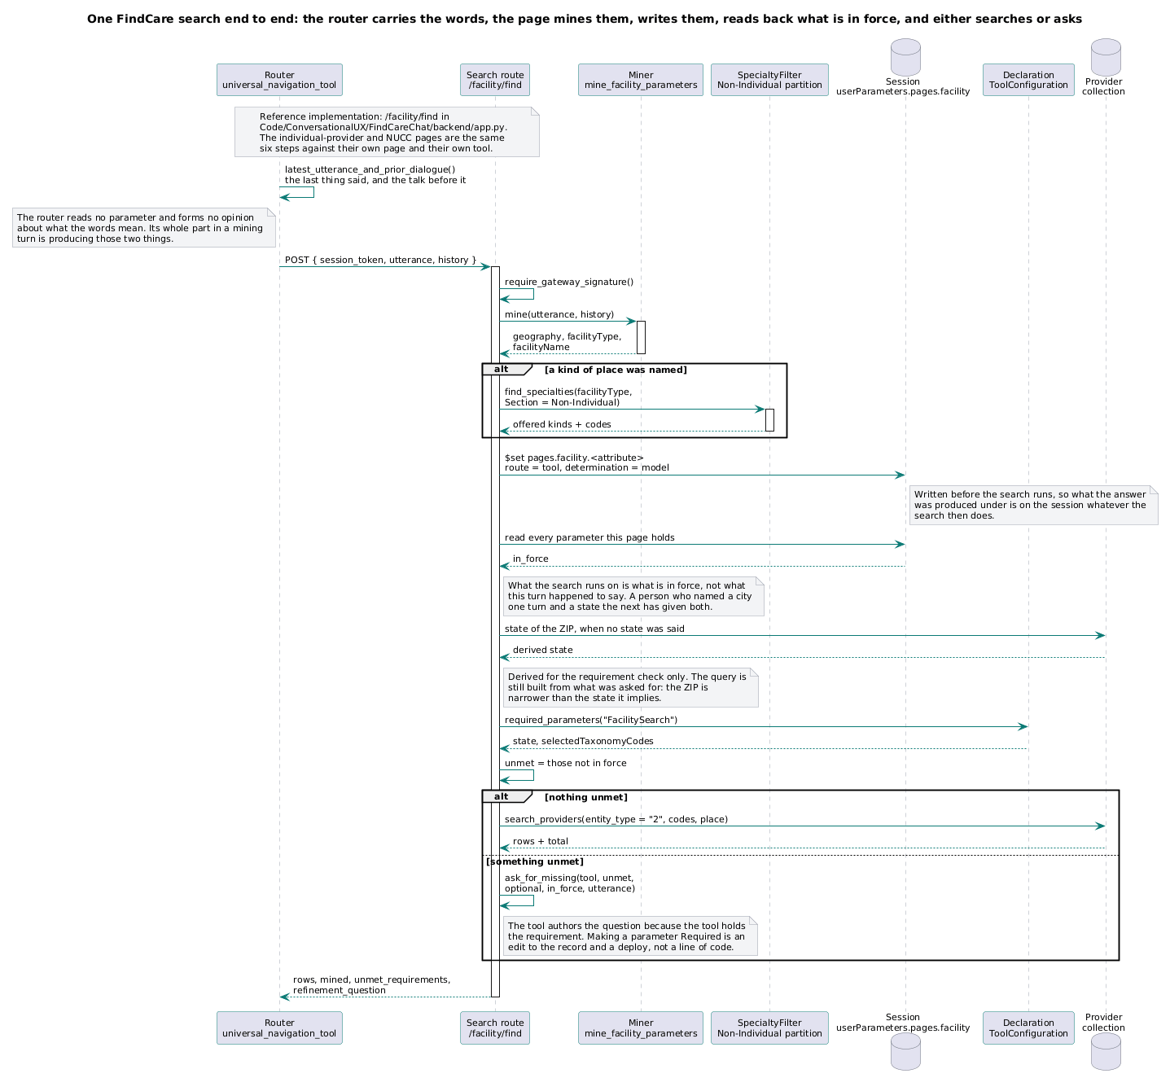
A provider search — classify, mine, resolve vocabulary, query deterministically, stream.
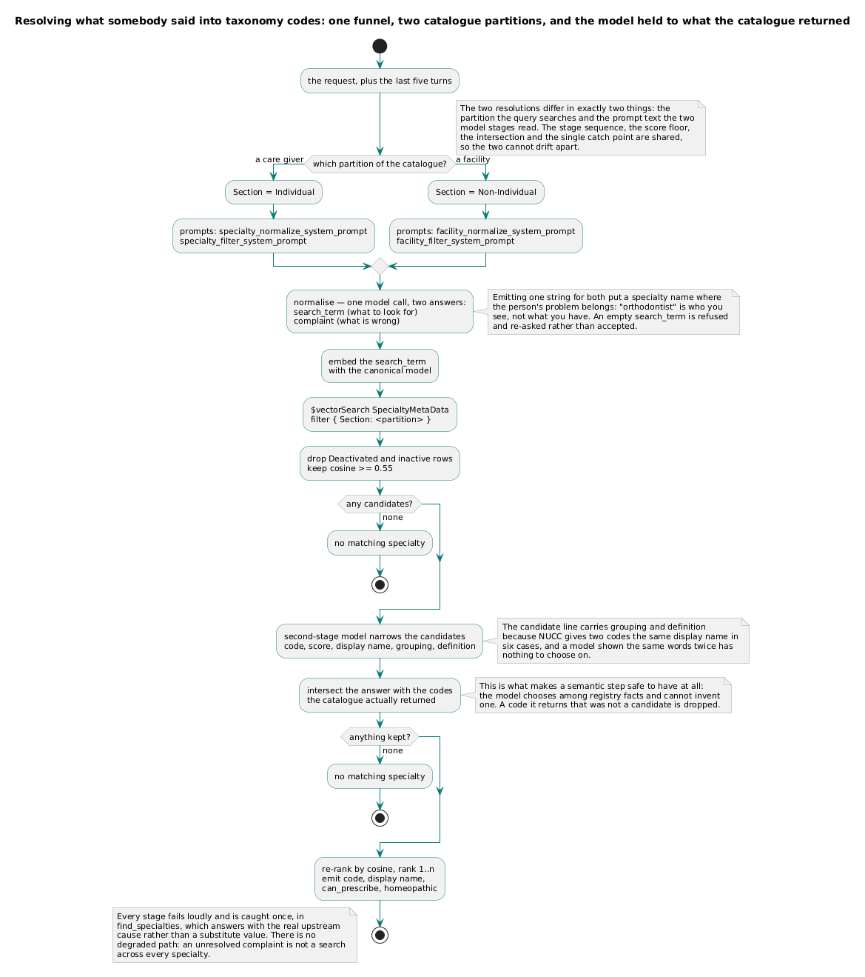
One funnel, two catalogue partitions, and the model held to what the catalogue returned.
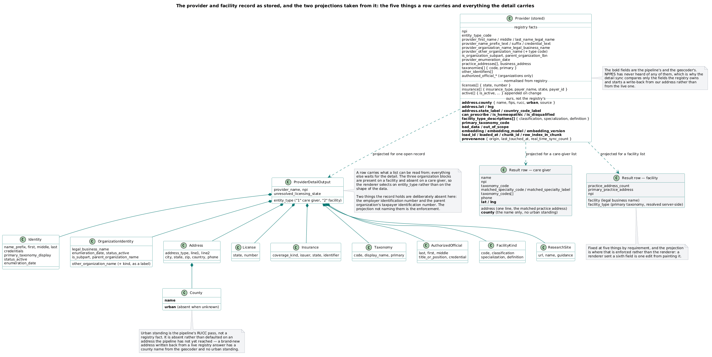
What a served provider record carries, and which fields are the registry's and which are ours.
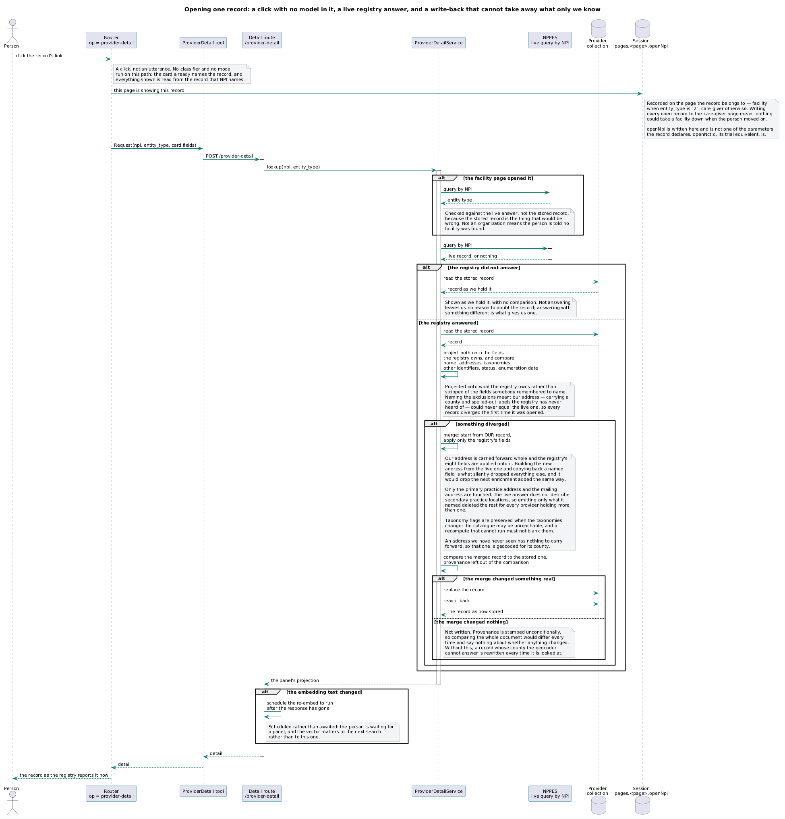
A detail brought to live-registry freshness on open, and still shown when the registry does not answer.
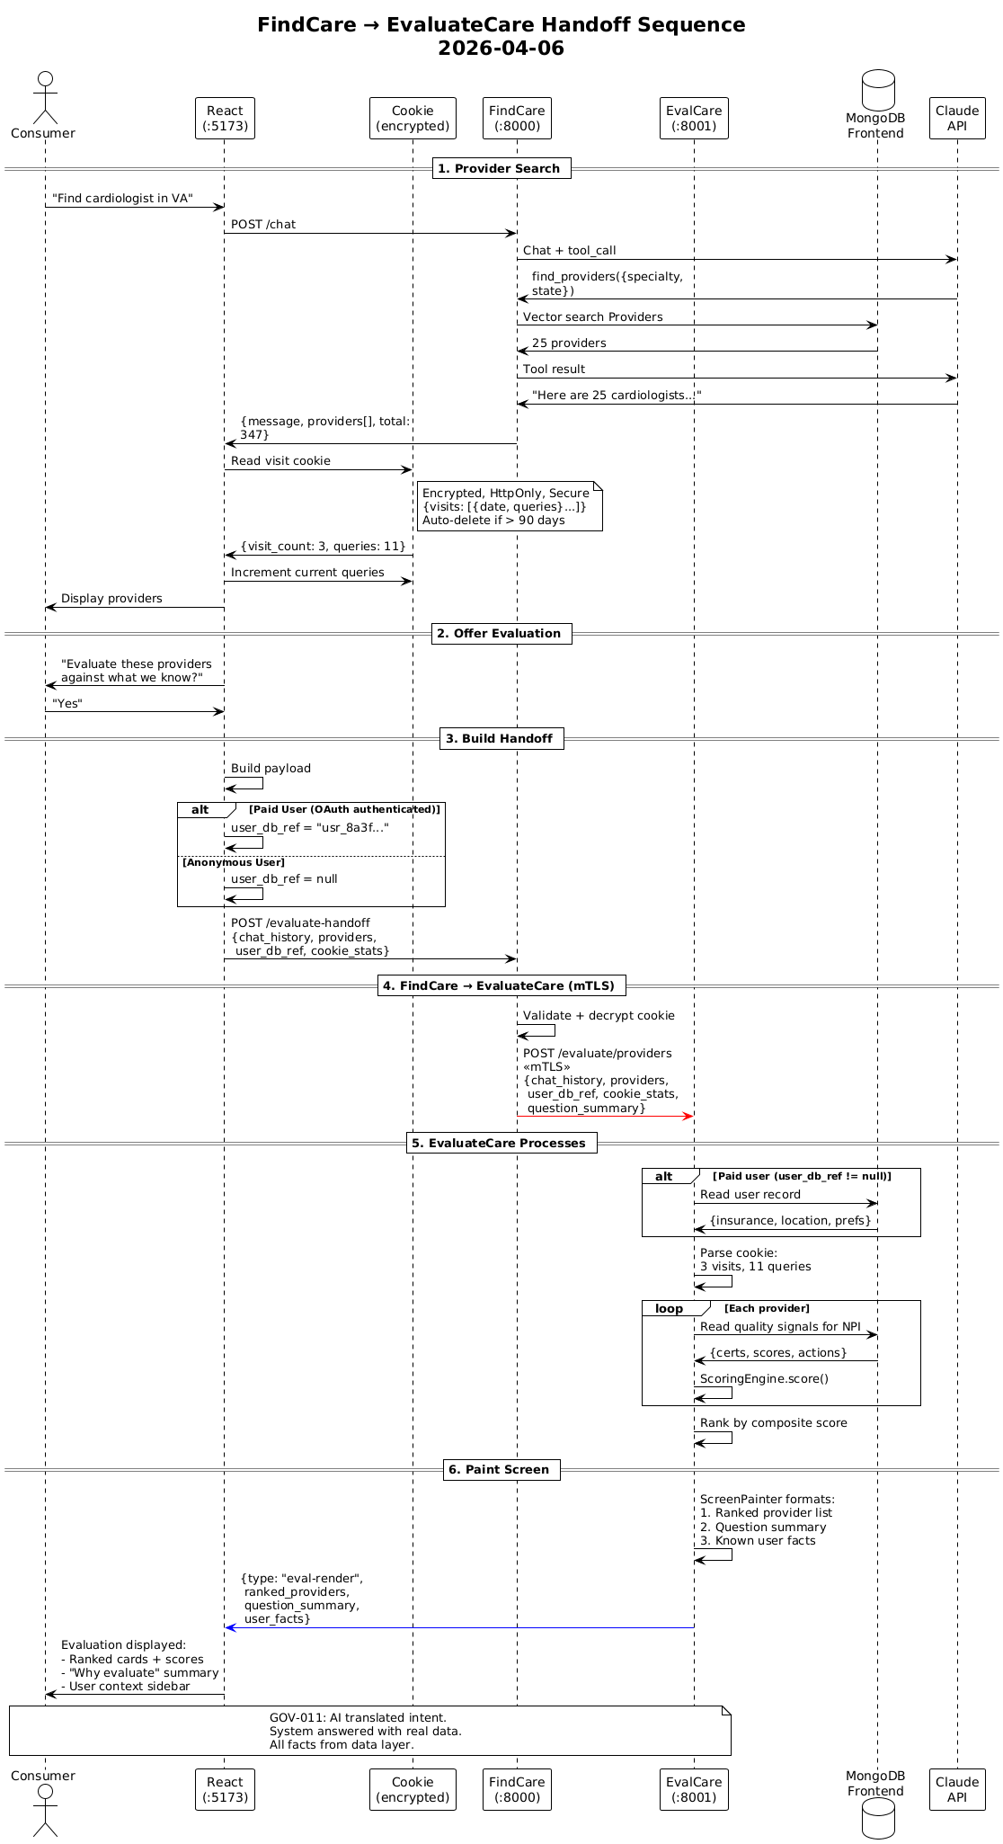
A selection handed to the scoring capability — server to server, on the browser's behalf.

2.10 Flows **[R]**
Every incoming request is triaged to its type, and every page the application builds has its own construction-and-reconciliation flow. One diagram per flow, embedded here as each is drawn — request-type flows first, page-type flows after, in the order the registry maps them. The six request-type flows are the five call types with the client-sessioned one split by input; the six page-type flows are the pages of §2.2.5, each carrying the page error management (timeout to a layman explanation; conflict to a raise; missing required to a raise; all instrumented).

flow_client_utterance (request-type)
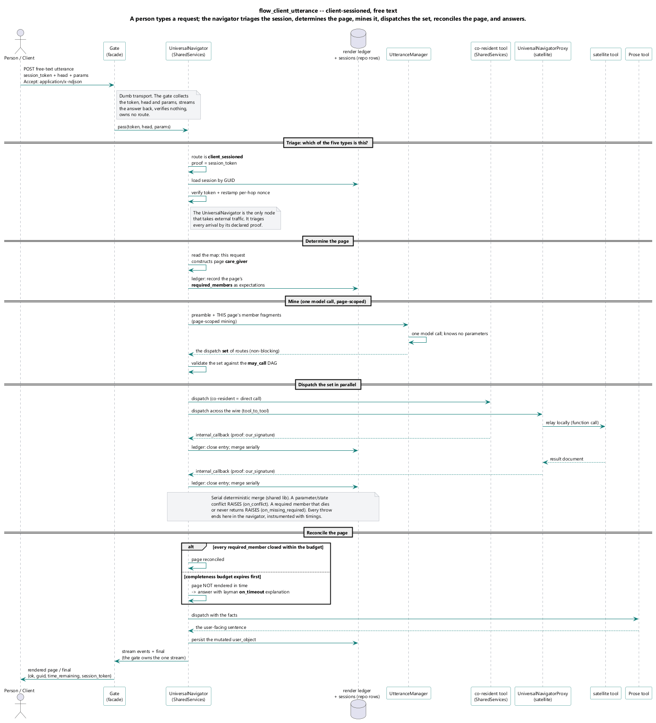
Client-sessioned, free text: the gate collects and passes inward; the UniversalNavigator triages the session_token, determines the page, scopes the utterance manager to that page's members, mines, dispatches the returned routes, reconciles the page, responds.

flow_client_gesture (request-type)
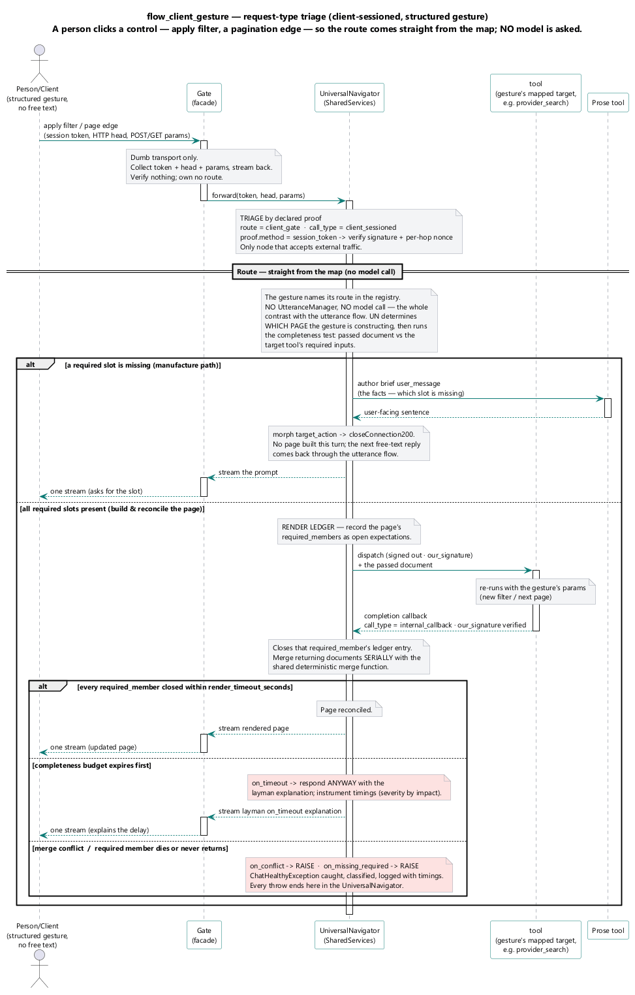
Client-sessioned, a structured control — apply filter, a page edge: routed straight from the map, no model asked; the page is updated and reconciled.

flow_tool_to_tool (request-type)
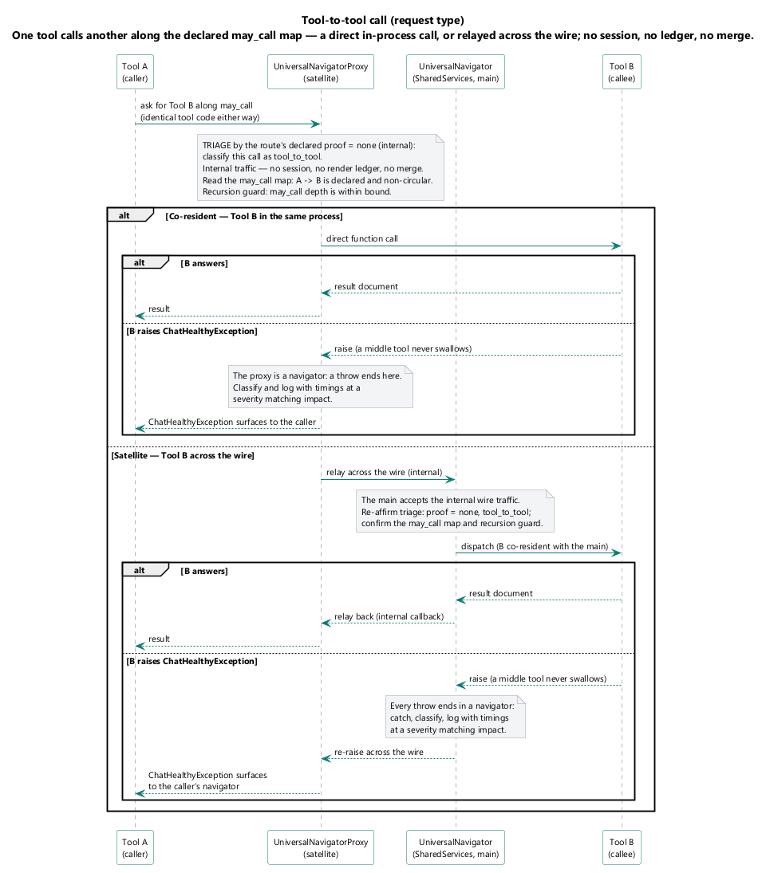
One tool calls another along the declared may_call map, through the satellite's proxy; no session, no ledger; a throw re-raises to a navigator, never swallowed in the middle.

flow_internal_callback (request-type)
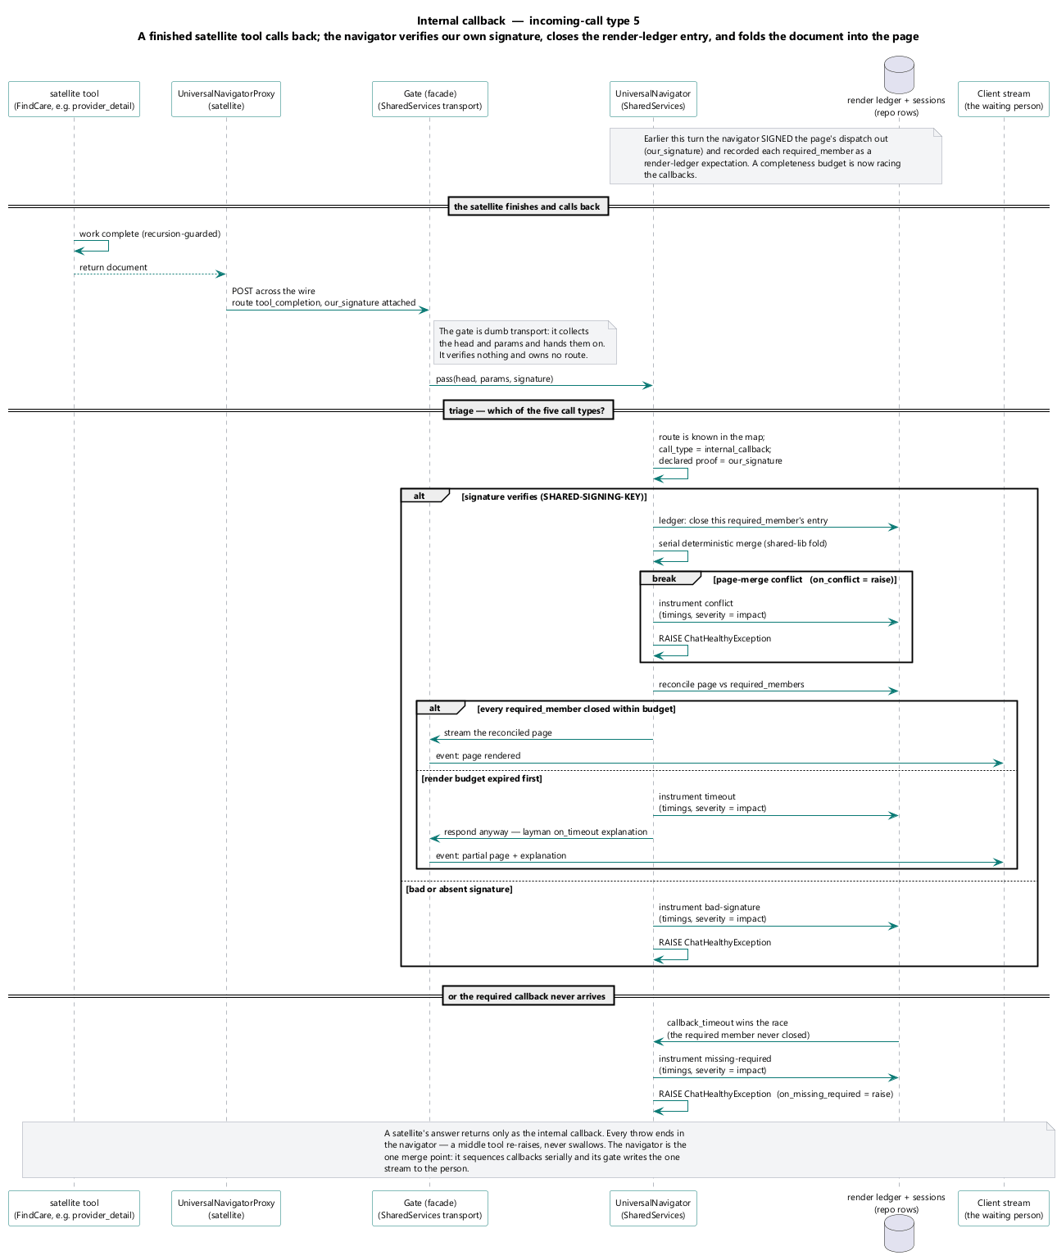
A finished tool calls back into the main UniversalNavigator; our_signature verified against the dispatch it was signed out with; the call closes the page's render-ledger entry.

flow_third_party_callback (request-type)
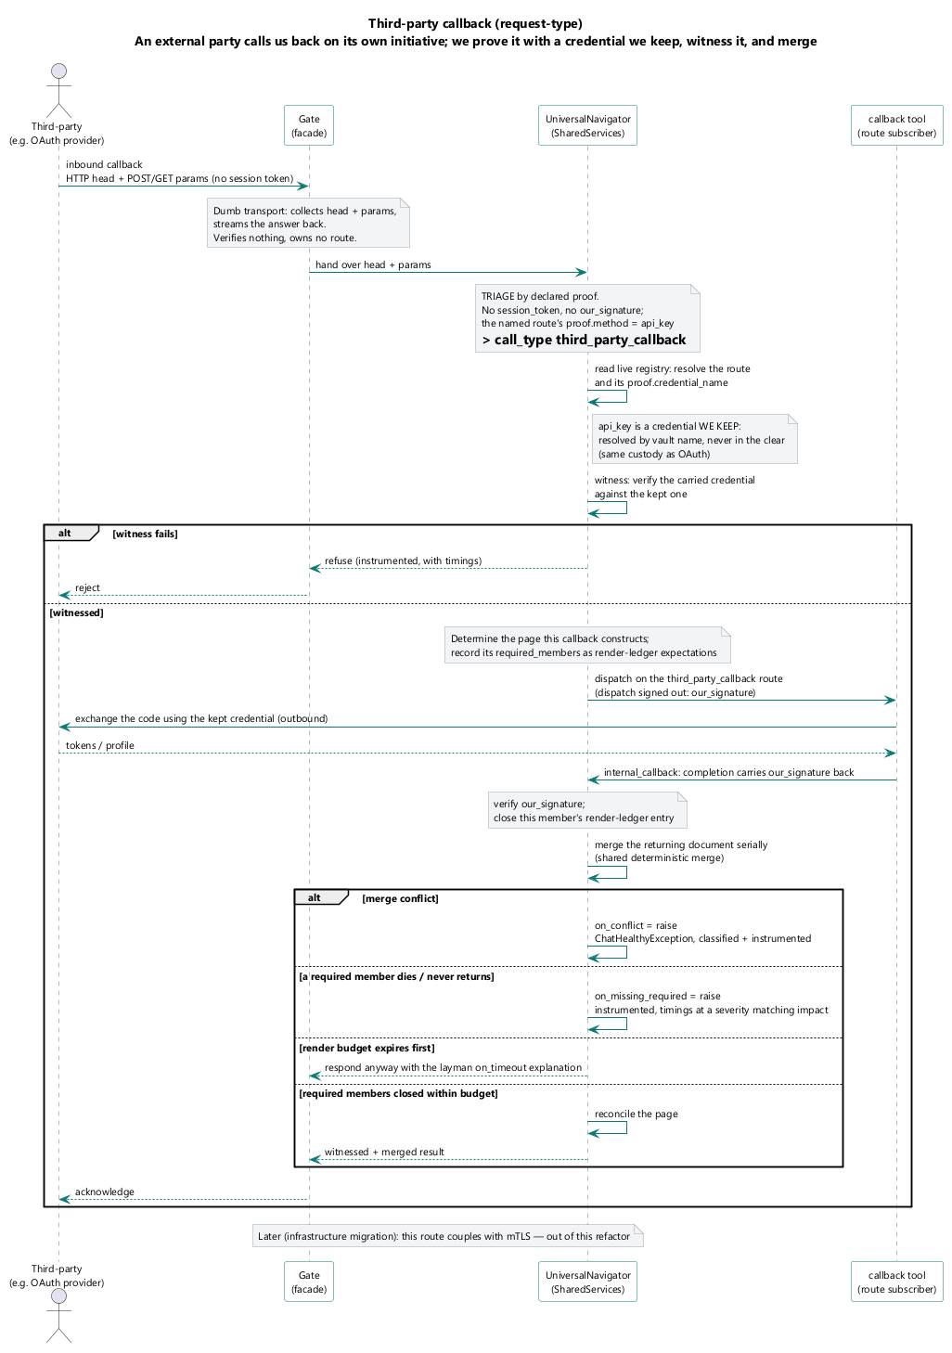
An external party calls us back on its own initiative; api_key proof, the credential named in the vault; witnessed and merged like any other returning document.

flow_static_witness (request-type)
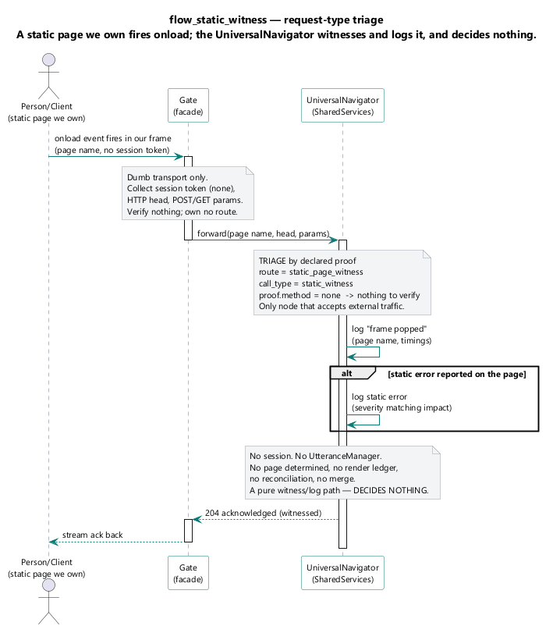
The onload witness of a static page we own; proof none; logs at frame pop, logs static errors when they occur; decides nothing.

flow_page_care_giver (page-type)
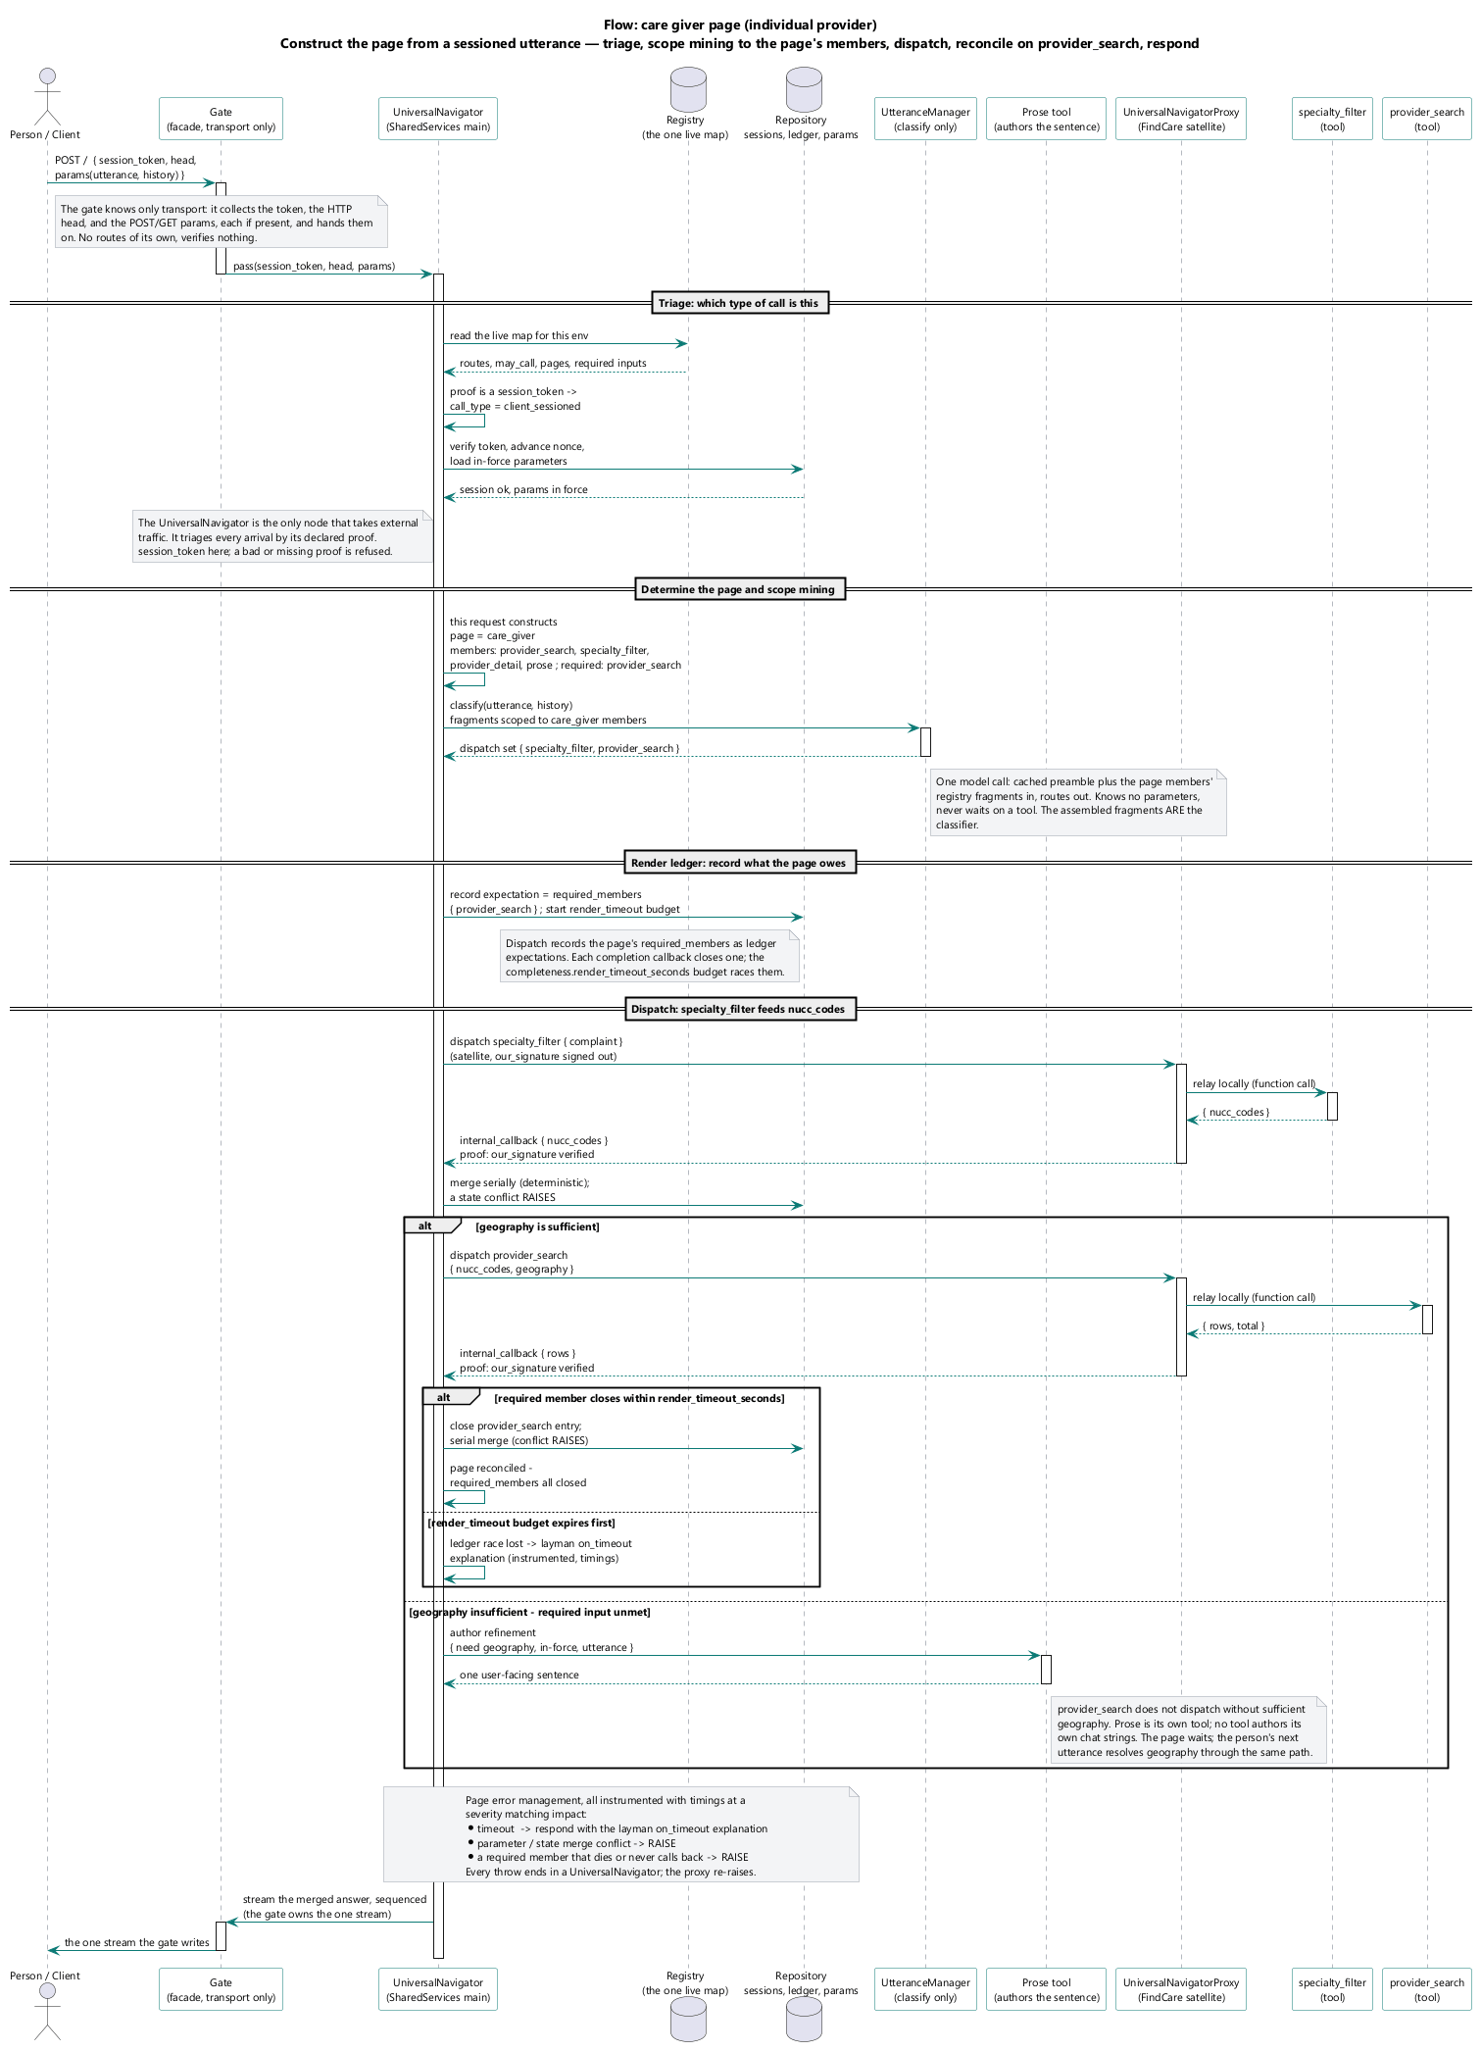
The care-giver page: determine the page, scope mining to its members, dispatch, reconcile against its required members within the completeness budget, respond.

flow_page_facility (page-type)
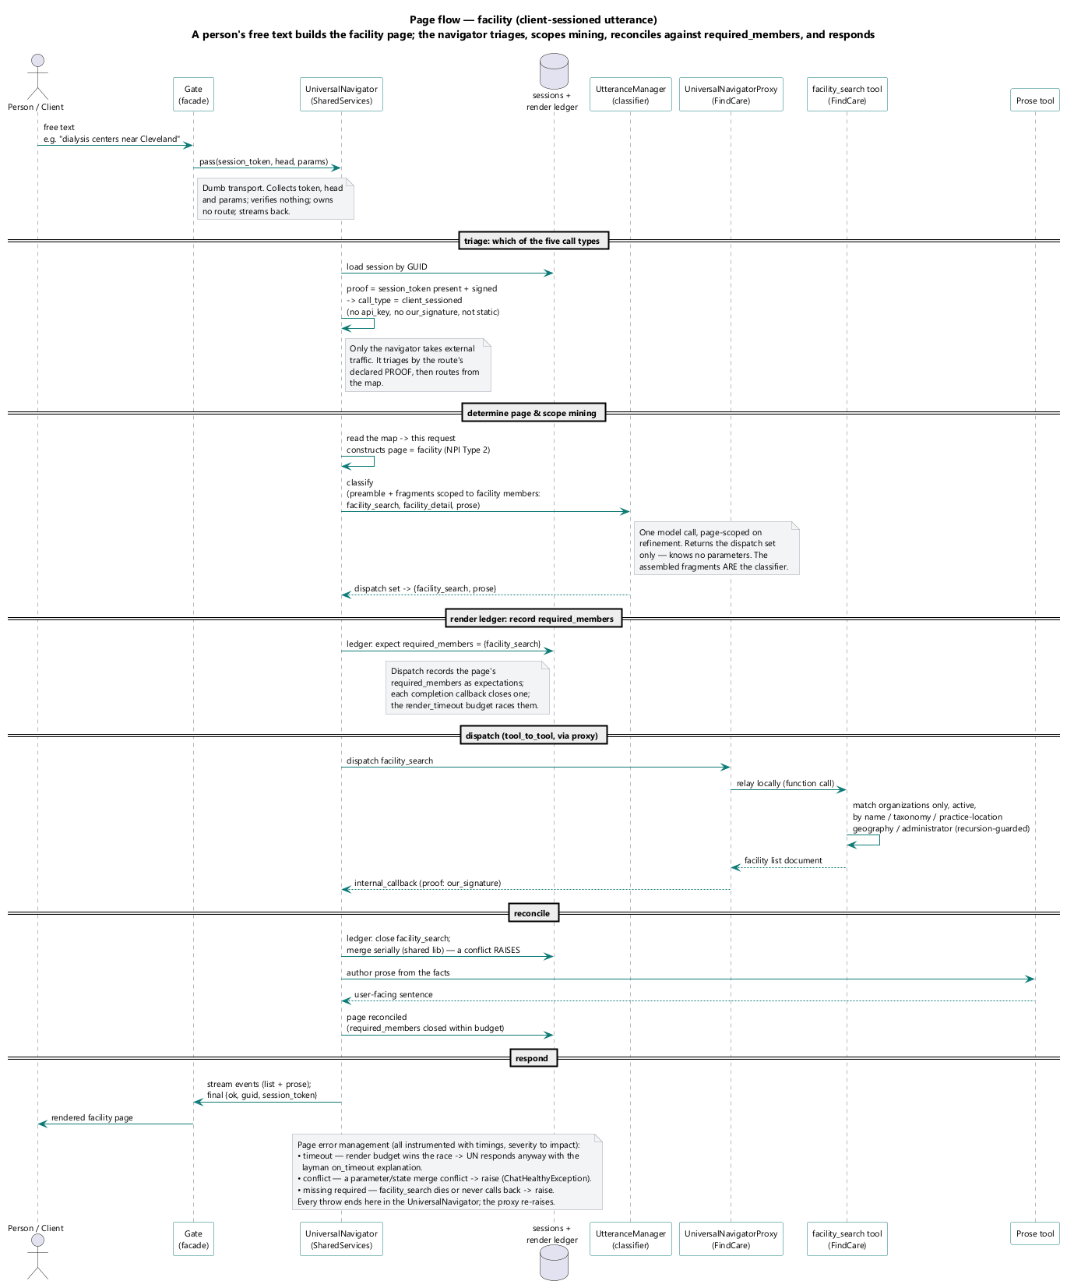
The facility page: the same construction-and-reconciliation path over the facility page's members.

flow_page_clinical_trial (page-type)
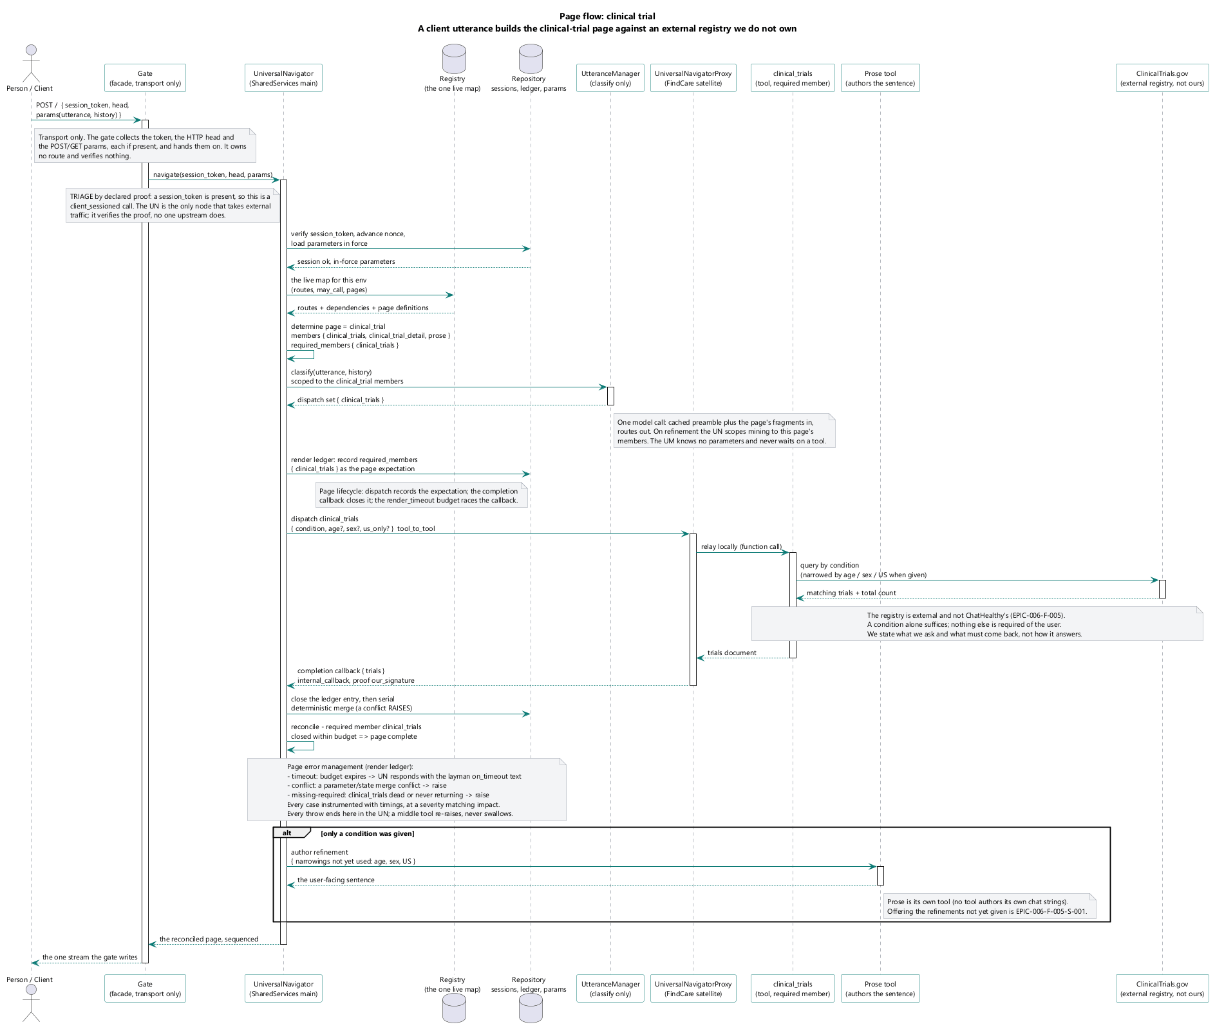
The clinical-trial page: the same path over the clinical-trial page's members.

flow_page_provider_detail (page-type)
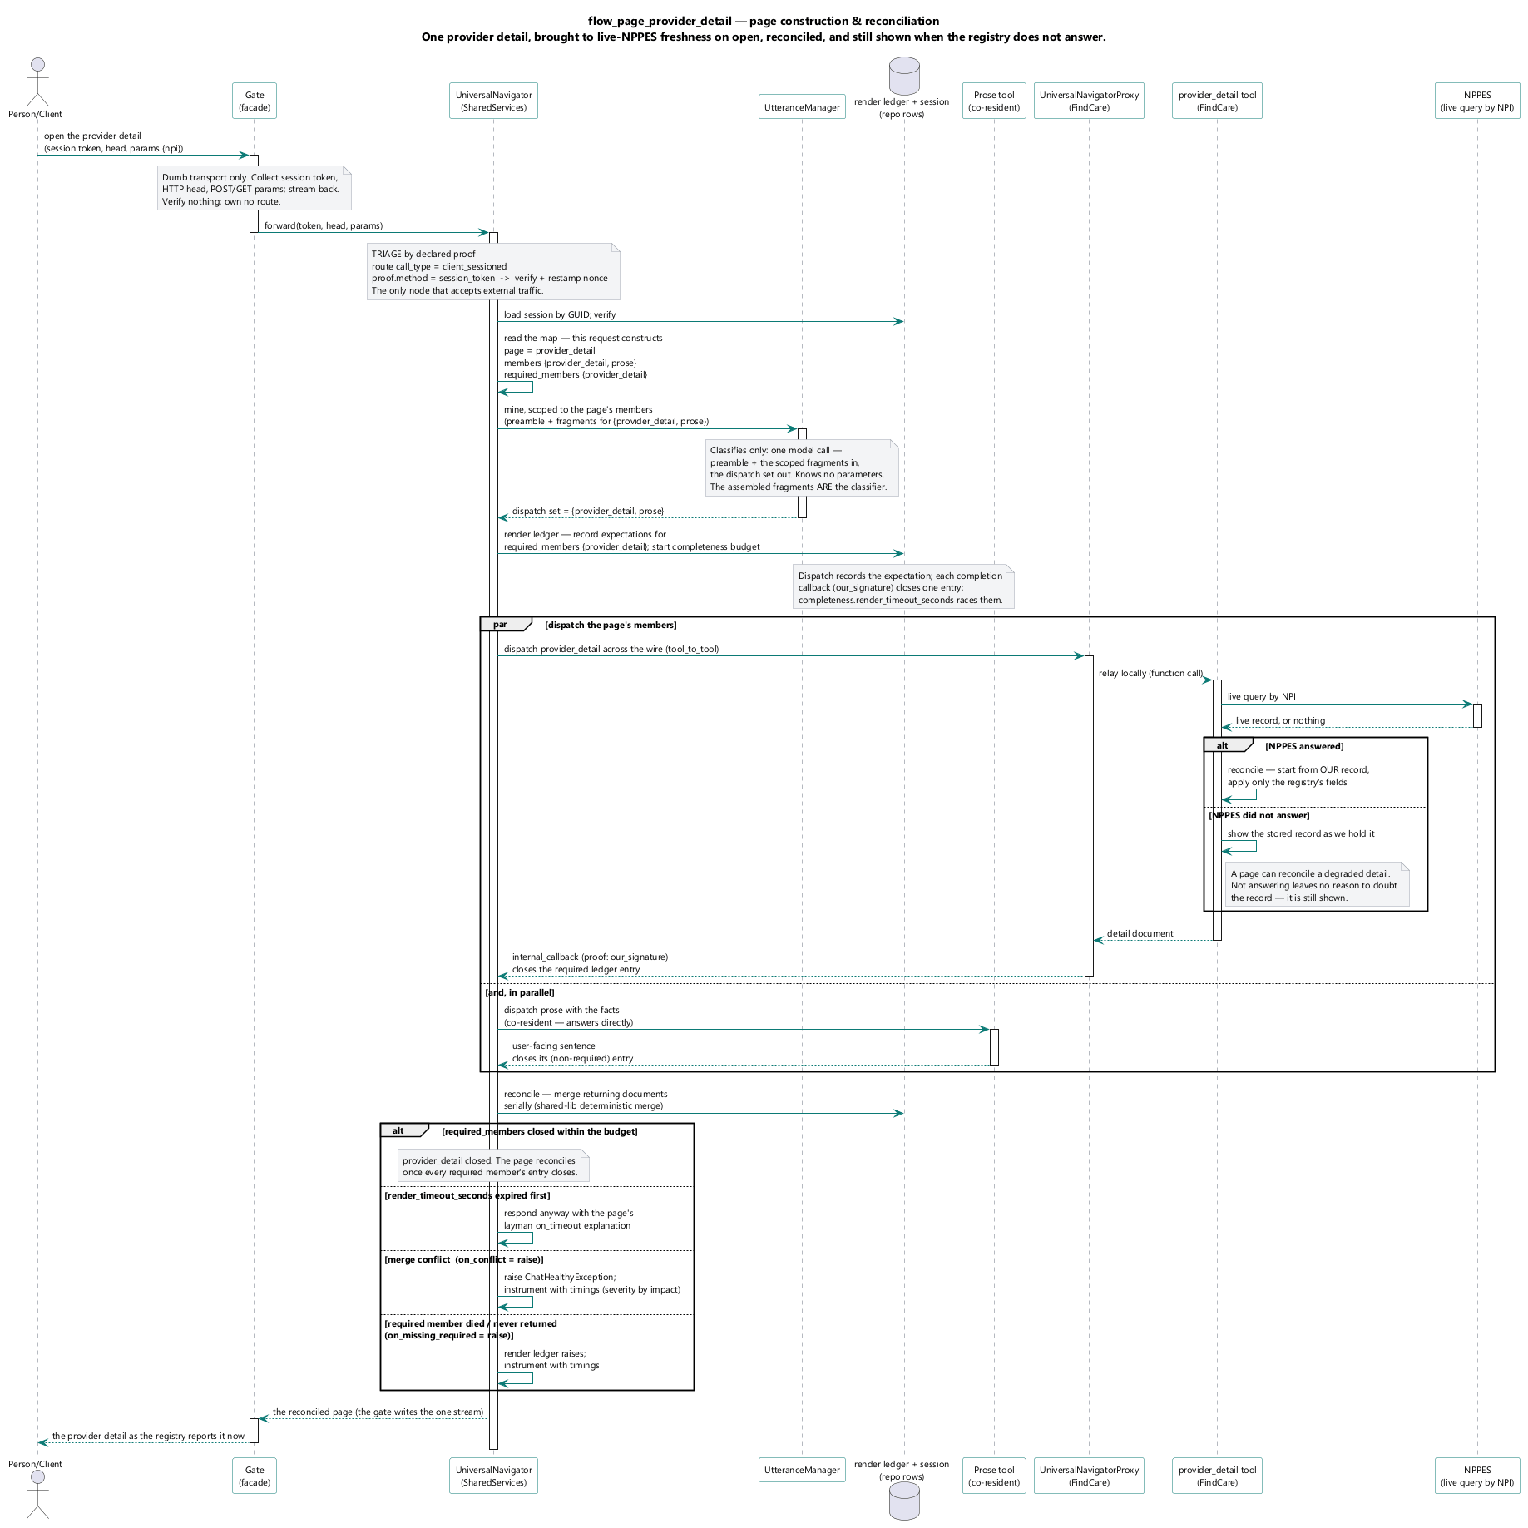
The provider-detail page: a detail brought to live-registry freshness on open, reconciled against its required members, and still shown when the registry does not answer.

flow_page_facility_detail (page-type)
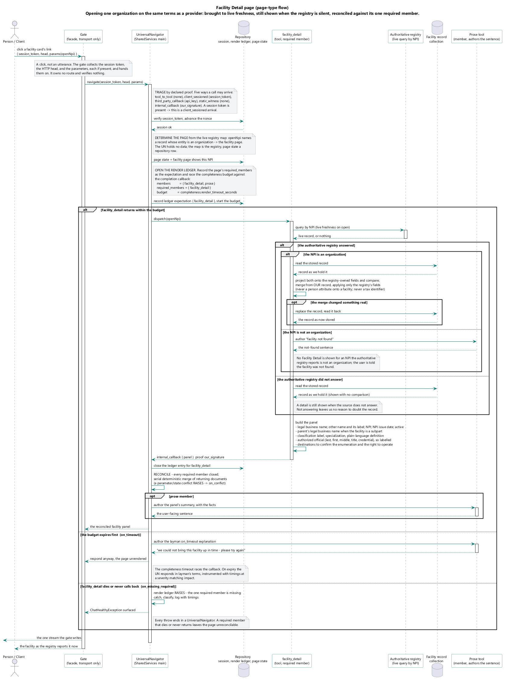
The facility-detail page: the detail path over the facility-detail page's members.

flow_page_clinical_trial_detail (page-type)
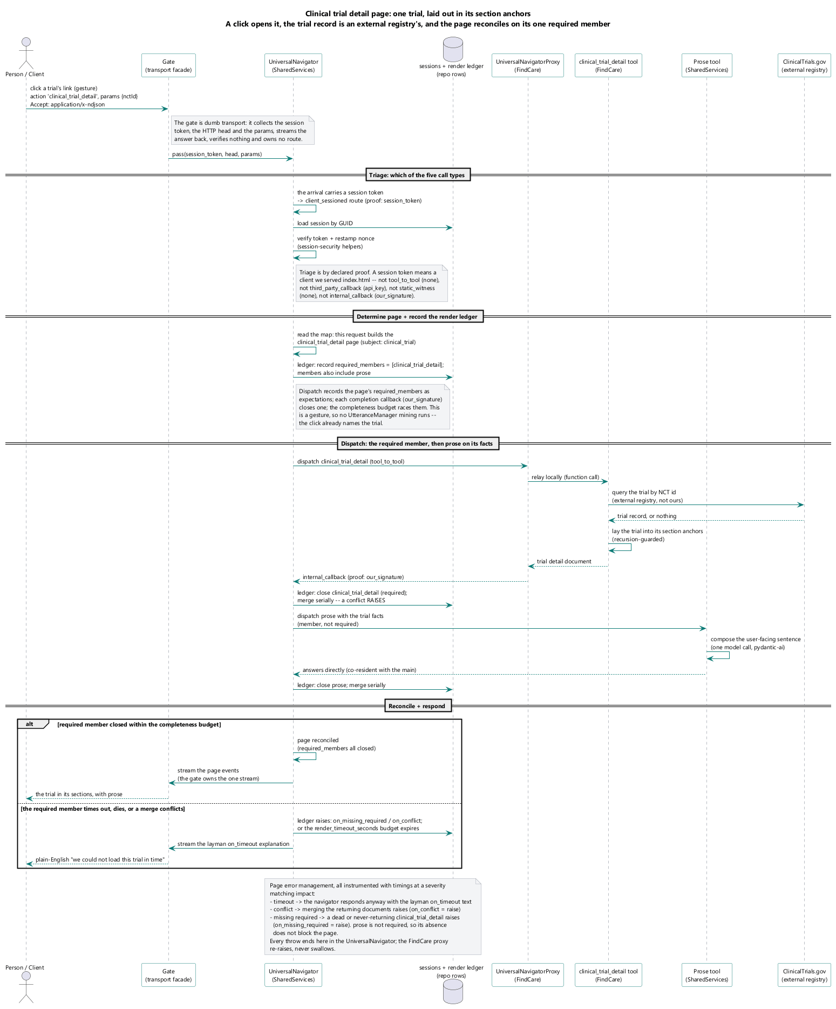
The clinical-trial-detail page: the detail path over the clinical-trial-detail page's members.

3. Conformance
Against the thirteen reference principles of 01_system.md §11. Every check below names an effect a program could observe, not a spelling it could grep. Where the parent's own check names a spelling, I say what the effect-shaped version is.
# | principle | the check, stated as an effect | verdict
11.1 | closed world | the set of action names the deployed classifier can emit, the set the deployed schema publishes, and the set the deployed router can resolve are all equal to the record's | fail
11.2 | language boundary | no function both issues a model call and returns records — except the vocabulary chooser, whose returned records are the intersection of the model's answer with a set retrieved before the call | pass
11.3 | evaluation | a prompt change with no re-scored result is refused | fail
11.4 | drift | every model call's vendor and version are resolvable from the record at the moment of the call | partial
11.5 | prompts are data | every prompt a running process sends resolves to a record id | fail
11.6 | system authors facts | no message carrying a count, an identifier or a date was produced by a model call | pass
11.7 | irreversible decisions | every member of the closed action set is classified reversible or not, and the unavailable path fires a floor | partial
11.8 | materialise before acting | every deterministic stage reads its inputs from a store, not from a model result in hand | pass
11.9 | audit | for a sampled request the store yields model, version, prompt, version, raw output, transformation | partial
11.10 | cost | a query returns cost and duration per turn by call site | fail
11.11 | what a model may never see | every field sent to a vendor is drawn from a declared-permitted set for that vendor | fail
11.12 | non-determinism | identical inputs against one catalogue version produce identical outputs, and sampling is declared | partial
11.13 | the model layer holds no credential, address or policy | no call site selects a vendor or a model | fail

Tally: passes 3, partial 3, fails 7.

3.1 The three it passes, and why they are the right three
[R] They are the three the product was designed around, and they are the three whose absence could not be repaired later, because each is a shape rather than a mechanism.
- 11.2 holds everywhere but the vocabulary chooser, and that exception is the parent's own: a model choosing among retrieved items, intersected back against what was retrieved.
- 11.6 holds by requirement and by construction — the summary is the system's, the sentence around it is the model's.
- 11.8 is the strongest. Parameters are written to the page before the search runs, not after, and the search reads back what is in force — the merge of everything said so far, not only this turn. That ordering is why a follow-up adds to an earlier turn instead of replacing it: it is the difference between a conversation and a series of unrelated queries.

3.2 The vendor finding **[R]**
The most transferable thing in this section, and it is invisible to the parent's check as written.
[I] What I established, by reading the files. Eight Agent(...) constructions across five files build the model client at the call site. (Counting the facade's own vendor construction makes nine sites across six files; the facade's is legitimate and the other eight are not.) Of the eight: three name the model as a source literal; five read the model name from the prompt record and hardcode the vendor prefix in source. Three vendors are live.
The model is data. The vendor is code.
A record can swap one model for another without a release. It cannot move a call off that vendor without one. So the half that is declared is the half that tunes quality, and the half that decides where the data goes is the half that is not declared — which is precisely 11.11's subject. A check for a hardcoded model id passes over this entirely.
[R] And the facade shape matters. The library's facade is a runner, not a constructor: it receives an already-built agent and runs it. So retry, timeout and failure conversion are genuinely central — that half of 11.13 is met — while client construction and vendor selection cannot be, because the agent arrives built. A principle scored as a single pass/fail hides which half a system actually has.

3.3 The list 11.7 asks for **[I]**
11.7 requires the architecture to carry the list. No other artifact does, so it is here:
model-mediated decision | reversible | floor when the model is unavailable
which capability the turn asks for | yes — the next turn re-classifies | a clarification turn
a mined parameter value | yes — stored with visible provenance, changeable from the panel | not in force; the tool refuses and asks
a vocabulary selection | yes — ticks the person adjusts before applying | none; the panel is empty and the person is asked
authored prose | yes — it is a sentence | none
a safety lockout | operator only | a deterministic keyword path

One row of five is safety-bearing and it is the only one with a real floor. That is the correct shape — and it was true by accident rather than by decision, which is exactly what 11.7 exists to catch.

4. Non-compliance register
Every row is a claim this document makes, walked against disk. Evidence types: behaviour (I read the code path), data (I read the record or the store), requirement (an approved requirement says so), intent (a design document states it as a target). Prose is not an evidence type.
# | the claim | what is actually there | evidence | closes it
R-01 | The capability set is closed and stated once. | Three enumerations — 7, 6 and 5 names — that disagree. The published schema is missing two live capabilities while asserting completeness. Nothing compares them. | behaviour | §2.8.3
R-02 | The capability set lives in the record. | It is a static type in source. The record carries no capability list. | behaviour + data | §2.8.3
R-03 | The router dispatches by name and holds no capability knowledge. | A conditional chain with one arm per capability; three arms do the work inline, one builds its own HTTP client and hand-assembles its stream event; four capability-naming tables live in the router. | behaviour | §2.8.3
R-04 | An undispatchable action is refused. | The chain's final branch logs and continues. | behaviour | one raise
R-05 | Three writers, one outcome. | Two code paths write the same session document path — one validates the page against the closed set and builds the entry through the model, the other hand-builds the dict and validates nothing. | behaviour | make them one
R-06 | A kind is claimed by exactly one widget. | No claim protocol. The main window is an assignment; last writer wins. Widgets stand down voluntarily on a signal not emitted for the commonest turn. | behaviour | §2.6.5
R-07 | The browser is told what a page is. | No such op. Frame knowledge is hard-coded in three unreconciled places. | behaviour | §2.6.5
R-08 | Authored front-end carries no business logic. | Client-side pagination of a whole result set with no server record of position; a widget discarding the server's summary and composing its own count; a handoff panel painted from a browser cache; retry cadence owned by a widget. | behaviour | §2.6.6
R-09 | One session validation. | The entrance validates once. A third place also derives session liveness. | behaviour | security's §5.3 ruling
R-10 | Every component refuses traffic that did not come through the entrance. | One component verifies on most routes. Another verifies on none that serve work, and one route computes a verification result and never tests it. | behaviour | → 02_security.md
R-11 | A model runs in five kinds of place, all behind the facade. | Eight call sites construct their own agent; three name the model as a source literal. A sixth model-backed service is constructed on the request path and called by nothing. | behaviour | §3.2
R-12 | Prompts are data. | The classifier's prompt is a multi-line literal in a runtime module; the record for it declares a different vendor's model than the one that runs, and its own source_file field records that the code is the source and the record a copy. A second record names a source directory that does not exist. | behaviour + data | §2.8.2
R-13 | Carry-over is decided per parameter, per source, per destination. | The mechanism runs on every dispatch with an empty input; the declaration states no triples and a router table meant to hold destinations is empty and read by nothing. | behaviour + data | operator — §5
R-14 | Requirements are per tool, so a missing one can always be named. | Two declared tools carry no subscription at all, so neither can ever be found to be missing anything. One capability kind is resolved inside another tool's route and cannot be required of. | data | a subscription each
R-15 | The library holds no domain knowledge and mounts no routes. | It holds an utterance-mining model call — live, wrapped as a tool and imported — an embedding projection, four pipeline modules, and the capability catalogue; and it mounts two HTTP routes into every host that imports it. | behaviour | §2.7
R-16 | The declaration says where a tool is served and callers read it there. | A reader exists; callers construct their routes themselves. Two facts that can differ, and nothing compares them. | behaviour | check 2
R-17 | The four capability kinds are filled for every subject. | Nine of twelve. One vocabulary chooser is resolved inside a search route rather than being a tool; one subject has neither a vocabulary step nor a detail tool and paints its detail from a cached search result. | data + behaviour | four tools
R-18a | Unoriginated traffic arrives at a URI the gate owns and is dispatched (§2.2.1). | The identity-provider callback is served on its own route outside the gate. It is non-compliant, not an exception: it already carries an HMAC-signed session reference in state, the fact-collector already accepts any request, and the handler is already its own module. | behaviour | Scheduled. One dispatch entry; register the handler as a tool. Sequenced with 06_migration.md Phase 1 (the contract) and Phase 4 (the router dispatches by name).
R-18b | Nothing is exempt (§2.2.1). | A secrets-name route and a debug route sit outside the gate. Neither is originated traffic, neither is a callback, and neither is a liveness probe — so no class in §2.2.1 admits them. | behaviour | Not a routing job — deletion. A route that answers questions about the process it runs in has no place in either inbound class.
R-18c | Nothing is exempt (§2.2.1). | Session issuance sits outside the gate. This one is a genuine either/or and it is not mine: an unauthenticated op on the gate weakens "no op is exempt", and a separate endpoint weakens "one entrance". Both readings comply with something and neither with everything. | behaviour + requirement | operator — §5 Q7. Not scheduled, because which target is right is undecided.
R-19 | A tool never authors display. | True on the server. | behaviour | —
R-20 | A page's requirements are its tools', never its own. | True in the record and in the readers. | data | —
R-21 | Sensitive text is de-identified before storage. | The de-identification layer does not exist — no service, no module, no symbol. The verbatim utterance reaches a model vendor through the classifier on every typed turn, and the lockout path stores the trigger message and the conversation history beside the network address. | behaviour | → 02_security.md
R-22 | A running target reports the build it carries, as evidence. | It reports a value read from a file baked into its own image. A target repeating what it was handed is weaker evidence than the requirement intends. | behaviour | → 03_devops.md
R-23 | The library's tool contract carries no policy. | The base class's cross-service call disables peer certificate verification on the same call that forwards the session token, so every tool inheriting the contract ships without transport authentication. | behaviour | §2.7
R-24 | The browser addresses one component (§2.2.1, originated class). | A widget fetches a capability component directly — the browser addressing a second component, and the route it calls is that component's one non-health route with no signature guard, so both halves of the boundary fail at one line. Originated traffic, so the rule is unambiguous: it MUST POST to the gate. | behaviour | Scheduled and named: serve the content through a gate op and delete the capability-component route. Deleting it is the half that matters — routing the caller while leaving the route open closes the call site and not the door. 06_migration.md Phase 5 (the front end) is where the widget moves.
R-30 | Declared equals dispatched can be evaluated. | It cannot. The record names seven tools in one convention; the modules declare nineteen in another; nothing declares the mapping, and the string intersection of the two sets is zero. Crosswalk check 2 can neither go green nor go usefully red, and the record's own where-is-this-tool-served reader is dead for the same reason — a caller looking up its own name would never find itself. | behaviour | §2.8.5a. The record's tool row carries the module's name, or the module takes its name from the record. Prerequisite to `06_migration.md` Phase 0 gate 2 and Phase 4's proof.
R-31 | The published schema is readable, so the closed set is checkable from outside. | The published schema address returns HTTP 403 (coordinator's gate run; not verified by me). If it holds, the falsifier's first read (§2.8.6) is unexecutable and the drift between the served schema and the record is undetectable from outside the network. | behaviour, attributed | Make the address serve; then generate the schema from the record (§2.8.2) so there is nothing to drift.
R-25 | The application does not write served data. | An application test writes the served collection directly — an approved requirement's fixture manufactured by mutating the collection the requirement is about. | behaviour | delete it
R-26 | The library's database utility holds no key material. | It writes the certificate and private key as a PEM into the system temp directory, with the permission-tightening failure swallowed. (That it is never removed I did not verify; that half is `04_pipeline.md`'s NC-21.) | behaviour, partial | §2.7
R-27 | The transport carries the authority tags, and a result says when it matched on a derived value. | Neither is carried. No widget could distinguish a reported code from a repaired one even if required to, and a result that matched through a repair looks identical to one that matched directly. | behaviour | §2.6.6; the rule itself is §5 Q4
R-28 | The courier has one verb. | It accepts a message type that runs new Function(...) on an arbitrary string in the top window, inside a swallowing try/catch; the receiver checks no origin and outbound posts target any origin. | behaviour | §2.6.4
R-29 | The nine crosswalks make the rollout mechanical. | Two do. Five name a spelling and share the failure mode of §2.8.5; one is not implementable as written; one is sound only if built one particular way. No check in this system has been proven by a seeded violation. | behaviour (self-audit) | §2.8.5, §2.8.6

5. Open questions for the operator
Q1 — Does `EPIC-006-F-008-S-002` (carry-over) stand? The story is approved and binds; the operator has since called carry-over an anti-pattern; the built mechanism runs with an empty input. Keeping it costs a decision surface of parameters × pages × pages, an ordering guarantee, and a display obligation. Withdrawing it costs a convenience — a person states a geography twice — and orphans a second approved requirement (-S-005-REQ-B-008, name where a carried value came from) and the record field that serves it. The architecture will not withdraw a requirement and will not author a replacement.
Q2 — Result-row width. Two approved requirements already close this at two different widths for two different subjects: a facility row at exactly five things, a care-giver row at eight elements plus headings and paging controls. The question is whether you accept two widths. If yes, this is not an open question but a non-compliance row and I will move it.
Q3 — Which parameter-writing practice is confirmed? Ability is fixed by approved requirement — all three routes must be able to write any parameter. Practice is open, and the parent's §6.4 takes the position that each page mines its own. Confirm the practice; the ability is not removable without moving a requirement. Either way -REQ-B-004 requires the two live write paths (R-05) to become one.
Q4 — When a record matched through a repaired code, does the display show the reported value, the derived value, or both? This is one question with `04_pipeline.md` Q6, and it is recorded in both documents by cross-reference rather than restated. The joint position that artifact and this one have already settled between us: the store's authority tags survive to the display and the result-row contract carries them; the tag vocabulary belongs to `04_pipeline.md` §7.4; the rendering rule belongs here (§2.6.7). What neither of us may decide is which value the person sees, because two approved requirements pull against each other — EPIC-006-F-001-S-004-REQ-B-001 says show the specialty the person chose, and the non-conversion rule says never present a repair as though it were the report.
Q5 — Does location extraction stay in the shared library? It is a live, single-purpose model call that mines a geography from an utterance, sitting in the library every front-end component installs. It fails test 2 of §2.7. Either the code moves or the boundary gets a stated exception — and it is the template for four other modules in the same position.
Q7 — Where does session issuance live? The one case in §2.2.1 that is a genuine either/or, and the only reason R-18c is unscheduled while R-18a and R-24 are scheduled. A session must come from somewhere and cannot present the thing it is about to create. Two targets, each complying with one half of the architecture and neither with both: an unauthenticated op on the gate keeps one entrance and weakens no op is exempt; a separate endpoint keeps every op authenticated and weakens one entrance. I have no basis to prefer one and will not invent one — but the choice is small and the consequence is not, because whichever is chosen becomes the sentence a buyer is told about how a session begins. Security's view is that resuming a session should require proof of possession of the prior token rather than knowledge of its identifier; that is orthogonal and holds under either answer.
Q6 — Which classes of data may cross to which vendor? No such declaration exists: the record names the vendors as credentials to fetch and says nothing about what is sent to them. Three vendors are live and every typed sentence reaches at least one, carrying the recent conversation with it. This is not an engineering gap; it is a position the firm has not taken, and no artifact owns taking it.
Q8 — Does the utterance manager keep prose and parameters, or shed both? The target splits user-facing prose into a separate tool the UniversalNavigator dispatches with the facts, and strips the utterance manager of parameters entirely — it classifies only, non-blocking, and returns the dispatch set knowing no parameter. Three approved requirements place both inside it: EPIC-002-F-010-S-001 has the utterance manager author user_message, EPIC-002-F-010-S-003 gives it the manufacture path, and EPIC-006-F-008-S-003 names it one of the three parameter writers. The architecture will not move a requirement, so which stands is the operator's to say. Until then §2.3 and §2.5.4 describe the behaviour that is built, and this question records the target that contends with it.

