ChatHealthy.ai
Find Care. Evaluate Care. Discuss Care.
Business Architecture

ChatHealthy.ai provides the data, tools, and an AI-enlightened space to empower regular people to prevail over the broken healthcare system. Whatever a person's circumstances might be, they deserve the best possible care, at the best value. ChatHealthy.ai gives them the platform to get it. By presenting and evaluating care options but never giving medical advice, the platform allows families, individuals, and friends to collaborate with the most powerful AI models in order to choose the best provider they can have.

Copyright 2026 Skip Snow. All rights reserved.

Executive Summary
Healthcare is the largest consumer market in the world, yet the individual remains the least empowered participant. Decisions are fragmented across search, opaque quality data, and isolated conversations with no coordination. The result is predictable: overpayment, underperformance, and preventable harm. ChatHealthy.ai exists because this gap is not a feature of the system — it is the system’s failure point.
ChatHealthy.ai unifies the healthcare decision process into a single consumer-controlled environment: find care, evaluate it with real quality signals, and decide collaboratively with people and AI. This is not another point solution. It is the decision layer sitting above the entire healthcare system, where choices are actually made. Once this layer exists, control shifts from institutions to individuals.
The business model follows the control point. We own the decision room. AI companies, not patients, pay to participate in it. As healthcare decisions become AI-assisted and collaborative by default, ChatHealthy.ai becomes the gateway through which those decisions flow. This is not a feature set. It is inevitable infrastructure.

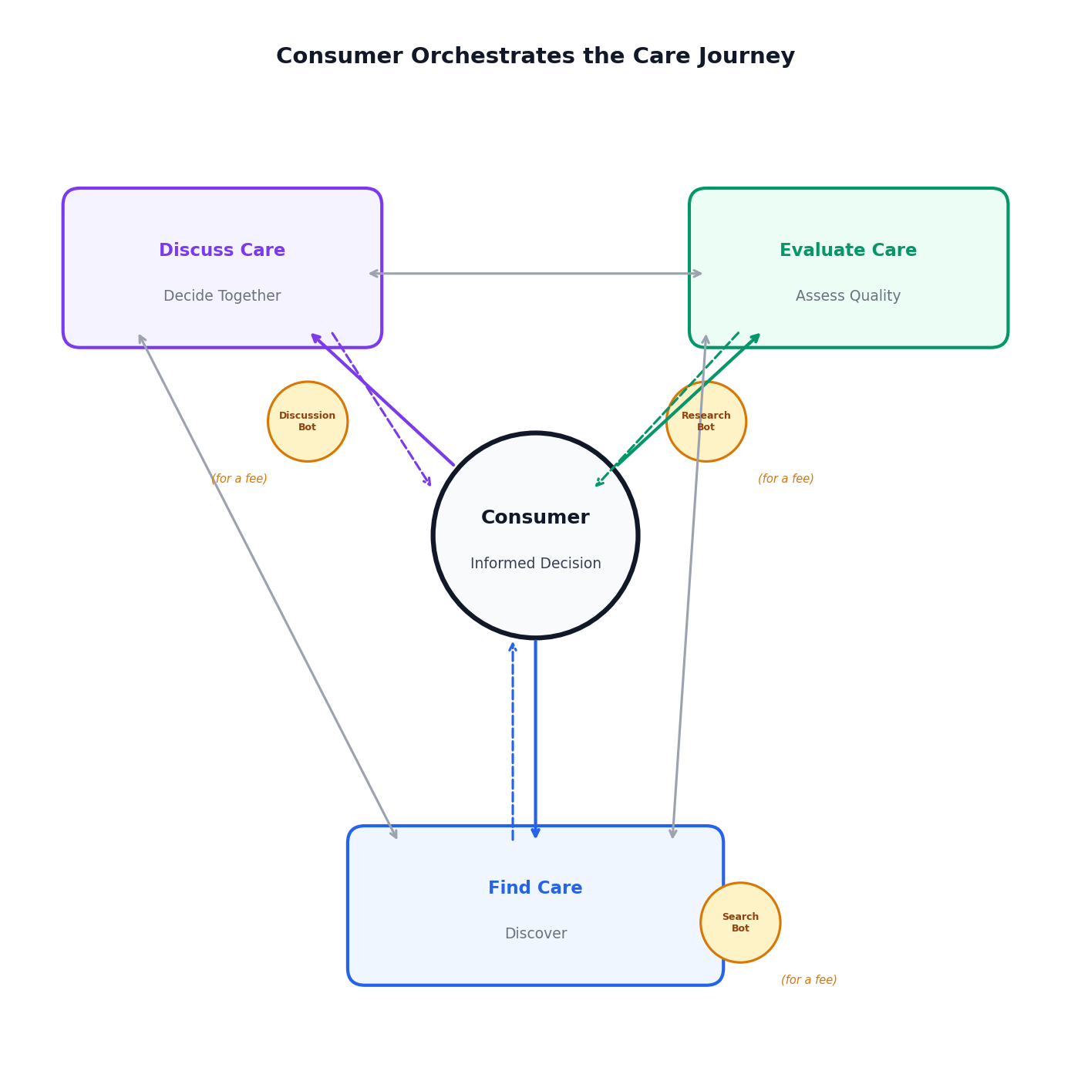
Fig. 1: The consumer orchestrates the care journey. Three components serve the decision, not a linear pipeline.

Platform Architecture
ChatHealthy.ai is built on three business components. The consumer is at the center, orchestrating the relationship between all three. This is not a sequential journey -- it is a decision-making environment.
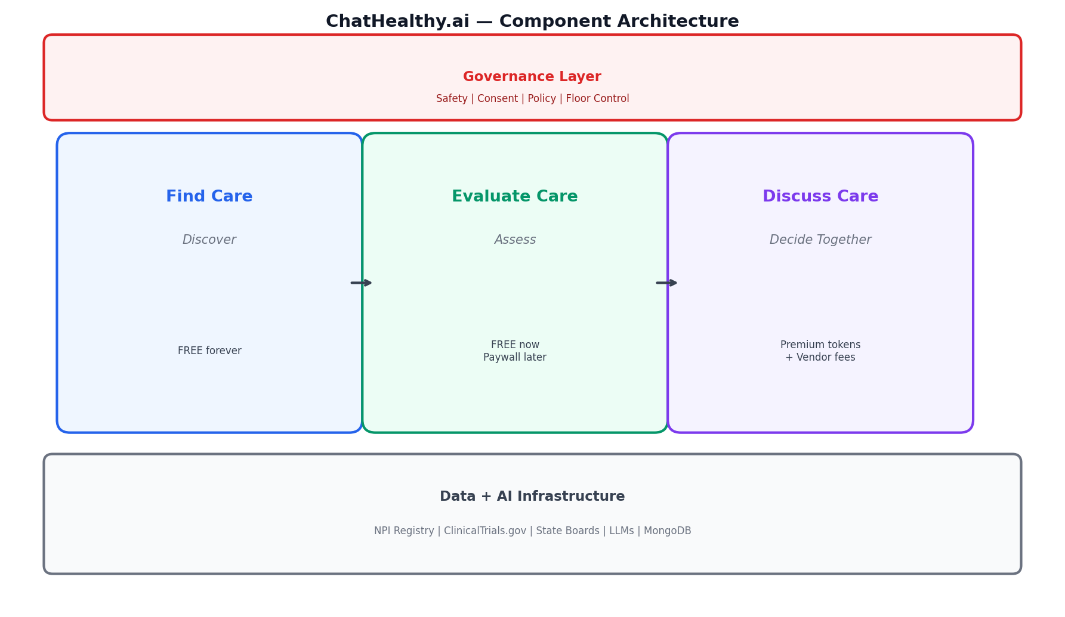
Fig. 2: Three components share a governance layer and data infrastructure.

find_care
The entry point to the healthcare system, redesigned for clarity and control. Users discover providers, specialties, and care pathways without friction or bias.

Capabilities
- Provider and specialty discovery
- Navigation of care pathways
- Geographic and access-based filtering
- Integrated entry into evaluation and discussion
Pricing: Free forever

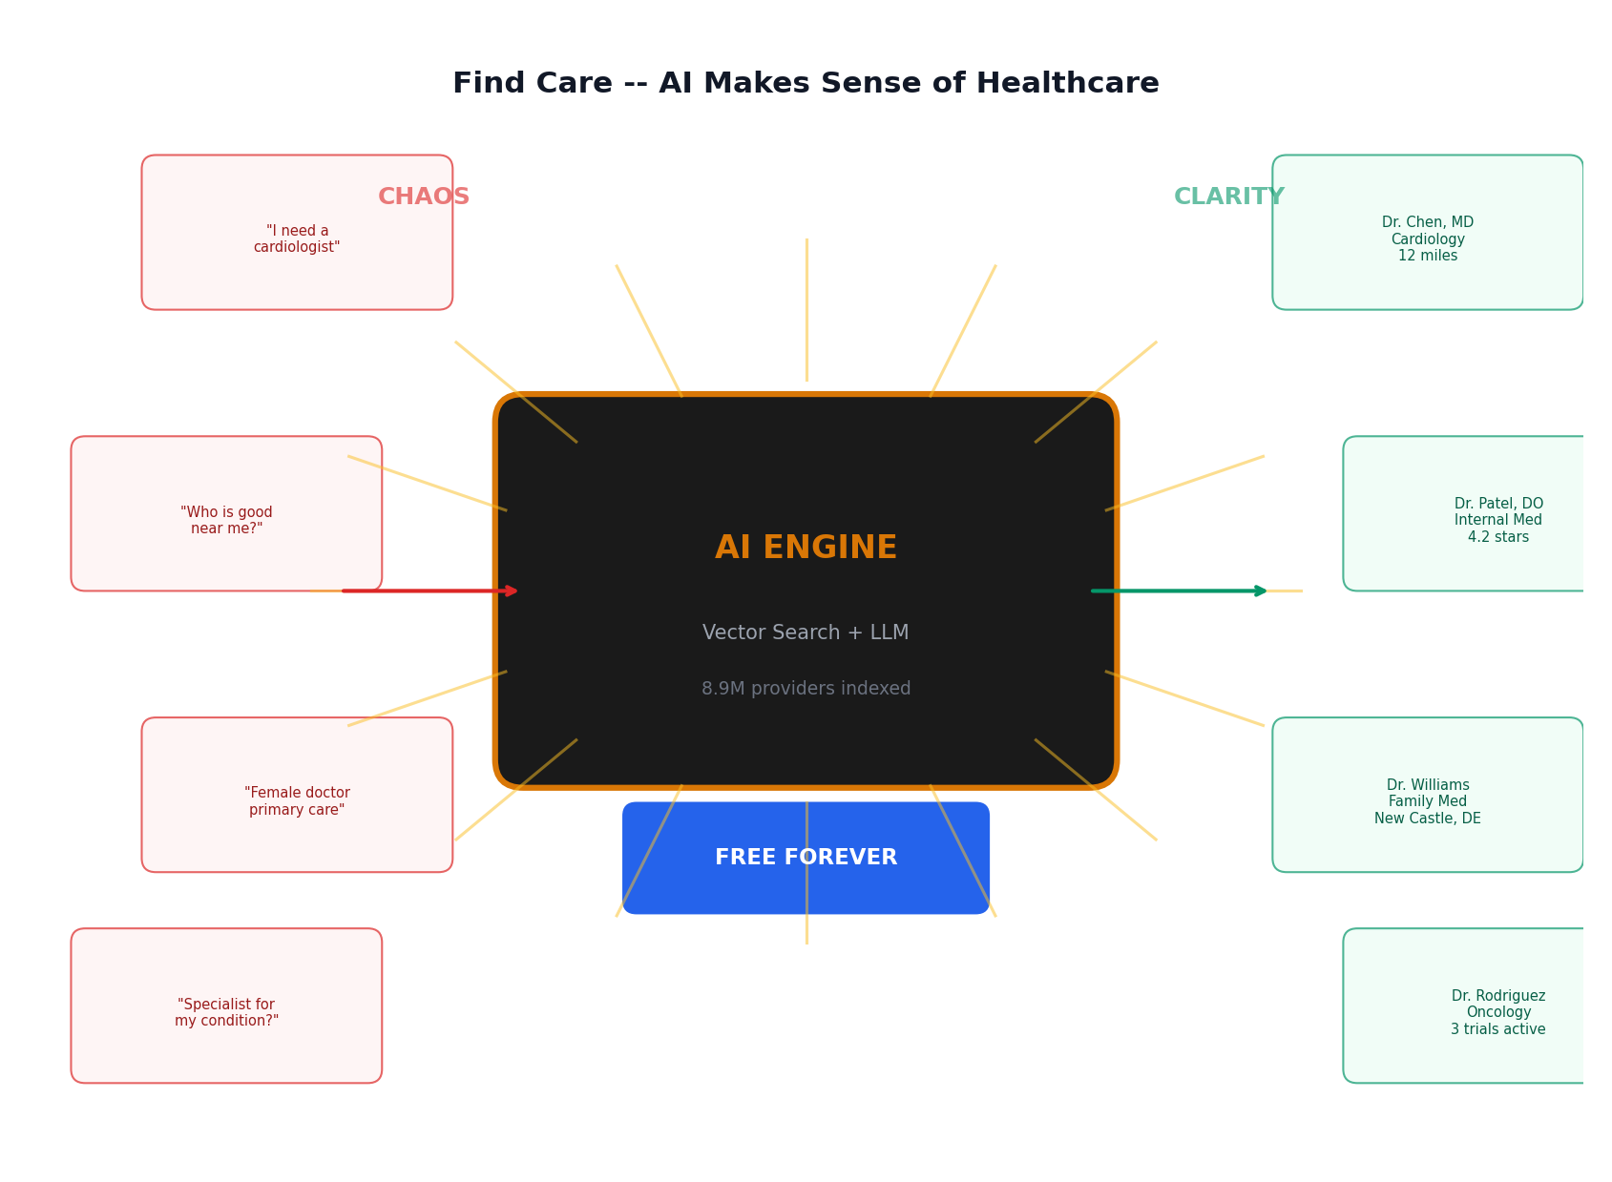
Fig. 3: Chaos in, clarity out. The AI engine translates natural language into precise provider matches.

evaluate_care
Transforms fragmented public and clinical data into clear, consumer-comprehensible quality signals using proprietary AI synthesis.

Capabilities
- Clinical trials discovery and matching
- Provider credential analysis
- Quality signal aggregation and interpretation
- Comparative provider evaluation
Pricing: Free initially, with premium paid tiers for advanced insights and deeper analysis

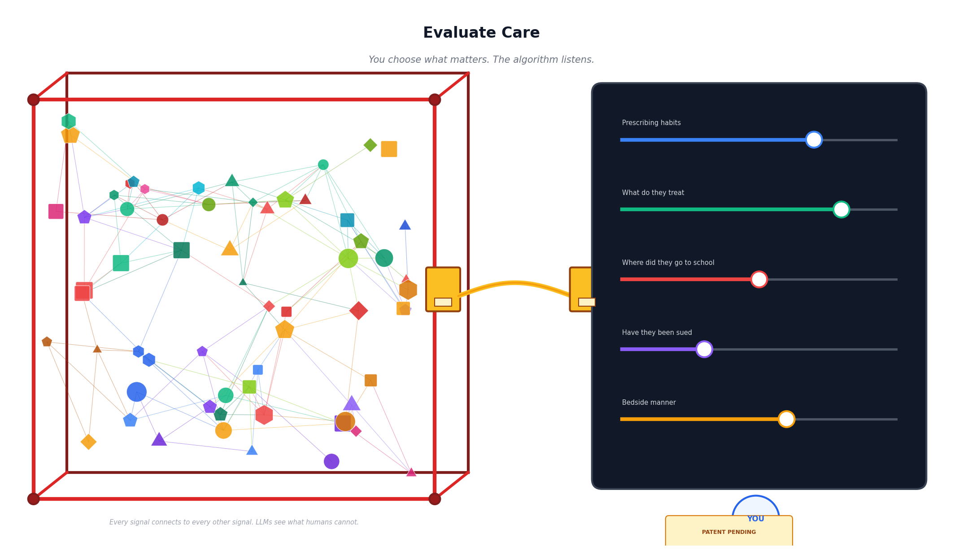
Fig. 4: Public data flows through a graph network. The consumer tunes the algorithm. Patent pending.

discuss_care
A real-time, multi-participant decision environment where individuals bring family, caregivers, and multiple AI models into a single structured conversation.

Capabilities
- Multi-human, multi-AI shared sessions
- Invite-based collaboration with no account friction
- AI model selection and competition within the same session
- Shared tools across participants (search, evaluation, trials)
- Persistent sessions with exportable transcripts
- Shared research bot for autonomous analysis
- Consent-based participation and governance controls

Features
- DC-01: Shared Chat Session -- Multiple humans in one conversation with AI assistance
- DC-02: Invite System -- User sends invite link to friends, family, caregivers. No account required.
- DC-03: Multi-Model AI -- Multiple AI models participate in the same session (Claude, GPT, etc.), each with access to all tools
- DC-04: Shared Tool Access -- All participants (human and AI) can trigger provider search, clinical trials, specialty identification, provider detail
- DC-05: Healthcare Guardrails -- Conversations constrained to healthcare navigation. Same safety filter, emergency detection, scope rules.
- DC-06: Session Transcript -- Exportable transcript for sharing with doctors, care teams
- DC-07: Consent per Participant -- Each participant manages their own consent tier independently
- DC-08: Participant Roles -- Session creator (host), invited participant (peer). No admin/enterprise roles.
- DC-09: Real-Time Collaboration -- All participants see messages and AI responses live
- DC-10: Session Persistence -- Sessions survive disconnects, resumable by invite link
- DC-14: Shared Research Bot -- Any participant or component can dispatch a research bot to gather information. Shared object across all three components and pipelines. Bot runs autonomously, returns findings to the session. Dispatched by consensus or individual request. All bot work incurs a fee.
- DC-15: Licensed Provider Detection and Compliance Disclosure -- If a participant identifies as or is detected as a licensed healthcare provider, the system triggers automatic compliance disclosure: (1) ChatHealthy.ai is not subject to HIPAA, (2) This session does not create a provider-patient relationship, (3) Security standards disclosed (HITRUST/DOD/SOC2). All participants must acknowledge before session continues. Consent re-confirmed.
Pricing: Premium via AI token usage markup; users pay only when they choose advanced AI participation

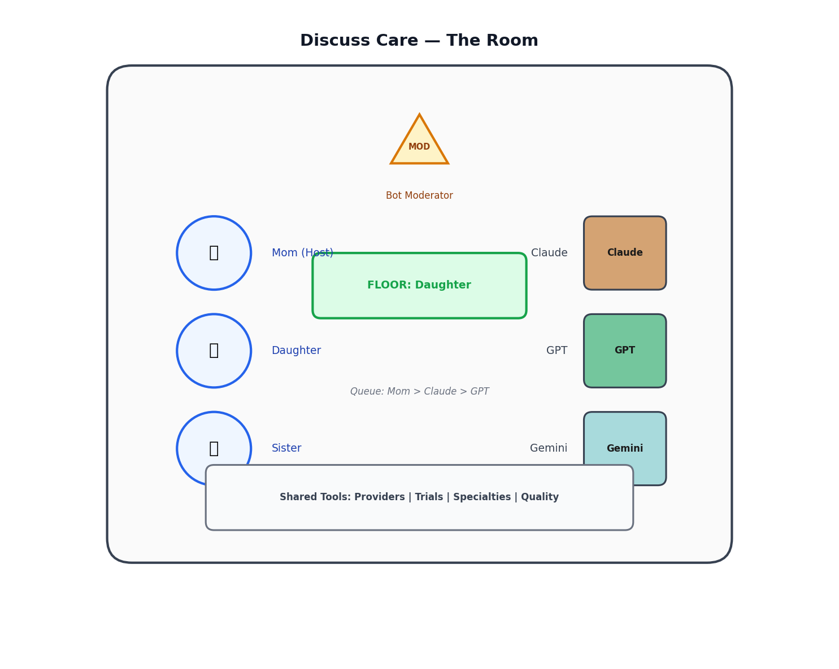
Fig. 5: Inside a Discuss Care session: humans and AI models collaborate with shared tools.

Revenue Model
- AI token markup on premium model usage within Discuss Care
- AI vendor access fees to participate in decision sessions
- Future premium subscriptions for advanced evaluation insights

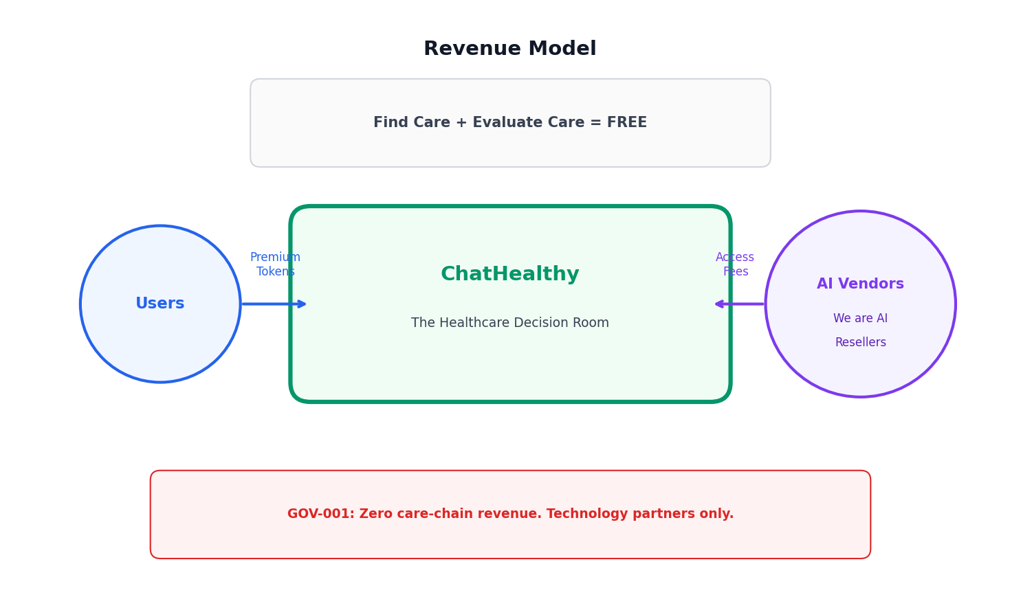
Fig. 6: Two-sided platform. Consumers pay token premiums. AI vendors contribute capital.

Competitive Moat
Regulatory Willingness
AI vendors avoid FDA classification and HIPAA compliance. They need someone else to own the healthcare room.
Governance Framework
Multi-AI safety, consent, floor control, moderation. Nobody else has this.
Data + Network
Provider, trial, and quality signals compound over time. Takes years to build.
Consumer Trust
Years to build, seconds to lose. Trust is the ultimate barrier.
Patent
LLM-based synthesis of provider quality signals. Method patent pending.
IP Protection & Trade Secrets
Proprietary algorithms, data processing methods, and governance frameworks.

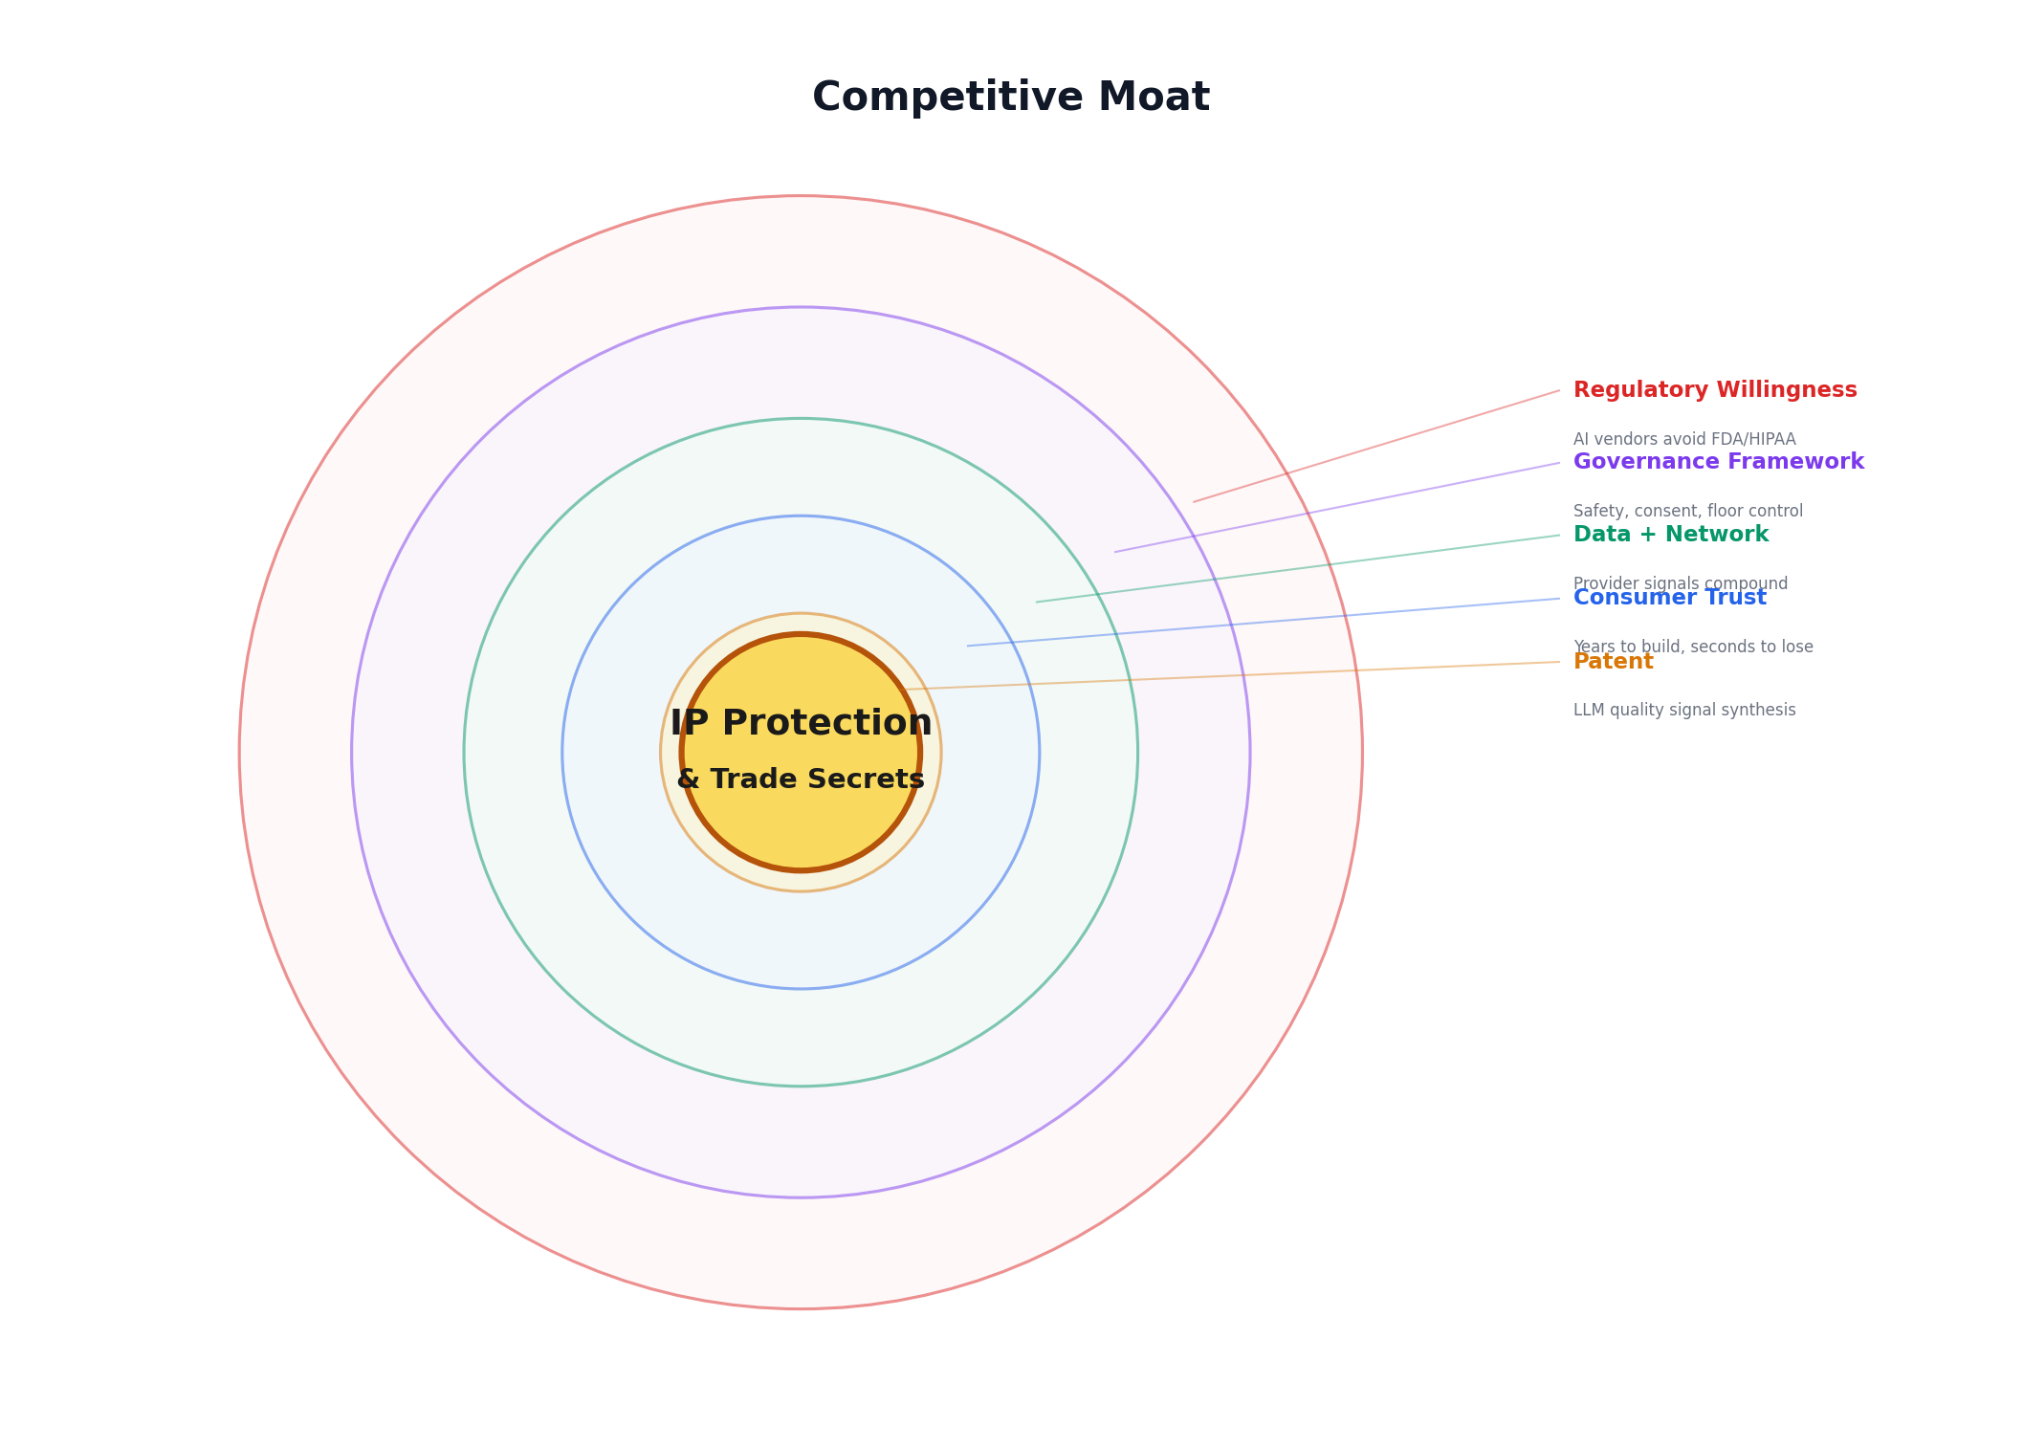
Fig. 7: Five concentric barriers. IP Protection & Trade Secrets at the core.

Competitive Landscape
The healthcare navigation market is dominated by platforms that earn revenue from the providers they claim to evaluate. ChatHealthy.ai is the only platform built entirely on the consumer side of the table.
Every incumbent earns money from the care chain -- providers, hospitals, or payers. This creates a structural conflict of interest. The consumer cannot trust a platform that is paid by the people it is supposed to evaluate.
Yelp Health
Earns revenue from sponsored listings. Providers who pay appear first. Consumer trust is the product being sold.
ZocDoc
Charges providers for patient bookings. The platform is a referral engine disguised as a search tool.
Healthgrades
Revenue from provider advertising and hospital partnerships. Ratings influenced by who pays.
Angies List
Merged with HomeAdvisor. Lead generation model. Providers pay for leads. Consumer is the product.

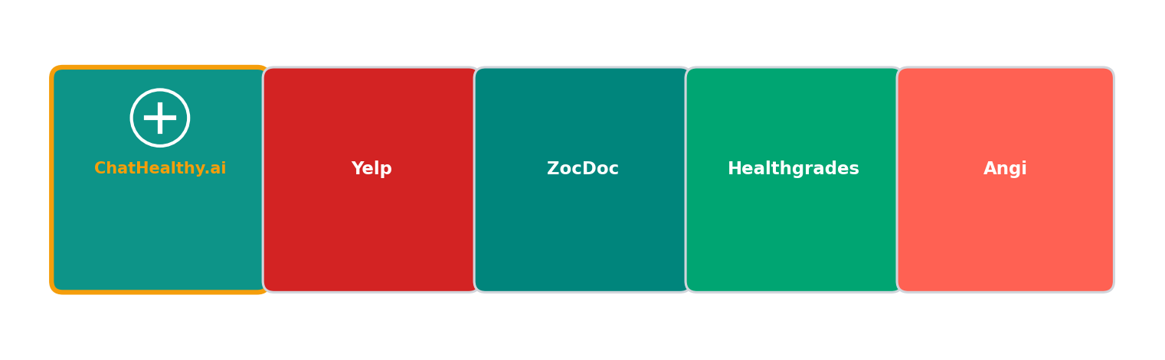
Fig. 8: The healthcare navigation market. ChatHealthy.ai is the only platform that takes zero revenue from the care chain.
ChatHealthy.ai will never take money from providers, hospitals, payers, pharmaceutical companies, PBMs, or any entity in the care delivery or payment chain. This is not a guideline. It is governance policy GOV-001, permanent and non-negotiable. Our revenue comes exclusively from consumers (token premiums) and technology partners (AI vendor capital). This is our moat. No incumbent can match it without destroying their business model.

Security Positioning

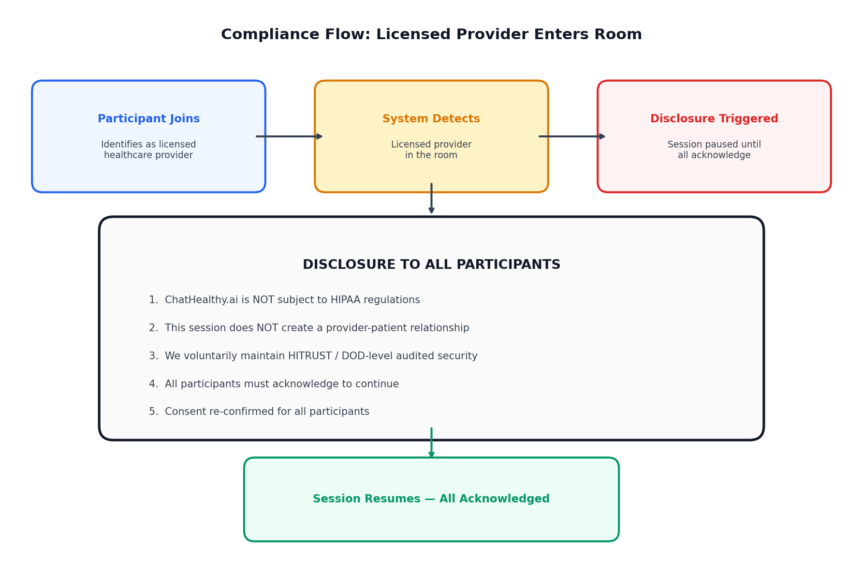
Fig. 9: Licensed provider enters the room -- mandatory disclosure to all participants.

Investment Thesis
ChatHealthy.ai sits at the intersection of two inevitable shifts: consumer control of healthcare decisions and AI participation in those decisions. The company captures value by owning the environment where both converge. Investors are backing a platform that becomes the default interface for navigating a $4 trillion market. Strategic value is immediate for AI companies seeking distribution, and long-term for any entity that benefits from influencing healthcare decisions without regulatory exposure.

Timeline
- 2026-09-30 -- iPhone App Launch

ChatHealthy.ai Business Architecture | 2026-03-31 | Authored by Claude Code

