FindCare — Architecture
Three capabilities, twelve tools, one shape. The entrance, the router, the session and the parameter model are the SharedServices architecture and are not restated here.

1. The three capabilities
FindCare answers three questions, and a page answers each. A page is not a screen: the application is one screen of frames, and a page is which of them are in force, what they show, and whose parameters are read.

1.1 Find an individual
A care giver — a named practitioner, or whoever treats what is wrong with the person asking. Rows are people, each with a licence, a specialty and one or more practice addresses.
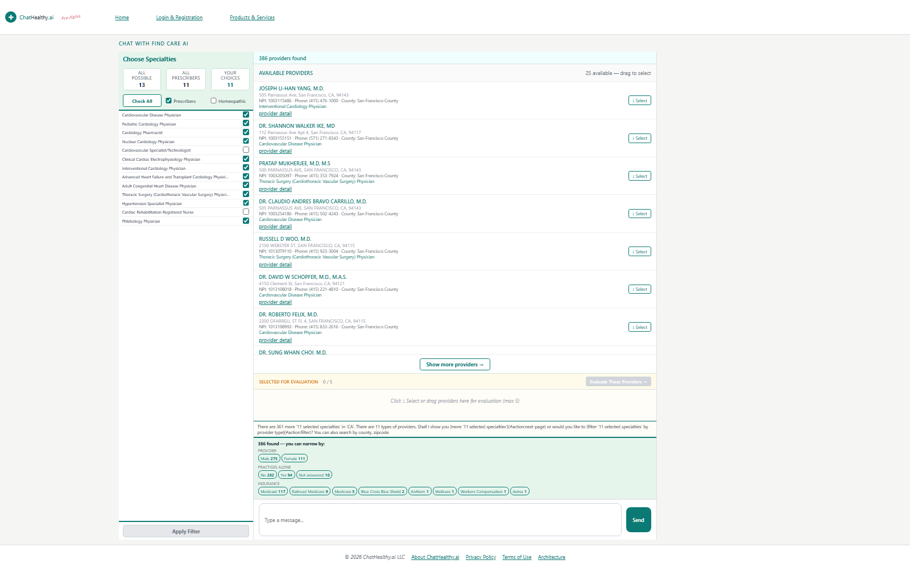
The taxonomy panel states what is being searched for; the rows are in the centre.

1.2 Find a facility
A place rather than a person. In the registry a facility is an organization: the same record shape as a care giver, told apart by its entity type. The architecture is the architecture of finding an individual.
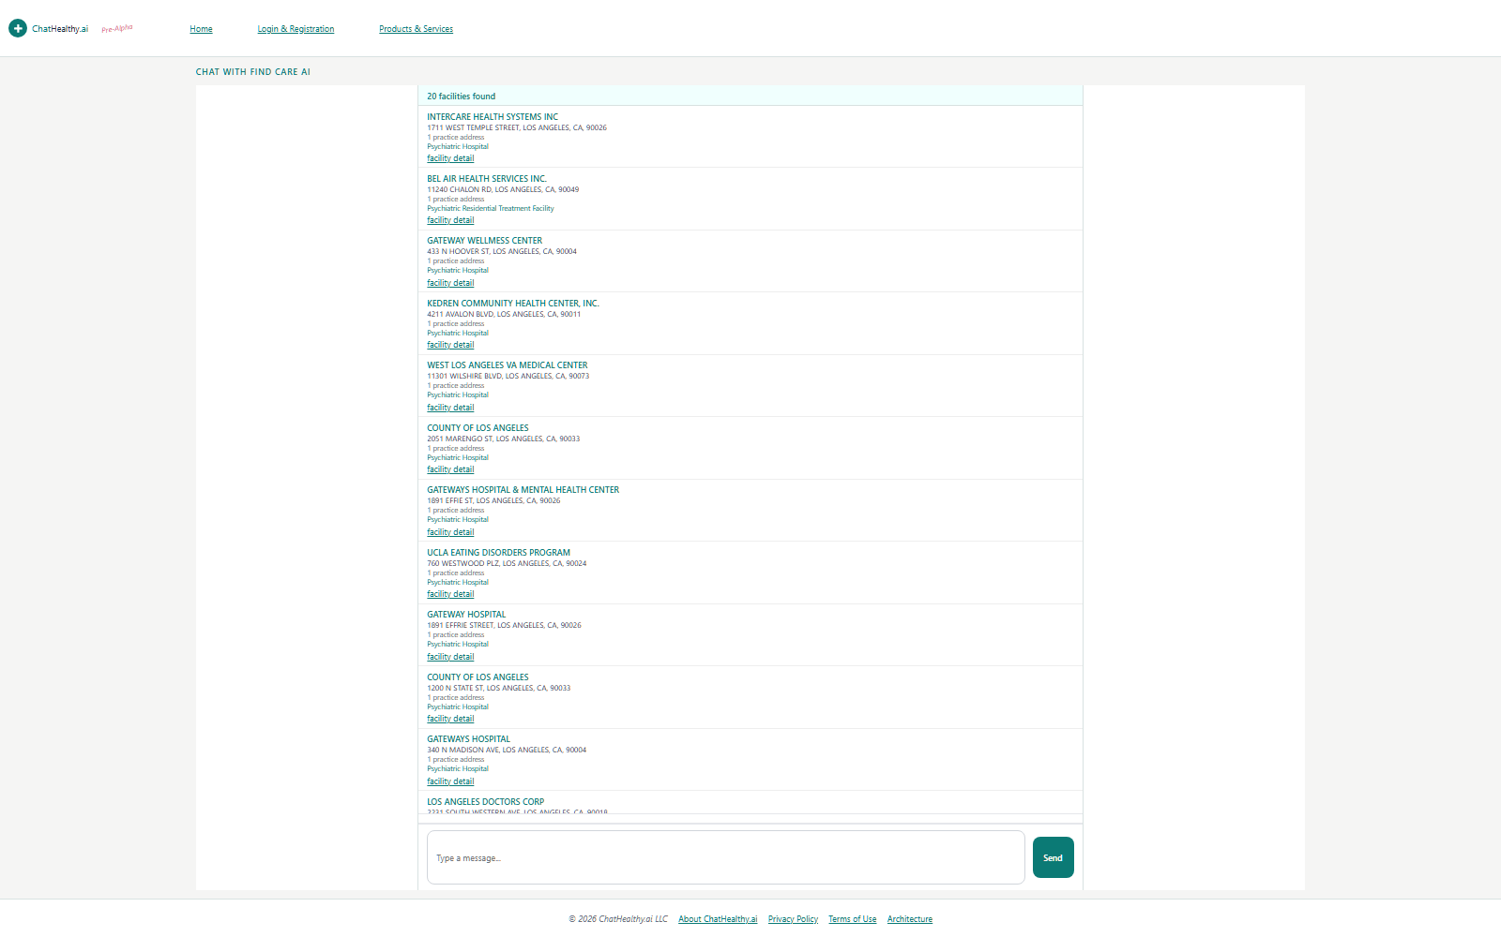
The left panel is empty because the page does not yet declare a taxonomy chooser — §3.

1.3 Find a clinical trial
A trial the person might enter. The registry is clinicaltrials.gov and is not ours, so this capability states what it asks for and what must come back, and states nothing about how the registry produces an answer.
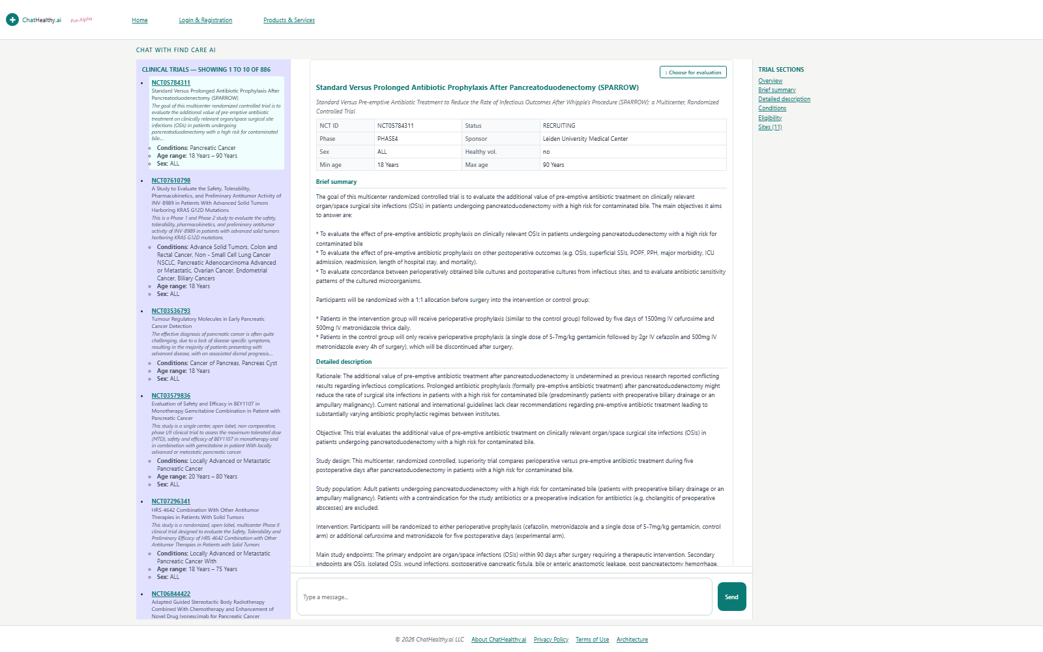
Rows on the left, one trial in the centre, its sections on the right.

2. One shape, three times
A capability is four tools, and the four are the same four whatever is being found: something that searches, something that decides the vocabulary the search runs on, something that opens one record in full, and something that holds what the person picked. Three capabilities, four tools each, twelve tools. No capability has a shape of its own.
They are four tools and not one because a requirement is per tool. A detail cannot open without the record's identifier and a search must run before any record exists to open; one tool holding both would make the detail's requirement a precondition of the search that has to precede it, and the page could never run. There is no list tool anywhere, because a list is what a search returns.
 | Find an individual | Find a facility | Find a clinical trial
Page | individualProvider | facility | clinicalTrial
Search | ProviderSearch | FacilitySearch | ClinicalTrials
Vocabulary | SpecialtyFilter  NUCC, Individual | SpecialtyFilter  NUCC, Non-Individual | the registry's conditions
Detail | ProviderDetail | FacilityDetail | ClinicalTrialDetail
Selection | ProviderSelection | FacilitySelection | ClinicalTrialSelection

2.1 What every search does
Four steps, the same in all three. Mine the parameters from the utterance — the caller sends what was said and the talk before it, and nothing else. Write them to the page before searching, so that what the answer was produced under is recorded whatever the search then does. Read back what is in force, which is the merge of everything said so far and not just this turn — that is what lets an answer add to a request instead of replacing it. Then ask the declaration which required parameters are not in force; if any are, no search runs, their names are returned, and the person is asked about exactly those.

2.2 Where FindCare is reached
Tool | Route
ProviderSearch | /provider/find
ProviderDetail | /provider-detail
FacilitySearch | /facility/find
FacilityDetail | /provider-detail
SpecialtyFilter | /specialty/find
ClinicalTrials | /trial/find

A route is stated in the declaration beside the tool it serves, and a caller reads it there. Every route verifies the SharedServices signature before doing anything, and does not re-validate the session.

3. The vocabulary: one funnel, two capabilities
Both registry searches must turn what a person said into NUCC codes before they can search, because the registry classifies on those codes and nothing else. That is one capability in the sense that it is one funnel, and two in the sense that matters to the person using it.
The funnel: normalise what was said into the catalogue's vocabulary; embed it; vector-search the catalogue; hand the candidates to a second model that narrows them; intersect the answer with the candidate set so nothing is returned that was not a candidate. One stage sequence, one score floor, one catch point.
The two resolutions differ in exactly two things — the partition of the catalogue searched, and the prompt text the two model stages read. Everything else is shared, so they cannot drift apart.
 | A care giver | A facility
Partition | Section = Individual | Section = Non-Individual
The question | What kind of practitioner treats this? | What kind of place delivers this?
Stage 1 prompt | specialty_normalize_system_prompt | facility_normalize_system_prompt
Stage 2 prompt | specialty_filter_system_prompt | facility_filter_system_prompt
Panel | Choose specialties | Choose facility type

The difference is not a filter applied to one answer. The two partitions answer differently to the same words, and a resolution that borrowed the other's answer would be wrong rather than imprecise: a place that treats kidneys is an End-Stage Renal Disease treatment centre, not nephrology; somewhere to get an x-ray is a radiology clinic, not a radiologist. One is a specialty a person holds; the other is a kind of place a person goes to.
This is why NUCC is a page in the declaration and not a part of either search page. The tool is shared; the values are not. The codes ticked on one page are not the codes ticked on the other, and a page is the scope a value lives in.

4. What a row carries, and what a detail carries
A row carries little and a detail carries everything. The projection enforces it, not the renderer — a renderer sent a sixth field is one edit away from painting it.
 | The row | The detail
An individual | The name, the specialty chosen, the primary practice address, how many addresses, a link to the detail. | Identity, credentials, every practice and business address labelled and ordered, every licence, insurance identifiers, county and urban standing, and destinations to verify the person independently.
A facility | The facility, how many practice addresses, its primary practice address, its facility type, a link to the detail. | Everything the record holds, plus what a person's detail does not have: the legal and other organization name, the relationship to a parent, and the authorized official who administers it.
A trial | The registry identifier, the title, the conditions, the age range and sex. | The registry's full record, laid out in sections, with a section list that jumps between them.

A detail is brought to the registry's current answer at the moment it is opened, and is still shown when the registry does not answer. The enrichments the pipelines produced — the county of an address, whether that county is urban — are ours and are never overwritten by a live answer that does not carry them.

5. What the search is, and is not
Provider search is deterministic. It filters registry facts — taxonomy codes, geography, name, entity type, active state — on indexed fields. It does not embed a provider, does not vector-search providers, and does not infer which provider matches. Meaning is resolved once, in the vocabulary tool; everything downstream is a parameterised query returning what the registry says.
That is the product. A person can verify a deterministic filter on registry data against the registry itself; they cannot verify a semantic guess.
Geography comes from practice addresses and never from a business address. This matters more for an organization than a person, because an organization's business address is frequently a headquarters in a state where it delivers no care.

6. Where this is not yet true
Six of the twelve tools are as described. The other six are wrong in three distinct ways, and the migration plan is the answer to all of them.
Cell | State
FacilitySelection, ClinicalTrialSelection | Live and dispatched, declared nowhere. A tool the record does not name can hold no requirement, so it cannot refuse and cannot ask.
FacilitySearch's tool file | Declared, hashed and shipped on every deploy; imported by nothing. The work is done inline in the router instead.
The facility vocabulary | Resolved inside the search rather than offered, because the page does not declare the chooser. The person never sees the panel and cannot narrow what was chosen for them.
ClinicalTrialDetail | Does not exist. The centre panel is painted from the cached search chunk, so the record shown is whatever the search returned earlier rather than the registry's current answer.
The trial vocabulary | Does not exist. The condition is mined as free text and sent to the registry unresolved.
Every FindCare route | Shares one 2000-line file in a legacy directory, so the capabilities have no boundary from one another.

