SharedServices — Architecture
The entrance, the router, the utterance, the session, the parameter model, and the library. Boundaries are the system architecture's; this document is what happens inside this one.

1. What SharedServices is for
It is the entrance and the router, and it owns three things no other component may hold: the session, the interpretation of what a person said, and the parameters a capability runs on. It holds no domain knowledge. It does not know what a provider search is made of, and adding a capability does not change it.

2. One entrance
Every browser call arrives at POST /gate. A call names its gesture in op and there is no default: a body with no op is a caller error. Session establishment is /auth/issue and nothing else.

2.1 What the gate collects
What | From | Why here
The gesture | op | Decides the handler. An unknown op is answered as unknown, not guessed at.
The payload | payload | Whatever the gesture carries. The gate does not read it.
The session token | session_token in the body | Threaded by ClientRouter from memory. Cookies are not used: the edge proxy strips the credentials header from preflights, so a cookie-borne session could not survive the hop.
The client address | X-Forwarded-For, else the socket peer | The proxies hold the real client. Needed before any tool runs, because the safety lockout is keyed on it.

These are stated once, through request_facts.state_the_facts(token, posted, headers), and read from there. A component several calls deep needs no parameter to know whose request it serves.

3. The session, and what authorises a call
A signed token, not a cookie and not a server-side object keyed by an opaque id. Minted once at /auth/issue and carried on the body of every call.
Field | What it is
origin | Which service signed it. Chooses the verifying certificate.
token | CH + the nonce field + the guid. 69 characters.
guid | 32 characters. The session identifier, stable for the whole session and preserved across every hop.
nonce field | 35 characters: two 17-character stamps separated by one. The first is when the session was minted and never changes; the second is re-stamped by every server on receive. The replay defence, NIST 800-53 SC-23.
signature | RSA PKCS1v15 over SHA-256 of origin : original stamp : guid.
created_at, server_env | When, and in which environment.

Three facts, and the third is why the arrangement works. The guid says which session this is and never changes. The current stamp says which hop this is and changes every time, so a captured token is stale a moment later. And the signature covers the ORIGINAL stamp, not the current one — which is what lets every hop re-stamp the token without invalidating a signature it has no key to reproduce.
Verification happens at the gate and nowhere else. No op is exempt, and a call with no valid token is answered 401 whatever it names. Downstream components verify the SharedServices signature to know the request came through the entrance; they do not re-validate the session.

4. The router
Past the gate everything is UniversalNavigationTool. It holds a map from op to handler; adding a gesture is a method and a line in the map. What matters about the handlers is what divides them.
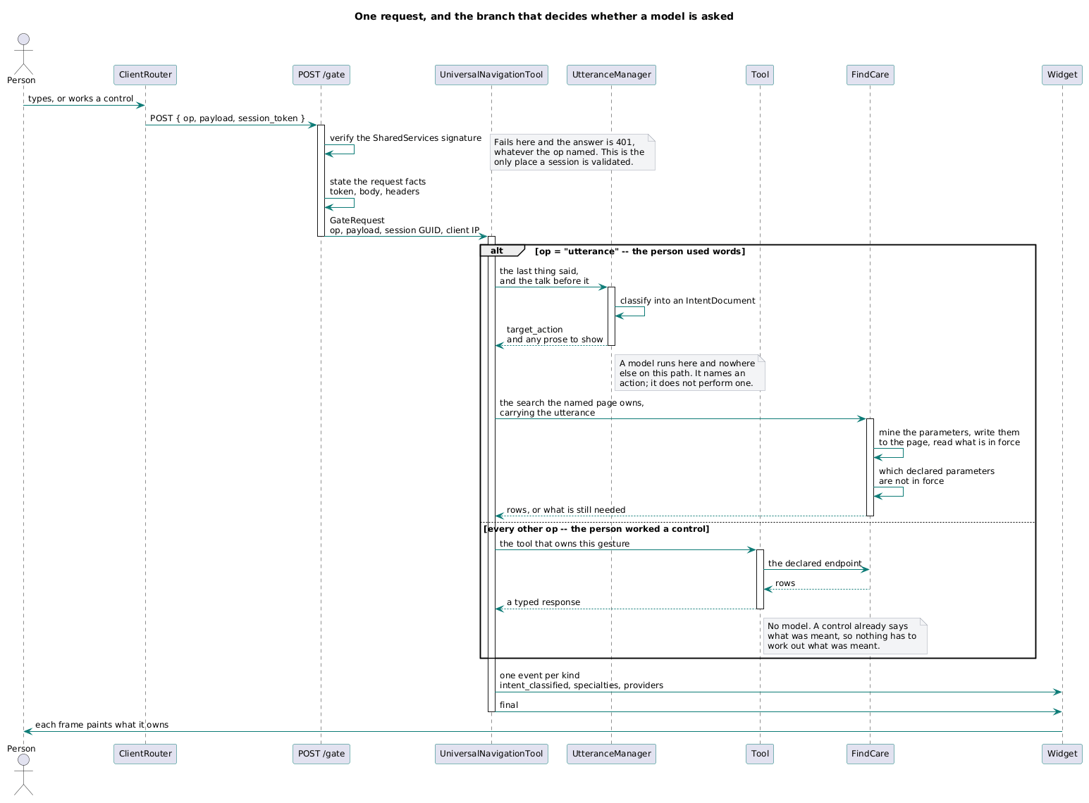
One request, and the branch that decides whether a model is asked.
One op is utterance. The person used words, and words must be interpreted before anything can be done about them, so the router hands the last thing said and the talk before it to the UtteranceManager. UM classifies it into an IntentDocument carrying a target_action, and may author prose to show. It names an action; it does not perform one.
Every other op is a control the person worked. A control already says what was meant, so nothing has to work it out and no model runs. That is why a page turn is fast and a typed question is not, and it is a property of the architecture rather than an optimisation on top of it.

4.1 The router dispatches the tool that owns the action
A target_action is not a place to write the work. It is the name of the tool that does it. The tool holds the request shape, the failure modes and the streamed result, which is what makes them testable apart from the routing and reusable by a second caller. A handler that does the work itself is a defect, not a shortcut.

4.2 The router addresses no frame
A turn ends the same way whichever branch ran. The router streams NDJSON, one event per kind, and each widget subscribes to the kinds it owns and paints its own frame. This is why one dispatch can light two frames, and why adding a frame does not mean adding a tool.

5. The parameter model
A tool that runs on parameters must answer three questions about every name it might see: one it cannot run without, one it will use if it has it, or one that is none of its business. Answered in code, no two tools answer them the same way and making a parameter required is a change in however many places happen to care.
None of it is in code. It is declared in one document — ChatHealthyConfig.ToolConfiguration, one record per environment — and read where a tool needs to know. Making a parameter required is an edit and a deploy. No page holds a rule of its own, and nothing can enforce a requirement the record does not state.
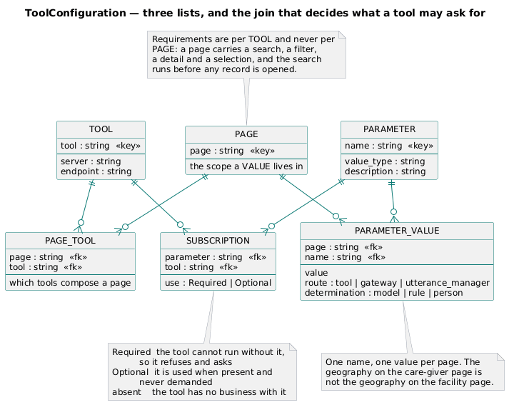
Three lists, and the joins that decide what a tool may ask for.
The record is a document; the diagram is relational because the joins are what it is about. There are no foreign keys: a subscription names a tool by its string. The three lists are flat and nothing is nested — a tool appears in all three, nothing is stated twice, so nothing can disagree with itself.

5.1 Required, optional, and silence
Use | What it means
Required | The tool cannot run without it. It refuses, and asks the person for it.
Optional | The tool uses it when it has it and runs correctly without it. It is never asked for as though it were needed.
(absent) | The tool has no business with it. Not registered as excluded, because listing every tool against every parameter is a great deal of record for a fact that reads perfectly well as silence.

Two are declared and the third is the default. Exclusion needs no entry because a tool reaches a parameter only through a subscription, so a tool with no subscription to a name cannot see it. Adding a parameter obliges nobody to write rows saying it does not apply.

5.2 Per tool, and per page
- A requirement is per tool and never per page. A page carries several tools, each with its own answer. The detail needs a record identifier and the search does not; requiring the detail's parameter of the page would stop the search that must run before any record exists to open.
- A value is per page and never per tool. The geography on one page is not the geography on another, and a person who searched for a clinician somewhere has not thereby said where a hospital should be. A parameter is addressed as a page and an attribute together; there is no default page, because a default page is the flat model with a longer spelling.
The consequence is the reason for the arrangement. When a search cannot run, nothing decides what to ask for: the page asks the record which of its declared requirements are not in force, and the router asks the person about exactly those, by name. A parameter made required is asked for without a line of code written for it. A value present but empty is not in force — an empty string and a missing string are the same absence to the person who did not say it.

6. The library
ChatHealthyLib is what more than one component needs and none of them should own. It is installed into each component rather than called across the wire, and it holds no domain knowledge and no business logic. It mints no session token: manufacture belongs to SharedServices alone; the library carries only verification and parsing.
What | The rule
The tool contract | What a capability's search takes, returns and how it fails, written once. A concrete tool names itself and the declaration says where it is served; no tool learns an address.
ChatHealthyException | Every deliberate raise is this class with a mode discriminator. Catch sites discriminate on mode, not on type. An external exception keeps its native type until a boundary converts it, and a conversion carries the original.
ChatHealthyLoggingService | All logging. The stdlib logging module is not imported and print() is not used outside the service. A function that raises does not also log — the catcher logs, not the thrower.
Database access | A handle is obtained only through the canonical utility, with an identity and a cluster. No client is constructed, no connection string appears anywhere, and no test stands a fake in place of one: the certificate is the credential, and code that reaches the data without an identity is code whose authorisation is never tested.
Request management | How a component calls a peer and answers one, synchronously and asynchronously, and how a returned user state is merged.

7. Where this is not yet true
- Three search actions do the work in the router instead of dispatching a tool, and one of the three builds its own HTTP client. A complete tool sits beside it, declared, shipped and imported by nothing.
- Two live tools are undeclared. A tool the record does not name can hold no requirement, so it cannot refuse and cannot ask — the model of §5 does not reach it at all.
- The declaration's server and endpoint are unread. Every caller writes the route into itself, so the record's answer and the code's answer are two facts that can differ.
- Nothing compares dispatch against declaration in either direction, which is how all three of the above happened with a green build.

