ChatHealthy.ai — Enterprise Architecture
An AI-native company: how it is organised, what it builds, who builds it, and what governs them. This document owns the boundaries; the component architectures own what happens inside one.

1. What this document decides
Four things, and nothing else. How the company's work is divided and who owns each part. Which components exist and where the boundary between any two of them falls. Which of them may reach which data. And what governs a change — by whoever makes it, human or agent.
Everything else belongs to a component's own architecture. Where those documents and this one disagree, this one is wrong and is corrected: a boundary stated in two places is a boundary that will be stated two ways.

1.1 What makes this AI-native rather than a company that uses AI
Two things, and the second is the unusual one.
- A model is in the product, confined to one job: turning what a person said into something the system can act on. It names an action and resolves vocabulary. It does not perform work, does not decide what is shown, and does not reach data.
- A model is in the workforce. The code is written by an agent working under an identity of its own, and the governance in §7 exists because that is true. An enterprise architecture that assumed a human author would be describing a different company.
The consequences run through every section below. They are the reason the record of what is deployed is treated as evidence rather than documentation, the reason a commit needs an authorisation given at the moment it fires, and the reason entitlements are reported on a schedule rather than reviewed when someone remembers.

2. The operating model
The work is divided into epics, features and stories, and that division is not a project-management convenience: it echoes the organisational and general-ledger model. An epic is a capability the firm sells or depends on, and it has an owner and a cost. A feature is a thing that capability does. A story is a unit of work, and a requirement under it is what must be true when the work is done.
Layer | What it is | Where it lives
Epic | A capability with an owner and a P&L. | agile_backlog.json
Feature | Something that capability does. | agile_backlog.json
Story | A unit of work. | agile_backlog.json
Requirement | What must be true when it is done. The unit that is approved, implemented and tested. | agile_backlog.json
Engineering rule | What must be true of all work, enforced mechanically rather than reviewed. | engineering_rules.json
Deployment record | What is deployed, where, and under which identity. | deployment_architecture.json

Two rules follow and both are load-bearing. The code tree mirrors this tree, so a file belongs to the feature that owns it and a file that belongs to no feature is a finding. And a requirement is the only thing that authorises work: nothing is built because it seems wise, and a gap in the requirements is escalated rather than filled.

3. The workforce
Every actor that authenticates has exactly one identity, and the certificate is the credential. This holds for people, for components, and for agents — there is one registry and no category is exempt.
Actor | Authenticates as | May do
A person | An identity provider, then a session. | Whatever their entitlements permit. Authorises what an agent may not do alone.
A component | Its own certificate. | Reach the data its identity is entitled to, and call a peer.
An agent | Its own certificate, never a component's. | Write code and read the systems it is entitled to. Cannot commit, and cannot change a grant, without an authorisation given at the moment it acts.
A scheduled job | A declared identity, read from a vault at run time. | Exactly what its declaration says, unattended.

The distinction that matters is between doing and authorising. An agent does the work; a person authorises the acts that cannot be undone. Which acts those are is not left to judgement — it is the set the engineering rules gate, in §7.

4. The components
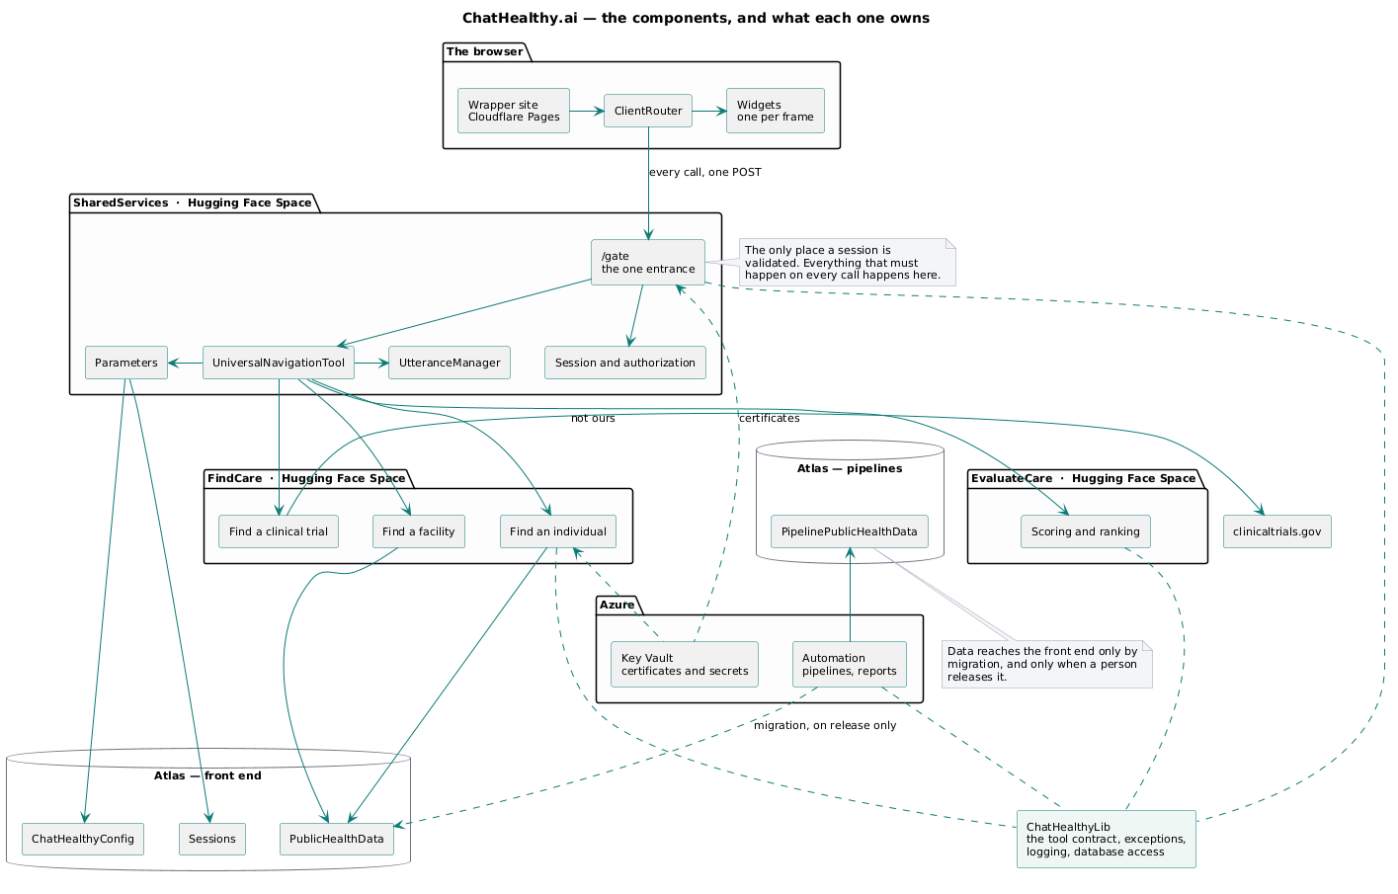
The components, and what each one owns.
Component | What it is for | Runs on
Wrapper site | The page a person arrives at, and the frames the application is laid out in. | Cloudflare Pages
SharedServices | The entrance. Every call arrives, is authenticated, and is routed from here. Owns the session, the interpretation of what was said, and the parameter model. | Hugging Face Space
FindCare | Finding a care giver, a facility or a clinical trial. | Hugging Face Space
EvaluateCare | Scoring and ranking what was found. | Hugging Face Space
ChatHealthyLib | What more than one component needs and none should own: the tool contract, the exception, logging, database access. | a package, installed into each
Pipelines | Producing the data — loading, enriching, publishing it for release. | Azure Automation
Engineering governance | The rules that gate a change, and the record of every authorisation. | the workstation, and GitHub

5. The boundaries

5.1 The browser reaches one address
Every browser-initiated call goes to POST /gate on SharedServices. Not one endpoint per component, not one per page, not a REST surface per resource. A component that needs another's answer gets it server-to-server, on the browser's behalf.
Everything that must happen on every call happens in one place and cannot be forgotten by a route that did not know about it. And because there is one entrance, a component can refuse anything that did not come through it.

5.2 A component is reached only through the entrance
The components are public HTTPS hosts and cannot demand a client certificate, so the refusal is a signature: SharedServices signs the session token with its own key, each component receives that certificate at deploy time, and each verifies the signature on every route. A request arriving by any other path carries no such signature.
The session is validated once, at the entrance. Downstream components verify who sent the request and do not re-validate the session — a second validation that could give a different answer is worse than none.

5.3 The model is confined to one place
A model runs when a person used words, and produces one thing: the name of an action, drawn from a closed set, together with any prose to show. It does not perform the action, does not choose what is displayed, and does not reach data. Every other path — a control worked, a page turned, a record opened — invokes no model at all.
Downstream of that one interpretation everything is deterministic: a parameterised query returning what the source says. That is what makes an answer checkable. A person can verify a filter on registry data against the registry; they cannot verify a semantic guess. An architecture that lets a model touch the result loses that property silently, and cannot get it back by testing.

5.4 A component owns its own domain knowledge
The router carries what the person said and the talk before it, and reads nothing else. It does not know what a search is made of. The component that owns the question mines its own parameters from the utterance — which is why a new capability needs no change to the router.

5.5 What crosses a boundary
Crossing | Carries | Never carries
Browser to SharedServices | The gesture, its payload, and the signed session token. | Business logic. The client decides nothing that changes state.
SharedServices to a component | The signed token, the utterance, and the prior dialogue. | A search criterion. A caller that may pass one may omit one.
Component to component | The signed token and a typed request, server to server. | A browser hop. A person's browser never addresses two components.
Pipelines to the front end | Whole collections, under the name they left with, on release. | A transformation. Nothing is changed in transit.

6. Data
Two clusters, and the separation is not tidiness: the front end must not be able to read a collection that is still being built, and the pipelines must not be able to write one that is being served.
Store | Holds | Written by | Read by
Atlas front end — PublicHealthData | The registry records the application serves. | the migration, on release only | FindCare, EvaluateCare
Atlas front end — ChatHealthyConfig | The tool declaration and the versions record. | a deploy | SharedServices, FindCare
Atlas front end — Sessions | The session and its page parameters. | SharedServices | SharedServices
Atlas pipelines — PipelinePublicHealthData | The records being built and enriched. | the pipelines | the migration

Migration is the only path by which data reaches the front-end cluster, it is separate from the pipeline that produced the data, and it runs only when a person releases it. Data is versioned rather than segregated by environment: there is no dev copy of a collection.

7. DevOps and governance
This section states what governs a change and points at the documents that specify each mechanism. It does not restate them.

7.1 How code becomes a running system
Four operator-facing acts and no fifth. Each reads the record; none takes an instruction that the record could have stated.
Act | What it does | What it refuses
Commit | Puts work in the repository, on the dev branch and no other. | Anything failing an engineering rule. Anything without an authorisation given at that moment.
Promote | Advances the whole tree one step: local to dev to qa to prod. | A skipped step. A partial tree.
Build | Turns source into one directory per target per package. Reads the working tree for local and the environment's branch otherwise. | A declared file not on disk. A file whose content has drifted from the record.
Deploy | Installs named packages to the target that declares them. Reads only build output, never source. | A target that does not report the build it was given.

Specified in: DeploymentArchitectureDesignAndMigrationPlanPhase_v19 under architecture/DevOpsBuildDeployAndEnvironmentManagement/, and the record itself at brain/machine_artifacts/content/deployment_architecture.json.

7.2 Engineering rules
A rule is a statement about all work, enforced by a program rather than by review. Rules are dispatched on events — the agent's session boundaries and the repository's commit hooks — by one manager that reads the rule registry and runs the workers a rule declares. A rule with no enforcement is a rule that is not in force, and the registry says which is which.
Fires on | What is enforced
Every prompt and every response | The conversation is persisted as business data before anything else happens.
Session start, and after a context compaction | The agent is booted with recent conversation and the business taxonomy, so it resumes with context rather than assumptions.
Every commit | Nine checks across the whole repository: exceptions, database access, logging, separation of display from logic, schema validity, secrets, entry-point uniqueness, and the data migration's compliance with its story. Plus two authorisations — the commit itself, and any change to an identity or a role grant.

Specified in: CH-EPIC8-Feachure-002-EngineeringRulesEnforcement-designV32 under architecture/EngineeringRuleEnforcement/, and the registry at brain/machine_artifacts/content/engineering_rules.json.

7.3 Identity and entitlement
One registry for every authenticating actor, certificates issued by the firm's own authority, private material held in a vault and reached only by the identity entitled to it. What each identity holds is reported on a schedule and mailed to a named reviewer, so entitlement is reviewed rather than assumed — and the report covers both planes of the data store, the credentials that reach the data and the members who administer the place it lives.
Specified in: ChatHealthy_Identity_And_LeastPrivilege_Design_v1 and EPIC-002-F-003-Design-v1 under architecture/IdentityCertificatesAndAuthentications/.

7.4 What the record is for
The deployment record is the only statement of what the firm runs. It names each target, the packages it carries, the files in each package, the bindings it reads, the identities it may act as, and the configuration documents it is given. Every gate checks that what ships is declared.
Its weakness is stated here rather than discovered: it is written by the same actor it constrains, and nothing checks the reverse direction — that what runs is declared. That is §9's first entry and it is the single largest gap in this architecture.

8. Compliance posture
The firm handles healthcare data and its case to enterprise buyers rests on auditability, so the controls above are not internal hygiene — they are the evidence. The committed posture is NIST 800-53 and HITRUST CSF, and the architecture's contribution to it is specific: one entrance means one place where access is decided and logged; one identity registry means every actor can be named; the deployment record means a running system can be traced to the source it was built from; and the conversation archive means the instruction that produced a change is retained alongside the change.

9. Where this is not yet true
Stated here rather than left to be found, because a reference architecture that describes an intention in the present tense is worse than no document.
- The record is written by the actor it constrains, and nothing compares what is deployed against what is declared in the reverse direction. A thing that runs undeclared is not detected. BUG-008.
- A build context ships files no runtime path reads, because the build copies subtrees rather than the files the record enumerates. BUG-011.
- Eleven call sites reach a model vendor directly rather than through the library's facade, so the model is a literal in eleven places and the failure mode is invented eleven times. BUG-003.
- FindCare's routes share one file in a legacy directory, so its capabilities have no boundary from one another. The migration plan is the answer to this one.
- Nothing constrains what an agent may run. The rule intended to gate an agent's shell commands carries no enforcement, so remote-state governance rests on a person watching. BUG-002.

