ChatHealthy.ai — Enterprise Architecture
The reference architecture for an AI-native corporation. This document owns the boundaries; the four frameworks own what happens inside one.

System Architecture — the AI-native corporation
The parent of six deliverables. The Security Framework, the DevOps Governance Framework, the Data Pipeline Framework and the Live Application Architecture comply with this document and do not restate it. The Refactor Plan is the sequence by which the code reaches it. §1.2 gives every address.
ChatHealthy.ai is the reference implementation. The architecture is the product.

0. How to read this

0.1 Two kinds of sentence, marked
mark | meaning
[R] | Reference. Transfers unchanged to any AI-native firm in any domain.
[I] | Instance. True of ChatHealthy because of what it sells, its size, or what it bought. Replaceable without touching an [R].

A header carries the mark when the whole section does; otherwise the marks sit on the paragraphs. A reader who reads only the [R] sentences gets a complete architecture. The [I] sentences are the worked example that proves each [R] was affordable. §6 indexes which sections transfer whole.

0.2 What counts as evidence in this document — [R]
This is a rule about the document, and it is also a principle of the architecture (G-7). Four kinds of thing can support a claim, in this order:
- Behaviour — what the code does when it runs.
- Data — what the record, the database or the live platform holds.
- Requirement — an approved requirement, read, not cited by id.
- Intent — a design document, labelled as intent and never as fact.
And one limit on this hierarchy. It protects against citing the wrong kind of thing. It does not protect against reading the right kind of thing wrongly — a true observation about a neighbouring artifact, generalised into a claim about ours, has the right evidence type and a false conclusion.
The only defence that works against that is another party reading the same code and contesting the conclusion. Which is G-2 again, applied to an architecture document rather than to a record.
A comment is none of them. Neither is a docstring, a variable name, a log line's wording, a bug record's description, or another agent's report. Every row of the register in §4 names which of the four it rests on.

0.3 What this document is not
It owns boundaries and defers every interior. Where it and a subordinate architecture disagree about a boundary, this one is wrong and is corrected — a boundary stated twice will be stated two ways. Where they disagree about an interior, the subordinate wins.

0.4 One shared vocabulary — [R]
Five artifacts used one word for three things. The parent owns the vocabulary.
term | means | owner
product capability | One thing a person can ask the product to do, answered by one tool. | the Live Application Architecture
deployable target | A host with packages, files, secrets and environment bindings. | the DevOps Governance Framework
granted privilege | Something a principal may reach. | the Security Framework
component | A thing that runs and holds an identity. Never a source directory. | §2.4
generation | A version of a published collection. Published when something binds to it. | the Data Pipeline Framework, §2.8
act | One of the four in §2.7.2. Nothing else is an act. | the DevOps Governance Framework
record | One of the five in §2.5. Nothing else is a record. | §2.5

The bare word capability appears nowhere in the six artifacts. One of the three qualified forms, always.
And one word is retired. *Exception* has no live meaning in this architecture. There are no exceptions to a boundary; there are compliant paths and non-compliant ones, and the latter are scheduled work with a phase or open questions with an owner. A document that carries a boundary and a list of exceptions to it has carried two boundaries, and readers will follow the shorter list. (The word survives in exactly one unrelated sense — the programming-language `ChatHealthyException` type in §2.4's library row. That is a class name, not a carve-out, and no reader should be able to confuse the two once this is said.)

1. What this document decides, and what it defers

1.1 It decides five things — [R]
- How the firm's work is divided, and why that division is the organisation and the
general ledger expressed once.
- Which components exist and where the boundary between any two falls.
- What crosses each boundary, in both directions, and what never does.
- Which actor may reach which data.
- What governs a change, by whoever makes it, and which framework is authoritative for
each mechanism.

1.2 It defers everything else
This document is one of six. Every reference below and throughout is to a deliverable by name; the addresses are given once, here. All six live in architecture/TargetArchitecture/.
deferred | to | address
Identity issuance, certificates, custody, sessions, entitlement, what may cross to a vendor, safety controls | the Security Framework | 2_SecurityFramework.docx
The four acts, the rule registry, authorisation mechanics, the deployment record's schema, the conversation archive | the DevOps Governance Framework | 3_DevOpsGovernanceFramework.docx
Acquisition, load, enrichment, quality, provenance, publication, the release | the Data Pipeline Framework | 4_DataPipelineFramework.docx
The request path, the tool contract, parameters and session state, display, prose | the Live Application Architecture | 5_LiveApplicationArchitecture.docx
The sequence by which the code reaches this target, and its gates | the Refactor Plan | 6_RefactorPlan.docx

This document is the Enterprise Architecture, 1_ChatHealthyEnterpriseArchitecture.docx.
If a framework restates something in §2, the restatement is deleted rather than reconciled.
An address given once and a name used thereafter is the same discipline this architecture applies to every other fact: a full citation repeated thirty-five times is thirty-five places for it to go stale.

2. The architecture

2.1 What makes a corporation AI-native — [R]
Not "we use AI." Two structural facts, and the second reorganises the company.
A model is in the product, confined to one job. A model converts between natural language and structured values, in either direction, and does nothing else. It does not retrieve, filter, rank, authorise, calculate or persist. This is one decision and everything downstream depends on it: once a model can rank or filter, no answer can be reproduced, explained or checked against its source, and the system's behaviour becomes a property of a vendor's weights that change without anyone's action.
A model is in the workforce. The code is written by an agent holding its own identity, its own certificate and its own role in the corporate directory — not a human's credentials borrowed for a session. This is the fact that makes §2.7 necessary rather than fussy.
Three consequences run through everything below:
- The record of what is deployed is evidence, not documentation. Documentation drifts from a system slowly, as people forget. A record maintained by an actor that can also change the system drifts at machine speed and in silence.
- Authorisation is given at the moment of the act. A standing approval granted to an agent is an approval of everything the agent later decides it covers.
- Entitlement is reported on a schedule rather than reviewed when someone remembers. An agent accumulates grants in the course of doing what it was asked. Nobody accumulates them deliberately, so nobody remembers to look.

2.1.1 The asymmetry that organises the whole architecture — [R]
An agent does the work. A person authorises the acts that cannot be undone.
Which acts those are is not judged at the moment of acting. It is a declared set, enforced by a program. The corollary is the sharpest single rule here: an agent may not create an identity. It may hold every other privilege the firm can grant — provision, deprovision, deploy, mint a certificate, grant a role — but bringing a new principal into existence is reserved to a named person, because an agent that can create identities can create the one with no governance on it, and no later control reaches that.
[I] ChatHealthy's agent identity is claudeCodeAgent, and its repository declares exactly this constraint. The platform does not carry it. §4 entry 1.
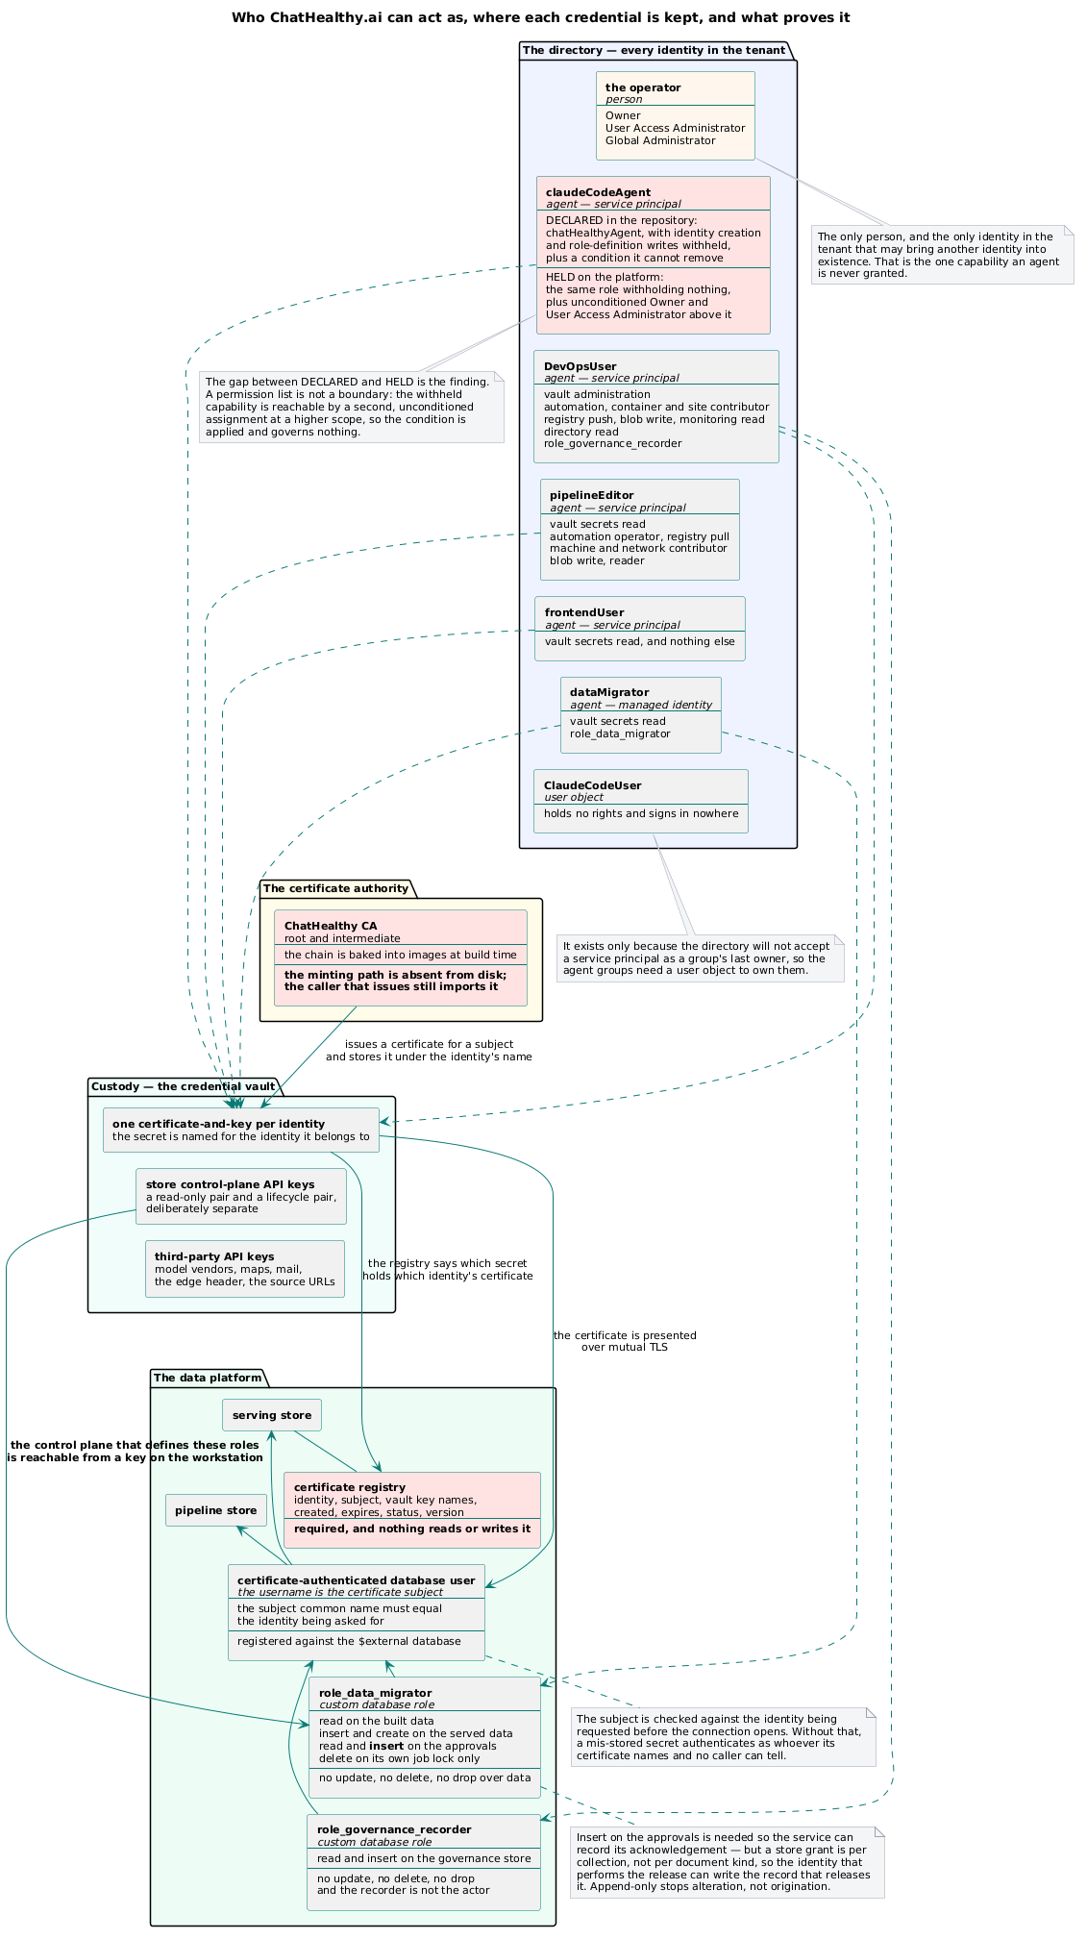
Every identity in the tenant, where each credential is kept, and what proves it. Identity creation is the one capability reserved to a person — declared in the repository, and absent on the platform.

2.1.2 The three writers, and why an AI-native firm needs all three — [R]
Settled by the Security Framework and adopted here as the frame the whole architecture hangs on. Three questions, asked of three different things:
 | asks | of
S-1 | Can the governed party lift this? | controls
S-2 | Can an independent reading falsify this? | records
S-3 | Does this test what it claims to test, and has it ever caught anything? | the checks that enforce both

A firm whose workforce is entirely human needs S-1 and can mostly assume S-2 and S-3, because the author of a control, the author of the record and the author of the check are different people and their errors are independent.
In an AI-native firm the agent writes all three. So the errors are correlated: a control, the record that describes it and the check that enforces it can be written consistently with one another and be wrong together, and every gate will pass. S-3 is the one that catches that case, and it is the one no firm builds, because a check that has never gone red looks exactly like a check that works.
These are principles G-6 (S-1), G-2 (S-2) and G-5 (S-3) in §3, and the G-numbers are the one index. Two numbers for one principle is the drift this architecture spends its length warning about, and a shared number is an address rather than a claim of origin. The origins are recorded here because they belong to the artifacts that found them: S-1 is artifact 2's, from its work on what makes a constraint real; S-2 is the DevOps Governance Framework's, generalised from the operator's instruction that the entitlement report must be read from the platform and not from the record; S-3 is the DevOps Governance Framework's, and it stopped being an argument and became a measurement the moment that artifact ran it against 580 logged gate executions and found an enforcement green in every one of 569 runs.

2.2 The operating model — [R]

2.2.1 One tree, four readings
Work divides into epic → feature → story → requirement → test. This is the organisational chart and the chart of accounts, expressed once.
layer | what it is | organisational reading | ledger reading
Epic | A capability the firm sells or depends on | A group with an owner | A cost centre with a P&L
Feature | Something that capability does | A team's remit | An account
Story | A unit of work | An assignment | A posting
Requirement | What must be true when it is done | The acceptance a person gives | The audited entry
Test | What decides whether the requirement holds | — | The supporting document

The identifier is the account code and it is a path: EPIC-006-F-001-S-001-REQ-B-001-TEST-1. Every artifact the firm produces — a source file, a test, a bug, a package, a prompt, a report — posts to an account. An artifact posting to no account is a finding, in exactly the sense an unreconciled entry is a finding.

2.2.2 What it buys and what it costs
Buys. Four systems collapse into one: the backlog, the org chart, the cost model and the code layout are the same fact read four ways. When a capability is sold, priced, staffed or refactored, one tree moves. And specifically for an AI-native firm: the agent needs a destination for every file and an authorisation for every act, and a tree that already encodes ownership answers both without a person being asked each time.
Costs. There is no home for a function that is real but is neither a capability the firm sells nor a group that exists. Cross-cutting operational concerns — how any report is delivered, how any job reports failure — have no cost centre and therefore no epic. They are stated once as an engineering standard inside the governance epic and inherited.
[I] The case that settled it: an operational report nearly got its own epic. It did not, because the firm has no reporting group and will sell no reporting SKU. The report lives with the domain it reports on. The failure mode avoided is the enterprise reporting group with no domain knowledge that takes a quarter to ship one report.

2.2.3 Two rules that follow — [R]
- The code tree mirrors the requirements tree. A file belongs to the feature that owns it; a file belonging to no feature is a finding, and so is a feature with no files. Attribution is a person's decision, never an agent's inference. Binding: EPIC-008-F-002-S-003-REQ-B-009. And the gate on it must check the right feature, not merely a real one — see P-1's general form and §4 entry 4, where 88 per cent of declared files resolve to one wrong feature and the gate is green.
- A requirement is the only thing that authorises work. Nothing is built because it seems wise. A gap is escalated, never filled by the builder — and when the builder is an agent this is a control rather than a courtesy, because a control an agent invents is indistinguishable a week later from one the firm specified. G-4.

2.3 The workforce — [R]
Every actor that authenticates has exactly one identity, in one registry. Four classes, no exemptions, no second registry.
actor | authenticates as | may do | may never do
A person | An identity provider, then a session | Whatever entitlements permit; authorises what an agent may not do alone | —
A component | Its own certificate, issued by the firm's authority | Reach the data its identity is entitled to; call a declared peer | Act as another component
An agent | Its own certificate, never a component's and never a person's | Write code; read and change what it is entitled to | Commit or change a grant without an authorisation given at that moment. Create an identity.
A scheduled job | A declared identity, read from a vault at run time | Exactly what its declaration says, unattended | Hold a credential on disk

Four rules bind all four classes:
- One canonical identity per authenticating component, the same string on every surface at which it authenticates.
- A new identity requires a person's approval before it enters the registry and receives a credential. No identity is created ad hoc, by anyone.
- No deployed component holds a secret on disk. It is told the vault's address and the identity it is, and fetches at the moment of use. [I] The operator's workstation is where a secret originates and is therefore a boundary rather than a component.
- An identity is never borrowed. An agent operating "as" a component, or a person "as" the agent, destroys the only thing an audit trail is for.
And one place where reaching and changing are the same thing — [R]. The architecture otherwise separates them cleanly: what an actor may reach is the Security Framework's, what an actor may change is the DevOps Governance Framework's. The separation fails at the credential store, and only there. Because the certificate is the credential, whoever can read an identity's private material is that identity — on every surface, from anywhere, until it expires — and the store being read from has no way to ask how the presenter came by it.
**Read access on a credential store is not a read. It is the union of every privilege
every credential in that store confers.**
Two consequences, and both are why this is stated at parent level rather than left inside a framework. Vault scoping is a primary control, not housekeeping: one secret per identity, granted per secret and never per store, because a store-wide read grant is a grant of every identity at once. And a finding about a credential-store grant belongs with identity, not with change governance, because it is a statement about who the holder can be rather than about what they may do.
Binding: EPIC-002-F-003-S-008-REQ-B-001 through REQ-B-005.
The one-identity / least-privilege tension, resolved. REQ-B-001 binds one identity per component; REQ-B-005 binds least privilege. They collide when a component performs two functions needing disjoint rights. The resolution is not a merged identity and not two credentials in one process: the component is two components. A boundary inside a process that the identity model cannot express is a boundary the architecture has not drawn. Artifact 2 §2.2.1 gives the security reasoning and reaches the same answer.
The grant boundary is the resource, not the host. One identity may be registered on several stores with a different role on each. This is what lets a control record live outside the resource it governs (§2.8 rule 5) without handing the governed party the store it was moved to.

2.4 The components — [R] shape, [I] contents
The shape is reference: one entrance, N capability components, one shared library, one pipeline plane, one governance plane that is not part of the running product, and the model vendors. The contents are the instance.
component | owns | [I] runs on
Wrapper site | The page a person arrives at and the frames the application lays out in. Owns no business decision. | Cloudflare Pages
SharedServices | The entrance. Every browser call arrives, is authenticated and is routed here. Owns the session, the interpretation of what was said, the parameter model, token manufacture. | Hugging Face Space
FindCare | Finding a care giver, a facility or a clinical trial. | Hugging Face Space
EvaluateCare | Scoring and ranking what was found. | Hugging Face Space
Shared library | What more than one component needs and none should own: the tool contract, the exception type, logging, store acquisition, the model facade, the terminal-report escape. A versioned package. | installed into each
Pipelines | Producing the data: loading, enriching, publishing it for release. | Azure
Governance plane | The rules that gate a change and the record of every authorisation. Not part of the running product. Its own substrate is not in any record — §4 entry 6. | the workstation and the repository host
Model vendors | The language boundary of §2.6.3 and nothing else. Third parties the system exports data to under a contract. | [I] three reached; two on the live request path

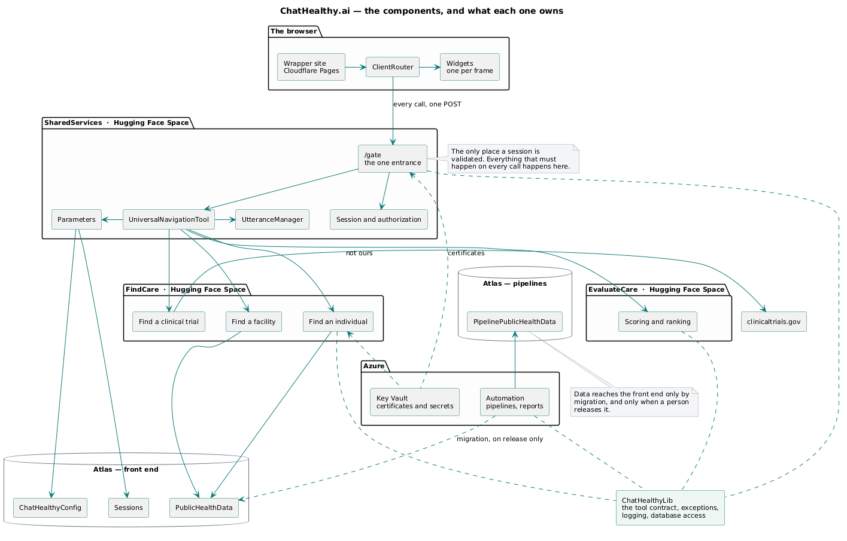
The components and what each owns. The browser touches exactly one box; the governance plane is not in the request path.
Three shape rules — [R]:
- The shared library is a versioned package, not a directory several components import. A shared folder makes every consumer's release the same release.
- A module belongs in the library when no single component can own it and more than one needs it — the test is ownership, not tier. Where consumers in different tiers need different subsets, the subset each may import is declared in the record per consumer. A tier boundary is a convention enforced by whoever remembers which tree a file is in; a declared exclusion is a boundary a gate can read in both directions. [I] LibraryPermissions declares per-component excluded_modules, and the firm's terminal-report escape sits in the library for a reason that generalises: anything that can lose its ability to record why it died has that problem, and solving it twice produces two divergent solutions.
- The application's composition is data, not code. Which product capabilities exist, which parameters each needs, which of those it requires, and which surfaces they appear on — a record, read where a component needs to know. Adding a product capability is a declaration and a deploy. This is the deployment record's argument one level up: a system whose shape is spread through its own source cannot state its shape.
A component appears in this architecture when it is built, not when it is planned. [I] Talk About Care is a capability in the requirements tree with one feature and one story. It has no component row and this document declines to give it one — an enterprise architecture that draws boxes for intentions cannot be read as a statement of what exists, which is the only thing it is for.

2.5 The firm's canonical records — [R]
Five, and the firm has no sixth source of truth. Everything here resolves to one.
record | states | authority
Requirements tree | What the firm is building and who owns it | §2.2
Engineering rules | What must be true of a change, and which rules are in force | the DevOps Governance Framework
Deployment record | What runs, where, composed of what, under which identity | the DevOps Governance Framework
Identity registry | Every actor that may authenticate, and what it may hold | the Security Framework
Conversation archive | Every instruction and every response, as business data | the DevOps Governance Framework

[I] Two are today one file: the identity registry is a key inside the deployment record. That is why a commit touching an identity is gated by the same mechanism that gates a deployment change — a real benefit — and why an identity change and a deployment change are one kind of event to every downstream reader — a real cost. Named here rather than discovered. §4 entry 12.
Ruling, since the Security Framework asked: the permitted-data-class set per model vendor is a key inside the deployment record, not a sixth record. It is a property of a deployable target, the same category as the secrets it reads; a sixth record would be a second place declaring what a target does; and the shape the record already mandates — a named platform holding name/value facts — is exactly right. It inherits the identity registry's cost as well as its gate, and whoever adds it should say so at the time.

2.6 The boundaries — [R]

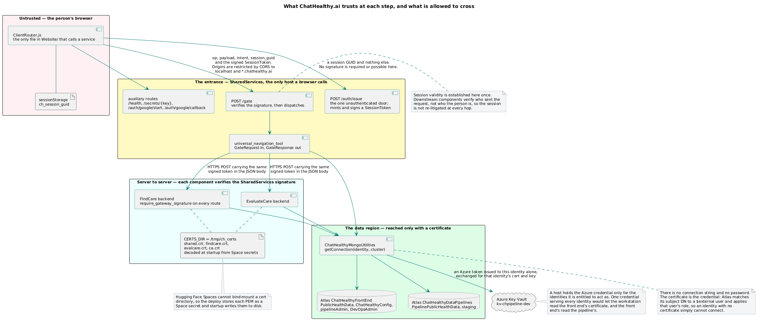
Every crossing, and the credential presented at each. The Security Framework owns what each obligation is; this document owns which crossings exist.

2.6.1 The browser reaches one address
Every browser-initiated call goes to one authenticated operation endpoint on the entrance component. Not one endpoint per component, not one per page, not a REST surface per resource. A component needing another's answer gets it server-to-server.
Two properties follow and they are the reason: everything that must happen on every call happens in one place and cannot be forgotten by a route that did not know about it; and because there is exactly one entrance, every other component can refuse anything that did not come through it.
Nothing is exempt. Every other URL returns 404; the bare domains redirect to the gate. A second unauthenticated surface, however small, is a second place where access is decided — the property the one entrance exists to prevent, and the property the compliance case rests on.

2.6.1a Two classes of traffic, because the firm registers the address and the sender chooses the method — [R]
The requirement has two clauses because inbound traffic divides in exactly one way that matters, and it is not the way an implementer first reaches for:
class | how it arrives | what the gate does
Traffic the firm originates | POSTs to the gate. Every call carries a signed session token. | Validates, routes, streams.
Traffic the firm does not originate | Arrives at a URI the gate owns, by whatever method the sender chose. | Collects the facts of the request, then dispatches as it would any other.

Why the method cannot be required of the second class, and why that is not a licence for a route outside the gate. The firm registers a redirect address with a third party; the sender decides the verb. A browser redirect is a GET unless the provider implements form-post, which the firm may request and cannot compel. So "MUST POST" is enforceable only against traffic the firm originates. That is a fact about verbs. It says nothing about addresses, and the address is the thing the gate owns.
Every mechanism the routing needs already exists and is already in use on this exact path:
- the redirect already arrives carrying a signed session reference — an HMAC-signed state payload, verified on return with a constant-time comparison. The gate's rule is that every call carries a signed token; state is one, differently shaped;
- the entrance already has a function that collects the facts of an arbitrary request — token, body, headers — and states them for whatever serves it;
- the callback is already a separate module: a tool in everything but registration.
Routing it is one entry in a dispatch map. A route sitting outside the gate on the grounds that it already sits there is not a technical constraint; it is protectiveness of code written before the architecture, and the architecture is the thing that decides.
One [R] rule follows, and it is why it sits here rather than only in the register: an architecture that declares something impossible has made a claim about mechanism, and a claim about mechanism is checkable. Impossible reads like a conclusion rather than an assertion, which is exactly why the class of sentence needs a check of its own. The check is cheap: an architecture may not state that a requirement cannot be met without naming the mechanism that prevents it, so that a reader can go and look. G-7's second check is the same shape one layer down.
The routes that exist outside the gate today are therefore non-compliant routes, not exceptions, and the word exception has no live meaning anywhere in this architecture. §4 entries 8, 8a and 8b carry them, separated rather than bundled, because they are three different situations and only one of them is an open question.
Conformance — the two classes change the check, so it is stated here rather than left implied. A single assertion that every URL other than the gate returns 404 cannot distinguish an address the gate owns from a route that escaped. Three assertions:
- **Every address the service answers on is either the gate's operation endpoint or an
address enumerated in the record as gate-owned inbound.* Anything else returns 404. The enumeration is data, so adding an inbound address is a gated change.*
- **Every gate-owned inbound address dispatches through the same fact-collection and
dispatch path as an originated call.** A handler that serves a request itself, rather than collecting its facts and dispatching, is a route outside the gate wearing the gate's address.
- **Every request the firm originates carries a signed token; every inbound request carries
a reference the firm issued and can verify.** The second is the weaker obligation and it is still an obligation: an inbound address that accepts an unverifiable request is an open door with the gate's name on it.
Assertion 2 is the one that matters and the one an implementer will skip, because moving a URL under the gate's prefix satisfies assertion 1 and changes nothing.
A related boundary, stated once. Dynamic servers accept POST and OPTIONS and reject every other method with 405; static hosts accept GET and HEAD. A verb is not a permission system, but a surface accepting verbs it never uses is a surface nobody has enumerated.
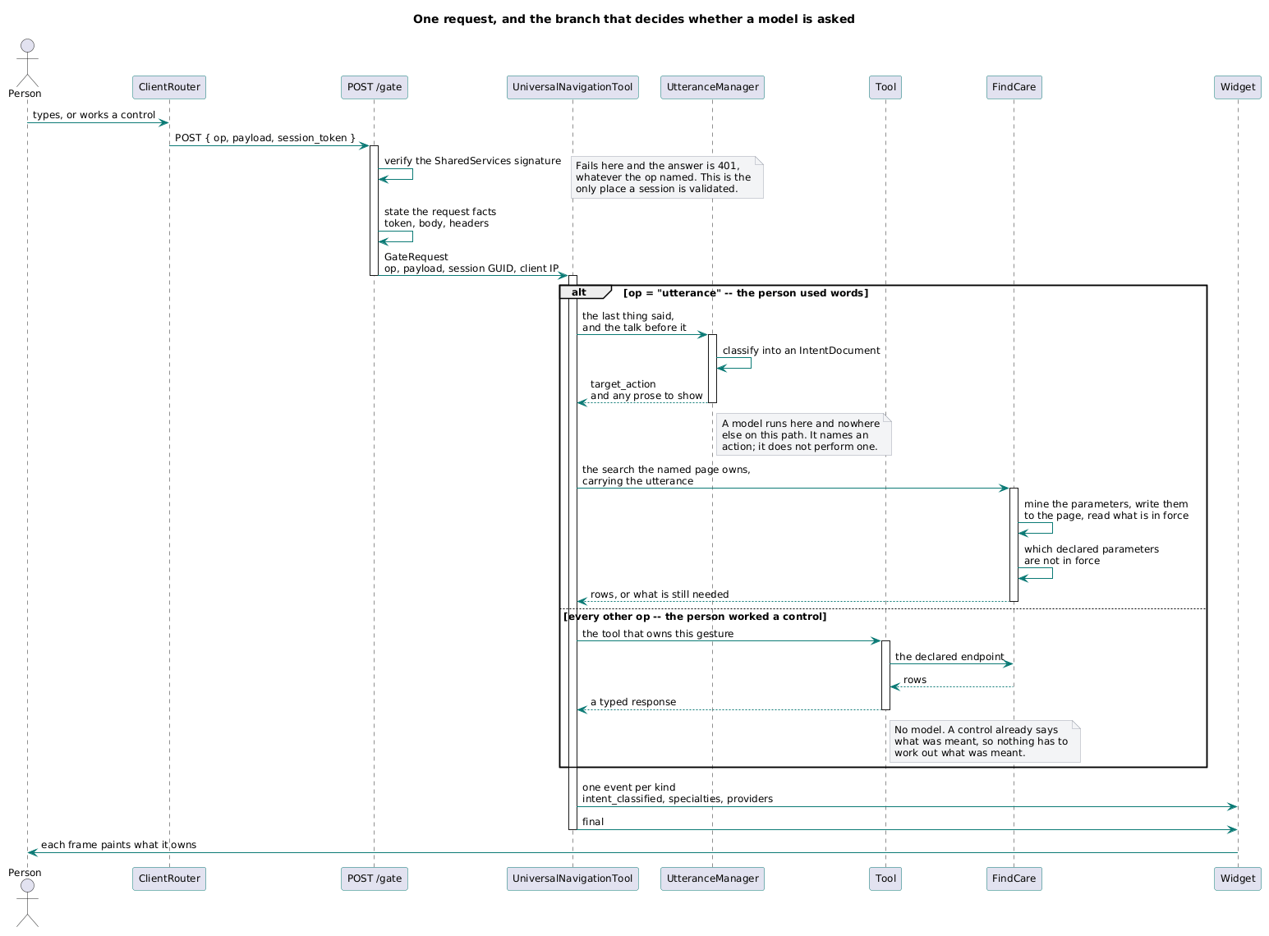
One user's web request through the single entrance. Every browser-originated call takes this path or does not arrive.

2.6.2 A component is reached only through the entrance
Capability components are public hosts and cannot demand a client certificate, so the refusal is a signature rather than a network control: the entrance signs the session token with its own key, each component is given the entrance's certificate at deploy time, and each verifies that signature on every route it serves.
Three questions are asked at a crossing and conflating them is what produces the recurring argument about how often a session is validated. The Security Framework §5.3 is the authority; this is the parent's citation of it:
question | establishes | how often | answered by
Is a session live? | a person holds a live, unexpired session | once, at the entrance | the entrance
Who is the caller? | the peer's identity | every hop | the mutual-TLS handshake, never the payload
Did this arrive through the entrance? | provenance | every inbound hop | each receiving component, against a constant it holds

A valid session presented by a peer proves that some session is live. It does not prove
the peer is entitled to act on it. That comes from caller authentication alone — so where
mutual TLS is not enforced, session validation is being asked to do work it cannot do.
Two generalisations — [R]:
- A signature is not a property of a signature. It is a relation between a signature and a key the verifier chose. A verifier reading the expected origin off the object it is verifying has built a self-certifying token, and a forged token naming the forger's anchor verifies perfectly.
- Where the network cannot enforce a boundary a signature can, and the signature is only as good as the transport under it. A signed token forwarded over a channel that authenticates nobody proves who wrote the token and nothing about who received it.

2.6.3 The model is confined to one place
Stated as a boundary rather than a preference: no function both issues a model call and returns records to its caller — unless the records are the intersection of the model's answer with a set retrieved before the call, in which case the intersection is the boundary and is visible in the function.
A model runs at two points and no others: reading what a person said, and authoring what to say back. Between them everything is deterministic. A person can verify a filter over registry data against the registry; they cannot verify a semantic guess. An architecture that lets a model touch the result loses that property silently and cannot get it back by testing.
Honest limit, so no subordinate document overstates it. The intersection buys soundness — nothing invented. It does not buy completeness: a candidate discarded before the model saw it is not detectable in the answer. Any architecture that pre-filters before a model call must say so, and should carry a signal in the response when it dropped anything. And soundness is against the catalogue, not against reality — if the catalogue holds an entry that should not be there, the intersection returns it and is working correctly when it does.

2.6.4 A component owns its own domain knowledge
The entrance carries what the person said and the talk before it, and reads nothing else. It does not know what a search is made of, what makes one valid, or what is missing from one. The component that owns the question mines its own parameters and states its own sufficiency.
The test: can a new product capability be added without changing anything between the browser and the tool that answers it? Asked of the entrance alone the answer flatters; the dispatcher behind it is where the knowledge accumulates.

2.6.5 What crosses — [R] rows, [I] examples
crossing | carries | never carries
Browser → entrance | The gesture, its payload, the signed session token | Business logic. The client decides nothing that changes state
Third party → entrance | A signed reference the firm issued and can verify, arriving by the sender's method at an address the gate owns | A route of its own. Not originating a request is not grounds for bypassing the entrance
Entrance → capability component | The signed token, what the person said, the prior dialogue | A search criterion. A caller that may pass one may omit one
Component → component | The signed token and a typed request, server to server | A browser hop. A person's browser never addresses two components
Pipeline plane → serving plane | Whole collections, under the name they left with, on release | A transformation. Nothing changes in transit
Any component → a model vendor | Only the field classes declared for that vendor in the record | Anything not on that list. The decision is architectural, not per call site
Governance plane → anything | Nothing at run time | A runtime dependency
Any tool → a third-party service | Only what that service's declaration permits | Anything else. A tool used to produce the architecture crosses this row as surely as one that runs it

The fifth row is the one most often missing from an AI system's architecture and the one discovered during an audit rather than chosen. A model call is an export of data to a third party under a contract someone signed, and it binds unattended components — a nightly job sending a catalogue is a crossing — as much as request-path ones.
The sixth row exists because the fifth was not general enough. A boundary crossing is created by any tool that sends the firm's material to a third party, including tools used to produce documentation. The governance plane is not in the request path and it still has an egress, which is precisely why no boundary table catches it: every table is drawn around the running product.
[I] Found while looking for something else: the repository's diagram renderer builds a URL against a public rendering host and fetches from it, and the vendored library defaults to the same host over plain HTTP. What would cross is the firm's own architecture source — thirty-six files, several of which enumerate every identity, the roles each holds, the vault layout and the grants on every custom role. §4 entry 20.
This also sharpens G-6's second enumeration in a direction nobody was looking. That enumeration asks which control planes can rewrite a constraint. A rendering service reads the description of every constraint the firm has — a different risk, and not nothing.
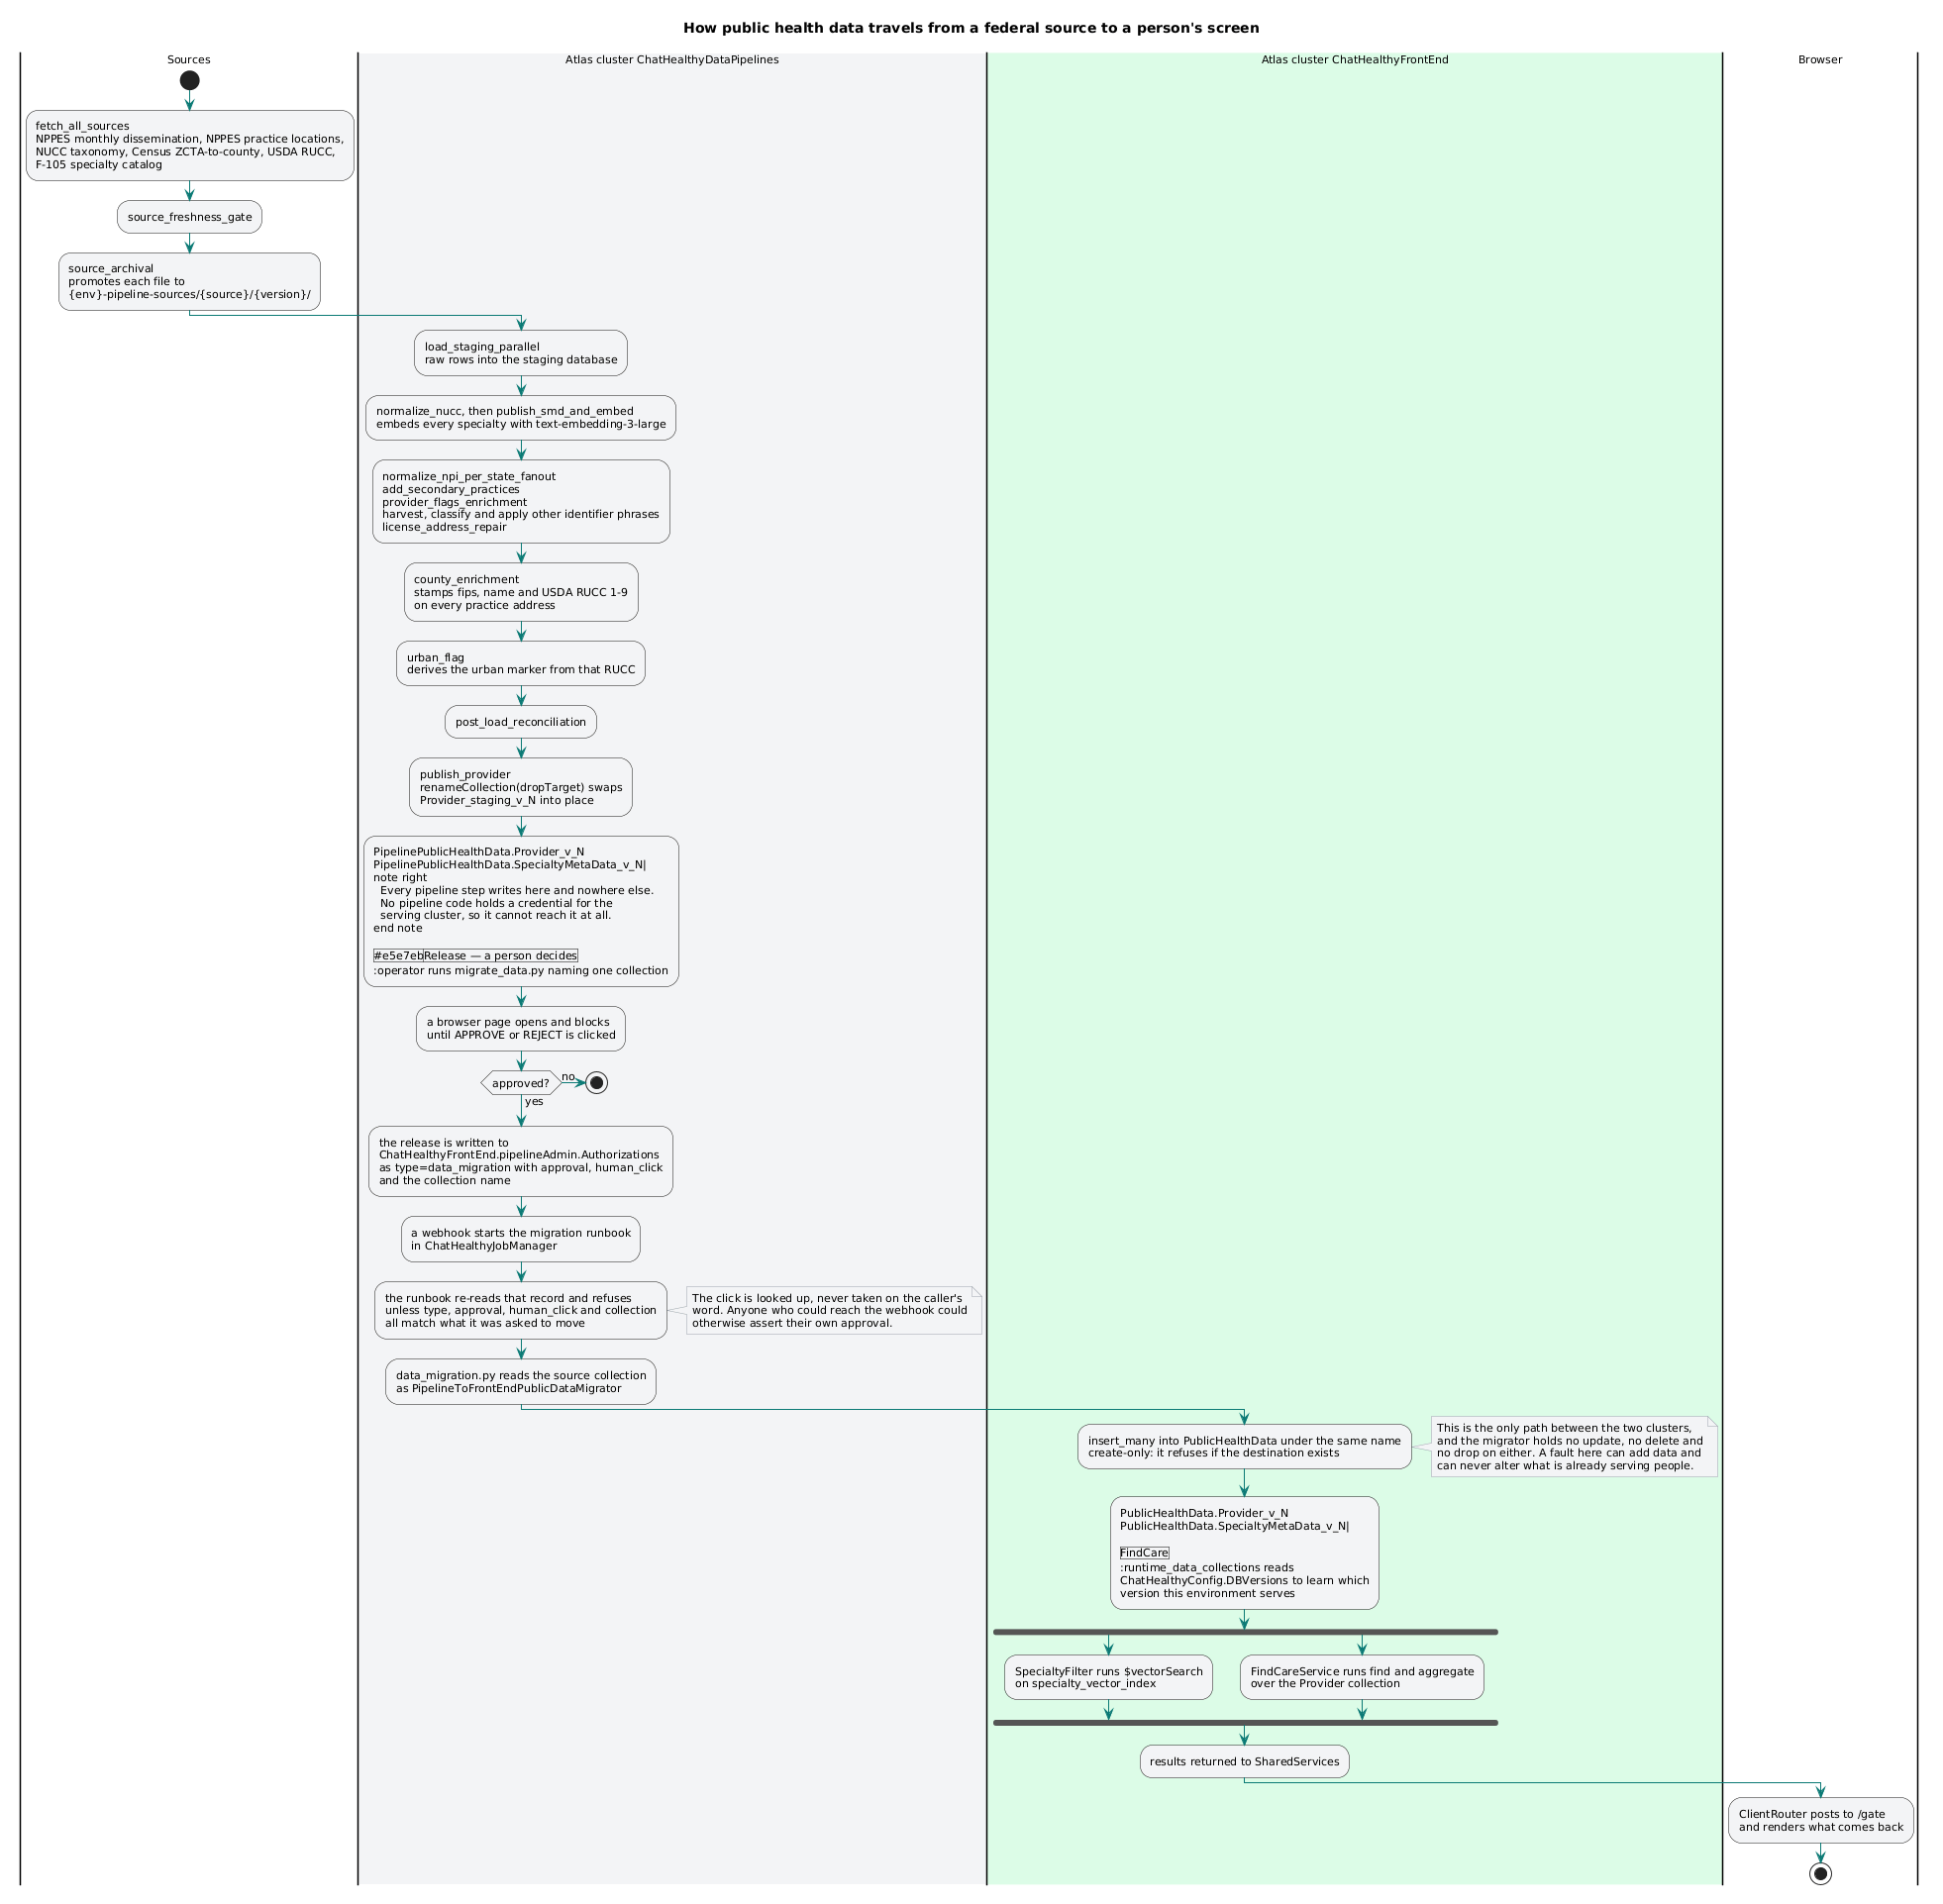
Where data comes from, what changes it, and the one path by which it reaches a user.

2.7 Governance — [R]

2.7.1 What governs a change
Governance fires on the agent's session boundaries and the repository's gates, because that is where an AI-native firm's work actually enters. A firm whose gates are only in CI has left the author ungoverned.
- A rule is a statement about all work, enforced by a program rather than by review. One concern, one rule, one enforcement. A concern split across several rules drifts apart from itself; a rule with several enforcements cannot say what it enforces.
- A rule with no enforcement is not in force, and the registry says which is which.
- A gating hook that dispatched nothing is a failure, not a pass. Nothing was checked, so nothing can be certified.
- A governed record validates against the schema at the address the record declares, fetched then. [I] The gate reads each file's declared $schema, fetches it over HTTP, and treats any fetch failure — HTTP error, unreachable host, timeout — as a violation against the file that declared it. It refuses; it does not fall back to a local copy. The one schema served from disk is the external JSON Schema meta-schema, a third party's artifact that is contractually frozen.

2.7.2 How code becomes a running system
Four operator-facing acts and no fifth: commit, promote, build, deploy. Each reads the record; none takes an instruction the record could have stated; there is one entry point per act. Between them they change every kind of thing the firm authors.
Three of the four require a person's authorisation and it is recorded. Commit, promote, and every non-local deploy. The promote authorisation must carry proof that a human and not an agent gave it — a firm whose workforce includes an agent cannot treat "an approval is on file" as evidence a person approved. Local deploy is exempt by design: the agent must iterate without a person in the loop, and a page in front of the inner loop teaches the operator to dismiss the page that guards production.
The authorisations are a record of their own, outside the repository the work lands in, holding refusals as well as approvals. A governance record that keeps only what was allowed cannot show what was stopped.
The record is the only statement of what the firm runs. Build artifacts — containers, workflow files, host configuration — are manufactured from it, never maintained beside it. A record with a second copy has no copy.
The record states shape, not technology. It names no vendor, platform, product or language, and its schema enumerates none; a platform-specific fact is carried as data. This is what lets a target move hosts by editing one binding, and what makes the substrate usable by a firm whose platforms are not these.
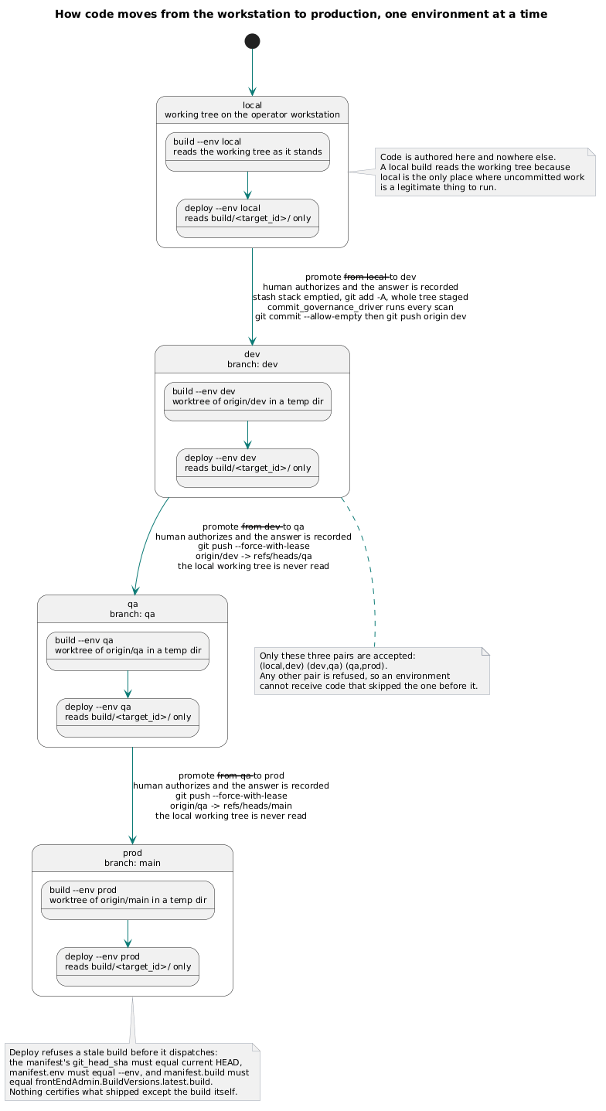
The four acts and the one direction. No act reaches another's kind of state, and no arrow runs backwards.

2.7.3 Publishing data is a binding, not a fifth act
The firm does not author its data. It acquires it, derives it and publishes it, on separate compute under a separate identity from a source the repository does not contain. That is why data has a framework of its own — and it is why the closure needs stating carefully, because producing a generation is not one of the four acts and no build produces a provider collection.
The closure holds because publishing decomposes into two things and only one is new:
- Producing a generation — the pipeline writes a versioned collection nothing is bound to. Under §2.8 rule 4 that is not a change to what the firm serves, because nothing serves it. Outside the four, governed by the Data Pipeline Framework.
- Binding it — a pointer change. This is the publish, and it is inside the four: a commit of the record, then a deploy that installs it.
[I] Verified in the record and the deploy code: the front-end store declares the version binding as a per-environment config collection, and the deploy writes config collections. Cutover is a one-line commit; rollback is the same line changed back.
This is why the pipeline's two strongest controls exist, and it is worth saying plainly: the append-only release grant and the versioned collection are not defence in depth around a dangerous act — they are what make producing a generation harmless, so that binding can be the only governed moment.

2.8 Data — [R] rules, [I] stores
Five rules govern every store.
- A store has exactly one writer. Read access is granted; write access is owned.
- A handle is obtained through one acquisition path that binds an identity — never by
constructing a client, reading a connection string, or standing a double in place of one. No test exemption: the certificate is the credential, and code reaching a store without an identity is code whose authorisation is never tested.
- Data is versioned, not segregated by environment. The physical name is composed — a
base and a generation — so two environments differ in which generation they bind, not in whether the data exists twice. Environment-suffixed collections are how a firm ends up with four datasets of unknown relative age and no way to reproduce a defect.
- **Published data is immutable, and a generation becomes published when something binds to
it. A release never alters or removes what was already there; finding its destination present is a stop, not a merge. An unbound generation is not published data, so a part-way-failed release leaves an unbound generation an operator drops deliberately — and *"does this collection exist"* is the wrong question for a retry gate, where *"is anything bound to it"* is the right one. Granting the release identity a delete so it can clear its own partial output is refused: it converts the one control that is a grant rather than a convention into a comment. The property this buys is that rollback and roll-forward are the same act.**
- **Any component whose resource can be stopped needs its control record somewhere the same
event cannot stop. A ledger answering "is a job running" cannot live inside the thing whose uptime that answer decides. This is the same mistake as a governance log inside the repository it governs and a manifest written by the actor it constrains: putting the record of a thing inside the thing.**
Two planes, and the separation is a control rather than tidiness. The serving plane must not be able to read a collection still being built; the pipeline plane must not be able to write one being served. Enforced by identity, not by convention. Migration is the only path by which data reaches the serving plane, it is separate from the pipeline that produced it, and it runs only when a person releases it. The pipeline plane is never in a user request path — a capability reading it at request time has erased the release gate.
[I] The stores:
store | holds | written by | read by
Serving — public data | The registry records the application serves | the migration, on release only | FindCare, EvaluateCare
Serving — configuration | Tool declarations, version bindings, library exclusions | a deploy | every component
Serving — sessions | The session and its page parameters | the entrance | the entrance
Serving — conversation archive | Every operator utterance and agent response | the archive drain | the governance plane
Serving — control | Run records, approvals, locks | the pipeline and the gates | the reaper, the report
Pipeline — working data | The records being built and enriched | the pipelines | the migration

2.9 Environments — [R]
Four: local, dev, qa, prod. A promotion chain and nothing else.
- Promotion advances the whole tree one adjacent step. Never a skipped step, never a partial tree, nothing stashed. The destination is byte-identical to the source.
- A target declares one set of files, packages, secrets and variables, and that set serves every environment. An environment binding declares only what genuinely differs: which host, which address, which store. The environment selects the host and nothing else. A difference in a target's contents between two environments is a defect in the declaration, not a property of the target.
- Every environment runs the same code path. A branch asking which environment it is in is a defect. Display chrome that names the environment on the page is not such a branch — it renders the environment's identity, which is the whole of its purpose.
- An environment is reproducible end to end from the repository and the deploy alone, including creating the hosts, vaults, secrets, databases, indexes and identities it needs — or failing while naming the privilege it lacked. This is the test that separates a deployment record from deployment documentation.
- After a deploy, nothing exists on a host that the record does not declare, and what is removed is logged.
- The running target reports the build it carries and the deploy verifies that rather than asserting it. Agreement is the only evidence a deploy succeeded; having sent the artifact is not.
What an environment is for, stated because it is usually left implicit: the chain exists so a change is observed at increasing cost of being wrong. That survives only if a failure in one environment cannot reach another. Where two environments bind the same host, the chain governs the code and governs nothing about the data or the credentials. An architecture that shares a store across the chain must say so plainly rather than let the promotion diagram imply an isolation that is not there.
[I] All four environments bind one front-end cluster, and dev, qa and prod bind one vault; all four currently bind the same data generation. Because the binding is a record value, giving them different generations is a commit rather than a project. §5.
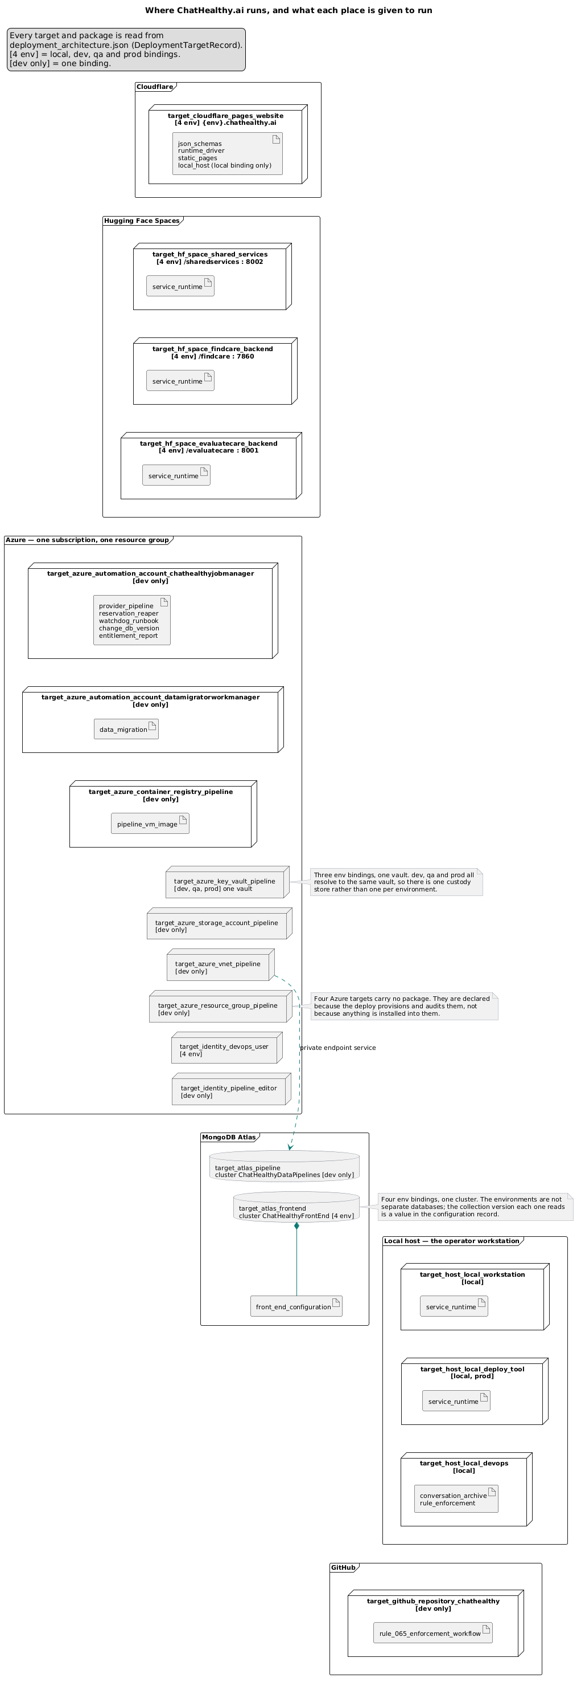
Which target runs where, per environment. The environment selects the host; the target's contents are the same in all four.

2.10 Compliance posture — [R]
The firm's case to enterprise buyers rests on auditability, so the controls above are not internal hygiene. They are the evidence, and the contribution is enumerable:
what an auditor asks | what answers it
"Show me where access is decided." | One entrance. One place, one log. §2.6.1
"Name every actor that can reach this data." | One identity registry, four classes, no exemption. §2.3
"Prove this running system came from this source." | The deployment record and the build the target reports. §2.7.2
"Show me the instruction that produced this change." | The conversation archive, retained beside the change. §2.8
"Show me that least privilege holds." | The scheduled entitlement report, read from the platform. §3 G-2
"Why did the system tell this user this?" | The model-decision audit record — and this one is not yet answerable. §4

Two things this posture demands that a non-AI firm's does not:
- The instruction is part of the record. When an agent authored the change, the prompt that produced it is as much a part of its provenance as the diff.
- A model-mediated decision needs its basis retained, not its outcome. An outcome record answers what; a regulator asks why, and asks after the moment the basis would have had to be captured.
And two rules about how the posture is written, which are the difference between evidence and assertion:
- A requirement is never weakened to match a substrate. Where a platform cannot meet one, the requirement stands and the gap is carried as a defect with an owner. Writing "mutual TLS where supported" produces a sentence nothing can fail.
- The non-compliance register is part of the posture, not an appendix to it. A firm that publishes only what holds is asking to be believed. §4 is the part a sceptical buyer should read first.
[I] The committed frameworks are NIST 800-53 and HITRUST CSF.

3. The principles, and the check a program could run
Twenty principles. P-1 … P-13 are what a team needs to ship a model-mediated product. G-1 … G-7 are what a firm needs to be a model-mediated company — a firm with no agent in its workforce does not need them, and a firm with one cannot operate without them.
(These were §11.1–11.13 and §11.14.1–.7 on the board. Peer artifacts cite the old numbers; the mapping is one to one.)
A principle with no test is a preference. Every check below is stated as something a program does, and each names an effect, not a spelling — a check that names a mechanism inherits that mechanism's lifetime, and reports green from the moment the mechanism it named stops being how the violation is committed. Where a check has never gone red against a real violation, it is marked unproven: a check that has never gone red is a hypothesis, not a control.

P-1 — The closed world
A model output that selects an action or a record is a choice from a set the system enumerated before the call. The enumeration is a type the model generates against, not a check applied afterwards. Why: a model that can name a target the system did not register turns any text a user supplies — or any text inside a retrieved document — into a request to execute. Validating afterwards is weaker than it looks, because the unregistered name stays reachable from any path that forgets to validate. Check: every model call site whose output selects an action declares a closed output type; the dispatcher is a registry lookup against that same declared set, not a conditional chain; and the set is read from one declaration in every place it is used. A set stated in more than one place is not closed.

P-2 — The language boundary
A model converts between natural language and structured values and does nothing else. Retrieval, filtering, ranking, authorisation, arithmetic and persistence are deterministic. Why: §2.1. Every principle here depends on it. Check: no function both issues a model call and returns records to its caller, unless the records are the intersection of the model's answer with a set retrieved before the call — in which case the intersection is visible in the function.

P-3 — Evaluation
Every prompt that runs in production has a versioned evaluation set in the repository and a recorded score against it. A prompt with no evaluation record is unapproved, whatever a registry says. Why: without a set, every prompt edit is an unmeasured change to production behaviour and the only feedback channel is a complaint. Teams then either stop touching prompts out of fear or edit them freely and find the regression in the field. Check: the evaluation record has a declared location and schema; every prompt id resolves to one; a commit changing prompt text without a re-scored result is refused.

P-4 — Behavioural drift
A model identity and version is a deployed dependency, pinned in the record like any other, re-measured when the version changes, and gated on the result. Why: a vendor updating a model behind a stable alias changes every classification in the system with an unchanged prompt, an unchanged content hash and a green build. It is the only dependency in a normal stack that can change without anyone's action — which makes it the one that most needs a gate and the one least likely to have one. Check: no model identity is a literal in source; the record names vendor, model and pinned version per call site; a scheduled job re-runs the evaluation set and reports the delta.

P-5 — Prompts are data, under one regime
A prompt has an identity, a version, a declared model, an approval state and an evaluation reference. Code reads it; code does not contain it. Why: a prompt embedded in source cannot be diffed, approved or evaluated as a prompt — it is reviewed by people reading for code. Where two regimes coexist, the registry becomes a description of the system rather than its source. Check: no runtime module passes a literal multi-line string as a system prompt; every runtime prompt resolves to a registry id; the registry ships to every target that reads it; and the registry's declared model for a prompt equals the model the call site uses.

P-6 — The system authors the facts; the model authors the prose
Counts, identifiers, prices, dates and any value a person may act on are rendered by deterministic code from retrieved data. A model may author the sentence around them. Why: a model asked to summarise a result will state a number, and the number will sometimes be wrong in a way indistinguishable from right. This is the most common way a shipped AI product tells a user something false, and it is preventable by construction. Check: message-building functions partition into deterministic (no model call, takes structured data) and generative (model call, receives no retrieved quantities), and the two sets are disjoint.

P-7 — Irreversible and safety-bearing decisions have a deterministic floor
The architecture names every decision a model makes that cannot be reversed or that bears on a person's safety, and for each states what checks it and what happens when the model is unavailable. Why: the failure is rare, which is why it does not get built, and unbounded, which is why it must be. A model-mediated safety decision whose outage path is a generic apology fails silently in exactly the case it exists for. Check: the classification is a field on the declaration, not a list in a document — each product capability's row carries reversible and, where false, names a floor that resolves to a code path. Every member of the model's closed set has a row; a test exercises the floor with the model unavailable.

P-8 — Materialise before acting
A model's structured output is persisted to a named store before any deterministic stage consumes it, and that stage reads it back rather than receiving it in hand. Why: it makes the input to every deterministic stage inspectable independently of the call that produced it, so an answer can be reproduced and explained without re-invoking a model. It is also what lets a later request add to an earlier one rather than replace it — the difference between a conversation and a series of unrelated queries. Check: no function passes a model result object directly into a query builder.

P-9 — Auditability of a model-mediated decision
The record carries the model identity and version, the prompt identity and version, the raw output, and the deterministic transformation applied. A record of the outcome alone is not an audit trail. Why: without the basis you can establish that a decision was made and never why — so you cannot answer a regulator, reproduce a complaint, or distinguish a bad prompt from a bad model from a bad input. The cost lands when someone asks, which is always after the data would have had to be captured. Check: for any sampled request id the store yields all four.

P-10 — Cost and latency are measured, not estimated
Every model call records model, tokens in and out, and wall-clock duration on the same trace as the request that caused it. Why: one interaction commonly makes several model calls. Without instrumentation nobody can say what a user's web request costs, where its latency sits, or whether a change made either worse. Check: a query returns cost and duration per user's web request broken down by call site.

P-11 — What a model may never see
The architecture states, per vendor, which classes of data may cross and which may never. A row in the boundary table, not a decision left to each call site. Why: left unstated, the decision is made by whoever writes the next call site, and the firm's aggregate position is discovered during an audit rather than chosen. Check: the permitted set has a declared home (§2.5); every model call site's payload fields are drawn from it; and the check binds unattended components as well as request-path ones.

P-12 — Non-determinism is stated, not assumed away
The architecture states that identical inputs may produce different outputs, names where that is true, and states what is done about it. Why: every downstream guarantee about reproducibility is a claim about a stochastic process, and a document that does not say so promises more than it can. Check: no model agent is constructed without an explicit sampling configuration; evaluation results report variance across repeats.

P-13 — The model layer holds no credential, address or policy
Vendor clients, credentials, endpoints, retry, timeout and failure conversion live in one library facade. Why: otherwise the model is a literal in as many places as there are call sites, each invents its own failure behaviour, and there is nowhere to add retry, version pinning, cost accounting or a kill switch. P-4, P-10 and P-12 are unimplementable until it holds. Check — stated as an effect, not as a mechanism: no runtime module outside the facade obtains a model client or a model agent, by any library. A form naming vendor SDKs specifically reports green while the principle is violated eight times, because the live bypass constructs the facade's own substrate instead. §4 entry 5.

G-1 — Authorisation is an event, produced by a channel the governed process cannot originate
For the declared set of acts that cannot be undone, the authorising person is present when the act fires, naming the act, recorded. And the evidence that a human answered must come from somewhere the governed process cannot reach. Why: the firm's own threat model contains the conclusion — anything that actor can perform is not evidence of a human. Carried to its end that rules out every same-machine channel: a loopback page can be fetched, its token read and its form posted; hardening the server-side check only changes which field is forged. It follows that a model may not authorise a change. A model may review, score, advise or refuse; releasing is a person's act. Check: the act blocks until an answer arrives over a channel the governed host cannot originate, and the record carries a signature over the identity of the act, made by a key that host does not hold. A boolean the host supplied is the host answering its own question.

G-2 — Falsifiability
**A record the agent wrote becomes evidence the moment there is an independent reading of
the same fact to compare it against. The record does not have to be trusted; it has to be
falsifiable.**
The operator's own formulation, which is where this came from:
*"the entitlement report must come 100% from Entra, Mongo, and the vault. Not from the deployment
architecture… **This is the only way we can face an auditor and tell them we are actually
zero trust.*"
Why: every forward gate is satisfied by an actor declaring what it is about to do. Nothing in the forward direction detects a thing that runs and was never declared. In a firm whose workforce includes an agent, the record and the actor are the same party, so a gate that checks the record against itself certifies nothing. This is the one principle that cannot be satisfied by writing more gates.
And the general shape of the failure, which is broader than records: a check that a value resolves is a syntax check wearing a semantics check's clothes.
Check, in two parts. (a) The inventory is a record, not a paragraph. One row per class of declared fact, naming the declaration, the reader that could contradict it, and when that reader last ran. Then three assertions: every class of declared fact has a row; every row names a reader that exists; no reader's last run is older than its stated period. The count of classes with a reader is the architecture's soundness and it is a number a buyer can be given. (b) The reader is not the declaring party. An audit run by the audited party is evidence, not proof.
[I] Six classes of declared fact; two have an independent reading, and one of those two is weak — the target reports a build number read from a file baked into its own image, so it establishes arrival rather than contents.

G-3 — The instruction is retained with the change
Every operator utterance and every agent response is captured as business data, verbatim, attributed, timestamped, before anything downstream can fail. Why: when the author is an agent, the prompt is the design document. A change whose instruction was not retained cannot be explained after the fact by anyone. Check: capture writes to a local durable spool and exits; a separate drain ships it and deletes only on confirmed write; no network call sits in the capture path.

G-4 — A control an agent invents is indistinguishable from one the firm specified
An agent implements what an approved requirement states and nothing beyond it. A gap — including one that admits a real defect — is escalated, and the requirement is followed meanwhile. Why: every gate checks that what the requirements ask for is present. Nothing checks for what they never asked for. An invented control is therefore enforced on every run thereafter, by an authority nobody granted. Check: a requirement is the only authorisation for work, and the requirement tree is written by a person. A test a reader can run on this document: six deliverables, zero requirements authored — where each needed a rule no requirement supplies, it raised an open question instead.

G-5 — A check is proved by having caught something
A check that has never gone red against a real violation is a hypothesis, not a control. This is S-3, and it is the principle a firm skips because a green check and a broken check are the same colour. Why: the agent writes the control, the record and the check. Those three errors are correlated, so all three can be consistent and wrong together and every gate passes. Only a question asked of the check catches it. Check — three questions of every enforcement: (1) is it aimed at the mechanism that actually produces the violation, or at a spelling of it? (2) has it ever refused anything, and when? (3) does a seeded violation make it go red today? A new check ships with a seeded violation or it ships unproven. [I] Applied here, it produced §4 entry 5 — a check reporting green over eight live violations of its own principle, because the mechanism it named was deleted.

G-6 — A constraint binds only where there is no second path and no reachable control plane
A permission list is not a boundary. Two things defeat one:
- A second, unconstrained path to the same capability. Permission systems are
additive: a condition on one assignment constrains that assignment and nothing else.
- Reachable control-plane authority over the constraint itself. A grant that withholds
delete is defeated by whoever can rewrite the grant. Why: every other principle is enforced by something; this is the one that asks what enforces the enforcer. It is the only one that requires an enumeration rather than an assertion, and therefore the only one a document cannot satisfy by being well written. Check — three enumerations, all of which must come back empty: (1) every assignment, grant, role or policy conferring the withheld capability on the constrained party, at or above the scope where the constraint is written; (2) every control plane that can rewrite the constraint, and every credential reaching one; (3) every second-hop route — a capability that can hand out the capability, including the constrained party's own role, without which the holder deletes its conditioned assignment and creates an unconditioned replacement. The enumeration is performed against the platform, not the repository, which makes this a special case of G-2 and the sharpest one. [I] Two controls were held up in this swarm as structurally sound. Neither passes. One is applied and defeated by enumeration 1; the other is a genuine store-enforced control over its writer and is defeated by enumeration 2. Neither failed by being badly built. Both failed at an enumeration nobody ran.

G-7 — A rule that exists only as a comment is worse than no rule
Every rule the system relies on is carried by a program that enforces it or a requirement that states it. A rule existing only as prose inside the code is unenforced, reads as enforced, and answers the question a reader would otherwise have asked. Why: drift here is not a risk, it is the default, and its direction is fixed — code changes and prose does not, because nothing tests prose. And the reason it sits among the governance principles rather than in hygiene is the workforce: a human skims a comment; an agent reads it as a statement of the system's rules and builds to it. In a firm whose workforce includes an agent, a stale comment is not a documentation defect. It is a standing instruction to the workforce, issued by nobody, that no gate will retract — G-4's invented control at its cheapest delivery. Check — three parts: (1) Every citation is checked against what its target says, not against whether the target exists. Extract by lexical pattern; resolve; put the target's text and the citing sentence to a judge; fail on divergence. A citation that resolves is not a citation that says what the citer claims. This applies to every class of citation the firm makes, and the defect appeared in three of them within one day:
citation | what resolved | what did not
a comment naming a requirement id | the id | what the requirement says
a register row naming a defect record | the defect | whether its description matched the code
a register row naming a refactor phase | the phase | whether the phase carries the work

All three have a lexical form, so all three are extractable and all three are checkable by the same gate. A phase that exists is not a phase that carries the work, and a register citing one tells a reader work is planned when it is not — which is worse than an uncited row, because a reader stops asking. (2) A comment stating a prohibition in a runtime module names an enforcement that resolves in the rules registry, or it is a register row. (3) No artifact cites prose as support for a claim. §0.2. The hard part of (1) is already built and shipped: one enforcement in this firm already reads a story's requirements at gate time and puts each to a model against source. This is that enforcement pointed at a second surface — the cheapest gate on any list here. What it does not do, stated so it is not oversold: it checks a comment that cites an id, and most comments cite nothing. A rule worth writing in a comment is a rule worth citing, and one that cites nothing is announcing that nothing enforces it.

4. Non-compliance register
Every row is a claim this document makes, walked against disk or the platform. Each names its evidence type: behaviour (what runs), data (record, database, platform), requirement (approved, read), intent (a design document). Prose is not an evidence type. And every row states a finding: *not established* and *not true* are different states, and only one of them is a finding.
Ordered by consequence.
# | the claim | what disk or the platform says | evidence
1 | §2.1.1, G-6 — an agent may not create an identity, and the constraint cannot be lifted by the constrained party. | The constraint is declared in the repository and is not in force on the platform. The live role withholds nothing; the self-including condition is applied and governs nothing, because the same principal separately holds an unconditioned higher-scope assignment carrying identity creation directly. This is not a missing control. It is a control that reads as present in the record and is absent in fact. | data — live platform queries by the Security Framework and the coordinator, against the repository's declared role.
2 | G-1 — the human-presence proof comes from a channel the governed process cannot originate. | It is a client-supplied string the server trusts: the handler checks a form field equal to the literal "true", while the real presence tests run in the page's own script and are posted as that field. The approval URL is written where the invoking process reads it. Commit, promote, deploy and the data release all terminate in this one function. | behaviour — the request handler and the page script, read. Found by the DevOps Governance Framework, verified independently twice.
3 | §2.7.1, §2.1.1 — an agent's acts against remote state are gated by a declared set. | Nothing constrains what an agent may run. The rule intended to gate it carries an empty enforcement list; the hook it would fire on is not registered; and the harness's own permission layer is off. Three independent things are missing, so fixing one restores nothing. | data — the rules registry and the harness settings, read.
4 | §2.2.3 — the code tree mirrors the requirements tree, and the gate checks the right feature. | 331 of 377 record-level file entries — 88 per cent — resolve to one feature that owns almost none of them. Zero entries lack a value, so the referential-integrity gate is green throughout. The record is an index in form and a single wrong answer in substance. | data — walked the record, counting per feature. (The DevOps Governance Framework counts 337 of 385 by including package-level entries; both are right, and that two sets exist is itself its NC-7.)
5 | P-13 — no runtime module outside the facade obtains a model client. | The principle is violated eight times, and a check aimed at the mechanism a defect record describes reports green over all eight. That mechanism — direct vendor SDK construction — exists in two files and neither has a caller. The live bypass is eight constructions of the facade's own substrate, in five files. A check written from a defect description tests the mechanism the description imagined. | behaviour — pattern scan over the five source trees excluding build output and tests, plus caller search for each.
6 | G-5, and §2.4's governance-plane row — a governing program is subject to the governance it applies. | The governance substrate is ungoverned. All four repository hooks live in a directory that is never committed; none is tracked; none appears in the deployment record. The hook that unmakes an unapproved commit is a file the governed process can rewrite with no commit showing that it had been, because the file is in no commit. | data — hooks-path configuration, the tracked-file list, and the record, all read. Raised by the DevOps Governance Framework.
7 | §2.6.2 — a component verifies the entrance's signature on every route it serves. | One component does, on twelve of fourteen routes. The other verifies on none of the routes that serve work. A component that verifies nothing cannot refuse anything, so for it the one-entrance property fails in both directions at once. | behaviour — every route decorator in both applications, read and classified.
8 | §2.6.1 — every browser call goes to one address; §2.6.5 — a person's browser never addresses two components. | A browser fetch addresses a capability component directly, and the route it calls is that component's one unguarded non-health route, so both halves of the boundary fail at the same line. Scheduled work: the route moves in 06_migration Phase 3, and the fetch that calls it becomes a gate op. Note the move alone does not close this — Phase 3 relocates the route; routing the caller through the gate is the closing act. | behaviour + requirement — the call site and the route set, read, against the approved requirement, read.
8a | §2.6.1a — traffic the firm does not originate arrives at a URI the gate owns and is dispatched. | The identity-provider callback and start routes sit outside the gate. No longer an open question: the operator has settled that nothing is exempt, and the mechanisms are already present on this exact path — a signed state verified in constant time, a fact-collector for arbitrary requests, and a callback that is already its own module. This is scheduled work of Phase 4's shape — a dispatch-map entry plus a registration. `06_migration` §3 does not enumerate it, and I will not cite a phase that does not carry it; the Refactor Plan is asked to add it. | behaviour — the routes read on the entrance; the signing and verification path read; the fact-collector read.
8b | §2.6.1a — nothing is exempt, including session issuance. | The unauthenticated session-minting route sits outside the gate, and unlike 8a this one is a genuine either/or that only the operator can pick: an unauthenticated op on the gate weakens "no op is exempt", and a separate endpoint weakens "one entrance". Both weaken something. Not scheduled, because the shape of the fix is undecided. §5. Separately and not part of that choice: resuming a session currently requires knowledge of a 32-hex identifier that travels in request bodies, which makes any log that captured one a credential store. | behaviour — the route and its liveness check read. Raised by the Security Framework.
9 | §2.6.5 — a component-to-component crossing carries a signed token, server to server, and the signature is the boundary because the network cannot be. | The transport under that signature authenticates nobody. The shared library's own cross-service call disables peer certificate verification on the same call that forwards the session token, so every tool inheriting the contract ships without transport authentication, and twenty further call sites do it by hand. A signed token over an unauthenticated channel proves who wrote the token and nothing about who received it. | behaviour — the library call and a scan of the front-end tree. Raised by the Live Application Architecture.
10 | §2.6.5 row 1 — the browser tier decides nothing that changes state. | The courier holds a general-purpose execution primitive on an unauthenticated broadcast channel: a message type whose payload is executed as code, with the exception swallowed; no receiver anywhere checks the sender; every cross-frame send targets any origin. It is routine protocol, not a corner case. | behaviour — the courier read in full; origin-check search returns nothing. Raised by the Live Application Architecture.
11 | §2.8 rules 1 and 4 — one writer, and published data is immutable. | The application replaces whole documents in the bound served generation from the request path, and writes derived fields into them, under the runtime identity. This destroys pipeline-computed fields and breaks the generation's provenance. No approved requirement asks for it: the requirement says the detail must show live registry state, and its sibling requires the corpus to remain separately available. | behaviour + requirement — the write path read, and both requirements read rather than cited. Found by the Live Application Architecture, enlarged by the Data Pipeline Framework, requirement text read here.
12 | §2.5 — five records, each stating one thing. | The identity registry is a key inside the deployment record: one artifact carrying two concerns, so an identity change and a deployment change are one kind of event to every reader. Named rather than discovered, and unresolved. | data — the record's root keys.
13 | §2.9 — an environment binding selects the host, and a failure in one environment cannot reach another. | All four environments bind one front-end cluster and one data generation; dev, qa and prod bind one vault. The promotion chain governs the code and nothing about the data or the credentials. | data — the target's four environment bindings and its version-binding records. Confirmed independently by the Data Pipeline Framework.
14 | §2.8 rule 1, and G-2 — an authorisation record is evidence. | The release identity can insert into the collection holding the record that releases it. The grant is needed for a legitimate purpose — the service records its own acknowledgement — but a store grant is per collection, not per document type. Append-only protects a record from its writer; it does not protect it from an actor who is also a writer. | data — the role's fourteen grants, read, against the code's reach. Found by the Data Pipeline Framework.
15 | §2.7.2 — the four acts are the only route to remote state, one entry point per act. | A fifth exists and is ungated: a program that connects to the serving store as the deploy identity, drops the destination collection when non-empty and refills it, with no environment guard, no approval and no record. It is undeclared, so no gate can see it. Separately, the enforcement of the three-entry-point rule permits a fourth file by listing it. | behaviour + data — the program read; zero mentions in the record; the enforcement's allow-list read. Found by the Security Framework, verified by artifacts 3 and 4.
16 | §2.3 — certificates are issued by the firm's own authority. | The firm operates a trust chain without an issuer. The minting module is absent from disk; the caller that mints leaf certificates still imports it and therefore raises. Validating a chain works; issuing does not. | behaviour — module absent, import site read. Raised by the Security Framework.
17 | P-3, P-4, P-9, P-10, P-11, P-12 — evaluation, drift, audit, cost, the vendor boundary, non-determinism. | None is implemented. No evaluation harness exists; no version is pinned; no model-decision record is written; no usage is instrumented; no permitted-field set is declared; no sampling configuration is explicit. These are the six that make a model-mediated system operable after it works, which is why a team building the feature does not build them. | behaviour — searched for each; none found. Conformance run by the Live Application Architecture against these checks one-to-one.
18 | §2.5 — the records are internally consistent. | Nothing checks internal reference integrity at all. The gate checks a reference that crosses records and no check walks the references inside one; two target references resolve to nothing, cited four times each. One target in nineteen declares the runtime its code needs. | data — declared ids walked against references.
19 | §2.4 — the application's composition is data, so the record's declaration joins to the code that implements it. | The join does not exist, so "declared equals dispatched" cannot be evaluated at all. The record names tools in one convention — ProviderSearch, 56 occurrences — and the code declares them in another: every *_tool.py I read exports snake_case (clinical_trials, specialty_filter, about_chathealthy, authn). And the package the record points at for provider search exports no tool name at all. A gate cannot compare two sets that are not keyed alike. This blocks `06_migration` Phase 0 gate 2, which is written to fail in either direction and currently cannot key either side. | behaviour + data — TOOL_NAME exports read across both source trees; occurrence counts taken from the record. Raised by the coordinator's Phase 0 run; verified here.
20 | §2.6.5 row 6 — a tool sending the firm's material to a third party is a declared crossing. | The repository's diagram renderer constructs a URL against a public rendering host and fetches the image from it; the vendored library defaults to the same host over plain HTTP. What would cross is the firm's architecture source — including the file that enumerates every identity, its roles, the vault layout and the grants on every custom role. It appears in no boundary table and in no record. Not established: whether the images on disk were produced by that path. I did not run it and did not intend to; someone should establish which, because it decides whether this is an exposure that happened or a mechanism that would cause one. | behaviour — the render call site and the library's default server, read. data — 36 sources on disk.

Two patterns run through the register.
Rows 1, 2, 3 and 14 are one shape: the actor being governed writes the record of its own governance, and the controls meant to constrain it are declared, forgeable, absent or self-writable. Rows 1 and 2 are what a sceptical buyer should ask about first — not because they are the largest, but because both were invisible to every gate and to two rounds of review, and both were found by reading a platform and a request handler rather than a record.
Rows 4, 5, 6 and 18 are the other: every gate checks that a declaration is well-formed and that the declared thing is present; none checks that the declaration is true. Four artifacts found this independently; one found the remedy; it is G-2.

5. Open questions — operator only
The consolidated list is on the board and the Security Framework holds its authoritative form as eleven decisions. Two condition all the others and nothing else is worth answering first:
- What channel carries an authorisation the workstation cannot originate? Every
authorisation in the firm terminates in one function, and that function trusts a value the governed process supplies. No same-machine hardening closes it. (Register row 2, G-1.)
- Is the agent's platform privilege meant to be the declared constrained role? It is
not, today, and the divergence is at a scope above every control written to constrain it. By construction the agent cannot narrow its own assignment and have that mean anything. (Register row 1, G-6.)
Nine further decisions sit on the board. Four are the parent's to name here because they bear on boundaries this document states:
- Session issuance: an unauthenticated op on the gate, or a separate endpoint? This is
the residue of the one-entrance question and it is the only part of it still open. An unauthenticated op weakens no op is exempt; a separate endpoint weakens one entrance. Both weaken something and no third shape exists, which is why it is here and not scheduled. (Register row 8b. The rest of that question is settled: the requirement carries two classes, nothing is exempt, and the identity-provider callback is scheduled work — see §2.6.1a.)
- Do the four environments share one store, one vault and one data generation by intent?
They do. Because the binding is a record value, separating them is a commit rather than a project — which changes the decision from buy separation to decide whether you want it.
- The data pipeline has no requirements. Fifteen approved requirements govern moving a
collection without changing it; three govern a reaper; nothing governs fetch, staging, load, enrichment, validation, publication, provenance or quality. The firm has specified the transfer of its data and not the manufacture of it. A stage with no requirement cannot be made falsifiable even in principle.
- Which of the firm's rules about itself deserve to be requirements? The strongest
controls in the system — the branch restriction, authorisation at the moment, the post-commit rollback, the circumvention record — are in force with no product requirement behind them. Legitimate, and it means an auditor tracing the strongest control finds a rule and nothing behind it.
No requirement is authored anywhere in this document. Where a gap was found, it is here.

6. What transfers — the one-pass index
[R] sections transfer whole; the [I] paragraphs inside them are worked examples and delete without loss.
section | transfers | what is ChatHealthy-specific inside it
§0 How to read this | whole, including §0.2's evidence rule and §0.4's vocabulary | nothing
§1 What this decides and defers | the five decisions; the deferral table's shape | the four framework names
§2.1 What makes a firm AI-native | whole, including the three-writer frame | one paragraph naming the agent identity
§2.2 The operating model | whole | the reporting-epic example
§2.3 The workforce | whole | nothing
§2.4 The components | the shape and the three rules | every component name, every host
§2.5 The canonical records | the five and what each states | which two are one file
§2.6 The boundaries | whole, including every row of the crossing table | the entrance's address; which vendors
§2.7 Governance | the four acts, the three authorisations, the record rules, and §2.7.3's binding argument | the verification of it in this record
§2.8 Data | the five rules and the two-plane separation | the store table
§2.9 Environments | whole | which hosts are shared
§2.10 Compliance posture | the auditor table and the two writing rules | the named frameworks
§3 The principles | whole. Read this first. | nothing. Every [I] note is evidence, not architecture.
§4 Register | nothing — it is evidence | all of it
§5 Open questions | nothing | all of it

A different firm in a different domain adopts §0, §1, §2.1–§2.3, §2.6–§2.10 and §3 entire; it replaces §2.4's contents, §2.10's named frameworks, §4 and §5.
One division inside §3 is the whole point of this document. P-1…P-13 are what a team needs to ship a model-mediated product. G-1…G-7 are what a firm needs to be a model-mediated company. A team adopting only the first thirteen has built an AI application. A firm adopting both has built an AI-native corporation — and the difference is entirely in who may authorise what, and in whether anything can contradict the record written by the system's own author.
Of the seven governance principles, one is met.

7. What the reference implementation proves, and what it does not
Stated plainly because all three audiences need it and each needs a different half.
It proves the shape works. One entrance, one identity per actor, a record that manufactures the build, four acts and no fifth, data versioned rather than copied, composition as data — all of it is built, all of it runs, and a new deployable target is a record entry rather than new chain code. The three product principles the firm designed around — the language boundary, the system authoring facts, materialising before acting — are met, and they are the three whose absence could not have been repaired later, because each is a shape rather than a mechanism.
It does not prove the governance holds. Six of seven governance principles are unmet, and the two most important were found unmet by reading a platform and a request handler after two rounds of review had passed over both. That is the honest state and it is also the strongest argument for G-2 and G-5: the failures were not found by better documents. They were found by asking, of each claim, what would contradict it — and then going and looking.
A firm adopting this architecture should build G-2's inventory before it builds any gate. It is the only artefact that measures whether the gates mean anything, and every number in §4 that a buyer would want is a row in it.

