Data Pipeline Framework
How raw public data becomes something the application can serve, and what may write what.

The Data Pipeline Framework
How raw public data becomes something an application can serve.
Part of the reference architecture for the AI-native corporation. ChatHealthy.ai is the reference implementation.

How to read this
Every principle carries a marker.
- [R] — reference. Holds for any AI-native company ingesting any public dataset. Adopt as written.
- [I] — implementation. True of a national provider registry, or of ChatHealthy's platform choices. An instance of the [R] principle above it. Substitute your own.
Section 2 is the whole framework in twenty-three principles. It is the spine, not a summary: sections 3 to 12 elaborate each principle in order and add the reference implementation. A reader who wants only the transferable architecture can read section 2 and the diagrams and stop.

What counts as evidence
Every factual claim in this document is one of four kinds, and the register in section 14 labels each row:
type | what it means
behaviour | what the code does when it runs, established by reading the executable path
data | what a configuration record, a database or the platform actually holds
requirement | an approved requirement in the backlog, checked against what it says
intent | a design document, labelled as intent and never as evidence of behaviour

A comment, a docstring, a variable name, a log wording and a bug description are none of these. They are claims someone made once and nothing checks them. This document cites none of them as support. Where one contradicts behaviour, the contradiction is itself a finding — and section 6.7 is the sharpest instance in this codebase, where the only statement of a safety rule that would prevent data loss exists as a sentence in a docstring with no runtime guard behind it.
The design document ProviderPipeline_LowLevelDesign_v50.docx is cited throughout as intent. It is a considered, versioned, operator-reviewed statement of what the pipeline is for. It is not evidence that the code does what it says, and in three places established below it does not.

1. What this document decides, and what it defers

It decides
- The stage model: what a pipeline is made of and what each stage may touch.
- The store model: how many stores there are, what separates them, and where the boundary is enforced.
- Release: what it means for data to reach the served store, and what makes that a control rather than a step.
- Load semantics: idempotence, full versus incremental, and what deletion means.
- Provenance and enrichment: how a served record says where it came from and which of it is ours.
- Data quality: how a defect is detected, graded, recorded and delivered.
- Compute lifecycle and cost.
- Failure, including the case where the thing that failed is the thing you would record the failure in.

It defers
to | what
01_system | Boundaries between planes; the immutability of published data as a system rule; whether data release is an act of the firm. 01_system rules on boundaries.
02_security | The grant matrix itself, and who may hold which credential. This document states what the matrix must accomplish and cites §6.1.1 for its contents.
03_devops | How a pipeline is built, declared and deployed; how a schedule and a webhook are installed; the four acts.
05_application | What the application does with served data, how it renders provenance, and the shape of a served result. Also the gate's dispatch model, which §12.9 consumes.
06_migration | The sequencing of the remediation. Where a finding here is scheduled rather than open-ended, this document cites its phase and does not restate the plan.

One question shared with `05_application`, stated once
A provenance model that the store honours and the display cannot carry is not a provenance model. Section 7 requires a served record to name which authority asserted each fact; 05_application requires the display never to present a repaired value as though it were the reported one. Neither of us can specify the transport between them alone, and neither of us should specify it twice.
Joint position: the store's authority tags survive to the display, and the result-row contract carries them. The rendering rule belongs to 05_application; the tag vocabulary belongs here (§7.4). Where a record matched a query through a derived value rather than a reported one, the result says so. This is one question with one answer, recorded in both documents by cross-reference rather than restatement. What neither of us can settle is whether the display shows the reported value, the derived value, or both — that is a product decision and it is question Q6 in section 15.

2. The contract — the framework in twenty-three principles
Everything in this section is [R]. A different company, a different public dataset. Sections 3 to 12 elaborate each in order.

The stores
P1. Two data stores, separated by grant. A build store nothing user-facing reads, and a serve store nothing but the release agent writes. Enforced at the database server, not in code and not at review.
P2. Three identities. The application runtime reads the serve store. The pipeline owns the build store and has no access to the serve store. A release agent is the only writer of the serve store. The third identity is not a luxury: without it the release borrows the application's credential, which widens the most widely-held credential in the system to serve one batch job and makes the audit trail say the application did it.
P3. The grant boundary is the database, not the cluster. One identity can be a registered user on several clusters, granted differently on each. Cluster placement is routing; the role names databases. A framework that reasons in clusters will conclude P4 is a violation. It is not.
P4. A control store, on infrastructure that is up when the build store is down. Run records, reservations, locks and findings cannot live inside the resource whose availability they describe. Its uptime requirement therefore matches the serve store's, not the build store's, even though its contents are entirely about the build.

The stages
P5. Seven stage kinds — fetch, stage, load, enrich, validate, publish, migrate — each with a grant about what it may touch, not a guideline. The partition key is a property of the step, not of the pipeline.
P6. Fetch is conditional and archival. Ask whether the source changed before taking it; archive the bytes under their hash before anything parses them.
P7. Staging is verbatim and disposable. It exists so that a defect can be attributed to the source or to us.
P8. Validate measures; it does not repair. A stage that fixes what it finds reports nothing, and the count of things it fixed is the count of things nobody saw.
P9. Publish by atomic rename, and guard the rename by scope. Build under a name nothing reads; rename when whole. Write a loaded-metadata record, without which the collection is not published, merely present. A rename that replaces a broader collection with a narrower one destroys the difference, so the publish step must refuse unless what it is about to install covers what it is about to replace.

Release
P10. Migration is the only path to the serve store. It transforms nothing, is additive only, stops rather than overwriting, and fails loudly on a missing source. Indexes travel with the collection: constraint indexes before the documents, performance indexes after.
P11. Give the release identity insert and create, and no update, delete or drop, over any data anywhere. Then "a release never destroys what is serving users" is a property of the credential rather than of the code. Adopt this before anything else in the framework. It is the only control in the release path that a mistaken or compromised release cannot talk its way past.
P12. Release is a recorded human sign-off — a person not a schedule, durable, specific to this work, and attested by the service before it acts.
P13. A presence proof the gated process can produce is not a presence proof. Whatever tests run to establish that a human acted, if their verdict reaches the gate as a value the requesting process supplies, the gate establishes nothing. Nor may the releasing identity be able to write the record that authorises it.
P14. Producer and releaser are separate in code, identity, deployment and trigger. The releaser has no schedule, so it cannot start itself.

Versions and deletion
P15. Data is versioned, not copied per environment. An environment is a pointer to a generation. Cutover is a pointer change; rollback is the same change in reverse, and it moves no bytes.
P16. Full and incremental differ only in what absence means — nothing in a delta file, deletion in a full one. The clean resolution is to accept only full snapshots, so absence always means deletion and no flag can be got wrong.
P17. Scoped work scopes its deletions, with the same predicate that scopes the writes — and that includes the publish step, which is where the predicate is most often forgotten.

What we add
P18. Provenance per record: which source, which snapshot by hash, when taken, when built, and which fields are ours. Walkable to the archived bytes, and the bytes are still there. Where two upstream authorities drift, each assertion on the record names the authority that made it, and no authority's assertion is ever silently converted into another's.
P19. Enrichment is the product. It is distinguishable on the face of a record and it survives a refresh — by recomputation where cheap and deterministic, by carry-forward where expensive or human-authored. Curated data is always carry-forward.
P20. One quality report per run, emitted unconditionally, delivered as an output to a named human, with recipients as configuration. Findings are graded, volume promotes grade, and a finding is not a failure. Never assign a safe default to an untriaged value — an absent field is honest, a defaulted one is a lie no consumer can detect.

Running it
P21. The store does not run when nothing needs it. Reservation-driven, not timer-driven, released in a finally. The reservation is the only signal.
P22. A reaper, external and frequent, corrects what finally could not. A pass it could not finish is distinguishable from a pass that found nothing.
P23. One sanctioned escape: when the datastore is unreachable at the top, the run's terminal report goes somewhere that does not depend on it. One function, binary, in the shared library, and nothing else gets a fallback. The recorder of a failure never raises.
P24. A pipeline has inbound paths, and they are requests like any other. A batch pipeline looks like it has no front door. It has at least three: the trigger that starts a run, the callback that reports one finished, and the approval surface that releases data. Each is a request reaching the firm, so each arrives through the firm's single entrance and is dispatched to a tool — the firm's own traffic by posting to it, traffic the firm does not originate by arriving at a URI the entrance owns, with the entrance collecting the request facts and the method being whatever the sender sent. A platform's own liveness probe is not a client call and is not in this class. An unattended component is the easiest place for a second entrance to appear, because nobody is looking at it — see §12.9.

The principle behind the principles
P0. Decide from the fact, not from a proxy for the fact. This is not mine. It is the stated shape of the 2026-08-15 design revision (v50 §A.1, intent):
"Every change here shares one shape: a component was deciding from a proxy,
and now decides from the fact. Idleness was read from connection history and
is now read from demand; death was waited out on a clock and is now observed
on the host; county eligibility was inferred from a postcode's shape and is
now read from the country."
Its corollary is the one that is hardest to hold: the absence of an answer is not an answer. A platform that will not say whether a job is running is not saying it stopped. A cleaner that could not finish is not a cleaner that found nothing. A field defaulted because nobody triaged it is not a field whose value is false.

What does not transfer
The partition key (US states), the source protocol, the enrichment set (county, urban standing, prescriber flags, embeddings), the reference catalogues, the platform (Azure Automation, MongoDB Atlas, Blob), the cadence, and the shape of a provider record. Substitute all of it.

3. The stores
Elaborates P1–P4.
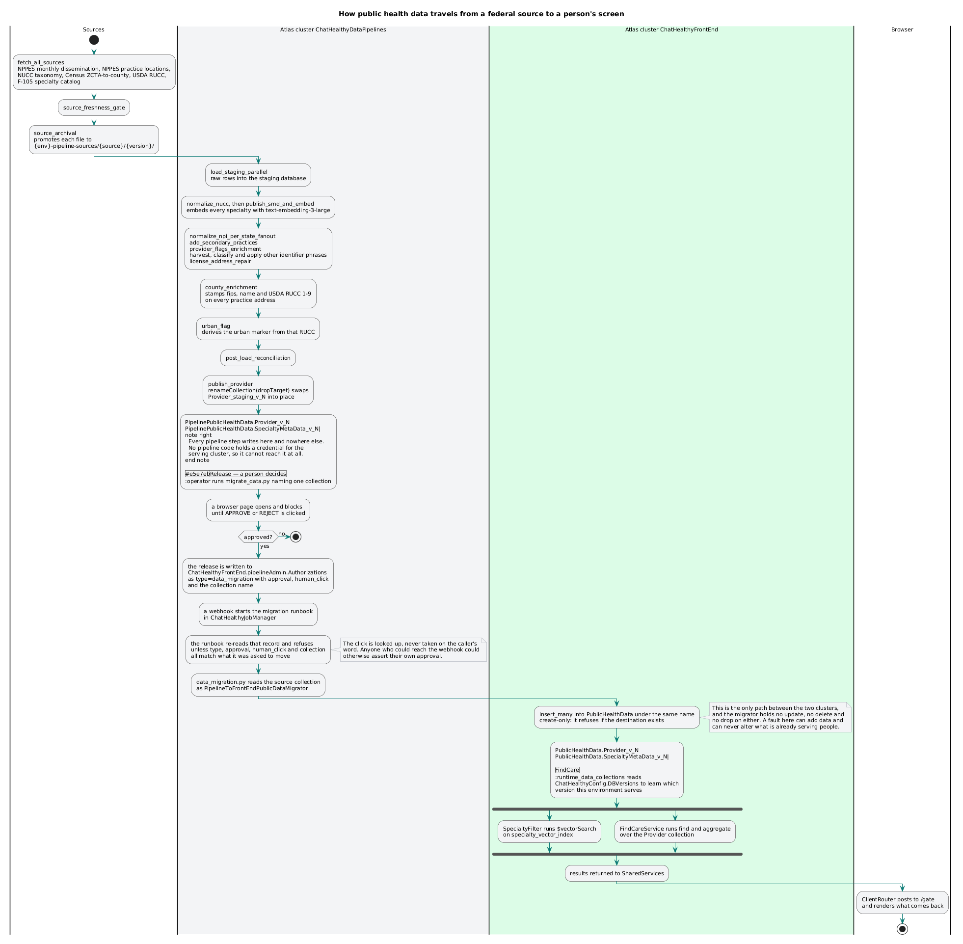
Source to served record: the seven stages, the three stores, and the single gated crossing between the build store and the serve store.

3.1 The invariant, in two directions
The front end must not read a collection that is being built.
The pipeline must not write a collection that is being served.
Both directions matter and neither is enforced by asking code to behave. Each is enforced by a grant, at the database server, so that a runaway process — human, scripted or agentic — fails on authorisation rather than on intent.
This was not designed up front. It was arrived at after a full-collection drop wiped every state's provider data, and after the discovery that a pipeline step was writing directly into the database the application serves from.

3.2 The grant matrix
[R] stated per class of data rather than per store, because one store can hold two classes with different writers:
identity | build store | serve store — batch-published | serve store — per-record live refresh | control store
application runtime | none | read only | read/write, narrowly | none
pipeline | read/write | none at all | none | read/write its own run metadata
release agent | read only | write, and the only writer | none | read/write

The contents of the matrix belong to 02_security §6.1.1 and are not restated here. What this document asserts is what it must accomplish: batch-published data can only change through one job.

3.3 The grant boundary is the database, not the cluster
[R] The part most easily got wrong. An identity is not bound to a cluster: one certificate subject can be registered on several clusters and granted differently on each. Cluster placement decides what is fast and what is paused, not what is permitted.
A framework that reasons in clusters will conclude that putting the control store on the serving cluster (§3.4) hands the pipeline the serving data. It does not, because the role names databases.
[R] A consequence: database names must be unique across all stores, not merely within one. If the same name exists on two clusters, every accessor is one mistake away from crossing, no log entry distinguishes which was meant, and a role written against the wrong cluster reads as a correct role.

3.4 Why the control store sits on the serving cluster
[R] Run records, reservations, locks and findings belong on infrastructure that is up when the build store is down. This is not tidiness. The build store is paused for cost (§11) and can fail (§12).
- A ledger answering "is a job running?" is useless if it lives in the thing whose uptime that answer decides.
- A record of why a run died is useless if it lives in the thing that killed it.
store | who writes it | when it must be up
build | pipeline | only while a run is in flight
serve | release agent, alone | always
control | pipeline, release agent, reaper | always — including while the build store is paused

[I] ChatHealthy. Build store: Atlas cluster ChatHealthyDataPipelines, holding PipelinePublicHealthData (built data) and PublicStaging (raw source rows). Serve store: cluster ChatHealthyFrontEnd, holding PublicHealthData, Users and ChatHealthyConfig. Control store: the database `pipelineAdmin`, on the front-end cluster — run manifests, work items, discrepancies, loaded metadata, reaper state, cluster reservations, the source registry and the pipeline configuration. (data: `pipeline_config.json` `dataset_versions[]`; `deployment_architecture.json` `target_atlas_frontend`.)
[I] The design records the same placement independently (intent: v50 §3.1.7).
The pipeline-side data database carries the Pipeline prefix so that "which PublicHealthData did you mean" cannot arise. It previously did, and the rename was made for that reason.

4. The stages
Elaborates P5–P9.
[R] Seven stage kinds. A concrete pipeline has more steps — ChatHealthy's has twenty-three — but every step is an instance of one kind, and the rule about what it may touch is a property of the kind.
# | stage | purpose | may touch
1 | fetch | acquire the source snapshot | outside world (read); archive (write); control store (own record)
2 | stage | land raw source rows verbatim | staging store only
3 | load | build the domain record from staging | build store (write); staging (read)
4 | enrich | add facts the source does not carry | build store (read + write)
5 | validate | measure the result against expectation | build store (read only); control store (findings)
6 | publish | make one built collection whole and nameable | build store only — an atomic rename, scope-guarded
7 | migrate | move a published collection to the serve store | build store (read); serve store (write, insert only)

4.1 [R] fetch is conditional and never destructive. Ask the source whether the snapshot changed — a strong validator if the protocol offers one, a content hash otherwise — and compare against the recorded signature of the last snapshot. If unchanged, skip. The bytes are archived under their hash before anything parses them, so any later question about a served record can be answered against the exact bytes that produced it. A source that has not changed must not cause a rebuild; a source that cannot be reached must not cause a partial one.
4.2 [R] stage. Verbatim, untyped, unjoined, unfiltered. Fully replaced every run: it is a projection of one snapshot and has no history of its own.
4.3 [R] load reads staging and writes the domain record — where the source's vocabulary becomes the company's. It is the longest stage and must be parallelisable by a natural partition of the source.
4.4 [R] enrich adds facts the source does not carry. Section 8 governs it.
4.5 [R] validate reads and does not fix. Its output is a finding, not a repair. Splitting measurement from correction is what stops a pipeline laundering its own defects.
4.6 [R] publish. A built collection becomes servable by an atomic rename, not by mutation in place. Build into a name nothing reads; when the build is whole, rename it onto the name that is read. There is then no window in which a partially built collection answers to the served name.
Publish also writes a loaded-metadata record: the run that produced this collection, the snapshot it came from, the row count and the time. A collection present without a loaded-metadata record has not been published; it has been left behind.
4.7 [R] The rename must be scope-guarded, and this is the part everyone forgets. Rename-with-replace installs exactly what was staged. If the staged collection is narrower than the one it replaces — fewer partitions, fewer records, one region instead of all — the difference is destroyed, silently, with no error and no finding. The publish step must refuse to install a collection that does not cover what it replaces. Section 6.6 is what happens when it does not.
4.8 [I] The reference implementation, mapped. Twenty-three steps, each an instance of one kind. (behaviour: `provider_pipeline_orchestrator.py` `STEPS`.)
# | step | kind | partition
1 | prepare_infrastructure | — lifecycle | serial
2 | source_freshness_gate | fetch | serial
3 | fetch_all_sources | fetch | per source
4 | source_archival | fetch | serial
5 | load_staging_parallel | stage | per source
6 | load_f006_catalog | stage | serial
7 | normalize_nucc | load | serial
8 | publish_smd_and_embed | enrich + publish | serial
9 | normalize_npi_per_state_fanout | load | per state
10 | add_secondary_practices | load | per state
11 | provider_flags_enrichment | enrich | per state
12 | harvest_other_identifier_phrases | enrich | serial
13 | classify_other_identifier_phrases | enrich | per state
14 | apply_other_identifier_classifications | enrich | per state
15 | entity_first_branch | enrich | per (state, entity kind)
16 | license_address_repair | enrich | per state
17 | county_enrichment | enrich | per county partition
18 | urban_flag | enrich | per state
19 | entity_second_branch | enrich | per (state, entity kind)
20 | post_load_reconciliation | validate | serial
21 | publish_provider | publish | serial
22 | discrepancy_and_notifications | validate — report | serial
23 | quiesce_infrastructure | — lifecycle, finally phase | serial

4.9 [R] Three things generalise out of that table:
- The partition key belongs to the step. Steps here partition by source, by state, by county and by (state, entity kind). Forcing one key on every step costs wall-clock.
- Ordering between an enrichment and the catalogue it reads is load-bearing. Step 8 publishes the taxonomy catalogue; step 9 stamps labels from it. Declared prerequisites, not array position, should carry this.
- Cleanup is a declared `finally` phase, not the last step. A step list that merely ends with cleanup does not clean up when step 14 throws.
4.10 [I] The execution substrate. One machine per run, created and destroyed with it; one controller process; workers as its subprocesses inheriting its credential; coordination by atomic claims on a control-store collection, with a heartbeat for liveness. No ports, no queues, no HTTP between controller and worker. (intent: v50 Executive Summary, §3.1.4, §3.1.5.) Explicitly not used, and each was tried: Durable Functions, Netherite, Function Apps, Container Apps Jobs.

5. Release
Elaborates P10–P14.
5.1 [R] Migration is the only path by which data reaches the serve store. No other process writes it. This is a grant, not a policy.
Binding requirement: EPIC-010-F-108-S-001-REQ-B-002 — "No process other than a migration writes to ChatHealthyFrontEnd.PublicHealthData."
5.2 [R] Migration is separate from the pipeline that produced the data — separate code, deployment target, identity, trigger and schedule. Producing data and releasing data are different acts with different authority, and a system in which the producer can release is a system in which the producer has already released.
5.3 [R] Migration transforms nothing. A collection arrives under the name it left with, document for document. A migration that transforms is a second, unvalidated pipeline running against the one store with no safety net. Binding: REQ-B-001.
5.4 [R] Migration is additive and only additive. It never alters or removes any document, collection or index that existed before it ran. If the destination already exists the migration stops — raises, logs the name it found, writes nothing. Binding: REQ-B-004, REQ-B-005.
5.5 [R] Indexes travel with the collection. A constraint index — unique, or a TTL — is built on the empty destination first, so the copy is validated by the database as it lands and a uniqueness violation is a failed migration rather than a duplicate seated in served data. A performance index is built after. Then assert the index set present equals the set intended.
5.6 [R] A part-way failure must be recoverable, and "additive only" makes that hard. Name the tension: if the copy dies at document 400,000, the destination holds a partial collection, and the refusal that protects served data now blocks the retry. Two dispositions are legitimate:
- The partial collection is a generation nothing binds to; a failed attempt leaves an abandoned generation an operator drops deliberately.
- The migration stages into a temporary destination name and renames on completion — publish-by-rename applied on the serve side.
Not legitimate: letting the migration delete its own partial output. That is a delete against the serve store, and P11 exists so no such code path can be written.
5.7 [R] The strongest form of 5.4 is a role that cannot do otherwise. The release identity holds insert and create-index, and no update, no delete and no drop, over any data anywhere. Then integrity is enforced by the server on every operation regardless of what the code asks, and the residual risk is capacity rather than correctness — the identity can add garbage, and it cannot destroy anything. Code can be edited; a role the code runs under cannot be edited by the code.
[I] ChatHealthy's role_data_migrator is granted FIND, LIST_COLLECTIONS, LIST_INDEXES, INSERT, CREATE_COLLECTION and CREATE_INDEX and no update, delete or drop over any data, with one scoped REMOVE on its own mutex. (data: `deployment_architecture.json` `CustomRoleCatalog`.)

5.8 What "release" means as a control
[R] Release is a recorded human sign-off that the releasing service reads and attests to before it does any work. Four properties, and dropping any one collapses it into theatre:
- A person, not a role or a schedule. Nothing on a timer releases data.
- Recorded and durable. An artefact with an identity, readable afterwards
by someone who was not there.
- Specific. It names this work. A request naming no approval stops.
- Attested by the actor. The service reads the approval, confirms it
releases this work, and records its own acknowledgement before acting.
Binding: REQ-B-003, REQ-B-014.
5.9 [R] Property 1 is the only hard one. Properties 2, 3 and 4 are bookkeeping. Property 1 is a claim about the world outside the process — that a human was present and assented — and a process cannot establish that about itself.
5.10 [R] A presence proof the gated process can produce is not a presence proof. If the approval is written by a request whose body carries a field meaning "a human clicked", the gated process can write that field. The tests that actually distinguish a human — pointer movement, key timing, trusted-event flags — run in the page, and the page reports their verdict as data. Whatever the page checked, the server received a string.
5.11 [R] Nor may the releasing identity be able to write the record that authorises it. An authorisation store the actor can insert into is not an authorisation store. Grants are per-collection, so "may write an acknowledgement but not an approval" cannot be expressed by scoping one collection: it needs two collections and two identities.
5.12 [R] So the shape a release gate must have, stated as what it cannot be:
- not a value the requesting process supplies, however many checks produced it upstream;
- not verified by the process that benefits from it passing;
- not written to a store the beneficiary can write.
It must rest on something the gated process does not hold: a credential released only to a human session, a second identity that signs the approval and that the pipeline identity cannot assume, or an out-of-band channel.

5.13 The honest statement: this control does not currently hold
[I] Both failures are present in the reference implementation.
- The presence proof is a client-supplied string. The server's decision is a comparison of a request-body field against a literal; the real presence tests run in page script and reach the server as data. (behaviour, established by `02_security` and accepted here; §14 NC-8.)
- role_data_migrator holds INSERT on pipelineAdmin.Authorizations — the collection carrying its own release authorisation. (data: `deployment_architecture.json` `CustomRoleCatalog`; §14 NC-9.)
Therefore `REQ-B-003` — approved and marked done — is not delivered by any mechanism on disk, and "runs only when a person releases it" is a target rather than a description.
[R] What still holds when the gate does not, and this is the argument for adopting P11 first:
control | forgeable by the code it governs?
the approval record | yes — a value the process writes, in a store it can write
the releaser having no schedule | no — topology, not a check
the append-only role (P11) | no — the server refuses, whatever the code asks

Every other control in this section is a check. That one is an incapacity. Adopt the incapacity first.
5.14 [R] Release is not deployment. Deploying the migration code and running a migration are separate authorisations. Code review does not release data; releasing data does not review code.
5.15 [R] One at a time. A release service does exactly one job at a time; a second invocation while one runs abends and logs. Binding: REQ-B-015.
5.16 [R] The releasing code is small enough to be verified whole, and is verified whole. One file performs migration and no other file does any part of it, reached through one class constructed with the collection name and nothing else. These are not style rules: they exist so a machine can read the entire release path in one pass. Binding: REQ-B-006 through REQ-B-010.

6. Versions, deletion, and the scoped-fire finding
Elaborates P15–P17.

6.1 Data is versioned, not segregated by environment
[R] There is one serve-store database. Environments do not get copies. Collections carry a generation, and an environment is a pointer to a generation.
Why this beats a copy per environment:
- Multi-million-row datasets copied three times cost three times as much and obscure what actually differs — which, for public reference data, is usually nothing.
- Promotion becomes a pointer change rather than a data movement, so what goes to production is byte-identical to what was tested by construction.
- Rollback is the same pointer change in reverse, with the previous generation still present — because migration is additive (5.4).
[R] The cutover is therefore its own operation: named, recorded, reversible, and it moves no bytes.
[I] One PublicHealthData database, no environment prefix. Collections Provider_v_4, SpecialtyMetaData_v_4. A binding table (ChatHealthyConfig.DBVersions, one row per environment) says which generation each environment reads; a service resolves it at startup. Environment prefixes existed and were removed. (data: `deployment_architecture.json` `target_atlas_frontend.config_collections`.) The design still describes the superseded prefixed model (intent: v50 §3.1.7); the data is the fact.

6.2 Idempotence
[R] A fire is idempotent with respect to its source snapshot: running it twice over the same snapshot produces the same built collection. That is what makes a failed run safe to re-run, which is what makes long runs affordable.
[R] Idempotence is not the same as safe-to-interrupt. A run interrupted mid-load leaves the build store inconsistent. That is acceptable precisely because nothing reads the build store — the second half of the argument for §3.

6.3 Full versus incremental
[R] Two load modes differing in exactly one respect: what happens to a record the source no longer mentions.
- Full: the target is rebuilt from the snapshot. An absent record is absent from the result automatically.
- Incremental: records present are upserted. An absent record is not automatically removed, and something must decide what its absence means.
[R] Absence means nothing at all in a delta file — the record simply did not change — and the source no longer carries this in a full file. Deleting on absence from a delta would delete the dataset on the first quiet week.
[R] The clean resolution is to accept only full snapshots. Then absence always means deletion, in both modes, and no flag can be got wrong. If delta files must be consumed, the run's declaration must name the kind — but the better design is not to need the flag.
[R] Incremental is a cost optimisation, not a correctness mode, and what it preserves is enrichment. The saving is not in reading less source; it is in not re-deriving the expensive per-record facts for records whose source did not change. This makes incremental the mechanism by which enrichment survives a refresh (§8.3), and the mode in which getting that wrong is catastrophic rather than wasteful.
[R] What counts as "unchanged" is semantic, not byte-level, and must be defined once. A record's identity for diffing is a bundle — every source row contributing to it, plus the current descriptors of every reference code it cites — normalised and hashed. A change in a reference descriptor is a change in the record, because what the user sees changed. Incremental cannot bootstrap: it needs a prior full run to diff against, and an incremental run without a baseline must abort by name, not silently behave like a full load.
[R] Incremental must still publish by rename, which means it must first copy the live collection into staging. Copy live → staging, apply the diff in staging, rename staging back over live. If the copy is skipped, staging holds only what this run touched, and the rename installs a partial collection over a complete one. The publish mechanism that makes full loads safe makes incremental loads destructive when its precondition is unmet.
[I] Incremental mode as implemented is a no-op synonym for full mode. It saves nothing, because there is no preserve-unchanged, and it destroys nothing, because it writes everything.
At the start of any run the staging collection does not exist: renameCollection removed it at the end of the previous run. The incremental path skips a drain that has nothing to drain, and issues a replace against an empty collection, where replace and insert are equivalent. No diff step exists, so an incremental run iterates every row of the full snapshot exactly as a full run does. The two toggles are the whole of the mode. (behaviour: `provider_normalize_engine.py:95-97`, `:151-156`; `steps/publish_provider.py:83-87`.)
The whole-document replace discards no county, no urban standing and no enrichment flag. The document it replaces does not exist yet, and those fields are written by steps that run later in the same fire (§4.8, steps 11, 17 and 18).

6.4 What deletion means
[R] Three cases, and a framework must answer all three:
- Full load — absence is deletion, achieved by rebuilding.
- Incremental over a full snapshot — absence must be reconciled explicitly:
after upserting everything present, find every record the source does not mention and delete it. Without that pass, retired records accumulate for ever.
- Tombstones — a source may mark a record dead rather than omitting it. A
tombstone is a fact and must be acted on, not merely stored on a document where nothing reads it.
[R] And a fourth that is not deletion at all: a derived fact whose computation is identical for every reader belongs to the load, computed once and indexed. Whether an entity is currently active, derived from a history of activation events, is a load-time boolean — not an array traversal the request path pays for on every query. Keep the history for provenance; derive the boolean for serving. Both, not one.

6.5 Scoped work scopes its deletions
[R] If a run is declared over a subset of the source, every destructive operation in it must remove only that subset, and the predicate that decides what to remove must be the same predicate that decides what to write. A narrower removal leaves records the load then collides with; a wider one destroys data the run was never asked to touch.
[R] This applies to the publish step, and that is where it is forgotten. A drain can be scoped correctly and the publish still replace everything, because the publish does not look at scope at all.
[I] The destructive case is scope, not load mode. At full scope an incremental run writes a complete collection (§6.3), so publishing it destroys nothing. A run scoped to fewer states than the loaded collection holds stages only the states it built, in either mode, and the publish installs exactly that. §6.6 establishes it.

6.6 The finding, stated as established
[I] The destruction is in publish, it is unconditional on load mode, and it is live today.
The chain, from executable code and configuration data only:
- Every provider write step targets a collection resolved as
staging_db . staging_collection_name("provider"). (behaviour: `pipeline_runtime.py:74-75`, `:103-104`.)
- The publish step renames staging_db . staging_name onto
loaded_db . loaded_name with replace-target enabled, computing its source from the identical registry calls. (behaviour: `steps/publish_provider.py:65-68`, `:83-87`.)
- They are therefore the same collection — identical expressions, both
executable.
- The names resolve to PublicStaging.Provider_staging_v_4 →
PipelinePublicHealthData.Provider_v_4, a cross-database rename. (data: `pipeline_config.json` `dataset_versions[]`; `pipeline_dataset_registry.py:371-377`.)
- Nothing seeds staging from the loaded collection. The property returning
the loaded collection name has zero readers; no aggregation-out, merge, clone or bulk copy exists in the pipeline tree. (behaviour.)
- The rename removes the source name, so staging does not exist at the start of
the next run. (behaviour of `renameCollection`.)
- **⇒ The loaded collection after a run is exactly what that run staged.
Nothing carries forward, ever.**
- Scope narrows what a run stages: a full-scope run partitions to all states
plus a residual, and a scoped run partitions to only the named states. (behaviour: `steps/_partitions.py:57-60`; `provider_normalize_engine.py:122`.)
⇒ Any run whose state scope is narrower than the loaded collection destroys every record outside that scope, silently, in either load mode, today. A single-state fire against a loaded national collection replaces it with one state. It needs no incremental flag, no delta file and no future work to reach.
Three paths to the condition, and only the first is presently reachable:
path | reachable now?
a state-scoped run, either mode | yes — today
incremental as designed (unchanged records never written to staging) | not yet: no diff step exists
incremental as implemented, full scope | no — it writes every row

The second is why the design requires the live→staging copy that step 5 shows is absent. The two halves of the design must land together, or the first half alone is catastrophic — and the design's own coverage table already claims the delete-on-absence contract is realized, which is exactly the kind of claim that invites building half of it.

6.7 The rule exists only as a docstring
[I] There is a statement of this danger in the codebase. It is a sentence in the publish step's module docstring saying that state-scoped runs replace the loaded collection wholesale, that a single-state fire would drop every other state, and that production fires must always be full-scope.
There is no runtime guard. No scope check in the publish step, no precondition, no requirement, no test. The rule exists as prose and nothing enforces it.
[R] This is the purest instance of the standing rule and it belongs in the architecture, not in a footnote. A safety rule that lives only in a comment is worse than no rule at all, because it reads to the next engineer — and to the next agent — as a control that has been considered and handled. It has been considered. It has not been handled. A rule stated in prose with nothing enforcing it is a finding, not a mitigation (§13, check C7).

7. Provenance
Elaborates P18.
7.1 [R] Every served record answers three questions from its own contents:
- Where did it come from — which source, which snapshot, identified by
content hash rather than filename or date.
- When — when the snapshot was taken, and when this record was built from
it. Different times, both needed.
- Which of it is ours — which fields the source supplied and which we
derived (§8).
7.2 [R] Provenance is carried per record, not per collection. Collection-level provenance fails the moment a collection is built by more than one run, repaired, or partially re-enriched — which every real pipeline eventually is.
7.3 [R] The run identifier is the join key, and the chain must be walkable by a person with read access and no special tooling: record → run record → snapshot hash → archived bytes. And the bytes are still there — a chain ending at a hash of bytes that no longer exist establishes only that we once had them.

7.4 When two authorities disagree
[R] A company consuming a records registry (entities, published by a regulator) and a reference registry (the code set those entities cite, published by a standards body) inherits the drift between them. The registries are revised on different cadences by different authorities and neither retroactively re-codes the other. Drift is a permanent operating condition, not a defect to be closed.
[R] Three authorities, each owning exactly one class of assertion:
authority | answers | does not answer
the records registry | which codes are asserted about this entity | whether a code is current, valid or mappable
the reference registry | what codes are standard today and what they mean today | what a code meant five years ago; what to call one it never issued
our own catalogue | product-specific flags, approved repairs, approved mappings | anything the other two own

[R] The non-conversion rule is the single most important governance property here: the system MUST NOT silently convert one authority's assertion into another. The reported value is preserved verbatim, for ever. A repair or a mapping appears as an additional element carrying its own authority tag and an explicit relationship — never as an overwrite. The reason is an audit question with only one acceptable answer: why does your record say X for an entity that registered as Y?
[R] The resolution status of a reference code is an enum, not a boolean. The distinctions that must survive: current; retired but once standard; present in records but never published by the standard; locally authored; observed but not yet triaged; confirmed invalid. Each implies different rendering, filtering, escalation and human action. A boolean carries none of it.
[R] Every resolution records the version of both registries it resolved against. "This code, at this reference version, against this catalogue version" is the unit of reproducibility.
[R] This is established interoperability convention, not a bespoke pattern — multiple codings in one conceptual field, code-system supplements, concept maps, extensions for implementation metadata, provenance for terminology repair. Adopting a published convention and citing the clause converts a design argument into a compliance argument, which is worth more in a regulated domain than a defensible in-house design.
7.5 [R] The authority tags survive to the display. A provenance model the store honours and the display cannot carry is not a provenance model. See §1 and 05_application.

8. Enrichment
Elaborates P19.
8.1 [R] An enrichment is a fact the company produced. It is the part of a served record a competitor copying the same public source does not have, and usually the expensive part — a geocoding call, a model inference, an embedding, a human curation.
8.2 [R] A served record distinguishes source fields from derived fields on its face, so a reader of one document can tell which is which without a schema document or the pipeline source. Two mechanisms work: separating derived fields into their own sub-document, or tagging each field with its origin (§7.4). Doing neither means the distinction exists only in the head of whoever wrote the loader.
8.3 [R] Enrichment survives a refresh from the source. That is the requirement. There are exactly two mechanisms and a pipeline must choose per enrichment and say which it chose:
- Recompute. Re-derived every fire. Survival is automatic. Correct when the derivation is cheap, deterministic, and its reference data is under pipeline control. This is the default and should be, because it has no state to get wrong.
- Carry forward. The prior value is read from the previous generation and written onto the new record, keyed by a stable natural identifier. Necessary when the derivation is expensive, non-deterministic, externally metered, or human-authored. It requires the key to be genuinely stable and the carried value to record when it was derived — a carried enrichment is by definition older than the record it sits on.
8.4 [R] A curated or human-authored enrichment is always carry-forward, and it is not the pipeline's to recompute. Human judgement a fire can overwrite is human judgement that will be overwritten.
8.5 [R] Curation needs a process, not just a store: a triage state for an untriaged value, an approval step, a rule that a draft value never reaches production, and a reconciliation cycle triggered by each new release of the upstream reference registry. Without the cycle, curated repairs rot as the registry moves — and a mapping whose target has itself since retired is a state that must have a name.
8.6 [R] An expensive enrichment that is not carried forward is a recurring bill to reproduce an answer you already had. That is a legitimate choice — it buys simplicity — but it must be a priced choice, not an accident of the loader running before the enricher.
8.7 [R] Eligibility for an enrichment is a fact about the record and must be read, not inferred from the shape of a field. An enrichment keyed on a lookup table has a domain. Records outside it must be excluded by a predicate reading the field that determines membership — not one testing whether a different field looks like it belongs.
[I] ChatHealthy inferred county eligibility from "has an unresolved county and a postcode present" — in effect, has five digits — and applied a US ZIP crosswalk to foreign addresses. On one state's load, nine of thirteen foreign practice addresses received a US county; one European address was published as a county in Texas, with a county name and a rurality score, indistinguishable from a real match. The four that came out null were alphanumeric-postcode countries, which failed to collide by luck rather than by design. (intent: v50 §A.7, which records the measurement.)
[R] Three lessons, and the third is the one to carry:
- An enrichment that cannot fail visibly will fail invisibly. A wrong value with a plausible name and a matching secondary attribute is indistinguishable from a right one, and no downstream check catches it.
- The absence of an error is not evidence of correctness.
- Excluding ineligible records also stops paying to enrich them. Correctness and cost pointed the same way, which is common and worth looking for.

9. Data quality
Elaborates P20.
9.1 [R] A defect in the data is a finding: detected by a validate stage that does not repair it, recorded as data, aggregated into one report per run, and delivered to a named person.
9.2 [R] Exactly one report per invocation, whatever happened and wherever it failed — and emitted unconditionally, on success, on failure and on abend. An operator who receives nothing then knows the run never started, rather than wondering which of the two it was.
9.3 [R] The report is an output, not a table. It has a destination outside the system that produced it and a named human recipient. A finding that lands only in a collection nobody queries has been recorded and not reported.
9.4 [R] Recipients are configuration, not code. Who sees the quality of the data changes more often than the code that measures it.
9.5 [R] Detection covers at minimum four kinds:
- Parity — did we load what the source contained? Source rows against built records, per partition. The cheapest and most valuable check.
- Reference integrity — does every coded value resolve against the catalogue it claims? Unresolvable codes are findings, not silent nulls.
- Enrichment coverage — what fraction of records got each derived fact? A coverage number that drops between fires is the earliest signal of an upstream change.
- Reconciliation — after the run, does the collection contain what the run intended? This is where §6.4's absence pass belongs, and where §6.6's scope guard would be caught if it were checked.
9.6 [R] Findings are graded, and the grade says what it costs: warning — recorded, blocks nothing; error — this record does not make it; fatal — this run does not make it.
9.7 [R] Volume promotes grade. A count above a configured threshold escalates to fatal, because a defect rate is a different fact from a defect. One unparseable row is a bad row; two hundred thousand is a changed source, and continuing to publish is the wrong response.
9.8 [R] Record-level anomaly versus artifact-level failure is the central policy. A record-level anomaly affects one record: encode it as data on the record, emit an event, increment a counter, continue. An artifact-level failure means no reliable output can be produced at all: abort with a structured cause and block release.
9.9 [R] A run's terminal status is a four-value enum, and the two most often omitted are the two that matter:
status | release
success | proceeds
success with anomalies | proceeds, and a human is notified of the outstanding list
failure — artifact | blocked
failure — infrastructure | blocked, retry-safe

"Success with anomalies" is what stops operators learning to ignore the report. Separating infrastructure failure from artifact failure is what makes "is it safe to run it again?" answerable from the status alone.
9.10 [R] At scale every per-record anomaly class has a non-zero rate. A policy that treats a certainty as an exception is a policy that stops the pipeline. Fail-hard on an unknown reference code was tried here and terminated a nationwide run.
9.11 [R] Never assign a safe default to an untriaged value. "False if we don't know" is a data-quality signal masquerading as a value: downstream cannot distinguish "we curated this and the answer is false" from "nobody has looked." Omit the field. An absent field is honest and a consumer can branch on it; a defaulted one is a lie no consumer can detect. This matters most where a default looks safest — a clinical capability flag defaulted to false reads as a fact about the provider.

10. Cost and the lifecycle of the compute
Elaborates P21–P22.
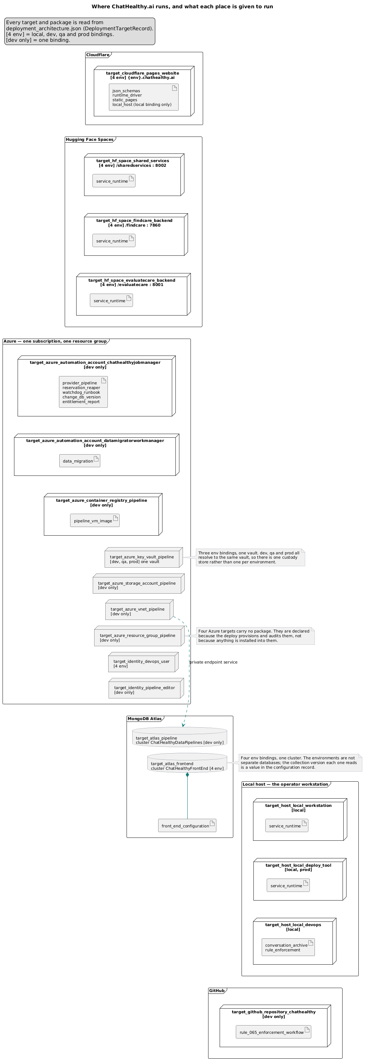
What exists permanently between runs and what exists only during one: the network, vault, registry and automation account are deploy topology; the run host and its worker processes are created per fire and destroyed with it.
10.1 [R] The build store must not run when nothing needs it. For a pipeline firing weekly or monthly over a large dataset, it is idle far more than it is busy, and an always-on cluster sized for the load is the largest line item.
10.2 [R] Uptime is driven by reservations, not timers. A component needing the store takes a reservation; when the last is released the store may be paused. A timer that pauses on a schedule will eventually pause a running job.
10.3 [R] The reservation is the only signal. No live reservation means nothing has claimed the store, and it is paused — whether or not something is connected. A job that works without reserving is a job with a defect, and keeping the store warm for it teaches nobody anything. Adding "but check for open connections too" looks safer and is not: it makes the defect invisible and the bill permanent.
10.4 [R] Every reservation is released in a `finally`, with explicit ownership per tier: the trigger owns its run record, the controller owns the store reservation and one per dispatched worker, a worker owns the item it holds.
10.5 [R] `finally` is not enough. Processes are killed and hosts vanish; a job that dies between two statements runs no finally. Therefore a reaper: external to every pipeline, so it can run when the thing it corrects cannot; on a frequent schedule; correcting metadata a failed job left wrong, so no job is recorded non-terminal while not running and no lock is held for a job that is not running.
Binding: EPIC-010-F-101-S-001-REQ-B-001, REQ-B-002, REQ-B-003.
10.6 [R] A cleaner that could not finish must not look like a cleaner that found nothing. Both leave no findings; only one means the system is clean. When a pass cannot complete, the metadata says so and says what it did not reach.
10.7 [R] Observe death; do not wait it out. A lease that has not expired says only that nobody has waited long enough. Ask the platform whether the host is allocated and the process alive; consult the timeout only when the platform will not answer. And when it will not answer, that is not evidence the job stopped.
10.8 [R] Every process a run starts records its identifier against that run. Then the expected set is knowable from the metadata, the host reports the actual set, and the difference between them is the definition of an orphan rather than a guess. A process that cannot name its run is left alone.
10.9 [R] One shared class answers "is this run alive", asked by every component that needs to know. Two components independently wrong in the same way is the signature of a duplicated decision.
10.10 [R] Scale is part of the lifecycle, not just power. Scale up for the run, lock auto-scaling off for its duration so the platform does not reshape the cluster mid-load, and scale down at quiesce — checking the store is still at the size the run set, so a human who resized deliberately is not overridden.
10.11 [R] Compute is created per run and destroyed with it, and every resource carries its deletion with it. Resources that outlive their run because a cascade was not declared are the second cost leak after the idle store.

11. Failure
Elaborates P23.
11.1 [R] A pipeline over a large dataset runs for hours. Over that window a transient outage of the datastore is expected, not exceptional.
11.2 [R] Distinguish a leaf failure from a root failure. A worker that cannot reach the store failed; the store may be fine, and the worker records through the normal path. A controller or trigger that cannot reach the store means there is no normal path.
11.3 [R] The hard case, stated plainly: the place a run records why it died is the datastore, and the thing that killed it is that the datastore is gone. A run that dies for that reason dies with no recorded cause — the one failure mode that leaves nothing to diagnose.
11.4 [R] Therefore one sanctioned escape. When the store is unreachable at the top, the run's single report is emitted to a destination that does not depend on it. Four properties keep it from becoming a general fallback:
- One function. Every tier calls the same emit; the escape lives inside it.
- It is the only one. A general "if the database is down, do something else"
is how a system acquires silent degraded modes.
- Binary and unconditional. Reachable ⇒ normal path. Not reachable ⇒
escape. No partial modes, no queueing for later.
- It belongs to the shared library. Anything that can lose its ability to
record why it died has this problem; solving it once is the same argument as sharing the retry policy.
11.5 [R] The destination must be reachable by an operator looking for it without being told it exists. A file on a host about to be destroyed does not qualify. The scheduler's own job record, or a mail path, do.
[I] A blob container was tried for this and rejected: a second store with its own account, credential and SDK holding one fact, which never worked in the sandbox the job runs in — so an incomplete pass recorded nothing anywhere. (intent: v50 §A.3.)
11.6 [R] The report renders what it is given and queries nothing. It holds its findings as they are recorded and states counts its caller supplies, so it cannot produce a wrong number from a connection that cannot see the data it is counting.
11.7 [R] The component that records a failure never raises. A secondary failure inside the recorder masks the primary failure, which is the only one anyone needed.
11.8 [R] A transient outage should not end a multi-hour run. The connection carries a retry policy with backoff, in one place shared by every component, and a run that survived an outage says so in its record.
[I] A stated disagreement with the design. v50 drops retry together with locks, polling and timeouts, and absorbs all failure by re-running from scratch (intent: v50 v42 item 8, §6.9). I accept "no resume" — it is a defensible choice about run granularity — and reject "no retry". A dropped connection during a multi-hour national load discards hours of paid compute and vendor spend for a condition that resolves in seconds, and the fix is a few lines at one boundary. The design's own detailed sections retry at step granularity, so the blanket statement is not what it actually specifies. Operator question Q5.
11.9 [R] A run that abends still quiesces. Releasing reservations and pausing the store are the failing run's responsibility; the reaper is the backstop for when that could not be discharged, not the primary mechanism.

12. How a pipeline is deployed and scheduled
Cross-cutting with 03_devops, which owns the acts. Stated here as what the pipeline requires of them.
12.1 [R] Pipeline code is deployed by the same governed chain as application code — built from a committed tree, declared in the record, installed by target and package. A pipeline is not a special case that gets hand-installed because it is "just a job."
12.2 [R] The trigger surface and the code are declared together. A job with no declared schedule and no declared webhook cannot be started; one with a schedule nobody declared runs anyway. Both have been found here.
12.3 [R] Trigger possession is an entitlement. On-demand work is started by a webhook whose URL is a vault secret, not a URL in code, so whoever can read the secret can fire the job.
12.4 [R] The compute image and the code on it are versioned together, tagged by the commit that produced them, so "which code produced this data" is answerable from the run record.
12.5 [R] One scheduling account per identity. A scheduling account is a credential boundary, not a folder: its variables are account-scoped and readable by every job inside it, so two jobs sharing an account share every credential either one carries, whatever identity each was written to run as. A job needing another identity's credential does not receive that credential; it receives a boundary, and the work crosses it as a call.
12.6 [R] Therefore the platform's quota on scheduling accounts is a security limit, not an administrative one. When it binds, the next identity's work has nowhere to run but inside another identity's boundary — and the pressure to put it there is a delivery deadline, which always beats a boundary nobody has named. Quota headroom belongs on the prerequisite list beside certificates.
12.7 [R] Some prerequisites cannot be provisioned by the deploy chain, and they must be enumerated, because the failure mode is silent — the deploy succeeds and the pipeline fails on its first live invocation. Either the substrate's control plane refuses the credential the chain carries, or the substrate is owned outside the company's account. Verify what you cannot create: the chain checks that declared roles are held; it does not grant them. (intent: v50 §3.2 enumerates fourteen for this pipeline.)
12.8 [I] Runbook packages on the pipeline's automation account: provider_pipeline, reservation_reaper, change_db_version, watchdog_runbook, entitlement_report. One package on a separate account for the migrator: data_migration, with no schedule declared. Webhooks for the pipeline and the migration, both with URLs stored as vault secrets. The control image is built from a declared Dockerfile and tagged by commit. (data: `deployment_architecture.json`.)
[I] That the migrator account has no schedule is a claim about the record, not about the platform. Nothing enumerates what actually runs on an account and compares it to the record. See 03_devops §5, NC-4.

12.9 Every inbound path arrives through the gate
Elaborates P24.
12.9.1 [R] Approved requirement EPIC-002-F-004-S-001-REQ-B-001 — every request reaches the firm through the Universal Gate — reaches this framework even though a pipeline serves no users. Nothing is exempt, and the reason a batch component is the likeliest place to find a second entrance is that it has no user to notice one.
Two classes, and a pipeline has traffic in both:
class | rule | the pipeline's instances
traffic the firm originates | MUST POST to the gate | the operator or agent firing a run; firing a release; requesting a cutover
traffic the firm does not originate | MUST arrive at a URI the gate owns; the gate collects the facts and dispatches; the method is whatever the sender sends | a platform callback reporting a job finished; a scheduler invoking a job

Not in either class: a platform's own liveness probe against a host. That is the platform checking its own tenancy, not a client calling the firm. Listing it as non-compliance is a category error.
12.9.2 [R] What this demands of a pipeline, stated as target:
- The trigger is a gate op, not a URL. "Run the provider pipeline" is a request dispatched to a tool, and the tool starts the run. The scheduler's webhook becomes an implementation detail behind the gate rather than an address the operator posts to.
- The callback arrives at a URI the gate owns. A platform reporting a job finished is not-originated traffic: the gate owns the address, collects the facts and dispatches to the tool that records the outcome.
- The approval surface is a gate op. This is the one that changes the release path, and §12.9.4 states it.
- Trigger possession stays an entitlement (§12.3), but the thing held is the right to invoke a gate op, not the knowledge of a URL. A secret URL is an entitlement anyone who reads a log inherits; an op the gate authorises is one the gate can refuse.
12.9.3 [R] The gain is not tidiness. Three properties a pipeline cannot have while its triggers are private URLs:
- One place that knows a request happened. Today the record that a run was fired lives only in the platform's job history.
- One place that authorises. A held URL cannot be refused per-caller; a dispatched op can.
- One place to add a control. A rate limit, an audit row or a concurrency refusal added at the gate reaches every inbound path at once.
12.9.4 [R] What it changes about the release path, which is the substantive consequence. §5 states that release is a recorded human sign-off the service reads and attests to. The approval surface is where a human acts, so it is a request reaching the firm, so it is a gate op. Three things follow, and the third is why this matters beyond routing:
- The approval is collected by the gate and dispatched to the tool that records
it. The releasing service reads the recorded approval; it never serves the surface that collects it.
- **The service that benefits from the approval is no longer the service that
receives it.* That is §5.12's second condition — not verified by the process that benefits from it passing* — obtained as a property of the topology rather than as a check.
- It does not by itself fix the presence proof. A gate op still receives
whatever the sender sends. Routing moves the collection point; it does not make a client-supplied value into evidence of a human. NC-8 stays open and §12.9.5 says so.
12.9.5 [R] What routing does not fix, because the temptation is to count a route change as progress:
- Routing the approval through the gate does not make a presence proof unforgeable (NC-8). The gate is a better place to put the fix — one chokepoint instead of three implementations — and it is not the fix.
- Routing changes nothing about who may write the authorisation record (NC-9).
- Routing changes nothing about the publish scope guard (NC-1). The scoped-fire destruction is inside a run, downstream of every entrance.
A requirement moving is not progress on code.
12.9.6 [I] Where ChatHealthy stands, from behaviour:
- The release is fired by reading a webhook URL out of the vault and posting it directly. (behaviour: `pipeline/Code/ops/migrate_data.py:73-84, :245, :254`.)
- The pipeline run is fired the same way, by a webhook declared against the automation account. (data: `deployment_architecture.json`, package `provider_pipeline`, `webhook_to_kv`.)
- The cutover job carries a docstring saying it is "triggered by the gateway when `ChatHealthyTask = 'ChangeDBVersion'` is posted to `POST /Router`" — and it is not. Behaviourally it reads its payload from process arguments with an automation-webhook marker, and a search of the shared-services and website trees for that task name returns nothing: the gate does not dispatch it. (behaviour: `pipeline/Code/change_db_version.py:185-198`, plus the absence of any dispatch entry.) The docstring is the only place the compliant design exists. It is the same failure as §6.7 and the second instance in this document: a control that reads as implemented because someone wrote down that it was.
- The approval surface is a loopback HTTP handler the release path reaches directly, not a gate op. (behaviour: `migrate_data.py` imports and calls the authorisation function.)
So all three inbound paths and the approval surface sit outside the gate, and one of them documents itself as being inside it. Register rows NC-18 to NC-21, scheduled against 06_migration Phase 4.

13. Conformance
For each principle, the check a program could run. Every check names an effect, not a spelling. Where a check does not exist, or has never gone red against a real violation, the table says so — a check that has never fired is a check whose sensitivity is unmeasured.
# | principle | the check — an effect a program can observe | status
C1 | P1, P2 | Authenticate as the application identity and attempt a write to a batch-published collection. It must be refused by the server. | not implemented. Would require a live-platform probe.
C2 | P2 | Enumerate every write to the serve store across the whole repository — not one file — and assert each is the release agent. | not implemented. §13.1 explains why the existing gate does not do this.
C3 | P3 | For each identity, assert the granted database set is disjoint from the database sets its architecture forbids, on every cluster it can authenticate to. | not implemented.
C4 | P4 | Pause the build store; assert the control store still answers "is a job running". | not implemented.
C5 | P9 | After publish, assert the loaded collection's partition set is a superset of the pre-publish loaded collection's partition set. | not implemented — this is the check whose absence is NC-1.
C6 | P9 | Assert every published collection has a loaded-metadata record naming the run and snapshot that produced it. | partially: the publish step writes one. No check asserts a collection cannot exist without one.
C7 | P17, §6.7 | For every destructive operation reachable in a scoped run, assert a scope predicate is evaluated in the same call path. A prose statement of the rule counts as absence. | not implemented.
C8 | P11 | Read the release identity's role from the platform and assert it grants no update, delete or drop over any data. | not implemented as a check; the grant is declared in the record.
C9 | P13 | Assert the gate's decision cannot be produced by the gated process: that no request field determines it, and that the beneficiary cannot write the authorisation store. | not implemented — and it fails today (NC-8, NC-9).
C10 | P14 | Enumerate schedules actually present on the releaser's account and assert the set is empty. | not implemented (NC-10).
C11 | P15 | Assert no collection name in the serve store carries an environment prefix, and that each environment's binding names a generation. | data-checkable today from the record.
C12 | P16 | Assert an incremental run without a prior baseline aborts by name. | not implemented (NC-2).
C13 | P18 | Take a served record at random; walk record → run → snapshot hash → archived bytes. Assert every hop resolves and the bytes exist. | not implemented. Would fail today at hop 1 and hop 4 (NC-4, NC-5).
C14 | P19 | For each derived field, assert its value after a fire equals its value before, for a record whose source did not change. | not implemented (NC-6).
C15 | P20 | Assert exactly one report per run identifier, and that its delivery reached at least one recipient. | delivery raises on zero recipients. No check on the one-per-run invariant.
C16 | P20 | Assert no untriaged field is written with a default value — that the field is absent rather than false. | not implemented.
C17 | P21, P22 | Assert no reservation exists for a run whose host is not allocated. | the reaper performs this correction; no independent check asserts it succeeded.
C18 | P22 | Assert a reaper pass that could not complete is distinguishable in the metadata from one that found nothing. | the reaper writes a failure-streak record. Never observed red.
C19 | P23 | Make the datastore unreachable at the top of a run; assert one report still arrives. | not implemented. The escape exists; no failure-injection test exercises it.
C20 | P24 | Enumerate every address that can start, report on, or authorise pipeline work, and assert each is owned by the gate. A held URL that reaches a job directly fails. | not implemented (NC-18 to NC-21).
C21 | P24 | Fire each inbound path and assert the gate's request-facts record exists for it. The check is the gate's record, not the job's log — a job that ran without a gate record is the violation. | not implemented. This is the check that would have caught NC-21, whose docstring claims compliance.
C22 | P24, §12.9.4 | Assert the process that receives an approval is not the process the approval authorises. | not implemented — and it fails today (NC-20).

13.1 [R] The one check that does exist, and its limit. A pre-commit enforcement reads the release story's requirements out of the backlog at gate time and puts each one to a model against the migration file's source, blocking the commit on any requirement the code does not enforce or that could not be established. Three properties make it honest rather than decorative: an undecided verdict blocks exactly as a failed one does; prose is stripped before the source is shown, so the file cannot argue for itself; and anything decidable by parsing is decided by parsing, with the model asked only where judgement is required.
Its limit is structural and must be stated wherever the check is claimed. The file it examines is a hardcoded path. So the requirement "no other file writes the serve store" — a claim about the whole codebase — cannot be established by reading one file.
A green result means "the migration file complies." It never means "the invariant holds."
[I] NC-4 is the proof. A second writer of the serve store exists, the gate reports nothing, and the gate is correct to report nothing, because it was never pointed at that file. A check that passes for a reason unrelated to the principle is worse than a missing check, because it is counted as coverage.
13.2 [R] The general form, worth carrying: a check inherits the lifetime and the scope of the mechanism it names. A check aimed at one file measures one file for ever, however the principle grows.

14. Non-compliance register
What the target says, where the reference implementation is not there, what would close it. Every row names its evidence type. Prose is not an evidence type.

A. The finding that ranks above the rest
id | target | what is true | evidence | what would close it
NC-1 | P9, P17, §6.6 — publish is scope-guarded | The publish step renames staging over the loaded collection with replace-target enabled and no scope check. Nothing seeds staging from the loaded collection; the rename empties staging between runs. The loaded collection is therefore exactly what the last run staged, and any run whose scope is narrower than the loaded collection destroys the difference, silently, in either load mode. Live today. | behaviour — pipeline_runtime.py:74-75, :103-104; steps/publish_provider.py:65-68, :83-87; steps/_partitions.py:57-60; provider_normalize_engine.py:122. data — pipeline_config.json dataset_versions[]. | Check C5 or C7: refuse the rename unless the incoming collection covers the partitions of the one it replaces. No approved requirement covers publish scope.
NC-1a | §6.7 — a rule is enforced or it is a finding | The only statement of NC-1's danger is a sentence in the publish step's module docstring. There is no runtime guard, no requirement and no test. | behaviour (absence of a guard in the executable path); the docstring itself is prose and is not cited as evidence of anything. | The guard. Until then the sentence reads as a handled control and is not one.

B. Approved requirements not met
id | requirement | what is true | evidence | what would close it
NC-2 | REQ-B-002 (approved, done) — only a migration writes the serve store | A workstation tool connects to the serve cluster under an operations identity, drops the destination collection and refills it, using the superseded environment-prefixed model. It is a second writer and it deletes. | behaviour — Code/Shared/ops/promote_data.py:70, :95, :107, :114. | Scheduled: `06_migration` Phase 2, which deletes the file — "an undeclared writer holding drop-and-refill on the served database". Open until the deletion lands; the file still runs today. Three of five agents found it independently by different routes; it is unreachable by literal search because the database name is composed at runtime.
NC-3 | REQ-B-002 | The application's request path replaces whole served provider documents and writes embeddings into them, as the application identity, on every detail open — required by approved EPIC-006-F-002-S-002-REQ-B-018. Two approved requirements contradict each other and both are marked done. | behaviour — FindCare/ProviderDetail/provider_record_sync.py:646-651, :701-708; called from provider_detail_service.py:434, :306; collection injected at app.py:1825. | An operator decision, not an engineering one: either served data has two writers by design, or the freshness write goes somewhere that is not the served collection. Q1.
NC-4 | P18 — a served record answers its own provenance | The built record carries a run identifier and nothing else — no source hash, no snapshot identifier, no build time. The chain is walkable only by indirection through two control-store collections. | behaviour — provider_record_builder.build_provider_record. | Stamp the snapshot hash and build time on the record. The design specifies the run-manifest hop and is met there (intent: v50 §6.2); the record-level requirement is mine and nothing binds it.
NC-5 | P18 — the archived bytes are still there | The archive retains the current snapshot and one prior. A record more than two snapshots old reaches a hash whose bytes have been deleted. | behaviour — pipeline_source_archival retention constant and rotation. | A retention policy tied to the oldest served generation. The design is silent on retention depth, so this is a gap rather than a deviation.
NC-6 | P19 — curated enrichment is carry-forward | No carry-forward mechanism exists anywhere in the pipeline. Every enrichment is recomputed. A curated allow-list — the identified remedy for a live data-quality defect — has no home that survives a fire. | behaviour (absence across the pipeline tree). | A carry-forward stage keyed on the natural identifier, with a derivation timestamp per carried field.
NC-7 | EPIC-010-F-101-S-001 REQ-B-001/002/003 (approved, done) | All three requirements carry no test. The reaper story is done with nothing behind it. | data — the backlog's test fields. | Tests. Check C17 and C18.

C. The release control
id | target | what is true | evidence | what would close it
NC-8 | P13, REQ-B-003/REQ-B-014 | The human-presence proof reaching the release gate is a client-supplied string: the server decides on a request-body field, while the real presence tests run in page script and report their verdict as data. The data-release path reaches this same function. | behaviour — established by 02_security and accepted here, not independently re-verified. | A channel the gated process cannot originate. Q4 — shared with 03_devops, which raised it first.
NC-9 | P13 — the beneficiary cannot write its own authorisation | role_data_migrator holds INSERT on the collection carrying its own release authorisation. Grants are per-collection, so "may write an acknowledgement but not an approval" cannot be expressed by scoping one collection. | data — deployment_architecture.json CustomRoleCatalog. | Two collections and two identities: one only a human session can write, one the migrator writes its acknowledgement into.
NC-10 | P14 — the releaser has no schedule | True of the record. Nothing enumerates what actually runs on the account. The design names the migrator differently from the record — a different canonical name, a different source path and a different host account — and a bug record lists that name among runbooks found live and undeclared. | data (the record) versus intent (v50 §3.1.18, which also contradicts v50 §3.1.19 and §6.11). | An enumeration of the platform compared to the record. 03_devops owns it.
NC-11 | P11, §5.6 — a part-way failure is recoverable | The migration returns a failure code on a partial write, leaving what landed. It holds no delete — correctly — and its existence check then refuses the retry, so a half-migrated collection is unrecoverable by this code. | behaviour — pipeline/Code/data_migration.py. | Either disposition in §5.6. The design does not address it.
NC-12 | REQ-B-015 — one job at a time | Implemented via a mutex released in a finally, but the mutex is taken three statements before the guarding try opens. If any of the three raises, the mutex is held for ever and the service wedges until a human deletes the record. | behaviour — pipeline/Code/data_migration.py, take at :454, try at :475. | Move the take inside the try.

D. Design states it; code does not do it
id | design (intent) | what is true | evidence | what would close it
NC-13 | v50 §5.3 specifies incremental in full — a content-identity hash, a four-way diff, preserve-unchanged, delete-removed and a baseline guard — and v42 item 4 requires the live→staging copy. | None of it exists. The identity-hash field appears in no Python file; there is no diff step, no preserve/changed/new/removed steps, no baseline guard, and the orchestrator never branches on the load mode. Incremental is two toggles: skip the drain, and replace instead of insert. | behaviour. | Build it, or withdraw incremental mode. If built without the live→staging copy it becomes NC-1's second and worse path (§6.6).
NC-14 | v50 §6.9 — four named restart points with prerequisite validation | Not established. The restart machinery is unread here and its absence is not asserted. | unverified. | A read of the invocation path.
NC-15 | v50 §7.3 — a four-value run status | Terminal statuses are three: success, failed, aborted. The two distinctions that make the enum useful — anomalies-but-shippable, and retry-safe — are absent, so "is it safe to run it again?" is not answerable from the status. | behaviour. | The two values, and the threshold that promotes to the first.
NC-16 | v50 §6.11 — one scheduling account per identity | The migrator's own account — created to isolate it — carries three variables belonging to a second identity, because the job logs as that identity. A boundary built to keep one identity's credentials away from another's holds a second identity's client secret. | data — deployment_architecture.json. | The job logs as itself; the three variables are withdrawn. Held shut by an account quota, which is why §12.6 exists.
NC-17 | P22, §12.2 — the record is the truth about schedules | Three sources give three cadences for the reaper: one schedule in the record, three staggered schedules in the design, and a different interval in the code's own prose. All satisfy the approved requirement, so the requirement is met on every reading. The defect is that nothing is the truth. | data (record) versus intent (design). The code's statement is prose and is not evidence of its own cadence. | Enumerate the schedules on the platform.

D2. Inbound paths outside the gate
Approved requirement EPIC-002-F-004-S-001-REQ-B-001 reaches every inbound path (§12.9). These are non-compliant routes, not exceptions.
id | target | what is true | evidence | what would close it
NC-18 | P24, §12.9.2 — the run trigger is a gate op | The pipeline run is started by posting a webhook URL held as a vault secret, declared against the automation account. No gate involvement. | data — deployment_architecture.json, package provider_pipeline, webhook_to_kv. | Route as a gate op dispatched to a tool that starts the run. Scheduled: `06_migration` Phase 4, where the router stops doing the work and dispatch is driven by the declaration.
NC-19 | P24, §12.9.2 — the release trigger is a gate op | The release is fired by reading the webhook URL out of the vault and posting it directly from a workstation script. | behaviour — pipeline/Code/ops/migrate_data.py:73-84, :245, :254. | Same as NC-18. Scheduled: Phase 4. Note this is firm-originated traffic, so the rule is the strict one: it must POST to the gate.
NC-20 | P24, §12.9.4 — the approval surface is a gate op | The release path reaches a loopback HTTP approval handler directly. The service that benefits from the approval is the service that serves the surface collecting it. | behaviour — migrate_data.py imports and calls the authorisation function. | Route the approval as a gate op. Scheduled: Phase 4. Obtains §5.12's second condition as topology; does not close NC-8 or NC-9.
NC-21 | P24 — and the standing rule | The cutover job's docstring states it is triggered by the gateway on a named task posted to a router route. It is not. It reads its payload from process arguments with an automation-webhook marker, and no dispatch entry for that task name exists in the shared-services or website trees. | behaviour — pipeline/Code/change_db_version.py:185-198, plus the absence of any dispatch entry. The docstring is prose and is not evidence. | Route it, and delete the sentence. The compliant design exists only as a docstring — the second instance of §6.7's pattern in this document, and the reason §13 check C7 treats a prose statement of a rule as absence.

D3. The published record is validated by the firm alone
id | target | what is true | evidence | what would close it
NC-22 | §13 — a check a reader outside the firm can run | The gate fetches each record's declared $schema from the canonical published address and turns a fetch failure into a per-file violation rather than a pass; only the external JSON-Schema meta-schema is served locally. The address returns HTTP 200 with the real schema — 6,142 bytes, carrying $schema, $id, title and description — to any request presenting an explicit User-Agent; the edge provider's automated-tool blocklist answers the default library user-agent with 403. So access depends on an explicit user-agent and an optional shared-secret header, and the firm can validate its own records against the address it publishes and nobody else can. A buyer cannot check the one claim most cheaply checkable. 03_devops NC-22 owns the finding. | behaviour — two fetches, two different explicit user-agents, 200 and a parseable schema both times; the resolution path at scan_files_enforcement_worker.py:542-573. 03_devops adds data — 580 gate runs with 33 red, behavioural proof that the fetch succeeds in production. | Serve the schema addresses publicly and read-only. 03_devops owns the remediation; the gate needs no change.

A 403 from that address is a proxy, not a fact about availability — a status produced by the identity of the client rather than by the reachability of the resource, and reading availability off it is precisely P0's failure. The enforcement worker's own constants name that trap as the reason the explicit user-agent exists. This framework's reliance on a validated record stands.

E. The requirement gap — for the operator, unauthored
EPIC-010 holds eighteen approved requirements: fifteen on Data Migration and three on the reaper. Nothing binds fetch, staging, load, enrichment, validation, publication, provenance, enrichment survival, data-quality reporting, or the scope guard of NC-1.
The design's own requirement-coverage table cites roughly fifty requirement ids across five features. I sampled seventeen against the live backlog; sixteen resolve to nothing. The design also names two features as its own scope boundaries and neither exists, so a reader of the design cannot resolve what it says it excludes.
So the requirements were not merely never written: they existed, the design was written to realize them, and they were deleted while the design survived.
(evidence: data — the backlog compared against the design's citation table; the design itself is intent.)
The firm has fifteen approved requirements governing how data is released and none governing what is in it. This is not mine to close. I author no requirement. It is question Q2.

15. Open questions for the operator
Q1. Does served data have two writers by design? The application's request path writes the served collection under approved EPIC-006-F-002-S-002-REQ-B-018; approved EPIC-010-F-108-S-001-REQ-B-002 says only a migration writes it. Both are marked done. Either served data has two writers by design, or the live-freshness write goes to a store that is not the served collection. A batch pipeline cannot serve per-click freshness, so the requirement is real. (NC-3; shared with `05_application` and `02_security`.)
Q2. Does the pipeline get requirements? Section 14.E. Either EPIC-010 regains features for the stages, or the design is accepted as the governing statement and the requirement layer is abandoned for the pipeline. Either is coherent; a design citing requirements that do not exist is not.
Q3. Should all environments bind the same generation? They do today. The promotion chain therefore governs the code and nothing about the data. Intended, or drift?
Q4. What channel carries an authorisation the workstation cannot originate? Raised first by 03_devops; it reaches the data release identically (NC-8). Recorded here because release is this document's control and it does not currently hold.
Q5. Is connection retry worth having? The design drops it deliberately with locks, polling and timeouts. I think that swept a cheap safeguard in with expensive machinery it was right to reject (§11.8). Operator call.
Q6. When a record matched through a repaired code, does the display show the reported value, the derived value, or both? The store keeps both and names the authority for each (§7.4); the transport carries the tags; the rendering rule is 05_application's. What neither of us can decide is which the user sees. Two approved requirements pull in different directions — show the specialty the user chose, and never present a repair as though it were the report.
Q7. Which control record is authoritative for "what is published"? The design specifies two mechanisms in different stores and both claim to be what consumers read. The code writes one. Two records of the same fact will disagree.

Diagrams needed

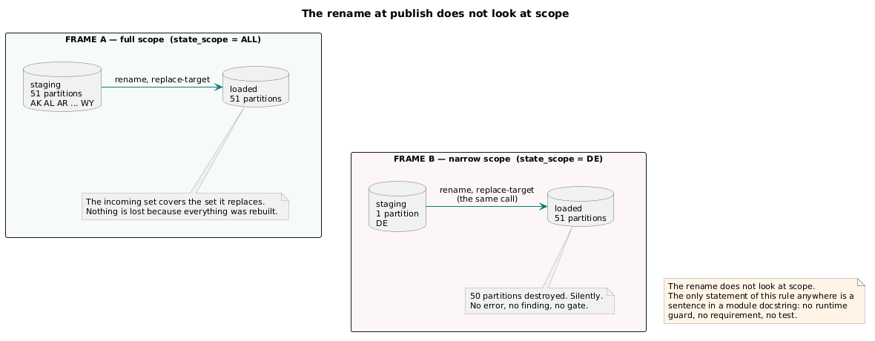

Two frames, side by side, showing the rename at the moment of publish.
Frame A — full scope. A staging cylinder labelled with fifty-one partition chips, and a loaded cylinder beside it with the same fifty-one. An arrow labelled rename, replace-target carries staging onto loaded. Beneath, a green bar: the incoming set covers the set it replaces.
Frame B — narrow scope. The staging cylinder carries one partition chip; the loaded cylinder still carries fifty-one. The same arrow, same label. Beneath, a red bar: fifty partitions destroyed, silently, no error and no finding. A caption strip across both frames reads: the rename does not look at scope; the only statement of this rule is a sentence in a docstring.
This is the single most important diagram in the document and no existing rendering covers it.
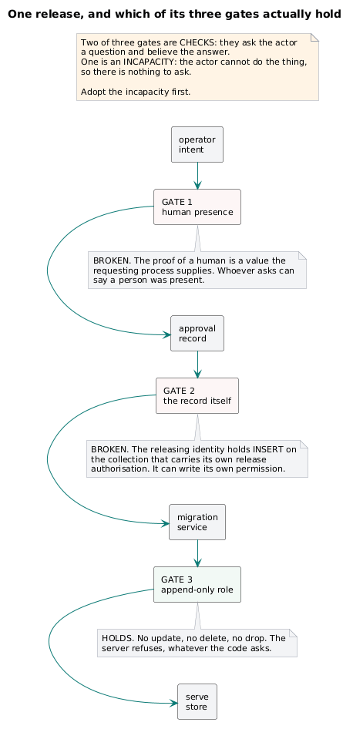
A decision path for one release, drawn to show which controls hold and which do not. Left to right: operator intent → approval record → migration service → serve store. Three guards are drawn as gates across the path, each annotated with whether the gated process can defeat it:
- gate 1, human presence — annotated forgeable: a value the requesting process supplies, drawn as a broken gate;
- gate 2, approval record — annotated forgeable: the releasing identity holds insert on the store that carries it, drawn as a broken gate;
- gate 3, append-only role — annotated not forgeable: the server refuses, whatever the code asks, drawn as a solid gate.
Beneath: two of three gates are checks; one is an incapacity. Adopt the incapacity first.
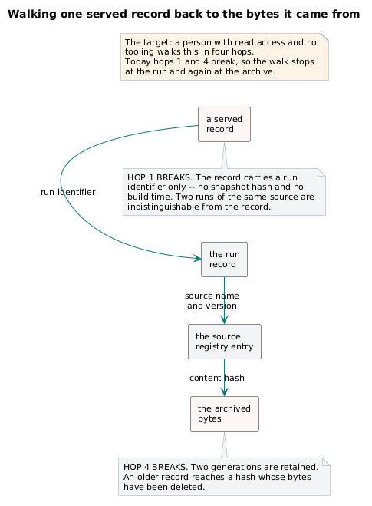
Four hops, left to right, each an object with the field that carries the link named on the arrow: a served record → the run record → the source registry entry → the archived bytes. Under hop 1, a red annotation: carries a run identifier only — no snapshot hash, no build time. Under hop 4, a red annotation: two generations retained; older records reach a hash whose bytes are gone. Caption: a person with read access and no tooling must be able to walk this in four hops. Today hops 1 and 4 break.

