ChatHealthy FindCare

Prompt Factory Architecture Design
Version: Draft 1.0
Date: April 14, 2026
Authors: Skip Snow (CTO), Claude Opus 4.6, GPT-4.1 (reviewer)
Pattern: Interface-First with Middleware and Experience-Driven Lifting

1. Problem Statement
ChatHealthy FindCare has a fully functional backend with 10 domain services, a tool router, an LLM chat loop, safety filtering, HIPAA consent triggers, lead capture, clinical trials search, URL validation, and provider search — all accessible through a `/chat` endpoint.
None of it is reachable by users.
The current production UI (`FindCareApp.tsx`) bypasses `/chat` entirely. It calls `/classify` (vector search for specialties) and `/search` (direct MongoDB query) — two endpoints that skip every backend capability except raw provider lookup. The result: six funded, implemented backend capabilities are invisible to all users.
A codebase audit (April 12, 2026) identified 13 findings. An independent GPT review validated all 13. The root cause of the most critical cluster of findings is a single architectural decision: `FindCareApp.tsx` does not use the prompt-driven chat endpoint.
This design document defines the architecture that fixes this by routing all user input through a single prompt factory — ensuring every backend capability is reachable through one unified path.

1.1 What Users Experience Today
- | User Action | What Happens | What Should Happen |
|---|---|---|
- | "Find me a bone doc in Virginia" | Vector search → specialty codes → DB query → provider cards | Same, plus AI triage, context carry-forward, specialty ranking |
- | "What about in Richmond?" | New stateless /classify call — Virginia is lost | System infers Virginia from prior turn, narrows to Richmond |
- | "What does a physiatrist do?" | Provider cards (no explanation) | Narrative LLM response with Markdown |
- | "Tell me about clinical trials for diabetes" | Provider cards (wrong) | Clinical trials search via ClinicalTrials.gov API |
- | "Who is Skip Snow?" | Provider cards (wrong) | About ChatHealthy narrative response |
- | 5th message in session | Nothing | HIPAA two-tier consent trigger |
- | User shares contact info | Nothing | Lead capture to MongoDB |
- | AI generates fake URL | Reaches user | URL Guardian validates before rendering |

1.2 Audit Findings Addressed by This Design
- | Finding | Priority | Status |
|---|---|---|
- | F1: FindCareApp /chat bypass | CRITICAL | **Design-resolved** |
- | F2: Context carry-forward regression | CRITICAL | **Design-resolved** |
- | F5: URL Guardian dead-coded | HIGH | **Design-resolved** |
- | F7: Specialty ranker limbo | MEDIUM | **Design-resolved** |
- | F8: LLM narrative response inaccessible | MEDIUM | **Design-resolved** |
- | F11: Dynamic context loading inefficiency | LOW | **Design-resolved** |

1.3 Audit Findings NOT Addressed by This Design
- | Finding | Priority | Why Not |
|---|---|---|
- | F3: UMLS CPT compliance | HIGH | Legal/compliance — handled by compliance middleware |
- | F4: ChatWindow.tsx retirement | HIGH | UX governance decision |
- | F6: Regex specialty fallback | MEDIUM | Infrastructure resilience — specialty_service needs try/except |
- | F9: HuggingFace mTLS | MEDIUM | Network/security layer |
- | F10: Brain loop dead code | LOW | Internal tooling |
- | F12: Google Maps | LOW | Feature not built |
- | F13: EvaluateCare scoring | LOW | Feature not built |

2. Core Business Requirements

2.1 The Fundamental Requirement
**One prompt does all the work via a prompt factory.** Every user input — whether it's a provider search, a conversational question, a clinical trials query, or an emergency — enters the system through a single manufactured prompt that carries the user's history and context.

2.2 Business Requirements
- Every user input MUST be routed through the prompt factory. No UI component may bypass the factory by calling backend services directly.
- The system MUST carry conversation context across turns. If a user says "Virginia" then "Richmond", the system MUST infer Virginia from the prior turn.
- The system MUST be able to return both structured results (provider cards) and narrative responses (Markdown text) from the same entry point.
- The HIPAA two-tier consent trigger MUST fire on every 5th user message regardless of which capability is handling the request.
- All URLs in LLM responses MUST be validated before reaching the user.
- Emergency/safety detection MUST occur before any other processing.
- Lead capture MUST trigger when the user provides contact information, regardless of conversation context.
- Clinical trials search MUST be accessible through the same entry point as provider search.
- The system MUST redact UMLS CPT codes from all user-facing output (compliance middleware).
- Each epic's prompt logic MUST be independently deployable and testable. A bug in one epic's facade MUST NOT affect other epics.
---

3. Architecture

3.1 Pattern: Interface-First with Middleware
The architecture uses four layers:
1. **PromptFactoryInterface** — defines the contract. No implementation.
2. **Epic Facades** — one per epic. Each implements the interface. Each owns its own routing rules, tools, and output schemas.
3. **Middleware Stack** — composable chain handling cross-cutting concerns: history, context, validation, compliance, consent counter, URL validation.
4. **Dispatcher** — thin entry point that identifies the epic and delegates. No business logic.
The key constraint: **no shared base class at startup.** As patterns emerge across epic facades over time, shared logic is lifted into an abstract base — but only when proven by real duplication, not assumed.

3.2 Why Not a Monolithic Factory
A single factory class handling all nine epics would become a God Object — the exact maintenance and regression risk the audit identified. One class per epic means one failure domain, one test surface, and one deployment unit per capability cluster. (Source: Perplexity external audit)

3.3 Cross-Cutting Concerns Placement

4. UML Class Diagram
The diagram below shows the complete architecture with four layers: Prompt Factory (green), Middleware (red), Epic Facades (blue), and Existing Domain Services (yellow/orange/gray).
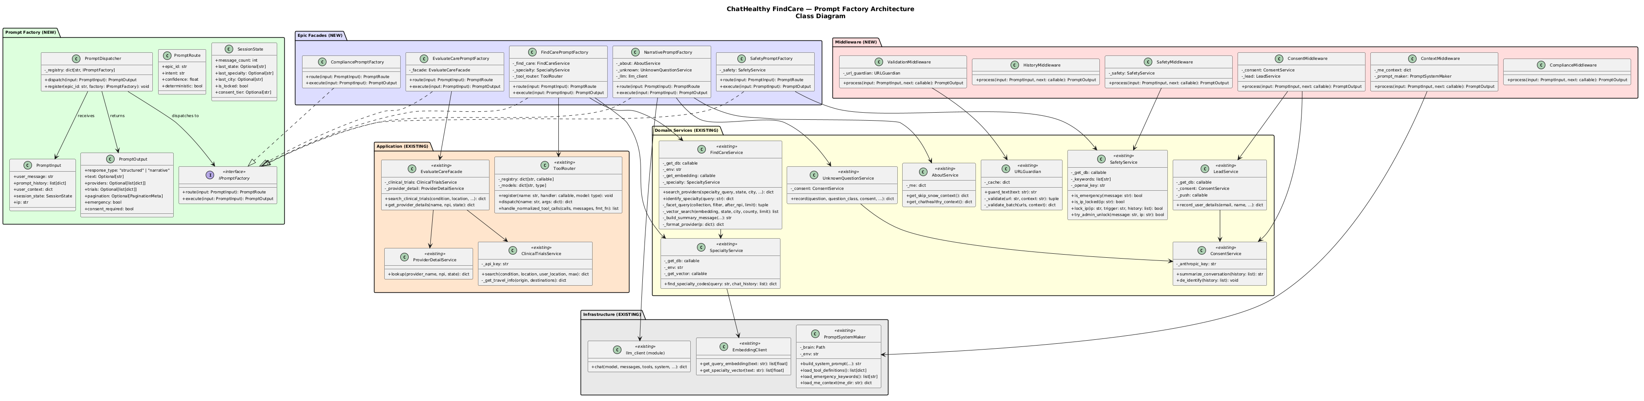

5. UML Sequence Diagrams

5.1 Provider Search — Happy Path
User searches for a provider. The full middleware chain executes: safety check, history management, context loading, specialty vector search, MongoDB query, URL validation, and consent check.
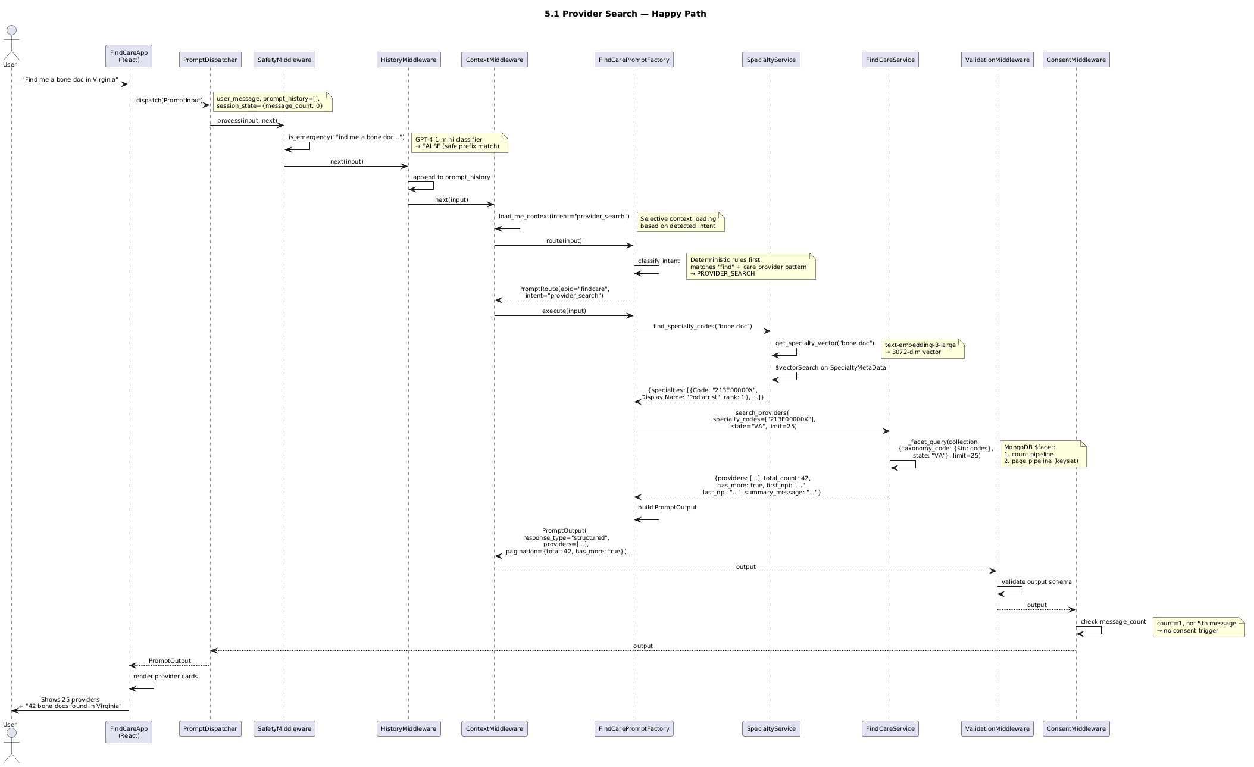

5.2 Conversational Question — Narrative Response
User asks a non-search question. The NarrativePromptFactory handles it via LLM chat, returning Markdown text instead of provider cards.
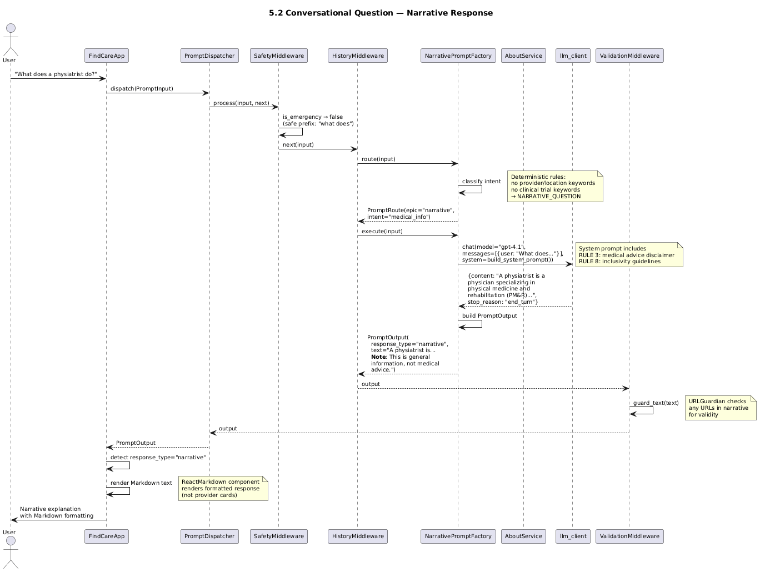

5.3 Clinical Trials Search
User searches for clinical trials. The EvaluateCarePromptFactory delegates to ClinicalTrialsService which queries ClinicalTrials.gov and optionally adds travel times via Google Routes API.
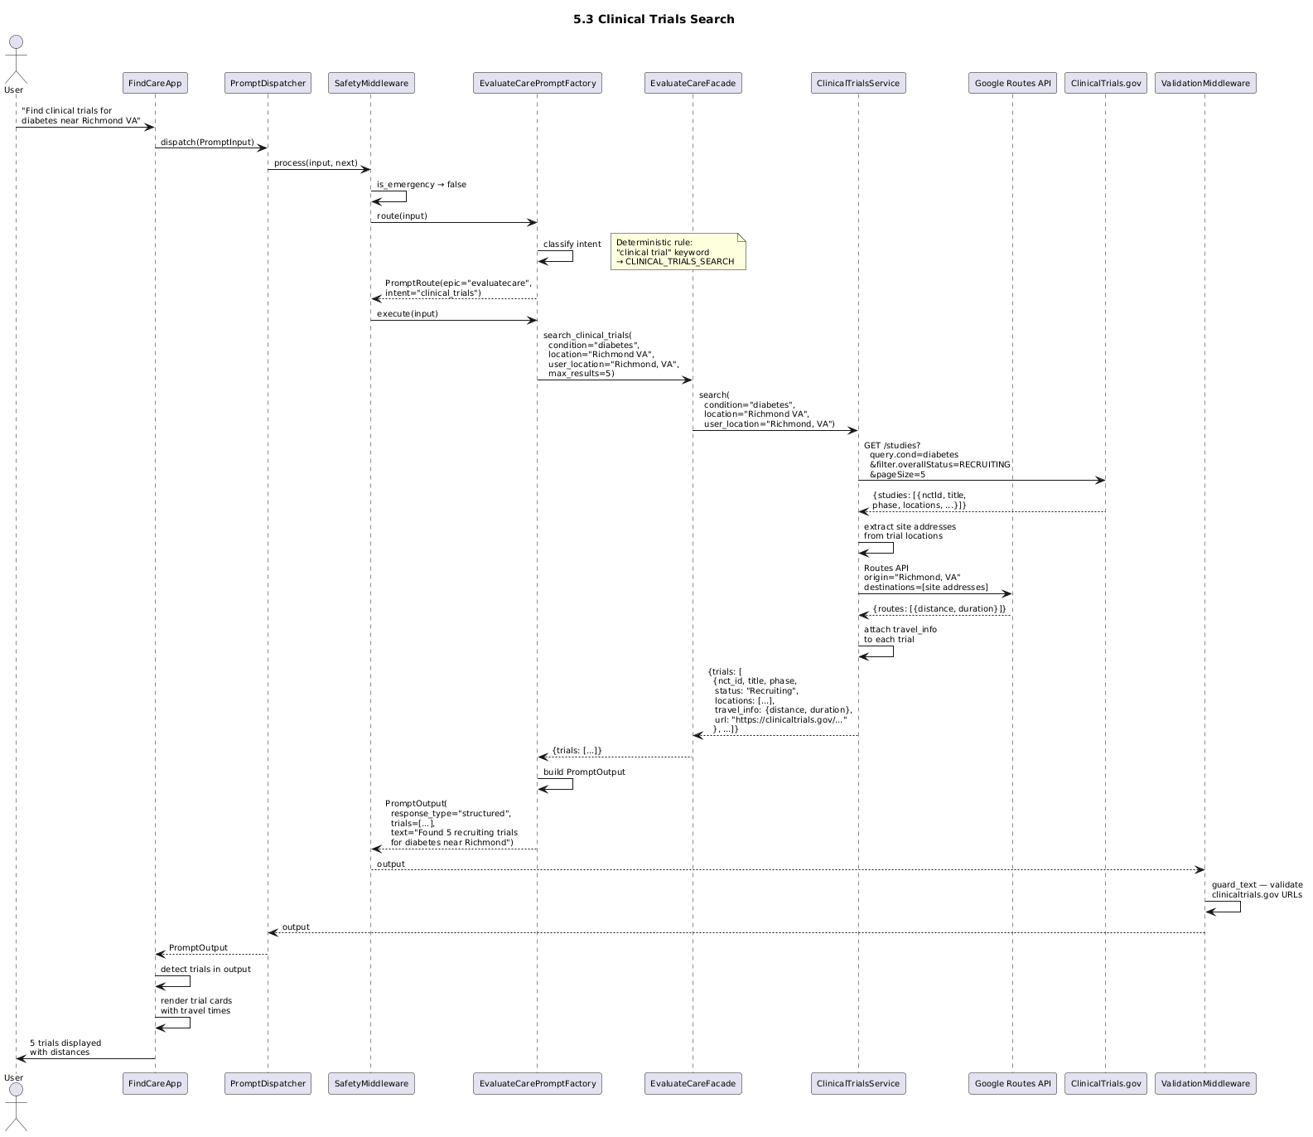

5.4 Emergency/Safety Detection
User reports a medical emergency. SafetyMiddleware short-circuits the entire pipeline, locks the IP, and returns an emergency response. No epic facade is called.
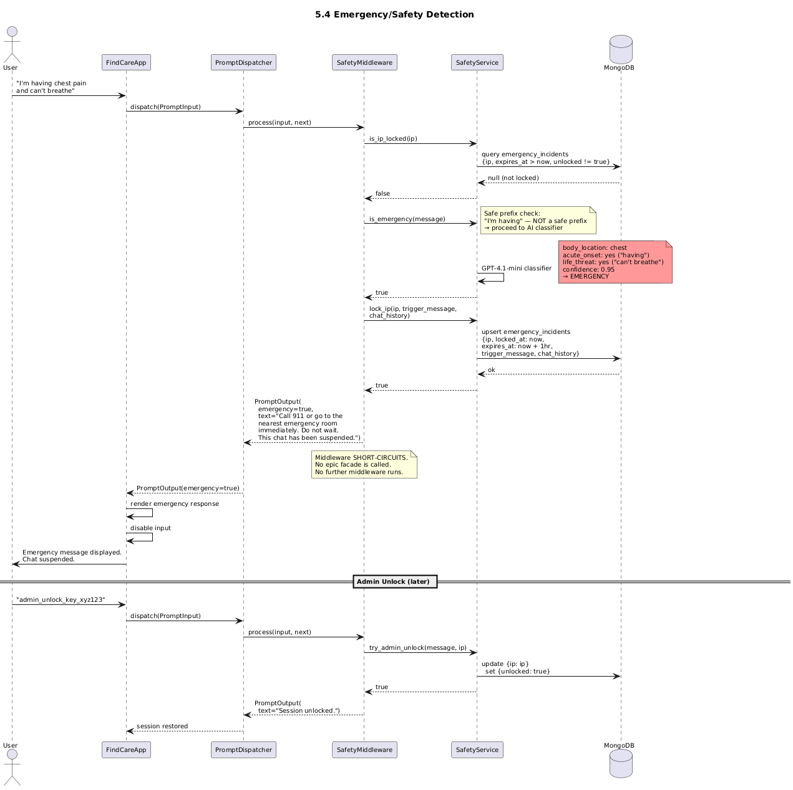

5.5 Context Carry-Forward — Virginia then Richmond
User says Virginia in Turn 1, then Richmond in Turn 2. SessionState carries last_state and last_specialty across turns so the system infers Virginia from the prior turn.
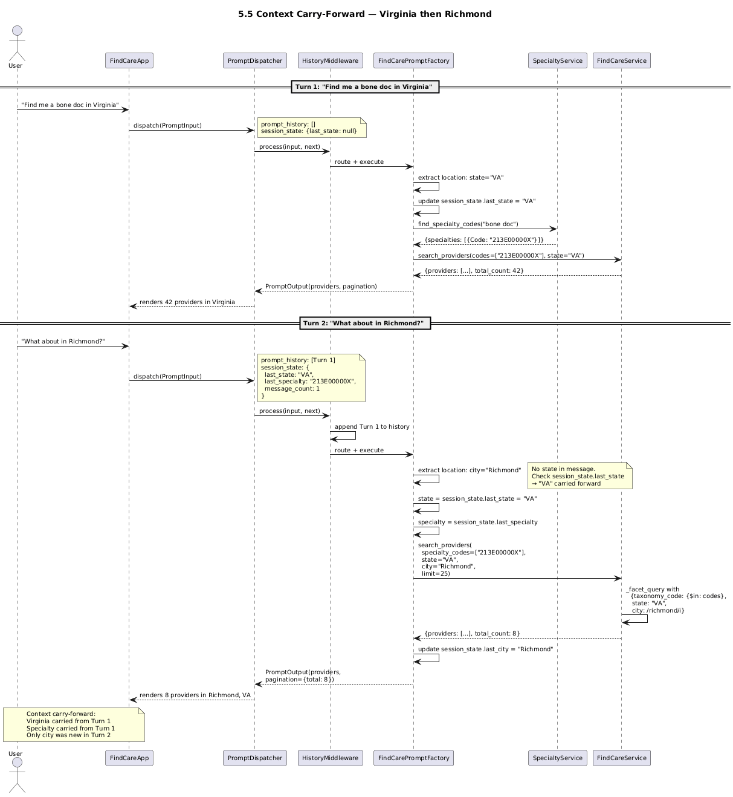

5.6 Consent Trigger — 5th Message
Every 5th message triggers the HIPAA two-tier consent flow. ConsentMiddleware fires post-dispatch, overlaying a consent dialog on the normal results.
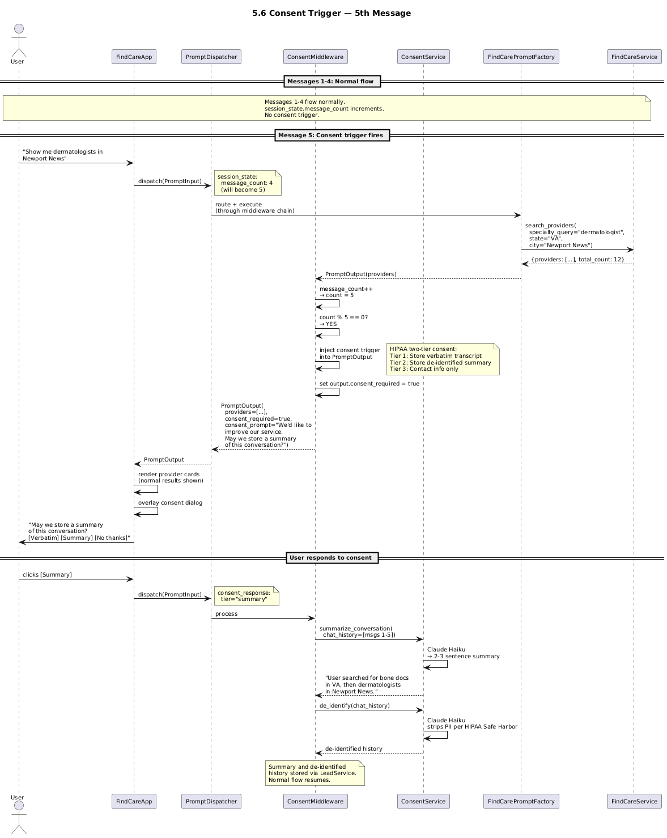

5.7 URL Validation on Tool Response
When the LLM generates a response containing URLs (from tool results or narrative), ValidationMiddleware runs URLGuardian to validate, correct, or defang each URL before rendering.
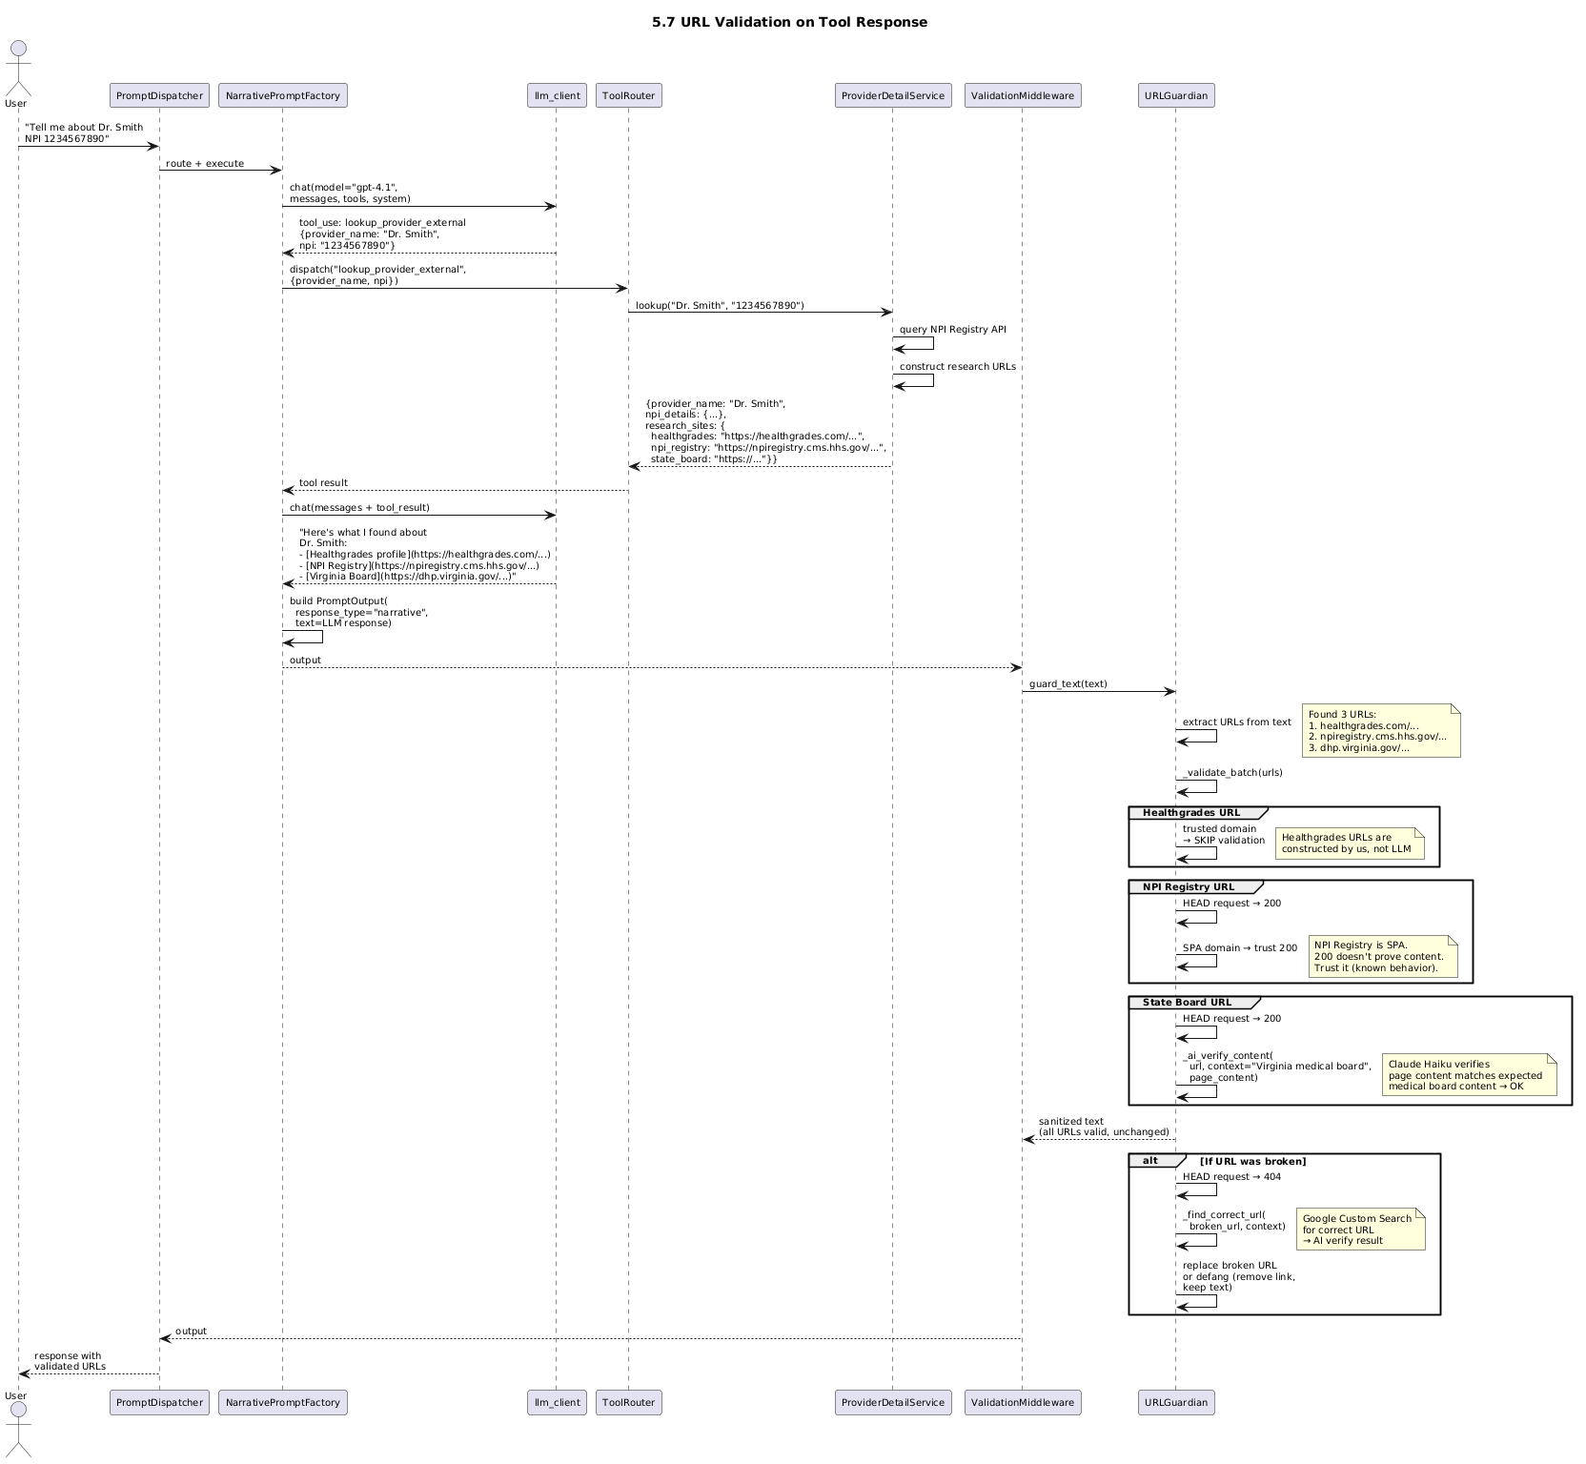

6. Assumptions
- A-01: The existing `/chat` endpoint and tool loop in main.py is the correct backend architecture. The prompt factory wraps it, not replaces it.
- A-02: FindCareApp.tsx will be modified to call the prompt factory endpoint instead of /classify and /search directly.
- A-03: The prompt factory runs server-side in the FastAPI backend, not client-side.
- A-04: Session state (HIPAA counter, conversation history) is maintained per browser session via the existing session token mechanism.
- A-05: The ToolRouter and all registered tools remain unchanged. The prompt factory dispatches to them through the existing tool loop.
- A-06: No new LLM models are introduced. The existing GPT-4.1 chat model and GPT-4.1-mini for extraction/classification remain.

7. Known Gaps
The following gaps are NOT addressed by this design and require separate workstreams:
- G-01: UMLS CPT code compliance (F3) — Legal pre-launch blocker
- G-02: ChatWindow.tsx formal retirement (F4) — Governance debt
- G-03: Regex specialty fallback (F6) — Silent failure if vector index missing
- G-04: HuggingFace mTLS (F9) — Security gap in deployed environment
- G-05: Schema drift between factory output and tool contracts — Silent degradation
- G-06: FindCareApp UI rendering of narrative responses — Users see only provider cards

