ChatHealthy Enforcement Manager
EPIC-008-F-002 — Engineering Rules Enforcement
Design Document | V1 (dev) | April 25, 2026
Backlog: EPIC-008-F-002 · Author: Skip Snow (with Claude)

1. Problem, Approach, and Background
Claude Code is incapable of following directions sufficiently to build systems at scale. It is a consummate hacker and left to its own devisces it will architect torturously fragile systems. In addition because Large Language models are built to flatter, and Claude code is designed to minimize its use of an LLM to do research, and maximize traditional software techniques such as grep to explore the code base it often misrepresents facts in ways that are dangerous to system integrity. LLM form factors such as code bots and web interface use loosely structured files that write ‘Markdown’ files to keep track of state and user profiles. These files are a jumble of confusion and do not allow the human user of a code bot to govern through them.
The outcome is that while Claude Code and other coding agents are superb at doing small radius tasks it is absolutely impossible to build a system at scale without ‘harnessing’ these code bots and creating a ‘control plane’ to reduce the ‘blast areas’ of harm that Claude Code and other code bots do when unleashed, as they must be to efficiently build distributed and complex systems.
ChatHealthy.ai’s work has been tremendously slowed down because of these issues and has been forced to supplement the tool’s native capacity by building a ‘Brain’ that is intended to govern requirements, bugs, deployment facts, and other normal SDLC processes. One mechanism of this governance attempt has been to craft over 50 engineering rules. But up to now those rules have had little to no automated eforcment and Claude Code for the most part ignores those rules in the repository.
The Brain’s Engineering_rules.jsaon has carried 50 engineering rules in engineering_rules.json for several weeks. Every rule has rule_statements that describe what must be true. Zero rules carry a populated enforcements.enforcement[] array. The rules are documentation. They do not govern.
This document defines the architecture that converts the rules from documentation into runtime governance, executed deterministically by hooks and Git lifecycle events.

1.1 The six-week journey
- Phase 1 — Rules without enforcement. The team wrote rules and trusted Claude to honor them. Drift was inevitable; rules slid out of compliance with no programmatic signal.
- Phase 2 — The dead-script problem. Several governance scripts (pre_deploy_rule_check.py, brain-validation runtime checks, BRAIN-SCHEMA-REQ-001 enforcement) were wired into pre-commit but did not actually exercise the rules. They were deliberately unwired in recent commits (3c0b27e, 85757d7, f29dbd6) because they were inventions of claude that had no relationship to the requirements found in agile_pipeline.json and often were in oposision of the actual business needs of ChatHealthy.ai.
- Phase 3 — The realization. engineering_rules.json is documentation, not code. Until each rule carries a concrete enforcement entry that names a hook and an executor, the brain cannot enforce anything.
- Phase 4 —: contributes to the core design below, the event hooks can come very quickly and corrupt the system. This was discovered because the business needs a log of all conversations between Claude Code and its human operator to be stored in a Mongo data base. Requirements, architecture and design decisions as well as conversations can be tracked and the institutional memory of ChatHealthy.ai can be preserved. The conversation_log_hook.py started life as a single-process file writer. But the magnitude of events overwhelmed the system. The fix to install a Kafka producer sidecar (PID 1) plus a single consumer (PID 2) that batches into Mongo. This solved the problem but also gave the team the queue that some of the work that we must do to automate governance will have the same problem. Thus a mutex had to be created to stop the governnce process to overwhelm the system and act unpredictably.
- Phase 5 — Today. Drop the empty enforcement[] arrays as documentation. Add real enforcement entries that map (rule, hook, worker_id). Build a single manager that manages workers that enforce the governance rules.

1.2 Locked decisions
Decision | Resolution
Naming | PEP-8. ChatHealthyEnforcementManager and ScanFilesEnforcementWorker. UPPER_SNAKE constants.
Manager shape | One file, one main(), one class. Invoked by every hook with hook_name as the only positional arg.
Manager I/O on rules | Read-only. Filters enforcements by hook. Never edits.
Concurrency in manager | concurrent.futures.ThreadPoolExecutor. Manager dispatches, joins, aggregates exit codes, exits with worst.
Concurrency primitives | Owned by each worker. Allowed: filelock, Kafka pub + single consumer, Mongo atomic ops, POSIX O_APPEND. In-process locks forbidden — separate PIDs cannot see them.
Worker constructor | __init__(self, enforcement_id: str). One arg. Worker reads engineering_rules.json itself, finds its own entry by id.
POC scope | ScanFilesEnforcementWorker on pre-commit performs HTTP scan + JSON schema validation in parallel.

2. Business Requirements
These are written in business language. They reflect what the operator actually wants this system to deliver, distilled from this session and the prior multi-week governance work. They are not yet in the backlog. They are the destination.
# | Business Requirement
BR-1 | Every engineering rule that the team intends to enforce MUST carry at least one programmatic enforcement entry. A rule with an empty enforcement array is documentation, not governance, and SHALL be either populated, retired, or annotated as documentation-only.
BR-2 | Enforcement runs at the moment a violation can occur — the relevant Git or Claude Code hook — not on a separate cadence. There is no nightly job that catches yesterday's mistake.
BR-3 | An engineering rule MUST be able to reach beyond a single Git event. Rule-001 (no misrepresentation) fires on every UserPromptSubmit and Stop. Rule-008 (JSON schemas) fires on pre-commit. The framework is hook-agnostic; the rule declares which hook it cares about.
BR-4 | The system MUST be debuggable by a human. One file per role. One class per file. One entry point. Per-rule, per-worker output to stdout, with worst exit code propagated.
BR-5 | The framework MUST handle multi-PID race conditions correctly out of the box. The same hook can fire many times concurrently across different Claude Code PIDs and Git invocations
BR-6 | Adding the next enforcement MUST be a small, additive change. New rule entries get a new enforcement_id and a new worker class; existing rules and workers are not touched.
BR-8 | Enforcement entries are first-class records: every entry carries a stable enforcement_id (format <rule_id>-ENF-NNN) and a declared hook. They can be cited in audit trails, bug reports, and the backlog like requirements are today.
BR-9 | The architecture MUST be aligned with the EPIC / Feature / Story tree. The home for this feachure is business aligned. New code lives in:  projectRoot/governance/EngineeringRuleEnforcement.  This mirrors the tree found in ChatHealthy’s agile backlog exactly, and therefore enforces the firms core operating model.
BR-10 | The doc the operator is reading right now is the artifact that moves the project from "we have rules" to "the rules govern." When the solution ships, BR-1 and BR-2 are satisfied for one rule, demonstrably.

3. Technical Requirements
# | Technical Requirement
TR-1 | engineering_rules.json schema gains two required fields per enforcement entry: enforcement_id (string, format <rule_id>-ENF-NNN) and hook (enum: pre-commit, commit-msg, post-commit, pre-push, SessionStart, UserPromptSubmit, PreToolUse, Stop, SessionEnd, InstructionsLoaded).
TR-2 | ChatHealthyEnforcementManager lives at {projectRoot}/governance/EngineeringRuleEnforcement/chathealthy_enforcement_manager.py. Single class. Single main(). Constructor takes hook_name. run() returns int.
TR-3 | Manager loads engineering_rules.json read-only, filters enforcement[] by hook, dispatches one task per matching enforcement to a concurrent.futures.ThreadPoolExecutor, joins all futures, returns max(exit_codes). Manager does not own any concurrency primitives beyond the pool.
TR-4 | ScanFilesEnforcementWorker lives at projectRoot/governance/EngineeringRuleEnforcement/scan_files_enforcement_worker.py. __init__(enforcement_id: str). The worker re-reads engineering_rules.json and locates its own entry by id. Worker.run() returns int.
TR-5 | ScanFilesEnforcementWorker performs two checks in parallel on every staged file: (a) HTTP-vs-HTTPS regex scan ported from preCommitScan.py; (b) JSON schema validation ported from validate_all_json.py. Layered whitelists are enforced in declared order.
TR-6 | HTTP scan whitelist layers (in order): file-type whitelist (.py, .ts, .tsx, .js, .jsx, .html, .yml, .yaml, .cfg, .toml; .json is NOT included), file-level exemption (test_*, conftest.py, brain/BusinessArtifacts/, scanner files themselves), URL allowlist (localhost, 127.0.0.1, dev/qa/chathealthy.ai/index.html, w3.org, 169.254.169.254).
TR-7 | JSON validation: schema is resolved per-file via the file's own $schema field (Draft 2020-12). File-level exemption is config-driven (explicit list for fixtures, dumps, third-party). New JSON without $schema and not exempted MUST FAIL LOUD. This is desired behavior.
TR-8 | Workers MAY use cross-PID concurrency primitives only: filelock package, Kafka pub + single consumer, Mongo atomic ops, POSIX O_APPEND. In-process Python locks are forbidden.
TR-9 | preCommitScan.py SHALL drop ".json" from SCAN_EXTENSIONS and \.json$ from HTTP_EXEMPT_PATTERNS once ScanFilesEnforcementWorker is the single source of truth.
TR-10 | The manager and the workers MUST NOT import each other's internals. The only contract is enforcement_id (str) in, exit code (int) out, and stdout.
TR-11 | Tests live at Code/Shared/governance/tests/. Each new worker ships with at least one happy-path and one violation-path test.
TR-12 | Hook plumbing: .git/hooks/pre-commit invokes `python -m chathealthy_enforcement_manager pre-commit`. .claude/settings.json hook entries invoke the manager with the matching hook_name (SessionStart, UserPromptSubmit, PreToolUse, Stop, SessionEnd, InstructionsLoaded).

4. Design
The design has three diagrams. The sequence diagram traces one pre-commit invocation end-to-end with the HTTP+JSON scanner as the worker. The class diagram captures the two classes and the read-only artifact they share. The folder diagram shows where every new file lives.

4.1 Sequence — pre-commit HTTP+JSON scan
Worked example: developer runs git commit. The pre-commit hook invokes the manager with hook_name="pre-commit". The manager loads rules, filters to enforcements whose hook matches, dispatches each to a worker on a thread pool, joins, and exits with the worst exit code.
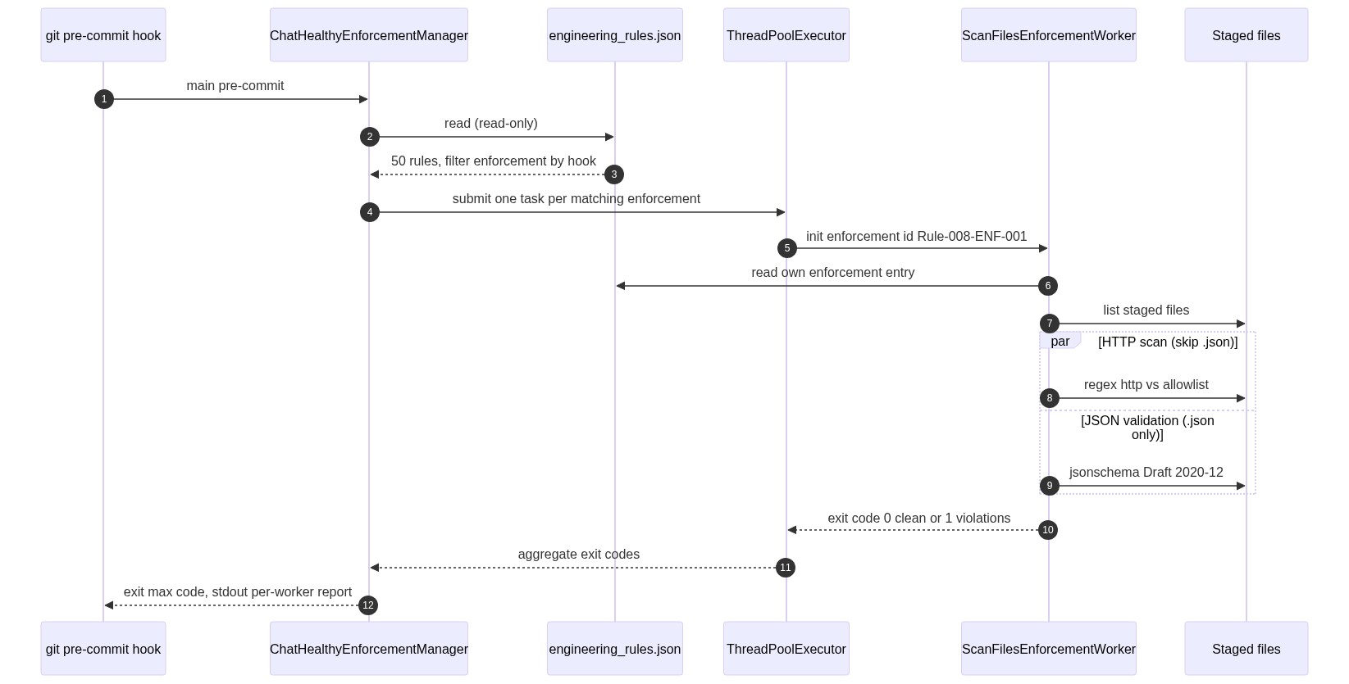
Figure 4.1 — pre-commit sequence

4.2 Class diagram
Two production classes. The manager owns dispatch and aggregation. The worker owns its enforcement entry, its whitelists, its concurrency primitives, and its exit code. Neither class subclasses anything ChatHealthy-specific.
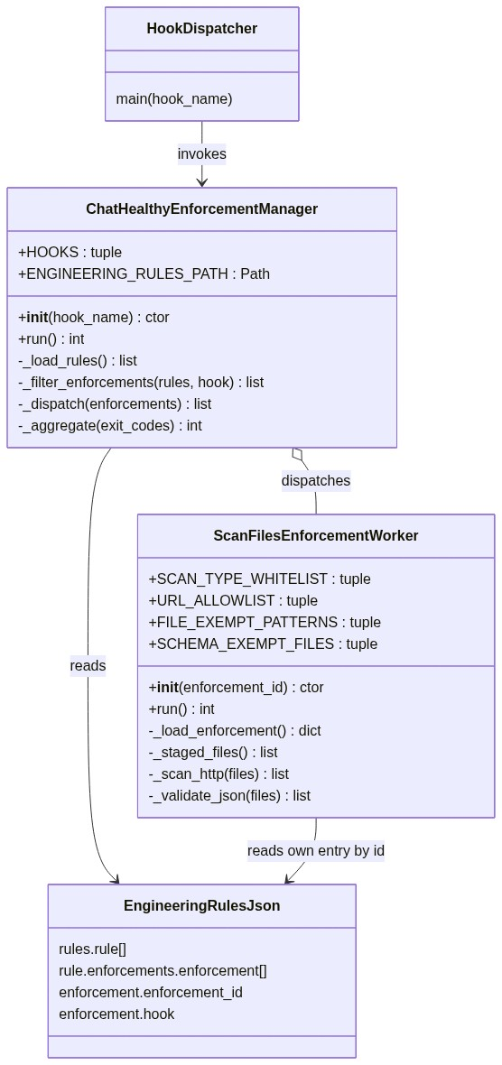
Figure 4.2 — Class structure

4.2.1 ChatHealthyEnforcementManager
Member | Type | Purpose
HOOKS | tuple[str, ...] | Frozen enum of allowed hook names
ENGINEERING_RULES_PATH | Path | brain/machine_artifacts/content/engineering_rules.json
__init__(hook_name) | ctor | Validate hook_name; store
run() | int | Load rules, filter, dispatch, aggregate, return worst exit code
_load_rules() | list[dict] | Read-only load; supports old/new rules shape
_filter_enforcements(rules, hook) | list[dict] | Return enforcement entries whose hook matches
_dispatch(enforcements) | list[int] | Parallel ThreadPoolExecutor; one worker per enforcement
_aggregate(exit_codes) | int | max(exit_codes), defaulting to 0 if empty

4.2.2 ScanFilesEnforcementWorker
Member | Type | Purpose
SCAN_TYPE_WHITELIST | tuple[str, ...] | Extensions that the HTTP scan reads (.py, .ts, .tsx, .js, .jsx, .html, .yml, .yaml, .cfg, .toml)
URL_ALLOWLIST | tuple[Pattern, ...] | Compiled regex patterns for allowed http URLs
FILE_EXEMPT_PATTERNS | tuple[Pattern, ...] | Files exempt from HTTP scan (test_*, conftest.py, brain/BusinessArtifacts/, scanner files)
SCHEMA_EXEMPT_FILES | tuple[str, ...] | Config-driven list of JSON files exempt from $schema requirement
__init__(enforcement_id) | ctor | Store id; lazy-load own enforcement entry
run() | int | Run HTTP scan and JSON validation in parallel; return worst code
_load_enforcement() | dict | Read engineering_rules.json; return entry whose enforcement_id matches
_staged_files() | list[str] | git diff --cached --name-only --diff-filter=ACM
_scan_http(files) | list[str] | Apply layered whitelists; return violations
_validate_json(files) | list[str] | jsonschema Draft 2020-12 against file's $schema

4.3 Physical folder layout
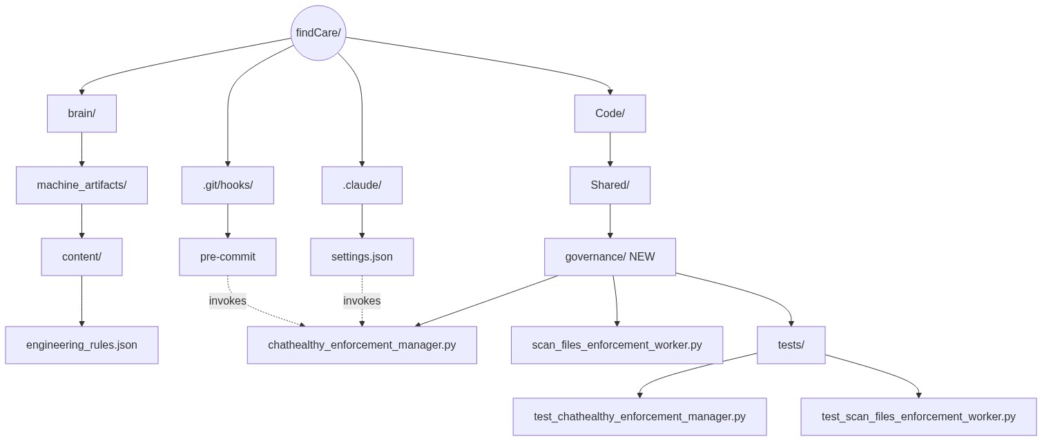
Figure 4.3 — Where every new file lives
Path | Status | Purpose
Code/Shared/governance/ | NEW | Biz-aligned home for all enforcement code
Code/Shared/governance/chathealthy_enforcement_manager.py | NEW | The manager — one class, one main()
Code/Shared/governance/scan_files_enforcement_worker.py | NEW | POC worker for pre-commit HTTP+JSON scan
Code/Shared/governance/tests/ | NEW | Pytest tree for manager + workers
brain/machine_artifacts/content/engineering_rules.json | EXISTING (schema extended) | Authoritative rule registry; gains enforcement_id and hook fields
Code/Shared/ops/tools/preCommitScan.py | EXISTING (trimmed) | Drop .json from SCAN_EXTENSIONS and \.json$ from HTTP_EXEMPT_PATTERNS once worker is live
.claude/settings.json | EXISTING (hook entries updated) | Each hook event invokes the manager with its own hook_name
.git/hooks/pre-commit | EXISTING (rewired) | Invokes the manager with hook_name="pre-commit"

4.4 Enforcement schema additions
Every entry inside rule.enforcements.enforcement[] gains two required fields. The schema for engineering_rules.json is updated in lockstep.
Field | Type | Required | Format / Enum
enforcement_id | string | Yes | <rule_id>-ENF-NNN (e.g. Rule-008-ENF-001)
hook | string | Yes | pre-commit | commit-msg | post-commit | pre-push | SessionStart | UserPromptSubmit | PreToolUse | Stop | SessionEnd | InstructionsLoaded

4.5 Whitelist semantics

4.5.1 HTTP scan — three ordered layers
Layer | Check | Effect
1 | Type whitelist | If file extension is not in SCAN_TYPE_WHITELIST, skip. (.json is intentionally absent — JSON validation handles those.)
2 | File-level exemption | If file matches FILE_EXEMPT_PATTERNS, skip the HTTP scan.
3 | URL allowlist | If a matched http URL matches URL_ALLOWLIST, the line is not a violation.

4.5.2 JSON validation
Rule | Behavior
$schema present | Fetch and validate Draft 2020-12. Errors = violation.
$schema missing AND file in SCHEMA_EXEMPT_FILES | Skip silently.
$schema missing AND not exempt | FAIL LOUD. Desired behavior.
$schema points at relaxed placeholder | FAIL. Strict validation only.

4.6 Worker accountability — concurrency story
Every worker owns its concurrency story end-to-end. The manager does not provide locks. This is forced by reality: Claude Code spawns multiple PIDs, and a Python lock created in one PID is invisible to another. The conversation_log proved this in production.
Primitive | Use case | Allowed in workers?
filelock package (advisory file lock) | Coarse mutual exclusion across PIDs on a single host | Yes
Kafka pub + single consumer | Serialize a high-volume write stream (conversation_log pattern) | Yes
Mongo atomic op (findOneAndUpdate, $inc) | Distributed counter or claim | Yes
POSIX O_APPEND | Single-line append to a shared log file | Yes
threading.Lock / multiprocessing.Lock | In-process only; invisible across PIDs | No
ScanFilesEnforcementWorker is read-only against staged files and engineering_rules.json. It needs no concurrency primitive today. Future workers (e.g. those that append to a violations ledger) will declare and use one of the allowed primitives.

4.7 preCommitScan.py — what changes
Item | Today | After POC ships
.json in SCAN_EXTENSIONS | Yes | Removed (covered by JSON validation in worker)
\.json$ in HTTP_EXEMPT_PATTERNS | Yes | Removed (redundant once .json is out of SCAN_EXTENSIONS)
HTTP scan logic | Lives here | Migrated into ScanFilesEnforcementWorker._scan_http
Pre-push rule executor loop | Stays for now | Migrates to manager when pre-push hook is wired in Phase 6

4.8 Phase 6 — migration backlog
Out of scope for V1 but explicitly tracked. Each item is a future enforcement entry that wires an existing in-the-wild behavior into the manager.
- Rule-001 prompt-injection executor → UserPromptSubmit hook (today lives in CLAUDE.md preamble only).
- Mode-selection rules (Unattended / Normal / Idiot) → SessionStart / UserPromptSubmit hook.
- Boot orchestration (chathealthy_devops_boot) → SessionStart / InstructionsLoaded hook.
- conversation_log_hook.py → migrate to a dedicated ConversationLogEnforcementWorker registered against UserPromptSubmit + Stop, dispatched by the manager.
- Pre-push rule executors (file_present, file_absent, json_check, no_pattern) → migrate from preCommitScan.py to per-rule workers under the manager on pre-push.

5. Open Items
Documented and deferred. Resolve before code lands.
# | Item | Resolution path
O-1 | Manager class name. This design says ChatHealthyEnforcementManager. Backlog story EPIC-008-F-002-S-002 references AnthropicsClaudeCodeHookManager.py. Naming inconsistency. | Pick one before the file is created. Recommendation: ChatHealthyEnforcementManager (it manages enforcement, not just Claude Code hooks; pre-commit and pre-push are Git hooks).
O-2 | Parent rule for the HTTP scan. The current scan in preCommitScan.py cites a requirement_id (EPIC-002-F-001-S-012-REQ-B-004), not a rule. | Either elevate REQ-B-004 to a rule, or attach the HTTP scan as a rule_statement under an existing security rule. Decide before the first enforcement_id is minted.
O-3 | Confirm Rule-008 is the parent rule for JSON validation. | Rule-008 today reads: "Brain JSONs must conform to human-approved schemas." Confirmed match. Adopt Rule-008-ENF-001 = JSON schema validation on pre-commit.
O-4 | v4-028 backlog cleanup is partial; agent classified 71 entities (test_output/scan_validate_relevance.json) but full cleanup is pending. | Triage in a follow-up backlog grooming session. Not blocking V1.

6. Sources and inputs
Source | Reachable? | Used for
This session's transcript (C:/Users/skips/.claude/projects/c--chatHealthy-findCare/f52a6998-5f63-4ff6-b1a6-a0f75cd69d1a.jsonl, ~17 MB) | Yes | Decision history; locked decisions; open items.
MongoDB conversation_log_archive (ClaudeCodeLog database) | Yes (5,052 docs; latest archived utterance is 2026-04-19; today's entries are still in the local rolling log and the transcript) | Confirmed Kafka cross-PID pattern; pulled prior architectural context from earlier sessions.
brain/machine_artifacts/content/conversation_log.json (rolling 24 h) | Yes | Filling the gap between today's transcript and Mongo's last archived day.
brain/machine_artifacts/content/engineering_rules.json | Yes | Confirmed: 50 rules, 0 of 50 with a non-empty enforcement[] array. Rule-008 confirmed as parent for JSON validation.
Code/Shared/ops/tools/preCommitScan.py | Yes | Source of HTTP-scan logic to port into the worker.
brain/enforcement_code/validate_all_json.py | Yes | Source of JSON validation logic to port into the worker.
Code/Shared/ops/conversation_log_hook.py and Code/Shared/ops/kafka/conversation_log_producer.py | Yes | Reference implementation for the cross-PID pattern.
brain/BusinessArtifacts/ops-manager-design-EPIC3-V1.docx | Yes | Style and structural template for this document.
Copyright 2026 Skip Snow / ChatHealthy.ai LLC. All rights reserved.

