ChatHealthy Engineering Rules Enforcement
EPIC-008-F-002 — Engineering Rules Enforcement
Design Document | V3 (dev) | April 26, 2026
Backlog: EPIC-008-F-002 · Author: Skip Snow (with Claude)

1. Problem, Approach, and Background
Claude Code is incapable of following directions sufficiently to build systems at scale. It is a consummate hacker and left to its own devices it will architect torturously fragile systems. In addition, because Large Language Models are built to flatter, and Claude Code is designed to minimize its use of an LLM to do research and maximize traditional software techniques such as grep to explore the code base, it often misrepresents facts in ways that are dangerous to system integrity. LLM form factors such as code bots and web interfaces use loosely structured files that write ‘Markdown’ files to keep track of state and user profiles. These files are a jumble of confusion and do not allow the human user of a code bot to govern through them.
The outcome is that while Claude Code and other coding agents are superb at doing small-radius tasks, it is absolutely impossible to build a system at scale without ‘harnessing’ these code bots and creating a ‘control plane’ to reduce the ‘blast areas’ of harm that Claude Code and other code bots do when unleashed, as they must be to efficiently build distributed and complex systems.
ChatHealthy.ai’s work has been tremendously slowed down because of these issues and has been forced to supplement the tool’s native capacity by building a ‘Brain’ that is intended to govern requirements, bugs, deployment facts, and other normal SDLC processes. One mechanism of this governance attempt has been to craft over fifty engineering rules. But up to now those rules have had little to no automated enforcement and Claude Code for the most part ignores those rules in the repository.
The Brain’s engineering_rules.json has carried 50 engineering rules for several weeks. Every rule has rule_statements that describe what must be true. Zero rules carry a populated enforcements.enforcement[] array. The rules are documentation. They do not govern.
This document defines the production architecture that converts the rules from documentation into runtime governance, executed deterministically by Git lifecycle events and Claude Code hooks. It specifies the framework: a manager, an EnforcementWorker base class, the enforcement schema, the full hook taxonomy, the concurrency-primitive menu, and the worker contracts. The first concrete worker — file scanning on pre-commit — is presented later as a worked example, not as the centerpiece.

1.1 The six-week journey
- Phase 1 — Rules without enforcement. The team wrote rules and trusted Claude to honor them. Drift was inevitable; rules slid out of compliance with no programmatic signal.
- Phase 2 — The dead-script problem. Several governance scripts (pre_deploy_rule_check.py, brain-validation runtime checks, BRAIN-SCHEMA-REQ-001 enforcement) were wired into pre-commit but did not actually exercise the rules. They were deliberately unwired in recent commits (3c0b27e, 85757d7, f29dbd6) because they were inventions of Claude that had no relationship to the requirements found in agile_pipeline.json and often were in opposition to the actual business needs of ChatHealthy.ai.
- Phase 3 — The realization. engineering_rules.json is documentation, not code. Until each rule carries a concrete enforcement entry that names a hook and an executor, the brain cannot enforce anything.
- Phase 4 — The cross-PID race condition, proven in production. The business needs a log of every conversation between Claude Code and its human operator stored in MongoDB so that requirements, architecture and design decisions, and the institutional memory of ChatHealthy.ai can be preserved. conversation_log_hook.py started life as a single-process file writer; concurrent Claude Code PIDs corrupted the file. The fix — a Kafka producer sidecar (PID 1) plus a single consumer (PID 2) batching into Mongo — is the canonical pattern this design adopts. Governance enforcement faces the same multi-PID reality and inherits the same primitive menu.
- Phase 5 — Today. Drop the empty enforcement[] arrays as documentation. Add real enforcement entries that map (rule, hook, worker_id). Stand up the framework: a manager, an EnforcementWorker base class, and a growing taxonomy of concrete workers across all four Git hooks and all six Claude Code hooks.

1.2 Locked decisions
Decision | Resolution
Naming | PEP-8. ChatHealthyEnforcementManager, EnforcementWorker (base), ScanFilesEnforcementWorker (first concrete subclass). UPPER_SNAKE constants.
Manager shape | One file, one main(), one class. Invoked by every hook with hook_name as the only positional arg.
Manager I/O on rules | Read-only. Filters enforcements by hook. Never edits.
Concurrency in manager | concurrent.futures.ThreadPoolExecutor. Manager dispatches, joins, aggregates exit codes, exits with worst.
Concurrency primitives | Declared per worker on the enforcement entry. Menu: none, filelock, Kafka pub + single consumer, Mongo atomic op, POSIX O_APPEND. In-process locks forbidden — invisible across PIDs.
Worker base class | EnforcementWorker. Owns four-list scope evaluation, violation record shape, exit-code semantics, telemetry envelope, and structured error handling. Subclasses implement check() only.
Worker constructor | __init__(self, enforcement_id: str). One arg. Worker reads engineering_rules.json itself, finds its own entry by id.
Filesystem layout | Filesystem mirrors the operating model. All code for this feature lives under projectRoot/governance/EngineeringRuleEnforcement/. crossEpicConcerns/ holds shared business artifacts only — no code there.
Worked example | ScanFilesEnforcementWorker on pre-commit performs HTTP scan and JSON schema validation in parallel. It illustrates the framework; it does not define it.

2. Business Requirements
Business-language statements of what this system must deliver. Each requirement is testable and backlog-ready.
# | Business Requirement
BR-1 | Every engineering rule that the team intends to enforce MUST carry at least one programmatic enforcement entry. A rule with an empty enforcement array is documentation, not governance, and SHALL be either populated, retired, or annotated as documentation-only.
BR-2 | Enforcement runs at the moment a violation can occur — the relevant Git or Claude Code hook — not on a separate cadence. There is no nightly job that catches yesterday’s mistake.
BR-3 | An engineering rule MUST be able to attach to any of the four Git hooks (pre-commit, commit-msg, post-commit, pre-push) and any of the six Claude Code hooks (SessionStart, UserPromptSubmit, PreToolUse, Stop, SessionEnd, InstructionsLoaded). Rule-001 (no misrepresentation) fires on UserPromptSubmit and Stop. Rule-008 (JSON schemas) fires on pre-commit. The framework is hook-agnostic; the enforcement entry declares its hook.
BR-4 | The system MUST be debuggable by a human. One file per role. One class per file. One entry point. Per-enforcement, per-worker structured stdout and telemetry, with worst exit code propagated.
BR-5 | The framework MUST handle multi-PID race conditions correctly. The same hook can fire many times concurrently across different Claude Code PIDs and Git invocations. Workers MUST declare a concurrency primitive from the framework menu; in-process locks are forbidden.
BR-6 | Adding the next enforcement MUST be a small, additive change. New enforcement entries get a new enforcement_id and — if needed — a new worker subclass; existing rules and workers are not touched.
BR-7 | Every worker MUST inherit from EnforcementWorker. Subclasses implement only their domain-specific check logic. The base class owns scope evaluation, violation shape, exit codes, telemetry, and error handling so every worker behaves the same from the manager’s perspective.
BR-8 | Enforcement entries are first-class records: every entry carries a stable enforcement_id (format <rule_id>-ENF-NNN), a declared hook, four scope lists, and a declared concurrency primitive. They can be cited in audit trails, bug reports, and the backlog like requirements are today.
BR-9 | The architecture MUST be aligned with the EPIC / Feature / Story tree. Filesystem mirrors operating model. The home for this feature is projectRoot/governance/EngineeringRuleEnforcement/. crossEpicConcerns/ holds shared business artifacts only — no code lives there.
BR-10 | Once V1 ships, BR-1 through BR-9 are demonstrably satisfied for the worked example (file scanning on pre-commit) and the framework is in place to absorb every other rule on its own schedule.
BR-X | The framework MUST support all four scope-list types on every enforcement entry, even when a given worker uses only a subset. The four permitted terms are the only vocabulary used anywhere in this system. They are defined as the canonical JSON contract immediately below this row.
BR-X canonical contract. The four terms below are the only scope-list vocabulary in this system. “Exact match” means exact string equality against the full resource identifier (absolute path, URI, or other complete-string attribute). “Pattern” means regex / partial string match.
[
{ "label": "allowed by exact match", "match_style": "exact string equality", "resource_form": "full absolute path or URI" },
{ "label": "allowed by pattern", "match_style": "regex / partial string", "resource_form": "regex" },
{ "label": "excluded by pattern", "match_style": "regex / partial string", "resource_form": "regex" },
{ "label": "excluded by exact match", "match_style": "exact string equality", "resource_form": "full absolute path or URI" }
]

3. Technical Requirements
# | Technical Requirement
TR-1 | engineering_rules.json schema gains the following required fields per enforcement entry: enforcement_id (string, format <rule_id>-ENF-NNN); hook (enum: pre-commit, commit-msg, post-commit, pre-push, SessionStart, UserPromptSubmit, PreToolUse, Stop, SessionEnd, InstructionsLoaded); allowed_exact (array of strings); allowed_pattern (array of regex strings); excluded_exact (array of strings); excluded_pattern (array of regex strings); concurrency_primitive (enum: none, filelock, kafka, mongo_atomic, posix_o_append).
TR-2 | ChatHealthyEnforcementManager lives at projectRoot/governance/EngineeringRuleEnforcement/code/chathealthy_enforcement_manager.py. Single class. Single main(). Constructor takes hook_name. run() returns int.
TR-3 | Manager loads engineering_rules.json read-only, filters enforcement[] by hook, dispatches one task per matching enforcement to a concurrent.futures.ThreadPoolExecutor, joins all futures, returns max(exit_codes). Manager owns no concurrency primitives beyond the pool.
TR-4 | EnforcementWorker (abstract base) lives at projectRoot/governance/EngineeringRuleEnforcement/code/enforcement_worker.py. It owns: __init__(enforcement_id), _load_enforcement(), is_in_scope(resource), run(), violation emission, telemetry emission, and structured error handling. Subclasses override check(resource) only.
TR-5 | Scope evaluation is fixed-precedence and lives entirely in the base class. Order: excluded_exact → excluded_pattern → allowed_exact → allowed_pattern → default. The default behavior (in scope vs. out of scope when no list matches) is declared per worker subclass via a class attribute SCOPE_DEFAULT.
TR-6 | Violation record shape (emitted by base class): {enforcement_id, rule_id, resource, message, severity}. severity in {info, warn, error}.
TR-7 | Exit-code semantics (returned by base class run()): 0 = clean, 1 = violations found, 2 = worker error (uncaught exception trapped in run()). The base class wraps subclass check() in try/except and converts unhandled exceptions to exit 2 with a structured error record.
TR-8 | Telemetry envelope (emitted by base class): start record and end record per worker invocation, both carrying enforcement_id, hook, duration_ms, files_scanned, violation_count, exit_code. Format: one JSON object per line to stdout.
TR-9 | Workers MUST declare a concurrency primitive on their enforcement entry, drawn from: none, filelock, kafka (pub + single consumer), mongo_atomic, posix_o_append. In-process Python locks are forbidden — they are invisible across PIDs.
TR-10 | ScanFilesEnforcementWorker (worked example, V1) lives at projectRoot/governance/EngineeringRuleEnforcement/code/scan_files_enforcement_worker.py. It implements check(file) for two domains in parallel: (a) HTTP-vs-HTTPS regex scan ported from preCommitScan.py; (b) JSON schema validation ported from validate_all_json.py. Concurrency primitive: none (read-only).
TR-11 | ScanFilesEnforcementWorker scope lists (using only the four permitted terms). HTTP scan: allowed_pattern includes extensions .py, .ts, .tsx, .js, .jsx, .html, .yml, .yaml, .cfg, .toml; excluded_pattern includes test_*, conftest.py, brain/BusinessArtifacts/, the scanner files themselves; URL-level allowed_pattern includes localhost, 127.0.0.1, dev/qa/chathealthy.ai/index.html, w3.org, 169.254.169.254. JSON validation: a config-driven excluded_exact list (fixtures, dumps, third-party). Files outside both lists without $schema MUST FAIL LOUD.
TR-12 | preCommitScan.py SHALL drop ".json" from SCAN_EXTENSIONS and \.json$ from HTTP_EXEMPT_PATTERNS once ScanFilesEnforcementWorker is the single source of truth.
TR-13 | Manager and workers MUST NOT import each other’s internals. The only contract is enforcement_id (str) in, exit code (int) out, and the structured stdout / telemetry envelope.
TR-14 | Tests live at projectRoot/governance/EngineeringRuleEnforcement/tests/. The base class ships with its own test suite covering scope evaluation, exit-code semantics, violation shape, telemetry envelope, and the try/except fail-safe. Each new worker ships with at least one happy-path and one violation-path test.
TR-15 | Hook plumbing. .git/hooks/{pre-commit, commit-msg, post-commit, pre-push} each invoke `python -m chathealthy_enforcement_manager <hook>`. .claude/settings.json wires SessionStart, UserPromptSubmit, PreToolUse, Stop, SessionEnd, and InstructionsLoaded to the same manager with the matching hook_name.
TR-16 | Worker taxonomy supported by the framework: file scanning (pre-commit / pre-push), prompt-injection check (UserPromptSubmit — returns additionalContext), post-response audit (Stop), log publishing (UserPromptSubmit + Stop → Kafka), boot orchestration (SessionStart), and mode selection (SessionStart). Each is a concrete subclass of EnforcementWorker.

4. Design
The design has two halves. First, the framework: the manager, the EnforcementWorker base class, the enforcement schema, the hook taxonomy, the concurrency menu, and the worker taxonomy. Second, a worked example — ScanFilesEnforcementWorker on pre-commit — that exercises every part of the framework concretely.

4.1 Framework overview
Three production classes plus the rules registry. ChatHealthyEnforcementManager owns dispatch and aggregation. EnforcementWorker (abstract) owns scope evaluation, violation shape, exit codes, telemetry, and error handling. Concrete worker subclasses own only their domain-specific check logic. engineering_rules.json is the read-only authority that ties them together by enforcement_id.

4.2 Sequence — manager dispatch with base-class scope evaluation
The pre-commit case is shown because it is the densest. The same flow applies to every other hook — only the filtered enforcement[] and the concrete worker subclass differ. Note that is_in_scope() runs in the base class before the subclass-specific check() is ever called.
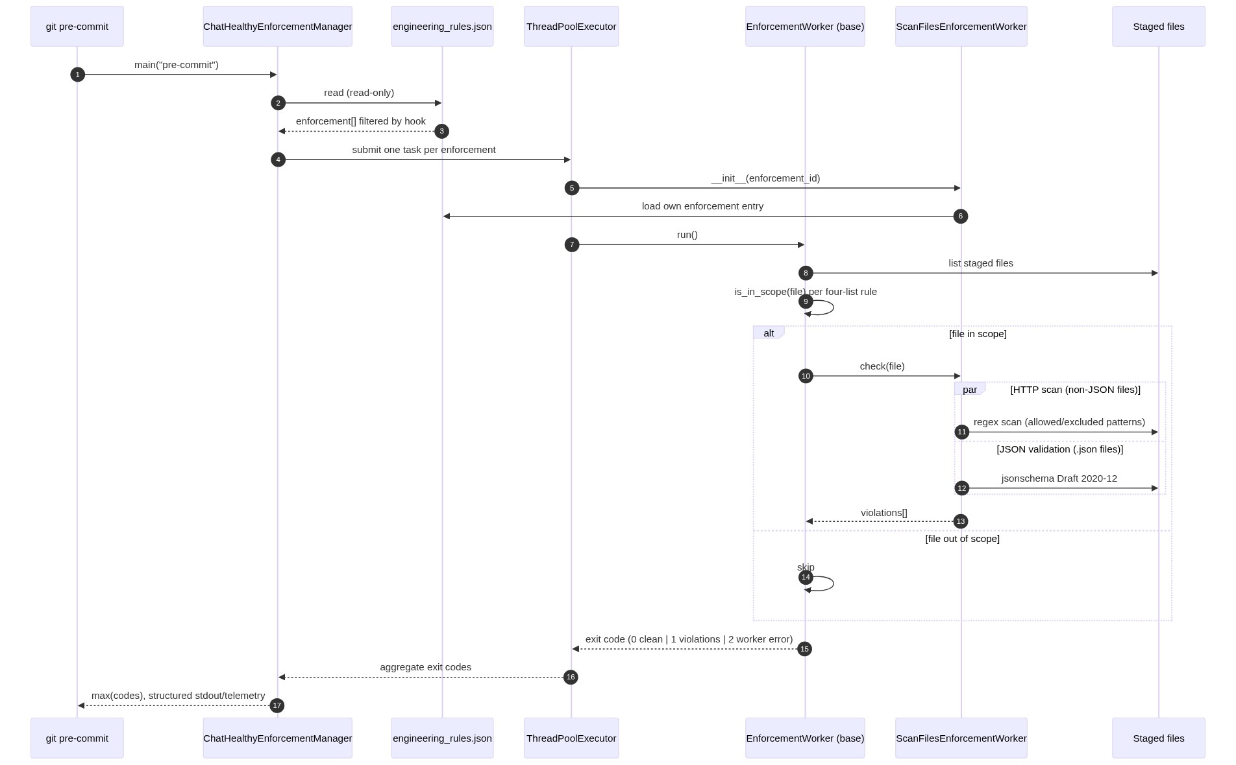
Figure 4.2 — Manager dispatch with base-class scope evaluation

4.3 Class diagram — framework + taxonomy
EnforcementWorker is the contract. ScanFilesEnforcementWorker is the V1 concrete subclass. The five <<future>> subclasses are the named members of the worker taxonomy that the framework already accommodates; they are drawn here so that the manager’s association with EnforcementWorker is understood as polymorphic from day one.
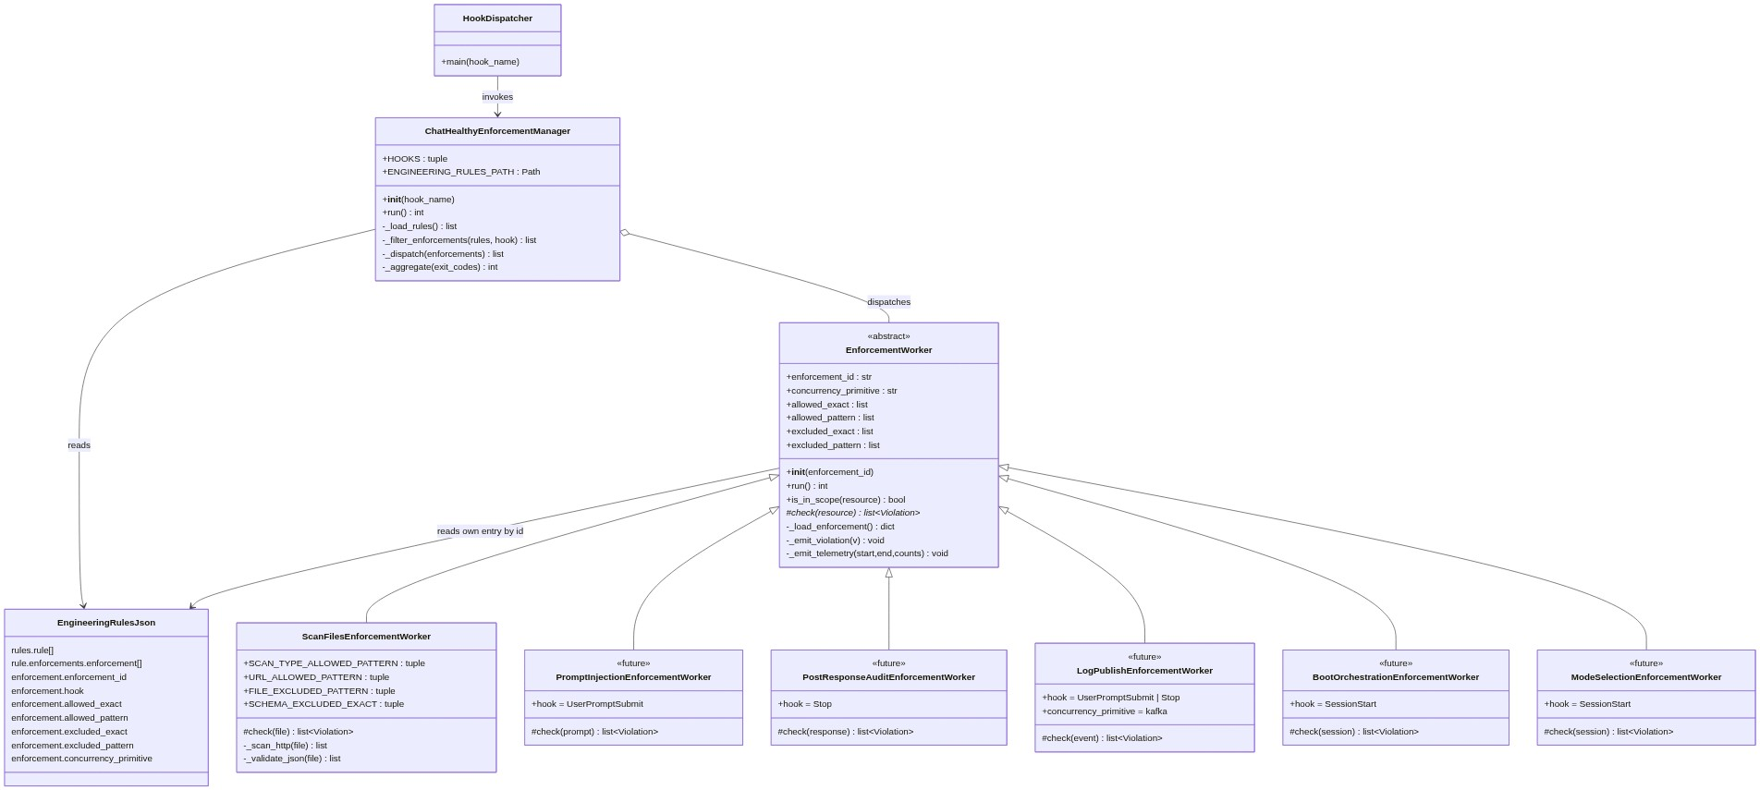
Figure 4.3 — Class diagram with EnforcementWorker hierarchy

4.3.1 ChatHealthyEnforcementManager
Member | Type | Purpose
HOOKS | tuple[str, ...] | Frozen enum of allowed hook names (4 Git + 6 Claude Code = 10)
ENGINEERING_RULES_PATH | Path | brain/machine_artifacts/content/engineering_rules.json
__init__(hook_name) | ctor | Validate hook_name; store
run() | int | Load rules, filter enforcement[] by hook, dispatch, aggregate, return worst exit code
_load_rules() | list[dict] | Read-only load of engineering_rules.json
_filter_enforcements(rules, hook) | list[dict] | Return enforcement entries whose hook matches
_dispatch(enforcements) | list[int] | ThreadPoolExecutor; one worker per enforcement; each worker is instantiated by class name resolved from enforcement.worker_class
_aggregate(exit_codes) | int | max(exit_codes), defaulting to 0 if empty

4.3.2 EnforcementWorker (abstract base)
Member | Type | Purpose
enforcement_id | str | Identifies this worker’s entry in engineering_rules.json
concurrency_primitive | str | Declared on the entry; one of {none, filelock, kafka, mongo_atomic, posix_o_append}
allowed_exact / allowed_pattern | list[str] | Resource is in scope if it matches one of these (after exclusion lists clear it)
excluded_exact / excluded_pattern | list[str] | Resource is out of scope if it matches one of these
SCOPE_DEFAULT | bool (class attr) | Default scope decision when no list matches; subclass declares
__init__(enforcement_id) | ctor | Store id; load own enforcement entry from engineering_rules.json
_load_enforcement() | dict | Resolve enforcement entry and populate the four scope lists and concurrency_primitive
is_in_scope(resource) | bool | Apply the four-list precedence: excluded_exact → excluded_pattern → allowed_exact → allowed_pattern → SCOPE_DEFAULT
run() | int | Template method: emit start telemetry; iterate resources; for each, if is_in_scope() then call check() inside try/except; aggregate violations; emit end telemetry; return 0 | 1 | 2
check(resource) | list[Violation] | Abstract. Subclass implements domain-specific logic.
_emit_violation(v) | void | Write violation record {enforcement_id, rule_id, resource, message, severity} to structured stdout
_emit_telemetry(start, end, counts) | void | Write start/end telemetry record to structured stdout

4.4 Enforcement schema additions
Every entry inside rule.enforcements.enforcement[] gains the fields below. The schema for engineering_rules.json is updated in lockstep.
Field | Type | Required | Format / Enum
enforcement_id | string | Yes | <rule_id>-ENF-NNN (e.g. Rule-008-ENF-001)
hook | string | Yes | pre-commit | commit-msg | post-commit | pre-push | SessionStart | UserPromptSubmit | PreToolUse | Stop | SessionEnd | InstructionsLoaded
worker_class | string | Yes | Fully qualified class name of the EnforcementWorker subclass
allowed_exact | array[string] | Yes (may be empty) | Full absolute paths or URIs; exact string equality
allowed_pattern | array[string] | Yes (may be empty) | Regex / partial-string patterns
excluded_exact | array[string] | Yes (may be empty) | Full absolute paths or URIs; exact string equality
excluded_pattern | array[string] | Yes (may be empty) | Regex / partial-string patterns
concurrency_primitive | string | Yes | none | filelock | kafka | mongo_atomic | posix_o_append

4.5 Hook taxonomy
Ten hooks. Four Git lifecycle, six Claude Code runtime. Every enforcement entry declares exactly one. The manager is the single dispatch point for all ten.
Hook | Origin | Typical worker categories
pre-commit | Git | File scanning (e.g. ScanFilesEnforcementWorker), commit-content rules
commit-msg | Git | Commit-message format rules (mode markers, ticket refs)
post-commit | Git | Post-write audit, log publishing
pre-push | Git | Cross-file consistency, deployment-readiness rules
SessionStart | Claude Code | Boot orchestration, mode selection
UserPromptSubmit | Claude Code | Prompt-injection check (returns additionalContext), log publishing
PreToolUse | Claude Code | Tool-use guards (resource access, deployment surface)
Stop | Claude Code | Post-response audit, log publishing
SessionEnd | Claude Code | Session-level cleanup audits
InstructionsLoaded | Claude Code | Instructions / prompt-system audit

4.6 Concurrency primitive menu
Every worker declares a concurrency primitive on its enforcement entry. The manager owns no primitives beyond its thread pool. This is forced by reality: Claude Code spawns multiple PIDs; a Python lock created in one PID is invisible to another. The conversation_log Kafka pipeline is the proof point and is referenced as the canonical pattern, not as work in progress.
Primitive | Use case | Cross-PID safe?
none | Read-only worker (e.g. ScanFilesEnforcementWorker) | N/A — no shared mutable state
filelock (advisory file lock) | Coarse mutual exclusion across PIDs on a single host | Yes
kafka (pub + single consumer) | Serialize a high-volume write stream (conversation_log pattern, future LogPublishEnforcementWorker) | Yes
mongo_atomic (findOneAndUpdate, $inc, etc.) | Distributed counter or claim | Yes
posix_o_append | Single-line append to a shared log file | Yes
threading.Lock / multiprocessing.Lock | In-process only; invisible across PIDs | FORBIDDEN

4.7 Worker taxonomy
Six categories of concrete worker are already known and accommodated by the framework. ScanFilesEnforcementWorker is the V1 concrete subclass; the rest are sketched as future subclasses with the same base contract.
Category | Hook(s) | Role
File scanning | pre-commit, pre-push | Inspect staged or about-to-push files; emit violations on content rules. Worked example: ScanFilesEnforcementWorker.
Prompt-injection | UserPromptSubmit | Inspect inbound user prompt; return additionalContext (or block) when policy says so.
Post-response audit | Stop | Inspect Claude’s response after the turn; emit violations on misrepresentation, scope creep, etc.
Log publishing | UserPromptSubmit + Stop | Publish the prompt+response pair to the conversation_log Kafka topic. Concurrency primitive: kafka.
Boot orchestration | SessionStart | Run chathealthy_devops_boot logic: mode detection, environment posture, header banner.
Mode selection | SessionStart | Resolve and announce session mode (Unattended / Normal / Idiot) based on context flags and CLAUDE.md.

4.8 Worked Example: ScanFilesEnforcementWorker on pre-commit
This is the V1 concrete worker. It illustrates how the framework operates end-to-end. It does not define the framework; the framework defines it.

4.8.1 ScanFilesEnforcementWorker class
Member | Type | Purpose
SCAN_TYPE_ALLOWED_PATTERN | tuple[Pattern, ...] | Extension regexes the HTTP scan reads (.py, .ts, .tsx, .js, .jsx, .html, .yml, .yaml, .cfg, .toml)
URL_ALLOWED_PATTERN | tuple[Pattern, ...] | Compiled regex patterns for allowed http URLs
FILE_EXCLUDED_PATTERN | tuple[Pattern, ...] | File-level regex exclusions (test_*, conftest.py, brain/BusinessArtifacts/, scanner files themselves)
SCHEMA_EXCLUDED_EXACT | tuple[str, ...] | Config-driven list of JSON files exempt from $schema requirement (full-path exact match)
SCOPE_DEFAULT | bool | False. A staged file is in scope only if a positive allowed_* match clears it.
check(file) | list[Violation] | Run _scan_http and _validate_json in parallel; return violations
_scan_http(file) | list[Violation] | Apply layered scope evaluation (already done by base class); regex-scan for http://; emit violation if no URL_ALLOWED_PATTERN match
_validate_json(file) | list[Violation] | jsonschema Draft 2020-12 against file's $schema; FAIL LOUD if $schema missing and file not in SCHEMA_EXCLUDED_EXACT

4.8.2 Categorized scope-list inventory (worked example)
All four permitted scope-list types, populated for this worker. Empty lists are explicit, not implicit.
Scope-list type | Concrete entries (worked example)
allowed by exact match | (empty for HTTP scan; for the broader file-scan domain, potentially specific files added one-off)
allowed by pattern | HTTP scan file-type: \.py$, \.ts$, \.tsx$, \.js$, \.jsx$, \.html$, \.ya?ml$, \.cfg$, \.toml$. URL allow list: ^https?://localhost, ^https?://127\.0\.0\.1, ^https?://(dev|qa)\.chathealthy\.ai/index\.html, ^https?://w3\.org, ^https?://169\.254\.169\.254.
excluded by pattern | test_, conftest\.py, ^brain/BusinessArtifacts/, scan_files_enforcement_worker\.py, preCommitScan\.py
excluded by exact match | JSON validation excluded list (config-driven full-path list for fixtures, dumps, third-party JSON not authored here)

4.8.3 JSON validation behavior
Condition | Behavior
$schema present | Fetch and validate Draft 2020-12. Errors = violation.
$schema missing AND file in SCHEMA_EXCLUDED_EXACT | Skip silently.
$schema missing AND not in SCHEMA_EXCLUDED_EXACT | FAIL LOUD. Desired behavior.
$schema points at relaxed placeholder | FAIL. Strict validation only.

4.9 Filesystem layout — mirrors the operating model
All code for this feature lives under projectRoot/governance/EngineeringRuleEnforcement/. The feature is self-contained: code, tests, and business artifacts under one root. crossEpicConcerns/ holds shared business artifacts only — no code lives there. This mirrors the agile EPIC / Feature backlog exactly.
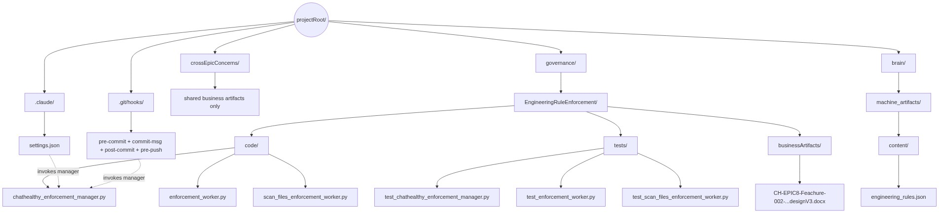
Figure 4.9 — Filesystem mirrors the operating model
Path | Status | Purpose
projectRoot/governance/EngineeringRuleEnforcement/ | NEW | Self-contained home for this feature’s code, tests, and business artifacts
…/code/chathealthy_enforcement_manager.py | NEW | The manager — one class, one main()
…/code/enforcement_worker.py | NEW | EnforcementWorker abstract base class
…/code/scan_files_enforcement_worker.py | NEW | V1 concrete worker (worked example)
…/tests/ | NEW | Pytest tree for manager, base class, and each worker
…/businessArtifacts/ | NEW | Design docs and other business-facing artifacts for this feature
projectRoot/crossEpicConcerns/ | NEW (or formalized) | Shared business artifacts only. No code lives here.
brain/machine_artifacts/content/engineering_rules.json | EXISTING (schema extended) | Authoritative rule registry; gains the V3 enforcement-entry fields
Code/Shared/ops/tools/preCommitScan.py | EXISTING (trimmed) | Drop .json from SCAN_EXTENSIONS and \.json$ from HTTP_EXEMPT_PATTERNS once the worker is live
.claude/settings.json | EXISTING (hook entries updated) | Each Claude Code hook event invokes the manager with its hook_name
.git/hooks/{pre-commit, commit-msg, post-commit, pre-push} | EXISTING (rewired) | Each Git hook invokes the manager with its hook_name
Footnote on the existing Code/ tree: the legacy Code/ directory will atrophy over time as code migrates to the operating-model-mirroring layout. That migration is tracked separately and is not in scope for this design.

4.10 Manager-worker contract
Direction | Payload | Notes
Manager → Worker (instantiation) | enforcement_id (str) | Worker resolves its own enforcement entry from engineering_rules.json by id.
Worker → stdout (violation) | {enforcement_id, rule_id, resource, message, severity} | One JSON object per line. Emitted by base class.
Worker → stdout (telemetry) | {enforcement_id, hook, phase: start|end, duration_ms, files_scanned, violation_count, exit_code} | One JSON object per line at start and end.
Worker → Manager (return) | exit_code int (0 | 1 | 2) | 0 clean, 1 violations, 2 worker error. Manager aggregates max.
Manager → Git/Claude Code (return) | max(exit_codes), structured stdout report | Worst exit code wins. Per-enforcement records preserved on stdout.

4.11 Migration backlog
Out of scope for V1 but explicitly tracked. Each item is a future enforcement entry, mapping an existing in-the-wild behavior to a concrete subclass of EnforcementWorker.
- Rule-001 prompt-injection executor → PromptInjectionEnforcementWorker on UserPromptSubmit (today lives in CLAUDE.md preamble only).
- Mode-selection rules (Unattended / Normal / Idiot) → ModeSelectionEnforcementWorker on SessionStart.
- Boot orchestration (chathealthy_devops_boot) → BootOrchestrationEnforcementWorker on SessionStart / InstructionsLoaded.
- conversation_log_hook.py → LogPublishEnforcementWorker registered against UserPromptSubmit + Stop, dispatched by the manager. Concurrency primitive: kafka.
- Pre-push rule executors (file_present, file_absent, json_check, no_pattern) → per-rule subclasses of EnforcementWorker on pre-push, migrated out of preCommitScan.py.
- Post-response audit on Stop → PostResponseAuditEnforcementWorker enforcing Rule-001 (no misrepresentation) and related post-turn audits.

5. Open Items
Tightly scoped. Resolve before code lands.
# | Item | Resolution path
O-1 | Manager class name. This design says ChatHealthyEnforcementManager. Backlog story EPIC-008-F-002-S-002 references AnthropicsClaudeCodeHookManager.py. | Adopt ChatHealthyEnforcementManager. It manages enforcement across both Git hooks and Claude Code hooks; the older name is too narrow.
O-2 | Parent rule for the HTTP scan. The current scan in preCommitScan.py cites a requirement_id (EPIC-002-F-001-S-012-REQ-B-004), not a rule. | Either elevate REQ-B-004 to a rule, or attach the HTTP scan as a rule_statement under an existing security rule. Decide before the first enforcement_id is minted.
O-3 | Confirm Rule-008 is the parent rule for JSON validation. | Rule-008 today reads: “Brain JSONs must conform to human-approved schemas.” Confirmed match. Adopt Rule-008-ENF-001 = JSON schema validation on pre-commit.
O-4 | Default-scope behavior when all four scope lists are empty. Two natural readings: (a) empty lists → every resource is in scope (“all” default); (b) empty lists → no resource is in scope (“none” default). | TR-5 makes this explicit per worker via SCOPE_DEFAULT. Recommendation: SCOPE_DEFAULT = False for the worked example (in scope only on a positive allowed_* match). Each new worker subclass declares its own SCOPE_DEFAULT.
O-5 | How an enforcement entry resolves to a concrete worker class. Two options: (a) worker_class field on the entry holds a dotted path that the manager imports; (b) a registry of <rule_id, hook> → class lives in code. | Adopt (a) — worker_class on the entry. Keeps engineering_rules.json the authority and avoids drift between rule and registry. TR-1 already lists the field.
O-6 | v4-028 backlog cleanup is partial; agent classified 71 entities (test_output/scan_validate_relevance.json) but full cleanup is pending. | Triage in a follow-up backlog grooming session. Not blocking V1.

6. Sources and inputs
Source | Reachable? | Used for
This session’s transcript (C:/Users/skips/.claude/projects/c--chatHealthy-findCare/f52a6998-5f63-4ff6-b1a6-a0f75cd69d1a.jsonl, ~17 MB) | Yes | Decision history; locked decisions; open items.
MongoDB conversation_log_archive (ClaudeCodeLog database) | Yes | Confirmed Kafka cross-PID pattern as the canonical primitive; earlier-session architectural context.
brain/machine_artifacts/content/conversation_log.json (rolling 24h) | Yes | Bridged today’s transcript with Mongo’s last archived day.
brain/machine_artifacts/content/engineering_rules.json | Yes | Confirmed: 50 rules, 0 with a non-empty enforcement[] array. Rule-008 confirmed as parent for JSON validation.
Code/Shared/ops/tools/preCommitScan.py | Yes | Source of HTTP-scan logic to port into the worked-example worker.
brain/enforcement_code/validate_all_json.py | Yes | Source of JSON validation logic to port into the worked-example worker.
Code/Shared/ops/conversation_log_hook.py and Code/Shared/ops/kafka/conversation_log_producer.py | Yes | Reference implementation for the cross-PID Kafka pattern.
CH-EPIC8-Feachure-002-EngineeringRulesEnforcement-designV2.docx | Yes | V2 baseline. Skip’s hand-edited prose preserved verbatim in section 1; remainder restructured to specify the framework, not a single instance.
Copyright 2026 Skip Snow / ChatHealthy.ai LLC. All rights reserved.

