Provider Pipeline
Low-Level Design
Version 25 · 2026-07-18

Executive Summary
This is the Low-Level Design for the ChatHealthy Provider Pipeline. The pipeline ingests the NPPES full monthly dissemination (plus the pl_pfile practice-locations file), the NUCC provider taxonomy CSV, the U.S. Census ZCTA-to-County crosswalk, and the USDA RUCC classification workbook; it produces the runtime provider record consumed by FindCare on the front-end MongoDB cluster.
This document specifies behavioral WHAT with just enough mechanism to be mechanically executable. It does not restate F-003 identity and cryptographic rules and it does not restate F-012 deployment mechanics. The pipeline is a client of both. Every consumption point cites the specific REQ IDs that govern it.
Scope framing anchored on the following:
- The Provider Pipeline consumes F-003 identity, certificates, and authentications. Runtime nodes hold F-003-issued certificates; Mongo data-plane auth is X.509 client authentication using those certificates; Azure resource-plane auth uses managed identity for the bootstrap and cert-authenticated Azure AD for post-bootstrap. See §3, §9 (per-step Mongo touches), and §9.4.
- The Provider Pipeline consumes F-012 deployment. Every artifact that ships to a target is enumerated in deployment_architecture.json per EPIC-008-F-012-S-001-REQ-B-010. The Runbook and the Control container ride the promoted plane; Worker containers self-mint identities per run. See §3, §11.
- The Provider Pipeline runtime substrate is Runbook + ACA Control + ACA Workers coordinated through Mongo work-items, per §3 of this document. No Durable Functions runtime is used. Any legacy Durable-Functions code path in the current pipeline tree is being deleted.
- EPIC-008-F-012-S-019 Zero Trust network posture applies: every runtime component sits inside a declared network boundary; undeclared traffic is refused at the boundary; HTTPS-only at the boundary. See §3.5 and §9.6.
- BUG-004 (mutual TLS gap on HuggingFace-hosted services) does not affect the Provider Pipeline: pipeline traffic is Runbook to Azure ARM, Control to ACA/Mongo/Azure Blob/Azure Key Vault/vendor HTTPS, Workers to Mongo/vendor HTTPS. No HuggingFace-hosted service participates.
Anchored EPIC-010 requirement categories:
- Provider data source and canonical key per EPIC-010-F-103-S-002. NPPES is the base; NPI is the canonical key; pl_pfile brings additional practice addresses; every run declares its state scope.
- Individual (Type-1) vs Institutional (Type-2) semantics per EPIC-010-F-103-S-007 and F-105. Individual providers carry can_prescribe, is_homeopathic, is_disqualified.
- Curated NUCC classification allow-list per EPIC-010-F-105. The pipeline consumes a business-maintained classification catalog rather than trusting NPPES registration alone.
- Full-load and incremental-load semantics per EPIC-010-F-102-S-005 and EPIC-010-F-103-S-001. This LLD implements the full-load path end-to-end.
- Resource lifecycle per EPIC-010-F-101-S-001. Compute is provisioned per run and torn down on both success and failure; the pipeline cluster is paused when no live work is using it.
- Discrepancy report and notifications per EPIC-010-F-102-S-005. Every run produces a structured operator-consumable discrepancy report.
Out of scope for this LLD: EPIC-010-F-104 (Specialty Pipeline, sibling), EPIC-010-F-105 catalog authoring (referenced but not authored here), consumers of the provider dataset (contract lives in §9).

Table of Contents
Right-click and select "Update Field" to populate the Table of Contents.

2. Components - Ecosystem Enumeration
This chapter enumerates every runtime component and every external counterpart that participates in the Provider Pipeline. The diagram below is normative for the enumeration: every component that ships or that we integrate with must appear here as its own level-2 sub-section. External components (outside the ChatHealthy trust boundary) are marked as such; external actors are drawn as UML stick figures.
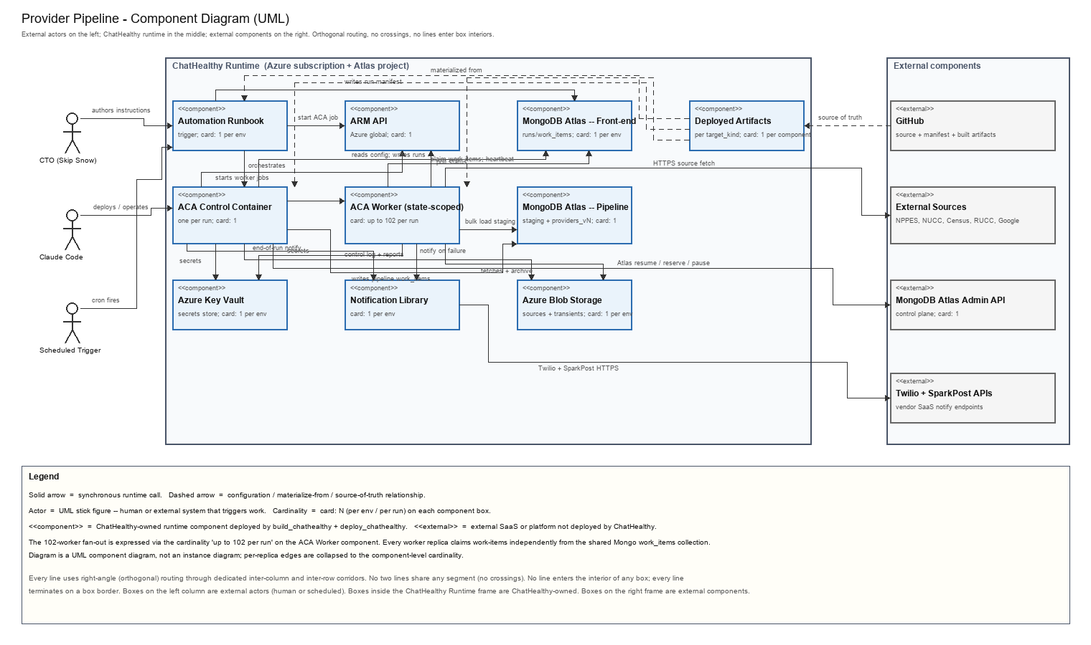
Figure 2.1 - Provider Pipeline ecosystem, UML component diagram. Cardinality decorators mark replica counts on the component itself; the 102-worker fan-out is expressed as cardinality <<N>> on the ACA Worker node.

Automation Runbook
PowerShell runbook hosted in an Azure Automation account. One runbook per pipeline. Fires on a schedule (cron) or an on-demand webhook and starts the ACA Control container via ARM API. Cardinality: 1 per env.

ARM API
Azure Resource Manager REST endpoint. Not a ChatHealthy-owned component in the deploy sense but ChatHealthy code talks to it every run to start and stop ACA jobs. Cardinality: 1 (Azure global).

ACA Control Container
Azure Container Apps job (`provider_pipeline_ctrl`) that owns the run. Reads pipeline config, writes work-items, starts worker replicas, polls for stage completion, and drives quiesce. Cardinality: 1 per run.

ACA Worker (state-scoped)
Azure Container Apps job (`provider_pipeline_wrk`) that does the state-partitioned work. Up to 102 replicas per run (51 states x 2 flow types). Each replica atomically claims work-items from the front-end cluster. Cardinality: <<N>>.

Azure Key Vault
PKI material and pipeline secrets are stored in Key Vault and fetched at container start using the runtime managed identity. Cardinality: 1 per env.

MongoDB Atlas - Front-end cluster (chathealthyfrontend)
Hosts pipeline.runs, pipeline.config, pipeline.work_items, and pipeline.discrepancies. Front-end reads its own consumer collections from a different set of databases in the same cluster. Cardinality: 1 per env.

MongoDB Atlas - Pipeline cluster (chathealthydatapipeline)
Holds staging collections and the versioned providers_v<N> collection. Reservation-gated pause/resume. Cardinality: 1 per env.

Azure Blob Storage
Source archive (immutable copies of every fetched source file, keyed by content hash) and per-run artifacts (discrepancy PDF, run log). Cardinality: 1 storage account per env.

Notification Library
The shared notification library wraps Twilio SMS and SparkPost email. The Control container calls it at end-of-run; workers call it on hard failures. Cardinality: 1 per env.

Deployed Artifacts (per target_kind)
Every runtime component (Runbook, ACA Control image, ACA Worker image) is materialized from a deployed artifact produced by build_chathealthy.py and pushed by deploy_chathealthy.py. Cardinality: one per component per env.

GitHub (external component)
Source of truth for the code, the deployment_architecture.json manifest, and the built artifact packages. GitHub Actions workflows execute Promote (dev -> qa -> prod). Cardinality: 1 org, 1 repo.

External Sources (external component)
NPPES NPI dissemination + practice-locations file, NUCC provider taxonomy, Census county gazetteer, USDA RUCC urban classification, Google geocoding. Rate-limited HTTPS fetches from the Worker tier. Cardinality: many.

MongoDB Atlas Admin API (external component)
Control-plane endpoint used at run start (unpause + reserve + user + role admin) and at run end (release + pause). Cardinality: 1 (Atlas global).

Twilio + SparkPost APIs (external component)
Vendor SaaS endpoints hit by the Notification Library. Cardinality: 2.

External Actor - CTO (Skip Snow)
The human operator. Authors natural-language instructions to Claude Code, echoes APPROVE tokens for Rule-065 commit and Rule-065 deploy gates, and receives the successful-run and abnormal-end notifications.

External Actor - Claude Code
The delegated engineering agent. Executes commit/build/deploy on the operator's authorization but never without it. Rule-006 classifies its shell invocations at PreToolUse to block ad-hoc mutations.

External Actor - Scheduled Trigger (cron)
Azure Automation schedule that fires the runbook on the operator-approved cadence. Distinct from the on-demand webhook path also handled by the runbook.

Prerequisites Not Managed by Our Deployment Architecture
Certain substrates that the Provider Pipeline runs on cannot be provisioned by the deploy_chathealthy.py chain -- either the substrate's own control plane refuses the credential our chain carries, or the substrate is administratively owned by a party outside the ChatHealthy Azure subscription. Every prerequisite below MUST exist and be correctly configured in the target environment before the first pipeline run of that environment; otherwise the deploy will succeed on the ChatHealthy-owned side and the pipeline will fail on its first live invocation.

Atlas Private Endpoint Service (private network peering to Atlas)
The Atlas Private Endpoint Service -- the Atlas-side half of the private-network peering that binds the ChatHealthy VNet snet-aca subnet to the MongoDB Atlas cluster endpoint -- MUST be hand-created via the Atlas UI. Our deploy chain cannot create it: Atlas Admin API rejects the POST with our API-key auth (see BUG-001 for the substrate mismatch and the current manual step). Deploying the Azure side of the private endpoint (the Private Endpoint resource on snet-aca) IS handled by our chain; only the Atlas peer object is out of scope. Without this prerequisite the pipeline containers cannot reach Mongo Atlas on the private path and the run aborts at prov-normalize with a connection failure.

ClaudeCode Azure Entra user identity
Claude Code executes deploy_chathealthy.py under an Azure Entra user identity created out-of-band once per environment. The identity is provisioned by the human operator via the Azure portal and granted the Contributor and User Access Administrator role assignments the deploy chain needs to create resources and assign identities. Our chain does not create the ClaudeCode user itself, because an identity cannot bootstrap its own principal. Without this prerequisite the deploy chain has no principal under which to authenticate and every ARM API call in the chain is rejected 401.

Azure subscription and resource-group root
The Azure subscription hosting the ChatHealthy runtime MUST exist and MUST be assigned to the ChatHealthy tenant with billing configured before any deploy runs. The subscription is a Microsoft-billed substrate; our chain cannot provision it. The chain expects a top-level resource group (per environment) to exist inside the subscription and to be writeable by the ClaudeCode identity; the chain then provisions every child resource (VNet, subnet, ACA environment, Key Vault, storage account, container apps, jobs) inside that resource group.

MongoDB Atlas project and organization
The MongoDB Atlas organization and the Atlas project that will host the front-end cluster (chathealthyfrontend) and the pipeline cluster (chathealthydatapipeline) MUST exist before the first pipeline deploy. The clusters themselves ARE created by our chain via the Atlas Admin API, but the organization and project are the billing and access-control substrates that host the API key our chain uses. Without them the Atlas Admin API rejects our chain's cluster-create call.

DNS zone for the environment host name
The DNS zone that terminates on the environment's public host name ({env}.chathealthy.ai) MUST be provisioned in the platform we use for DNS (Cloudflare) before any deploy that publishes public endpoints. Zone creation requires domain-registrar delegation, which is out of scope for our deploy chain. Individual DNS records (CNAMEs, A records) inside the zone ARE managed by our chain, but the zone itself is prerequisite.

F-003 CA root certificate trust bundle
The F-003 CA root certificate (the root that signs every runtime identity certificate placed at deploy time and every worker-minted certificate) MUST be present in each environment's Key Vault under a well-known secret name before the first deploy. Root generation is a one-time ceremony performed out-of-band per environment; our chain does not generate CA roots because a root cannot be self-signed by an unprivileged automation chain. Subsequent per-identity certificate issuance IS driven by the chain.

1.1 Vision
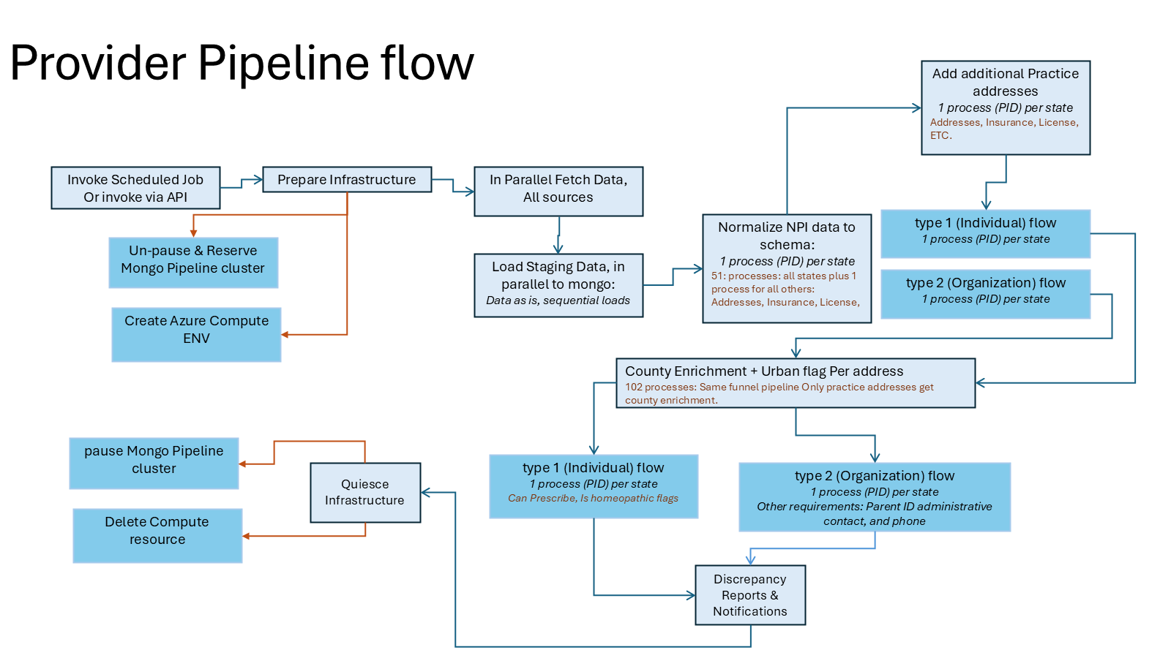
Figure 1.1 - Provider Pipeline flow (author's vision diagram, restored from v22).
ChatHealthy's pipeline vision is a single deterministic conveyor that turns raw public-domain health data - NPPES, NUCC, Census, RUCC, CT.gov and licensed CMS PUFs over time - into the authoritative collections the front-end reads. The conveyor is triggered on a schedule or on demand, provisions its own infrastructure, fetches every source in parallel, normalizes and enriches at state-scoped parallelism, then quiesces itself. Nothing runs between runs and no human sits in the loop of a successful pass.
The diagram above expresses that vision as a single flow of work. The top row (Invoke -> Prepare -> Fetch -> Load -> Normalize) is the read-side journey of every source. The parallel branches (type-1 individual, type-2 organization, address enrichment, county enrichment, urban flag) are the write-side fan-out where the pipeline does its actual value-add before landing records in the front-end cluster. The Quiesce block at the bottom-left is the terminal contract: infrastructure is deleted, cluster is paused, discrepancies are reported.
This vision generalizes. Every future pipeline in the platform (Specialty, Medicare utilization, clinical trials) MUST re-use this same shape - reservation-gated infrastructure, parallel fetch, state-scoped normalize, discrepancy-reported quiesce - and MUST reuse the shared substrate (BasePipelineOrchestrator + ACA Control + ACA Workers + Mongo work-items) that Section 3 defines.

3. Deployment Model (Runbook + ACA + Mongo)
The Provider Pipeline runtime is three tiers coordinated through one shared Mongo substrate. No Durable Functions runtime is used. Each tier is a client of F-003 identity and F-012 deployment.

3.1 Trigger tier — Azure Automation Runbook
One Python-3 runbook lives in the ChatHealthy Automation Account. Two invocation modes: (a) cron schedule (nightly 02:00 UTC), (b) signed HTTPS webhook for on-demand and CI-driven invocations. The runbook is short-lived: it reads the run configuration from Mongo, materializes a new run manifest, and starts the Control container job execution via ARM API.
Identity. The Runbook runs under a long-lived F-003 identity in the pipeline-runbook.* namespace per EPIC-002-F-003-S-006-REQ-B-004. The identity and cert are placed at deploy time per EPIC-002-F-003-S-006-REQ-B-002; the deploying principal loses read access to the placed private key after the write per §9.4 and F-012 secret-propagation rules (EPIC-008-F-012-S-012-REQ-B-005). Runbook authenticates to Mongo via X.509 (EPIC-002-F-003-S-007-REQ-B-001), to Azure ARM via managed identity for bootstrap and cert-authenticated Azure AD post-bootstrap, and to Azure Key Vault via cert-authenticated Azure AD (EPIC-002-F-003-S-008-REQ-B-004).
Network. The Runbook sits inside the declared trigger-tier network boundary per EPIC-008-F-012-S-019-REQ-B-001. Its only permitted egress patterns are the four declared per EPIC-008-F-012-S-019-REQ-B-004: Mongo Atlas (X.509), Azure ARM (HTTPS), Azure Key Vault (HTTPS), and the on-demand webhook ingress.

3.2 Orchestration tier — ACA Control container
One long-lived Azure Container Apps job execution per run, carrying the ProviderPipelineOrchestrator code. Control drives every stage of the pipeline from the run manifest, writes work-items to the shared Mongo substrate, launches per-stage Worker jobs, polls work-item state, updates the run manifest at every step boundary, and quiesces on success or failure.
Identity. Control runs under a long-lived F-003 identity in the pipeline-control.* namespace (EPIC-002-F-003-S-006-REQ-B-004). Deploy-time cert placement; deployer loses read access after write; Mongo X.509 authentication (EPIC-002-F-003-S-007-REQ-B-001, EPIC-002-F-003-S-008-REQ-B-001). Every issued certificate is traceable per EPIC-002-F-003-S-006-REQ-B-002.
Idempotency. Control is idempotent by run_id. Every decision it makes — a stage to launch, a reservation to write, a discrepancy count to publish — is keyed by (run_id, stage). A resumed run reconstructs state from the run manifest and skips completed stages.
Resumability. If the runbook next cron fire discovers a run manifest with status=running and no live Control container (checked by ARM API against the ACA jobs resource), it treats the prior run as dead and starts a new Control container with the same run_id. Control resume-boots from the run manifest.

3.3 Worker tier — ACA stage jobs
Each pipeline stage that fans out into parallel work is registered as its own ACA Job with a distinct container image built from the same repo. When a stage needs N replicas of work, Control writes N work-item documents to Mongo and starts the corresponding ACA Job with parallelism=N. Each replica claims one work-item, executes, records its result, and exits.
Identity. Every Worker replica self-mints a short-lived F-003 identity in the pipeline-worker-* namespace at container start per EPIC-002-F-003-S-006-REQ-B-004 (job-scoped destruction). The identity is bound to the (run_id, stage, replica_index) triple. When the work-item completes and the container exits, the cert and private key die with the container; no separate revocation is required. The cert namespace policy on the F-003 CA refuses any subject not matching pipeline-runbook.*, pipeline-control.*, or pipeline-worker-* per EPIC-002-F-003-S-006-REQ-B-002 and the identity-registry contract in EPIC-002-F-003-S-008-REQ-B-002.
Stage inventory (provider pipeline): prov-fetch-sources, prov-normalize (serial single-PID), prov-normalize-state-fanout, prov-add-secondary-practices, prov-type1-first-branch, prov-type2-first-branch, prov-license-address-repair, prov-county-enrichment, prov-urban-flag, prov-type1-second-branch, prov-type2-second-branch, prov-post-load-reconciliation, prov-discrepancy-and-notifications.

3.4 Coordination substrate — Mongo work-items
The coordination substrate is chathealthyfrontend.pipeline.work_items on the front-end cluster. There is no REST between Control and workers. There are no queues. There is no Event Grid. Every unit of parallel work is a Mongo document; every worker claim is a findOneAndUpdate; every completion is an update on the same document. Mongo is the single source of truth for both the run manifest and every work unit.

2.4.1 Work-item schema
{ _id, run_id, stage, status ∈ {pending, running, done, failed}, payload, claimed_by, claimed_at, heartbeat_at, output, finished_at, created_at }
Claim primitive: findOneAndUpdate on {run_id, stage, status:"pending"} sorted by created_at ASC, update {$set:{status:"running", claimed_by:<worker_id>, claimed_at:now, heartbeat_at:now}}, returnDocument:"after". Atomic; two workers never claim the same row.
Heartbeat and lease reclaim: running workers write heartbeat_at every 30 seconds. Control resets any work-item whose heartbeat_at is older than 90 seconds back to status="pending".
Indexes: compound {run_id, stage, status, created_at} for the claim; compound {run_id, stage, heartbeat_at} for the stale-heartbeat scan; single-field {run_id} for run-level reads.

3.5 Network topology
Realizes EPIC-008-F-012-S-019. Every runtime component sits inside a declared network boundary; every permitted flow is declared; the network layer is independent of the identity layer.
- ACA containers (Control and Workers) run on subnet snet-aca inside the ChatHealthy Azure VNet per EPIC-008-F-012-S-019-REQ-B-001.
- The subnet NSG refuses any traffic not matching a declared allow-list per EPIC-008-F-012-S-019-REQ-B-002 and REQ-B-004. Permitted egress: Mongo Atlas endpoint, Azure Blob endpoint, Azure Key Vault endpoint, Azure ARM endpoint, vendor HTTPS endpoints (npiregistry.cms.hhs.gov, maps.googleapis.com, geocoding.geo.census.gov, and the four source-of-truth publication endpoints).
- Azure Key Vault firewall permits (a) the operator dynamic-IP allowlist for break-glass and (b) the authorized subnet for runtime access. All other source IPs are refused at KV boundary. Realizes EPIC-008-F-012-S-019-REQ-B-002 and REQ-B-004.
- HTTPS-only at every boundary per EPIC-008-F-012-S-019-REQ-B-006. Every vendor call and every Azure resource call uses TLS 1.2+.
- Runtime-created network nodes (per-run ACA Job resources) comply with every REQ in the story per EPIC-008-F-012-S-019-REQ-B-005: they inherit the snet-aca placement, the NSG, and the identity boundary.
- The network layer decision is independent of the identity layer decision per EPIC-008-F-012-S-019-REQ-B-003. A packet must pass both the NSG and the identity gate to be accepted.

3.6 Sequence walkthrough — successful run
1. Cron schedule fires at 02:00 UTC. Automation Runbook dispatched into the Azure Sandbox worker pool.
2. Runbook loads its F-003 cert from Key Vault (cert-authenticated Azure AD); reads chathealthyfrontend.pipeline.config for pipeline_name="provider" via Mongo X.509 auth.
3. Runbook writes a new run manifest to chathealthyfrontend.pipeline.runs with fresh run_id, status="running", started_at=now, invocation_mode="scheduled".
4. Runbook calls ARM API to start the prov-control ACA Job, overriding env vars with {run_id, env, invocation_mode, load_mode}. Runbook exits.
5. Control container starts. Control self-authenticates via its long-lived F-003 identity (cert already placed at deploy time), loads the run manifest, and calls Atlas Admin API to resume-and-scale-up the chathealthydatapipeline cluster from paused/M20 up to the run tier. Polls until cluster_state==IDLE.
6. Control writes prov-fetch-sources work-items (one per source) and starts the prov-fetch-sources ACA Job with parallelism=1 per source. Each Worker self-mints a short-lived F-003 identity, claims its work-item, fetches the source, writes to Azure Blob, records source metadata on the manifest, exits.
7. Control polls; when all fetch work-items report status="done", it records the source_versions block on the run manifest.
8. Control launches prov-normalize (serial, one replica). Worker bulk-loads NPPES from Blob into chathealthydatapipeline.staging.provider_npi_all and exits.
9. Control writes N prov-normalize-state-fanout work-items (N derived from state_scope; up to 51 when state_scope=["ALL"]) and starts the ACA Job with parallelism=N. Workers claim per-partition work, normalize records, write to providers_v<N>.
10. Control polls Mongo every 15 seconds for stage completion; scans for stale heartbeats every 30 seconds.
11. Control launches prov-add-secondary-practices, then prov-type1-first-branch and prov-type2-first-branch in parallel, then prov-license-address-repair.
12. Control launches prov-county-enrichment with N replicas (up to 102 when state_scope=["ALL"]; state partitions × entity types).
13. Control launches prov-urban-flag, prov-type1-second-branch, prov-type2-second-branch, prov-post-load-reconciliation.
14. Control launches prov-discrepancy-and-notifications (1 replica). Worker aggregates discrepancies, builds the PDF report, uploads to Blob.
15. Control sends the four §9 notifications through the shared notification library.
16. Control calls Atlas Admin API to scale chathealthydatapipeline back down to min_cluster_tier and pause when reservations clear.
17. Control writes status="success", finished_at=now to the run manifest and exits 0. ACA Job self-terminates; the per-run ACA Job resources are deleted by the quiesce step. Total run duration for the full national NPPES load: 45–60 minutes wall-clock.

3.7 Failure and restart branch
The Control container dies mid-run. This is the fundamental failure the design absorbs. Two sub-cases:
(a) The Control container process died but its ACA Job execution is still marked running by the ACA control plane. The next cron fire of the Automation Runbook (or an operator on-demand webhook fire) discovers the stale manifest, detects the dead container, launches a new Control container with the same run_id.
(b) The resume Control container starts on the same run_id. It reads the run manifest — every step_transitions entry is a resume boundary. It skips any stage whose work-items are entirely status="done" and re-enters the first stage with any pending or failed work. Any work-item whose heartbeat is stale is reset to status="pending" so a fresh Worker claim can pick it up.
Never-lose-work property: Mongo is the durability boundary. As long as the front-end cluster is up, work_items and the run manifest survive every ACA execution death, and Control resumes deterministically.

3.8 References
- EPIC-002-F-003-S-006-REQ-B-001, REQ-B-002, REQ-B-004 — CA operations, cert traceability, cert lifetime.
- EPIC-002-F-003-S-007-REQ-B-001, REQ-B-002, REQ-B-003 — private-credential custody rules.
- EPIC-002-F-003-S-008-REQ-B-001, REQ-B-002, REQ-B-004 — one canonical identity per component, single authoritative identity registry, entitlement-declaring surfaces.
- EPIC-008-F-012-S-019-REQ-B-001 through REQ-B-006 — zero-trust network topology.
- EPIC-008-F-012-S-012-REQ-B-003 through REQ-B-006 — Key Vault, secret fetching, access audit.
- Microsoft Learn — Jobs in Azure Container Apps.
- Microsoft Learn — Runbook execution in Azure Automation.

4. Runtime Substrate

4.1 BasePipelineOrchestrator
BasePipelineOrchestrator is a Python abstract base class shipped by the EPIC-010-F-102 shared foundation module. It realizes EPIC-010-F-102-S-001-REQ-B-001 (Durable Orchestration Framework and Activity Contract) and the base-worker contract in EPIC-010-F-102-S-002-REQ-B-001. No Durable Functions runtime is used.
Constructor. PIPELINE_NAME (str) and STEPS (list[StepSpec]) declared by the concrete subclass. StepSpec fields: name, prerequisites[], invocation_phase in {"normal", "finally_block"}, timeout_seconds.
Prerequisite gate. Every StepSpec.prerequisites list names prior steps that MUST have status=="success" on the run manifest before the step is entered.
Failure threshold. chathealthyfrontend.pipeline.config.failure_thresholds carries a per-run failure count that trips an abort when exceeded, per EPIC-010-F-102-S-005-REQ-T-002. The threshold is checked at every step exit.
Finally-block guarantees. run() wraps the main step loop in try/finally; every StepSpec whose invocation_phase == "finally_block" runs on both success and failure paths.

4.2 ProviderPipelineOrchestrator
Concrete subclass declaring PIPELINE_NAME="provider" and the STEPS list matching §9 (prepare_infrastructure, source_freshness_gate, fetch_all_sources, source_archival, load_staging_parallel, load_f006_catalog, normalize_npi_serial_bulk_load, normalize_npi_per_state_fanout, add_secondary_practices, type1_first_branch, type2_first_branch, license_address_repair, county_enrichment, urban_flag, type1_second_branch, type2_second_branch, post_load_reconciliation, discrepancy_and_notifications, quiesce_infrastructure).

4.3 Execution — ACA jobs, provisioned per run
Zero idle cost is a design non-negotiable per EPIC-010-F-101-S-001-REQ-B-001 (need-to-use allocation) and EPIC-010-F-101-S-001-REQ-B-004 (reservation-driven cluster usage). The pipeline does NOT use scale-to-zero on always-provisioned resources.
- Docker image build cadence. The pipeline container image is built by architecture/DevOpsBuildDeployAndEnvironmentManagement/build_chathealthy.py on repo push per EPIC-008-F-012-S-001-REQ-T-054 (versioned build packages tracked in git). Pushed to the ChatHealthy Azure Container Registry with tag = git commit SHA per EPIC-008-F-012-S-001-REQ-T-050 (code-branch facts in deployment_architecture.json).
- ACA Job provisioning on invocation. Every invocation begins with an ARM deployment that creates a per-run set of ACA Job resources under a naming pattern derived from run_id.
- Healthcheck gate. Control polls until the ACA Job resource reaches provisioningState=Succeeded and the /health endpoint returns 200.
- Teardown. The quiesce_infrastructure step (§9.19, finally_block) calls the ARM delete API on every ACA Job resource created for the run. No compute resource remains between runs.

4.4 State — Atlas cluster with reservation-driven pause/resume
The pipeline cluster is paused when no live work uses it per EPIC-010-F-101-S-001-REQ-B-004 and EPIC-010-F-101-S-001-REQ-B-001. Cluster usage is reservation-driven: a run registers a reservation in chathealthyfrontend.pipeline.cluster_reservations before consuming cluster resources and deletes the reservation in quiesce.
- Reservation document fields: cluster_name, run_id, requester, expected_duration_minutes, reservation_class ("pipeline" | "operator"), created_at.
- Prepare-infrastructure (§9.2) inserts the reservation, then calls Atlas API to resume the cluster if paused, then polls until cluster_state==IDLE.
- Quiesce (§9.19, finally_block) deletes the reservation keyed on run_id. Idempotent.
- When the deletion leaves zero live reservations AND no operator-class reservation exists, quiesce calls the Atlas pause API.

4.5 Storage — Azure Blob layout
Two containers per environment. Every archived source keeps its version identity per EPIC-010-F-102-S-004-REQ-B-001.
- {env}-pipeline-sources — permanent-until-superseded source archives. Layout: {env}-pipeline-sources/{source_name}/{version}/{filename}.
- {env}-pipeline-transients — per-run scratch. Layout: {env}-pipeline-transients/{run_id}/{step}/{artifact}.

4.6 Run manifest — chathealthyfrontend.pipeline.runs
Durable state-of-record for every pipeline run and the persistent monitoring surface per EPIC-010-F-102-S-001-REQ-T-008. Fields: _id, run_id, pipeline_name, env, invocation_mode, load_mode, state_scope, started_at, finished_at, status, source_versions, step_transitions[], discrepancy_summary, aca_job_resource_ids[], metrics, git_head_sha, operator_email, operator_sms.
Indexes: {run_id} unique; {pipeline_name, started_at:-1} for last-12-runs trend; {status, started_at:-1} for admin dashboard.

4.7 Configuration store — chathealthyfrontend.pipeline.config
One collection holds every tunable knob per EPIC-010-F-101-S-005-REQ-B-003 (hand-maintained under human supervision). Documents by _id: source_freshness, batch_limits, failure_thresholds, cost_bands, dataset_versions, throttle_rates, notification_receivers.

4.8 Security-issues collection — normative schema
chathealthyfrontend.pipeline.security_issues is the durable audit trail for every security event the pipeline surface produces: auth rejections at the runbook entry point, webhook token failures, KV read failures, X.509 handshake failures. Realizes the audit obligation in EPIC-002-F-003-S-007-REQ-B-003 (every secret read is audited).
Fields: _id, event_id, event_type in {auth_rejection, webhook_token_failure, credential_read_denial, x509_handshake_failure, cert_mint_denial}, timestamp, pipeline_name, caller_identity, caller_ip, failure_reason, notes.
Indexes: {event_id} unique; {pipeline_name, timestamp:-1}; {event_type, timestamp:-1}.

5. Provider Pipeline — Step-by-Step
Every step below carries a fixed template: Purpose → Requirement anchors (EPIC-010, plus F-003 or F-012 REQs at consumption points) → Inputs → Outputs → Sub-processes → Failure modes → Idempotency → Mongo/Blob touches → Cost.

5.1 Invoke Scheduled Job or invoke via API
Purpose. Start a run and admit it to the orchestrator.
Requirement anchors:
- EPIC-010-F-102-S-007-REQ-B-001 (single authenticated entrance)
- EPIC-010-F-102-S-007-REQ-B-002 (pipeline named as first argument) — inferred from the pipeline-independence design constraint.
- EPIC-002-F-003-S-006-REQ-B-002 (every issued certificate is traceable to identity, node, server) — the caller cert on the webhook path is validated against the F-003 CA chain.
- EPIC-002-F-003-S-008-REQ-B-001 (one canonical identity per component) — caller_identity is the canonical F-003 identity subject.
Inputs. Invocation payload: {pipeline_name="provider", load_mode="full"|"incremental", state_scope=["CA",...]|["ALL"], resume_from_step=<optional>, caller_identity=<F-003 cert subject or scheduler service principal>}.
Outputs. A new chathealthyfrontend.pipeline.runs document with status="running".
Sub-processes.
- 4.1.1 Validate caller_identity against chathealthyfrontend.pipeline.authorized_callers per EPIC-002-F-003-S-008-REQ-B-002. Reject unknown callers; write chathealthyfrontend.pipeline.security_issues entry per EPIC-002-F-003-S-007-REQ-B-003.
- 4.1.2 Validate pipeline_name matches the container image PIPELINE_NAME.
- 4.1.3 Validate state_scope.
- 4.1.4 Insert chathealthyfrontend.pipeline.runs document.
Mongo touches. Read chathealthyfrontend.pipeline.authorized_callers, chathealthyfrontend.pipeline.config via Mongo X.509 auth per EPIC-002-F-003-S-007-REQ-B-001; write chathealthyfrontend.pipeline.runs.

5.2 Prepare Infrastructure
Purpose. Bring compute and cluster online.
Requirement anchors:
- EPIC-010-F-101-S-001-REQ-B-001 (need-to-use allocation)
- EPIC-010-F-101-S-001-REQ-B-004 (reservation-driven cluster usage)
- EPIC-002-F-003-S-006-REQ-B-004 (long-lived Control cert; deploy-time placement)
- EPIC-002-F-003-S-007-REQ-B-002 (least privilege on secrets) — Control reads only the secrets its identity is entitled to.
- EPIC-008-F-012-S-019-REQ-B-001 (runtime component sits inside declared network boundary) — the per-run ACA Job resource is provisioned on snet-aca.
- EPIC-008-F-012-S-012-REQ-B-005 (managed-identity secret fetch, no plaintext propagation).

4.2.1 Un-pause and reserve Mongo pipeline cluster
- 4.2.1.1 Insert reservation into chathealthyfrontend.pipeline.cluster_reservations.
- 4.2.1.2 If cluster is paused, POST Atlas resume API; poll until IDLE.
- 4.2.1.3 If standing tier is smaller than run needs, request scale-up.

4.2.2 Provision Azure Container Apps job
- 4.2.2.1 ARM-deploy per-run ACA Job resources via az containerapp job create. Image tag = git_head_sha. Job resources land on snet-aca per §3.5 (EPIC-008-F-012-S-019-REQ-B-005).
- 4.2.2.2 Wait for provisioningState=Succeeded and one replica Ready.
- 4.2.2.3 Fire GET /health; require 200 before proceeding.

5.3 Source freshness gate
Purpose. Decide per-source whether the archived copy is current or must be re-fetched.
Requirement anchors: EPIC-010-F-102-S-003-REQ-B-002 (manage data source freshness); EPIC-010-F-102-S-003-REQ-T-004 (AI-agent URL discovery for NPPES and USDA RUCC).
Sub-processes. For each source, probe canonical publication location; compare to archived_version; produce action="reuse" or "fetch".

5.4 In parallel, fetch all sources
Purpose. Bring every source file into local scratch, verified by content hash and staged for durable archive.
Requirement anchors:
- EPIC-010-F-102-S-003-REQ-B-001 (data-source fetching)
- EPIC-010-F-102-S-003-REQ-T-002 (gather activity inventory)
- EPIC-010-F-102-S-003-REQ-T-003 (source-gather concurrency bounded by throttle)
- EPIC-010-F-103-S-002-REQ-B-001 through REQ-B-005 (NPPES sources)
- EPIC-010-F-103-S-003 (multi-address file / pl_pfile)
- EPIC-010-F-103-S-004 (Census ZCTA-to-County)
- EPIC-010-F-103-S-005 (USDA RUCC for urban classification)
- EPIC-002-F-003-S-007-REQ-B-001 — vendor HTTPS calls originate from a Worker that holds only its self-minted F-003 cert; no vendor credentials leave the Worker.

5.5 Source archival
Purpose. Move fetched files from run-scoped transients into version-addressed archive.
Requirement anchors: EPIC-010-F-102-S-004-REQ-B-001 (source file storage management); EPIC-010-F-102-S-004-REQ-T-001 (two-places persistence).

5.6 Load Staging Data (parallel across sources; NPPES NPI load is serial-single-PID)
Purpose. Land the source bytes into Mongo staging collections in as-is shape.
Requirement anchors:
- EPIC-010-F-102-S-004-REQ-T-003 (source CSV is byte-offset indexed before any record processing)
- EPIC-010-F-102-S-004-REQ-T-004 (pre-indexing pairs every secondary-source row with its NPI key)
- EPIC-010-F-103-S-002-REQ-B-001, REQ-B-002 (NPPES base and canonical NPI key)
- EPIC-002-F-003-S-007-REQ-B-001 — Worker authenticates to Mongo via its self-minted X.509 cert.

5.7 Load F-006 classification catalog (parallel with source load)
Purpose. Materialize the business-maintained classification catalog into a per-run read cache.
Requirement anchors: EPIC-010-F-105-S-001-REQ-B-001, REQ-B-002 (single source of truth for classification); EPIC-010-F-105-S-002-REQ-B-001, EPIC-010-F-105-S-003-REQ-B-001 (can_prescribe, is_homeopathic per NUCC code).

5.8 Normalize NPI data to schema
Purpose. Convert raw NPPES staging rows into the normative provider record shape.
Requirement anchors:
- EPIC-010-F-103-S-001-REQ-B-001 through REQ-B-019 (provider pipeline orchestration flow)
- EPIC-010-F-103-S-008 (provider normative schema — see §9.3)
- EPIC-002-F-003-S-007-REQ-B-001 — worker X.509 auth for all Mongo touches in this step.
Fan-out partition key — provider BUSINESS mailing address state code. Not the primary practice state.
Sub-steps: serial bulk-load, then state-scoped fan-out (up to 51 replicas when state_scope=["ALL"]).
Sub-processes (per replica).
- 4.8.1 Determine kind. Entity Type Code "1" → individual; "2" → institutional (EPIC-010-F-103-S-007 flag structure).
- 4.8.2 Identity fields.
- 4.8.3 Primary practice address (address_type="primary_practice", primary=true).
- 4.8.4 Business mailing address (address_type="mailing", primary=false). NOT eligible for county enrichment.
- 4.8.5 Taxonomies (up to 15 slots).
- 4.8.6 Insurance normalization.
- 4.8.7 License normalization.
- 4.8.8 Institutional-only identity + roles.
- 4.8.9 Activity status log.
- 4.8.10 Human-readable code labels — every coded field carries its *_label sibling.
- 4.8.11 Schema conformance check against §9.3.

5.9 Add additional practice addresses from pl_pfile
Purpose. Union pl_pfile onto the base record so every published practice address is on the record.
Requirement anchors: EPIC-010-F-103-S-003 (multi-address file).

5.10 Type-1 (Individual) flow — first branch
Purpose. Complete individual-specific normalization: canonical name, sex, sole-proprietor, license lookups per state.
Requirement anchors: EPIC-010-F-103-S-007-REQ-B-001 through REQ-B-004 (proprietary flag enrichment substrate).

5.11 Type-2 (Organization) flow — first branch
Purpose. Complete institutional-specific normalization: legal name + DBA, authorized official, parent organization when subpart, administrative contact.

5.12 License-based address repair
Purpose. Infer a missing state on an address using the provider’s license, in the case one license unambiguously implies a state.

5.13 County Enrichment (streaming per-record cascade, state-scoped partitions — up to 102)
Purpose. Attach county identity to every practice address at 98% SLA using a cost-ordered cascade.
Requirement anchors: EPIC-010-F-103-S-004-REQ-B-001 through REQ-B-008 (county enrichment).
Cascade order: zip_crosswalk (free) → census_batch (free) → nppes_registry (free, ~5 req/s per IP) → google_maps (paid, throttled).
Vendor calls all leave the Worker over HTTPS; each call carries no ChatHealthy credentials — the Worker uses vendor API keys fetched at container start from KV per §9.4 and EPIC-008-F-012-S-012-REQ-B-005.

5.14 Urban flag per address (paired with 4.13)
Purpose. Stamp urban true/false on every enriched practice address using USDA RUCC.
Requirement anchors: EPIC-010-F-103-S-005-REQ-B-001, REQ-B-002.

5.15 Type-1 (Individual) flow — second branch
Purpose. Stamp the F-105 classification flags on every individual record.
Requirement anchors: EPIC-010-F-103-S-007-REQ-B-001 through REQ-B-004; EPIC-010-F-105-S-001, S-002, S-003.

5.16 Type-2 (Organization) flow — second branch
Purpose. Complete the institutional record with the human-readable facility-type description and materialize the institutional_identity object.

5.17 Post-load reconciliation
Purpose. Diff destination against source; produce a formal reconciliation report.
Requirement anchors: EPIC-010-F-102-S-005-REQ-B-001 (source↔DB reconciliation); EPIC-010-F-102-S-005-REQ-T-001 (discrepancy reporter persists per-record failures).

5.18 Discrepancy Reports and Notifications (finally_block)
Purpose. Produce the operator-consumable discrepancy PDF; send four notifications per §9.
Requirement anchors: EPIC-010-F-102-S-005-REQ-T-001, REQ-T-002 (discrepancy reporter, threshold-driven abort); EPIC-002-F-003-S-007-REQ-B-003 (audit trail); EPIC-002-F-003-S-008-REQ-B-004 (notification channel entitlement declared).

5.19 Quiesce Infrastructure (finally_block)
Purpose. Release every resource reserved for the run.
Requirement anchors:
- EPIC-010-F-101-S-001-REQ-B-001 (deallocate when done)
- EPIC-010-F-101-S-001-REQ-B-004 (reservation released on both paths)
- EPIC-002-F-003-S-006-REQ-B-004 (Worker short-lived certs die with the container; no external revocation)
- EPIC-008-F-012-S-012-REQ-B-001 (zero-footprint deployment capability) — ACA Job ARM resources are deleted.
Sub-processes.
- 4.19.1 Delete chathealthyfrontend.pipeline.cluster_reservations for this run_id.
- 4.19.2 If no other live reservations and no operator-class reservation, request Atlas pause.
- 4.19.3 If cluster tier was scaled up in 4.2.1.3, scale it back.
- 4.19.4 ARM delete all per-run ACA Job resources. No compute cost accrues between runs.
- 4.19.5 Transient blob cleanup on success runs; retain on failure for triage.
- 4.19.6 Finalize run manifest: status, finished_at, metrics.

6. Cross-cutting concerns

6.1 Discrepancy schema
Every per-record failure across every step lands in chathealthyfrontend.pipeline.discrepancies with a uniform schema. Controlled reasons vocabulary: parse_error, schema_violation, identity_incomplete, sex_absent, org_name_absent, authorized_official_incomplete, parent_organization_incomplete, state_missing_no_license, state_missing_ambiguous_license, zip_state_mismatch, zip_state_mismatch_no_license, zip_state_mismatch_multiple_licenses, county_unresolvable, rucc_lookup_miss, taxonomy_code_unclassified, nucc_lookup_miss_institutional, reconciliation_diff, external_api_error, pl_pfile_parse_error, deactivated, foreign_provider, no_address.

6.2 Run manifest
§9.6 gives the full schema. The last-12-runs trend read is served by the compound index {pipeline_name, started_at:-1} with $limit 12.

6.3 Configuration surface
Every tunable knob lives on chathealthyfrontend.pipeline.config per EPIC-010-F-101-S-005-REQ-B-003. On startup the orchestrator reads config once into an in-process PipelineConfig; mid-run config changes take effect on next run.

6.4 Certificate lifecycle — deploy-time placement, runtime self-mint, no plaintext propagation
Realizes the pipeline’s consumption of EPIC-002-F-003-S-006 and S-007. Two identity classes:
- Long-lived identities (Runbook, Control). Cert placed at deploy time per EPIC-002-F-003-S-006-REQ-B-004. Cert namespace pipeline-runbook.* and pipeline-control.* enforced by the F-003 CA subject policy per EPIC-002-F-003-S-006-REQ-B-002. Deployer loses read access on the placed private key immediately after write per EPIC-008-F-012-S-012-REQ-B-005 (managed-identity secret fetch — no plaintext propagation). Runtime access to the private key is by the identity itself via KV RBAC.
- Short-lived identities (Workers). Cert self-minted at container start against the F-003 cert-issuance API per EPIC-002-F-003-S-006-REQ-B-004; namespace pipeline-worker-* enforced by the CA. Lifetime bounded to the container lifetime. Cert dies with the container; no explicit revocation.
Cert rotation cadence. Long-lived cert rotation is operator-driven today: the operator re-runs the deploy-time provisioning flow. Automated rotation on the S-006-REQ-B-004 upper bound is deferred; the pipeline consumer contract does not change when it lands.
Cert revocation policy. Deferred at F-003 substrate. Consumed here without restatement; when the F-003 CRL surface lands, Control and Runbook consume it read-only. Worker revocation is a no-op because short-lived cert death is the revocation.

6.5 Audit logging
Every secret read (KV, Mongo cert password if any) is audited per EPIC-002-F-003-S-007-REQ-B-003 through chathealthyfrontend.pipeline.security_issues plus the KV audit stream (EPIC-008-F-012-S-012-REQ-B-006). Every auth rejection at the webhook entry point writes a security_issues row.

6.6 Idempotency and resumability
Every step declares idempotency and resumability inline. Orchestrator-level rules:
- Every step boundary is a manifest checkpoint. Sub-step state is NOT checkpointed; the step is the resumability granularity.
- resume(run_id, from_step) reconstructs StepContext from the manifest, marks steps before from_step as inherited, and calls the step function.
- Stalled runs. A run whose last step_transition heartbeat is older than stall_threshold_seconds is flagged "stalled"; the operator invokes resume().
- Incremental loads use per-record field-by-field comparison; identical records are skipped; differing records are merged fact-by-fact.

6.7 Cost tracking
Per-step wall-clock and peak memory are captured by the base class and appended to step_transitions. Per-run totals computed at quiesce_infrastructure and stored on metrics. Realized against EPIC-010-F-101-S-004-REQ-T-003 (dry-run records minute-billed compute cost).

6.8 Dataset version management
Per EPIC-010-F-101-S-005-REQ-B-001, the provider dataset supports multiple versions coexisting under distinct collection names. The active version pointer lives on chathealthyfrontend.pipeline.config.dataset_versions per EPIC-010-F-101-S-005-REQ-B-003. A full load writes into a NEW target version; promotion to active is a separate operator action.

7. Data Contracts

Runtime sequence - successful run
The diagram below is the runtime interaction between the trigger tier (Automation Runbook), the orchestration tier (ACA Control container), the worker tier (ACA Workers), the Front-end and Pipeline Mongo clusters, external data sources, and the notification library. It is restored from v22 unchanged because the interaction contract has not changed since v22. The diagram is wide; the doc is best viewed in landscape orientation for this figure, or zoomed to 150%%.
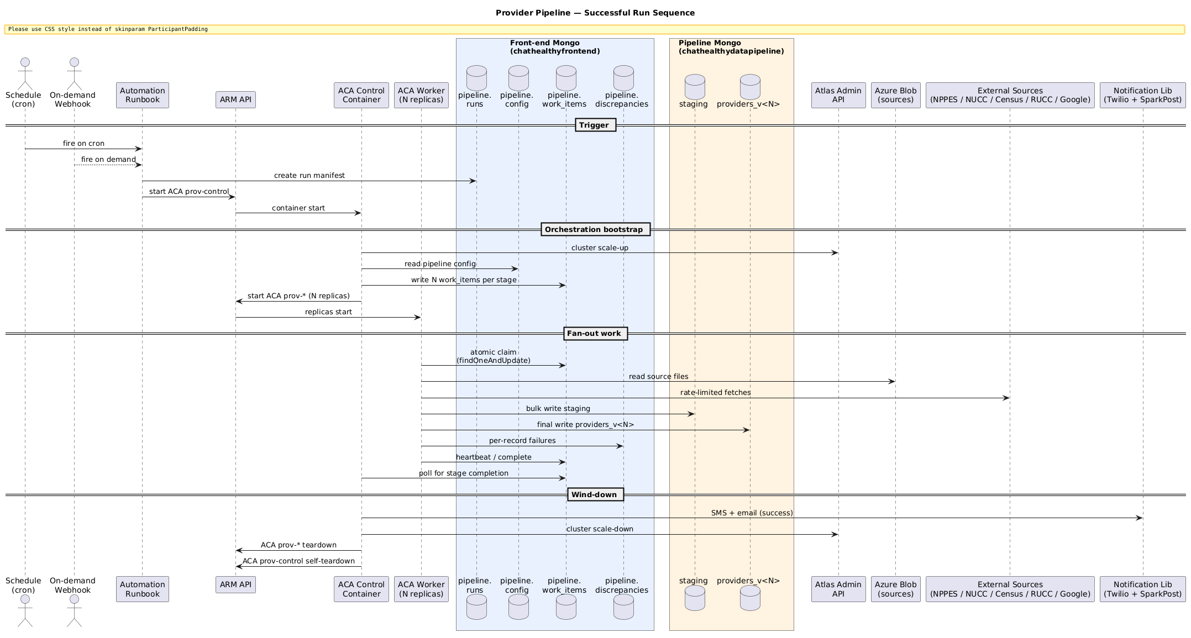
Figure - Provider Pipeline runtime sequence, successful run (restored from v22). Widest lifelines are the Front-end and Pipeline Mongo clusters; the fan-out is expressed by the ACA Worker (N replicas) lifeline.

7.1 Provider record — schema fields and where each is set
The runtime provider record per EPIC-010-F-103-S-008 is the published contract. §9.3 is the normative JSON Schema (Draft 2020-12). Field-to-step map lives on the schema property descriptions.

7.2 F-105 Classification Catalog schema
The F-105 classification catalog is the business-maintained lookup keyed on NUCC taxonomy code. Every record in the catalog carries: code, is_licensed_clinical_role, can_prescribe, is_homeopathic, is_disqualified. Collection: ProprietaryData.SpecialtyAndProviderFlags on the pipeline cluster per EPIC-010-F-105-S-001-REQ-B-001. Loaded per-run into pipeline_sources_specialty_catalog on the front-end cluster per §9.7.
Indexes: {code} unique; {is_licensed_clinical_role} for the allow-list check.

7.3 Normative JSON Schema (Draft 2020-12)
Every field, every type, every required/optional status is defined by the schema published at https://dev.chathealthy.ai/schemas/ProviderRecordSchema.json. All coded fields carry their *_label sibling. This schema is the object of the consumer contract per EPIC-010-F-103-S-008.

7.4 Staging schemas per source
- pipeline_sources_nppes_npi. One document per NPPES row; NPPES column names preserved verbatim.
- pipeline_sources_pl_pfile. One document per practice-location row.
- pipeline_sources_nucc_taxonomy. Columns: Code, Grouping, Classification, Specialization, Definition, Display Name.
- pipeline_sources_zip_county_crosswalk. Columns: ZCTA5, GEOID (county FIPS), state, name.
- pipeline_sources_rucc. Columns: FIPS, State, County Name, RUCC 2023.
- pipeline_sources_specialty_catalog. Per-run copy of ProprietaryData.SpecialtyAndProviderFlags.

8. Pipeline Notifications
Four notifications per run per EPIC-010-F-102-S-005-REQ-T-001. Notifications flow through the shared library at EPIC-003-F-006 (Manage Requests) / EPIC-003 notifications shared surface; underlying channel is Twilio SMS and Twilio SendGrid (or equivalent). Every notification carries the F-003 signature of the sending identity — the pipeline signs outbound notifications with its long-lived F-003 identity per EPIC-002-F-003-S-003-REQ-B-002 (origin field identifies the response sender).
Per-notification template contract: template_name, destination_type ("email"|"sms"), receiver_list, title, notification_classification, notification_severity, formatted_content, attachments, sample.

8.1 Text notification — abnormal end
template_name: "provider_pipeline_abnormal_end_sms". Severity: critical. Sample:
ChatHealthy Provider Pipeline prod — ABNORMAL END
run_id: prov-2026-07-14T02:00:11Z-abc123
status: aborted
abort_reason: failure_threshold_exceeded (bad_data_count=5124 > threshold=5000)
step: normalize_npi_per_state_fanout

8.2 Text notification — successful end
template_name: "provider_pipeline_successful_end_sms". Severity: info. Sample:
ChatHealthy Provider Pipeline prod — SUCCESS
run_id: prov-2026-07-14T02:00:11Z-abc123
records_processed: 7482913
county_enrichment_rate: 98.7%
wallclock: 47 min
cost: $84.22

8.3 Email notification — abnormal end (error report)
template_name: "provider_pipeline_error_report_email". Severity: critical. Body: full step_transitions, discrepancy aggregates, tail of Control container logs, links to Blob artifacts.

8.4 Email notification — discrepancy report (PDF attachment, every run)
template_name: "provider_pipeline_discrepancy_report_email". Severity: info or warning depending on cost-band exceedance. Attachment: discrepancy_report.pdf aggregated by state then by entity type per EPIC-010-F-102-S-005-REQ-T-001.

9. Requirement coverage table
One row per EPIC-010 requirement realized in this LLD, plus F-003 and F-012 requirements the pipeline consumes at the section that realizes each.
REQ ID | Realizing section | Note
EPIC-010-F-101-S-001-REQ-B-001 | §3.4, §4.2, §4.19 | Reservation-owned uptime; deallocate when done.
EPIC-010-F-101-S-001-REQ-B-004 | §3.4, §4.2.1, §4.19.1 | Reservation-driven cluster usage.
EPIC-010-F-101-S-005-REQ-B-001 | §5.8 | Provider collection versioning.
EPIC-010-F-101-S-005-REQ-B-003 | §3.7, §5.3 | Config collection hand-maintained.
EPIC-010-F-102-S-001-REQ-B-001 | §3.1, §3.2 | Orchestration framework + activity contract.
EPIC-010-F-102-S-001-REQ-T-008 | §3.6 | Metrics on persistent monitoring surface.
EPIC-010-F-102-S-002-REQ-B-001 | §3.1 | Base worker classes.
EPIC-010-F-102-S-003-REQ-B-001 | §4.4 | Data-source fetching.
EPIC-010-F-102-S-003-REQ-B-002 | §4.3 | Source freshness management.
EPIC-010-F-102-S-003-REQ-T-004 | §4.3 | AI-agent URL discovery for moving sources.
EPIC-010-F-102-S-004-REQ-B-001 | §3.5, §4.5 | Source file storage management.
EPIC-010-F-102-S-004-REQ-T-003 | §4.6 | Byte-offset indexing.
EPIC-010-F-102-S-005-REQ-B-001 | §4.17 | Source↔DB reconciliation.
EPIC-010-F-102-S-005-REQ-T-001 | §4.18, §5.1 | Discrepancy persistence + notifications.
EPIC-010-F-102-S-005-REQ-T-002 | §3.1, §4.18 | Failure threshold aborts.
EPIC-010-F-102-S-007-REQ-B-001 | §4.1 | Single authenticated entrance.
EPIC-010-F-103-S-001-REQ-B-001 | §4 orchestration | End-to-end provider orchestration.
EPIC-010-F-103-S-002 | §4.4, §4.6 | NPPES base + canonical NPI key.
EPIC-010-F-103-S-003 | §4.9 | Multi-address file (pl_pfile).
EPIC-010-F-103-S-004 | §4.13 | County enrichment.
EPIC-010-F-103-S-005 | §4.14 | Urban classification.
EPIC-010-F-103-S-007 | §4.15, §4.16 | Proprietary flag enrichment.
EPIC-010-F-103-S-008 | §6.1, §6.3 | Normative provider schema.
EPIC-010-F-105-S-001-REQ-B-001 | §4.7, §6.2 | F-105 single source of truth.
EPIC-010-F-105-S-002 | §4.15 | can_prescribe.
EPIC-010-F-105-S-003 | §4.15 | is_homeopathic.
EPIC-002-F-003-S-006-REQ-B-001 | §2.1–§2.3, §5.4 | ChatHealthy operates its own CA; pipeline nodes consume it.
EPIC-002-F-003-S-006-REQ-B-002 | §2.3, §4.1, §5.4 | Every issued cert traceable to identity, node, server; CA subject policy refuses any non-pipeline-* namespace.
EPIC-002-F-003-S-006-REQ-B-004 | §2.1–§2.3, §5.4 | Long-lived (Runbook/Control) vs job-scoped (Worker) cert lifetime.
EPIC-002-F-003-S-007-REQ-B-001 | §2.1–§2.3, §4.1–§4.19 | Private credentials held only by their issued identity; Mongo X.509 auth throughout.
EPIC-002-F-003-S-007-REQ-B-002 | §4.2, §5.4 | Least privilege on secrets.
EPIC-002-F-003-S-007-REQ-B-003 | §3.8, §4.1, §4.18, §5.5 | Every secret read audited via security_issues + KV audit.
EPIC-002-F-003-S-008-REQ-B-001 | §2.2, §2.3, §4.1 | One canonical identity per component (Runbook, Control, Worker).
EPIC-002-F-003-S-008-REQ-B-002 | §2.3, §4.1 | Single authoritative identity registry consumed at admission time.
EPIC-002-F-003-S-008-REQ-B-004 | §4.2, §4.18 | Registry entry names every authenticating surface.
EPIC-008-F-012-S-001-REQ-B-006 | §10 | Human authorization gate on deploy.
EPIC-008-F-012-S-001-REQ-B-007 | §10 | No commit or deploy without explicit human authorization (Rule-065).
EPIC-008-F-012-S-001-REQ-B-010 | §10 | Manifest is exact-truth for files shipped to each target.
EPIC-008-F-012-S-001-REQ-T-050 | §3.3, §10 | Code-branch facts in deployment_architecture.json.
EPIC-008-F-012-S-001-REQ-T-054 | §3.3, §10 | Versioned build packages tracked in git.
EPIC-008-F-012-S-003-REQ-B-001 | §10 | Single parameterized deploy script for env targets.
EPIC-008-F-012-S-003-REQ-B-003 | §10 | Promote chain pairs are invariant.
EPIC-008-F-012-S-012-REQ-B-003 | §4.2, §5.4 | Secrets in Key Vault.
EPIC-008-F-012-S-012-REQ-B-005 | §2.1, §2.2, §5.4 | Managed-identity secret fetch — no plaintext propagation.
EPIC-008-F-012-S-012-REQ-B-006 | §5.5 | Key Vault access audit.
EPIC-008-F-012-S-012-REQ-B-011 | §2, §5.4 | Comply with F-003 mTLS as producer and client.
EPIC-008-F-012-S-019-REQ-B-001 | §2.5 | Every runtime component sits inside a network boundary.
EPIC-008-F-012-S-019-REQ-B-002 | §2.5 | Undeclared traffic is refused.
EPIC-008-F-012-S-019-REQ-B-003 | §2.5 | Network layer independent of identity layer.
EPIC-008-F-012-S-019-REQ-B-004 | §2.5 | Authorized traffic patterns are declared.
EPIC-008-F-012-S-019-REQ-B-005 | §2.5, §4.2 | Runtime-created network nodes comply.
EPIC-008-F-012-S-019-REQ-B-006 | §2.5 | HTTPS-only at the network boundary.

10. Regression Test Strategy
This chapter describes how the pipeline is regression-tested end-to-end so that a fresh promote from local to dev provably meets every requirement in EPIC-010 realized in this LLD.

10.1 Layered strategy
- Unit — pure-function tests fixing inputs to a single per-stage transformer and asserting exact outputs. No I/O. Fast. Run on every commit.
- Integration — end-to-end slices of the pipeline against frozen source snapshots. Uses real Mongo (test databases) and real Azure Blob.
- Collection regression — after every full integration run, a walker walks the finished collection and asserts every document against the §9.3 schema plus the per-REQ assertion table.

10.2 Unit tests
Per pipeline stage (§9.3 through §9.19), a pytest module in pipeline/EPIC-010/EPIC-010-F-103/tests/ names the pure functions to test and the fixture inputs.

10.3 Integration tests
Integration runs are end-to-end pipeline executions against frozen source snapshots. Snapshots live in Azure Blob under pipeline-sources-test/{snapshot_id}/, one per source. Every integration run is invoked under the deploy-time-placed Control cert against the test Mongo cluster.

10.4 Collection regression — per-REQ assertion table
After each successful integration run, tests/regression/assert_business_rules.py walks the finished collection and executes an assertion for each REQ in §9. Assertion table format: REQ id — assertion — code path — expected outcome. Every row in §9 has a corresponding assertion function.

10.5 CI/CD gate
The regression run is a required gate on the promote from local to dev, per §11 step 6, and the required gate on the promote from dev to qa and qa to prod per EPIC-008-F-012-S-003-REQ-B-003. Failure blocks promotion.

11. Develop → Commit → Build → Deploy → Runtime
The chain from operator-writes-code to pipeline-run-completes. Every step is mechanical. The only judgment calls are the explicit authorization gates at commit and deploy (Rule-065; realized by EPIC-008-F-012-S-001-REQ-B-006 and REQ-B-007).

Deployment sequence (UML)
The sequence below covers the four phases of a Provider Pipeline deployment: author + commit (Rule-065 gated), build (local, per target_kind), deploy (local -> live substrates), and promote (dev -> qa -> prod via GitHub Actions). It complements the runtime sequence diagram above; runtime is what happens AFTER deployment materializes the components.
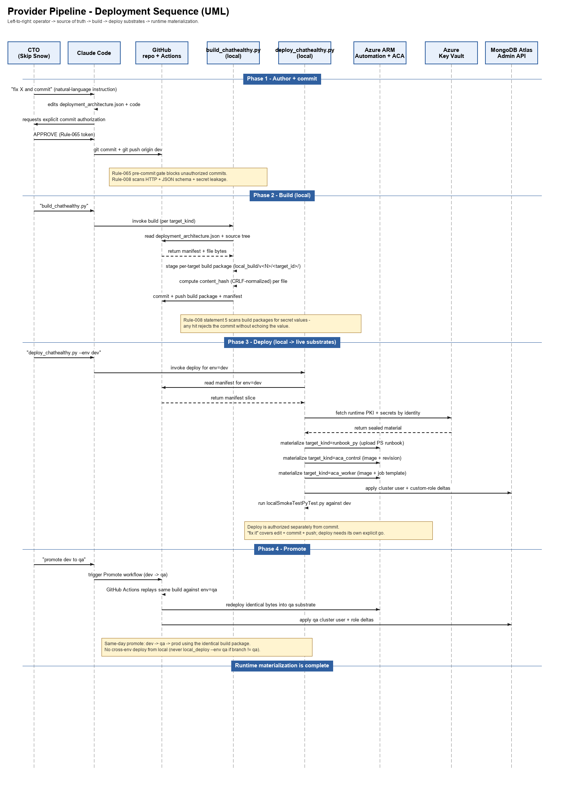
Figure - Provider Pipeline deployment sequence. Yellow notes call out the gating REQs (Rule-065 for commit and deploy authorization; Rule-008 statement 5 for secret-in-build-package rejection).
Step | Actor | Input | Output | Authorization gate / governing REQ
1. Develop | Operator (via Claude Code) | Feature or bug in agile_backlog.json; pipeline source under pipeline/ and architecture/DevOpsBuildDeployAndEnvironmentManagement/. | Working-tree edits: pipeline code, deployment_architecture.json file entries, unit tests. | None. Governed by EPIC-008-F-012-S-009 (file system mirrors backlog).
2. Local pre-commit scan | Git pre-commit hook (chathealthy_enforcement_manager) | git staged files. | PASS or REJECT verdict. Rejects: manifest drift, secret paste, HTTP URL, JSON schema failure, deliberate-raise class, direct MongoClient, etc. | None; rejection blocks commit. Governed by Rule-003, Rule-004, Rule-005, Rule-008, Rule-066.
3. Commit authorization | Operator (echoed APPROVE token) | Diff to be committed. | Authorization record written; git commit proceeds. | EPIC-008-F-012-S-001-REQ-B-007 (Rule-065). No commit without explicit human authorization.
4. Push to dev | Git | Commit SHA. | Ref updated on origin/dev. | None separately; push is implicit in commit authorization per Rule-065.
5. Build | build_chathealthy.py (local workstation or named CI runner) | HEAD of dev branch; deployment_architecture.json target list. | Per-target build package under architecture/DevOpsBuildDeployAndEnvironmentManagement/localBuild/<target_id>/ or remoteBuild/<target_id>/. Container images pushed to ACR with tag = git commit SHA. admin.Versions builds[<env>].build entry. | EPIC-008-F-012-S-001-REQ-T-054 (versioned build packages tracked in git). EPIC-008-F-012-S-001-REQ-T-055 (builds run on local workstation or named CI runner; never elsewhere).
6. Regression gate | Regression runner (§9) | Fresh integration snapshot; built container image. | PASS or REJECT verdict on the per-REQ assertion table (§9.4). | EPIC-008-F-012-S-003-REQ-B-003 (promote chain pairs). Failure blocks the promote to dev.
7. Deploy authorization | Operator (echoed APPROVE token) | Named target(s); env; build id. | Authorization record written; deploy_chathealthy.py proceeds. | EPIC-008-F-012-S-001-REQ-B-006 (human authorization gate). Rule-065.
8. Deploy | deploy_chathealthy.py | Build packages; deployment_architecture.json; secrets from local .env (dev bootstrap) or KV (higher envs). | Runbook uploaded to Automation Account; ACA Job image references updated to new tag; long-lived certs (Runbook, Control) placed via KV per §5.4; deployer principal loses read on placed private keys; deployment_architecture.json byte-equals on-disk artifacts (crosswalk PASS per EPIC-008-F-012-S-001-REQ-T-031). | EPIC-008-F-012-S-001-REQ-B-001 (atomic deploy); EPIC-008-F-012-S-001-REQ-B-006 (authorization gate); EPIC-008-F-012-S-012-REQ-B-005 (managed-identity secret fetch); EPIC-008-F-012-S-019-REQ-B-001 (network boundary placement).
9. Runtime — Runbook fires | Azure Automation cron / operator webhook | None (cron) or signed webhook payload. | Run manifest created; Control ACA Job started. | EPIC-010-F-102-S-007-REQ-B-001 (single authenticated entrance); EPIC-002-F-003-S-006-REQ-B-002 (webhook caller cert traceable).
10. Runtime provision | Control container | Run manifest; deployment_architecture.json (via image); F-003 CA endpoint; Atlas Admin API. | Per-run ACA Job resources provisioned on snet-aca; cluster resumed; reservation written. | EPIC-010-F-101-S-001-REQ-B-001; EPIC-010-F-101-S-001-REQ-B-004; EPIC-008-F-012-S-019-REQ-B-005.
11. Runtime execute | Control + Workers | Mongo work-items; source files from Blob; F-105 catalog. | Populated providers_v<N>; discrepancies; PDF report; notifications. | EPIC-010-F-103-S-001 (orchestration flow). Per-step REQ anchors in §4.
12. Runtime deprovision | Control container (quiesce_infrastructure, finally_block) | Run state at completion or failure. | ACA Job resources deleted; cluster reservation released; cluster paused if no other consumers; run manifest finalized; Worker certs already died with their containers. | EPIC-010-F-101-S-001-REQ-B-001 (deallocate when done); EPIC-002-F-003-S-006-REQ-B-004 (short-lived cert destruction); EPIC-008-F-012-S-012-REQ-B-001 (zero-footprint deployment capability).
13. Runtime report | Discrepancy-and-notifications step (§4.18) | discrepancies collection for run_id; run manifest. | PDF report to Blob; four notifications sent per §7; operator receives SMS and email. | EPIC-010-F-102-S-005-REQ-T-001; EPIC-002-F-003-S-003-REQ-B-002 (origin field on outbound notification).

12. References
- EPIC-002-F-003 Design v1: architecture/IdentityCertificatesAndAuthentications/ArchitectureDesignAndAuditDocs/EPIC-002-F-003-Design-v1.docx
- EPIC-008-F-012 Deployment Architecture Design and Migration Plan: architecture/DevOpsBuildDeployAndEnvironmentManagement/ArchitectureDesignAndAuditDocs/DeploymentArchitectureDesignAndMigrationPlanPhase_v7.docx.
- Engineering rules: brain/machine_artifacts/content/engineering_rules.json (Rule-003, Rule-004, Rule-005, Rule-008, Rule-065, Rule-066).
- Deployment manifest: brain/machine_artifacts/content/deployment_architecture.json (exact-truth source of every artifact shipped to every target).
- Agile backlog: brain/machine_artifacts/content/agile_backlog.json (EPIC-010 story and requirement tree).
- Microsoft Learn — Jobs in Azure Container Apps.
- Microsoft Learn — Runbook execution in Azure Automation.
- MongoDB Manual — db.collection.findOneAndUpdate.
- CMS — NPPES Data Dissemination file spec.

