ChatHealthy Engineering Rules Enforcement
EPIC-008-F-002 - Engineering Rules Enforcement
Design - V31 (dev) | 2026-08-21
Backlog: EPIC-008-F-002
Author:Claude Code,
supervised by Skip Snow
Version 31Version 31
Accepted for UAT implementation

Contents
1. Problem, Approach, and Background 4
1.1 Locked decisions 4
2. Requirements 5
2.1 Business requirements 5
2.2 Technical requirements 6
4. Design 10
4.0 Implementation discipline 10
4.1 Framework overview 10
4.2 Hook dispatch 10
4.3 Operational Concerns: Concurrency and Runaway-Process Control 11
4.3.1 Concurrency model 12
4.3.2 Runaway-process control 13
4.4 Framework classes 14
4.4.1 ChatHealthyEnforcementManager 15
4.4.2 EnforcementWorker (abstract base) 15
4.4.3 Runtime environment 16
4.4.4 Why the enforcements did not catch this 17
4.5 Scope-list mechanism: how rules in scope are decided 18
4.6 Enforcement schema additions 21
4.7 Hook taxonomy 23
4.8 Worker taxonomy 23
4.8.1 Worker accountability 24
4.9 Worked Example: ScanFilesEnforcementWorker on pre-commit 25
4.9.1 ScanFilesEnforcementWorker class 25
4.9.2 Categorized scope-list inventory (worked example) 26
4.9.3 JSON validation behavior 26
4.10 Filesystem layout — mirrors the operating model 31
4.11 Manager-worker contract 32
4.12 Known gaps 33
4.12a Reporting a refusal 33
4.13 Enforcement surfaces 35
4.14 Promote authorization 37
4.15 Proof of human presence 41
5. Deploying the rule enforcements 43
5.1 What the requirements already fix 43
5.2 Verified state, 2026-08-08 43
5.3 How resolution works 43
5.4 The deploy path, and the one code change it requires 44
5.5 What deployment consists of 45
5.6 The target 45
5.7 Versioning and rollback 46
5.8 Risks 46
5.9 Out of scope 46
5.10 Deploying the GitHub Action 47
6. Open Issues 47
7. Enforced rules index 49
Rule-001: Persist Claude conversation events to the local spool 49
Rule-002: Boot execution on SessionStart and PostCompact 50
Rule-003: Deliberate raises must use ChatHealthyException 50
Rule-004: Direct MongoClient instantiation forbidden outside the canonical utility 50
Rule-005: Uniform logging discipline 51
Rule-006: Constrain Claude Code's tool use via the PreToolUse hook 51
Rule-007: Identity/RBAC manifest git-delta requires operator APPROVE echo 51
Rule-008: All files added must be scanned for architectural compliance 52
Rule-009: Separation of concerns between React display, plumbing JS/HTML, and Python tools 52
Rule-065: No commit without explicit human authorization 53
Rule-066: Build/deploy/promote entry-point uniqueness 53
Appendix A - Remediation work 53

1. Problem, Approach, and Background
Claude Code is incapable of following directions sufficiently to build systems at scale. It is a consummate hacker and left to its own devices it will architect torturously fragile systems. In addition, because Large Language Models are built to flatter, and Claude Code is designed to minimize its use of an LLM to do research and maximize traditional software techniques such as grep to explore the code base, it often misrepresents facts in ways that are dangerous to system integrity. LLM form factors such as code bots and web interfaces use loosely structured files that write ‘Markdown’ files to keep track of state and user profiles. These files are a jumble of confusion and do not allow the human user of a code bot to govern through them.
The outcome is that while Claude Code and other coding agents are superb at doing small-radius tasks, it is absolutely impossible to build a system at scale without ‘harnessing’ these code bots and creating a ‘control plane’ to reduce the ‘blast areas’ of harm that Claude Code and other code bots do when unleashed, as they must be to efficiently build distributed and complex systems.
The Brain governs requirements, bugs, deployment facts and the rest of the SDLC record. engineering_rules.json is the part of it that governs engineering practice, and this document specifies how those rules are executed.
engineering_rules.json holds four rules and thirteen enforcement entries across eleven distinct workers. Rule-006 is the one rule carrying no enforcement; BUG-002 holds its disposition. A rule with an empty enforcements list is documentation and does not govern, which is why the count matters.
This document specifies that execution: a manager, an EnforcementWorker base class, the enforcement schema, the hook taxonomy, the manager-owned mutex coordination, the worker contracts, and how the enforcements are deployed.

1.1 Locked decisions
Decision | Resolution
Naming | PEP-8. ChatHealthyEnforcementManager, EnforcementWorker (base), ScanFilesEnforcementWorker (first concrete subclass). UPPER_SNAKE constants. Files: chathealthy_enforcement_manager.py, enforcement_worker.py, scan_files_enforcement_worker.py.
Manager shape | One file, one main(), one class. Invoked by every hook with hook_name as the only positional arg.
Manager I/O on rules | Read-only. Filters enforcements by hook. Never edits.
Worker invocation | Manager spawns each worker as a subprocess via subprocess.run([sys.executable, executable_path, enforcement_id], timeout=...). The manager reads executable_path from the enforcement entry. The worker no longer discovers its own location.
Concurrency in manager | Manager dispatches workers as subprocesses, collects returncodes, aggregates by exit-code precedence, exits with the worst code.
Mutex coordination | Manager-owned. Each enforcement entry declares a requires_lock boolean. When requires_lock = True, the manager acquires a process-safe lock keyed on enforcement_id before invoking subprocess.run, and releases it after. Default mechanism: advisory file lock. Workers do not declare a concurrency primitive. In-process locks are forbidden — invisible across PIDs. Workers MAY still use non-mutex coordination internally (e.g. spool write, Mongo atomic ops) for their own data-access patterns; those are not declared on the entry.
Worker base class | EnforcementWorker. Owns scope evaluation (rows on the enforcement entry's scopes field), violation record shape, exit-code semantics, telemetry envelope, and structured error handling. Subclasses implement run() to orchestrate their domain checks.
Worker constructor | __init__(self, enforcement_id: str). One arg. Worker reads engineering_rules.json itself, finds its own entry by id.
Filesystem layout | Filesystem mirrors the operating model. All code for this feature lives under projectRoot/architecture/EngineeringRuleEnforcement/. crossEpicConcerns/ holds shared business artifacts only — no code there.
Worked example | ScanFilesEnforcementWorker on pre-commit. Its run() calls _scan_http(file) and _validate_json(file) synchronously inside the same subprocess. Multi-threading inside run() is a future enhancement, not V1.

2. Requirements

2.1 Business requirements
The business requirements for this feature are held in the backlog, at brain/machine_artifacts/content/agile_backlog.json under feature EPIC-008-F-002, Engineering Rule Enforcement, and its stories. The backlog is the single statement of them; they are not restated here, because two statements of one requirement drift apart and neither can then be relied upon.

2.2 Technical requirements
This section enumerates the technical requirements that flow from the business requirements named in 2.1. TR-2 defines the manager class, its file location, its run() signature, and the full set of named exit-code constants the manager and workers honor.
# | Technical Requirement
TR-1 | engineering_rules.json schema gains the following required fields per enforcement entry: enforcement_id (string, format <rule_id>-ENF-NNN); hook (enum: pre-commit, commit-msg, post-commit, pre-push, SessionStart, UserPromptSubmit, PreToolUse, Stop, SessionEnd, InstructionsLoaded); executable_path (string — repo-relative path to the worker script that implements this enforcement); requires_lock (boolean — true if the manager must acquire a lock before dispatching this worker); scopes (array of three-column arrays — [function_name: str, scope_list_type: str, list_of_terms: list[str]] — carrying this enforcement's per-enforcement scope-list rules; scope_list_type ∈ {allowed_exact, allowed_pattern, excluded_exact, excluded_pattern}; the EngineeringRulesSchema.json validator enforces this row shape; see §4.6); timeout (integer, optional — seconds; defaults to manager constant DEFAULT_TIMEOUT_SECONDS = 30 when omitted; the manager passes this value to subprocess.run(..., timeout=N); on timeout the manager kills the worker subprocess and returns EXIT_WORKER_TIMEOUT (4); the worker does not see this field — the timeout is enforced by the parent process; see §4.3.2). The four scope-list types are carried only by scopes; there are no separate top-level allowed_exact / allowed_pattern / excluded_exact / excluded_pattern fields on the entry.  Implementation: HOOKS carries twelve names, not ten - the four Git hooks plus SessionStart, UserPromptSubmit, PreToolUse, Stop, SessionEnd, InstructionsLoaded, PreCompact and PostCompact. PostCompact is in use today by Rule-002-ENF-002.
TR-2 | ChatHealthyEnforcementManager lives at projectRoot/architecture/EngineeringRuleEnforcement/code/chathealthy_enforcement_manager.py. Single class. Single main(). Constructor signature __init__(hook_name: str). run() returns int. The manager module defines the following named exit-code constants and run() returns one of them: EXIT_OK = 0 (all matched enforcements passed), EXIT_VIOLATIONS_FOUND = 1 (at least one worker reported violations; commit/push must block), EXIT_MANAGER_ERROR = 2 (manager-level failure: cannot read engineering_rules.json, malformed schema, unknown hook name, or any other pre-dispatch error), EXIT_WORKER_SPAWN_FAILURE = 3 (one or more workers could not be launched: missing executable_path, executable not found, permission denied, OSError on subprocess), EXIT_WORKER_TIMEOUT = 4 (one or more workers exceeded the configured subprocess timeout), EXIT_WORKER_INTERNAL_ERROR = 5 (a worker exited with a non-0 / non-1 status — i.e. anything ≥ 3 from a worker is treated as an internal worker failure rather than a violation). Aggregation by precedence (highest wins): 2 > 3 > 5 > 4 > 1 > 0. Manager-level errors trump worker errors trump violations trump success, so the caller can immediately tell whether the issue is in the framework or in the user’s code. Worker exit codes follow the same convention for the worker’s subset: 0 = clean, 1 = violations, 2 = worker error; any worker exit ≥ 3 is promoted by the manager to EXIT_WORKER_INTERNAL_ERROR.  Implementation: the exit vocabulary is EXIT_OK 0, EXIT_VIOLATIONS_FOUND 1, EXIT_MANAGER_ERROR 2, EXIT_WORKER_SPAWN_FAILURE 3, EXIT_WORKER_TIMEOUT 4, EXIT_WORKER_INTERNAL_ERROR 5, aggregated by precedence 2 > 3 > 5 > 4 > 1 > 0. DEFAULT_TIMEOUT_SECONDS is 30. On a gating hook - pre-commit - an empty enforcement list is not a pass.
TR-3 | Manager loads engineering_rules.json read-only, filters enforcement[] by hook, and for each matching enforcement reads executable_path and spawns the worker via subprocess.run([sys.executable, executable_path, enforcement_id], timeout=...). The manager collects each subprocess returncode, aggregates by the exit-code precedence in TR-2, and returns the worst code. Manager owns the mutex mechanism: when an enforcement entry has requires_lock = True, the manager wraps subprocess.run in _acquire_lock(enforcement_id) / _release_lock(lock).  Implementation: dispatch is concurrent, not serial. Two or more enforcements run in a ThreadPoolExecutor sized to their number, because each worker is its own process and shares no state; a single enforcement is spawned directly with no pool. The gate costs the slowest worker rather than the sum of them.
TR-4 | EnforcementWorker (abstract base) lives at projectRoot/architecture/EngineeringRuleEnforcement/code/enforcement_worker.py. It owns: __init__(enforcement_id), _load_enforcement(), is_in_scope(resource), main() (CLI entry that parses the enforcement_id arg, instantiates the subclass, calls run(), and returns its exit code), violation emission, telemetry emission, and structured error handling. Subclasses implement run() and any private helper methods their domain requires.  Implementation: the signature is is_in_scope(resource, function_name) - scope is evaluated per check method, not per resource alone - and main(argv) is a classmethod on the base. The base also owns SCOPE_DEFAULT, SCOPE_DEFAULTS, the files property, _load_scopes(), _validate_scope_function_names() and _scope_default_for().
TR-5 | Scope evaluation is fixed-precedence and lives entirely in the base class. For each (resource, function_name) the base class walks the matching rows in self.scopes (filtered by function_name) in this fixed order: excluded_exact, excluded_pattern, allowed_exact, allowed_pattern, then per-check SCOPE_DEFAULT. Subclasses do not override this walk. The default behavior (in scope vs. out of scope when no row matched) is declared per check via the per-method SCOPE_DEFAULT class attribute.
TR-6 | Violation record shape (emitted by base class): {enforcement_id, rule_id, resource, message, severity}. severity in {info, warn, error}.
TR-7 | Telemetry envelope (emitted by base class): start record and end record per worker invocation, both carrying enforcement_id, hook, duration_ms, files_scanned, violation_count, exit_code. Format: one JSON object per line to stdout.
TR-8 | When an enforcement entry declares requires_lock = True, the manager MUST acquire a process-safe lock keyed on enforcement_id before invoking subprocess.run for that worker, and MUST release the lock after subprocess.run returns (whether by clean exit, non-zero exit, or timeout). The default implementation is an advisory file lock; the mechanism is a manager-implementation choice and MAY be promoted to a distributed claim if cross-machine coordination becomes required. In-process Python locks are forbidden — they are invisible across PIDs. Workers do not declare a concurrency primitive.  Implementation: the lock is taken inside _spawn_worker, around that worker's own subprocess.run, as an advisory file lock under architecture/EngineeringRuleEnforcement/locks/. Because peers dispatch concurrently, a lock-taking enforcement serializes against others on the same key while unrelated workers continue.
TR-9 | ScanFilesEnforcementWorker (worked example, V1) lives at projectRoot/architecture/EngineeringRuleEnforcement/code/scan_files_enforcement_worker.py. It is a standalone Python script with a main() that takes enforcement_id as a CLI argument and exits with a status code. Its run() implements two domain checks synchronously, in this order, on every in-scope file: (a) _scan_http(file) — the HTTP-vs-HTTPS regex scan ported from the legacy pre-commit script (deleted); (b) _validate_json(file) — the JSON schema validation ported from validate_all_json.py. Both run inside the same subprocess. Multi-threading inside run() is a documented future enhancement, not V1. requires_lock = false (read-only worker; the manager dispatches without acquiring a lock). ScanFilesEnforcementWorker's scope-list rules live in its enforcement entry in engineering_rules.json under the scopes field (see §4.6); the worker inherits the default _load_scopes() from EnforcementWorker, which returns self.entry.get("scopes", []). It does NOT override _load_scopes() and contributes no SCOPES class attribute (see §4.5 for the mechanism, §4.9.1 for the per-method spec, and §4.9.2 for the worked-example rows).
TR-10 | ScanFilesEnforcementWorker scope rules are expressed as a flat three-column list in its enforcement entry in engineering_rules.json under the scopes field. Each row has the shape [function_name: str, scope_list_type: str, list_of_terms: list[str]] where scope_list_type is one of the four canonical terms (allowed_exact, allowed_pattern, excluded_exact, excluded_pattern) and function_name is the name of a check method on the worker (e.g. _scan_http, _validate_json). The EnforcementWorker base class loads the list at worker startup through the virtual _load_scopes() method, whose default implementation returns self.entry.get("scopes", []); ScanFilesEnforcementWorker inherits that default and does NOT override it. The base class then resolves function_name to a bound method via getattr(self, row[0]) at startup, so a typo in function_name fails loudly rather than silently dropping a rule. The ordered precedence of the four types is fixed in the base class per TR-5 and is described in narrative form in §4.5. The SCOPE_DEFAULT class attribute is per-check: False for _scan_http (don't flag a path that no rule matched), True for _validate_json (every governed JSON is in scope unless explicitly excluded). The canonical worked example — exactly the rows used by V1 — is in §4.9.2.
TR-11 | Aligned to BR-12 / BR-13. The set of files allowed to contain “http:” is exactly the union of the enforcement entry’s allowed_exact rows and the files matched by the enforcement entry’s allowed_pattern rows for _scan_http. The set of files exempt from the scan entirely is exactly the union of the enforcement entry’s excluded_exact rows and the files matched by the enforcement entry’s excluded_pattern rows for _scan_http. Any file not matched by any of those four scope_list_type rows that contains the term “http:” — except where the URL itself matches an allowed_pattern row for _scan_http on the enforcement entry's scopes field — is a violation.
TR-12 | Aligned to BR-11. Governed JSON content lives under brain/machine_artifacts/content/. Each governed JSON file MUST declare its schema URL in a top-level $schema field. JSON parsing uses Python's standard library json module. Schema validation uses the jsonschema package against JSON Schema Draft 2020-12. Validation failure produces a violation record per TR-6 and contributes to the worker's exit code per TR-2 (EXIT_VIOLATIONS_FOUND = 1). Files identified by the worker's excluded_exact or excluded_pattern lists are skipped silently; files in scope without a $schema field MUST fail loudly per TR-10's existing 'FAIL LOUD' convention. There is no opt-out, and there is no quiet passing of unschemaed JSON content.
TR-13 | the legacy pre-commit script (deleted) SHALL drop ".json" from SCAN_EXTENSIONS and \.json$ from HTTP_EXEMPT_PATTERNS once ScanFilesEnforcementWorker is the single source of truth (note: SCAN_EXTENSIONS and HTTP_EXEMPT_PATTERNS are legacy module-level names inside the legacy pre-commit script (deleted) — the artifact being retired — and are not part of the new framework's vocabulary; the new framework uses scopes rows in engineering_rules.json). Once the manager dispatches all enforcement, the legacy pre-commit script (deleted) is retired.  Implementation: the legacy pre-commit script (deleted) no longer exists. ScanFilesEnforcementWorker is the single source of truth and this requirement is discharged.
TR-14 | Manager and workers MUST NOT import each other’s internals. The only contract is enforcement_id (str) in (via CLI argv), exit code (int) out (via subprocess returncode), and the structured stdout / telemetry envelope.
TR-15 | Tests live at projectRoot/architecture/EngineeringRuleEnforcement/tests/. The base class ships with its own test suite covering scope evaluation, exit-code semantics, violation shape, telemetry envelope, and the try/except fail-safe. Each new worker ships with at least one happy-path and one violation-path test.
TR-16 | Hook plumbing. .git/hooks/{pre-commit, commit-msg, post-commit, pre-push} each invoke `python <repo-root>/architecture/EngineeringRuleEnforcement/code/chathealthy_enforcement_manager.py --hook <hook>`. .claude/settings.json registers the same invocation under SessionStart, UserPromptSubmit, PreToolUse, Stop, SessionEnd, InstructionsLoaded with the matching `--hook <hook_name>` flag. A pytest under architecture/EngineeringRuleEnforcement/tests/ MUST verify, for every hook named above: (a) hard assert the wire-up exists when the hook carries at least one enforcement entry in engineering_rules.json; (b) advisory warning when the wire-up is missing and the hook has no enforcement (reserved for future Phase-6 workers). The test runs in the F-002 suite and the hard assertions gate pre-push.  .claude/settings.json registers the manager on four hooks today - SessionStart, PostCompact, UserPromptSubmit and Stop - which are the hooks carrying enforcements. PreToolUse, SessionEnd and InstructionsLoaded are accepted by the manager and wired to nothing, because no rule declares them.
TR-17 | Worker taxonomy supported by the framework: file scanning (pre-commit / pre-push), prompt-injection check (UserPromptSubmit — returns additionalContext), post-response audit (Stop), log publishing (UserPromptSubmit + Stop -> the spool), boot orchestration (SessionStart), and mode selection (SessionStart). Each is a concrete subclass of EnforcementWorker, deployed as its own standalone executable.  Implementation: log publishing writes the raw hook payload to a local spool and a drain ships it to MongoDB. the local spool and the producer sidecar were removed and are not in the path.
TR-18 | Aligned to BR-15. ChatHealthy schemas declared in $schema URLs are resolved via HTTPS GET to the URL the JSON file declared, performed at validation time. A per-run cache deduplicates identical URLs within a single worker invocation. Unreachable URL, non-200, timeout, or non-JSON response body produces a per-file ViolationRecord per TR-6.
TR-19 | Aligned to BR-16. Cached external standards live under Website/schemas/standard/. A standard is eligible for caching when its URL is contractually frozen by the spec maintainer (any change requires a new versioned URL). The framework's runtime serves those URLs from the cached copies. Cached standards remain under the stewardship of their original publisher; the framework's governance applies to content the framework owns.

4. Design
The design has two halves. First, the framework: the manager (which owns mutex coordination), the EnforcementWorker base class, the enforcement schema, the hook taxonomy, and the worker taxonomy. Second, a worked example — ScanFilesEnforcementWorker on pre-commit — that exercises every part of the framework concretely.

4.0 Implementation discipline
Principle (V19, 2026-04-27). Implementation traces to technical requirements, not to design choices or defensive habits. If no TR calls for a check, it must not be added. Schema validation enforces input shape upstream (commit-time via Rule-008-ENF-001). Workers must rely on that contract; runtime defensive duplication is forbidden. The framework's generic except Exception triage in main() is the only documented catch site for unexpected exceptions.

4.1 Framework overview
Three production classes plus the rules registry. ChatHealthyEnforcementManager owns dispatch and aggregation. It reads each matching enforcement entry, pulls executable_path off the entry, and spawns the worker as a subprocess. EnforcementWorker (abstract) owns scope evaluation, violation shape, exit codes, telemetry, and error handling. Concrete worker subclasses implement run() to orchestrate their own domain-specific check functions. engineering_rules.json is the read-only authority that ties them together by enforcement_id and executable_path.

4.2 Hook dispatch
One hook firing, from the hook to the exit code it gets back. Drawn from chathealthy_enforcement_manager.py: run(), _dispatch(), _spawn_worker() and _aggregate().
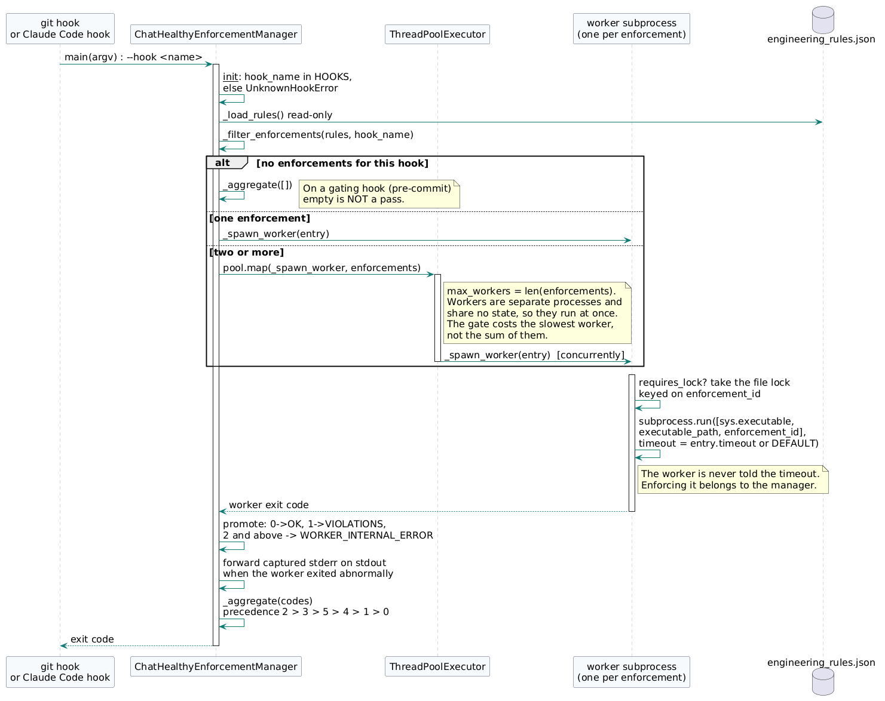
Figure 4.2 - Hook dispatch as implemented
Four properties of this sequence are worth naming, because each is a place the implementation differs from what a reader would assume. Workers run concurrently, in a ThreadPoolExecutor sized to the number of enforcements, because each is its own process and shares no state; the gate costs the slowest worker rather than the sum of them. A single enforcement skips the pool entirely. The lock is taken inside _spawn_worker, around that worker's own subprocess.run, so a lock-taking enforcement serializes against its peers on the same key whether or not anything else is in flight. And an empty enforcement list is not a pass on a gating hook: a registry that failed to yield enforcements once reported success while nothing had been checked.

4.3 Operational Concerns: Concurrency and Runaway-Process Control
Two operational concerns sit beneath every other decision in this design: how the framework behaves when many things run at once, and what happens when one of those things misbehaves. Both concerns are addressed in the technical-requirement tables and the worker accountability ledger, but they are spelled out here in plain language so the reader does not have to triangulate from exit-code tables. The short version: the manager itself is concurrency-safe by construction because it does not write anything; each worker is fully accountable for its own concurrency story; and every worker runs as an isolated subprocess with a hard wall-clock budget so that no individual worker can hang the commit, the push, or the Claude Code session.

4.3.1 Concurrency model
Hooks fire as separate operating-system processes. That is the starting point of the model, not an edge case. Two Claude Code sessions running side by side, a Claude session running while the operator manually issues a git commit in another terminal, a CI agent running pre-push while a developer is still iterating locally — all of these are normal, all of these are common in the ChatHealthy.ai workflow, and none of them is allowed to cause a race. The framework is designed so that the most concurrent firing pattern we can plausibly imagine is also the safe one.
The manager is the dispatch point AND the mutex owner. ChatHealthyEnforcementManager opens engineering_rules.json read-only, filters by hook, and dispatches each matching enforcement. It never writes back to the rules file, so multiple manager processes can run concurrently against the same rules without coordination. What the manager does coordinate is worker dispatch: before invoking subprocess.run for any enforcement whose entry declares requires_lock = True, the manager calls _acquire_lock(enforcement_id); after subprocess.run returns (clean exit, non-zero, or timeout) the manager calls _release_lock. The default mechanism is an advisory file lock; the choice of mechanism is internal to the manager and may be promoted (for example, to a Mongo atomic claim) without touching any worker.
The worker carries no concurrency requires_lock flag on its enforcement entry. The entry simply declares whether this worker requires mutual exclusion via the requires_lock boolean. Workers that are read-only — every V1 worker, every prompt-inspection worker, every audit worker — declare requires_lock = False and run unguarded. Workers that need to serialize their dispatch declare requires_lock = True and the manager takes the lock for them. Workers MAY still use non-mutex coordination patterns internally (publishing to the local spool, atomic Mongo updates, append-only log writes through the existing pipeline). Those patterns are worker-internal data-access decisions; they are not declared on the enforcement entry because they do not fit the generic manager-acquires-a-lock model.
For the V1 surface this discipline costs us nothing. Both V1 enforcements — the HTTP scan and the JSON validation — live inside the same read-only worker. They scan staged files, emit findings to stdout, and exit. Neither writes anything that another process might also be writing, so the worker's enforcement entry declares requires_lock = False and the manager dispatches unguarded.
Future writing workers will be a different story, and the framework is shaped to absorb them without rework. A worker that mutates a brain JSON or claims a single-session marker declares requires_lock = True and lets the manager serialize its dispatch through _acquire_lock / _release_lock. A worker that publishes to a spool — for example, the LogPublishEnforcementWorker that will supersede conversation_log_hook.py — uses the existing publish pipeline as its non-mutex coordination and declares requires_lock = False, because there is no shared file or counter that needs serializing at the manager layer.
The conversation_log spool and drain is the proof point that non-mutex coordination is a real category and not a theoretical one. That pipeline has been in production for weeks, solving exactly the high-frequency concurrent-append problem — many Claude Code PIDs all needing to record their prompt-and-response turns to the same store — without any mutex at the manager layer. The framework supports both categories: manager-acquires-a-lock for entries that declare requires_lock = True, and worker-internal non-mutex coordination for everything else.

4.3.2 Runaway-process control
Concurrency answers the question of what happens when many workers run at the same time. Runaway-process control answers the related but distinct question of what happens when one worker misbehaves — hangs on a network call, falls into an infinite loop, leaks memory, or simply takes longer than any reasonable budget allows. The framework's stance is that no single worker is ever permitted to hold up the commit, the push, the deploy gate, or the Claude Code session indefinitely. Timeout enforcement is exclusively a manager responsibility. Workers do not police their own deadlines, and the design admits no second path: a hung or runaway worker cannot be trusted to enforce its own deadline.
The first line of defense is process isolation. Every worker is spawned as a true operating-system subprocess via subprocess.run with the worker's executable_path and its enforcement_id as the only positional argument. This isolation is intentional and consequential: a worker that crashes, segfaults, hangs on a socket, or consumes excess memory cannot poison the manager's address space or the addresses of its sibling workers. The manager observes only the subprocess exit code and the structured stdout, never the worker's interpreter state. If a worker crashes outright the manager simply records the exit code and continues.
The second line of defense is the per-worker timeout, and it is enforced exclusively by the manager. When the manager dispatches a worker via subprocess, it reads the enforcement entry's optional timeout field (integer seconds) and falls back to the manager class constant DEFAULT_TIMEOUT_SECONDS — currently 30 — when the field is omitted. The resolved value is passed to subprocess.run(..., timeout=N). On timeout the manager kills the worker subprocess, catches subprocess.TimeoutExpired, and records EXIT_WORKER_TIMEOUT (4) for that worker. The other workers in the same dispatch are unaffected — they continue to completion, and the manager aggregates their outcomes alongside the timeout. Workers MUST NOT install signal handlers, watchdog threads, or any other in-process timeout mechanism. There is no second path. If a worker needs graceful internal cleanup before forced termination, that is a worker-internal nicety; it does not replace the manager's hard kill.
The third line of defense is the manager's own overall budget. Even if every individual worker honors its per-worker timeout, a long enough list of workers could in principle keep the manager running for an unacceptable amount of wall-clock time on a single hook firing. The framework therefore caps the entire dispatch at a configurable manager-level budget — five minutes is the working recommendation, generous enough that a fully populated taxonomy of workers can run to completion on pre-commit without scraping the ceiling, and tight enough that a runaway dispatch is bounded. If the wall-clock for the dispatch exceeds the budget, the manager exits with EXIT_MANAGER_ERROR (2) so that the caller can distinguish a framework-level overrun from a worker-level violation. The exact value of the manager-level budget remains a follow-on item in §5.
These three lines of defense compose cleanly with the rest of the framework because of how exit codes are aggregated. The exit-code precedence already documented in TR-2 — manager error trumps spawn failure trumps internal worker error trumps timeout trumps violation trumps clean — guarantees that a runaway worker surfaces to the caller as a timeout, never as a silent pass and never as a violation report that misrepresents the failure. The pre-commit hook, the pre-push hook, and the pre-deploy gate each see the worst-case code from the dispatch and act accordingly: timeout blocks the operation, the operator sees a clear telemetry record explaining which worker timed out, and the framework returns control to the human.

4.4 Framework classes
The manager and the abstract base as they exist in architecture/EngineeringRuleEnforcement/code/. The manager holds no reference to any worker class: it spawns a worker as a subprocess, passing the enforcement_id in argv and the file set on stdin, and reads an exit code back. That is the whole contract between them.
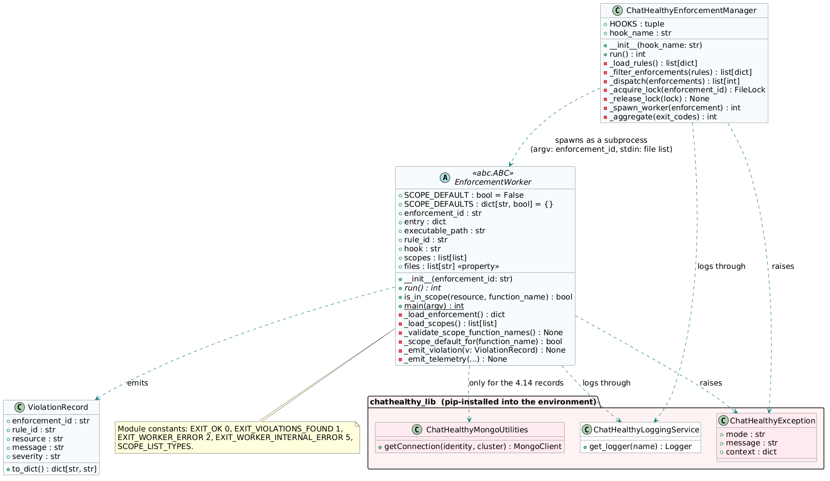
Figure 4.4a - Framework classes, with the library dependencies the rules require

4.4.1 ChatHealthyEnforcementManager
chathealthy_enforcement_manager.py, 374 lines.
Member | Kind | Purpose
PROJECT_ROOT | module constant | Path(__file__).resolve().parents[3]. Every path the manager resolves hangs off the manager's own location.
HOOK_CWD_ENV, LAUNCH_CWD | module constants | The hook's working directory, carried through the environment, and the directory the manager was launched from.
HOOKS | class attribute | The hook names the manager accepts.
hook_name | str | The hook this invocation is dispatching, validated in __init__.
__init__(hook_name) | constructor | Raises UnknownHookError when hook_name is not in HOOKS. Nothing else.
run() | int | Load, filter, dispatch, aggregate. The single public entry point.
_load_rules() | list[dict] | Reads engineering_rules.json read-only.
_filter_enforcements(rules) | list[dict] | Selects the enforcement entries declared for this hook.
_dispatch(enforcements) | list[int] | Runs each selected enforcement, in order.
_acquire_lock(id) / _release_lock(lock) | FileLock / None | Process-safe lock keyed on enforcement_id, taken only when the entry declares requires_lock.
_spawn_worker(enforcement) | int | subprocess.run of the worker at executable_path, with the entry's timeout. Returns its exit code.
_aggregate(exit_codes) | int | Worst code wins.
main(argv) | module function | argv carries one hook name. Returns the exit code.
UnknownHookError | exception | Raised for an unrecognised hook name.
Table 4.4a - ChatHealthyEnforcementManager members

4.4.2 EnforcementWorker (abstract base)
enforcement_worker.py, 417 lines. abc.ABC; run() is the only abstract method.
Member | Kind | Purpose
EXIT_OK / EXIT_VIOLATIONS_FOUND / EXIT_WORKER_ERROR / EXIT_WORKER_INTERNAL_ERROR | module constants | 0, 1, 2 and 5. The exit vocabulary the manager aggregates.
SCOPE_LIST_TYPES | module constant | The four scope terms, and no others.
ENGINEERING_RULES_PATH | module constant | Where the registry is read from.
SCOPE_DEFAULT | class attribute, bool | False. What a resource matching no scope row means for this worker.
SCOPE_DEFAULTS | class attribute, dict[str, bool] | Per-check overrides of SCOPE_DEFAULT. Subclasses populate it.
enforcement_id, entry, executable_path, rule_id, hook, scopes | instance attributes | Set in __init__ from the registry entry this worker was invoked for.
__init__(enforcement_id) | constructor | Loads the entry and the scopes, then validates that every function_name in scopes is a real method. A typo surfaces at startup rather than as a silently dropped rule.
files | property, list[str] | The file set handed to the worker on stdin, cached after first read.
run() | abstract, int | The only method a subclass must implement.
is_in_scope(resource, function_name) | bool | Fixed-precedence scope evaluation. Lives here and nowhere else.
_load_enforcement() / _load_scopes() | dict / list[list] | Read this worker's entry and its scope rows from the registry.
_validate_scope_function_names() | None | getattr against each function_name; AttributeError at startup on a typo.
_scope_default_for(function_name) | bool | SCOPE_DEFAULTS, falling back to SCOPE_DEFAULT.
_emit_violation(v) / _emit_telemetry(...) | None | The structured violation and telemetry envelopes, written by the base class.
main(argv) | classmethod, int | The worker's process entry point.
ViolationRecord | class | enforcement_id, rule_id, resource, message, severity, and to_dict().
WorkerInternalError | exception | The worker cannot do its job at all, as distinct from finding a violation.
Table 4.4b - EnforcementWorker members

4.4.3 Runtime environment
The framework depends on chathealthy_lib for three things, and the environment it runs in must provide the library as a versioned installed package - pip install chathealthy-lib==X.Y.Z into the interpreter that executes the manager. Nothing in the code manipulates sys.path, and nothing sets a logging environment variable at import time. The environment is a deployed fact, not something a module manufactures at run time.
What the framework needs | Through
Every deliberate raise | ChatHealthyException, carrying a mode. The three modes this framework raises are unknown_hook, worker_internal and scope_function_missing.
Every logger | ChatHealthyLoggingService, configured by declared environment variables.
A MongoDB client, if and when one is needed | No enforcement reaches a database today, by design: the manager and the base worker set the logging destination to stderr so a gate never depends on a write it has no grant for. Mongo becomes a dependency only when the authorization records of 4.14 exist, and then only through ChatHealthyMongoUtilities().getConnection(identity, cluster).
Target kind: container. The environment cannot be assumed to exist on a workstation, and today it does not - the interpreter that runs the chain has no chathealthy-lib installed. A container image carrying the interpreter, the pinned library version and nothing else makes the environment reproducible and removes every reason the code currently has to search the filesystem for its own library. The hooks invoke the container; the repository is mounted.
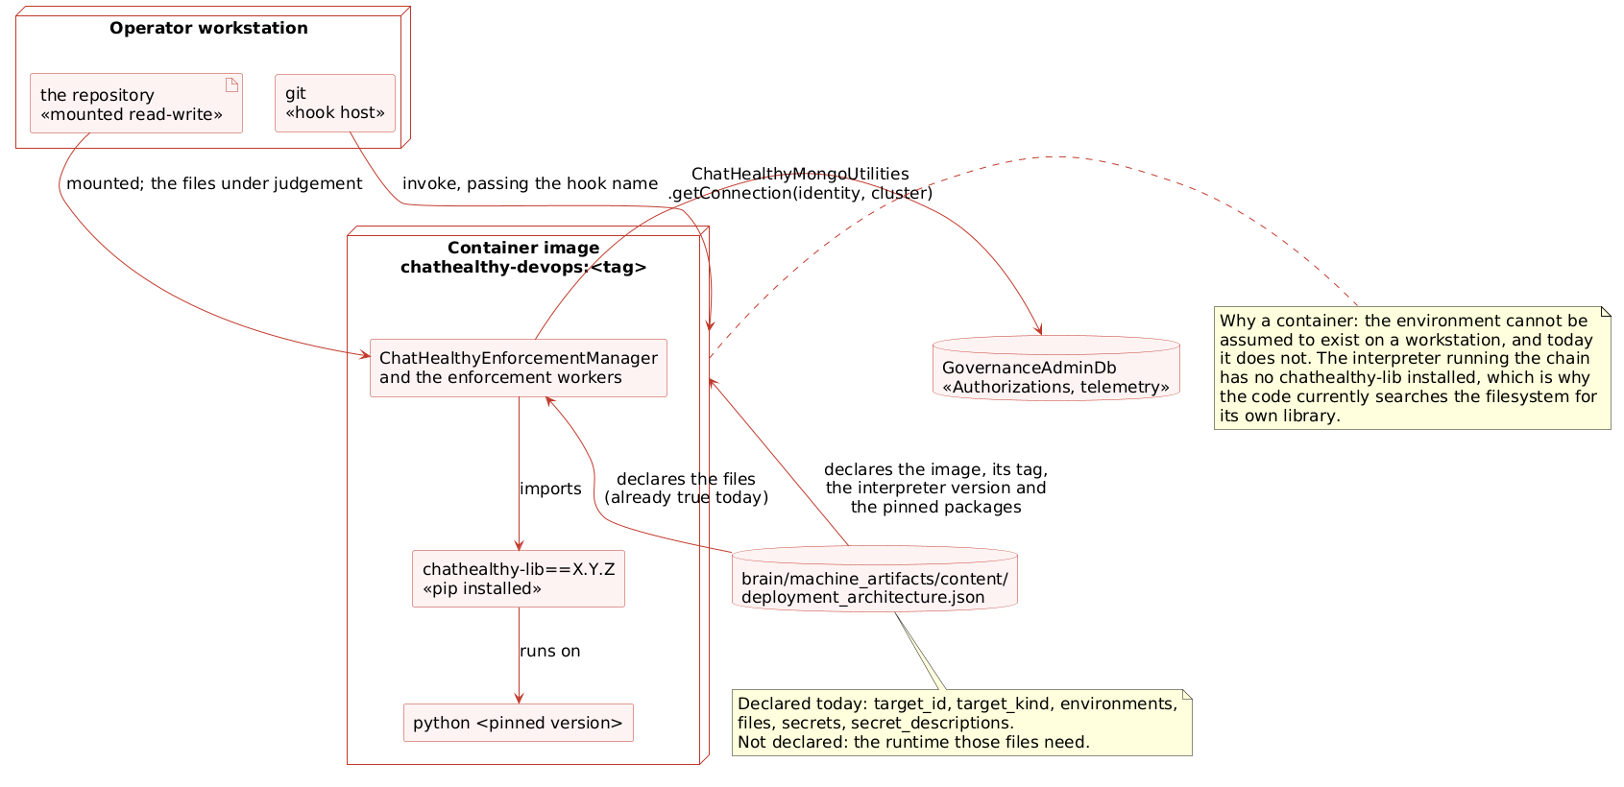
Figure 4.4b - Runtime environment (deployment diagram)
What deployment_architecture.json must carry for that target, and does not today: the container image and its tag, the interpreter version, and the pinned python packages. target_host_local_devops declares target_id, target_kind, environments, files, secrets and secret_descriptions - files and secrets, and nothing about the runtime those files need. A target whose environment is undeclared cannot be rebuilt from the record, which is the condition BUG-008 describes.

4.4.4 Why the enforcements did not catch this
This framework violates rules it exists to enforce, and every gate passed it. Each pass has a cause in how the enforcement is written, and the causes generalise beyond this file.
What was missed | The enforcement | Why it passed
UnknownHookError, WorkerInternalError, and a bare AttributeError | Rule-065-ENF-002 - deliberate raises use ChatHealthyException | _FORBIDDEN is a frozenset of five built-in names, tested as expr.func.id in _FORBIDDEN. The rule is a positive obligation and a blocklist cannot express one, so the enforcement implements a narrower rule than the one written.
The mode discriminator, absent throughout | Rule-065-ENF-002 | Nothing tests that a raised exception carries a mode, so catch sites must couple to the class - the coupling ChatHealthyException exists to remove.
Both files, never re-examined after the rule tightened | every pre-commit enforcement | Workers receive the staged files, so a rule judges a file only when that file is next staged. EPIC-008-F-012-S-001 requires the scans to pass across the whole repository; the implementation scans a diff.
sys.path surgery, and os.environ written at import time | no enforcement | No rule addresses how a module locates its dependencies or reconfigures a service through the process environment. The logging rule is satisfied - the service is used - and the reconfiguration is outside what it examines.
A target declaring files and secrets and no runtime | the deploy gate | The gate verifies that what ships matches what is declared. An undeclared runtime is an absence, not a mismatch. BUG-008 records this shape.
The common failure: every enforcement here tests for the presence of something forbidden, and none tests for the presence of something required. Code that fails by omission passes every scan. Appendix A carries the repair.

4.5 Scope-list mechanism: how rules in scope are decided
BR-14 canonical contract. The four terms below are the only scope-list vocabulary in this system. “Exact match” means exact string equality against the full resource identifier (absolute path, URI, or other complete-string attribute). “Pattern” means regex / partial string match.
[
{ "label": "allowed by exact match", "match_style": "exact string equality", "resource_form": "full absolute path or URI" },
{ "label": "allowed by pattern", "match_style": "regex / partial string", "resource_form": "regex" },
{ "label": "excluded by pattern", "match_style": "regex / partial string", "resource_form": "regex" },
{ "label": "excluded by exact match", "match_style": "exact string equality", "resource_form": "full absolute path or URI" }
]
Every enforcement entry exposes its scope-list rules as a flat list under the scopes field of the entry. The base-class virtual _load_scopes() loads them at worker startup; subclasses contribute no SCOPES class attribute unless they override _load_scopes() for documented code-driven reasons. The list is a flat sequence of three-column rows — [function_name, scope_list_type, list_of_terms]. function_name is the name of a check method on the worker class (e.g. _scan_http, _validate_json). scope_list_type is one of the four canonical terms and nothing else: allowed_exact, allowed_pattern, excluded_exact, excluded_pattern. list_of_terms holds full strings for the exact-match types and regex strings for the pattern types. One row, one rule. There is no nesting, no per-domain prefix vocabulary, no ad-hoc category names. The single shape covers every check this worker performs.
The grammar is deliberately small. The second column draws from a four-term canonical set — allowed_exact, allowed_pattern, excluded_exact, excluded_pattern — declared once in BR-14 and referenced everywhere else. This explicitly retires the earlier per-domain naming style, where each new check brought along its own URL_-prefix or SCAN_TYPE_-prefix or SCHEMA_-prefix attributes. Those prefixes carry no meaning the canonical four terms don't already supply, and they make every new check a small grammar invention. Under the SCOPES model, scope-list rules live as rows on the enforcement entry; adding a new check requires no new vocabulary: the same four terms describe whatever the new check needs.
Precedence is the same for every worker, every check, every resource, and lives entirely in the base class. The base class walks the SCOPES rows in fixed order: excluded_exact first, then excluded_pattern, then allowed_exact, then allowed_pattern, and finally — when no row matched — the per-check SCOPE_DEFAULT. Excludes always trump allows. Exact always trumps pattern. Subclasses do not override this walk and do not need to know it; they only declare their rows. This is the same TR-5 precedence the framework has carried since V3, now expressed uniformly across rows instead of repeated per named attribute.
SCOPE_DEFAULT is a per-worker class attribute, but its semantics are per-check — that is, the default applies in the context of a particular function_name, because what counts as 'in scope by default' is a property of the check, not of the worker as a whole. For ScanFilesEnforcementWorker._scan_http, the default is True (V21): every staged text file is scanned for http:// URLs unless an explicit excluded_exact or excluded_pattern row pulls it out. The allowed_pattern rows for _scan_http are URL whitelists used inside _scan_http to exempt loopback, link-local metadata, and well-known standards URLs from violation; they are not file-selection patterns. Binaries that fail UTF-8 decode are silently skipped inside _scan_http itself (UnicodeDecodeError -> []) — a binary cannot semantically contain a URL. For ScanFilesEnforcementWorker._validate_json, the default is False; the check is gated positively by the `\.json$` allowed_pattern row in the entry's scopes, so non-JSON files never enter the validator. The two defaults express two different policies on the same worker, which is exactly why the default belongs to the check rather than to the worker.
A walk-through makes the precedence concrete. Consider the staged file Code/Shared/ops/tools/the legacy pre-commit script (deleted) reaching the worker on a pre-commit invocation. The base class first asks _scan_http about it. The excluded_exact rows for _scan_http are empty, so it moves on. The excluded_pattern rows include ^test_, conftest\.py$, and ^brain/BusinessArtifacts/ — none match the legacy pre-commit script (deleted) — so the file is not excluded. The allowed_exact rows for _scan_http are empty. The allowed_pattern rows for _scan_http enumerate URL allowances rather than file allowances, so they don't apply at the file level either. With no row matched, the walk returns SCOPE_DEFAULT, which for _scan_http is False — the file is not in scope for the HTTP scan. Now consider brain/machine_artifacts/content/engineering_rules.json reaching _validate_json. The excluded_exact row package-lock.json does not match. The excluded_pattern row ^tests/fixtures/ does not match. With no exclusion firing, the walk falls through to SCOPE_DEFAULT, which for _validate_json is True — the file is in scope, and the method validates it against the schema named in its $schema field.
Extensibility falls out of the shape. Adding a new check on this worker is two things: define a new private method (say, _scan_secret_keys), then append rows to the scopes field on this worker's enforcement entry in engineering_rules.json whose function_name is "_scan_secret_keys". No existing rows change. No new class attribute is invented. The base class walks the rules and dispatches to the method named in column one via getattr(self, row[0]); a typo in the method name surfaces at worker startup as an AttributeError rather than as a silently dropped rule. The framework absorbs new checks linearly: one method, N rows.
Where SCOPES come from. By default, the scope rules for a worker live in its enforcement entry in engineering_rules.json (the scopes field — see §4.6). The base class loads them at worker startup through a virtual method, _load_scopes(), whose default implementation simply returns self.entry.get("scopes", []). Subclasses MAY override _load_scopes() if a worker's scope source is intrinsically code-driven (computed at runtime, sourced from a different artifact, or genuinely hardcoded for a documented reason). Overriding is the explicit signal that scope is code-driven for a specific worker; reviewers spot it immediately. The default — metadata-driven — is preferred. ScanFilesEnforcementWorker uses the default; future workers should too unless they have a stated reason not to.
The manager never reads, validates, or interprets SCOPES content. It dispatches by enforcement_id + hook only. SCOPES validation happens at the JSON Schema layer (the schema validator catches malformed scopes fields before the manager ever runs); SCOPES interpretation happens inside the worker. This preserves the manager-worker contract isolation in TR-14.
Two extensions are flagged here as known but untested. The first is UserPromptSubmit prompt-injection: the SCOPES grammar is designed for files, where a 'resource' is a path string and the patterns are anchored against that string. A PromptInjectionEnforcementWorker operates on user prompt text, not on file paths. The four canonical types still apply — the resource is the prompt content rather than a path — but the wiring may surface gaps when we actually build that worker. Wiring decisions for that worker are out of scope for V1 and will be made when the worker is designed. The second is multi-resource workers: workers that correlate across more than one resource at a time (for example, validating that every story.req_ids entry resolves to a real backlog requirement and that every such requirement has a matching pytest). The current SCOPES structure treats each row as a single-resource filter; multi-resource correlations may require composition at the check-method level rather than additional row shapes. This is documented as an open extension and is not in scope for V1.

4.6 Enforcement schema additions
Every entry inside rule.enforcements.enforcement[] gains the fields below. The schema for engineering_rules.json is updated in lockstep. The new field versus V3 is executable_path: the manager reads it and uses it to spawn the worker as a subprocess; the worker no longer has to discover its own location. The new field versus V9 is scopes: each enforcement entry now carries its own per-enforcement scope-list rules as a flat list of three-column rows. The base worker class loads this list at startup through a virtual _load_scopes() method whose default implementation returns self.entry.get("scopes", []); subclasses MAY override _load_scopes() if their scope source is intrinsically code-driven. The EngineeringRulesSchema.json validator enforces the row shape (column 1 = string; column 2 ∈ {allowed_exact, allowed_pattern, excluded_exact, excluded_pattern}; column 3 = list of strings) so a malformed scopes field is caught before the manager dispatches. See §4.5 for the mechanism in narrative form. The new field versus V13 is requires_lock: a boolean that tells the manager whether to acquire a lock around this worker's subprocess.run call. requires_lock replaces the previous per-worker requires_lock enum; mutex coordination is now manager-owned.
Field | Type | Required | Format / Enum
enforcement_id | string | Yes | <rule_id>-ENF-NNN (e.g. Rule-008-ENF-001)
hook | string | Yes | pre-commit | commit-msg | post-commit | pre-push | SessionStart | UserPromptSubmit | PreToolUse | Stop | SessionEnd | InstructionsLoaded
executable_path | string | Yes | Repo-relative path to the worker script. Manager invokes via subprocess.run([sys.executable, executable_path, enforcement_id], timeout=...).
requires_lock | boolean | Yes | True if the manager must acquire a lock before dispatching this worker. The manager owns the locking mechanism (default: file lock; promote to a distributed claim if cross-machine coordination becomes required). False for workers that are read-only or that handle their own non-mutex coordination internally (e.g., spool write patterns).
scopes | array[array] | Optional | Per-enforcement scope-list rules. List of three-column rows: [function_name: str, scope_list_type: str, list_of_terms: list[str]]. function_name is the name of a check method on the worker class. scope_list_type is one of the four canonical terms: allowed_exact, allowed_pattern, excluded_exact, excluded_pattern. list_of_terms holds full strings for the exact-match types and regex strings for the pattern types. Empty/absent means the worker's _load_scopes() returns [] and is_in_scope() falls through to SCOPE_DEFAULT. The EngineeringRulesSchema.json validator enforces the row shape: column 1 = string, column 2 ∈ the four canonical terms, column 3 = list of strings.
timeout | integer | No (defaults to manager constant DEFAULT_TIMEOUT_SECONDS = 30) | Seconds. Positive integer. The manager passes this value to subprocess.run(..., timeout=N). On timeout the manager kills the worker subprocess and returns EXIT_WORKER_TIMEOUT (4). The worker does not see this field; the timeout is enforced by the parent process. Cross-reference §4.3.2 (Runaway-process control) for the operational narrative.

4.7 Hook taxonomy
Ten hooks. Four Git lifecycle, six Claude Code runtime. Every enforcement entry declares exactly one (see TR-1 for the schema enum). The manager is the single dispatch point for all ten.
Hook | Origin | Typical worker categories
pre-commit | Git | File scanning (e.g. ScanFilesEnforcementWorker), commit-content rules
commit-msg | Git | Commit-message format rules (mode markers, ticket refs)
post-commit | Git | Post-write audit, log publishing
pre-push | Git | Cross-file consistency, deployment-readiness rules
SessionStart | Claude Code | Boot orchestration, mode selection
UserPromptSubmit | Claude Code | Prompt-injection check (returns additionalContext), log publishing
PreToolUse | Claude Code | Tool-use guards (resource access, deployment surface)
Stop | Claude Code | Post-response audit, log publishing
SessionEnd | Claude Code | Session-level cleanup audits
InstructionsLoaded | Claude Code | Instructions / prompt-system audit

4.8 Worker taxonomy
Six categories of concrete worker are already known and accommodated by the framework. ScanFilesEnforcementWorker is the V1 concrete subclass; the rest are sketched as future subclasses with the same base contract. Each is shipped as its own standalone executable referenced from its enforcement entry’s executable_path field.
The five <<future>> worker subclasses (Boot, Mode, PromptInjection, PostResponseAudit, LogPublish) have no class-member tables in this design. Their member specifications will be added when each is implemented.
Category | Hook(s) | Role
File scanning | pre-commit, pre-push | Inspect staged or about-to-push files; emit violations on content rules. Worked example: ScanFilesEnforcementWorker.
Prompt-injection | UserPromptSubmit | Inspect inbound user prompt; return additionalContext (or block) when policy says so.
Post-response audit | Stop | Inspect Claude’s response after the turn; emit violations on misrepresentation, scope creep, etc.
Log publishing | UserPromptSubmit + Stop | Publish the prompt+response pair to the conversation_log spool.
Boot orchestration | SessionStart | Run chathealthy_devops_boot logic: mode detection, environment posture, header banner.
Mode selection | SessionStart | Resolve and announce session mode (Unattended / Normal / Idiot) based on context flags and CLAUDE.md.

4.8.1 Worker accountability
Each enforcement entry declares a requires_lock boolean. The manager consults that flag at dispatch time and acquires a process-safe lock around subprocess.run for entries where requires_lock = True. This table is the running ledger of the concrete worker subclasses and the requires_lock value their enforcement entries declare.
Worker | Requires lock? | Why
ScanFilesEnforcementWorker | No | Read-only file scan; no shared mutable state across PIDs. The manager dispatches without acquiring a lock.
PromptInjectionEnforcementWorker (future) | No | Read-only prompt inspection; result returned as additionalContext. No mutex needed.
PostResponseAuditEnforcementWorker (future) | No | Read-only post-turn audit. No mutex needed.
LogPublishEnforcementWorker (future) | No | Publishes prompt+response pairs to the conversation_log spool. Coordination is handled inside the worker via the existing pub-plus-single-consumer pipeline; the manager does not need to acquire a lock.
BootOrchestrationEnforcementWorker (future) | Yes | First-boot-of-session race — the manager acquires a lock before dispatch so only one boot orchestration runs to completion per session.
ModeSelectionEnforcementWorker (future) | Yes | Single declaration of mode per session — the manager acquires a lock before dispatch so concurrent invocations cannot race on the mode write.

4.9 Worked Example: ScanFilesEnforcementWorker on pre-commit
This is the V1 concrete worker. It illustrates how the framework operates end-to-end. It does not define the framework; the framework defines it. The manager spawns this worker as a subprocess via the executable_path on its enforcement entry. Inside the subprocess, run() invokes two functions synchronously — _scan_http and _validate_json — against every in-scope file. Synchronous is acceptable for a pre-commit blocking check; multi-threading inside run() is a future enhancement (see Phase 6).

4.9.1 ScanFilesEnforcementWorker class
ScanFilesEnforcementWorker contributes only the per-check policy and the domain methods listed below. It does NOT override _load_scopes(); it uses the inherited default and pulls its scope content from the scopes field on its enforcement entry in engineering_rules.json (see §4.6). This is the canonical pattern — future workers should follow it unless they have a documented reason to override. The worked-example scope rows for this worker are listed in §4.9.2.
Member | Type | Purpose
SCOPE_DEFAULT | bool (per-check) | Default scope decision when no SCOPES row matches a given resource for a given check. Per-method semantics: False for _scan_http (a file path that nothing matched is not in scope for the HTTP scan); True for _validate_json (every governed JSON is in scope unless explicitly excluded). Declared on the class; consulted by the base-class scope evaluator.
run() | int | For each in-scope file: call _scan_http(file), then _validate_json(file). Aggregate violations. Return EXIT_OK (0) if clean or EXIT_VIOLATIONS_FOUND (1) if violations were emitted. Other exit codes follow the worker convention in TR-2.
_scan_http(file) | list[Violation] | Regex-scan for http://; emit violation if no allowed_pattern URL row matches. The base class has already cleared file-level scope using the rows where row[0] == "_scan_http".
_validate_json(file) | list[Violation] | jsonschema Draft 2020-12 against file's $schema; FAIL LOUD if $schema missing and the file is not in any excluded row for _validate_json. Implementation contract is in §4.9.3.

4.9.2 Categorized scope-list inventory (worked example)
Worked-example three-column scope inventory for ScanFilesEnforcementWorker. Each row is a single rule: [function_name, scope_list_type, list_of_terms]. These rows now live in engineering_rules.json under this worker's enforcement entry (the scopes field added in §4.6) — NOT as a class attribute in Python. The base class's default _load_scopes() returns this list directly off the entry at worker startup. Empty entries are absent rows, not empty cells. BR-14 is satisfied per row by column 2 being one of the four canonical terms (allowed_exact, allowed_pattern, excluded_exact, excluded_pattern). The narrative description of the mechanism — including the precedence walk and the per-check SCOPE_DEFAULT semantics — is in §4.5. The JSON example below shows the same rows as they appear in engineering_rules.json; the table that follows renders the same data row-by-row.
{
"enforcement_id": "Rule-008-ENF-001",
"rule_id": "Rule-008",
"hook": "pre-commit",
"executable_path": "architecture/EngineeringRuleEnforcement/code/scan_files_enforcement_worker.py",
"requires_lock": false,
"scopes": [
["_scan_http", "allowed_pattern", ["^http://(localhost|127\\.0\\.0\\.1)", "^http://www\\.w3\\.org/", "^http://169\\.254\\.169\\.254/"]],
["_scan_http", "excluded_pattern", ["^test_", "conftest\\.py$", "^brain/BusinessArtifacts/"]],
["_validate_json", "excluded_exact", ["package-lock.json"]],
["_validate_json", "excluded_pattern", ["^tests/fixtures/"]]
]
}
function_name | scope_list_type | list_of_terms
_scan_http | allowed_pattern | ^http://(localhost|127\.0\.0\.1), ^http://www\.w3\.org/, ^http://169\.254\.169\.254/
_scan_http | excluded_pattern | ^test_, conftest\.py$, ^brain/BusinessArtifacts/
_validate_json | excluded_exact | package-lock.json
_validate_json | excluded_pattern | ^tests/fixtures/

4.9.3 JSON validation behavior
Condition | Behavior
$schema present | Fetch and validate Draft 2020-12. Errors = violation.
$schema missing AND file matches any excluded_exact / excluded_pattern row for _validate_json on this worker's enforcement entry | Skip silently.
$schema missing AND file does not match any excluded_exact / excluded_pattern row for _validate_json on this worker's enforcement entry | FAIL LOUD. Desired behavior.
$schema points at relaxed placeholder | FAIL. Strict validation only.
Implementation contract — no wiggle room. The validate-JSON code MUST use exactly this algorithm with exactly these libraries. There is no custom JSON validation logic anywhere in this worker. There are no bespoke type checks, no homegrown field validators, no "soft" validation modes, no exception swallowing, and no caching. The jsonschema package's Draft202012Validator is the SOLE arbiter of validity.
Single library, single API, single source of truth.
The implementation uses two and only two Python packages:
• json (Python standard library) — for parsing the file content.
• jsonschema (pip package: https://pypi.org/project/jsonschema/) — for schema validation.
Method signature:
def _validate_json(self, data, schema) -> list[jsonschema.exceptions.ValidationError]:
"""Returns [] if valid; list of ValidationError if invalid.
Single responsibility: jsonschema.Draft202012Validator(schema).iter_errors(data)."""
Algorithm — exact step sequence. No deviations.
1. Parse the data file. with open(file_path, encoding="utf-8") as f: data = json.load(f). If json.JSONDecodeError is raised, emit one ViolationRecord with message = f"invalid JSON: {error.msg} at line {error.lineno} col {error.colno}" and return. Do not attempt recovery. Do not try alternate parsers.
2. Locate the $schema field. Read data.get("$schema"). If the field is absent or not a string, emit one ViolationRecord with message = "$schema field is required and must be a string" and return. This is the FAIL-LOUD behavior referenced by TR-12. There is no implicit schema, no default schema, no fallback.
3. Resolve the $schema URL to a schema dictionary. The JSON file's "$schema" URL is the source of truth (V19 §4.9.3.1).org/draft/2020-12/schema), use the locally cached copy at Website/schemas/standard/; (b) else if the URL is already in the per-run cache, use that; (c) else perform an HTTP GET on the URL with a 5-second timeout (urllib.request.urlopen, standard library only — no new dependency) and cache the parsed body. Any fetch failure (URLError, HTTPError, socket.timeout, OSError) or a non-JSON response body becomes a per-file ViolationRecord with message beginning "schema fetch failed:"; the worker does NOT raise WorkerInternalError on unreachable URLs (an unreachable schema URL is a deployment problem against the file that declared it, not a worker configuration error).
4. Load the schema. with open(schema_path, encoding="utf-8") as f: schema = json.load(f). If json.JSONDecodeError is raised, raise WorkerInternalError (the schema itself is broken; worker exit 5).
5. Construct the validator. validator = jsonschema.Draft202012Validator(schema). The draft is fixed at 2020-12. No other drafts are supported. Do not call jsonschema.validate(); use the Validator class directly so iter_errors yields all errors.
6. Run validation. errors = list(validator.iter_errors(data)). iter_errors returns ALL errors, not just the first. This is required so the human gets the complete failure picture in one run.
7. Map each jsonschema.exceptions.ValidationError to a ViolationRecord per TR-6: enforcement_id = self.enforcement_id; rule_id derived from enforcement_id per the <rule_id>-ENF-NNN convention; resource = the repo-relative path of the data file; message = f"{'/'.join(str(p) for p in error.absolute_path)}: {error.message}"; severity = "error". JSON validation errors are never warnings.
8. Return the list. Empty list = clean. Non-empty list = violations; the worker's overall exit code becomes EXIT_VIOLATIONS_FOUND (1) per TR-2.
Forbidden patterns — MUST NOT appear in this implementation:
• try: ... except: pass around any of the parsing or validation calls.
• Comparing field types directly (isinstance, type(x) == ...) outside of jsonschema.
• Custom regex on the file's raw bytes to "pre-validate" before json.load.
• Skipping validation based on file size, age, modification time, or any heuristic.
• Treating any subset of errors as warnings. All errors are violations.
• Maintaining a known-good cache or skip-if-unchanged optimization.
• Calling jsonschema.validate() (it raises on first error and hides the rest).
• Substituting an alternate validator (fastjsonschema, jsl, etc.). jsonschema is the only library.

$schema URL | Resolution mechanism (V19 §4.9.3)
https://json-schema.org/draft/2020-12/schema | Carve-out (frozen external) — local copy at Website/schemas/standard/json-schema-2020-12-meta.json
https://dev.chathealthy.ai/schemas/ChatHealthyAgileBacklogSchema.json | Web fetch (HTTP GET, 5s timeout, per-run cache)
https://dev.chathealthy.ai/schemas/ChatHealthyBugsSchema.json | Web fetch (HTTP GET, 5s timeout, per-run cache)
https://dev.chathealthy.ai/schemas/EngineeringRulesSchema.json | Web fetch (HTTP GET, 5s timeout, per-run cache)
https://dev.chathealthy.ai/schemas/ChatHealthyRiskAcceptanceSchema.json | Web fetch (HTTP GET, 5s timeout, per-run cache)
https://dev.chathealthy.ai/schemas/ChatHealthyVersionSchema.json | Web fetch (HTTP GET, 5s timeout, per-run cache)
https://dev.chathealthy.ai/schemas/ChatHealthyErrorsSchema.json | Web fetch (HTTP GET, 5s timeout, per-run cache)
https://dev.chathealthy.ai/schemas/ChatHealthyRelaxedSchema.json | Web fetch (HTTP GET, 5s timeout, per-run cache)
The resolver fetches the schema published at the JSON file's "$schema" URL via HTTP GET with a 5-second timeout. Successful fetches are cached in a per-run dictionary so the same URL is fetched at most once per worker invocation; the cache is cleared at the start of each run(). Schemas are governed and stable; deploy-then-commit is the dev discipline.json and is served directly without any HTTP call. See §4.9.3.ai schemas.

4.9.3.
_frozen_external_schemas in scan_files_enforcement_worker.py) MUST satisfy two conditions: (1) the URL is owned by an external standards body, not by chathealthy.ai; and (2) the standards body has documented immutable URL semantics — that is, the schema served at that URL cannot change in place. The JSON Schema 2020-12 meta-schema satisfies both: it is published by the JSON Schema Working Group, and the spec stipulates that any change requires a new draft URL (e.g., draft-2024-XX). It is the only entry today.
ChatHealthy. They are governed by the deploy pipeline; the worker fetches them at validation time. The rationale is asymmetric trust: we own chathealthy.ai schemas and can redeploy any update; we do not own the JSON Schema meta-schema and rely on its frozen URL contract.
Files under Website/schemas/standard/ are excluded from both _validate_json and _scan_http on Rule-008-ENF-001 (pattern-based exclusion: ^Website/schemas/standard/) so that future cached standards auto-exclude. The framework does not own those files; they may contain http URLs we cannot change.
Negative test fixtures (required, mapped to TR-15):
# | Fixture | Required outcome
1 | JSON with $schema and a required field deliberately missing | Exactly one ViolationRecord
2 | JSON with $schema and a field violating type or enum | One ViolationRecord per error
3 | JSON in scope, no $schema field at all | One ViolationRecord (FAIL LOUD)
4 | JSON whose $schema URL is unreachable or returns non-JSON content | One ViolationRecord (fetch failure); worker continues
5 | JSON with malformed syntax (e.g., trailing comma) | One ViolationRecord (parse error)
6 | JSON in excluded_exact or matched by excluded_pattern | Skipped silently — zero violations
7 | JSON that validates cleanly | Zero ViolationRecords
These fixtures live under projectRoot/architecture/EngineeringRuleEnforcement/tests/fixtures/json_validation/. Each fixture is a self-contained .json file. The test runner stages each fixture into a working repo, runs the worker, and asserts the exact outcome above. No fixture is opt-out. No fixture's outcome is approximate.
What the method body actually looks like.
Once the contract above is honored, the executable body of _validate_json is a short composition of json + jsonschema with explicit error mapping. Reference implementation:
def _validate_json(self, data, schema) -> list[jsonschema.exceptions.ValidationError]:
"""JSON validation per design §4.9.3. SOLE arbiter: jsonschema.Draft202012Validator.
Do not invent. See §4.9.3 for the binding contract.
"""
return list(jsonschema.Draft202012Validator(schema).iter_errors(data))
# Resolution (orchestrated by _check_one_file_json):
# 1. data = self._load_data(file_path)
# 2. schema_url = data["$schema"]
# 3. schema = self._resolve_schema(file_path, schema_url)
# a.# b. per-run cache lookup
# c. urllib.request.urlopen(schema_url, timeout=5); fetch failure -> per-file violation
# 4. errors = self._validate_json(data, schema)
# 5. map each ValidationError to a ViolationRecord
All non-trivial behavior — schema language, type coercion, required-field checks, enum matching, format validation, additionalProperties enforcement — is delegated to jsonschema. The worker contributes parsing, schema resolution, and error-shape conversion. That is the entire surface.
The method's docstring in the actual source file MUST include a one-line reference to this design section and the explicit statement: "jsonschema.Draft202012Validator is the SOLE arbiter of validity. Do not invent." The docstring is the in-code anchor against future drift. Reviewers reject any change to _validate_json that does not preserve both the reference and the statement.

4.10 Filesystem layout — mirrors the operating model
All code for this feature lives under projectRoot/architecture/EngineeringRuleEnforcement/. The feature is self-contained: code, tests, and business artifacts under one root. crossEpicConcerns/ holds shared business artifacts only — no code lives there. This mirrors the agile EPIC / Feature backlog exactly. File names use snake_case throughout: chathealthy_enforcement_manager.py, enforcement_worker.py, scan_files_enforcement_worker.py.
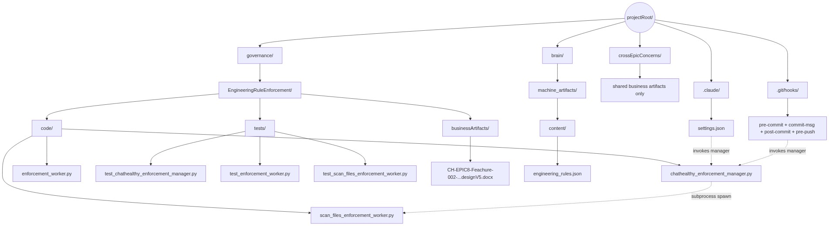
Figure 4.10 — Filesystem mirrors the operating model
Path | Status | Purpose
projectRoot/architecture/EngineeringRuleEnforcement/ | NEW | Self-contained home for this feature’s code, tests, and business artifacts
…/code/chathealthy_enforcement_manager.py | NEW | The manager — one class, one main(), spawns workers as subprocesses
…/code/enforcement_worker.py | NEW | EnforcementWorker abstract base class
…/code/scan_files_enforcement_worker.py | NEW | V1 concrete worker (worked example); standalone script with its own main()
…/tests/ | NEW | Pytest tree for manager, base class, and each worker
…/businessArtifacts/ | NEW | Design docs and other business-facing artifacts for this feature
projectRoot/crossEpicConcerns/ | NEW (or formalized) | Shared business artifacts only. No code lives here.
brain/machine_artifacts/content/engineering_rules.json | EXISTING (schema extended) | Authoritative rule registry; gains the V5 enforcement-entry fields including executable_path
Code/Shared/ops/tools/the legacy pre-commit script (deleted) | EXISTING (trimmed; retiring) | Drop .json from SCAN_EXTENSIONS and \.json$ from HTTP_EXEMPT_PATTERNS once the worker is live; retire the file once the manager dispatches all enforcement
.claude/settings.json | EXISTING (hook entries updated) | Each Claude Code hook event invokes the manager with its hook_name
.git/hooks/{pre-commit, commit-msg, post-commit, pre-push} | EXISTING (rewired) | Each Git hook invokes the manager with its hook_name
Footnote on the existing Code/ tree: the legacy Code/ directory will atrophy over time as code migrates to the operating-model-mirroring layout. That migration is tracked separately and is not in scope for this design.

4.11 Manager-worker contract
Direction | Payload | Notes
Manager → Worker (spawn) | subprocess.run([sys.executable, executable_path, enforcement_id], timeout=...) | Manager reads executable_path off the enforcement entry. enforcement_id is the only positional argument.
Worker → stdout (violation) | {enforcement_id, rule_id, resource, message, severity} | One JSON object per line. Emitted by base class.
Worker → stdout (telemetry) | {enforcement_id, hook, phase: start|end, duration_ms, files_scanned, violation_count, exit_code} | One JSON object per line at start and end.
Worker → Manager (return) | exit_code int (0 | 1 | 2) | 0 clean, 1 violations, 2 worker error. Manager promotes any worker exit ≥ 3 to EXIT_WORKER_INTERNAL_ERROR (5).
Manager → Git/Claude Code (return) | worst code by precedence (2 > 3 > 5 > 4 > 1 > 0), structured stdout report | Per-enforcement records preserved on stdout; the worst code wins so the caller can immediately tell whether the failure is in the framework or in the user’s code.

4.12 Known gaps
Requirements this feature does not meet, and hooks the manager accepts that no rule declares. Scope is set by the backlog; this section states what is unmet, not what is optional.
Gap | Requirement | State
No PreToolUse enforcement | EPIC-008-F-002-S-013, REQ-B-001 to REQ-B-012, approved | Rule-006 carries no enforcement; its worker and the operator wrapper were deleted, and Rule-064 went with them. Every Claude tool call is ungated. Not planned before October 2026: September is application building, not governance platform.
Already built, and carried in earlier drafts as future work: conversation-log capture is dispatched as Rule-001-ENF-001 and ENF-002; boot orchestration as Rule-002-ENF-001 and ENF-002; the legacy pre-commit script is retired and deleted.

4.12a Reporting a refusal
A gate that refuses and does not say why is a gate nobody can act on. Every refusal - a failed engineering-rule scan, a withheld commit authorization, a withheld promotion authorization, a promotion that fails after it was authorized - MUST reach the operator at the moment it happens, carrying the enforcement that refused, the resource it refused over, and the reason.
Reaching the operator means the person is told, by whatever channel is live at that moment: the terminal the command was run from, the approval page already on screen, or the conversation itself when an agent is driving. What is not sufficient is the current behaviour: the driver prints a per-enforcement line reading exit 0, returns a non-zero code, and writes the reason to a log file that nobody reads unless they already know to look. That cost this project a commit that failed three times before the cause - a fixture file with no $schema failing Rule-065-ENF-006 - was found by opening the log by hand.
A promotion that fails after its authorization was recorded is the sharper case, and the sequence of 4.14 does not cover it. The record says a promotion was authorized; if the ref then does not move, the record is the only evidence and it is misleading. The refusal must reach the operator and the record must carry the outcome, not only the authorization.
The mechanism
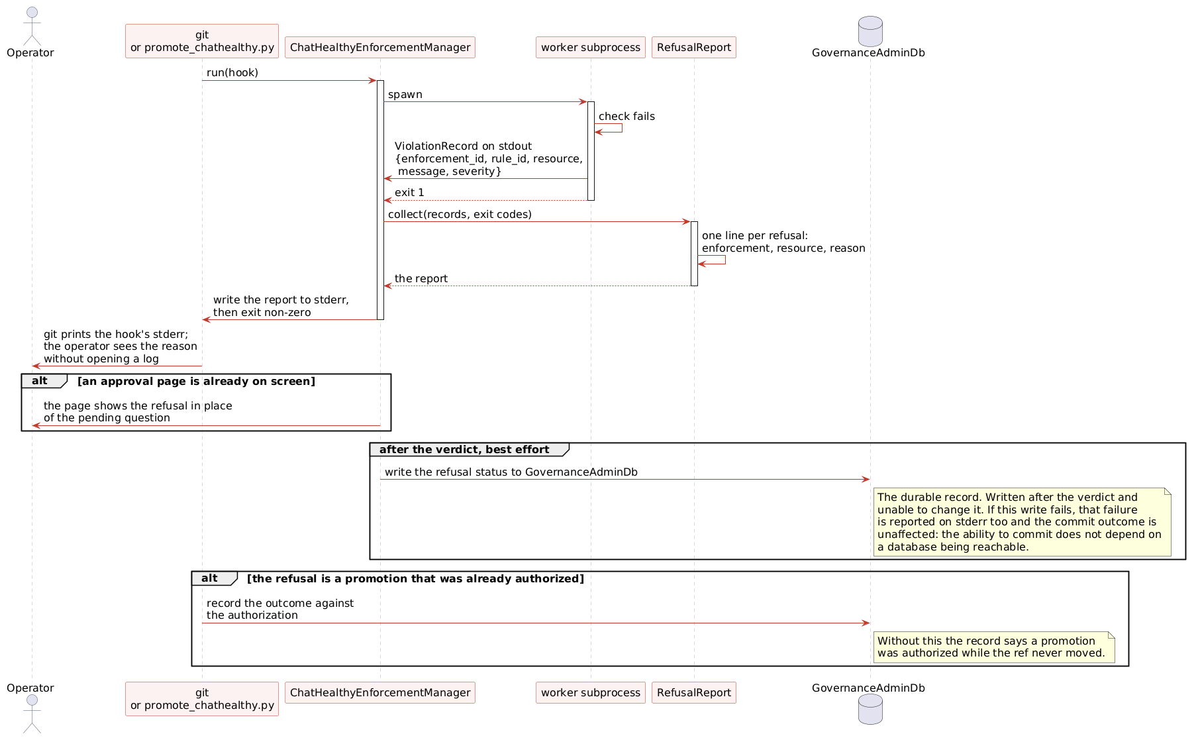
Figure 4.12a - How a refusal reaches the operator
The pieces already exist and are discarded. Workers emit a ViolationRecord per failure on stdout - enforcement_id, rule_id, resource, message, severity - and the manager reads their exit codes. What is missing is between the two: the manager keeps the codes and drops the records, so the reason never leaves the subprocess.
RefusalReport is the addition. The manager collects the ViolationRecords it already receives, renders one line per refusal - enforcement, resource, reason - and writes the report to stderr before exiting non-zero. git prints a hook's stderr, so the operator reads the cause where the command was run. No log file is involved in being told; the log remains the durable record, not the notification.
Channel | When it is used | What is delivered
The invoking terminal, on stderr | Always. It costs nothing and git surfaces it. | The full report: one line per refusal, then the aggregate exit code.
An approval page already on screen | A commit or promotion authorization is pending when the refusal occurs. | The page replaces its pending question with the refusal, so the operator is not left waiting on a decision that no longer matters.
The conversation | An agent is driving and no human is watching the terminal. | The same report text, surfaced in the tool result rather than buried in an exit code.
GovernanceAdminDb, after the verdict | Always, best effort. It records; it never notifies and never gates. | The refusal status as a durable record. A failed write is itself reported on stderr and cannot change the commit outcome - the ability to commit does not depend on a database being reachable.
A promotion that fails after authorization takes both: the report reaches the operator, and the outcome is written against the authorization record in GovernanceAdminDb. An authorization with no outcome is a claim that a promotion happened.
What makes this testable: for every refusal path, the reason appears on the caller's stderr, and no path exits non-zero with an empty report. A refusal the operator cannot read is a failed refusal.

4.13 Enforcement surfaces
Rule-065 is enforced at three surfaces. Each answers one question, and no surface covers another's failure.
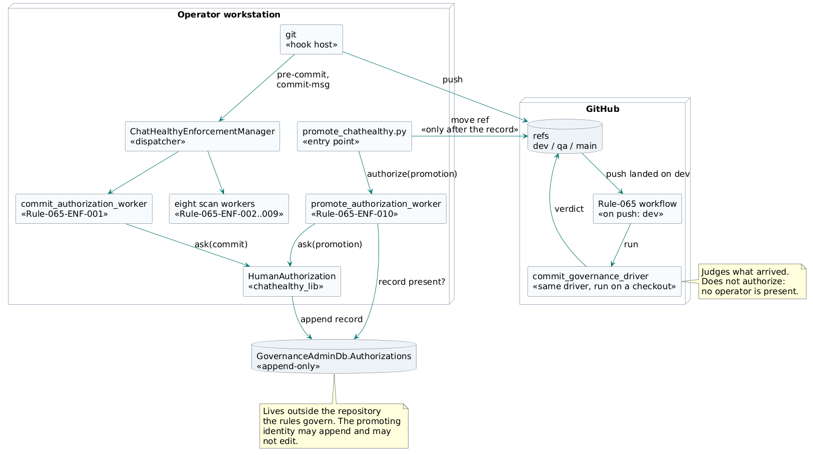
Figure 4.13 - Rule-065 enforcement surfaces (component diagram)
Component descriptions
Component | Responsibility | Invoked by
ChatHealthyEnforcementManager | Reads the rules registry, selects the enforcements declared for the firing hook, spawns each worker as a subprocess, and aggregates their exit codes worst-code-wins. | git, on pre-commit and commit-msg
commit_authorization_worker (Rule-065-ENF-001) | Asks the operator to authorize the commit and refuses the commit without an approval. | the manager, on commit-msg
Eight scan workers (Rule-065-ENF-002 to ENF-009) | Judge the staged files against the engineering rules and emit a ViolationRecord per failure. | the manager, on pre-commit
promote_chathealthy.py | The promotion entry point. Resolves the promotion facts, calls for authorization, and moves the destination ref only after an authorization record exists. | the operator
promote_authorization_worker (Rule-065-ENF-010) | Asks the operator to authorize this promotion, writes the authorization record, and returns refused when the approval or the record is absent. | promote_chathealthy.py
HumanAuthorization (chathealthy_lib) | Serves the approval page on the loopback interface, collects the decision, and establishes human presence per 4.15. Shared by both authorization workers. | either authorization worker
Rule-065 workflow and commit_governance_driver | Runs the same driver the hooks run, on a checkout of the pushed commit, and reports a verdict against what actually landed. | GitHub, on push to dev
GovernanceAdminDb.Authorizations | Holds every authorization record. The promoting identity may append and may not edit. | HumanAuthorization
Table 4.13a - Components of the enforcement surfaces
Surface | Fires on | What it decides | What it cannot decide
Local git hooks: pre-commit, commit-msg | A commit attempt on the workstation | Whether the staged files satisfy every engineering rule, and whether the operator authorizes this commit. | Nothing about a committer who bypasses it. It runs by the committer's consent.
GitHub Action, push to dev | A push landing on dev | Whether what arrived satisfies the rules, whoever ran the hooks and however they ran them. | Authorization. It runs after the fact, with no operator present.
Promote gate, in promote_chathealthy.py | A promotion, before any ref moves | Whether a human approves this promotion, and whether that approval is recorded. | Content. The commit was judged on its way to dev; a promotion advances a baseline and authors nothing.
Table 4.13b - What each surface decides
The Action is scoped to dev. Code enters ChatHealthy.ai's digital footprint at local to dev and is authorized there; qa and prod receive code by promotion, which moves a branch pointer and creates no commit. The promotion surface governs qa and prod.
Two enforcements do not run on the hosted runner: ENF-003 reaches MongoDB and ENF-009 reaches Key Vault and an LLM. Both are named as excluded in the run output. A check that fails for want of credentials is a check nobody reads.
The Action reports; branch protection on dev is what makes the report binding. How the Action is deployed is stated at 5.10.

4.14 Promote authorization
EPIC-008-F-012-S-002-REQ-B-006. Every code promotion MUST be approved by a human operator prior to any changes in the code REPO. This approval MUST be absolutely auditable, such that there is proof that a human and not an agent did the approval.
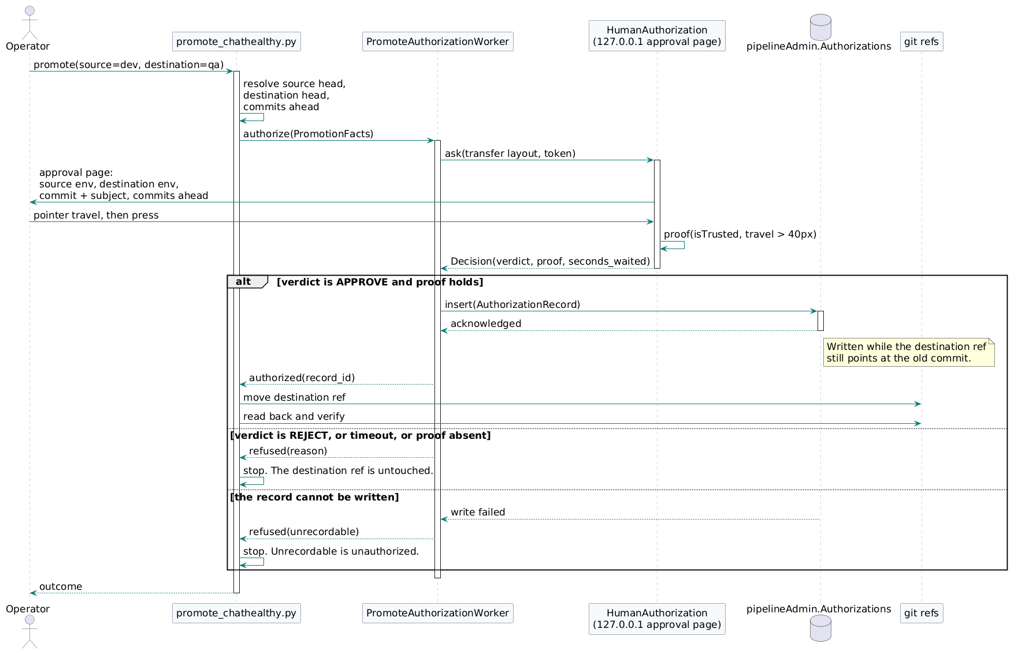

Figure 4.14a - Promote authorization (sequence diagram)
Sequence narrative
Step | What happens | Why it is where it is
1-2 | promote_chathealthy.py resolves the source head, the destination head and the number of commits the source is ahead. | The question put to the operator names one specific promotion; these are the facts that identify it.
3 | promote_chathealthy.py calls authorize(PromotionFacts) and does nothing else until it returns. | No ref has moved. Everything that follows happens prior to any change in the repository, which is what the requirement demands.
4-6 | HumanAuthorization serves the approval page, the operator moves the pointer and presses, and the page establishes presence per 4.15. | Presence is established at the moment of the decision, not asserted afterwards.
7 | The worker writes the AuthorizationRecord and waits for the acknowledgement. | The record is a precondition of the promotion, not a by-product of it.
8-9 | Only then does promote_chathealthy.py move the destination ref, then read it back and verify. | The ordering is the requirement, and it is observable: at write time the destination still points at the old commit.
alt 2 | REJECT, a timeout, or absent presence returns refused. | Silence is not approval.
alt 3 | A failed record write returns refused(unrecordable). | An authorization that leaves no record did not occur.
Table 4.14a - Sequence narrative for Figure 4.14a
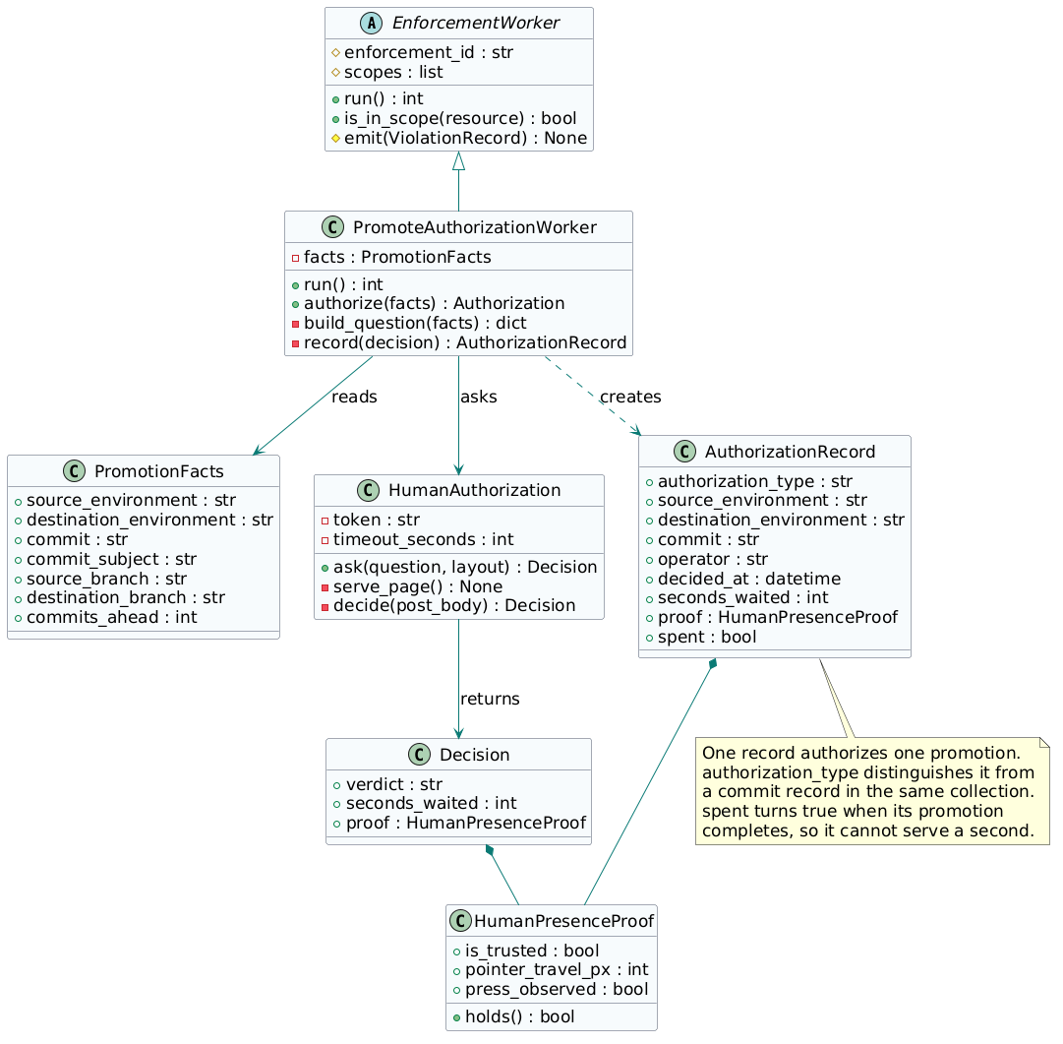
Figure 4.14b - Promote authorization (class diagram)
Class | Responsibility
PromoteAuthorizationWorker | Concrete EnforcementWorker for Rule-065-ENF-010. Builds the question from the promotion facts, asks HumanAuthorization, writes the record, and returns the authorization or a refusal.
PromotionFacts | The identity of one promotion. Carried into the question the operator sees and into the record, so the two cannot describe different promotions.
HumanAuthorization | Serves the page, holds the per-invocation token, applies the timeout, and returns a Decision. Shared with the commit gate; it has no promotion-specific behaviour.
Decision | The verdict, the seconds waited, and the presence proof.
HumanPresenceProof | The evidence defined in 4.15. holds() is true only when the press was trusted and the pointer travelled.
AuthorizationRecord | The durable fact. One record authorizes one promotion; spent turns true when that promotion completes.
Table 4.14b - Class responsibilities for Figure 4.14b
The authorization record
Written to GovernanceAdminDb.Authorizations, which is outside the repository the rule governs and to which the promoting identity holds append rights and no edit rights. authorization_type distinguishes a promotion record from a commit record and from a data_migration record in the same collection.
{
"authorization_type": "promotion",
"source_environment": "dev",
"destination_environment": "qa",
"source_branch": "dev",
"destination_branch": "qa",
"commit": "29d19a48...",
"commit_subject": "REQ-B-006: every promotion is approved by a human",
"commits_ahead": 7,
"operator": "skip.snow@gmail.com",
"decided_at": "2026-08-21T18:04:11Z",
"verdict": "approve",
"seconds_waited": 23,
"proof": { "is_trusted": true, "pointer_travel_px": 214,
"press_observed": true },
"spent": false
}
Figure 4.14c - AuthorizationRecord, promotion type
Field | Type | Meaning
authorization_type | string | promotion. Fixed for this record type.
source_environment / destination_environment | string | The adjacent pair being advanced: dev to qa, or qa to prod.
source_branch / destination_branch | string | The refs behind those environments.
commit | string | The commit being advanced. With the environment pair, this is what makes one record authorize one promotion.
commit_subject | string | The subject shown on the approval page, so the record carries what the operator actually read.
commits_ahead | integer | How far the source is ahead of the destination at the moment of the decision.
operator | string | The identity that answered.
decided_at | datetime | When the decision was taken, in UTC.
verdict | string | approve or reject. A rejection is recorded too.
seconds_waited | integer | Time between the page being served and the answer.
proof | object | HumanPresenceProof as defined in 4.15.
spent | boolean | False until the authorized promotion completes. A spent record authorizes nothing further.
Table 4.14c - Data dictionary for the promotion authorization record
Refusal cases
Attempt | Outcome
No authorization | Refused. The destination ref does not move.
Verdict is reject | Refused.
No answer before the timeout | Refused. Silence is not approval.
An approval naming another environment pair or another commit | Refused. One record authorizes one promotion.
A record whose spent is true | Refused. Approvals are not reusable.
A commit authorization offered for a promotion | Refused. authorization_type does not match.
No pointer travel before the press | Refused per 4.15.
An untrusted event | Refused per 4.15.
The record cannot be written | Refused. Unrecordable is unauthorized.
Table 4.14d - Refusal cases, each a case in tests/test_promote_authorization_worker.py

4.15 Proof of human presence
The actor being constrained runs on the operator's workstation and can open a browser, read the approval page, and post to any loopback endpoint it can see. Anything that actor can perform is not evidence of a human, so the evidence is drawn from flags the browser sets and code cannot.
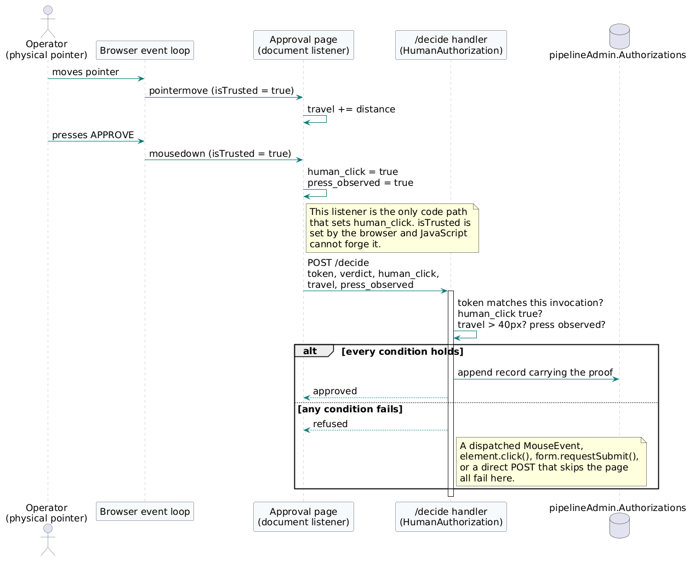
Figure 4.15 - Establishing human presence (sequence diagram)
Field | Type | Set by | Condition for approval
is_trusted | boolean | The browser, on the mousedown event. JavaScript cannot forge it. | true
pointer_travel_px | integer | The document pointermove listener, accumulating distance. | greater than 40
press_observed | boolean | The single document-level mousedown listener, the only code path that sets it. | true
token | string | HumanAuthorization, once per invocation. | matches the invocation being answered
Table 4.15a - HumanPresenceProof fields and the conditions each must meet
The buttons are type=button and the form has no submit listener, so intercepting submit achieves nothing. The /decide handler applies the conditions in Table 4.15a server-side, so a post that skips the page is refused on the same grounds as a synthetic event. The proof is copied into the authorization record, so a later reader establishes that a human answered without trusting that the gate behaved.
Mechanism not used | What it fails to prove
A typed token in the terminal | Retained where a real interactive TTY exists. An agent driving that terminal can type it, so it confirms intent and not humanity.
A local audit log | The log is a file inside the repository the rule governs, writable by the actor being constrained.
Table 4.15b - Mechanisms not used, and what each fails to prove

5. Deploying the rule enforcements

5.1 What the requirements already fix
Five approved requirements decide most of this design before it starts. They are not background; they are the constraint, and V1 of this document violated all five.
Requirement | Constraint
S-003-REQ-T-001 | executable_path is a repo-relative path to the worker script
S-003-REQ-B-009 | Filesystem mirrors operating model; home is projectRoot/architecture/EngineeringRuleEnforcement/
S-003-REQ-T-002 | The manager lives at projectRoot/architecture/EngineeringRuleEnforcement/code/
S-003-REQ-T-010 | Hooks invoke python <repo-root>/architecture/.../chathealthy_enforcement_manager.py
S-004-REQ-T-002 | The worked-example worker lives at projectRoot/architecture/EngineeringRuleEnforcement/code/
So the repository is the deployment substrate. That is a decision already taken, not an accident that grew. Filesystem mirrors operating model says the layout on disk is the layout of the thing. Staging a copy under a separate root would contradict it.
Deployment therefore means: the repository, at a known commit, present on the host, with the hooks registered and the service installed. There is no build output for the Python, because there is not meant to be one.

5.2 Verified state, 2026-08-08
Every enforcement resolves from the repository root today. Nothing has drifted.
13 enforcements, 11 distinct workers
non-repo-relative paths ............ 0
workers resolving to a real file ... 11 / 11
PROJECT_ROOT ...................... C:\CHATHealthyLLC == repo root
settings.json ..................... $CLAUDE_PROJECT_DIR/.../manager.py

5.3 How resolution works
Two indirections carry the whole system, and understanding them is what makes deployment a short list rather than a project.
Level | Who names it | Where
Master | settings.json names the enforcement manager | .claude/settings.json
Worker | engineering_rules.json names each worker | enforcement.executable_path
settings.json never learns which workers exist. Adding, moving or retiring a worker is a registry edit and nothing else.
Every worker path then resolves through one line:
chathealthy_enforcement_manager.py:204
executable_path = (PROJECT_ROOT / enforcement["executable_path"]).resolve()
PROJECT_ROOT = Path(__file__).resolve().parents[3]
PROJECT_ROOT is derived from where the manager itself sits, so a correctly placed manager makes every worker beneath it correct. That is REQ-B-009 working: mirror the layout and the resolution is free.

5.4 The deploy path, and the one code change it requires
The source of an enforcement and the copy that runs are not required to be the same file. REQ-T-001 requires executable_path to be repo-relative; it does not require it to name the authored source. A deployed copy staged UNDER the project root satisfies both: the path stays repo-relative, the feature home stays projectRoot per REQ-B-009, and the run path stops being the file under edit.
authored architecture/EngineeringRuleEnforcement/code/scan_files_enforcement_worker.py
deployed deploy/devops/architecture/EngineeringRuleEnforcement/code/scan_files_enforcement_worker.py
registry executable_path -> the deployed path, still repo-relative
This is the whole design. Deployment stages the target's files into deploy/devops/, mirroring the repository layout beneath it, and the registry points there.
Mirroring the layout is not cosmetic. PROJECT_ROOT is computed as parents[3] from the manager file, so a manager deployed to deploy/devops/architecture/EngineeringRuleEnforcement/code/ yields PROJECT_ROOT = deploy/devops, and every worker beneath it resolves correctly with no change at all.
That is also what breaks, and it is the code change:
Concern | Resolves to | Correct?
Workers | PROJECT_ROOT / executable_path -> deploy/devops/... | Yes
engineering_rules.json | PROJECT_ROOT / brain/machine_artifacts/content/... -> deploy/devops/brain/... | No
The manager reads the rules registry from the same PROJECT_ROOT it uses for workers. Deployed, that points at a brain directory inside the deploy tree, which is not where the brain lives. The two concerns are different and the manager currently conflates them.
Today | Change required
PROJECT_ROOT = Path(__file__).resolve().parents[3]  ENGINEERING_RULES_PATH = PROJECT_ROOT / brain/... | DEPLOY_ROOT = Path(__file__).resolve().parents[3] (where workers live)  PROJECT_ROOT = Path(os.environ['CHATHEALTHY_PROJECT_ROOT']) (where the brain lives)
Workers resolve against DEPLOY_ROOT, inferred from the manager's own location as now. The rules registry resolves against PROJECT_ROOT, read from the environment as an explicit deployed fact rather than guessed. Undeployed, both are the repository and behaviour is identical, so the change is safe before the deploy path exists.
A second benefit: reading the project root from the environment lets the manager fail loudly on a wrong root instead of quietly reporting missing executables, which is how a misplaced manager presents today.

5.5 What deployment consists of
# | Step | Note
1 | Repository present on the host at the intended commit | git is the version; there is no separate artefact
2 | Register the hooks in .claude/settings.json | Master only; workers come from the registry
3 | Install the ChatHealthyLogService Windows service | The one genuinely compiled artefact
4 | Publish the service binary to build/publish/ | dotnet build does NOT update what the service runs
5 | Ensure the declared environment variables are present | See target_host_local_devops
6 | Fire one hook of each kind and confirm it ran | Proof, not assumption
Only steps 3 and 4 resemble conventional deployment, and only because the supervisor is .NET. Everything Python is deployed by being in the repository, which is the point.
Step 4 is worth stating because it cost time on 2026-08-08: the service runs build/publish/ChatHealthyLogService.exe and dotnet build writes bin/. Building repeatedly and reporting success changed nothing the service executed.

5.6 The target
target_host_local_devops declares the surface: 20 files and 7 environment variables. The file list is generated from the rules registry rather than typed, so it cannot drift from what the manager actually dispatches.
Group | Count | Contents
Master and probes | 3 | enforcement manager, boot_probe, capture_brain_hashes
Enforcement workers | 11 | every distinct executable_path in the registry
Conversation-log runtime | 6 | drain, record, sweep, alarm, Worker.cs, csproj
Declaring the surface is not the same as relocating it. Every source_location stays repo-relative, consistent with REQ-T-001.

5.7 Versioning and rollback
The version of a deployment is the commit. Rollback is checking out the previous commit. No enforcement holds state between invocations, so there is nothing to unwind.
There is one sharp edge, and it is specific to this feature: the pre-commit gates are the enforcements. Deploy a broken worker and every commit is blocked, including the commit that would fix it. Git-based rollback assumes you can commit.
The escape is the property that looks like a weakness elsewhere. Because workers run directly from the working tree, repairing one takes effect immediately, with no commit and no deploy. Live-from-tree is what makes a broken gate recoverable: the same immediacy that let a half-written edit take utterance capture down on 2026-08-08 is what lets it be fixed in the next keystroke.
That is worth being explicit about, because the instinct is to remove the immediacy. Removing it would require a rollback path that does not depend on committing, and none exists today.

5.8 Risks
Risk | Consequence | Handling
Broken worker in the tree | All commits blocked | Repair in place; takes effect immediately
Partial edit saved mid-write | Capture or a gate fails silently | Observed 2026-08-08; the drain now logs every pass
dotnet build mistaken for deploy | Service keeps running old code | Publish to build/publish/; step 4
PROJECT_ROOT inferred, not declared | Wrong root reported as missing executables | Read from the environment; see the code change section
Environment variable undeclared | Component fails at startup | CH_LOG_DB was exactly this on 2026-08-08

5.9 Out of scope
One workstation. The registry carries a single path per enforcement, so a second host would need per-host paths, which do not exist today. The GitHub Action of 4.13 is not an exception to this and does not create one: it runs the driver from a checkout of the repository, where every path in the registry already resolves, and it registers no hooks and installs no service. It is this design's deployment substrate - the repository at a known commit - reached by a different route.
Rule-006 remains disabled (BUG-002). This design deploys the enforcements that exist and does not restore it.

5.10 Deploying the GitHub Action
The Action of 4.13 is the one enforcement surface this section does not yet cover, and the honest statement is that it was not deployed at all. The workflow file was written and pushed by hand: no target, no package, no source_location, no content hash in deployment_architecture.json, no build and no deploy. What runs in CI is therefore whatever was last pushed to the branch, which is precisely the failure BUG-008 records and precisely what 5.5 and 5.6 exist to prevent for every other component.
What it needs is what every other target has: a declaration naming GitHub Actions as a target, the workflow as a declared file with a source_location and a content hash, and a deploy step that writes .github/workflows/ and verifies the result rather than asserting it. Until that exists the Action is undeclared infrastructure, and the fact that it enforces governance does not exempt it from being governed.
This is stated and not scheduled. It is a deployment-chain change of the same size as adding any new target kind, and it is not part of the promote-authorization work of 4.14.

6. Open Issues
Open Issue 1 - Rule-006 carries no enforcement. engineering_rules.json holds four rules and thirteen enforcement entries across eleven distinct workers, the state 5.2 verifies. Rule-006 is the one rule with an empty enforcements list, and BUG-002 holds its disposition. Its requirements are EPIC-008-F-002-S-013-REQ-B-001 through REQ-B-012.
# | Item | Resolution path
O-1 | Parent rule for the HTTP scan. The current scan in the legacy pre-commit script (deleted) cites a requirement_id (EPIC-002-F-001-S-012-REQ-B-004), not a rule. | Attach the HTTP scan as a rule_statement under an existing security rule. Update the §4.9.2 enforcement entry's rule_id to match. Decide before the first enforcement_id is minted.
O-3 | [RESOLVED in V15] Subprocess timeout default. The manager invokes subprocess.run(..., timeout=...). What default is appropriate for the V1 pre-commit scan, and is it overridable per worker? | RESOLVED in V15. The optional `timeout` field is now declared in TR-1 and Table 5 (§4.6); the manager class table (§4.4.1) carries the DEFAULT_TIMEOUT_SECONDS = 30 constant; §4.3.2 rewrites the runaway-process narrative to declare the manager as the exclusive timeout enforcer. The manager-level wall-clock budget (working recommendation: 5 minutes) remains tracked separately as a follow-on item.
O-4 | v4-028 backlog cleanup is partial; agent classified 71 entities (test_output/scan_validate_relevance.json) but full cleanup is pending. | Triage in a follow-up backlog grooming session. Not blocking V1.
Open Issue 2 - UserPromptSubmit and Stop are dispatched by the manager as Rule-001-ENF-001 and ENF-002. The hook writes the raw payload to a local spool and a drain ships it to MongoDB; there is no message broker in the path. What remains open is the post-response audit on Stop, which has no worker.
Source | Reachable? | Used for
This session’s transcript (C:/Users/skips/.claude/projects/c--chatHealthy-findCare/f52a6998-5f63-4ff6-b1a6-a0f75cd69d1a.jsonl, ~17 MB) | Yes | Decision history; locked decisions; open items.
MongoDB conversation_log_archive (ClaudeCodeLog database) | Yes | Confirmed cross-PID spool pattern as the canonical primitive; earlier-session architectural context.
brain/machine_artifacts/content/conversation_log.json (rolling 24h) | Yes | Bridged today’s transcript with Mongo’s last archived day.
brain/machine_artifacts/content/engineering_rules.json | Yes | Confirmed: 50 rules, 0 with a non-empty enforcement[] array. Rule-008 confirmed as parent for JSON validation.
Code/Shared/ops/tools/the legacy pre-commit script (deleted) | Yes | Source of HTTP-scan logic to port into the worked-example worker.
brain/enforcement_code/validate_all_json.py | Yes | Source of JSON validation logic to port into the worked-example worker.
Code/Shared/ops/conversation_log_hook.py and Code/Shared/ops/kafka/conversation_log_producer.py | Yes | Reference implementation for the cross-PID spool pattern.
CH-EPIC8-Feachure-002-EngineeringRulesEnforcement-designV4.docx | Yes | V4 baseline. Skip’s tagged directives (subprocess dispatch, JSON-validation co-housing, BR-11/12, combined TR-2/TR-7, base-class file rename) applied throughout V5. Skip’s preserved V4 prose retained verbatim in section 1.

7. Enforced rules index
Read with 2026-08-10 in mind: the rules below are the pre-consolidation set. Rule-003, 004, 005, 007, 008, 009 and 066 were folded into Rule-065 on that date and their enforcement IDs were reissued in the Rule-065-ENF-NNN series, so the IDs in those entries are historical rather than current. the deleted legacy-path rule and its worker were deleted the same day, and Rule-006's worker was deleted on 2026-08-04. The registry, not this index, is the source of truth; the entries are retained because they record where each check came from.

Rule-001: Persist Claude conversation events to the local spool
Every UserPromptSubmit and Stop hook event writes the raw hook payload to the spool at C: mp\ChatHealthySpool, and a drain ships it to MongoDB. The hook does no network I/O. the local spool and the producer sidecar are not in the path.
- Statements: 1, 2, 3
- Hook Trigger: UserPromptSubmit, Stop
- Enforcement Entries:
- ID: Rule-001-ENF-001 | Hook: UserPromptSubmit | Worker: architecture/Conversation-logPipeline/conversation_log_publisher_worker.py | Timeout: 15s
- ID: Rule-001-ENF-002 | Hook: Stop | Worker: architecture/Conversation-logPipeline/conversation_log_publisher_worker.py | Timeout: 15s
- Status: Implemented
- Epic: EPIC-008-F-013-S-001

Rule-002: Boot execution on SessionStart and PostCompact
Wires the ChatHealthy boot program into the V19 engineering-rules architecture. The boot executable runs on SessionStart and PostCompact.
- Statements: 1, 2, 3, 4, 5
- Hook Trigger: SessionStart, PostCompact
- Enforcement Entries:
- ID: Rule-002-ENF-001 | Hook: SessionStart | Worker: Code/Shared/ops/tools/chathealthy_devops_boot.py | Timeout: 30s
- ID: Rule-002-ENF-002 | Hook: PostCompact | Worker: Code/Shared/ops/tools/chathealthy_devops_boot.py | Timeout: 30s
- Status: Implemented
- Epic: EPIC-008-F-002-S-007

Rule-003: Deliberate raises must use ChatHealthyException
Every deliberate raise of an exception must use ChatHealthyException with an appropriate mode discriminator.
- Statements: 1, 2
- Hook Trigger: pre-commit
- Enforcement Entries:
- ID: Rule-003-ENF-001 | Hook: pre-commit | Worker: architecture/EngineeringRuleEnforcement/code/scan_deliberate_raises_enforcement_worker.py | Timeout: 30s
- Status: folded into Rule-065. This check runs today as Rule-065-ENF-002.
- Epic: EPIC-008-F-002-S-009

Rule-004: Direct MongoClient instantiation forbidden outside the canonical utility
Direct MongoClient(...) instantiation is forbidden except within mongo_utilities.py itself.
- Statements: 1
- Hook Trigger: pre-commit
- Enforcement Entries:
- ID: Rule-004-ENF-001 | Hook: pre-commit | Worker: architecture/EngineeringRuleEnforcement/code/scan_mongo_client_direct_access_worker.py | Timeout: 30s
- Status: folded into Rule-065. This check runs today as Rule-065-ENF-003.
- Epic: EPIC-008-F-002-S-010

Rule-005: Uniform logging discipline
All ChatHealthy.ai Python code MUST log through ChatHealthyLoggingService in chathealthy_lib.
- Statements: 1, 2, 3, 4
- Hook Trigger: pre-commit
- Enforcement Entries:
- ID: Rule-005-ENF-001 | Hook: pre-commit | Worker: architecture/EngineeringRuleEnforcement/code/scan_uniform_logging_worker.py | Timeout: 30s
- Status: folded into Rule-065. This check runs today as Rule-065-ENF-004.
- Epic: EPIC-008-F-002-S-011

Rule-006: Constrain Claude Code's tool use via the PreToolUse hook
Carries no enforcement and no implementing code. What must be done is stated by story EPIC-008-F-002-S-013, requirements REQ-B-001 through REQ-B-012. The design that once realized it has been withdrawn, and its worker deleted; BUG-002 records why.
- Statements: 1, 2, 3, 4, 5, 6, 7, 8
- Hook Trigger: PreToolUse
- Enforcement: Currently deferred (no enforcement workers)
- Status: DEFERRED - enforcements list empty (as of 2026-08-04)
- Epic: EPIC-008-F-002-S-006
NOTE: See BUG-002 for details on deferral.

Rule-007: Identity/RBAC manifest git-delta requires operator APPROVE echo
Diffs staged deployment_architecture.json against HEAD. Changes to IdentityCatalog, CustomRoleCatalog, or allowed_roles[] require operator APPROVE echo.
- Statements: 1, 2, 3, 4
- Hook Trigger: pre-commit
- Enforcement Entries:
- ID: Rule-007-ENF-001 | Hook: pre-commit | Worker: architecture/EngineeringRuleEnforcement/code/identity_approval_worker.py | Timeout: 900s
- Status: folded into Rule-065. This check runs today as Rule-065-ENF-005.
- Epic: EPIC-008-F-002

Rule-008: All files added must be scanned for architectural compliance
All JSONs and code files must be scanned for compliance: permissible HTTP references, JSON schema validation, no regex in code, no secrets in build packages.
- Statements: 1, 2, 3, 4, 5
- Hook Trigger: pre-commit
- Enforcement Entries:
- ID: Rule-008-ENF-001 | Hook: pre-commit | Worker: architecture/EngineeringRuleEnforcement/code/scan_files_enforcement_worker.py | Timeout: 60s
- Status: folded into Rule-065. This check runs today as Rule-065-ENF-006.
- Epic: EPIC-008-F-002-S-012

Rule-009: Separation of concerns between React display, plumbing JS/HTML, and Python tools
Enforces front-end architectural separation: non-React JS/HTML must not author display, React must not change persistent state, and non-React JS/HTML must not carry business logic.
- Statements: 1, 2, 3
- Hook Trigger: pre-commit
- Enforcement Entries:
- ID: Rule-009-ENF-001 | Hook: pre-commit | Worker: architecture/EngineeringRuleEnforcement/code/scan_separation_of_concerns_worker.py | Timeout: 120s
- Status: folded into Rule-065. This check runs today as Rule-065-ENF-007.
- Epic: EPIC-008-F-002-S-016

Rule-065: No commit without explicit human authorization
Every commit is explicitly authorized by the operator at the moment it fires, and every check that gates a commit is an enforcement of the same rule. Rule-003, 004, 005, 007, 008, 009 and 066 were folded in on 2026-08-10; their entries in this index are retained as the record of where each check came from.
- Statements: 9
- Hook Trigger: pre-commit, commit-msg; plus the GitHub Action on push to dev (4.13)
- Enforcement Entries:
- Status: Implemented as nine enforcements. Promote authorization (REQ-B-006, 4.14) is specified and not implemented. The commit authorization record in Authorizations (4.14) is specified and not implemented.
- Epic: EPIC-008-F-012-S-001 (commit), EPIC-008-F-012-S-002-REQ-B-006 (promote)
- Epic: EPIC-008-F-012-S-001

Rule-066: Build/deploy/promote entry-point uniqueness
The repository has exactly three operator-facing Python entry points: build_chathealthy.py, deploy_chathealthy.py, promote_chathealthy.py.
- Statements: 1
- Hook Trigger: pre-commit
- Enforcement Entries:
- ID: Rule-066-ENF-001 | Hook: pre-commit | Worker: architecture/EngineeringRuleEnforcement/code/scan_entrypoint_uniqueness_worker.py | Timeout: 10s
- Status: folded into Rule-065. This check runs today as Rule-065-ENF-008.
- Epic: EPIC-008-F-012-S-001

Copyright 2026 Skip Snow / ChatHealthy.ai LLC. All rights reserved.

Appendix A - Remediation work
Everything below is specified and not built. Each item names what must become true, not how the work should be sequenced; sequencing is the operator's.
# | What must become true | Why it is not true today
A-1 | Every deliberate raise in this framework is ChatHealthyException carrying a mode. unknown_hook, worker_internal and scope_function_missing replace UnknownHookError, WorkerInternalError and a bare AttributeError. | Catch sites discriminate on mode, not on type. Two hand-rolled classes carry no mode, so any caller wanting to handle these conditions must couple to the class.
A-2 | Rule-065-ENF-002 requires ChatHealthyException rather than forbidding five built-in names. Bare re-raise remains allowed; every other raise resolves to ChatHealthyException or is a violation. | The rule is a positive obligation and the scan is a negative list. No set of forbidden names can express 'this class must be used', so the enforcement implements a narrower rule than the one written.
A-3 | Engineering-rule scans judge the repository, not only the staged set - by full sweep at a stated cadence, or by scanning the whole tree at the gate. | EPIC-008-F-012-S-001 requires the scans to pass across the whole repository. The workers receive the staged files, so a file committed before a rule existed is never examined by it. This framework's own two files are the proof.
A-4 | The framework runs in a declared environment: a pinned interpreter and chathealthy-lib installed as a versioned package, declared for the target in deployment_architecture.json, and built as a container image. | chathealthy-lib is not installed in the interpreter that runs the chain, and target_host_local_devops declares files and secrets and no runtime.
A-5 | No module manipulates sys.path, and no module writes to os.environ at import time. The logging destination for this target is a declared environment variable. | Both the manager and the base worker walk parent directories to find ChatHealthyLib/src, and both assign CH_LOG_DESTINATION at import. No enforcement observes either act.
A-6 | Commit and promote authorizations are recorded in GovernanceAdminDb.Authorizations. | The commit gate writes to a log file inside the repository it governs, and the promote gate of 4.14 does not exist.
A-7 | The Rule-065 workflow is a declared target and package, built and deployed through the chain, and its check is required on dev. | The workflow file was placed on the branch by hand and branch protection is not set, so the check reports and binds nothing.
A-8 | Every refusal reaches the operator at the moment it happens, naming the enforcement, the resource and the reason; and a promotion that fails after authorization records its outcome against the authorization. | Refusals are visible only as a non-zero exit code and a line in a log file inside the repository. The promote sequence has no branch for a move that fails after the record is written.

